* What is mean by inline template?  
  >> Inside the .ts file of the component we have a decorator which has the metadata of component. The decorator has selector, import, templateUrl, styleUrl  
  >> In this decorator if

>> If multiple templates then use ` sign to separate the template

* What is inline CSS?
* Does program increate if use inline template and CSS?  
  >> No

What is mean by component?  
Component is an entity which use to interact with end user.  
As it is going to interact with end user, it has backend and frontend files

**Pipes in Angular:**

* The concept of pipes is used to transform the data from one form to another form.
* There are two types of pipes in angular as   
   Inbuilt Pipe, Custom Pipe
* Just like the component we can create our own pipe
* Inbuilt Pipes:
  + Number pipe: X.Y-Z (X: minimum digits should be displayed before decimal point, Y: minimum digits should be displayed after decimal point, Z- Maximum digits should be displayed after decimal point)
  + String pipe: lowercase, uppercase, titlecase, slice
  + Currency pipe: {{ value | currency:’INR’}}
  + JSON Pipe: : {{ value | json }}
  + Date Pipe: date, date:’short’, date:’shortDate’, date:’shortTime’
* Custom Pipe:
  + We need to use following command to create custom pipe: ng generate pipe <name>
  + It creates two files pipe.ts and pipe.spects.ts
  + Following is structure of pipe.ts file
  + 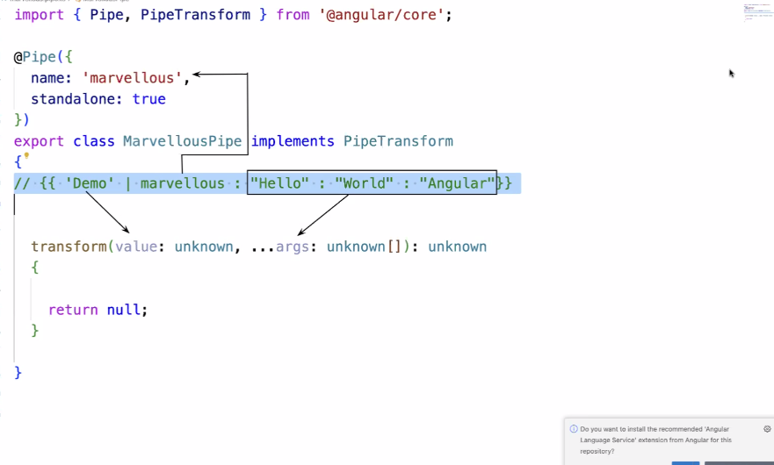

Pipes in Angular

(Transform the data from one form to another)

Custom pipe

Inbuilt pipe

ng generate pipe <name>

Currency

Number

JSON

Date

String

**Directives in Angular:**

* The concept of directives is used to provide the specific execution direction for the html elements
* There are two types of directives:  
  1) Structural directives (Inbuilt directives):
  + This are used to change the existing structure of an HTML
  + By using the structural directives, we can add the basic logical part into our HTML file
  + There are three structural directives
    - ngIf
    - ngFor
    - ngSwitch

2) Custom directives:

* + We can create our own directive which will add the functionality to the element of the html.
  + Like the custom pipe we can create the custom directive.
  + By using the concept of custom directive the html elements gets updated based on the logic.