**ARJUNA**

**Exam Portal**

**System Requirement Document**

**January , 2023**

|  |  |  |  |
| --- | --- | --- | --- |
| Document No. |  | Ver. Rev. | 0.7 |
| Authorized by |  | Date |  |

Revision History

|  |  |  |  |
| --- | --- | --- | --- |
| Ver. | Date | Author | Description |
| 0.1 | Feb 25, 2022 | Nilesh Dongre | Draft |
| 0.2 | Mar 1, 2022 | Nilesh Dongre | Updated the document for the following   * Points covered as discussed in the meeting on 25Feb2022 - 1 UC001: Default screen should not be sign-in screen.  2 UC003: Not in current phase   3 UC005: The user will be authenticated on the basis of email ID only 4 UC006: Captcha is not required for now. 5 UC010: User session timeout should be configurable. 6. UC054: “Integration with google captcha” use case is not required.   * Additional information added regarding ‘Manage Infrastructure’ section. |
| 0.3 | Mar 3. 2022 | Nilesh Dongre | Following use cases updated as discussed in the meeting on 01 Mar 2022 UC019,UC021,UC023,UC024,UC025,UC043,UC044 |
| 0.4 | Mar 4 2022 | Nilesh Dongre | Following use cases updated as discussed in the meeting on 03 Mar 2022 UC003,UC013,UC019,UC023, UC025,UC029 |
| 0.5 | Mar 16 2022 | Nilesh Dongre | Added screenshots corresponding to respective use cases and modified the document as per the feedback from Tenstorrent. |
| 0.6 | Mar 21, 2022 | Nilesh Dongre | Added following roles:  1. TT Account Payable  2. TT Partner  Added following Use Cases  1. UC024: Edit instance details by the logged-in user (changing the instance configuration runtime, apart from flavor, storage and archive storage can be modified by the user )  2. UC031: Organization admin has an ability to update user role from ‘User’ to ‘OrgAdmin’ |
| 0.7 | Mar 23, 2022 | Nitin | Reviewed and updated – Phase II |

TABLE OF CONTENTS

1. INTRODUCTION 1

1.1 Document Purpose 1

1.2 Intended Audience and Reading Suggestions 1

1.3 Application Scope 1

1.4 REFERANCES 1

2. Overall Description 2

2.1 Application Perspective 2

2.2 Assumptions and Dependencies 2

3. System Features (Common for all users) 3

3.1 General Requirements 3

3.1.1 Use Cases 3

3.1.2 UI Wireframe 4

3.2 Sign-in 4

3.2.1 Use Cases 4

3.3 Forgot password 4

3.3.1 Use Cases 4

3.4 Forgot username 5

3.4.1 Use Cases 5

3.5 SIGN-OUT 5

3.5.1 3.5.1 UI Wireframe 5

3.6 User session 5

3.6.1 Use Cases 5

3.7 Registration / Customer On-boarding 6

3.7.1 Use Cases 6

3.7.2 Flow Chart: 7

3.7.3 UI Wireframe 7

4. System Features (USER) 8

4.1 My profile 8

4.1.1 Use Cases 8

4.1.2 UI WIREFRAME (USER) 8

4.2 Manage infrastructure 16

5. System Features (Organization Administrator) 19

5.1 Use Cases 19

5.2 UI Wireframe (Orgadmin) 19

5.2.1 Dashboard: 19

5.2.2 My Organization Details: 20

5.2.3 My Organization Address: 20

5.2.4 Instances: 20

5.2.5 Create New Instance: 20

5.2.6 Order History Details: 20

5.2.7 Payment Information: 21

5.2.8 User Details: 21

5.2.9 Create New User: 22

5.2.10 Instance Details: 22

5.2.11 Payment Information: 23

5.2.12 Notifications: 24

5.2.13 Invoices: 25

6. System Features (Tenstorrent Administrator) 26

6.1 Use cases 26

6.2 Wireframe (Tenstorrent Administrator) 27

6.2.1 Dashboard: 27

6.2.2 Organizations Details: 27

6.2.3 Create New Organization: 28

6.2.4 Edit & Delete Org: 28

6.2.5 Organization Details: 28

6.2.6 Organizations Address Details: 29

6.2.7 Instances Details: 29

6.2.8 Add New Instance: Reference 4.1.2.5 30

6.2.9 Single Organization Users Details: 30

6.2.10 Order Details: 30

6.2.11 Payment Information: 31

6.2.12 All Users Details: 31

6.2.13 Create New User: 32

6.2.14 VM Flavour’s Details: 32

6.2.15 Create New VM Flavor: 33

6.2.16 Storage Details: 33

6.2.17 Create New Storage: 34

6.2.18 Archive Storage Details: 34

6.2.19 Create New Archive Storage: 35

6.2.20 Regions Details: 35

6.2.21 Create New Region: 36

6.2.22 Notifications Details: 36

6.2.23 Invoices Details: 37

7. System Features 38

7.1 Use cases 38

8. Roles 39

8.1.1 Description 39

9. Notifications 40

10. High Level Solution Architecture 40

11. For Next phase 41

11.1 Manage Infrastructure 41

11.1.1 Use Cases: 41

11.2 System Features (User) 41

11.2.1 Use Cases 41

11.3 System Features (Organization Admin) 41

11.3.1 Use Cases 41

11.4 System Features (tENSTORRENT aDMIN) 42

11.4.1 Use Cases 42

11.5 System Features (Tenstorrent account payable) 42

11.5.1 Use cases 42

11.5.2 UI Wireframe (TT Account Payable) 42

11.6 System Features (Tenstorrent PartNer) 42

11.6.1 Use cases 42

11.6.2 UI Wireframe (TT Partner) 42

11.7 System Features (Common for all users) 42

11.7.1 Use Cases: 42

# INTRODUCTION

ARJUNA is planning to develop Web application / portal for their customers which is one stop solution for conducting online exams .This platform enables client to conduct and candidate to appear for secure, efficient and user-friendly online examination.

A client has to simply register and subscribe exam packages, they will able to appoint an Exam admin for managing a particular exam and then authorized candidates of the Exam Admin will take exam further results and statistics will be published as per schedule.

Integration with payment gateway (Stripe) would enable online payment for clients. The main focus of the application will be to simplicity and ease provisioning / handling of Examination in any type of organization.

## Document Purpose

This document details the overall functionality required for development of web based application for Online Exam Portal.

## Intended Audience and Reading Suggestions

The primary audience of this document is Itarium Technologies India Pvt. Ltd stakeholders

## Application Scope

## REFERANCES

None.

# Overall Description

## Application Perspective

Online Exam Portal will be a web-based application which provisioning Conduct Examinations from Client Perspective

## Assumptions and Dependencies

* Every user must have access to internet while using the portal. (Online mode only)
* Portal should be accessible to the users via desktop web browser (Internet Explorer v 10 and above, Goggle Chrome v 98.x and above, Firefox v 97.x and above, Safari v 15.x and above)
* The portal will be accessible from smart phone browser.
* Stripe merchant account details will be provided for integration

# System Features (Common for all users)

## General Requirements

### Use Cases

|  |  |
| --- | --- |
|  | Exam Portal web application should be available over internet.  User should be able to launch Exam Portal application via web browser.  Default screen for the application will be launched from Exam Portal application.  This application will be linked from existing portal / any other place.  User password will be stored in encrypted format. |
|  | Exam Portal application will have English as language of user interaction. |
|  | Any User can register themselves as a Client to use Exam Portal Application |
|  | **Password policy**   * Minimum 8 characters and maximum 16 characters in length. * Should have at least one upper case, one lower case, one number and one special character. * No enforcement to change password after specific duration will be provided. Password will never expire. * Password history will not be maintained. User can change the password to previous one * Password strength meter will not be available * Security questionnaire will not be provided for password recovery |

### UI Wireframe

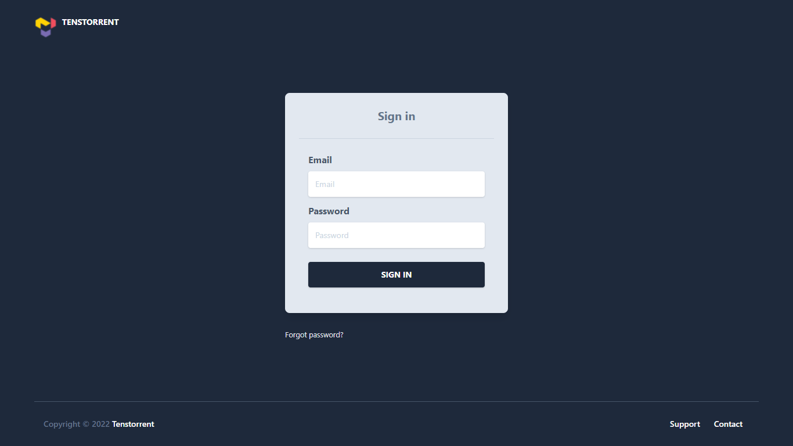

## Sign-in

### Use Cases

|  |  |
| --- | --- |
|  | User should be able to enter the registered email address and password to sign-in. |
|  | There will five attempts to enter correct password.  After five unsuccessful attempts the account will be locked for 10 min (configurable) |

## Forgot password

### Use Cases

|  |  |
| --- | --- |
|  | In case user forgets password, he can send reset password request by clicking ‘Forgot Password’ link. User needs to submit his email address used to sign-in to our system. After this system will send OTP to registered email address of the user. Upon validation of OTP user will be redirected to set new password screen. The OTP will be valid for 5 minutes (configurable). User will be redirected to sign-in screen after successfully setting new password. |

## SIGN-OUT

|  |  |
| --- | --- |
|  | User should be able to sign-out from the Exam Portal application.  User clicks on the sign-out link.  A confirmation (“Are you sure you want to sign-out”) popup will be displayed.  If user clicks on ‘Yes’, he will be signed-out from the application and will be redirected to sign-in screen.  If user clicks on ‘No’, he will stay on the same page and no action will be performed. |

### 3.5.1 UI Wireframe

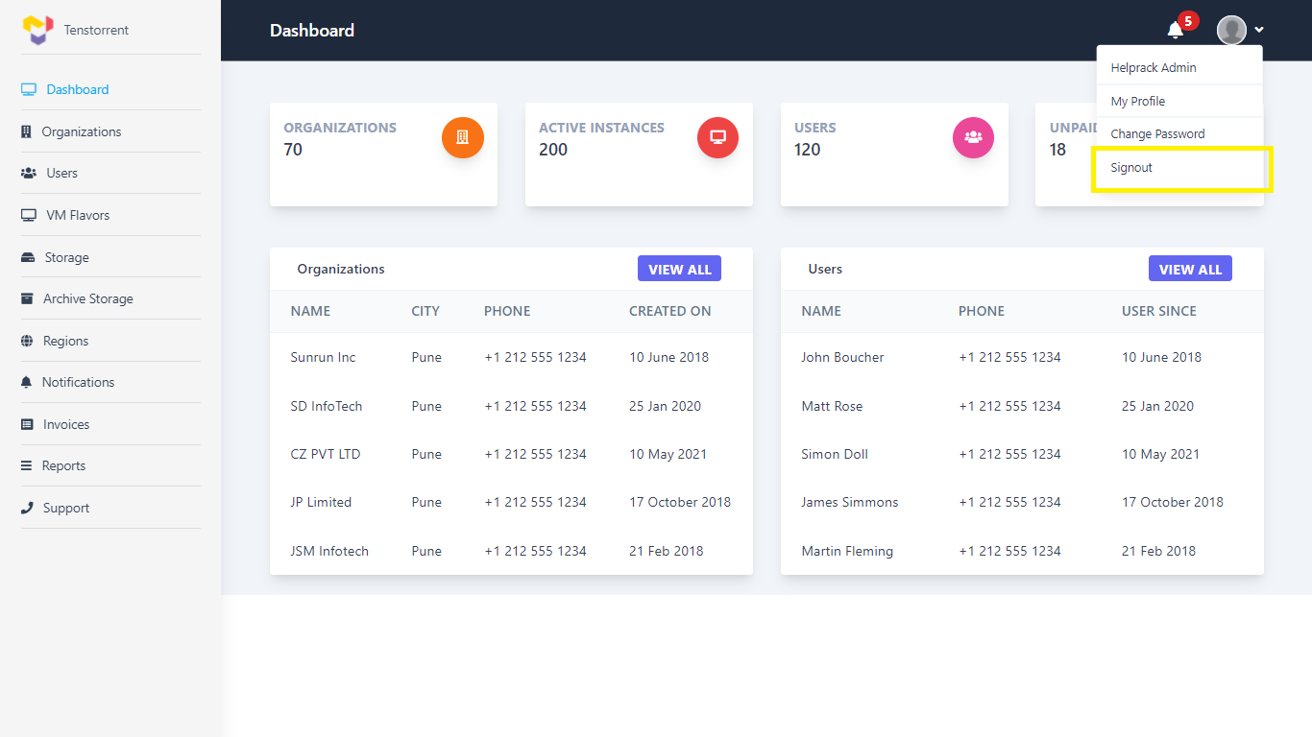

## User session

### Use Cases

|  |  |
| --- | --- |
|  | User session will expire in 30 mins (configurable) of inactivity. After that, any action will prompt user to sign-in again. |
|  | User will not be able to sign-in from multiple devices at a time. The latest signed-in session will be the only active session. |

## Registration / Customer On-boarding

### Use Cases

|  |  |
| --- | --- |
|  | User should be able to access the Exam Portal application using desktop or mobile web-browser and enter email address as part of registration information. |
|  | **Customer On-boarding:** Initially, default Exam Portal Administrator user is available in the system.  Custom onboarding process:  **Step1:** Client will register themselves on Exam Portal Application  Following organization/Client attributes will be captured during registration.   1. Organization/Client Name 2. Unique identification number (auto generated) 3. Mobile / phone 4. Email ID 5. Password 6. Address [Line1, Line2, City, State, Country, ZIP,] |
|  | When Client accesses account for the first time, they will be forced to enter the payment (Credit / Debit Card) details. Credit / Debit Card payment is the only option for now.  The payment details provided will be validated using Stripe integration. Upon successful validation, user will be allowed to use other customer portal features. |

### Flow Chart:

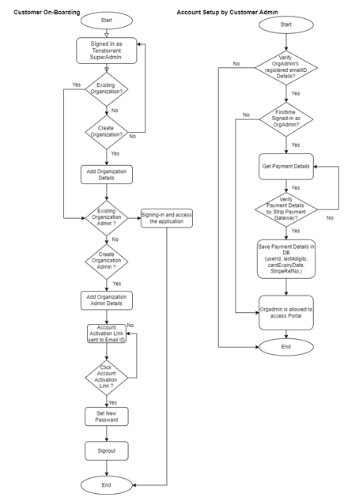

### UI Wireframe

# System Features (USER)

## My profile

### Use Cases

|  |  |
| --- | --- |
|  | User can view the details submitted during the registration. No provision will be there for uploading profile image. |
|  | User can update his profile data except the email address which is used for sign-in. |
|  | User can change his password if required. User needs to enter old password, new password and confirm new password to change the password. |

### UI WIREFRAME (USER)

#### Dashboard:

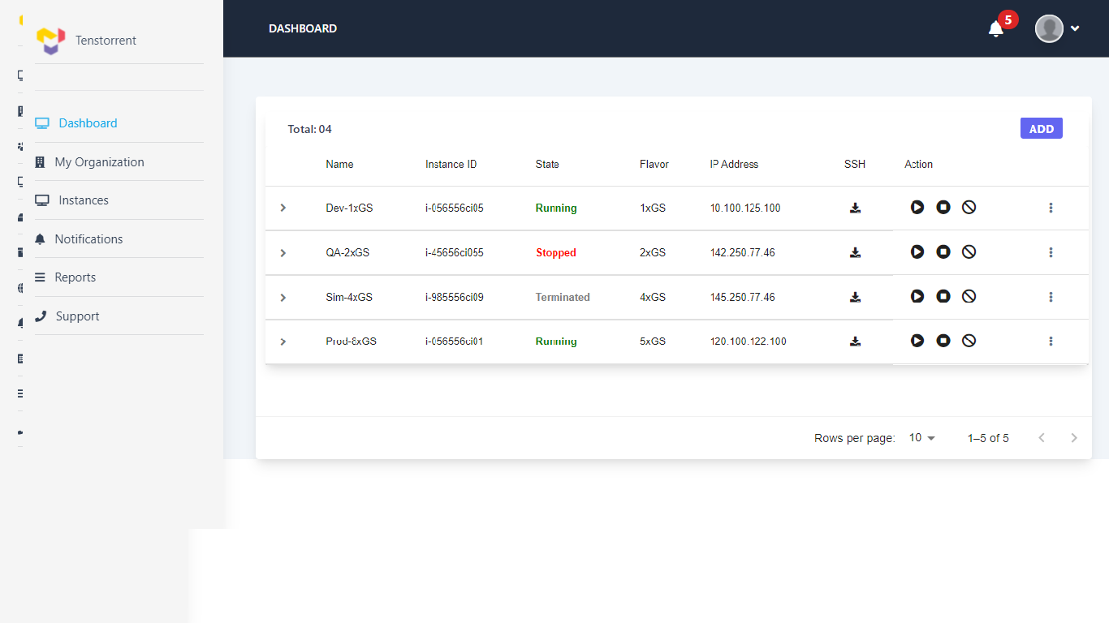

#### My Organization Details:

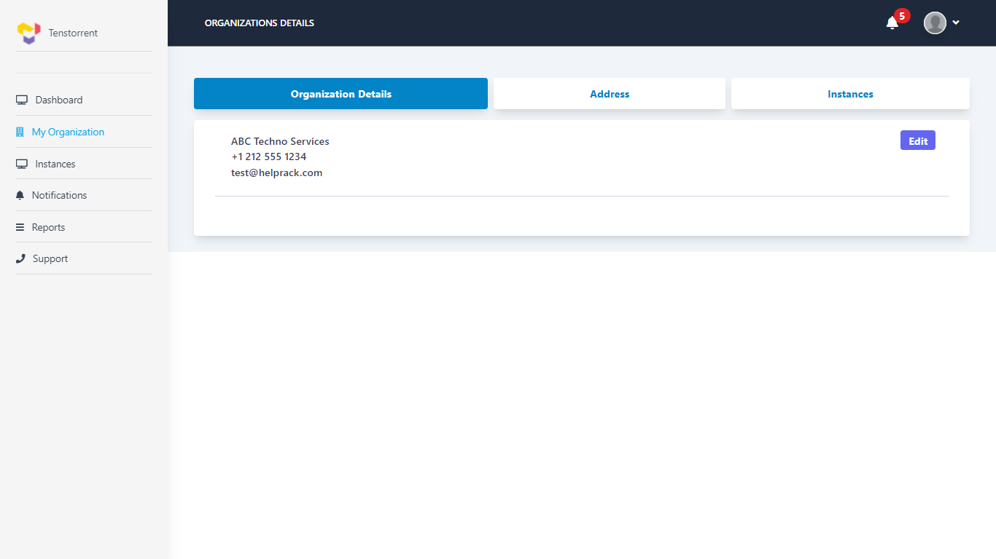

#### My Organization Address:

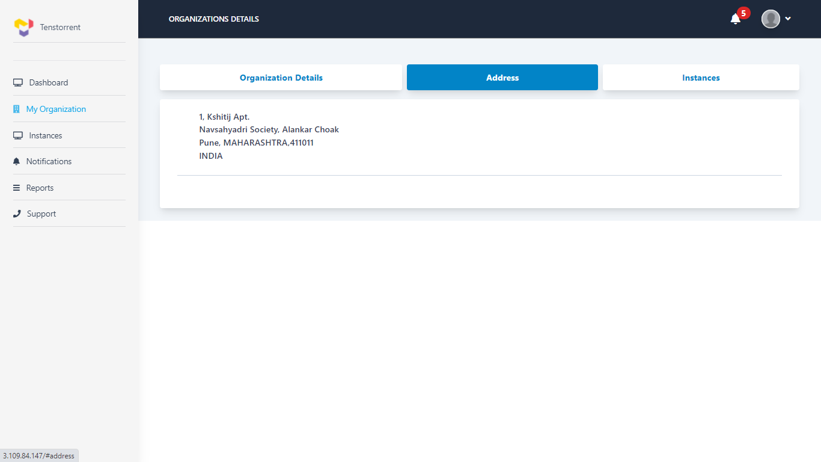

#### My Organization Instances:

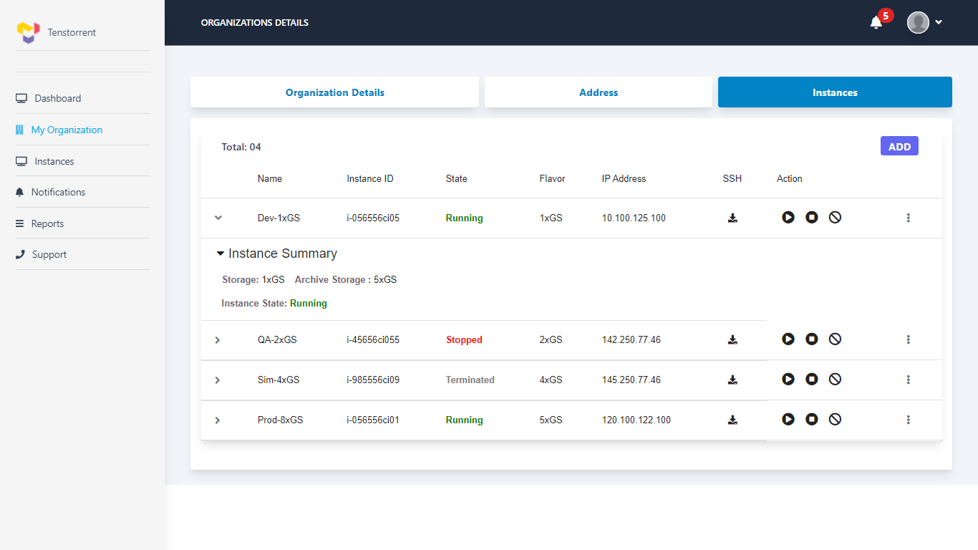

#### Create New Instance:

**Steps to create new Instance:**

##### Selection of Region:

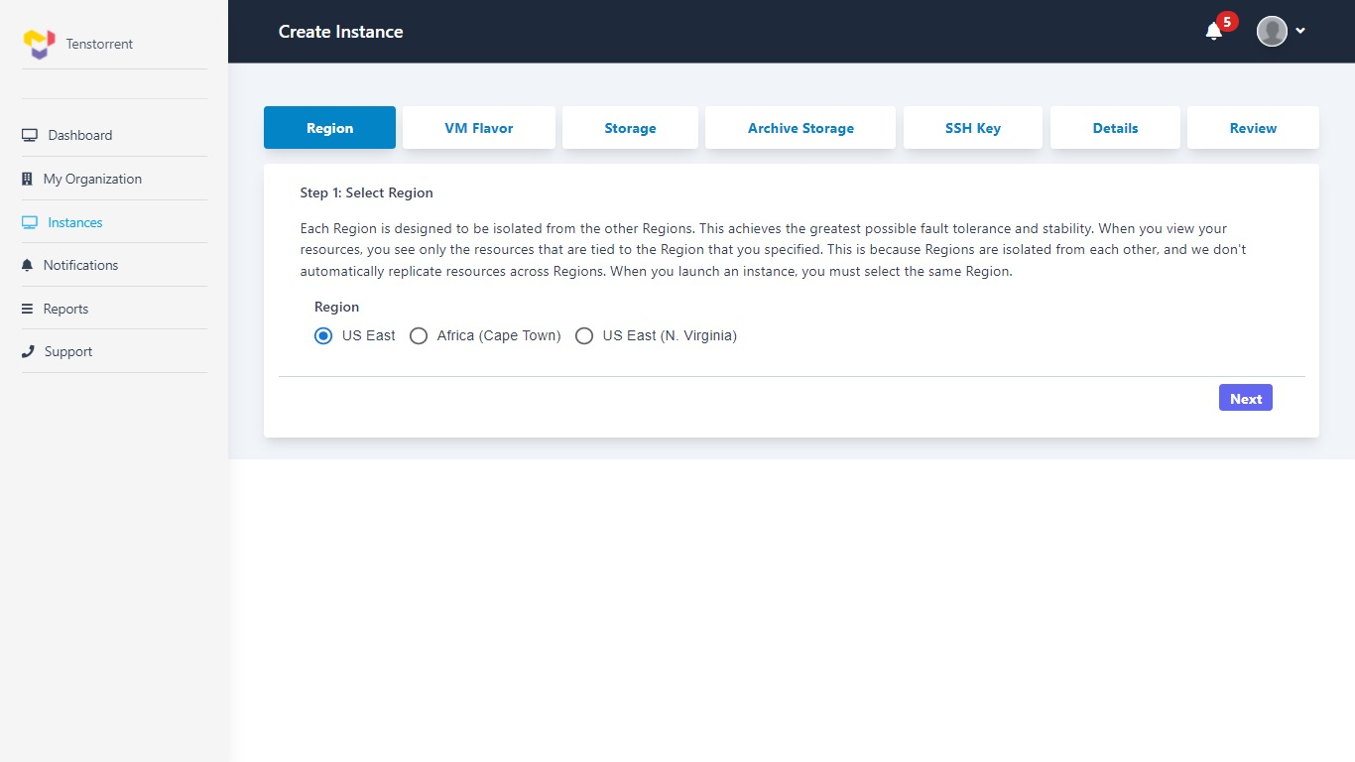

##### Selection of VM Flavor:

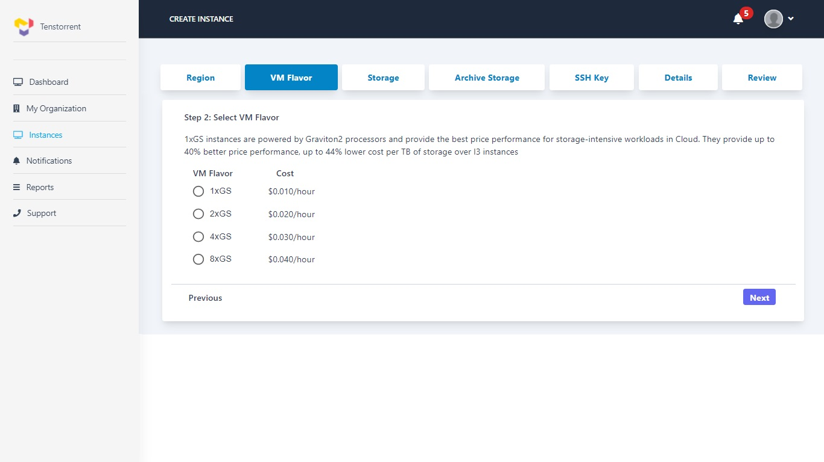

##### Selection of Storage:

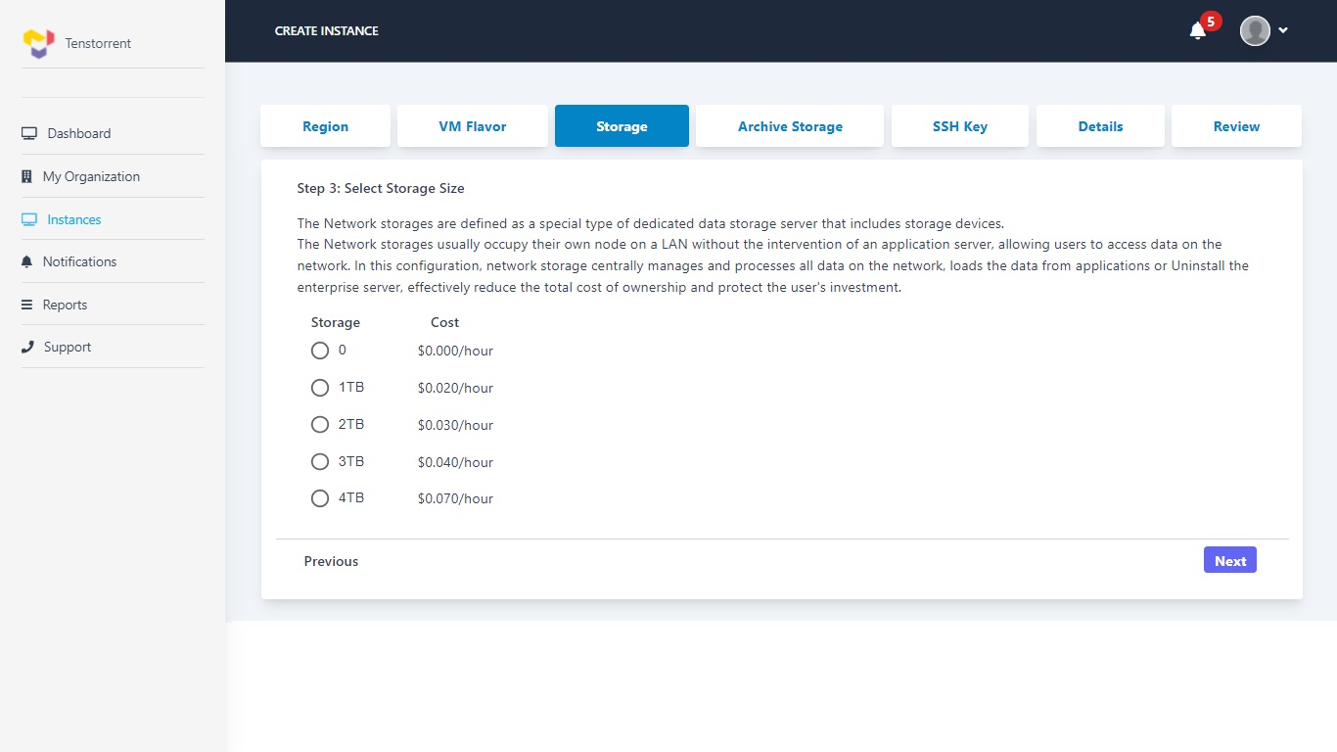

##### Selection of Archive Storage:

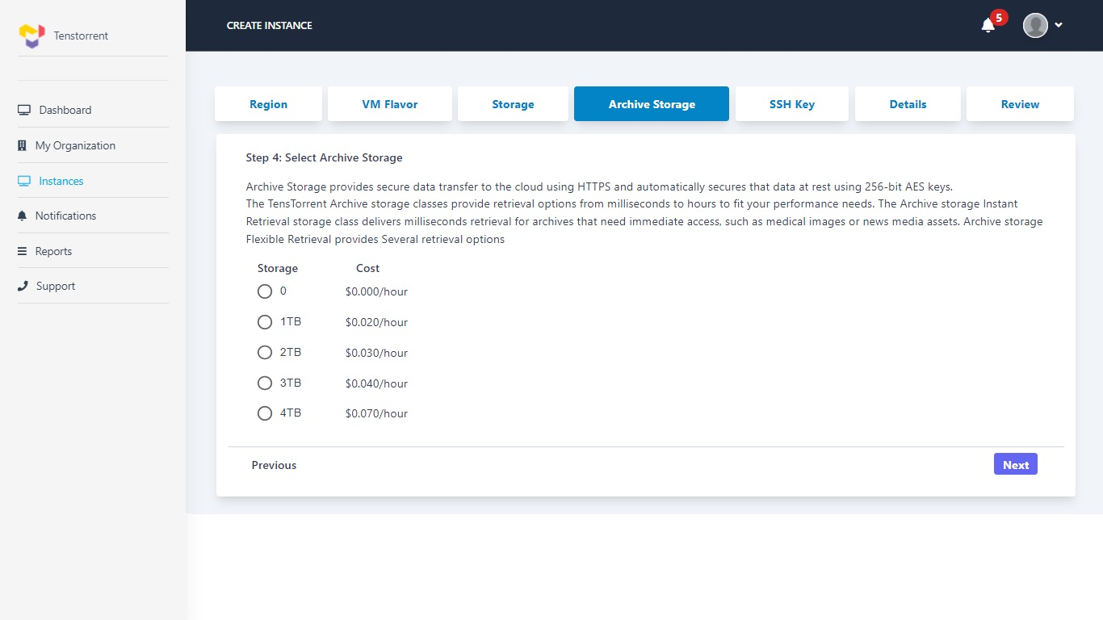

##### Selection of SSH Key:

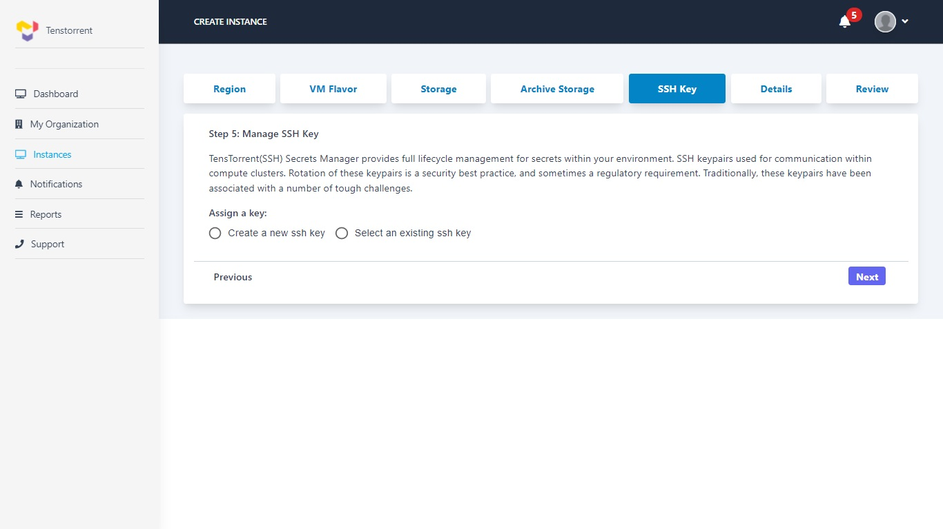

##### Option 1. Generate new SSH Key:

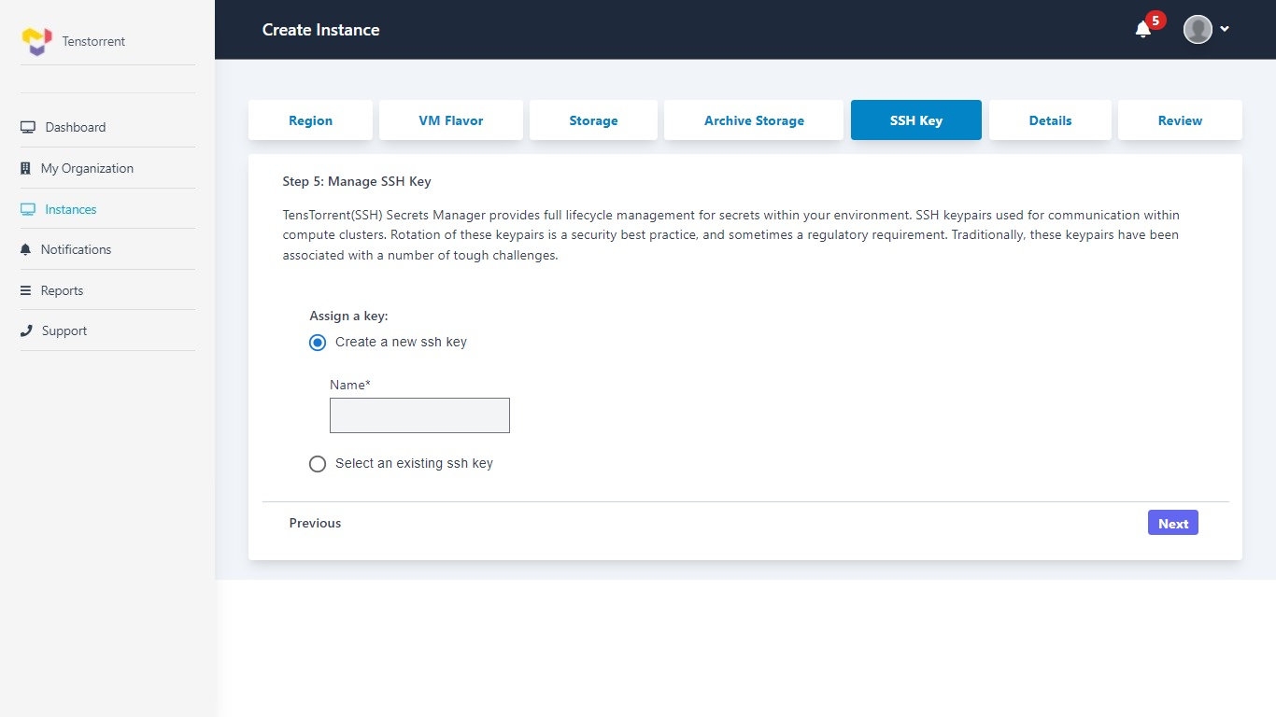

##### Option 2. Enter Existing SSH Key:

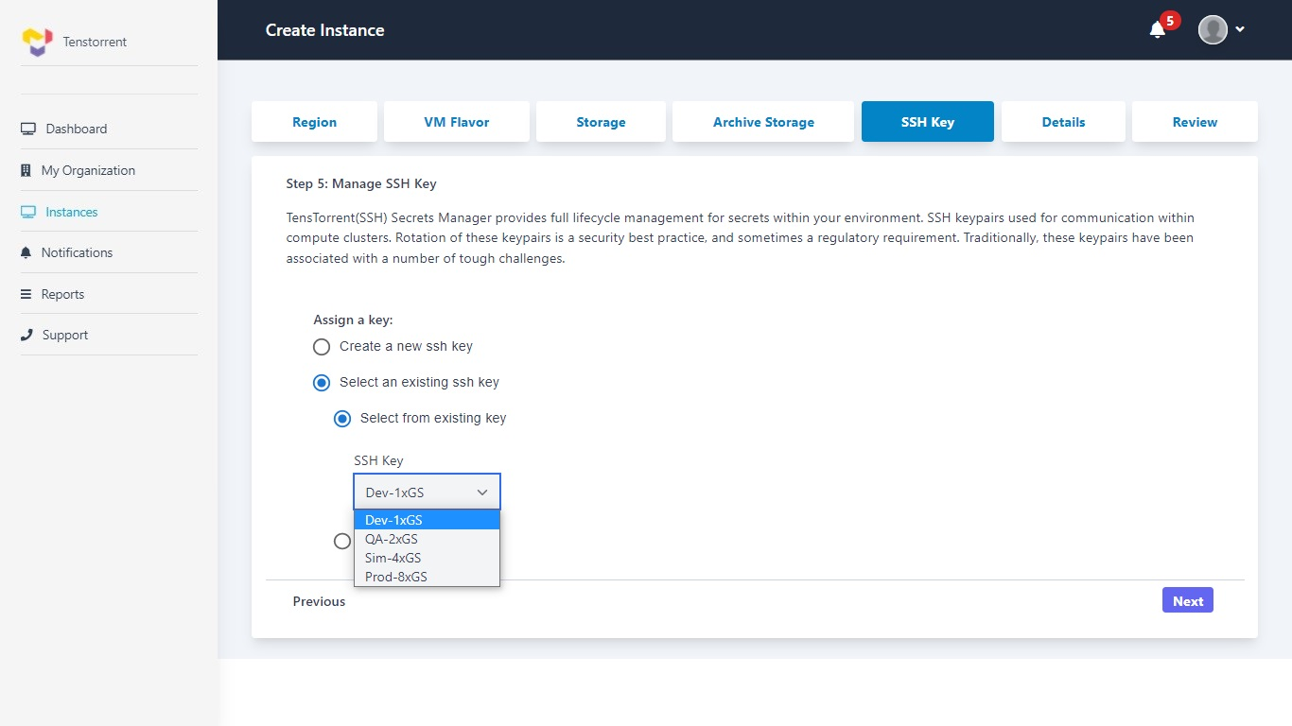

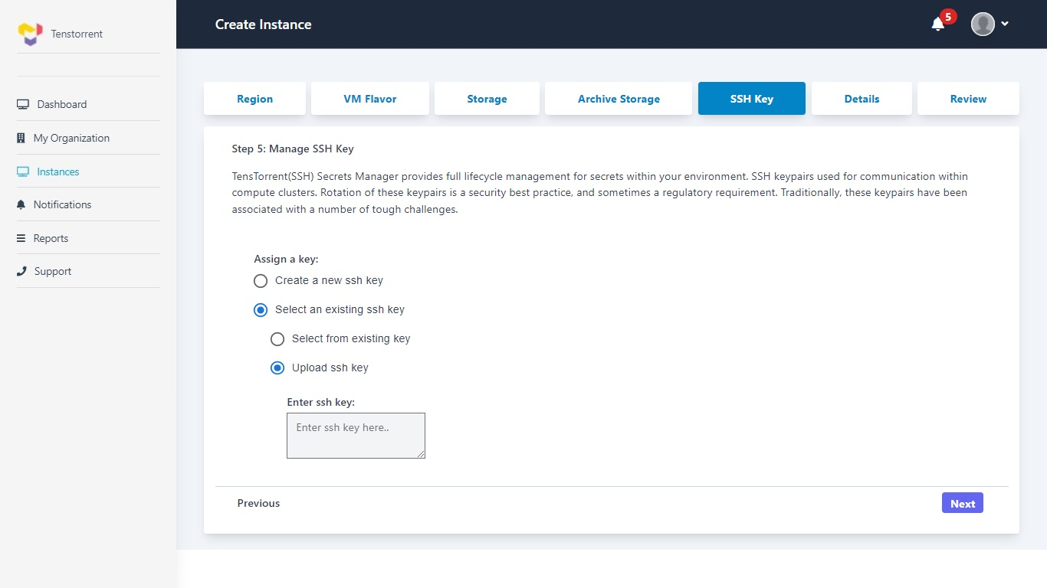

##### Add more details of Instance:

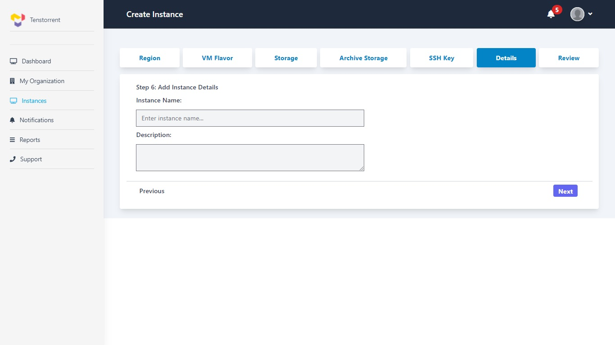

##### Review and Launch Instance:

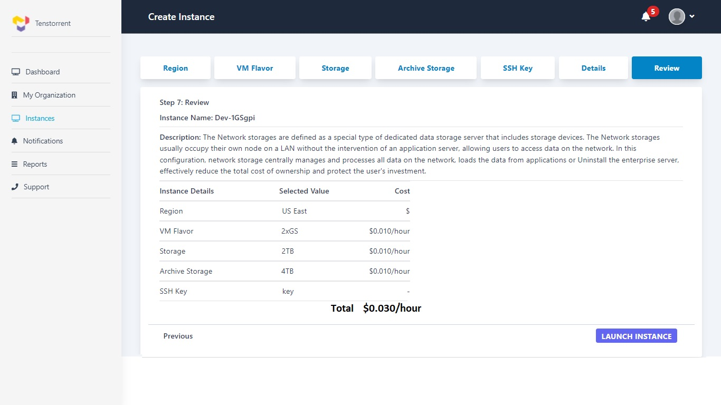

##### Instance List:

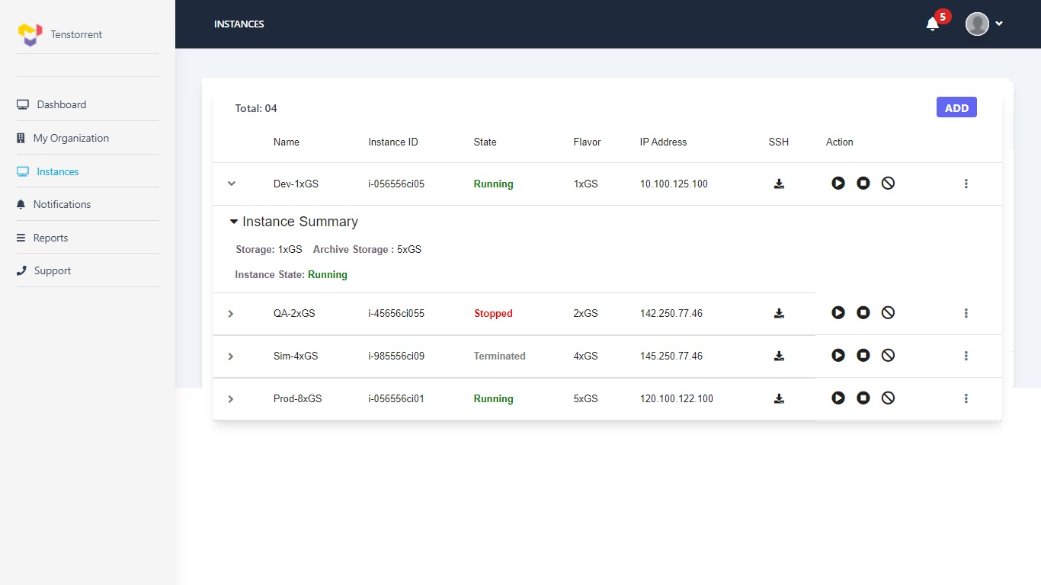

#### Notifications:

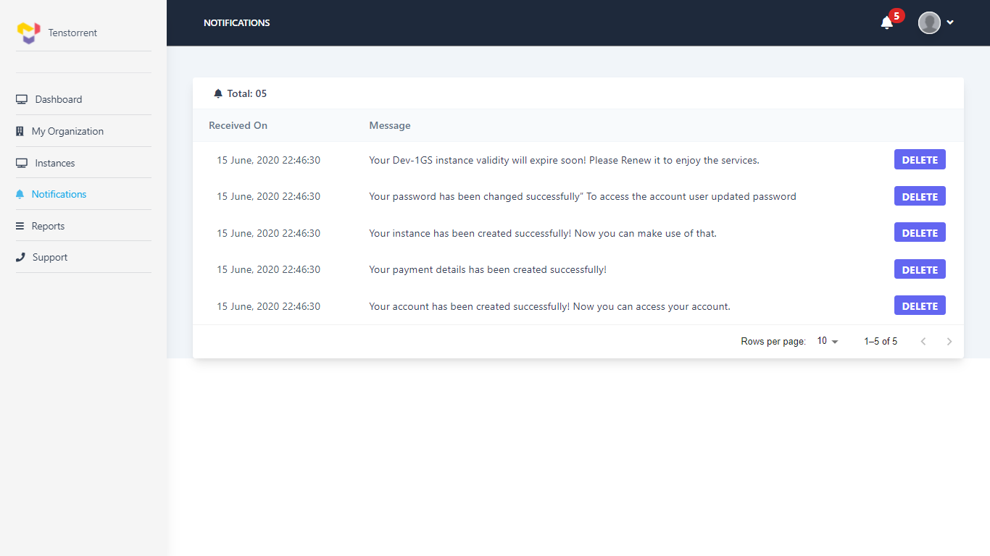

## Manage infrastructure

|  |  |
| --- | --- |
|  | View and select resource (hardware and software) catalogue |
|  | Customer user can view /select/ provision instance catalogue configuration. End point for each VM will vary with respect to the region.  VM provisioning will happen as per following steps through wizard-   1. Click on create instance button / option 2. Select region 3. Choose VM flavor 4. Choose storage size 5. Choose archive storage 6. Manage SSH Key 7. Add name, Comment / description 8. Review and Launch  * **Flow Chart:** |
|  | VM flavors and storage will be displayed as per the availability provided by Openstack and Weka APIs  Unavailable options will be greyed out to user for selection |
|  | View list of instances created by the logged-in user   1. Number of instances created 2. Instance name (free text) 3. Instance ID (Openstack generated unique ID) 4. Instance state (Provisioning / Starting / Running / Stopping / Stopped / Rebooting / Terminated) 5. Instance type 6. Instance created date 7. Instance details (region, flavor, storage size, archive storage) 8. Instance owner / created by 9. Public IP address of VM (IPv4). 10. Link to Manage SSH key. 11. User can see details or manage VMs created by another user in that organization. 12. Instance usage should be displayed.   *Instance type: Tenstorrent will provide different Instance types. |
|  | Logged-in user can Edit following details of instance   1. Instance name (free text) 2. Instance state (Provisioning / Starting / Running / Stopping / Stopped / Rebooting / Terminated) 3. Instance type 4. Instance details: storage size 5. Instance details: archive storage 6. Link to Manage SSH key.   *Instance type: Tenstorrent will provide different Instance types. |
|  | Manage instance (Create, start, stop, terminate)  Instance states are as follows-   1. Start Instance 2. Stop Instance 3. Reboot Instance 4. Terminate Instance |
|  | Manage SSH Key pair:  Following options can be considered at the time of creating new SSH key for Instance creation.   1. Create New SSH key 2. Use existing/import SSH key 3. Download SSH key |
|  | View resource consumption report   1. Report duration (monthly, date wise) 2. Instance owner details 3. Instance details 4. Instance running hours, total hours 5. Total consumption cost (Instance cost, Storage cost, Archive storage cost , Applicable Taxes) |
|  | View other statistics made available from OpenStack |

# System Features (Organization Administrator)

Organization Admin role will be primarily used for organization user creation and viewing reports. This web-based application will be accessed by administrators of Tenstorrent customer team.

## Use Cases

|  |  |
| --- | --- |
|  | Manage organization users (Search, add, update, disable) |
|  | Organization admin has an ability to update user role from ‘User’ to ‘OrgAdmin’ |
|  | Manage payment info |
|  | Manage payment (pay, Auto-pay) |
|  | Infrastructure management for all organization users |
|  | Activate / disable user |
|  | Manage organization master data |
|  | Reset password for organization users |
|  | Can see usage data, reports and billing details |
|  | View invoices |

## UI Wireframe (Orgadmin)

### Dashboard:

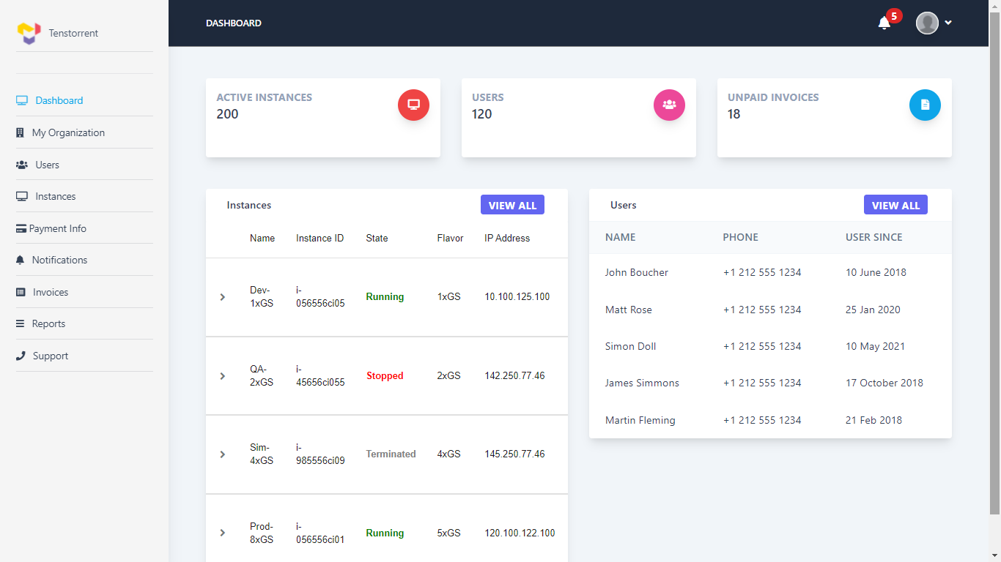

### My Organization Details:

*For screenshot refer: 4.1.2.2 My Organization Details*

### My Organization Address:

*For screenshot refer: 4.1.2.3 My Organization Address*

### Instances:

*For screenshot refer: 4.1.2.4 My Organization Instances*

### Create New Instance:

*For the steps and screenshots to create new instance refer: 4.1.2.5 Create New Instance*

### Order History Details:

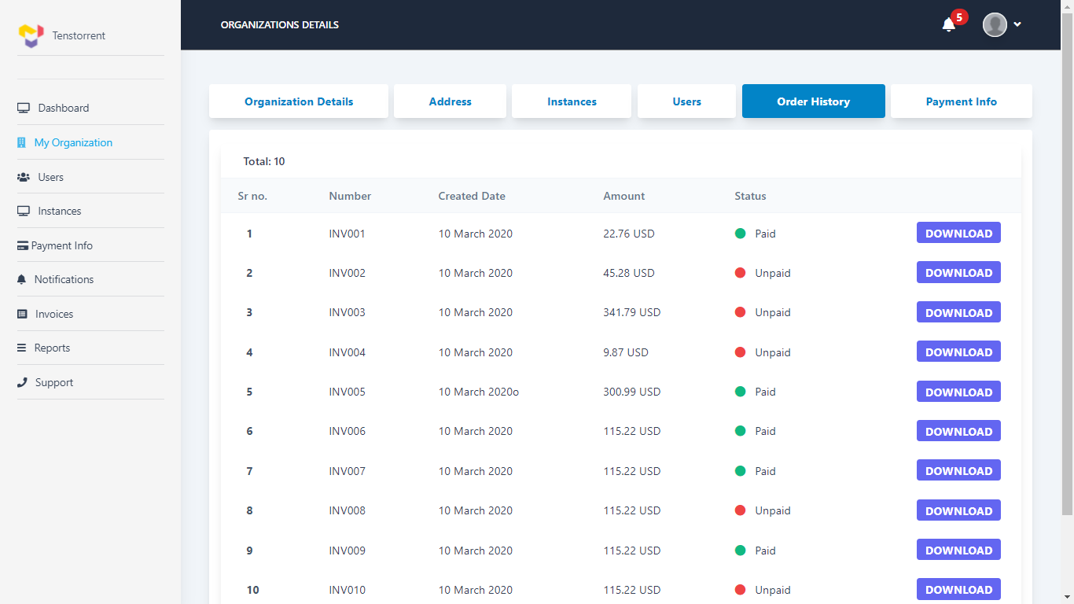

### Payment Information:

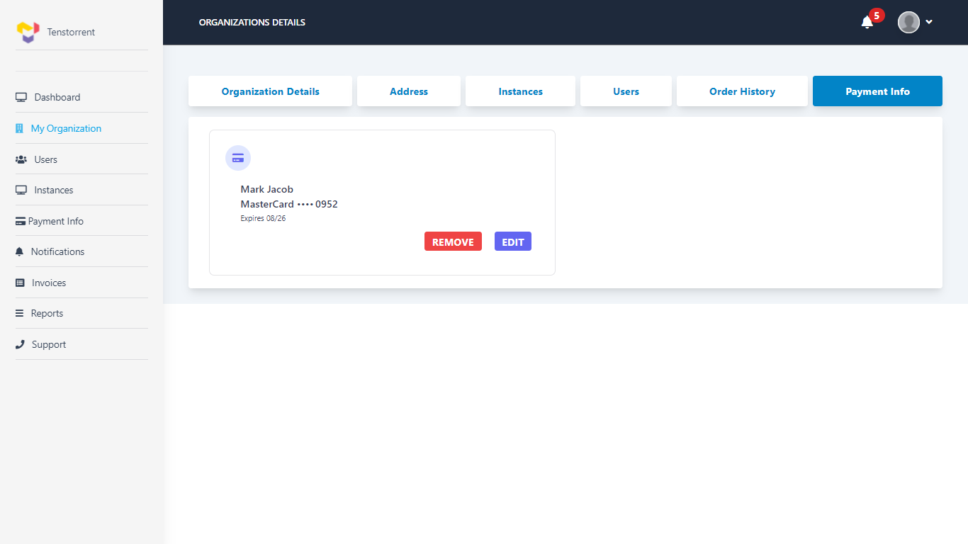

### User Details:

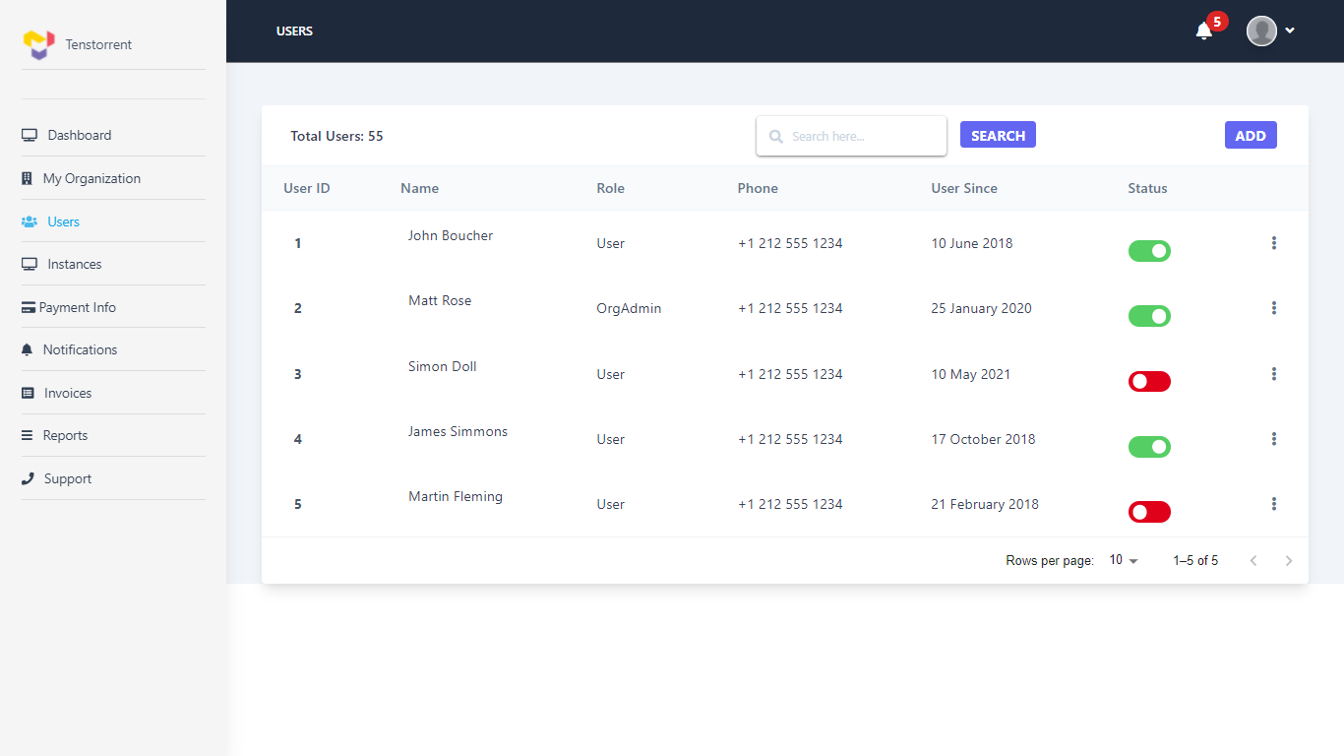

### Create New User:

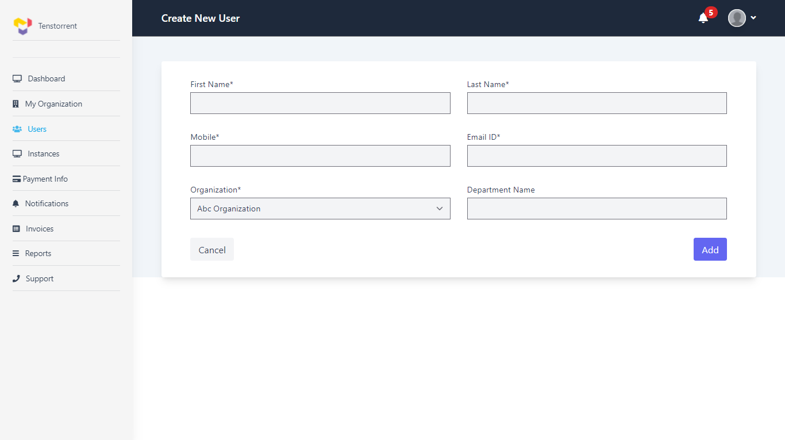

### Instance Details:

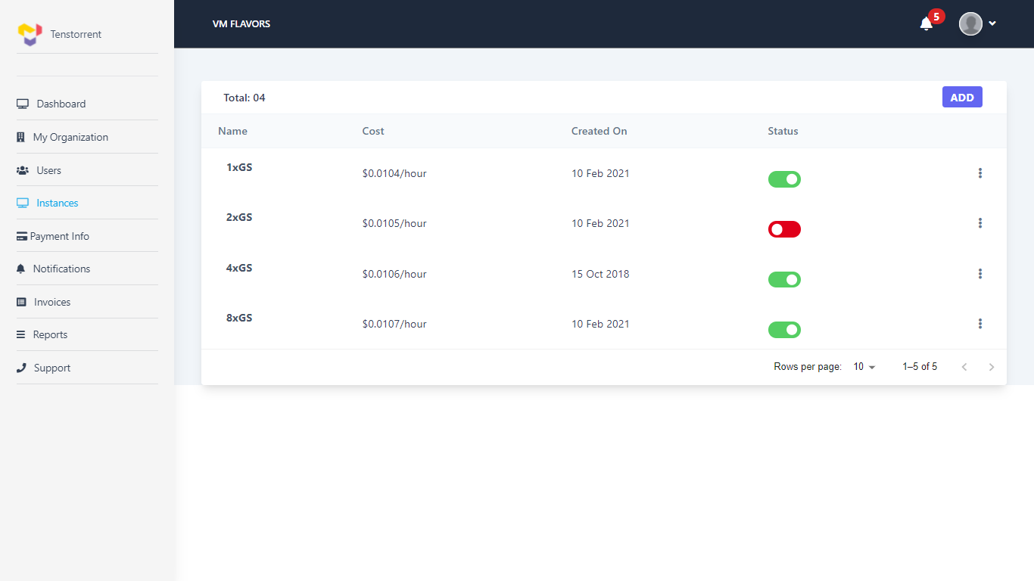

### Payment Information:

#### Add Card details:

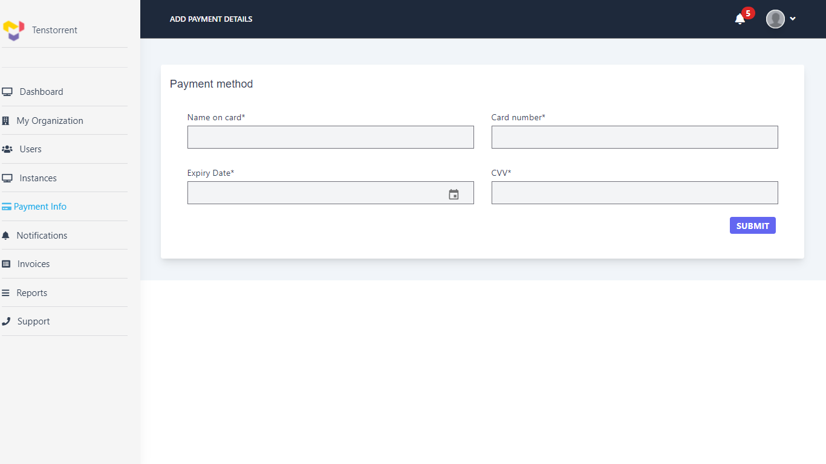

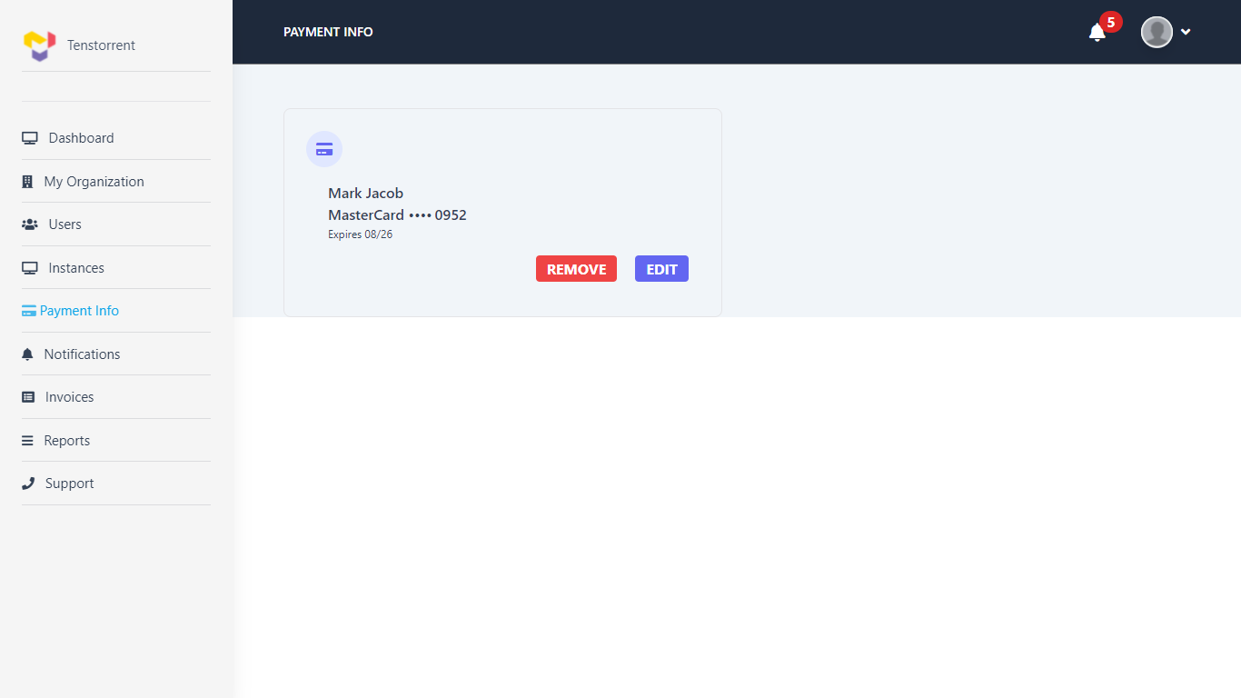

### Notifications:

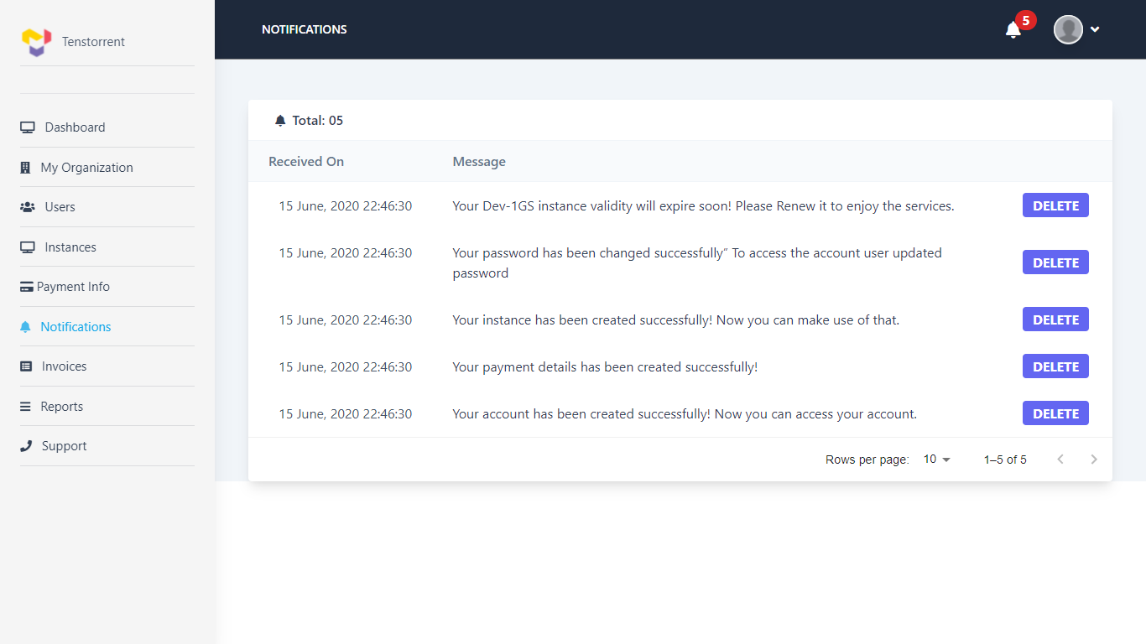

### Invoices:

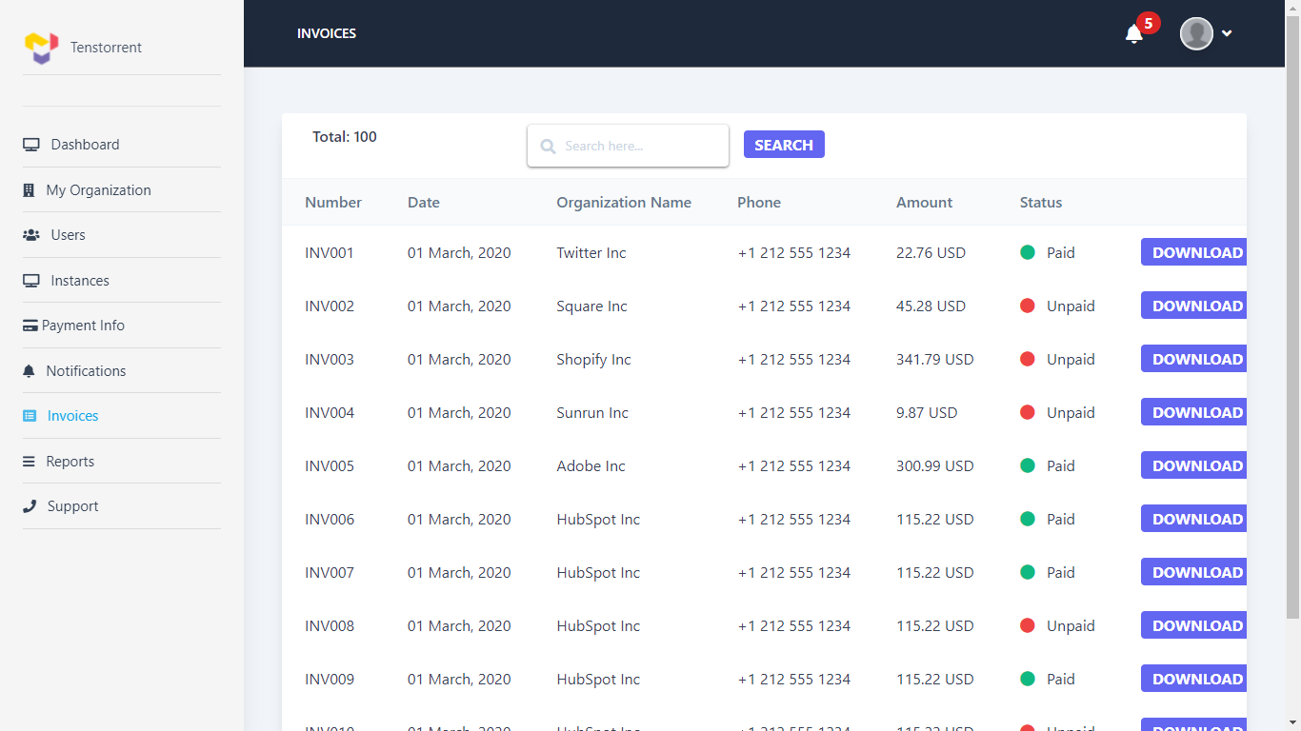

# System Features (Tenstorrent Administrator)

Tenstorrent Administrator role will be primarily used for Master data maintenance and viewing reports. This web-based application will be accessed by Tenstorrent Team.

## Use cases

|  |  |
| --- | --- |
|  | Manage organization (Search, add, update, disable) |
|  | Should be able to add / update organization administrators. |
|  | Should be able to see list of users registered in the system. |
|  | Manage users (Search, add, update, disable) |
|  | Should be able to see details of VMs provisoned by each user |
|  | Should be able to reset password of the user. |
|  | Setup configuration data for VMs (Storage, flavors etc.) Catalogue management   * **Master Data Management (View, create, modify, delete):** catalogue   Tenstorrent admin has an ability to create Master data to Manage Infrastructure.  Master data creation for catalogue includes -   1. Manage region 2. Manage VM flavors: 1xGS, 2xGS, 4xGS, 8xGS 3. Manage storage sizes: 0, 1TB, 2TB, 3TB, 4TB 4. Manage archive storage |
|  | Manage pricing   1. Manage Payment Mode. 2. Manage Billing Options (For eg. Pre Authorization) 3. Manage Tax details and Rules 4. Manage Discount percentage for customer. This discount will be applicable for all VMs provisioned under that customer account. 5. Manage Price. Per resource on hourly basis. The price details will have currency code, validity 6. Manage Invoice cycle. (Invoice will be generated on last day of every month and it is considered as Billing cycle) 7. System should have both the Payment options as mentioned below. But currently we will go for 'Monthly Payment' option only. |
|  | Infrastructure management for organizations |
|  | Activate / disable user |
|  | Manage organization master data |
|  | Reset password for organization users |
|  | Can see usage data, reports and billing details for organizations |
|  | View invoices for organizations |
|  | Manage system master data (City, state, zip, country, organization type, address type etc.) |

## Wireframe (Tenstorrent Administrator)

### Dashboard:

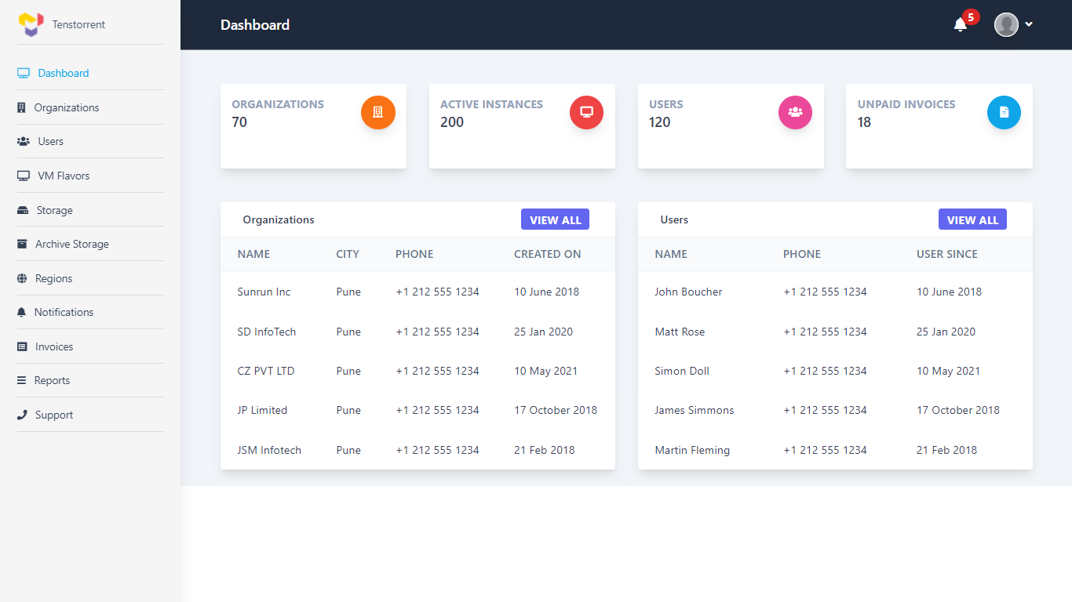

### Organizations Details:

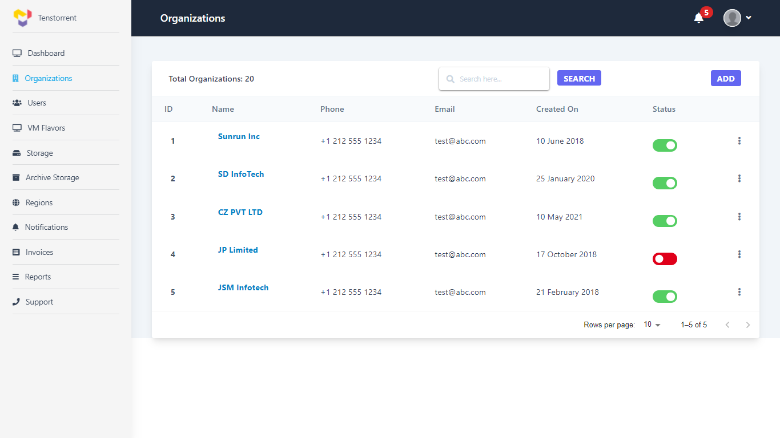

### Create New Organization:

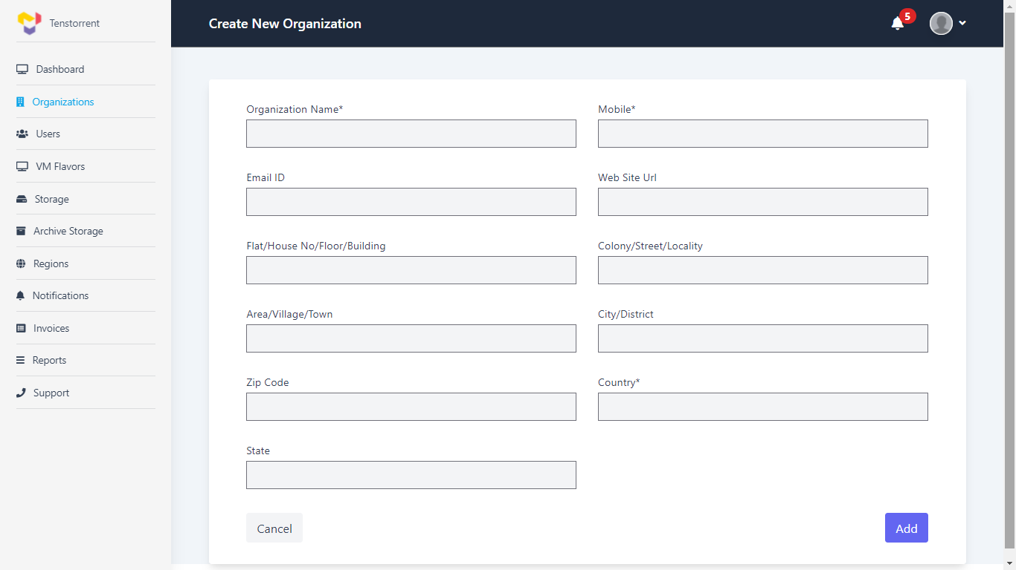

### Edit & Delete Org:

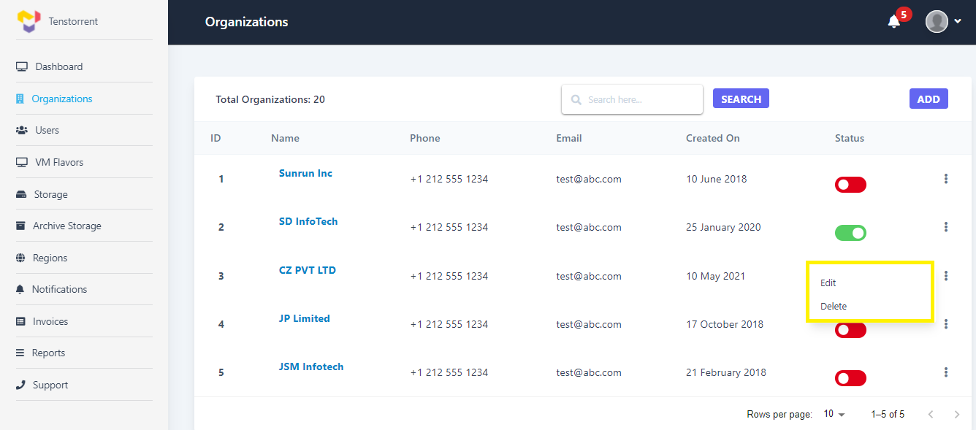

### Organization Details:

For Screenshot refer: 4.1.2.2

### Organizations Address Details:

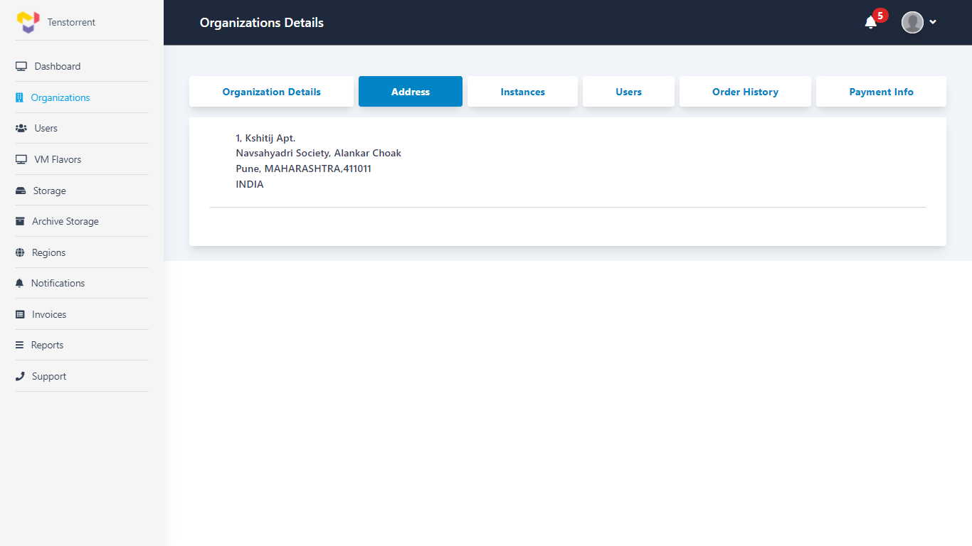

### Instances Details:

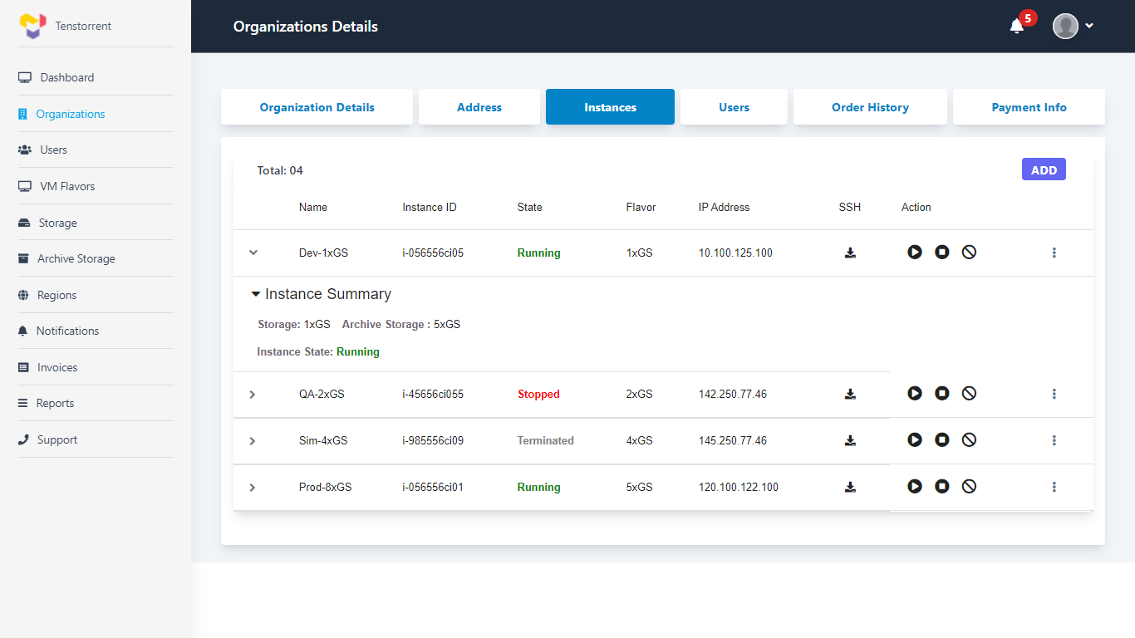

### Add New Instance: Reference 4.1.2.5

### Single Organization Users Details:

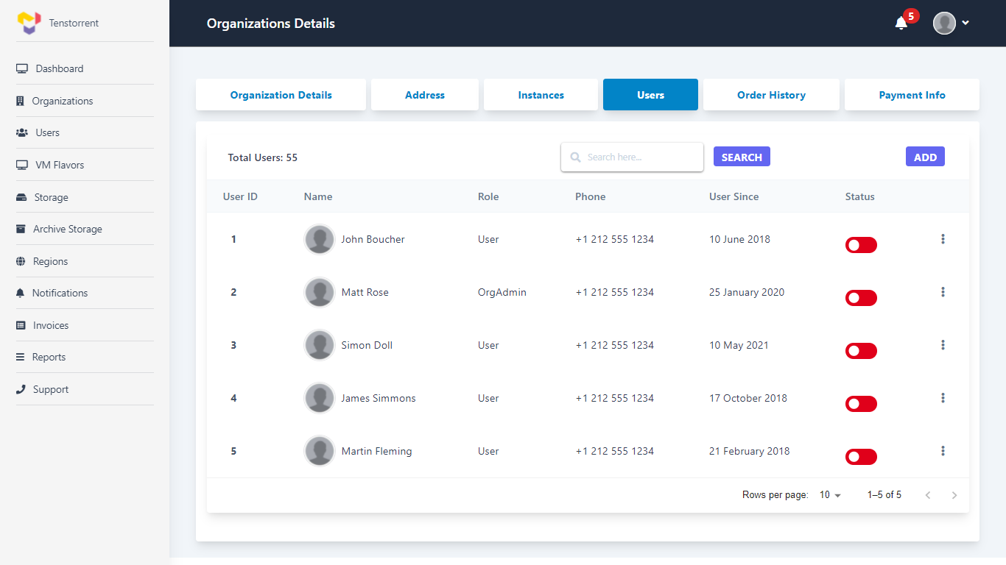

### Order Details:

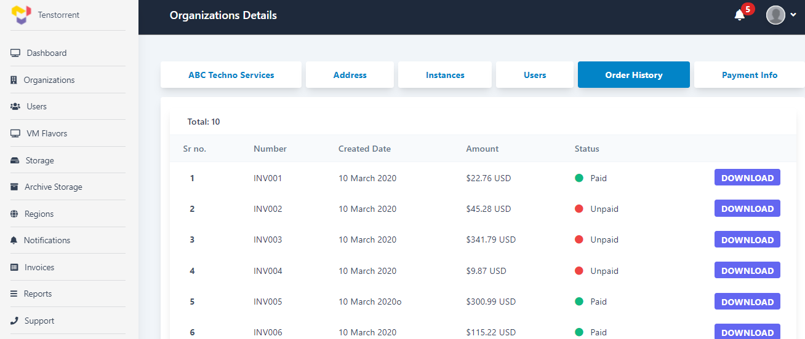

### Payment Information:

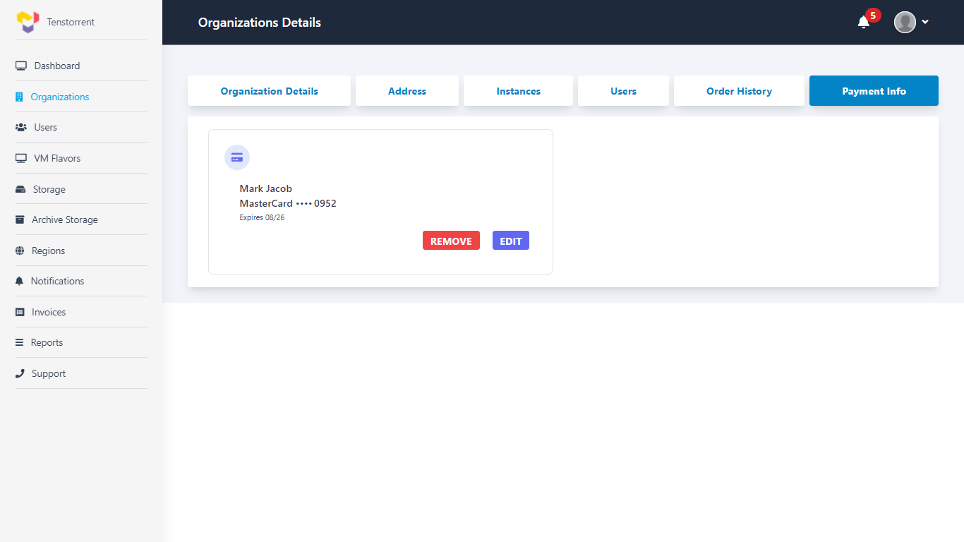

### All Users Details:

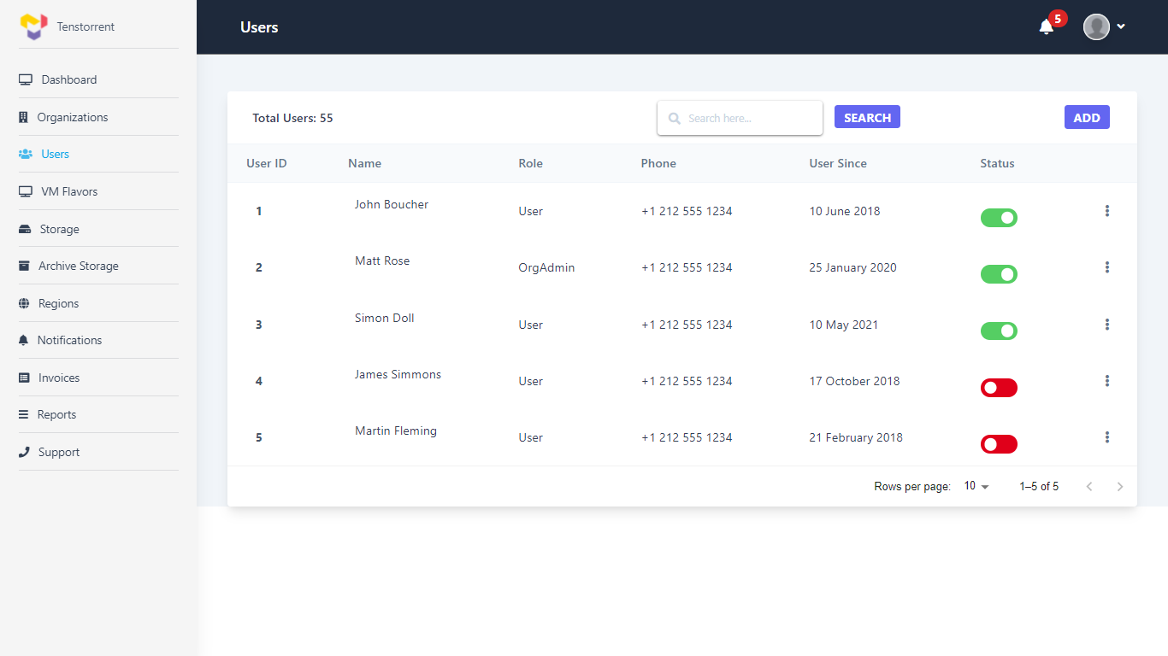

### Create New User:

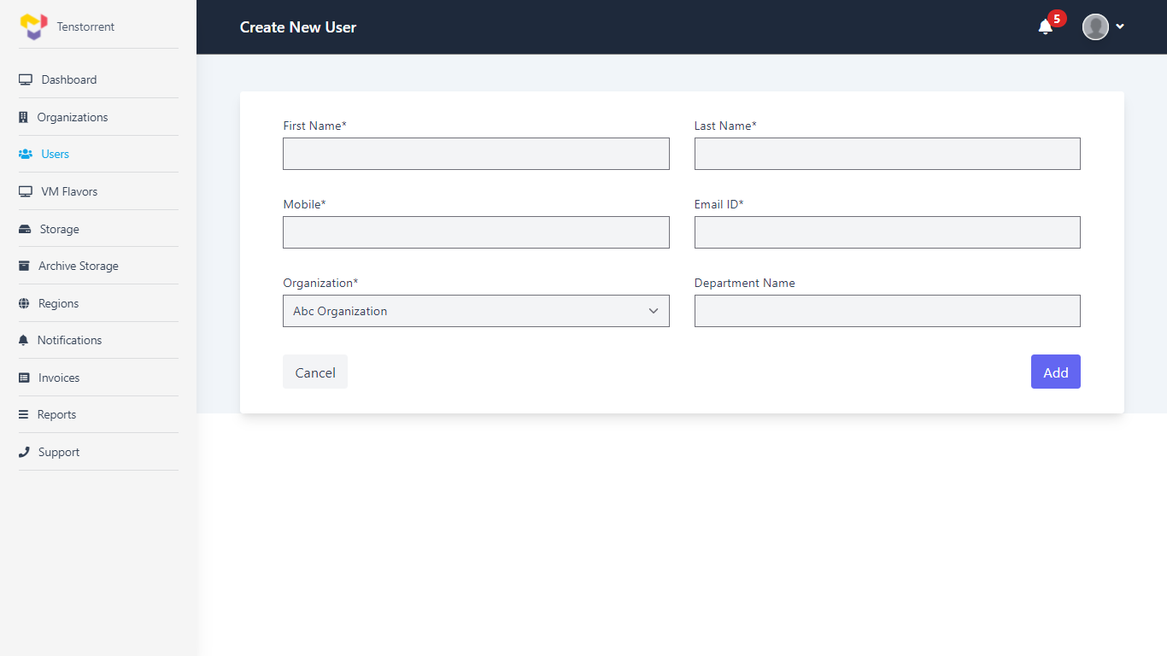

### VM Flavour’s Details:

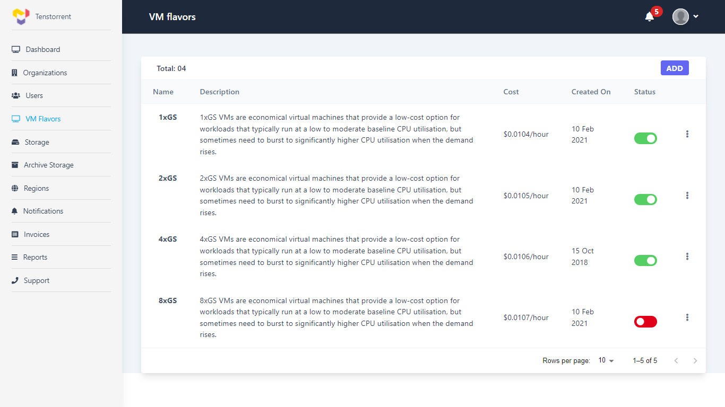

### Create New VM Flavor:

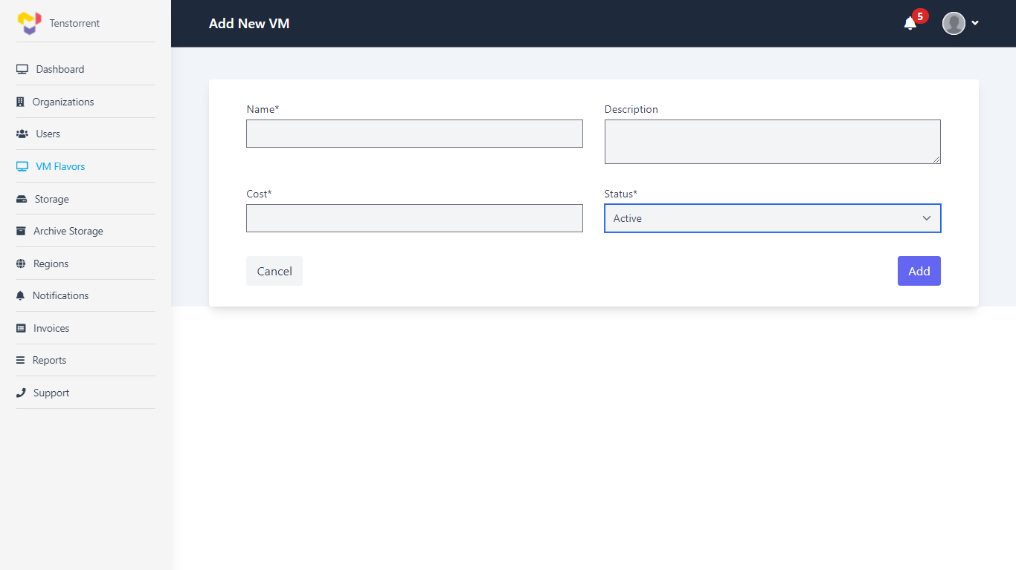

### Storage Details:

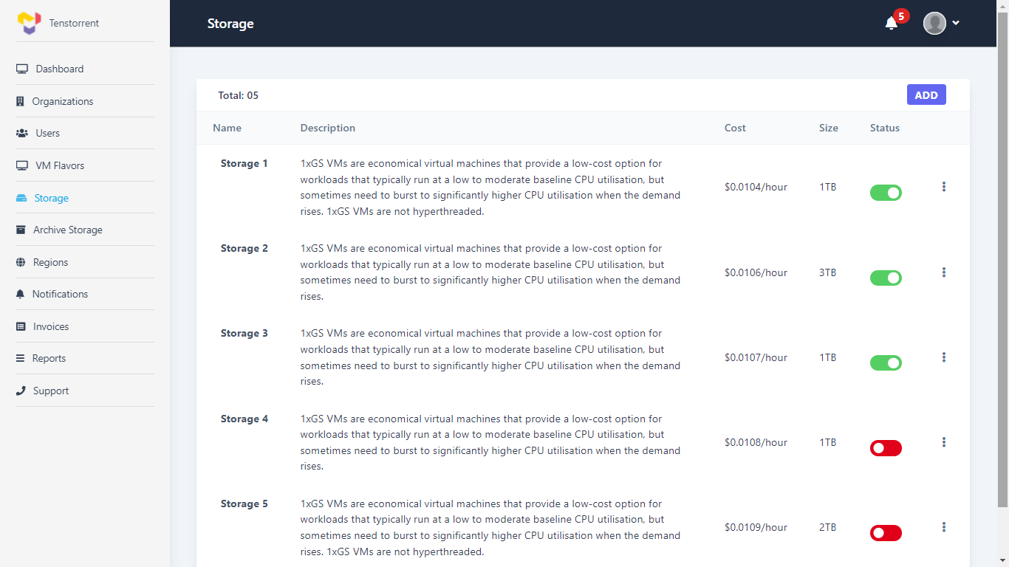

### Create New Storage:

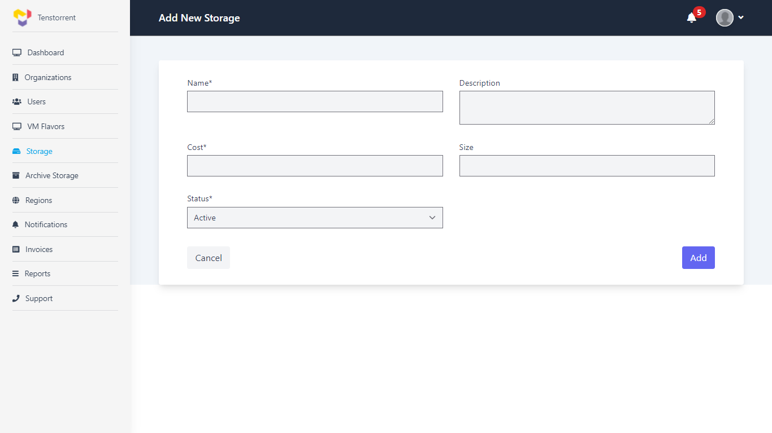

### Archive Storage Details:

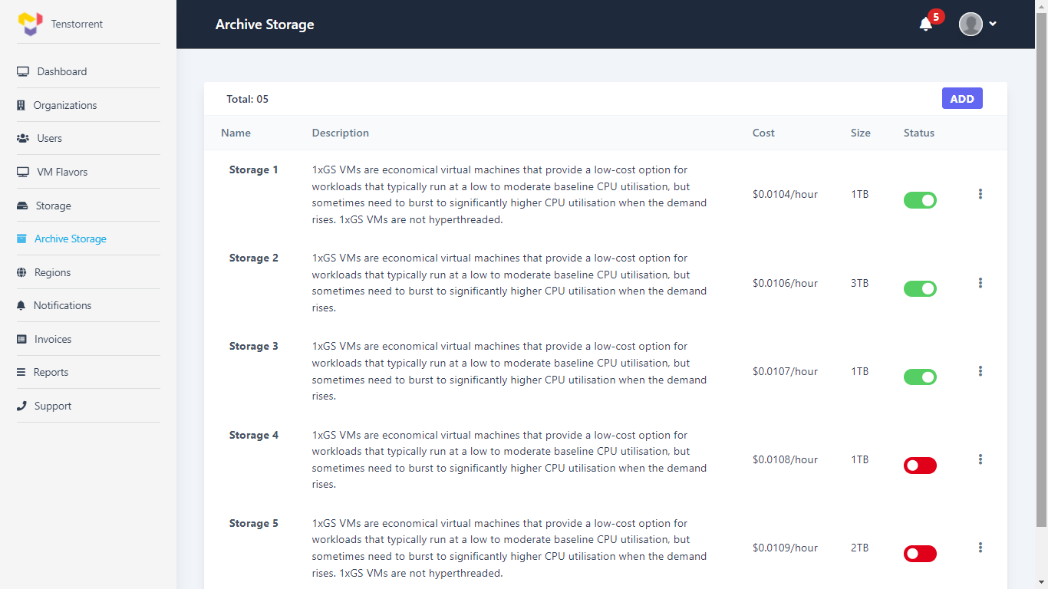

### Create New Archive Storage:

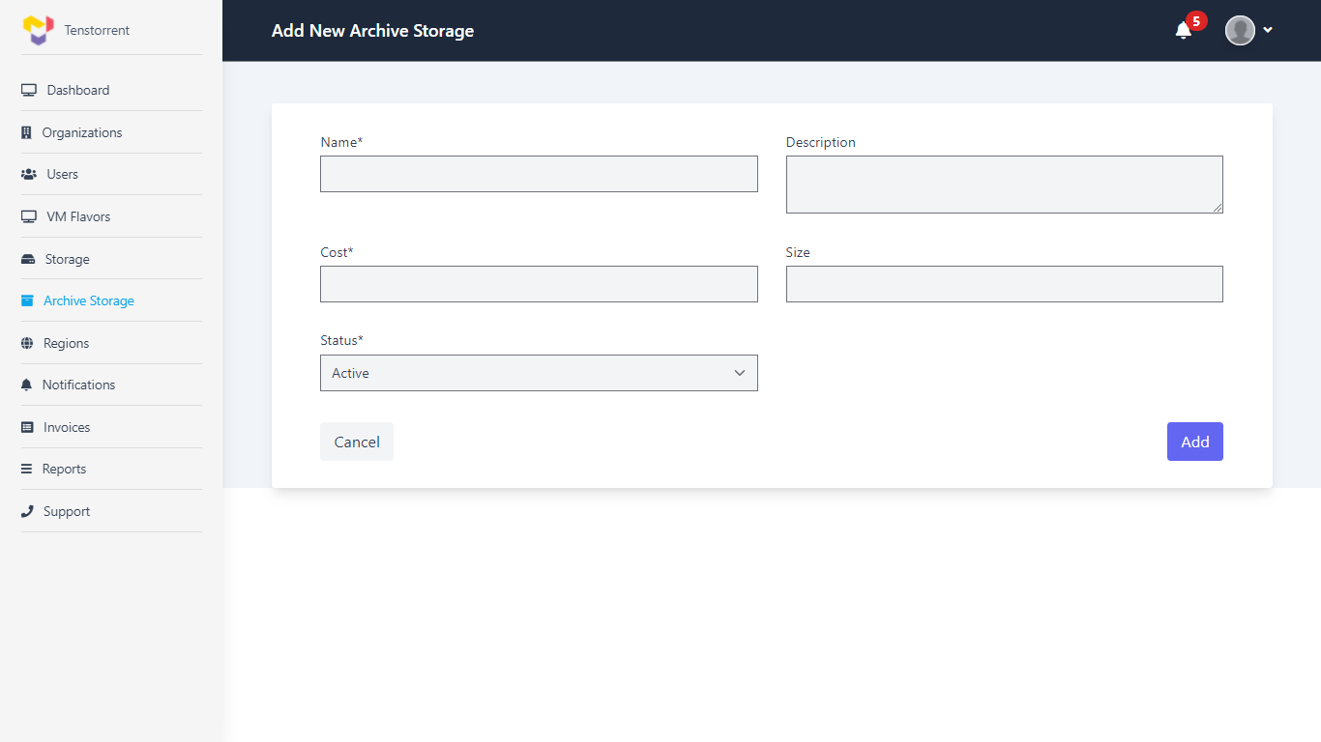

### Regions Details:

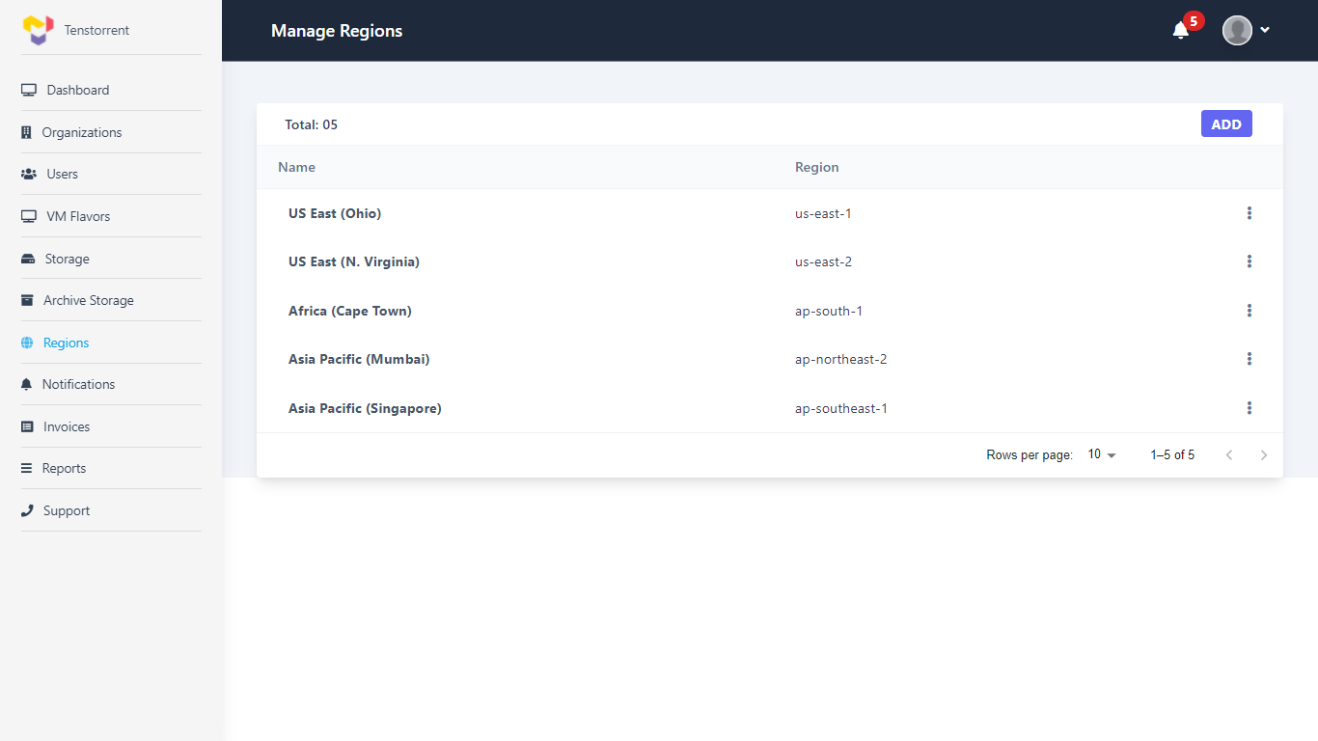

### Create New Region:

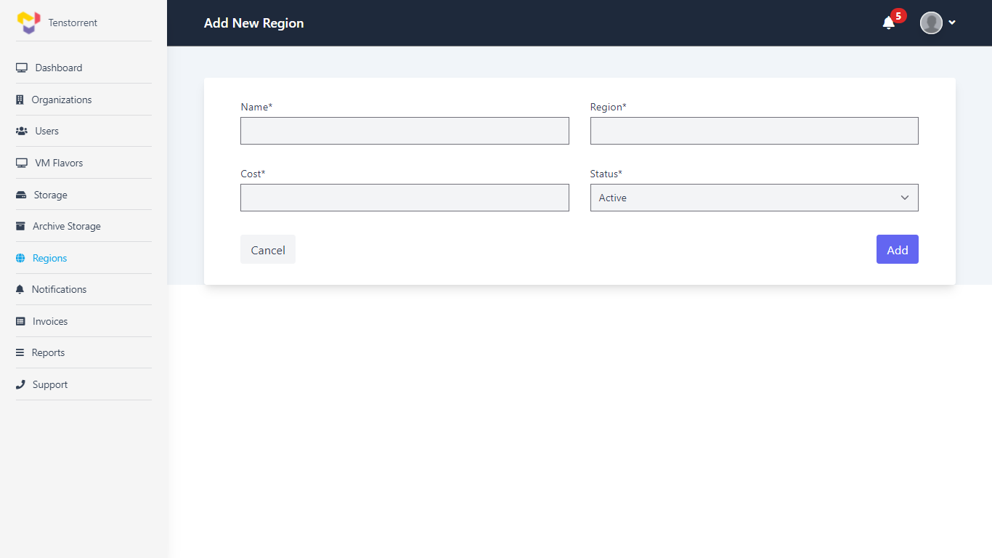

### Notifications Details:

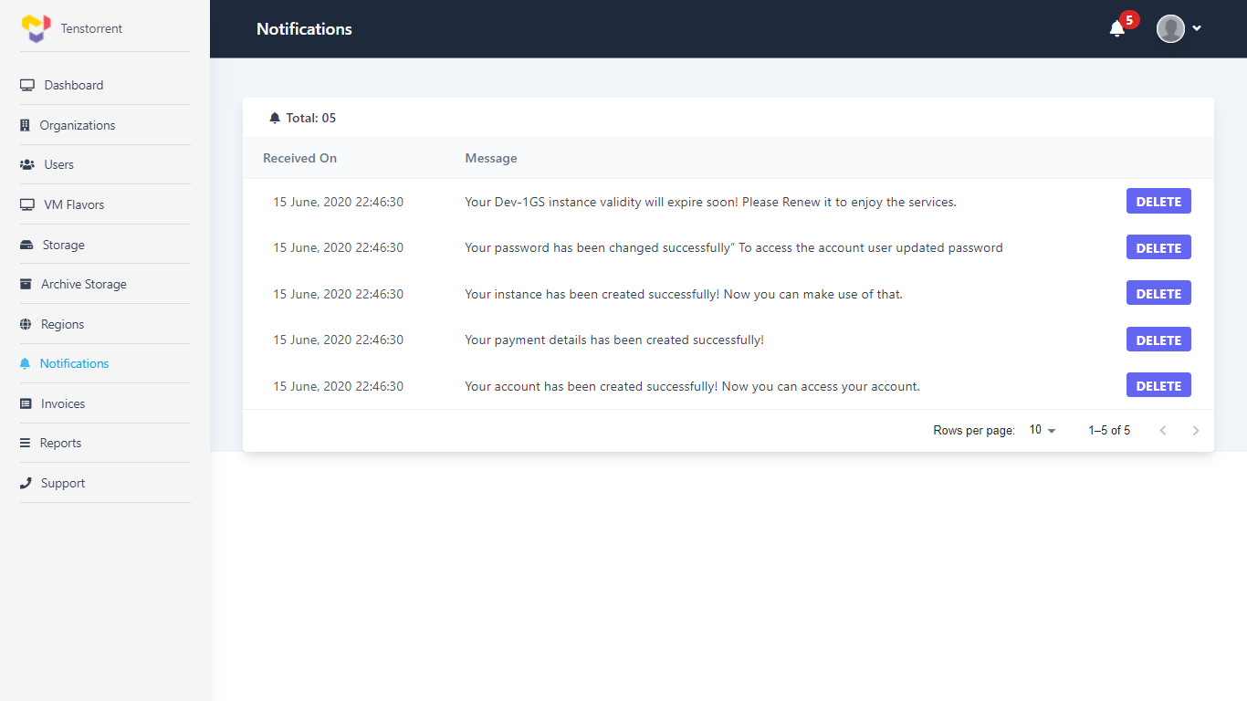

### Invoices Details:

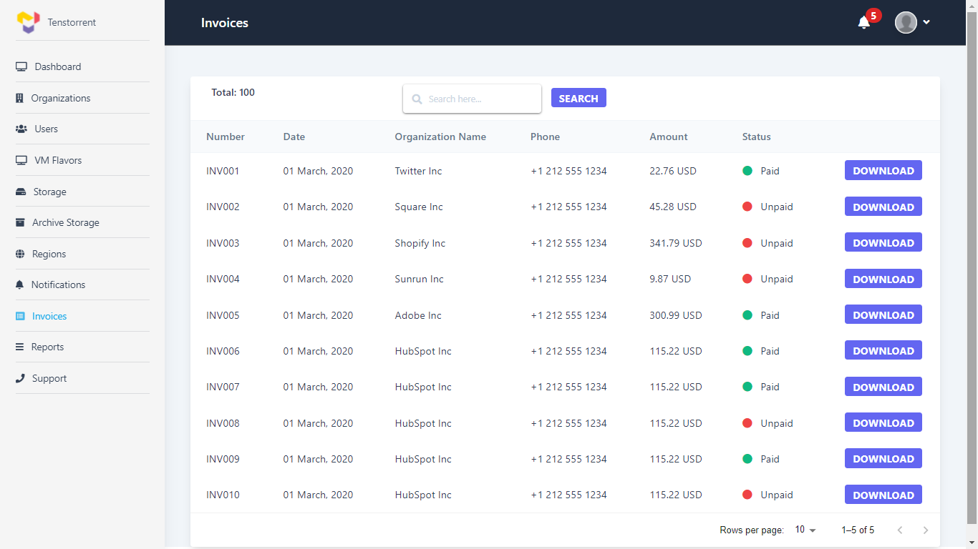

# System Features

## Use cases

|  |  |
| --- | --- |
|  | Generate invoice.  System will generate invoice at the end of each month. Billing cycle is assumed to be per month.  Invoice format |
|  | Integration with Stripe payment gateway  Initial Payment info validation – (1$ Transaction)  Payment info storage for future  Auto payment processing |
|  | Integration with LDAP Server (Directory Services)  User Management will be done in LDAP / AD provider as well (Authentication/Authorization) |
|  | Integration with Openstack/Kubenetes  In addition to infrastructure management, user account creation and SSH key store management will also be part of Openstack integration |
|  | Integration for auto renew / pay process |
|  | Integration with GitLab or similar system for support management |
|  | Integration with email |
|  | Integration with Weka for storage management |

# Roles

### Description

Various user roles and their permissions are as below.

|  |  |  |  |
| --- | --- | --- | --- |
| *Role*  *Permission* | Tenstorrent Admin  (Tenstorrent) | Organization Admin | User |
| View/Edit Own Profile | √ | √ | √ |
| Launch VM | √ | √ | √ |
| Manage VM within Organization |  | √ | √ |
| View Report | √ | √ | √ |
| View Organization User List / details | √ | √ |  |
| View Invoice | √ | √ |  |
| Payment against invoice |  | √ |  |
| Edit Payment Info |  | √ |  |
| Edit/Reset password of organization user | √ | √ |  |
| Enable / Disable organization users | √ | √ |  |
| Manage organization master data | √ | √ |  |
| View/Edit Profile of all Users | √ |  |  |
| View Organization User List / details | √ | √ |  |
| Create/Update Organization Admin Profile | √ |  |  |
| View Organization Admin Profile | √ |  |  |
| View organization Details | √ |  |  |
| Create organization | √ |  |  |
| Delete (disable) organization | √ |  |  |
| Raise payment request to organization admin | √ |  |  |
| Manage Master Data | √ |  |  |

* Organization administrator is restricted to manage data for own organization only

# Notifications

|  |  |  |
| --- | --- | --- |
| Event | Email Alert | ~~SMS~~ (For Next Phase) |
| Customer account creation | Activation link |  |
| Customer account activation | Welcome message |  |
| Forgot password | OTP |  |
| Payment info validation | Successful validation |  |
|  |  |  |

# High Level Solution Architecture

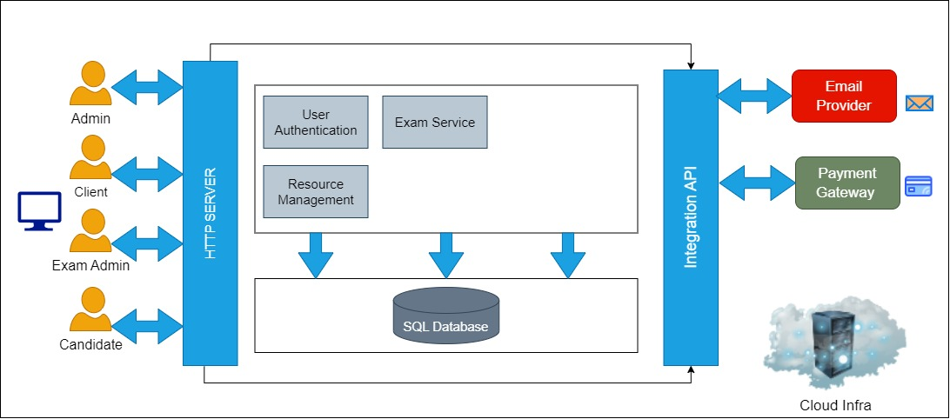

# For Next phase

## Manage Infrastructure

### Use Cases:

|  |  |
| --- | --- |
|  | Customer cannot sign-up or create an account on the portal directly. |

## System Features (User)

### Use Cases

|  |  |
| --- | --- |
|  | (Reference UC019) Customer user can view /select/ provision instance catalogue configuration. End point for each VM will vary with respect to the region.  VM provisioning will happen as per following steps through wizard-   1. End time for VM (Next phase) 2. Payment integration |
|  | **View and update resource/instance availability calendar**  Resource calendar should show the currently available resources along with the resources available in the future along with the date of availability. |
|  | **Scheduler**  User can schedule VMs to start/stop at specific time.  What should be duration of scheduler?  Can scheduler spawn / kill VMs |
|  | (Reference UC021) View list of instances created by the logged-in user  VM Consumption  User cannot see details or manage VMs created by another user in that organization. |
|  | Support / help desk  User can view support / help desk contact information and instructions  Integration with GitLab |

## System Features (Organization Admin)

### Use Cases

|  |  |
| --- | --- |
|  | Reference: UC014  When Organization Administrator user accesses account for the first time, user will be forced to enter the payment details using other payment options (in addition to Credit / Debit Card payment.) |
|  | Pay the unpaid invoices manually by clicking on the “Pay Now” option. |
|  | Organization admin has an ability to update user role from ‘User’ to ‘OrgAdmin’ |

## System Features (tENSTORRENT aDMIN)

Organization Admin role will be primarily used for organization user creation and viewing reports. This web-based application will be accessed by administrators of Tenstorrent customer team.

### Use Cases

|  |  |
| --- | --- |
|  | (Reference: UC043- Setup configuration data for VMs (Storage, flavors etc.) Catalogue management)  Manage Instance Inventory (Continuous updation of total and available instances information) |
|  | (Reference: UC044- Manage Pricing)  Provide option for Spot-Pricing/Customized bundle pricing (Phase III) |

## System Features (Tenstorrent account payable)

Tenstorrent Account Payable role will be primarily used to manage the payment, invoices and accounting related features. There will be option to update the Invoice status as ‘PAID’ for offline transactions.

### Use cases

|  |  |
| --- | --- |
|  | Manage offline Invoice transactions. Update the status of invoice to ‘PAID’. |
|  | Can see usage data, reports and billing details |
|  | View invoices |

### UI Wireframe (TT Account Payable)

## System Features (Tenstorrent PartNer)

Tenstorrent Partner role will be primarily responsible for managing Instance storage details (offerings) and pricing

### Use cases

|  |  |
| --- | --- |
|  | View and update Instance storage price |
|  | View and update Instance archive storage price |

### UI Wireframe (TT Partner)

## System Features (Common for all users)

### Use Cases:

|  |  |
| --- | --- |
|  | Integration for SMS notification (Phase II) |
|  | Impersonation Use case |