**ARJUNA**

**Exam Portal**

**System Requirement Document**

**January 2023**

|  |  |  |  |
| --- | --- | --- | --- |
| Document No. |  | Ver. Rev. | 1.0 |
| Authorized by | Nitin, Manoj | Date |  |

Revision History

|  |  |  |  |
| --- | --- | --- | --- |
| Ver. | Date | Author | Description |
| 0.1 | Feb 25, 2022 | Nilesh Dongre | Draft |
| 0.2 | Mar 1, 2022 | Nilesh Dongre | Updated the document for the following   * Points covered as discussed in the meeting on 25Feb2022 - 1 UC001: Default screen should not be sign-in screen.  2 UC003: Not in current phase   3 UC005: The user will be authenticated on the basis of email ID only 4 UC006: Captcha is not required for now. 5 UC010: User session timeout should be configurable. 6. UC054: “Integration with google captcha” use case is not required.   * Additional information added regarding ‘Manage Infrastructure’ section. |
| 0.3 | Mar 3. 2022 | Nilesh Dongre | Following use cases updated as discussed in the meeting on 01 Mar 2022 UC019,UC021,UC023,UC024,UC025,UC043,UC044 |
| 0.4 | Mar 4 2022 | Nilesh Dongre | Following use cases updated as discussed in the meeting on 03 Mar 2022 UC003,UC013,UC019,UC023, UC025,UC029 |
| 0.5 | Mar 16 2022 | Nilesh Dongre | Added screenshots corresponding to respective use cases and modified the document as per the feedback from Tenstorrent. |
| 0.6 | Mar 21, 2022 | Nilesh Dongre | Added following roles:  1. TT Account Payable  2. TT Partner  Added following Use Cases  1. UC024: Edit instance details by the logged-in user (changing the instance configuration runtime, apart from flavor, storage and archive storage can be modified by the user )  2. UC031: Organization admin has an ability to update user role from ‘User’ to ‘OrgAdmin’ |
| 0.7 | Mar 23, 2022 | Nitin | Reviewed and updated – Phase II |

TABLE OF CONTENTS

1. INTRODUCTION 1

1.1 Document Purpose 1

1.2 Intended Audience and Reading Suggestions 1

1.3 Application Scope 1

1.4 REFERANCES 1

2. Overall Description 2

2.1 Application Perspective 2

2.2 Assumptions and Dependencies 2

3. System Features (Common for all users) 3

3.1 General Requirements 3

3.1.1 Use Cases 3

3.1.2 UI Wireframe 4

3.2 Sign-in 4

3.2.1 Use Cases 4

3.3 Forgot password 4

3.3.1 Use Cases 4

3.4 SIGN-OUT 5

3.4.1 UI Wireframe 5

3.5 User session 5

3.5.1 Use Cases 5

3.6 Registration 6

3.7.1 Use Cases 6

3.7.2 Flow Chart: 7

3.7.3 UI Wireframe 7

4. System Features (ADMIN) 8

4.1 My profile 8

4.1.1 Use Cases 8

4.1.2 UI WIREFRAME (USER) 8

4.2 Manage infrastructure 16

5. System Features (CLIENT) 19

5.1 Use Cases 19

5.2 UI Wireframe (Orgadmin) 19

5.2.1 Dashboard: 19

5.2.2 My Organization Details: 20

5.2.3 My Organization Address: 20

5.2.4 Instances: 20

5.2.5 Create New Instance: 20

5.2.6 Order History Details: 20

5.2.7 Payment Information: 21

5.2.8 User Details: 21

5.2.9 Create New User: 22

5.2.10 Instance Details: 22

5.2.11 Payment Information: 23

5.2.12 Notifications: 24

5.2.13 Invoices: 25

6. System Features (EXAM-ADMIN) 26

6.1 Use cases 26

6.2 Wireframe (Tenstorrent Administrator) 27

6.2.1 Dashboard: 27

6.2.2 Organizations Details: 27

6.2.3 Create New Organization: 28

6.2.4 Edit & Delete Org: 28

6.2.5 Organization Details: 28

6.2.6 Organizations Address Details: 29

6.2.7 Instances Details: 29

6.2.8 Add New Instance: Reference 4.1.2.5 30

6.2.9 Single Organization Users Details: 30

6.2.10 Order Details: 30

6.2.11 Payment Information: 31

6.2.12 All Users Details: 31

6.2.13 Create New User: 32

6.2.14 VM Flavour’s Details: 32

6.2.15 Create New VM Flavor: 33

6.2.16 Storage Details: 33

6.2.17 Create New Storage: 34

6.2.18 Archive Storage Details: 34

6.2.19 Create New Archive Storage: 35

6.2.20 Regions Details: 35

6.2.21 Create New Region: 36

6.2.22 Notifications Details: 36

6.2.23 Invoices Details: 37

7. System Features (CANDIDATE) 26

8. System Features 38

7.1 Use cases 38

9. Roles 39

8.1.1 Description 39

10. Notifications 40

11. High Level Solution Architecture 40

12. **TECHNOLOGY STACK**

13. For Next phase 41

# INTRODUCTION

ARJUNA is planning to develop Web application / portal for their customers which is one stop solution for conducting online exams. This platform enables client to conduct and candidate to appear for secure, efficient and user-friendly online examination.

A client has to simply register and subscribe exam packages, they will able to appoint an Exam admin for managing a particular exam and then authorized candidates of the Exam Admin will take exam further results and statistics will be published as per schedule.

Integration with payment gateway (Stripe) would enable online payment for clients. The main focus of the application will be to simplicity and ease provisioning / handling of Examination in any type of organization.

## Document Purpose

This document details the overall functionality required for development of web based application for Online Exam Portal.

## Intended Audience and Reading Suggestions

The primary audience of this document is Itarium Technologies India Pvt. Ltd stakeholders

## Application Scope

## REFERANCES

None.

# Overall Description

## Application Perspective

Online Exam Portal will be a web-based application which provisioning Conduct Examinations from Client Perspective.

## Assumptions and Dependencies

* Every user must have access to internet while using the portal. (Online mode only)
* Portal should be accessible to the users via desktop web browser (Internet Explorer v 10 and above, Goggle Chrome v 98.x and above, Firefox v 97.x and above, Safari v 15.x and above)
* The portal will be accessible from smart phone browser.
* Stripe merchant account details will be provided for integration

# System Features (Common for all users)

## General Requirements

### Use Cases

|  |  |
| --- | --- |
|  | Exam Portal web application should be available over internet.  User should be able to launch Exam Portal application via web browser.  Default screen for the application will be launched from Exam Portal application.  This application will be linked from existing portal / any other place.  User password will be stored in encrypted format. |
|  | Exam Portal application will have English as language of user interaction. |
|  | Any User can register themselves as a Client to use Exam Portal Application |
|  | **Password policy**   * Minimum 8 characters and maximum 16 characters in length. * Should have at least one upper case, one lower case, one number and one special character. * No enforcement to change password after specific duration will be provided. Password will never expire. * Password history will not be maintained. User can change the password to previous one * Password strength meter will not be available * Security questionnaire will not be provided for password recovery |

### UI Wireframe

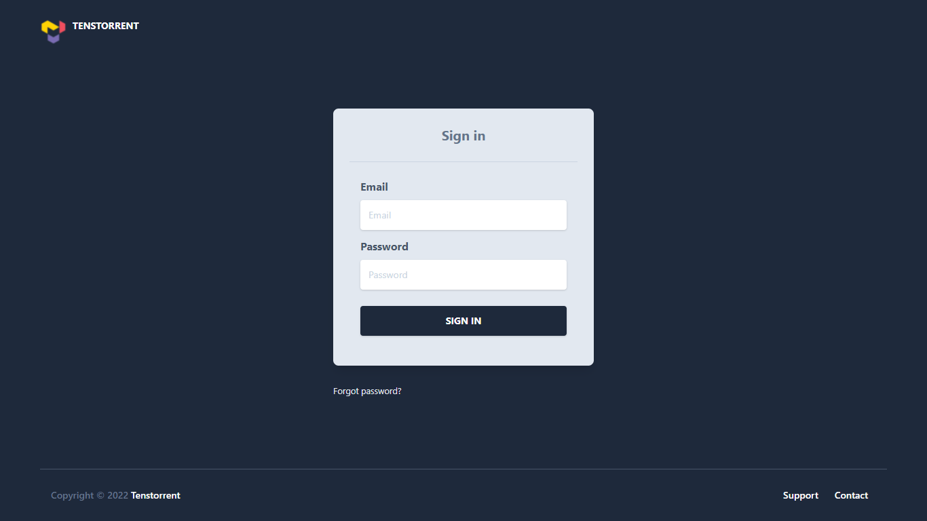

## Sign-in

### Use Cases

|  |  |
| --- | --- |
|  | User should be able to enter the registered email address and password to sign-in. |
|  | There will five attempts to enter correct password.  After five unsuccessful attempts the account will be locked for 10 min (configurable) |

## Forgot password

### Use Cases

|  |  |
| --- | --- |
|  | In case user forgets password, he can send reset password request by clicking ‘Forgot Password’ link. User needs to submit his email address used to sign-in to our system. After this system will send OTP to registered email address of the user. Upon validation of OTP user will be redirected to set new password screen. The OTP will be valid for 5 minutes (configurable). User will be redirected to sign-in screen after successfully setting new password |

## SIGN-OUT

|  |  |
| --- | --- |
|  | User should be able to sign-out from the Exam Portal application.  User clicks on the sign-out link.  A confirmation (“Are you sure you want to sign-out”) popup will be displayed.  If user clicks on ‘Yes’, he will be signed-out from the application and will be redirected to sign-in screen.  If user clicks on ‘No’, he will stay on the same page and no action will be performed. |

### 3.5.1 UI Wireframe

## User session

### Use Cases

|  |  |
| --- | --- |
|  | User session will expire in 30 mins (configurable) of inactivity. After that, any action will prompt user to sign-in again. |
|  | User will not be able to sign-in from multiple devices at a time. The latest signed-in session will be the only active session. |

## Registration

### Use Cases

|  |  |
| --- | --- |
|  | User should be able to access the Exam Portal application using desktop or mobile web-browser and enter email address as part of registration information. |
|  | **On-boarding:** Initially, default Exam Portal Administrator user is available in the system.  Custom onboarding process:  **Step1:** Client will register themselves on Exam Portal Application  Following organization/Client attributes will be captured during registration.   1. Organization/Client Name 2. Unique identification number (auto generated) 3. Mobile / phone 4. Email ID 5. Password 6. Address [Line1, Line2, City, State, Country, ZIP,] |
|  | When Client accesses account for the first time, they will be forced to enter the payment (Credit / Debit Card) details. Credit / Debit Card payment is the only option for now.  The payment details provided will be validated using Stripe integration. Upon successful validation, user will be allowed to use other customer portal features. |

### Flow Chart:

### UI Wireframe

# System Features (ADMIN)

## My profile

### Use Cases

|  |  |
| --- | --- |
|  | Admin can view the details submitted during the registration. No provision will be there for uploading profile image. |
|  | Admin can update his profile data except the email address which is used for sign-in. |
|  | Admin can change his password if required. He needs to enter old password, new password and confirm new password to change the password. |
|  | Admin can view the client list and specific client details (statistic) if required |
|  | Admin can activate or deactivate client. |
|  | Admin can see the subscriptions, add, edit or delete the subscription. |
|  | Admin don’t have authority to see the candidate and exam-admin details |
|  | Admin cannot view the exam paper as well as he cannot view the candidate result |

### UI WIREFRAME (ADMIN)

#### Dashboard:

# System Features (Client)

Client is the organization who want to use the service provided by Exam Portal application.

## Use Cases

|  |  |
| --- | --- |
|  | After completion of Registration with payment activity, client will receive login credentials |
|  | Client administrator can view the details submitted during registration. No provision will be there for uploading profile image. |
|  | Client administrator can update his profile data except the email address which is used for sign-in. |
|  | Client administrator can change his password if required. He needs to enter old password, new password and confirm new password to change the password. |
|  | Manage payment (pay, Auto-pay) |
|  | Client administrator can assign Exam Admin to manage exam related functionalities. Following are the steps to create exam- admin account, here client will add only basic information about Exam-admin  Step-1: Exam-Admin required details   * Name * Email * Date of Birth * Contact Number * Department * Password   Step-2: Create exam-admin account |
|  | Client administrator can view the Exam-admin list and activate or deactivate his status |
|  | Client administrator can view the Candidates list and candidate details |
|  | Client administrator can view Candidate’s performance in terms of grades |
|  | Client administrator can select subscription |

## UI Wireframe (Orgadmin)

### Dashboard:

# System Features (Exam-admin)

Exam-admin role is primarily used to create exam for candidate based on his/her competancies.

## Use cases

|  |  |
| --- | --- |
|  | Exam-Admin will receive the login credentials through email from client |
|  | Exam-admin can view the details submitted during registration. No provision will be there for uploading profile image. |
|  | Exam-admin can update his profile data except the email address which is used for sign-in. |
|  | Exam-admin can change his password if required. He needs to enter old password, new password and confirm new password to change the password. |
|  | Manage candidate profile, |
|  | Exam-admin can create candidate profile by adding his/her basic details:  Step-1: Candidate basic details   * Name * Email * Date of Birth * Contact Number   Step-2: Create candidate account |
|  | Exam-Admin will provide login credentials to candidate for initial login through email |
|  | Exam-admin can create exam for registered candidate by taking following details from Candidate:   * Candidate skills * Candidate experience relevant to specific skill * Can decides severity of questions * Can decide weightage for each topic (no. of questions) * Can decide the duration of exam |
|  | Exam-Admin can any time change the exam for candidate if there is any ambiguity in a question or in multiple questions |
|  | Exam-admin can view the candidate list along with his/her result |

## 

## Wireframe (Tenstorrent Administrator)

### Dashboard:

# System Features (Candidate)

Candidate is a person who is going to take the exam by using the services provided by the

## Use cases

|  |  |
| --- | --- |
|  | Candidate will receive login credentials through provided email |
|  | Candidate can view the details submitted during registration. No provision will be there for uploading profile image. |
|  | Candidate can update his profile data except the email address which is used for sign-in.  Candidate should add skill and experience information while updating profile. |
|  | Candidate can change his password if required. He needs to enter old password, new password and confirm new password to change the password. |
|  | Candidate can take the exam created for him |
|  | Candidate will receive his result through email |

# System Features

## Use cases

|  |  |
| --- | --- |
|  | Integration with frontend |
|  | Integration with payment gateway |
|  | Integration of User-Service-Api and Exam-Service-Api with Api-Gateway |
|  | Integration with GitLab or similar system for support management |
|  | Integration with email |
|  | Integration with Db versioning system |
|  | Containerization of application(docker) |
|  | Deployment on local (Itarium server) and remote server |
|  | Integration of Logging configuration to help debugging |
|  | Integration of security configuration to protect backend APIs |

# Roles

### Description

Various user roles and their permissions are as below.

|  |  |  |  |  |
| --- | --- | --- | --- | --- |
| *Role*  *Permission* | ADMIN | CLIENT | EXAMADMIN | STUDENT |
| Register |  | √ | √ |  |
| forgot password | √ | √ | √ | √ |
| login | √ | √ | √ | √ |
| Add/edit/delete subscription | √ |  |  |  |
| Select subscription |  | √ |  |  |
| client list (active/deactivate) | √ |  |  |  |
| Add exam admin |  | √ |  |  |
| add candidate basic details |  |  | √ |  |
| manage exam admin (active/ deactivate) |  | √ |  |  |
| manage exam (start / stop) |  |  | √ |  |
| manage candidate profile (active/deactivate) |  |  | √ |  |
| edit own profile | √ | √ | √ | √ |
| change Password | √ | √ | √ | √ |
| create exam |  |  | √ |  |
| select exam and attend exam |  |  |  | √ |
| See the result |  | √ | √ |  |
| Raise payment request to organization admin |  | √ |  |  |
| Manage Master Data | √ |  |  |  |

* Organization administrator is restricted to manage data for own organization only

# Notifications

|  |  |
| --- | --- |
| **Event** | **Email Alert** |
| Client account creation | Login credentials |
| Exam-Admin account creation | Login credentials |
| Candidate account creation | Activation link |
| Forgot password | OTP through Email |
| Payment info validation | Successful validation |

# 

# High Level Solution Architecture

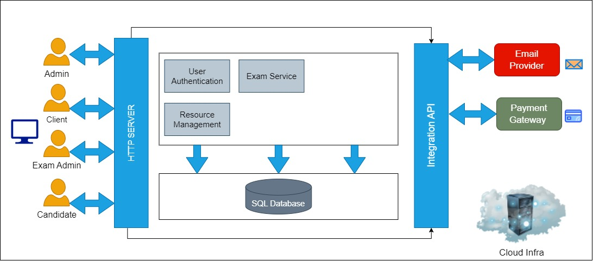

# Technology-Stack

Exam-Portal Application is planned to be designed using 3-Tier architecture. The technology stack for same is as follows:

## FRONTEND

Technology: ANGULAR

Programming Language: Typescript/Java-script

## BACKEND

Technology: Spring Boot framework using Java Version 11

Programming Language: Java

## DATABASE

DB: RDBMS (Relational Db) MySQL

## CONTAINARIZATION

Technology: DOCKER/ KUBERNETES

## DEPLOYMENT

Server: Local Server (UBUNTU VM), Remote server (AWS cloud)

# For Next phase

## Manage Infrastructure

### Use Cases:

|  |  |
| --- | --- |
|  | Customer cannot sign-up or create an account on the portal directly. |

## System Features (User)

### Use Cases

|  |  |
| --- | --- |
|  | (Reference UC019) Customer user can view /select/ provision instance catalogue configuration. End point for each VM will vary with respect to the region.  VM provisioning will happen as per following steps through wizard-   1. End time for VM (Next phase) 2. Payment integration |
|  | **View and update resource/instance availability calendar**  Resource calendar should show the currently available resources along with the resources available in the future along with the date of availability. |
|  | **Scheduler**  User can schedule VMs to start/stop at specific time.  What should be duration of scheduler?  Can scheduler spawn / kill VMs |
|  | (Reference UC021) View list of instances created by the logged-in user  VM Consumption  User cannot see details or manage VMs created by another user in that organization. |
|  | Support / help desk  User can view support / help desk contact information and instructions  Integration with GitLab |

## System Features (Organization Admin)

### Use Cases

|  |  |
| --- | --- |
|  | Reference: UC014  When Organization Administrator user accesses account for the first time, user will be forced to enter the payment details using other payment options (in addition to Credit / Debit Card payment.) |
|  | Pay the unpaid invoices manually by clicking on the “Pay Now” option. |
|  | Organization admin has an ability to update user role from ‘User’ to ‘OrgAdmin’ |

## System Features (tENSTORRENT aDMIN)

Organization Admin role will be primarily used for organization user creation and viewing reports. This web-based application will be accessed by administrators of Tenstorrent customer team.

### Use Cases

|  |  |
| --- | --- |
|  | (Reference: UC043- Setup configuration data for VMs (Storage, flavors etc.) Catalogue management)  Manage Instance Inventory (Continuous updation of total and available instances information) |
|  | (Reference: UC044- Manage Pricing)  Provide option for Spot-Pricing/Customized bundle pricing (Phase III) |

## System Features (Tenstorrent account payable)

Tenstorrent Account Payable role will be primarily used to manage the payment, invoices and accounting related features. There will be option to update the Invoice status as ‘PAID’ for offline transactions.

### Use cases

|  |  |
| --- | --- |
|  | Manage offline Invoice transactions. Update the status of invoice to ‘PAID’. |
|  | Can see usage data, reports and billing details |
|  | View invoices |

### UI Wireframe (TT Account Payable)

## System Features (Tenstorrent PartNer)

Tenstorrent Partner role will be primarily responsible for managing Instance storage details (offerings) and pricing

### Use cases

|  |  |
| --- | --- |
|  | View and update Instance storage price |
|  | View and update Instance archive storage price |

### UI Wireframe (TT Partner)

## System Features (Common for all users)

### Use Cases:

|  |  |
| --- | --- |
|  | Integration for SMS notification (Phase II) |
|  | Impersonation Use case |