**ROLE-PERMISSION MATRIX:**

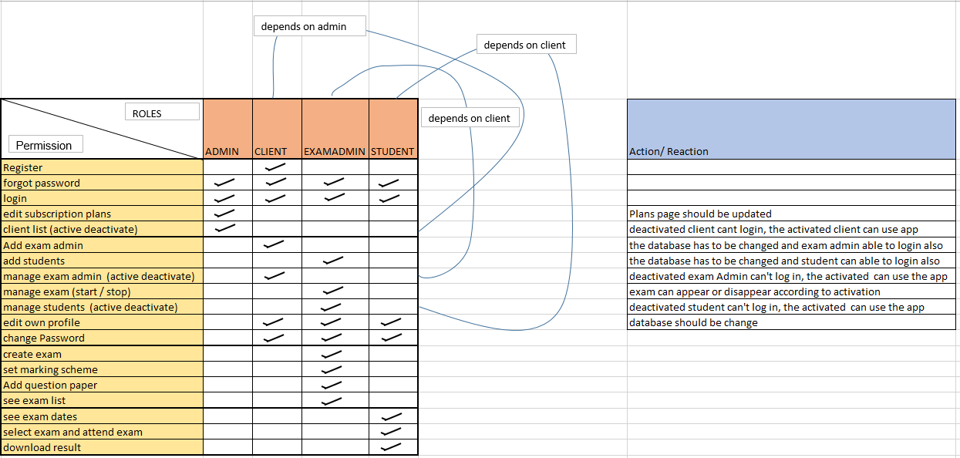

Fig 1.Role-Permission Matrix

**Table Structure:**

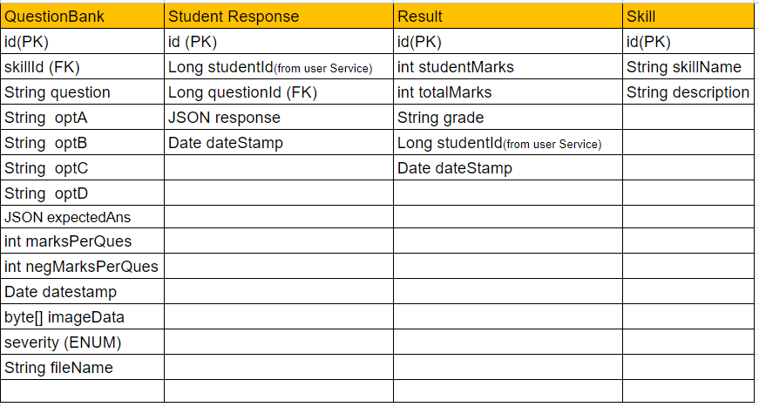

Fig 2.Tables of EXAM-SERVICE

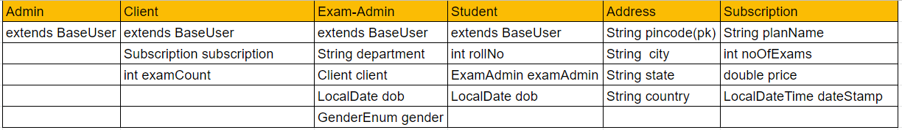

Fig 3.Tables of USER-SERVICE

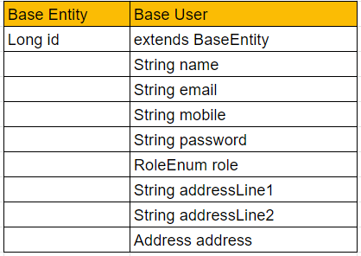

Fig 3.1.Tables of USER-SERVICE