A

**PROJECT REPORT**

ON

**WEATHER DASHBOARD**

AT

**KUKBIT SL PVT. LTD.**

SUBMITTED

IN PARTIAL FULFILMENT OF THE REQUIREMENTS

BY

**MS. ARATI VIJAY LANGOTE**

YEAR – 2023-24

**DECLARATION**

I declare that this report reflects my thoughts about the subject in my own words. I have sufficiently cited and referenced the original sources, referred or considered in this work. I have not plagiarized or submitted the same work for the award of any other degree. I also declare that I have adhered to all principles of academic honesty and integrity and have not misrepresented or fabricated or falsified any idea/data/fact/source in my submission.

The report submitted is my own work and has not been duplicated from any other source. I shall be responsible for any unpleasing moment/situation.

Date: 19th November, 2023

Arati Vijay Langote

**ACKNOWLEDGEMENT**

It was a great opportunity for me to work with Kukbit SL pvt ltd, pioneers in the field of full stack development. I am extremely grateful to all those who have shared their expertise and knowledge with me. I take this opportunity to thank all those who have contributed in the successful completion of a Internship at “Kukbit SL pvt ltd.”.

Firstly, I would like to thank Company, who has been constant source of inspiration for me during the completion of this project. They gave us invaluable inputs during our endeavour to complete this project.

At last, I would like to thank all the respondents met in the preparation, who gave their valuable time to provide us required information and their honest support to complete our project in time.

Nevertheless, I express my gratitude toward my family members for their kind co-operation and encouragement which helped me in the completion of this internship.

The Weather Dashboard project acknowledges the use of the OpenWeather API for weather data and the valuable contributions of the development team in bringing this application to fruition.

**ABSTRACT**

The Weather Dashboard is a user-friendly, browser-based weather application designed for quick and easy access to essential weather information. With a clean and intuitive interface, users can effortlessly search for a city and retrieve up-to-date weather conditions, including the current temperature, wind speed, and humidity. The dashboard also provides the current UV-index, offering insights into the sun's intensity and potential risks.

# **CONTENTS**

1. Introduction
2. Company Background & Structure

2.1 Introduction

2.2 Company Services

1. Project Overview
   1. Project Description
   2. Objectives
   3. Features
2. Technical Contents
   1. Technology stack
   2. Implementation
3. Conclusion
4. Future Enhancement
5. **INTRODUCTION**

The Weather Dashboard project is a browser-based weather application designed to provide users with up-to-date weather information for any city. The dashboard features a responsive user interface, dynamically displayed weather data, UV condition indicators, an intelligent five-day forecast, live updating search history, and the ability to store cities locally. Additionally, the application loads weather data for the last searched city on launch.

1. **COMPANY BACKGROUND AND STRUCTURE**
   1. **Company Introduction**

In today’s digital business world, you need a partner who can help you take advantage of marketing opportunities across a variety of channels in realtime. KUKbitsl combines a data-driven approach with knowledge gained from years in digital marketing to deliver outstanding results to our clients. We are a community of diverse people from diverse backgrounds all looking to create great businesses. At Startups Lab we are building an eco-system within an eco-system. Helping startups with business planning, marketing, funding & growth activities. Startups Lab is an Open, Inclusive and Collaborative community for entrepreneurs. The members of the community seek to support one another while furthering their own goals. People who could end up being your co-founders, partners, collaborators, customers or even investors. Our activities span the length and breadth of India and we have brought together entrepreneurs from Pan India!

* 1. **Services**
* **Search optimization**

It is a process to improve and increase the visibility of your business and gain new visitors or customers with organic methods.

* **Social Media Strategy**

Using SMM, We create, post, images and videos to engage an audience. Also, we get the lead for your business.

* **Pay per click**

A cost-effective way for the advertisers who pay a fee each time one of their ads is clicked. Connect with potential customers by selecting relevant keywords people are searching for on Google.

* **Social Media Manager**

Creating and posting content on Social Media is a hectic work for a brand. So we will assign one dedicated social media manager for all your social media posts or content on the internet.

* **Reporting & Analysis**

Website or social media analysis allows you to get a professional check-up of your internet presence and get the details of a report for the web or social audit.

* **Web Development**

We are designing and developing the website to make it a search engine friendly. That helps to index a website on any search engine to reach your target audience.

* **Content Marketing**

Content Marketing helps to engage your audience by sharing relevant articles, graphics, videos or any piece of content.

* **Influencing Marketing**

Get endorsements and product placement from a well-known celebrity or internet influencers who already have a fan base for your product.

* **Ads Optimisation**

Go through the process of creating an advertisement for reaching a relevant audience and optimising your ads with the help of KUKbit Ads Expert Team.

1. **PROJECT OVERVIEW**

**3.1 Project Description**

The Weather Dashboard is a user-friendly application that allows users to search for the current weather conditions, UV index, and five-day forecast of cities worldwide. The project focuses on delivering a seamless user experience with features such as responsive UI, dynamic data updates, intelligent forecast handling, and local data storage.

**3.2 Objectives**

* Provide real-time weather data for cities globally.
* Create a responsive and visually appealing user interface.
* Implement a live updating search history for quick access to previously searched cities.
* Display UV conditions using color-coded indicators.
* Optimize the five-day forecast to maximize accuracy.

**3.3 Features**

**3.3.1 Responsive UI**

The dashboard features a responsive design to ensure a sleek and user-friendly experience across various devices. On extra small devices, the search history collapses into a button for easy toggling.

**3.3.2 Dynamically Displayed Weather Data**

The application updates the user interface dynamically, eliminating the need for manual refreshes when requesting weather data for new cities.

**3.3.3 UV Condition Indicator**

Utilizing the EPA's standards, the application visually represents UV conditions in green (favorable), yellow (moderate), and red (severe).

**3.3.4 Intelligent Five-Day Forecast**

To enhance forecast accuracy, the application uses a noon forecast for the fifth day. If unavailable, it employs a series of conditions to display the next best option.

**3.3.5 Live Updating Search History**

Every city searched is added to the search history for convenient access. Clicking on a city triggers a re-request for its current weather and forecast data.

**3.3.6 Store Cities Locally**

All searches are saved to local storage, allowing users to resume their session seamlessly. The "Delete History" button removes all previously searched cities, except the most recent one.

**3.3.7 Load Weather Data on Launch**

The application retrieves and displays the current weather and forecast data for the last searched city stored in local storage upon launch.

**4. Technical Contents**

**4.1 Technology Stack**

* HTML5, CSS3 for frontend development
* JavaScript for dynamic and interactive features
* OpenWeather API for weather data retrieval
* Local storage for saving search history and last searched city

**4.2 Implementation**

The application leverages asynchronous JavaScript to fetch weather data from the OpenWeather API. The user interface is updated in real-time, and local storage is utilized for efficient data storage and retrieval.

4.2.1. Screenshot of website

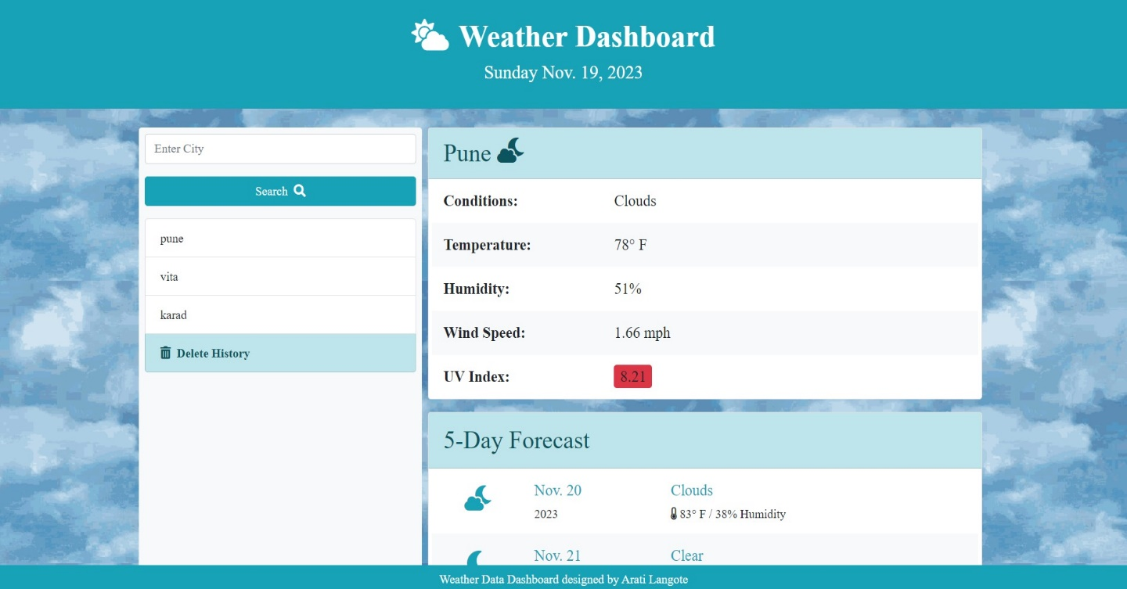

**5. Conclusion**

The Weather Dashboard project successfully delivers a user-friendly and feature-rich weather application. With its responsive design, dynamic data updates, intelligent forecast handling, and local data storage capabilities, the dashboard provides a seamless experience for users seeking accurate and timely weather information.

**6. Future Enhancements**

* Implement user accounts for personalized experiences.
* Integrate additional weather parameters and map functionalities.
* Provide support for multiple languages.
* Enhance accessibility features for a wider user base.