A

**PROJECT REPORT**

ON

**PERSONAL PORTFOLIO WEBSITE**

AT

**KUKBIT SL PVT. LTD.**

SUBMITTED

IN PARTIAL FULFILMENT OF THE REQUIREMENTS

BY

**MS. ARATI VIJAY LANGOTE**

YEAR – 2023-24

**DECLARATION**

I declare that this report reflects my thoughts about the subject in my own words. I have sufficiently cited and referenced the original sources, referred or considered in this work. I have not plagiarized or submitted the same work for the award of any other degree. I also declare that I have adhered to all principles of academic honesty and integrity and have not misrepresented or fabricated or falsified any idea/data/fact/source in my submission.

The report submitted is my own work and has not been duplicated from any other source. I shall be responsible for any unpleasing moment/situation.

Date: 19th November, 2023

Arati Vijay Langote

**ACKNOWLEDGEMENT**

It was a great opportunity for me to work with Kukbit SL pvt ltd, pioneers in the field of full stack development. I am extremely grateful to all those who have shared their expertise and knowledge with me. I take this opportunity to thank all those who have contributed in the successful completion of a Internship at “Kukbit SL pvt ltd.”.

Firstly, I would like to thank Company, who has been constant source of inspiration for me during the completion of this project. They gave us invaluable inputs during our endeavour to complete this project.

At last, I would like to thank all the respondents met in the preparation, who gave their valuable time to provide us required information and their honest support to complete our project in time.

Nevertheless, I express my gratitude toward my family members for their kind co-operation and encouragement which helped me in the completion of this internship.

The Weather Dashboard project acknowledges the use of the OpenWeather API for weather data and the valuable contributions of the development team in bringing this application to fruition.

**ABSTRACT**

The Personal Portfolio Website project is a comprehensive web platform that showcases an individual's skills, projects, and professional experiences. This website not only serves as an online portfolio but also incorporates advanced features such as a contact form, LinkedIn and GitHub integration, email communication, and the option to initiate a phone call. The technologies utilized in this project include HTML, CSS, JavaScript, Node.js, and Node Mailer.

# **CONTENTS**

1. Introduction
2. Company Background & Structure

2.1 Introduction

2.2 Company Services

1. Project Overview
   1. Project Description
   2. Objectives
   3. Features
2. Technical Contents
   1. Technology stack
   2. Implementation
3. Conclusion
4. Future Enhancement
5. **INTRODUCTION**

The Personal Portfolio Website project is a comprehensive web platform that showcases an individual's skills, projects, and professional experiences. This website not only serves as an online portfolio but also incorporates advanced features such as a contact form, LinkedIn and GitHub integration, email communication, and the option to initiate a phone call. The technologies utilized in this project include HTML, CSS, JavaScript, Node.js, and Node Mailer.

1. **COMPANY BACKGROUND AND STRUCTURE**
   1. **Company Introduction**

In today’s digital business world, you need a partner who can help you take advantage of marketing opportunities across a variety of channels in realtime. KUKbitsl combines a data-driven approach with knowledge gained from years in digital marketing to deliver outstanding results to our clients. We are a community of diverse people from diverse backgrounds all looking to create great businesses. At Startups Lab we are building an eco-system within an eco-system. Helping startups with business planning, marketing, funding & growth activities. Startups Lab is an Open, Inclusive and Collaborative community for entrepreneurs. The members of the community seek to support one another while furthering their own goals. People who could end up being your co-founders, partners, collaborators, customers or even investors. Our activities span the length and breadth of India and we have brought together entrepreneurs from Pan India!

* 1. **Services**
* **Search optimization**

It is a process to improve and increase the visibility of your business and gain new visitors or customers with organic methods.

* **Social Media Strategy**

Using SMM, We create, post, images and videos to engage an audience. Also, we get the lead for your business.

* **Pay per click**

A cost-effective way for the advertisers who pay a fee each time one of their ads is clicked. Connect with potential customers by selecting relevant keywords people are searching for on Google.

* **Social Media Manager**

Creating and posting content on Social Media is a hectic work for a brand. So we will assign one dedicated social media manager for all your social media posts or content on the internet.

* **Reporting & Analysis**

Website or social media analysis allows you to get a professional check-up of your internet presence and get the details of a report for the web or social audit.

* **Web Development**

We are designing and developing the website to make it a search engine friendly. That helps to index a website on any search engine to reach your target audience.

* **Content Marketing**

Content Marketing helps to engage your audience by sharing relevant articles, graphics, videos or any piece of content.

* **Influencing Marketing**

Get endorsements and product placement from a well-known celebrity or internet influencers who already have a fan base for your product.

* **Ads Optimisation**

Go through the process of creating an advertisement for reaching a relevant audience and optimising your ads with the help of KUKbit Ads Expert Team.

1. **PROJECT OVERVIEW**

**3.1 Project Description**

The Personal Portfolio Website is designed to provide a visually appealing and informative representation of an individual's skills and accomplishments. The website serves as a central hub for visitors to explore the individual's portfolio, get in touch via various communication channels, and learn more about their background.

**3.2 Objectives**

* Develop an interactive and aesthetically pleasing personal portfolio website.
* Implement a contact form to facilitate communication.
* Integrate LinkedIn and GitHub profiles for professional networking
* Enable email communication through Node Mailer
* Provide an option to initiate a phone call directly from the website.

**3.3 Features**

**3.3.1 Portfolio Showcase**

The website prominently displays the individual's skills, projects, and professional experiences in an organized and visually appealing manner.

**3.3.2 Contact Form**

A user-friendly contact form allows visitors to send messages directly from the website. The form collects essential information such as name, email, subject, and message.

**3.3.3 LinkedIn and GitHub Integration**

Links to the individual's LinkedIn and GitHub profiles are strategically placed for visitors to easily connect and explore their professional network and projects

**3.3.4 Email Communication**

The website facilitates communication via email through the integration of Node Mailer. Users can send messages directly to the individual's email address using the contact form.

**3.3.5 Phone Call Initiation**

A clickable button allows visitors to initiate a phone call directly from the website, providing a convenient way to establish immediate contact.

**4. TECHNICAL CONTENTS**

**4.1 Technology Stack**

* HTML5, CSS3 for frontend development
* JavaScript for dynamic and interactive features
* Backend- Node.js
* Email Communication - Node Mailer
* Version Control - Git (for GitHub integration)

**4.2 Implementation**

* HTML/CSS/JavaScript - The frontend is built using these standard web technologies to ensure a visually appealing and responsive design.
* Node.js - Powers the backend to handle server-side logic and facilitate communication.
* Node Mailer - Integrates email functionality, allowing users to send messages directly from the website.
* GitHub Integration - Utilizes Git for version control and seamlessly integrates GitHub profiles into the portfolio.

**4.2.1 Screenshot of website**

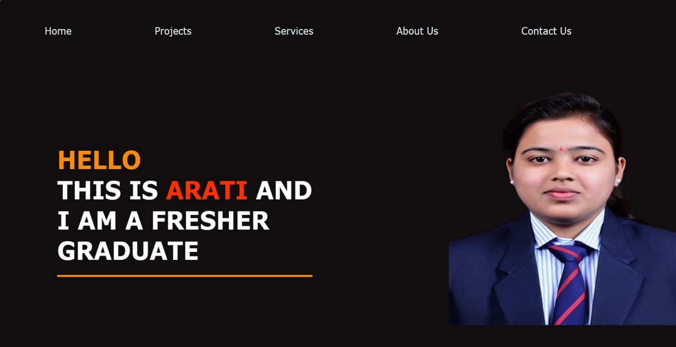

**5. Conclusion**

The Personal Portfolio Website project successfully combines aesthetics with functionality, providing a visually pleasing representation of the individual's professional journey. The incorporation of advanced features such as a contact form, LinkedIn and GitHub integration, email communication, and phone call initiation enhances the overall user experience and fosters seamless interaction.

**6. Future Enhancements**

* + Implement a blog section for sharing insights and experiences.
  + Integrate additional social media platforms for broader networking.
  + Enhance SEO to improve visibility in search engine results.
  + Incorporate analytics for tracking website traffic and user interactions.