YUVO INTERN – WEEK 4 TASK
Comprehensive Data Analysis Reporting and Presentation
Name: Arati Bhokare
Submission Date: 30 September 2026

Integrated analysis of the World Bank Fertility Rate dataset using R

1. Executive Summary
This Week 4 report consolidates the work completed during the previous three weeks into one cohesive data analysis and presentation. The project uses the World Bank Fertility Rate dataset, covering country-year observations from 1960 to 2011. The workflow combines data cleaning, exploratory visualization, statistical analysis, hypothesis testing, regression modeling, model evaluation, and communication of findings.
Week 1 focused on preparing the dataset for analysis. Missing values were handled, outlier patterns were reviewed, the main numerical variable was normalized for analysis, and categorical information was encoded where appropriate. The cleaned analytical dataset contains 10,920 observations across 210 countries/entities.
Week 2 converted the cleaned data into visual evidence. Line, bar, scatter, histogram, and boxplot visualizations were used to examine the time trend, country differences, relationship between year and fertility rate, overall distribution, and variation across selected years.
Week 3 extended the analysis into statistical and predictive modeling. Year was used as the predictor and FertilityRate_Clean as the target in a simple linear regression model. The test results showed R² of approximately 0.163, RMSE of approximately 1.851, and MAE of approximately 1.624. Five-fold cross-validation produced a mean R² of approximately 0.164. The model indicates a statistically significant negative association between year and fertility rate, while also showing that year alone explains only a limited share of country-level variation.
The combined findings demonstrate the importance of a complete data workflow: reliable cleaning supports meaningful visualization, visualization helps identify patterns, and statistical modeling quantifies relationships while revealing the limitations of simple predictors. The final section discusses challenges, lessons learned, and directions for further analysis.

2. Task Objective and Scope
The Week 4 task requires a comprehensive report that integrates all previous analyses into a cohesive presentation. It consolidates data cleaning, visualization, and predictive modeling into one detailed DOC file and emphasizes clear communication of data-driven insights to a diverse audience.
- Integrate the data preparation, visualization, and predictive modeling work from Weeks 1–3.
- Present methodology, analysis, results, impacts/implications, and conclusions in one structured report.
- Use annotated visualizations and selected R code snippets to support the narrative.
- Explain the major insights, limitations, challenges, and opportunities for future analysis.
- Maintain a clear progression from data preparation to interpretation.

3. Dataset and Project Context
The project uses the World Bank Fertility Rate dataset containing fertility-rate observations for countries/entities over time. The analysis period is 1960–2011. The central analytical measure is fertility rate, with Year used as the main time-related predictor in the Week 3 regression model.
Item | Project detail
Dataset | World Bank Fertility Rate
Period | 1960–2011
Countries/entities in cleaned data | 210
Cleaned observations | 10,920
Main outcome | FertilityRate_Clean
Week 3 predictor | Year
Model split | 80% training / 20% testing
Cross-validation | 5-fold

4. Week 1 – Data Cleaning and Preparation

4.1 Data preparation workflow
The first stage established a reliable analytical dataset. The raw fertility-rate data were examined for missing values, unusual values, variable types, and consistency. Cleaning decisions were documented so that the later visualization and modeling stages would use a consistent dataset.
- Inspect the raw data structure and variable types.
- Identify missing observations and assess their impact on analysis.
- Handle missing fertility-rate values to create the analytical variable FertilityRate_Clean.
- Review potential outliers and extreme observations rather than removing valid observations automatically.
- Normalize the numerical fertility-rate measure where required for analytical preparation.
- Encode categorical information where appropriate for structured analysis.
- Save the cleaned dataset for reuse in Weeks 2 and 3.

4.2 Cleaning outcome
After preparation, the working dataset contains 10,920 usable country-year observations across 210 countries/entities. Keeping the same cleaned dataset across all three analytical weeks provides consistency and makes the final integrated report reproducible.

4.3 Representative R code
# Load packages and cleaned data
library(readr)
library(dplyr)
fertility <- read_csv("week1_fertility_cleaned.csv")
# Basic structure and missing-value check
glimpse(fertility)
summary(fertility)
colSums(is.na(fertility))
# Reusable analytical variable
fertility <- fertility %>%
filter(!is.na(FertilityRate_Clean))

5. Week 2 – Data Visualization and Insight Communication
The second stage translated the cleaned data into visual evidence. Five complementary chart types were used because no single chart can communicate every aspect of a multi-country time series. Together, the charts describe the overall time trend, high values in 2011, the relationship between year and fertility rate, the distribution of fertility rates, and variation across selected years.
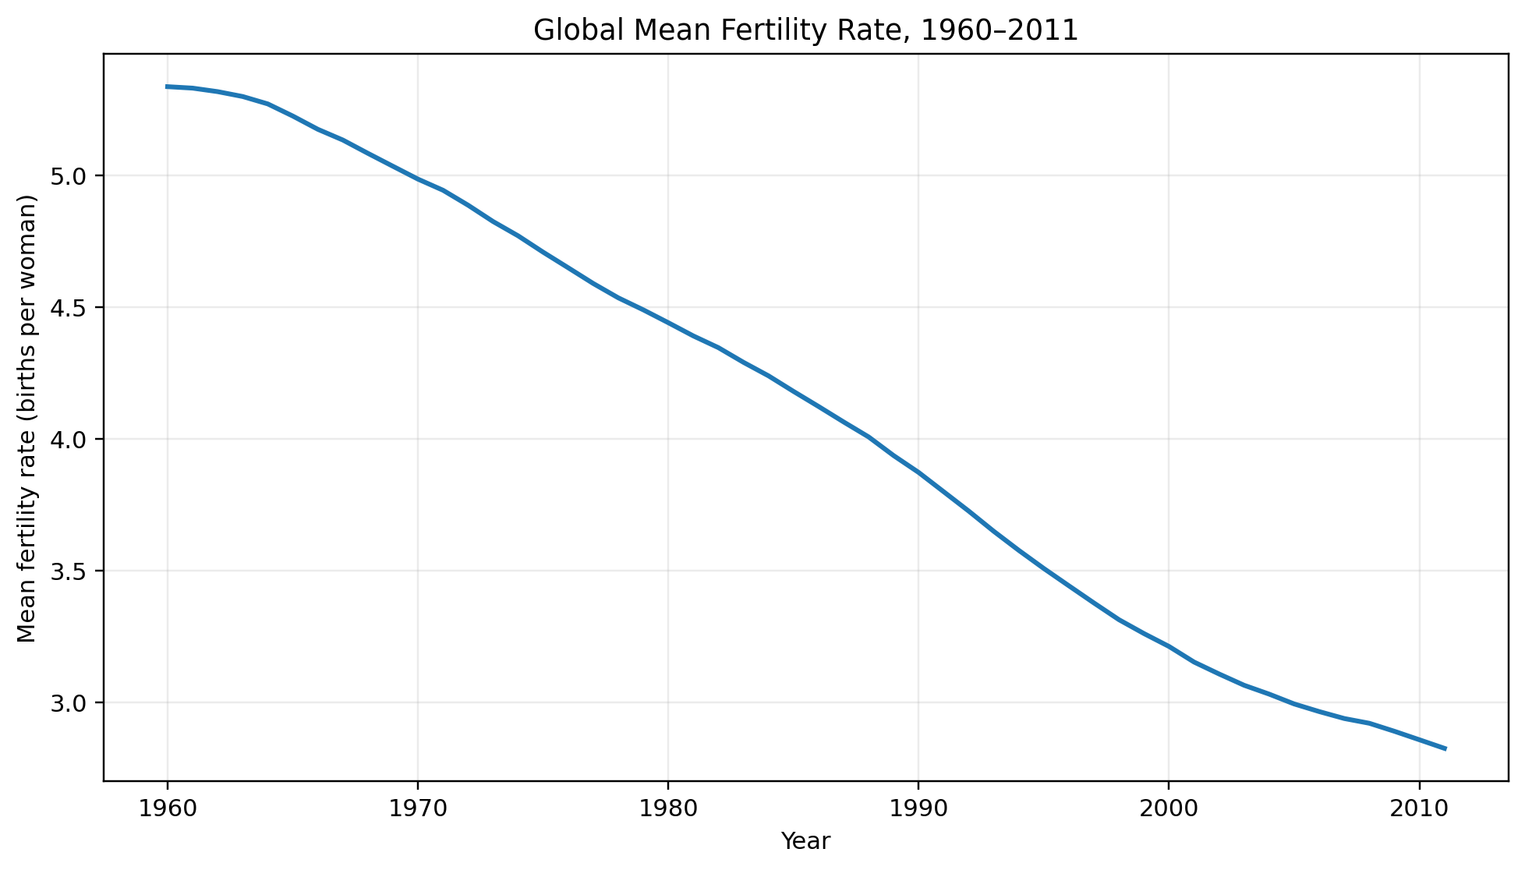
Figure 1. Global mean fertility rate trend over the study period.
The line chart shows a clear overall decline in the mean fertility rate from the beginning to the end of the period. The mean is approximately 5.337 in 1960 and approximately 2.825 in 2011. This is a descriptive time pattern and does not by itself establish causation.
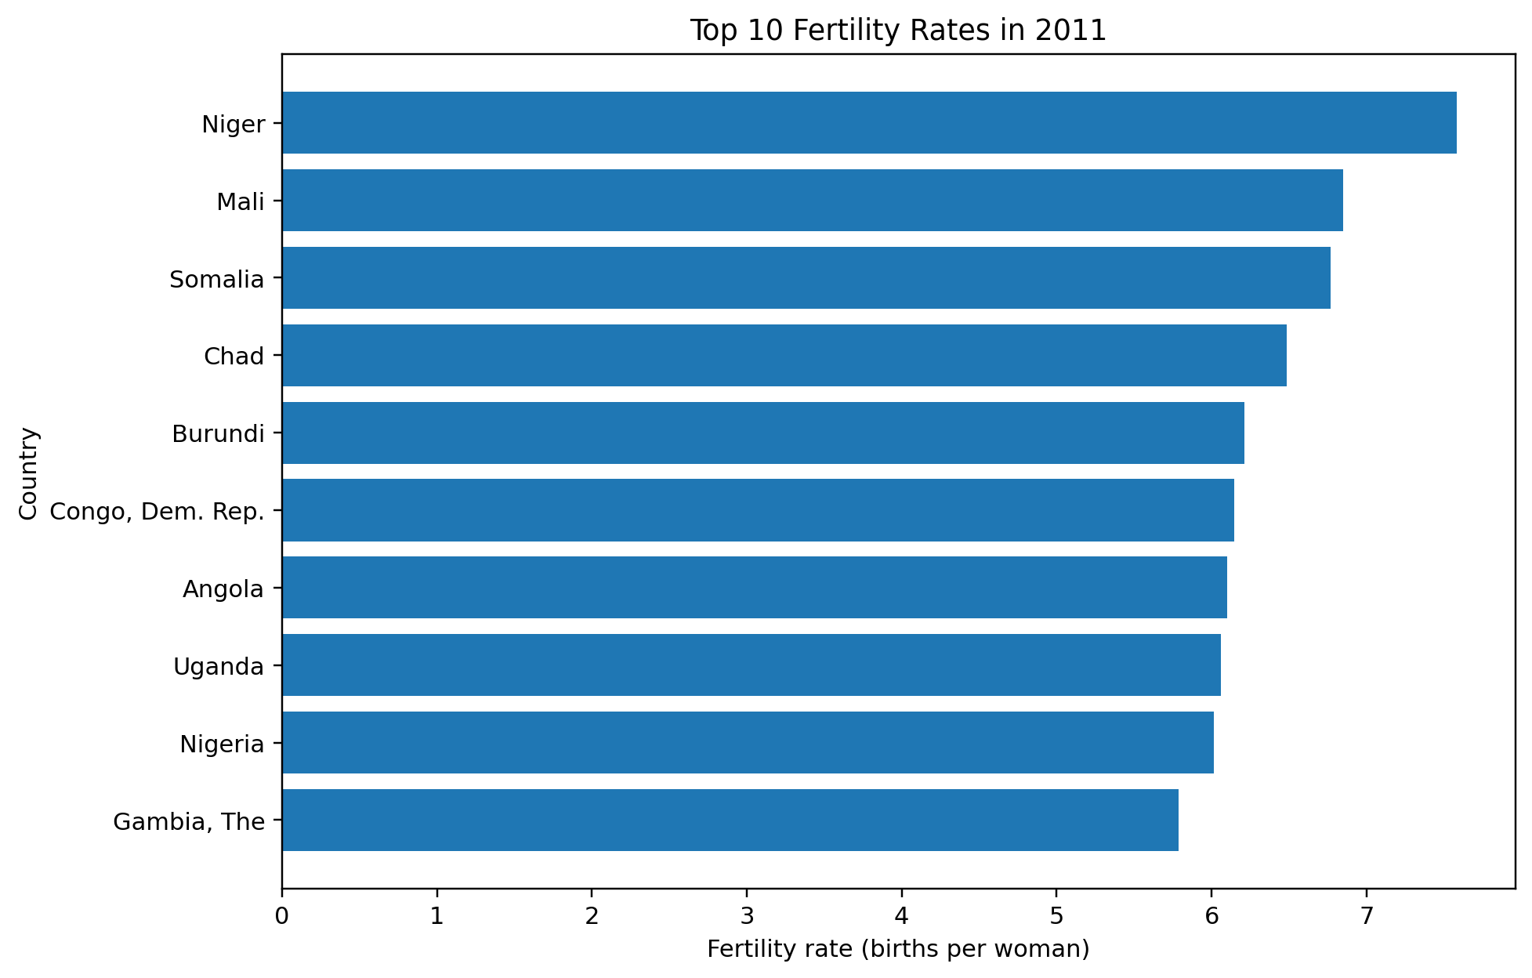
Figure 2. Ten highest fertility-rate observations in 2011.
The 2011 bar chart highlights substantial differences between country/entity observations in the same year. This reinforces that the global time trend does not imply that every country followed the same level or pace of change.
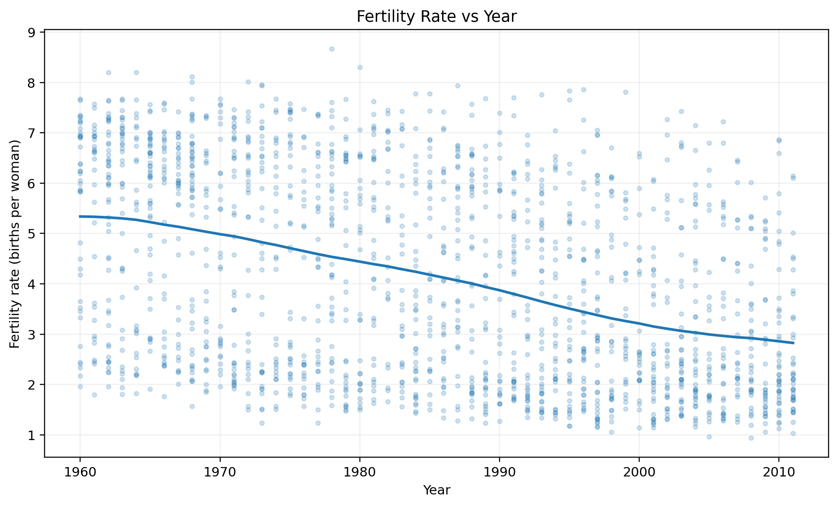
Figure 3. Country-year fertility observations plotted against Year.
The scatter plot shows a broad negative relationship between year and fertility rate, while also showing considerable dispersion around the overall trend. This dispersion becomes important in Week 3 because it limits how much variation can be explained by Year alone.
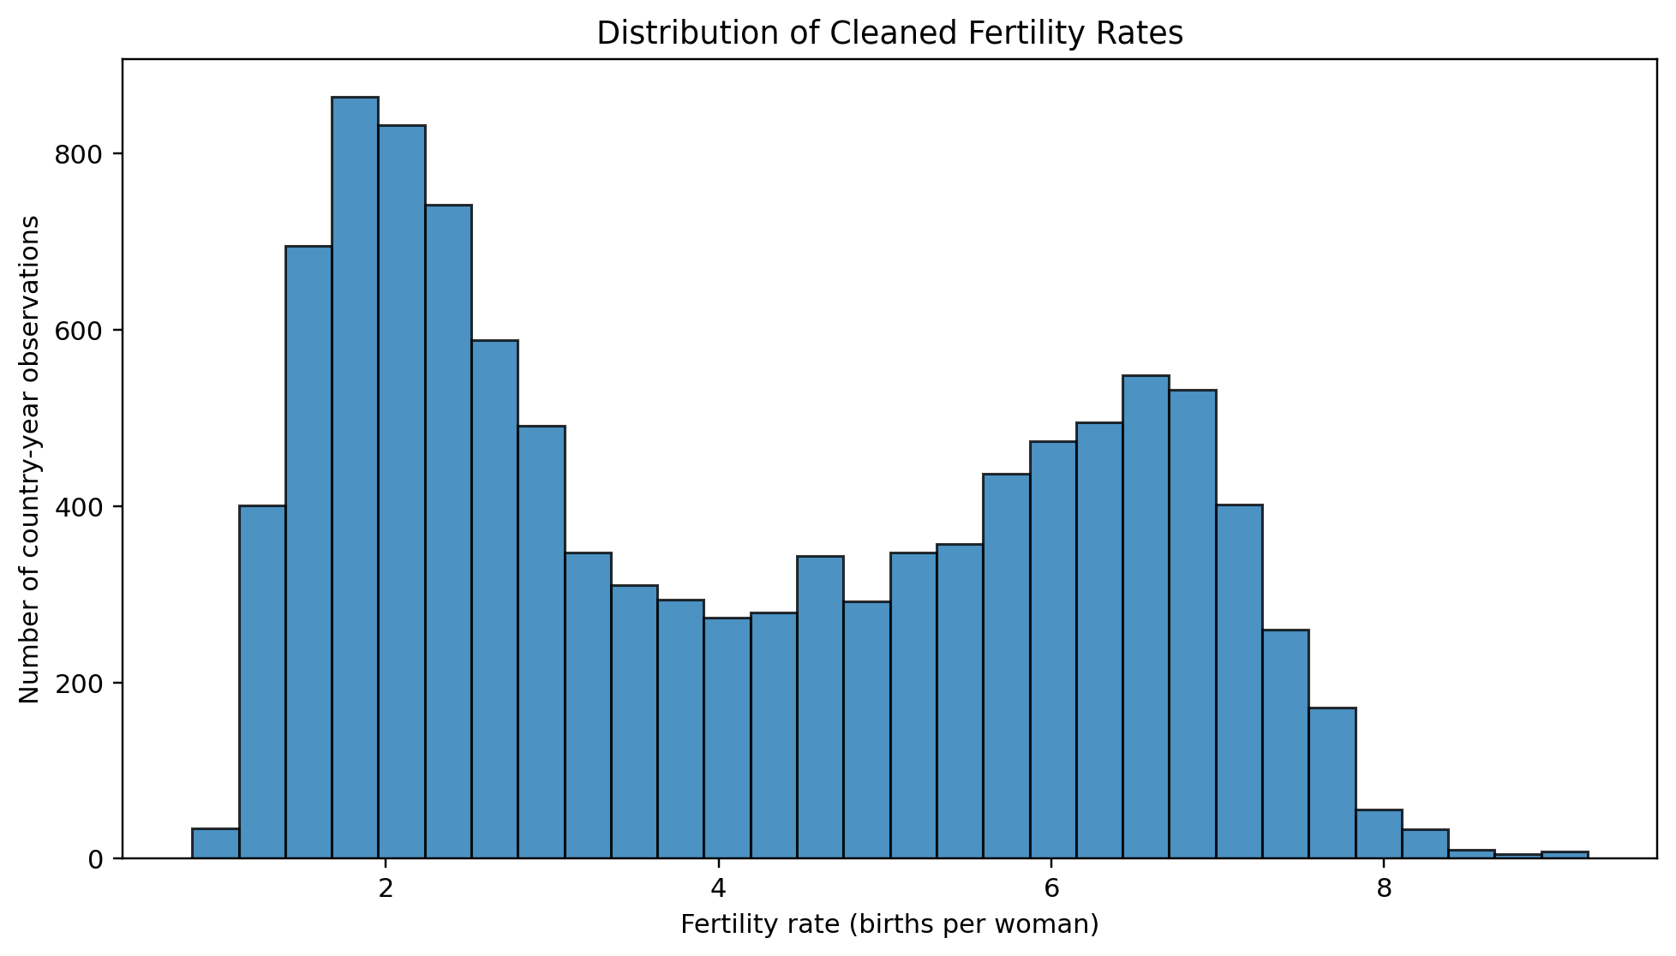
Figure 4. Distribution of fertility-rate observations.
The histogram shows that fertility-rate observations are distributed across a wide range, with substantial concentration in lower and middle values and a long upper tail. This distribution helps explain why a simple one-predictor regression may not capture all country-level differences.
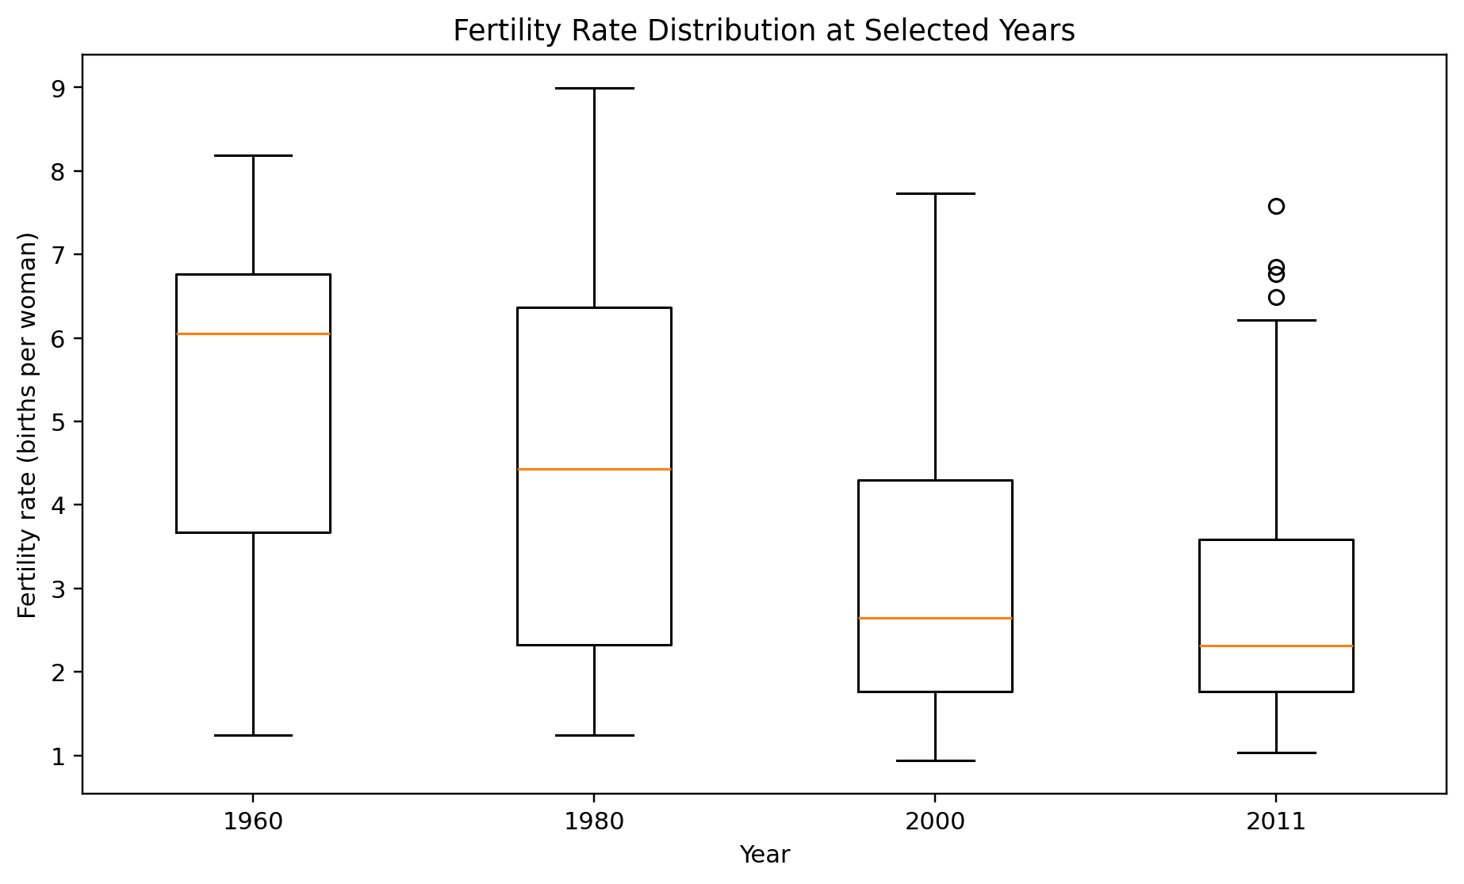
Figure 5. Fertility-rate distributions for selected years.
The boxplot comparison illustrates how the center and spread of fertility-rate observations change across selected years. It complements the line chart by showing within-year variation rather than only the global mean.

5.1 Visualization R code
library(ggplot2)
library(dplyr)
# Global trend
year_summary <- fertility %>%
group_by(Year) %>%
summarise(mean_fertility = mean(FertilityRate_Clean, na.rm = TRUE))
ggplot(year_summary, aes(Year, mean_fertility)) +
geom_line() +
labs(title = "Global Mean Fertility Rate Over Time",
x = "Year", y = "Mean Fertility Rate")
# Distribution
ggplot(fertility, aes(FertilityRate_Clean)) +
geom_histogram(bins = 30) +
labs(title = "Distribution of Fertility Rate",
x = "Fertility Rate", y = "Count")

6. Week 3 – Statistical Analysis and Predictive Modeling

6.1 Statistical question and hypothesis
The Week 3 analysis asked whether Year is statistically associated with fertility rate in the country-year dataset and whether Year can provide useful predictive information.
- H0: The regression slope for Year is equal to 0.
- H1: The regression slope for Year is not equal to 0.

6.2 Exploratory statistical result
The Pearson correlation between Year and FertilityRate_Clean is approximately -0.406, indicating a moderate negative linear association. The regression slope is negative and the hypothesis test indicates statistical significance (p < 0.001). Statistical significance should not be interpreted as proof that Year alone explains individual country-level fertility differences.

6.3 Model construction
An 80/20 train-test split was used with a fixed random seed of 42 to support reproducibility. A simple linear regression model used Year as the predictor and FertilityRate_Clean as the target.
set.seed(42)
train_index <- sample(seq_len(nrow(fertility)),
size = floor(0.80 * nrow(fertility)))
train <- fertility[train_index, ]
test <- fertility[-train_index, ]
model <- lm(FertilityRate_Clean ~ Year, data = train)
summary(model)

6.4 Model evaluation
Metric | Result
Test R² | 0.163
Test RMSE | 1.851
Test MAE | 1.624
5-fold cross-validation mean R² | 0.164
Pearson correlation (Year vs fertility) | -0.406
The test R² of approximately 0.163 means that the simple model explains a limited portion of the variation in the held-out observations. The RMSE and MAE indicate that prediction errors remain material. The similar cross-validation R² of approximately 0.164 suggests that the model's limited explanatory power is not solely a consequence of one particular train-test split.
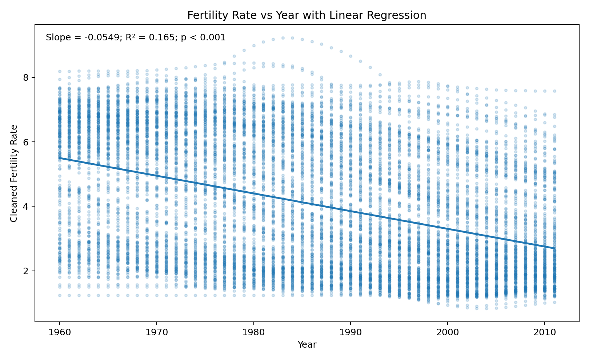
Figure 6. Regression relationship between Year and cleaned fertility rate.
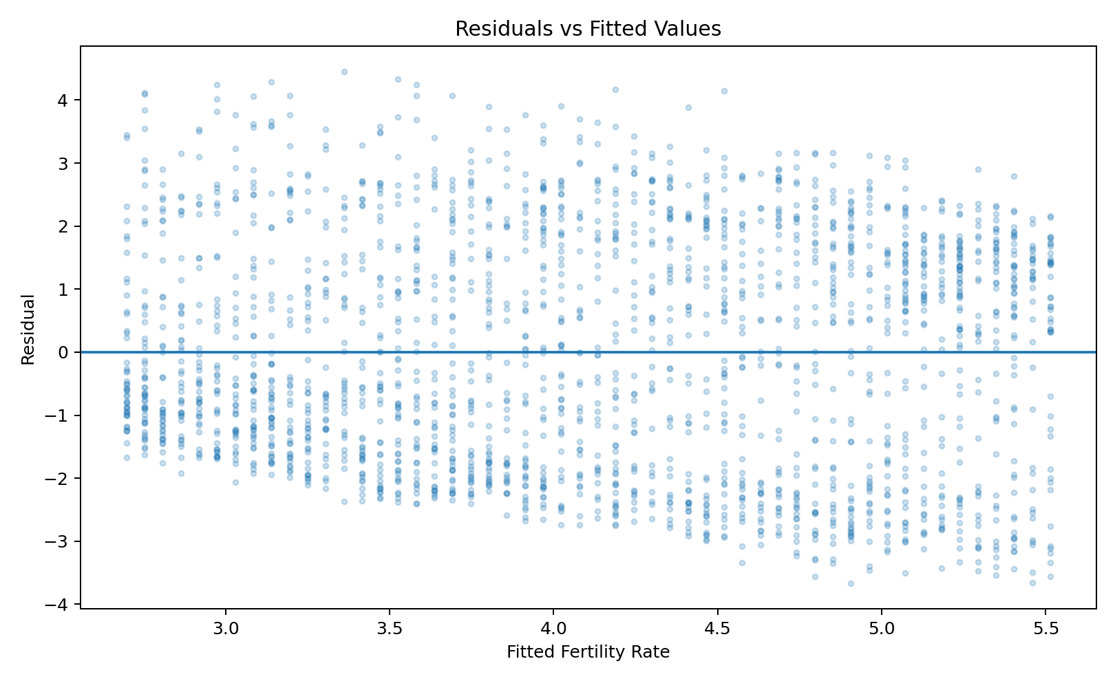
Figure 7. Residuals versus fitted values for model diagnostics.
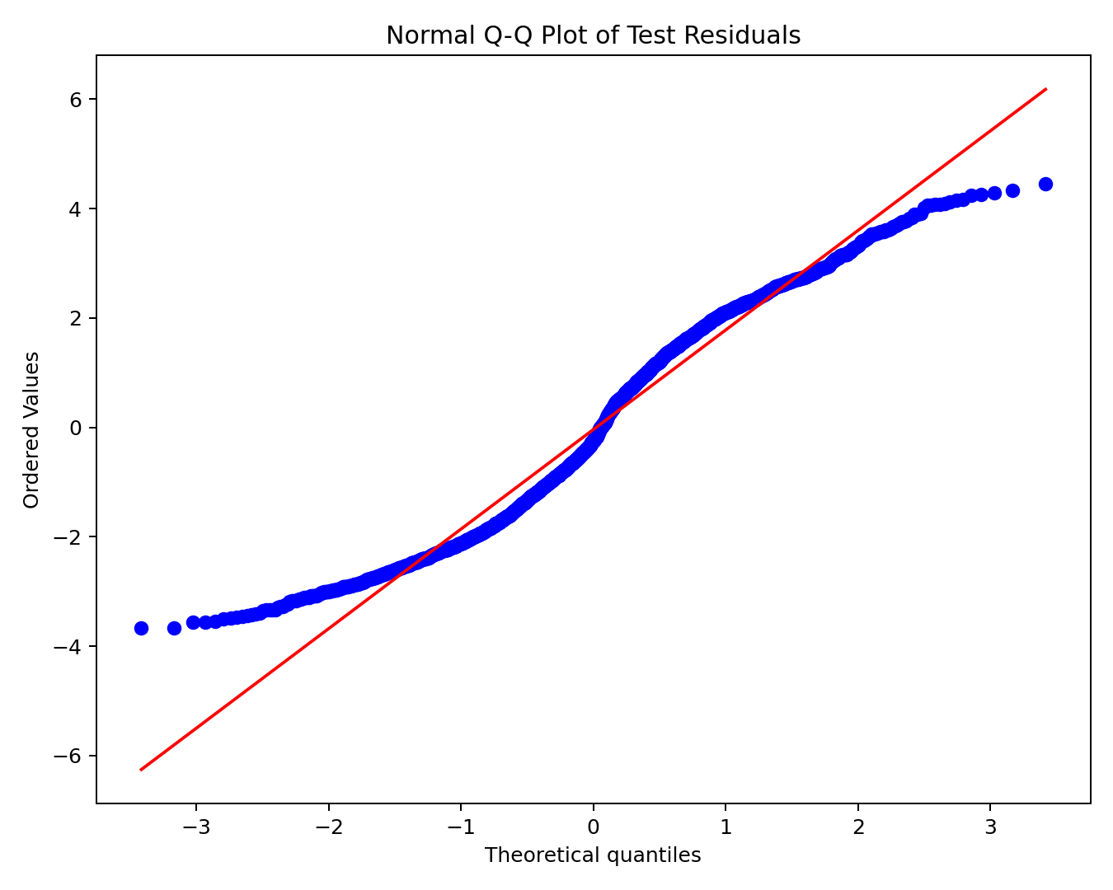
Figure 8. Normal Q-Q plot of regression residuals.
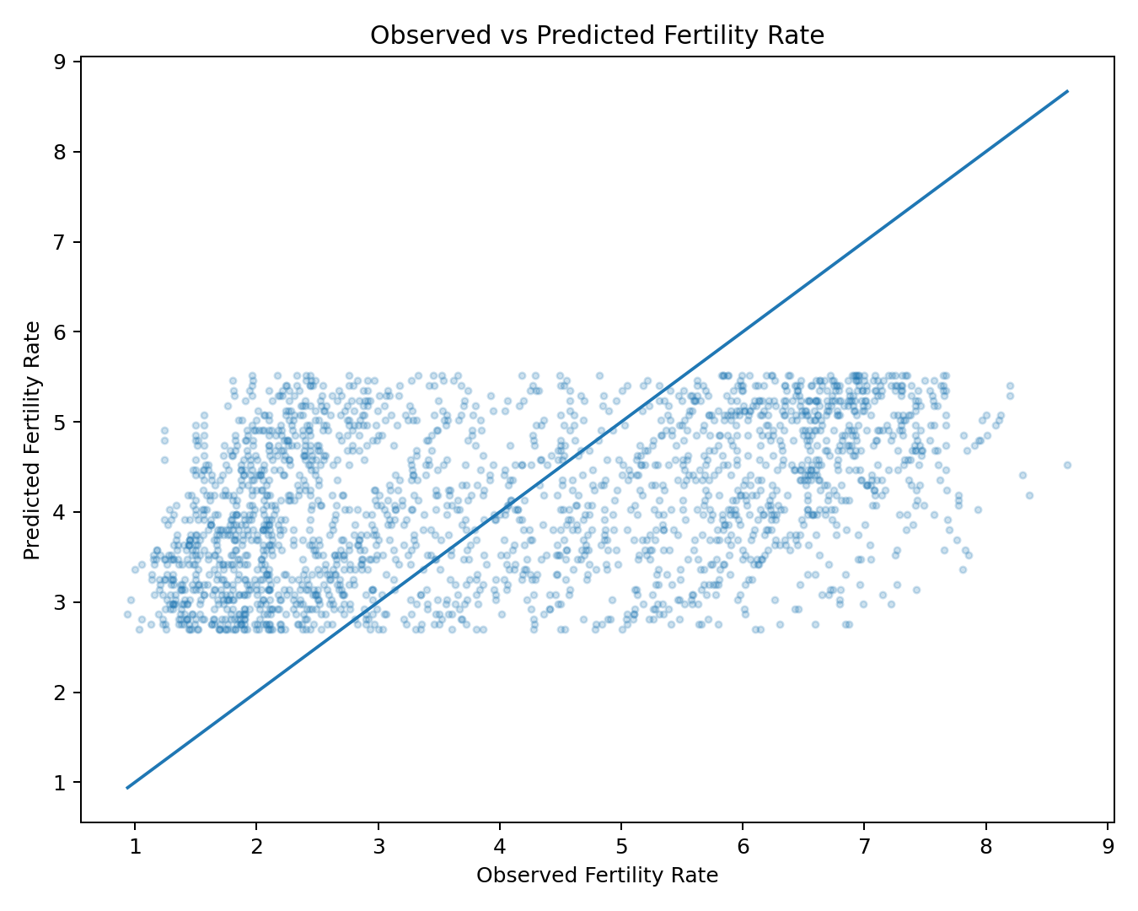
Figure 9. Observed versus predicted fertility-rate values.
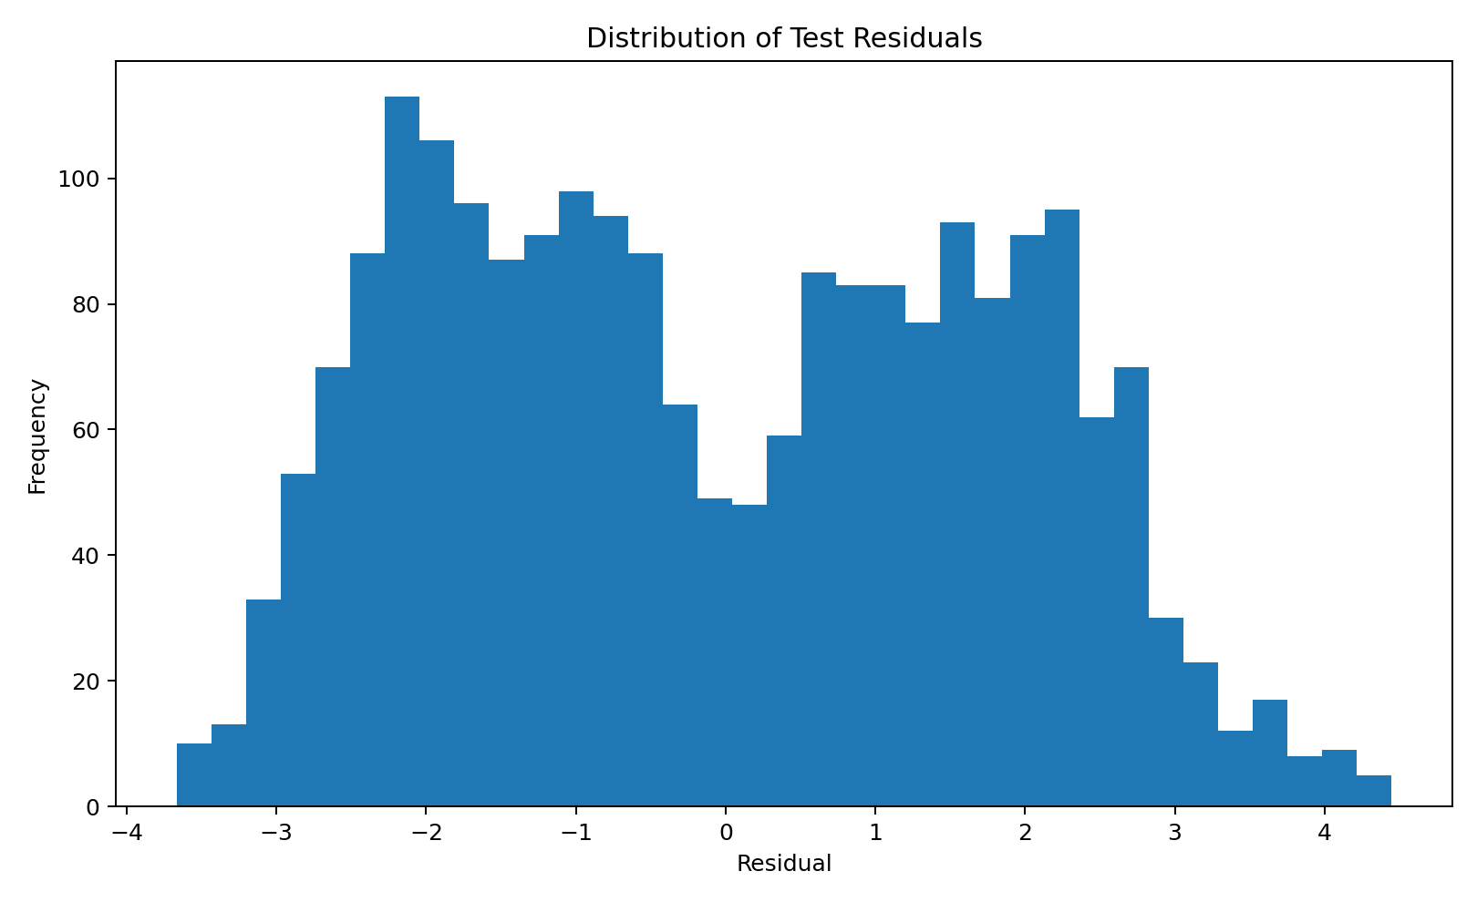
Figure 10. Histogram of model residuals.

6.5 Diagnostic interpretation
The residual diagnostic plots provide evidence about model assumptions and predictive limitations. The residual-versus-fitted plot is used to inspect non-linearity and changing spread. The Q-Q plot is used to assess how closely residuals follow a normal reference pattern. A Shapiro-Wilk check on a sample of 5,000 residuals produced p < 0.001, indicating departure from normality for that sample. This does not invalidate the descriptive relationship, but it is a reason to treat the simple model as a baseline rather than a complete representation of the data-generating process.
A quadratic specification was also checked to see whether adding curvature materially improved held-out performance. The comparison did not show a material improvement, so the simple linear model remains useful as a transparent baseline for this integrated report.

7. Integrated Findings Across Weeks 1–3
The three analytical stages form a connected workflow. Data cleaning established a consistent base dataset, visualization exposed the main patterns, and statistical modeling quantified one important relationship while showing the limits of a one-variable model.
- The overall mean fertility rate declines substantially over the study period.
- Country/entity observations remain highly variable within the same years.
- The negative correlation between Year and fertility rate is visible in both summary statistics and scatter plots.
- The regression slope is statistically significant, but the relatively low R² shows that Year alone is insufficient for strong individual-observation prediction.
- The difference between descriptive trend strength and predictive performance is an important analytical lesson.
- Consistent data preparation makes results from multiple weeks comparable and reproducible.

8. Data-Driven Discussion and Implications
The integrated analysis suggests that fertility rates changed markedly over time in the dataset, but the pattern is not uniform across all countries/entities. A global mean or a single regression line summarizes an important broad tendency, yet country-specific differences remain substantial. Therefore, the analysis should be communicated as evidence of an overall temporal association rather than as a complete explanation of fertility behavior.
From a reporting perspective, this distinction is important. Visualization communicates the pattern quickly, while statistical modeling provides a numerical estimate of the relationship. At the same time, evaluation metrics and diagnostic plots prevent overstatement of the model's predictive value.

9. Challenges Encountered and Lessons Learned
- Handling missing observations while maintaining a consistent analytical dataset.
- Working with a multi-country time series where observations differ considerably across entities.
- Selecting different visualization types to communicate different analytical questions.
- Understanding the difference between statistical significance and practical predictive performance.
- Using residual and prediction diagnostics instead of relying only on a single model metric.
- Maintaining reproducibility by reusing the cleaned dataset and fixed random seed.

10. Recommendations for Further Analysis
The Week 3 model is intentionally simple and should be treated as a baseline. Future work can extend the analysis by adding predictors that capture demographic, economic, social, and country-level differences. The following directions are consistent with the limitations observed in the current model:
- Add country/entity effects or country-specific intercepts and slopes.
- Incorporate economic and demographic variables such as income, education, mortality, urbanization, or other relevant indicators where available.
- Evaluate non-linear and interaction effects using models suited to panel or longitudinal data.
- Compare alternative regression and machine-learning approaches using the same train/test evaluation framework.
- Use time-aware validation when the goal is forecasting future years rather than explaining historical observations.
- Investigate influential observations and residual patterns at the country level.

11. Reproducibility and Project Files
The project was developed as a continuous four-week workflow. The Week 1 cleaned dataset was reused in Weeks 2 and 3, and the Week 4 report integrates the outputs into one document. The supporting R scripts and visualization files are maintained in the same GitHub repository used for the internship tasks.
GitHub repository: https://github.com/aratibhokare625-code/YUVO-Week1-Data-Cleaning-R
Key project outputs include:
- Week 1 cleaned fertility dataset and data-cleaning R analysis.
- Week 2 visualization R script and five visualization outputs.
- Week 3 statistical-analysis/modeling R script, report, and five diagnostic/model outputs.
- This Week 4 integrated comprehensive report.

12. Final Presentation Summary
This project demonstrates a complete data-driven workflow: prepare the data, explore the data, visualize patterns, formulate a statistical question, build a baseline predictive model, evaluate its performance, inspect assumptions, and communicate the results with appropriate limitations.
The strongest integrated finding is the consistency of the broad downward fertility-rate pattern over time. However, the country-level spread visible in the visualizations and the modest R² of the simple regression demonstrate why a single time variable cannot fully explain the observed variation. The report therefore treats the model as a baseline and recommends richer country-level and demographic/economic predictors for future work.

13. Conclusion
The Week 4 task brings together the previous three weeks into a single, coherent analysis. The project progressed from data cleaning to visualization and then to statistical modeling, with each stage building on the previous one. The cleaned dataset provided a consistent foundation; the visualizations communicated the main patterns; and the regression analysis quantified the association between year and fertility rate while highlighting the limits of a simple predictor.
The final report demonstrates the value of combining technical R analysis with clear narrative communication. It also shows why model evaluation and diagnostic analysis are necessary before making strong predictive claims. Future analysis can build on this foundation by incorporating additional variables, country-level effects, and more suitable longitudinal or predictive methods.

14. Selected R Code – End-to-End Workflow
# Load packages
library(readr)
library(dplyr)
library(ggplot2)
# Load cleaned data
fertility <- read_csv("week1_fertility_cleaned.csv")
# Descriptive summary
summary(fertility$FertilityRate_Clean)
# Correlation
cor(fertility$Year, fertility$FertilityRate_Clean,
use = "complete.obs")
# Train/test split
set.seed(42)
idx <- sample(seq_len(nrow(fertility)),
floor(0.80 * nrow(fertility)))
train <- fertility[idx, ]
test <- fertility[-idx, ]
# Linear regression
model <- lm(FertilityRate_Clean ~ Year, data = train)
# Prediction
pred <- predict(model, newdata = test)
# Evaluation
rmse <- sqrt(mean((test$FertilityRate_Clean - pred)^2))
mae <- mean(abs(test$FertilityRate_Clean - pred))
rmse
mae
summary(model)
# Diagnostics
par(mfrow = c(2, 2))
plot(model)

15. Submission Checklist
- Comprehensive Week 4 DOC report completed.
- Introduction, methodology, analysis, results, discussion, and conclusion included.
- Week 1 data cleaning integrated.
- Week 2 visualizations and insights integrated.
- Week 3 statistical analysis and predictive modeling integrated.
- Visual aids and R code snippets included.
- Challenges, lessons learned, and future directions included.
- GitHub repository reference included.

