YUVO INTERN – WEEK 3 TASK
Statistical Analysis and Predictive Modeling using R
Name: Arati Bhokare
Submission Date: 30 September 2026
Dataset: World Bank Fertility Rate (1960–2011)

1. Objective
The objective of this task is to perform in-depth statistical analysis and build a predictive model using R. The Week 1 cleaned World Bank Fertility Rate dataset was reused so that the workflow continues from data cleaning to statistical inference, model building, evaluation, and diagnostics.

2. Dataset Selection and Rationale
The analysis uses 10,920 cleaned country-year observations from 210 countries/entities covering 1960 to 2011. The target variable is the cleaned fertility rate and Year is used as the predictor. This choice allows a simple, interpretable regression question: whether fertility rate changes systematically over time.

3. Hypothesis Formulation
Null hypothesis (H0): The regression slope for Year is zero; Year has no linear association with fertility rate.
Alternative hypothesis (H1): The regression slope for Year is not zero; Year is linearly associated with fertility rate.

4. Exploratory Statistical Analysis
The cleaned fertility rate has mean 4.098, median 3.780, standard deviation 2.031, minimum 0.836, and maximum 9.223. The mean fertility rate was 5.337 in 1960 and 2.825 in 2011.
Pearson correlation between Year and fertility rate is -0.406. The corresponding regression slope is -0.0549 with standard error 0.0012. The test statistic is approximately -46.40 and the p-value is below 0.001. Therefore, the sample provides strong statistical evidence of a non-zero linear association in this dataset. This is an association and does not by itself establish causation.

5. Train/Test Split and Model Building
An 80/20 train-test split was used with a fixed random seed of 42 for reproducibility. A simple linear regression model was fitted on the training data:
FertilityRate_Clean = β0 + β1 × Year + error
The fitted training model had an estimated slope of -0.0552 and intercept of 113.715. The negative slope indicates that the predicted fertility rate decreases as Year increases in this simple model.

6. Model Evaluation
Metric | Linear model | Quadratic model | Interpretation
Test R² | 0.163 | 0.162 | Proportion of test variation explained
Test RMSE | 1.851 | 1.851 | Lower is better
Test MAE | 1.624 | 1.625 | Lower is better
The linear model achieved test R² = 0.163, RMSE = 1.851, and MAE = 1.624. Five-fold cross-validation produced mean R² = 0.164 and mean RMSE = -1.856. A quadratic specification was also checked; its test R² was 0.162 and RMSE was 1.851, so it did not materially improve the held-out results.

7. Model Diagnostics
Residual diagnostics were examined using residual-versus-fitted, Q-Q, and residual-distribution plots. A Shapiro-Wilk test on a reproducible sample of 2,184 test residuals returned W = 0.9630, p < 0.001. With this large sample, the test rejects exact normality. The Q-Q plot is therefore important for judging the practical size and pattern of departures rather than relying on the p-value alone.
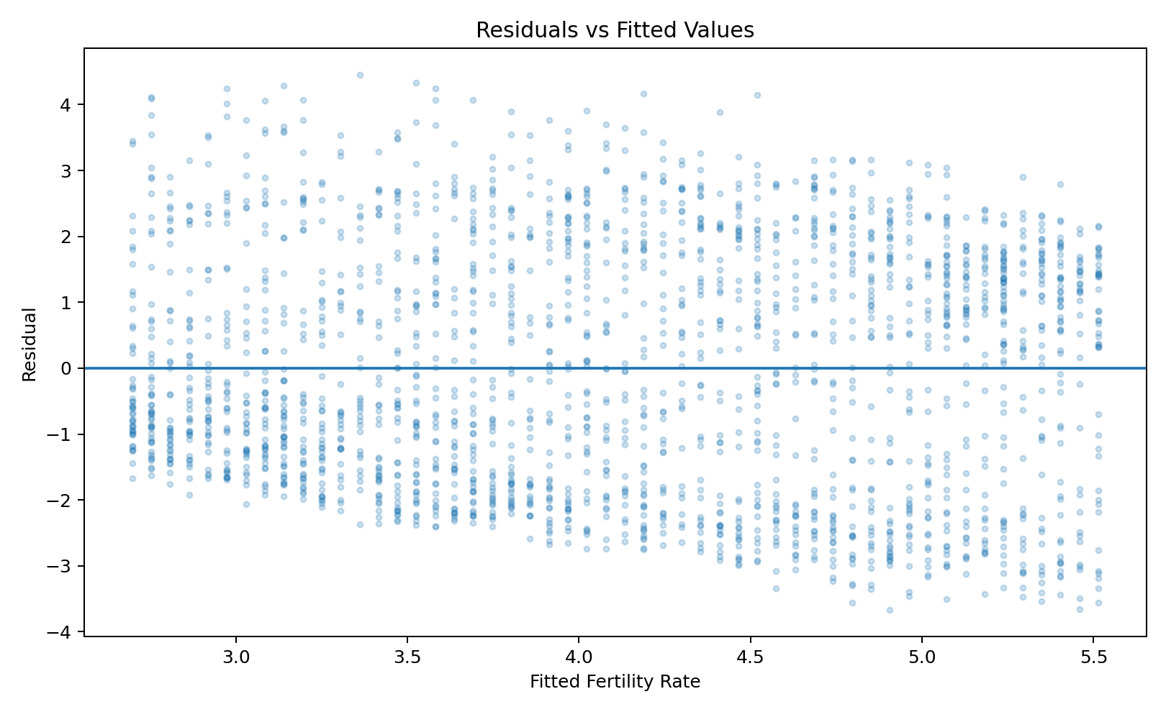
Figure 1. Residuals versus fitted values.
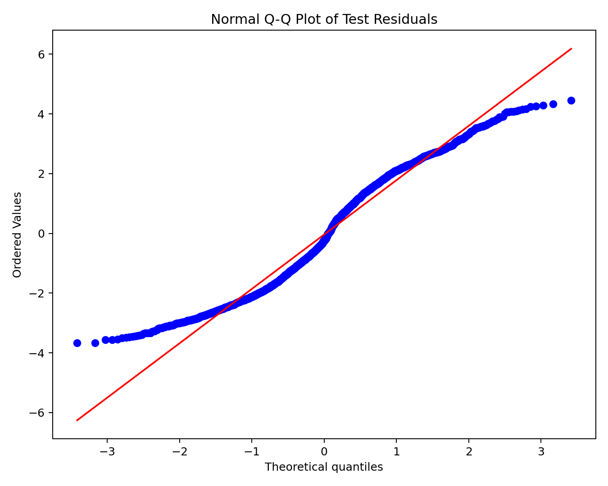
Figure 2. Normal Q-Q plot of test residuals.

8. Regression Relationship and Predictions
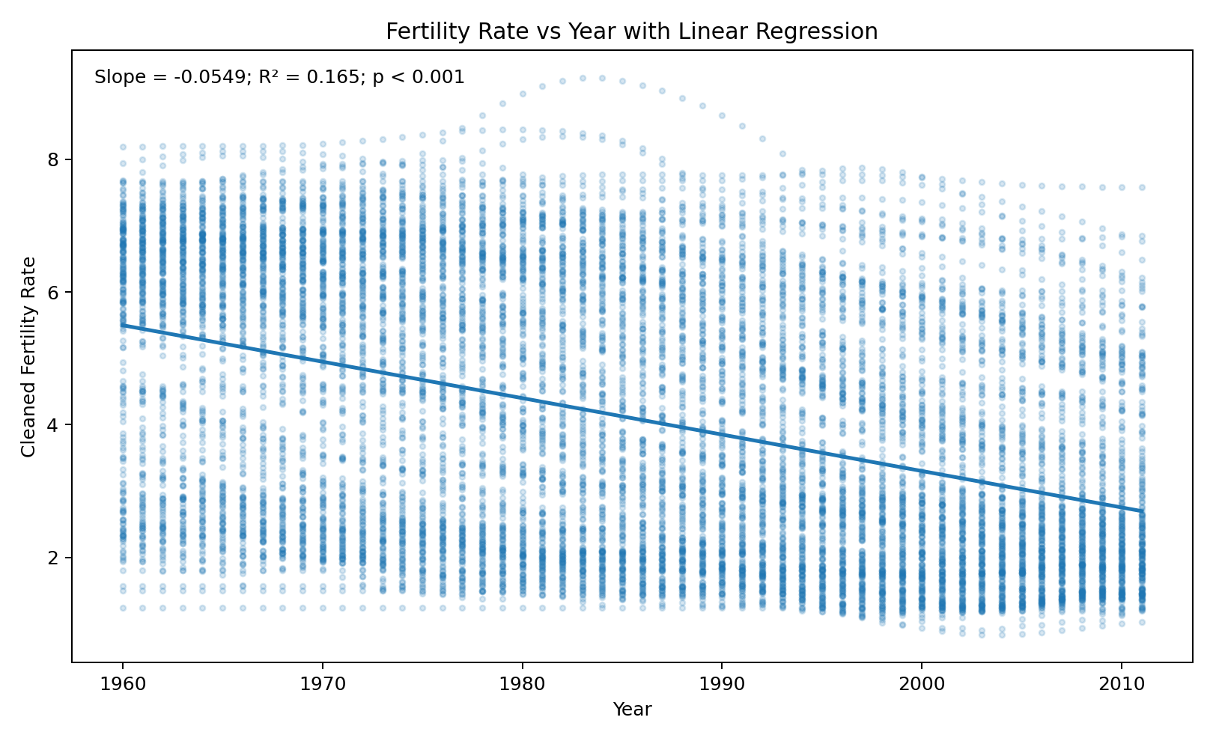
Figure 3. Fertility rate versus year with fitted linear regression.
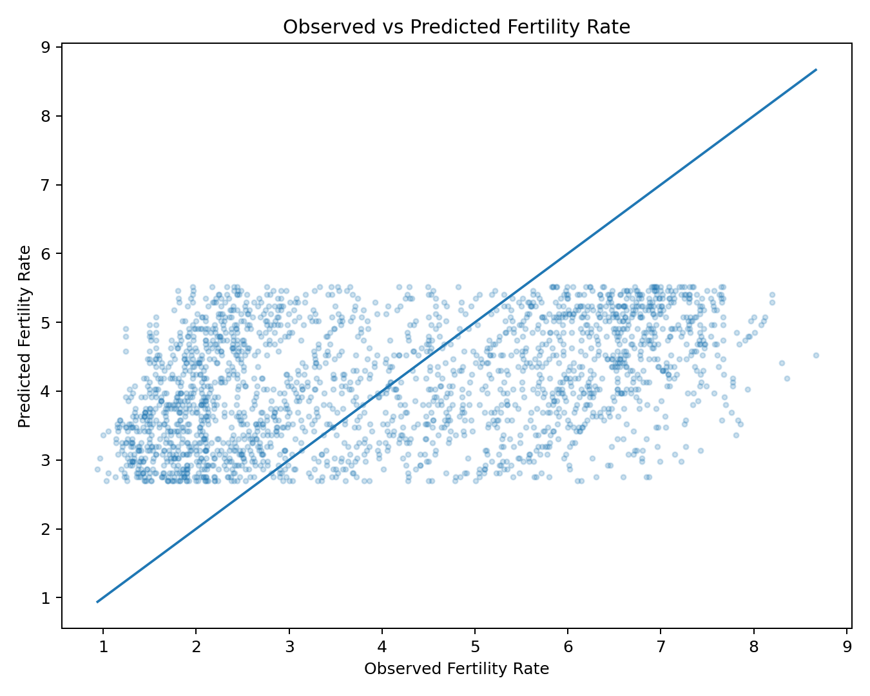
Figure 4. Observed versus predicted fertility rate on the test set.

9. Insights and Interpretation
- The observed mean fertility rate declined from 5.337 in 1960 to 2.825 in 2011.
- The estimated linear slope is -0.0549 fertility-rate units per additional year, indicating a downward time trend in the observed data.
- The model's test R² of 0.163 shows that Year alone explains a limited portion of individual country-year variation. Country-specific and other demographic factors are not represented in this one-predictor model.
- The residual and Q-Q diagnostics indicate that a simple linear model does not capture every feature of the data distribution. This is consistent with the relatively modest predictive performance.
- The quadratic comparison did not materially improve the held-out metrics, so adding polynomial curvature alone is not a sufficient solution to the remaining variation.

10. Potential Improvements
Future work could add country-level effects, regional indicators, population and economic variables, and other demographic predictors. A panel-data approach or mixed-effects model could account for repeated observations within countries. Additional validation strategies could hold out complete countries or time periods to test generalization more strictly. Transformations or robust regression could also be considered after inspecting residual patterns.

11. R Code Excerpts
model <- lm(FertilityRate_Clean ~ Year, data = train_data)
summary(model)
test_data$Predicted <- predict(model, newdata = test_data)
rmse <- sqrt(mean((test_data$FertilityRate_Clean - test_data$Predicted)^2))
mae <- mean(abs(test_data$FertilityRate_Clean - test_data$Predicted))
shapiro.test(res_sample)
par(mfrow = c(2,2)); plot(model)

12. Conclusion
This task completed the statistical-analysis and predictive-modeling workflow on the cleaned World Bank fertility dataset. The hypothesis test and correlation analysis identify a statistically significant negative linear association between year and fertility rate. The linear regression provides an interpretable baseline, while train/test evaluation and five-fold cross-validation show that Year alone has limited predictive power for individual observations. Diagnostic analysis also highlights departures from ideal residual assumptions. The results provide a reproducible baseline for a more complete model that incorporates country and other explanatory variables.

13. Reproducibility
The accompanying R script contains the data preparation, hypothesis testing, train/test split, regression, cross-validation, evaluation metrics, and diagnostic code. The same Week 1 cleaned CSV is used as the input.

