YUVO INTERN – WEEK 2 TASK
Data Visualization and Insight Communication using R
World Bank Fertility Rate Dataset (1960–2011)
Name | Arati Bhokare
Submission Date | 27 September 2026
1. Task Objective
The objective of this Week 2 task is to create dynamic and informative visualizations using R and communicate meaningful insights from a publicly available dataset. The Week 1 World Bank Fertility Rate dataset was continued so that the visualization stage builds directly on the cleaned analytical data. The analysis focuses on trends, cross-country differences, distributions, and changes across selected years.
2. Dataset Overview
The dataset contains country-level fertility-rate observations for 1960–2011. After the Week 1 cleaning process, the analytical dataset contains 10,920 country-year observations across 210 countries/entities. The main visualization variable is FertilityRate_Clean, measured as births per woman. Year provides the time dimension and Country Name provides the categorical grouping used for comparisons.
Across the cleaned observations, the mean fertility rate is 4.098, the median is 3.780, the minimum is 0.836, and the maximum is 9.223. The mean fertility rate is 5.337 in 1960 and 2.825 in 2011.
3. Visualization Design
Five visualizations were prepared to address different analytical questions. A line chart communicates the long-term time trend; a horizontal bar chart compares the highest fertility-rate countries in 2011; a scatter plot shows the relationship between year and country-year fertility observations; a histogram describes the overall distribution; and a selected-year boxplot compares distributional changes at four points in time. The combination provides both overview and detail and follows the task requirement to use multiple chart types.
4. Visualization 1 – Line Chart
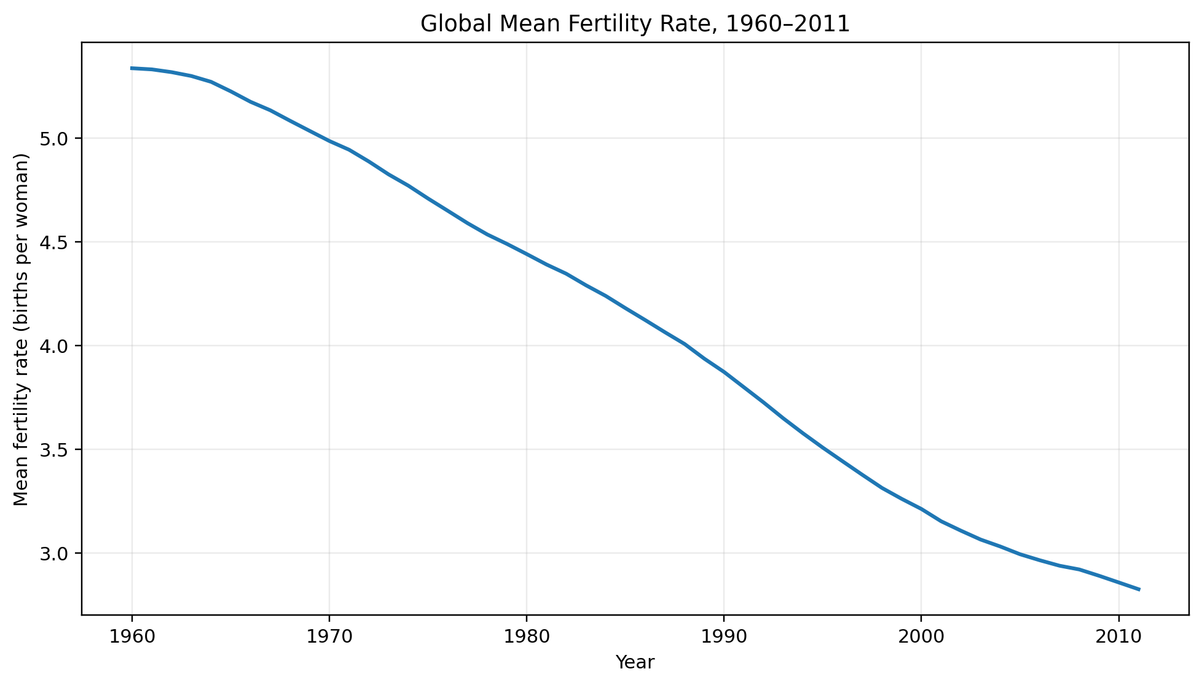
Figure 1. Global mean fertility rate across 1960–2011.
The line chart shows a sustained downward pattern in the global mean fertility rate over the selected historical period. The mean falls from approximately 5.337 births per woman in 1960 to 2.825 in 2011. This chart was selected because a line is well suited to communicating change over time. The visual makes the overall direction easy to identify while retaining the year-by-year sequence.
The descriptive correlation between Year and FertilityRate_Clean is -0.406. This is an association in the dataset and should not be interpreted as proof that time itself causes the observed change.
5. Visualization 2 – Bar Chart
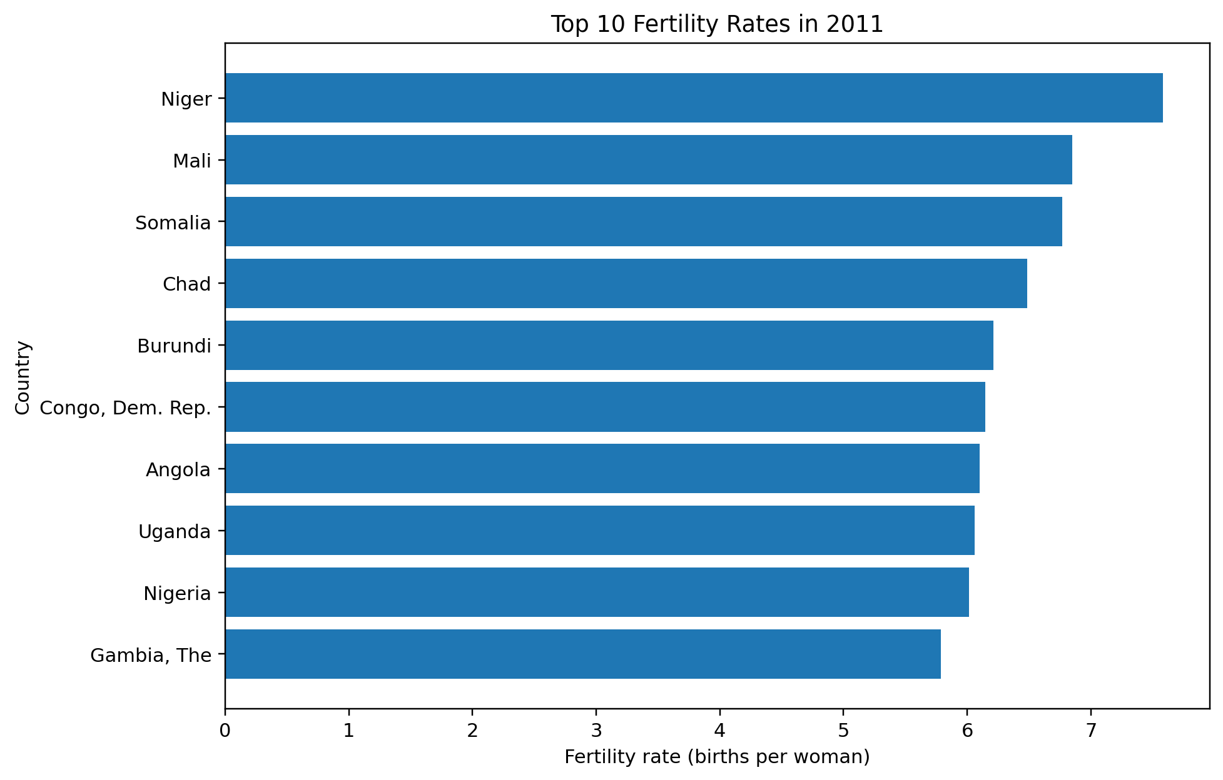
Figure 2. Ten countries/entities with the highest cleaned fertility rate in 2011.
The horizontal bar chart focuses on the latest year in the analytical period and ranks the ten highest country-level fertility rates. A horizontal layout makes country names easier to read and allows the magnitude of the differences to be compared directly. The chart highlights substantial cross-country variation that can be hidden when only a global mean is shown.
In 2011, the highest value among the displayed country-level observations is approximately 7.581 births per woman. The chart is descriptive and does not attempt to explain why countries differ.
6. Visualization 3 – Scatter Plot
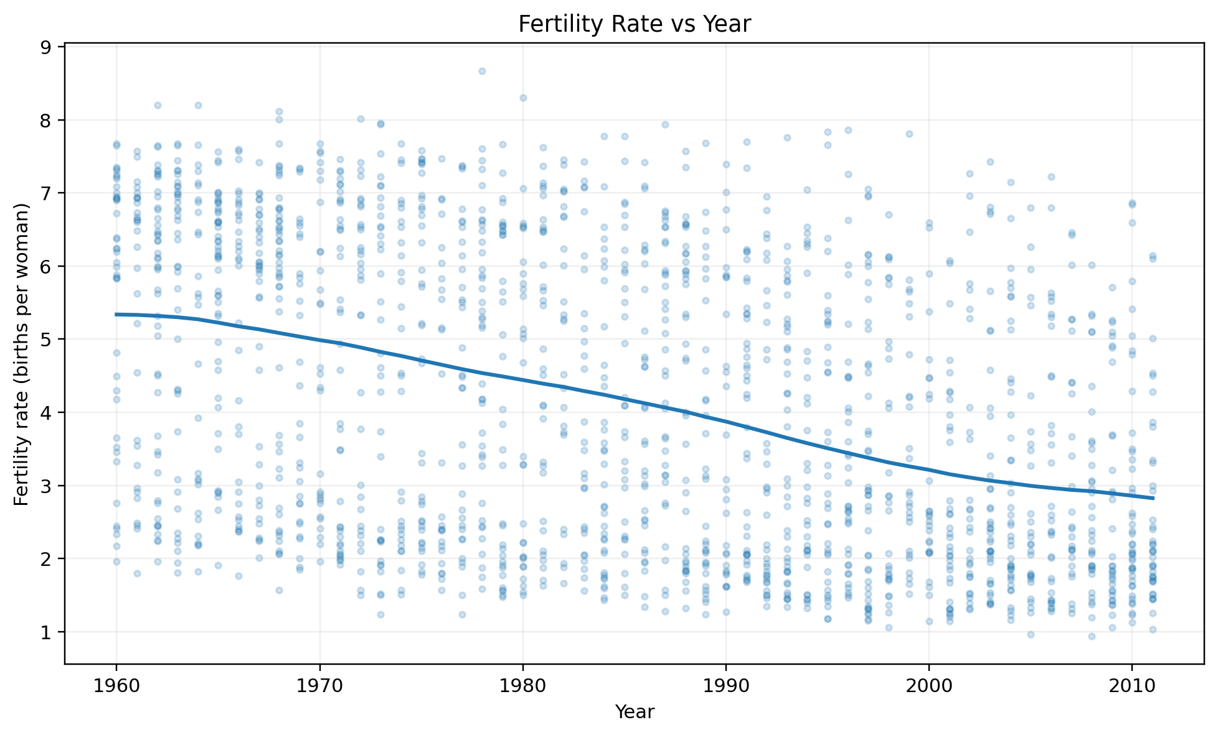
Figure 3. Sampled country-year fertility observations plotted against year, with the yearly mean trend overlaid.
The scatter plot displays individual country-year observations to show both the overall time direction and the spread between countries. A sample is used for readability because plotting every observation at full opacity would create excessive overlap. The yearly mean line is overlaid to provide a clear reference for the aggregate trend. The plot demonstrates that the downward historical pattern occurs alongside considerable country-level variation.
7. Visualization 4 – Histogram
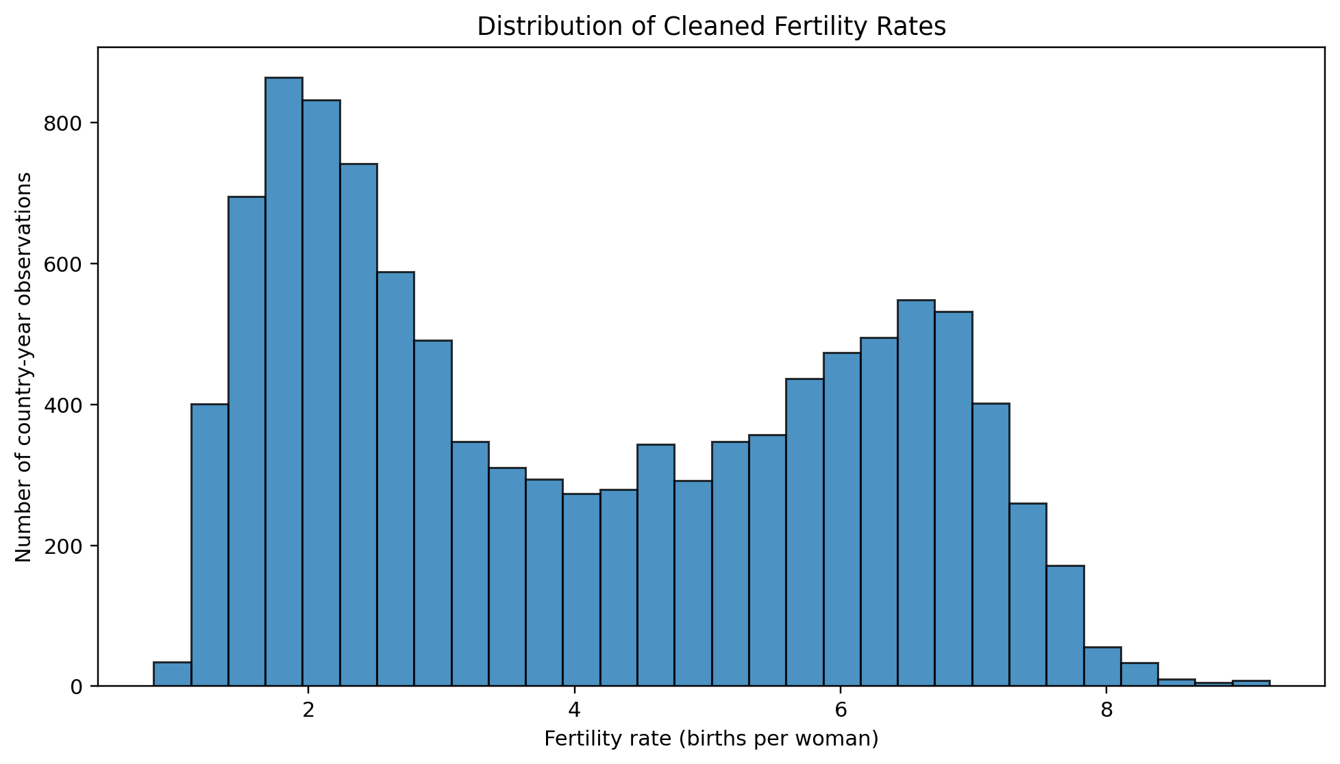
Figure 4. Distribution of cleaned fertility-rate observations.
The histogram shows how frequently different fertility-rate values occur across all country-year observations. It is useful for understanding concentration, spread, and the overall shape of the variable. The distribution contains observations across a broad range, with more mass in the lower-to-middle fertility-rate values than at the upper end. This complements the mean and median statistics by showing the full distribution rather than a single summary number.
8. Visualization 5 – Selected-Year Boxplot
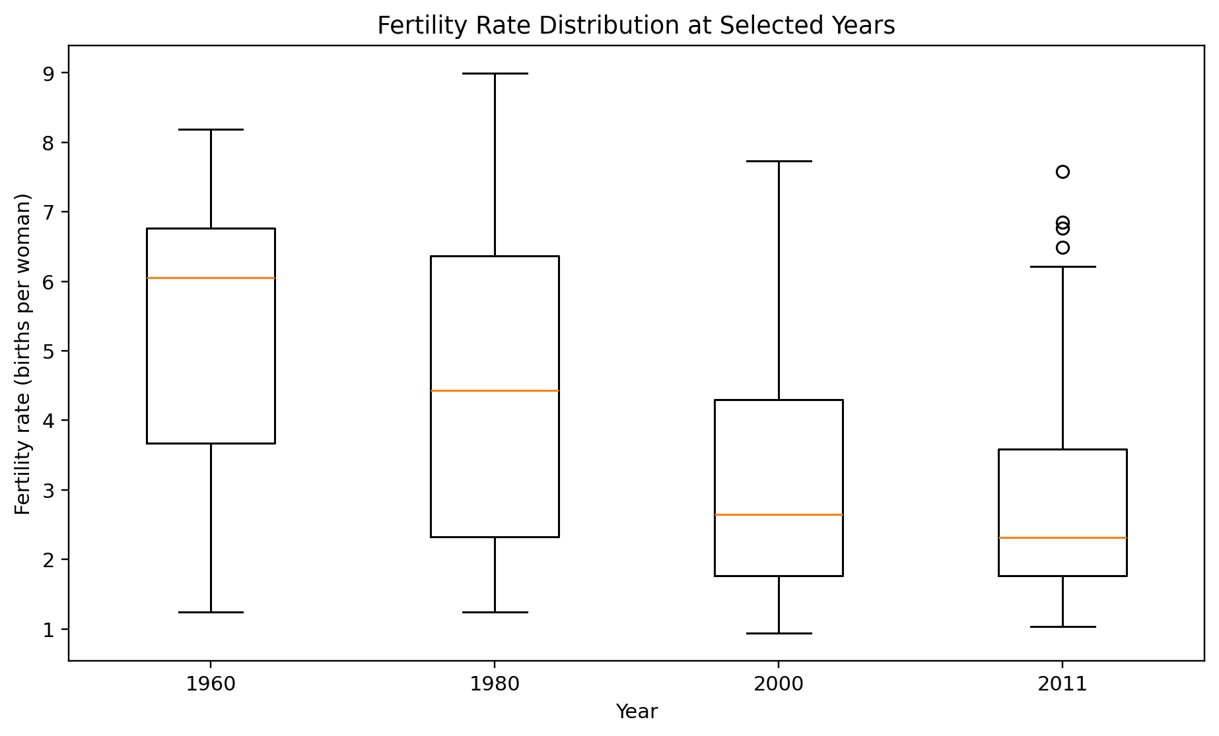
Figure 5. Fertility-rate distributions for 1960, 1980, 2000, and 2011.
The boxplot compares the distribution of fertility rates at four selected years. It communicates the median, interquartile range, and potential extreme observations for each year. The comparison shows how both the central level and the spread of fertility rates change over the historical period. This visualization was selected because it allows several distributions to be compared using a compact and consistent structure.
9. Key Insights
- The global mean fertility rate declines from 5.337 in 1960 to 2.825 in 2011.
- The dataset contains substantial cross-country variation, so the global mean does not represent every country equally.
- The 2011 bar chart demonstrates that the highest fertility-rate observations are concentrated in a smaller subset of countries/entities.
- The scatter plot shows a negative time association while also revealing considerable country-year dispersion.
- The histogram shows the overall distribution and confirms that fertility rates cover a wide range of values.
- The selected-year boxplot makes the change in the distribution over time easier to compare than a single global trend line.
10. R Code Used
# YUVO Intern - Week 2
# Data Visualization and Insight Communication using R
# Name: Arati Bhokare
# Dataset: World Bank Fertility Rate (cleaned Week 1 dataset)
library(readr)
library(dplyr)
library(ggplot2)
# Load the cleaned Week 1 dataset
data <- read_csv("week1_fertility_cleaned.csv", show_col_types = FALSE)
# Basic checks
str(data)
summary(data$FertilityRate_Clean)
# 1. Line chart: global mean fertility rate by year
year_mean <- data %>%
group_by(Year) %>%
summarise(Mean_Fertility = mean(FertilityRate_Clean, na.rm = TRUE))
ggplot(year_mean, aes(x = Year, y = Mean_Fertility)) +
geom_line(linewidth = 1) +
labs(
title = "Global Mean Fertility Rate, 1960-2011",
x = "Year",
y = "Mean fertility rate (births per woman)"
) +
theme_minimal()
# 2. Bar chart: top 10 fertility rates in 2011
top10_2011 <- data %>%
filter(Year == 2011) %>%
group_by(`Country Name`) %>%
summarise(FertilityRate = mean(FertilityRate_Clean, na.rm = TRUE)) %>%
arrange(desc(FertilityRate)) %>%
slice_head(n = 10)
ggplot(top10_2011,
aes(x = reorder(`Country Name`, FertilityRate),
y = FertilityRate)) +
geom_col() +
coord_flip() +
labs(
title = "Top 10 Fertility Rates in 2011",
x = "Country",
y = "Fertility rate (births per woman)"
) +
theme_minimal()
# 3. Scatter plot: year versus fertility rate
set.seed(42)
sample_data <- data %>% slice_sample(n = min(1800, nrow(data)))
ggplot(sample_data, aes(x = Year, y = FertilityRate_Clean)) +
geom_point(alpha = 0.25) +
geom_smooth(method = "lm", se = FALSE) +
labs(
title = "Fertility Rate vs Year",
x = "Year",
y = "Fertility rate (births per woman)"
) +
theme_minimal()
# 4. Histogram: distribution of cleaned fertility rates
ggplot(data, aes(x = FertilityRate_Clean)) +
geom_histogram(bins = 30, colour = "black") +
labs(
title = "Distribution of Cleaned Fertility Rates",
x = "Fertility rate (births per woman)",
y = "Number of country-year observations"
) +
theme_minimal()
# 5. Boxplot at selected years
selected <- data %>% filter(Year %in% c(1960, 1980, 2000, 2011))
ggplot(selected, aes(x = factor(Year), y = FertilityRate_Clean)) +
geom_boxplot() +
labs(
title = "Fertility Rate Distribution at Selected Years",
x = "Year",
y = "Fertility rate (births per woman)"
) +
theme_minimal()
# Correlation for descriptive interpretation
cor(data$Year, data$FertilityRate_Clean, use = "complete.obs")
11. Reproducibility and Documentation
The Week 2 R script reads the cleaned Week 1 CSV, creates a yearly summary, and generates the line, bar, scatter, histogram, and boxplot visualizations with ggplot2. A fixed random seed is used for the scatter-plot sample so that the sampled observations are reproducible. The GitHub repository can contain the R script, cleaned CSV, and exported chart images so that the work can be inspected and reproduced.
12. Conclusion
This Week 2 analysis converts the cleaned Week 1 dataset into a set of visual narratives. The line chart communicates the long-term trend, the bar chart communicates the 2011 cross-country comparison, the scatter plot shows the relationship between time and individual observations, the histogram describes the distribution, and the boxplot compares distributions at selected years. Together, these visualizations provide a structured view of trends, patterns, and variation in fertility rates. The conclusions are descriptive and are intended to support further analysis rather than establish causal explanations.
13. References
1. World Bank World Development Indicators – Fertility rate, total (births per woman), indicator SP.DYN.TFRT.IN.
2. statsmodels documentation – World Bank Fertility Data documentation used for the historical dataset context.
3. R packages used for the visualization workflow: readr, dplyr, and ggplot2.

