DATAMATICS KAiMS | AI OPERATIONS COMMAND CENTER
KaiMS 3-Minute Video Demo Script & Recording Walkthrough
Exact Screen-by-Screen Guide: Timings, Screenshot Previews, Click Actions, and Simple Spoken English
KEY RULES FOR YOUR RECORDING (Addressing Nishant, Kajol & Akshit's Feedback)
• Total Duration: Exactly 3 minutes (180 seconds).
• Pacing: 10 to 14 seconds per screen. Move your cursor or click every 5 seconds so the screen never looks frozen.
• Simple Everyday Language: Speak like you are showing the tool to a friendly teammate. Avoid difficult technical jargon.
• Exact On-Screen Words: Say the exact words shown on screen (e.g. 'Overview', 'Incidents', 'Approvals', 'Ask Kai', 'Needs me', 'Kai is handling').
• Quick Fix: If you see the yellow 'AI capability degraded' banner, press F5 / Refresh to reload live health before recording.

1. Video Timing & Quick Reference
Scene | Time | Screen / Route | Key Feature | Duration
01 | 0:00 - 0:14 | Overview (/) | Welcome & System Status | 14s
02 | 0:14 - 0:28 | Operations Pulse | Live Metrics & Work Lanes | 14s
03 | 0:28 - 0:42 | Incidents (/incidents) | Unified Inbox & Smart Grouping | 14s
04 | 0:42 - 0:56 | Incident Detail | Root Cause Analysis (RCA) & Impact | 14s
05 | 0:56 - 1:12 | Approvals (/approvals) | Assigned Decision Queue | 16s
06 | 1:12 - 1:28 | Decision Packet | Reviewing Safety & Clicking Approve | 16s
07 | 1:28 - 1:42 | Evidence Requests | Human-in-the-Loop Information Queue | 14s
08 | 1:42 - 1:56 | Ask Kai (/copilot) | AI Operations Assistant | 14s
09 | 1:56 - 2:10 | Runbooks & Knowledge | Knowledge Base & Self-Learning | 14s
10 | 2:10 - 2:24 | Platform Health (/platform) | Microservices & AI Health | 14s
11 | 2:24 - 2:36 | Connections | Integrations (Jira, ServiceNow, Datadog) | 12s
12 | 2:36 - 2:48 | Automation Readiness | Playbook Safety Guardrails | 12s
13 | 2:48 - 3:00 | Audit Log & Closed | Immutable Compliance & Wrap-up | 12s

2. Screen-by-Screen Recording Guide (With Screenshots)

Scene 01: Welcome & Operations Overview
⏱ Timing: 0:00 – 0:14 (14 Seconds) | 📍 Screen: Overview (/)
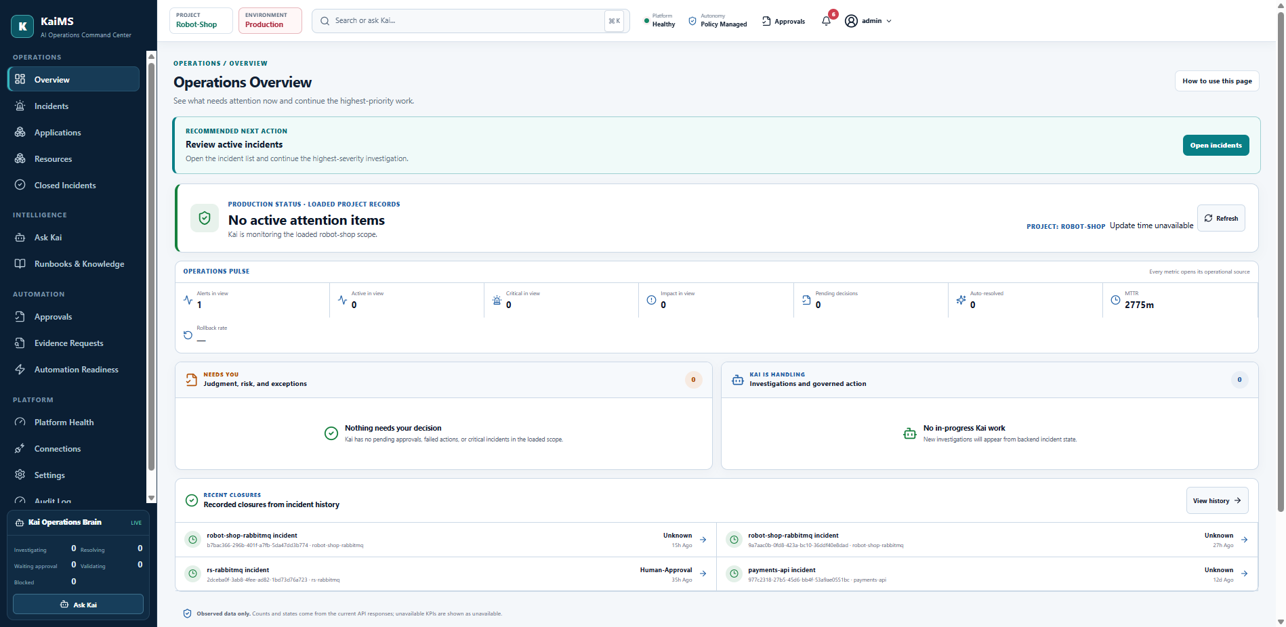
👉 WHERE TO CLICK & MOVE CURSOR
• Start on the Overview page.
• Move your cursor along the top status bar: 'Production status' and the project dropdown.
• (Tip: If you see the yellow warning banner, press F5 before recording to clear it!)

🗣 WHAT TO SAY (Plain, Simple English)
"Welcome to KaiMS. In simple terms, KaiMS is our AI Operations Command Center. It connects directly to monitoring tools, uses AI to find the real root cause of incidents, and helps teams fix issues safely with human approvals. Right now on my screen, we're looking at the main Overview page for our project."

Exact On-Screen Words to Mention: Overview, Production status, Project scope

Scene 02: Operations Pulse & Attention Lanes
⏱ Timing: 0:14 – 0:28 (14 Seconds) | 📍 Screen: Overview (Pulse & Lanes)
👉 WHERE TO CLICK & MOVE CURSOR
• Hover cursor across the Operations pulse cards: 'Alerts in view', 'Critical in view', 'Pending decisions'.
• Point cursor to the two split lanes: 'Needs you' on the left, and 'Kai is handling' on the right.

🗣 WHAT TO SAY (Plain, Simple English)
"Here in the Operations pulse, engineers can immediately see how many alerts are firing, critical issues, and pending decisions. Below, work is neatly organized into two lanes: 'Needs you' highlights critical tasks that need human judgment, while 'Kai is handling' shows where AI is already triaging and investigating in the background."

Exact On-Screen Words to Mention: Operations pulse, Needs you, Kai is handling, Pending decisions

Scene 03: Incidents: Unified Inbox
⏱ Timing: 0:28 – 0:42 (14 Seconds) | 📍 Screen: Incidents (/incidents)
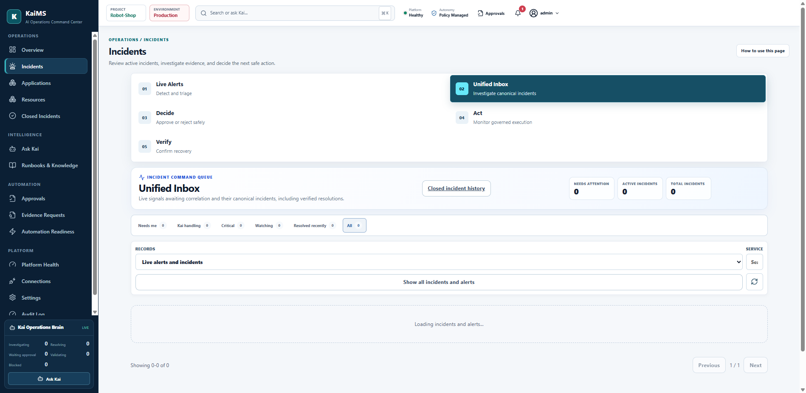
👉 WHERE TO CLICK & MOVE CURSOR
• Click 'Incidents' in the left sidebar under Operations.
• Click the 'Needs me' filter tab, then hover across 'Kai handling' and 'Critical'.

🗣 WHAT TO SAY (Plain, Simple English)
"Let's head over to Incidents. Instead of flooding on-call engineers with dozens of duplicate alerts, KaiMS groups related signals into single, clear incidents. You can filter by 'Needs me', 'Kai handling', or 'Critical', so your team knows exactly what to tackle first without getting lost in alert noise."

Exact On-Screen Words to Mention: Incidents, Needs me, Kai handling, Critical, Unified inbox

Scene 04: Incident Workspace & Root Cause Analysis (RCA)
⏱ Timing: 0:42 – 0:56 (14 Seconds) | 📍 Screen: Incident Workspace Drill-Down
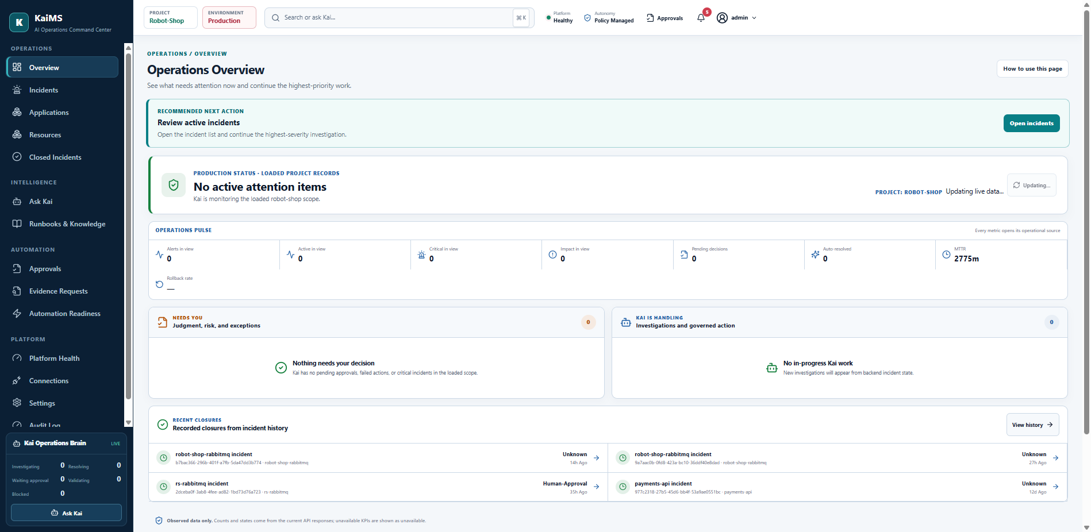
👉 WHERE TO CLICK & MOVE CURSOR
• Click on an incident row to open its details.
• Point your cursor to the 'Kai diagnosis' section, the AI confidence percentage, and the blast radius badge.

🗣 WHAT TO SAY (Plain, Simple English)
"When you open an incident, KaiMS brings all the facts together in one place. Instead of spending hours digging through logs, you get an instant 'Kai diagnosis', an AI confidence score, and the estimated blast radius—backed by live data citations from the actual systems."

Exact On-Screen Words to Mention: Kai diagnosis, Confidence score, Blast radius, Citations

Scene 05: Approvals: Assigned Decision Queue
⏱ Timing: 0:56 – 1:12 (16 Seconds) | 📍 Screen: Approvals (/approvals)
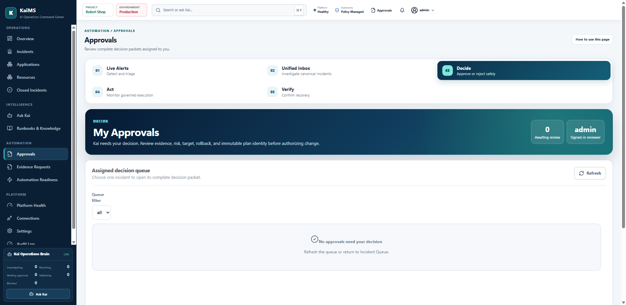
👉 WHERE TO CLICK & MOVE CURSOR
• Click 'Approvals' in the left sidebar under Automation.
• Point to the 'Awaiting review' counter at the top.
• Click 'Review packet →' on one of the incident cards.

🗣 WHAT TO SAY (Plain, Simple English)
"Next is one of our most important features: Approvals. For any high or critical action, KaiMS never runs changes blindly—it requires human sign-off. In the Assigned decision queue, the reviewer sees pending actions. Clicking 'Review packet →' opens the full, verified decision packet."

Exact On-Screen Words to Mention: Approvals, Assigned decision queue, Review packet, Awaiting review

Scene 06: Decision Packet & Approval Actions
⏱ Timing: 1:12 – 1:28 (16 Seconds) | 📍 Screen: Immutable Decision Packet (/approvals)
👉 WHERE TO CLICK & MOVE CURSOR
• Scroll through 'What happened', 'Proposed capability', and 'Execution safety plan' (Rollback plan).
• Hover over the action buttons: 'Approve', 'Approve dry run', 'Request more evidence', 'Reject'.
• Click 'Approve' to show the green confirmation receipt.

🗣 WHAT TO SAY (Plain, Simple English)
"Inside the Decision Packet, you can see 'What happened', the suggested fix, and a ready-to-go rollback plan. You stay in full control: you can click 'Approve', run a safe 'Approve dry run', ask for more data, or reject. Once approved, KaiMS logs an immutable receipt and executes the fix immediately."

Exact On-Screen Words to Mention: Immutable Decision Packet, What happened, Proposed capability, Rollback plan, Approve

Scene 07: Evidence Requests: Human-in-the-Loop Queue
⏱ Timing: 1:28 – 1:42 (14 Seconds) | 📍 Screen: Evidence Requests (/evidence-requests)
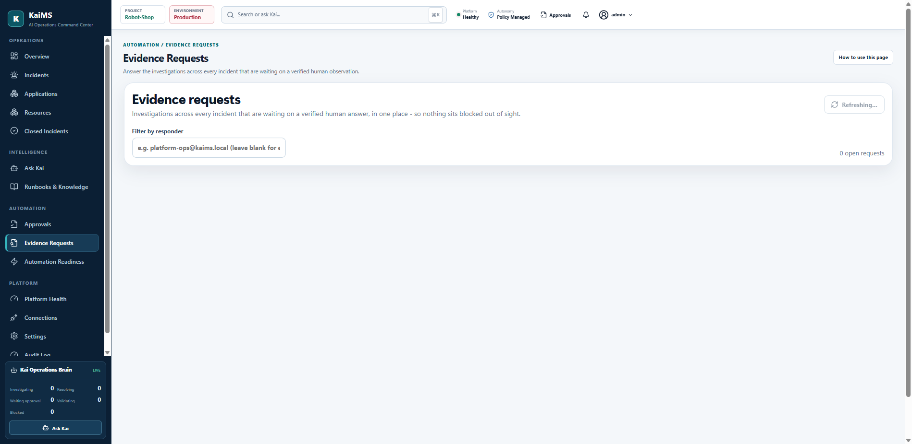
👉 WHERE TO CLICK & MOVE CURSOR
• Click 'Evidence Requests' in the sidebar under Automation.
• Point to the 'Waiting for your answer' status and the responder filter.

🗣 WHAT TO SAY (Plain, Simple English)
"If the AI is missing information during an investigation, it doesn't make things up. It logs a question in Evidence Requests. This queue gathers every item waiting on a human check—like inspecting physical hardware or manual access—so investigations never get silently stuck."

Exact On-Screen Words to Mention: Evidence Requests, Waiting for your answer, Filter by responder

Scene 08: Ask Kai: AI Operations Copilot
⏱ Timing: 1:42 – 1:56 (14 Seconds) | 📍 Screen: Ask Kai (/copilot)
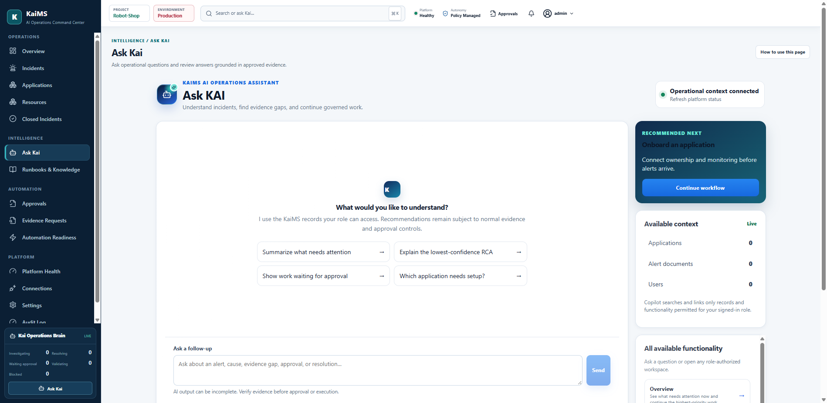
👉 WHERE TO CLICK & MOVE CURSOR
• Click 'Ask Kai' in the sidebar under Intelligence.
• Click the quick prompt button: 'Summarize what needs attention'.

🗣 WHAT TO SAY (Plain, Simple English)
"Under Intelligence, we have Ask Kai, our operations assistant. You can chat in plain English, asking things like 'Summarize what needs attention' or 'Explain the latest incident'. Kai answers using only verified company operational data, and gives you direct links to jump right into the issue."

Exact On-Screen Words to Mention: Ask Kai, Operational context connected, Summarize what needs attention

Scene 09: Runbooks & Knowledge Hub
⏱ Timing: 1:56 – 2:10 (14 Seconds) | 📍 Screen: Runbooks & Knowledge (/knowledge)
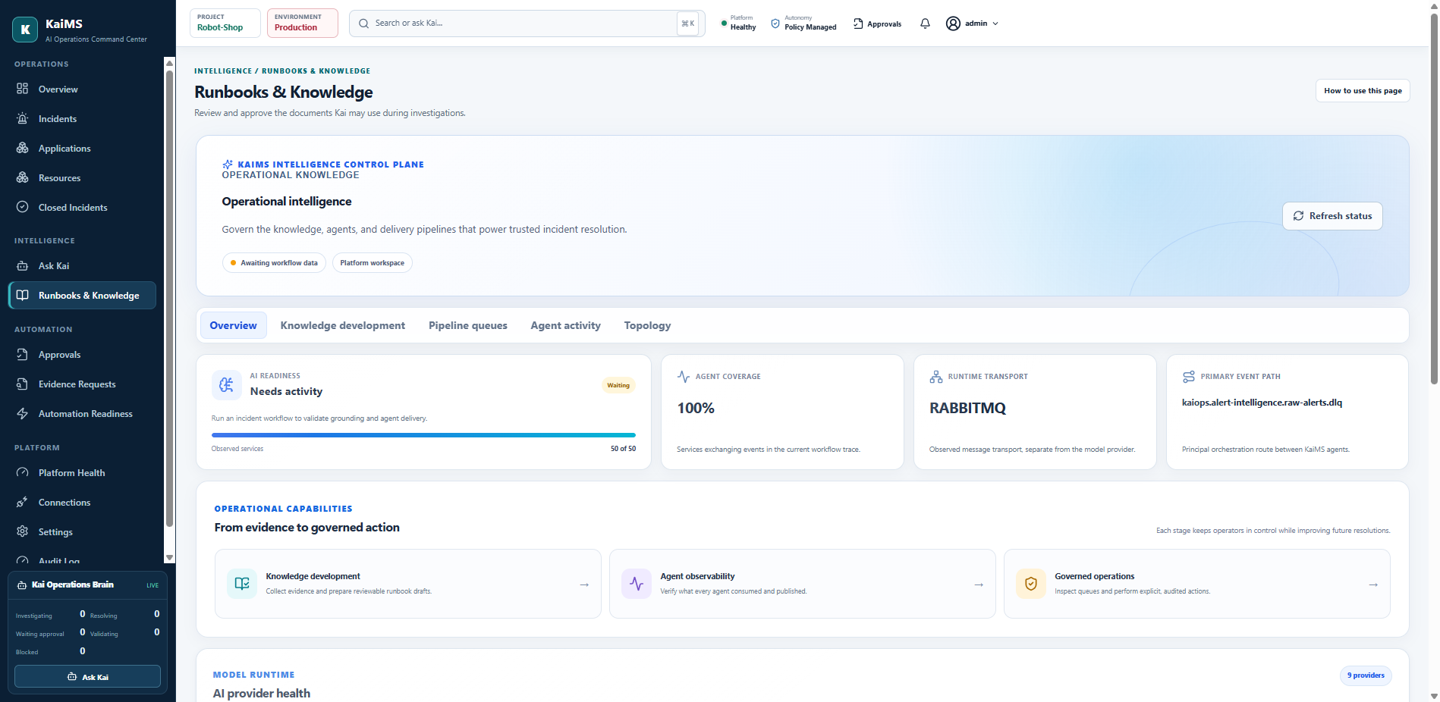
👉 WHERE TO CLICK & MOVE CURSOR
• Click 'Runbooks & Knowledge' in the sidebar.
• Click on the 'Knowledge development' tab.

🗣 WHAT TO SAY (Plain, Simple English)
"In Runbooks & Knowledge, KaiMS stores standard operating procedures used by the AI. With the Knowledge development pipeline, the system automatically turns post-incident learnings into reusable runbooks, so past fixes speed up future resolutions."

Exact On-Screen Words to Mention: Runbooks & Knowledge, Knowledge development, Overview, SOPs

Scene 10: Platform Health
⏱ Timing: 2:10 – 2:24 (14 Seconds) | 📍 Screen: Platform Health (/platform)
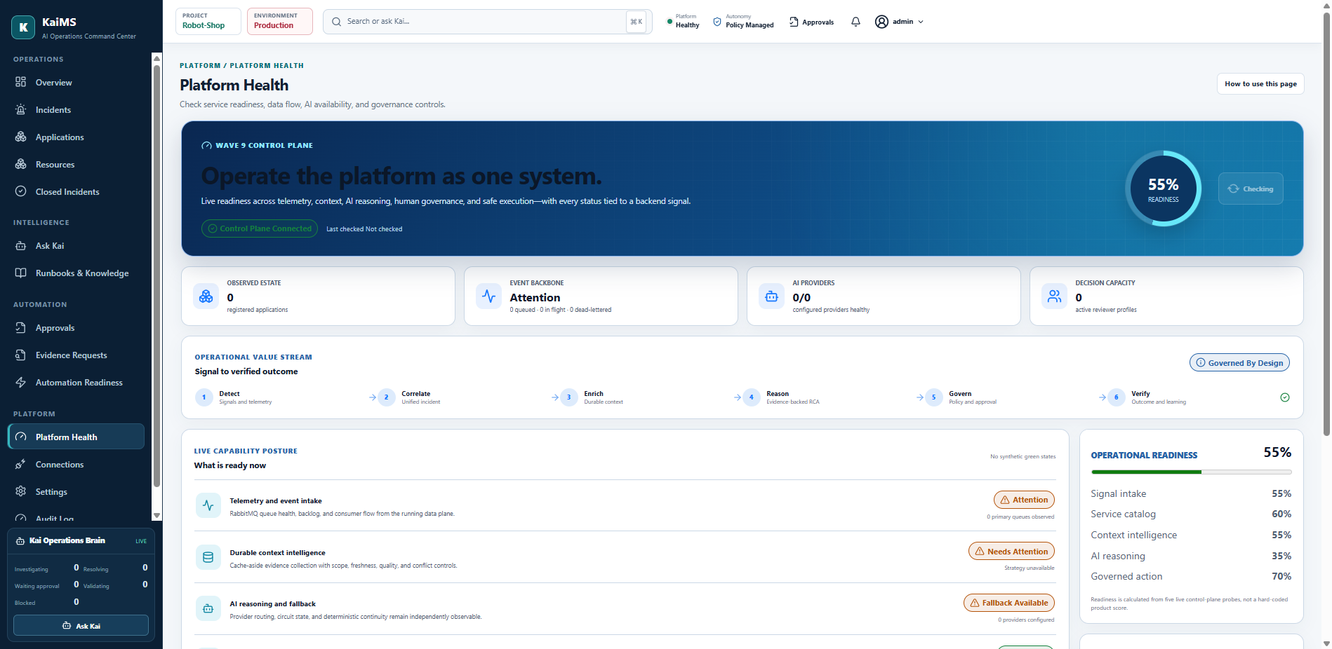
👉 WHERE TO CLICK & MOVE CURSOR
• Click 'Platform Health' under the Platform section in the sidebar.
• Hover across the service status cards, ingestion queues, and AI provider status.

🗣 WHAT TO SAY (Plain, Simple English)
"Under Platform, Platform Health gives administrators complete visibility into backend services, alert ingestion pipelines, and AI model availability. This guarantees our reasoning agents and safety rules are always active and running properly."

Exact On-Screen Words to Mention: Platform Health, Service readiness, AI availability, Governance controls

Scene 11: Connections & Enterprise Integrations
⏱ Timing: 2:24 – 2:36 (12 Seconds) | 📍 Screen: Connections (/cloud-ops/connections)
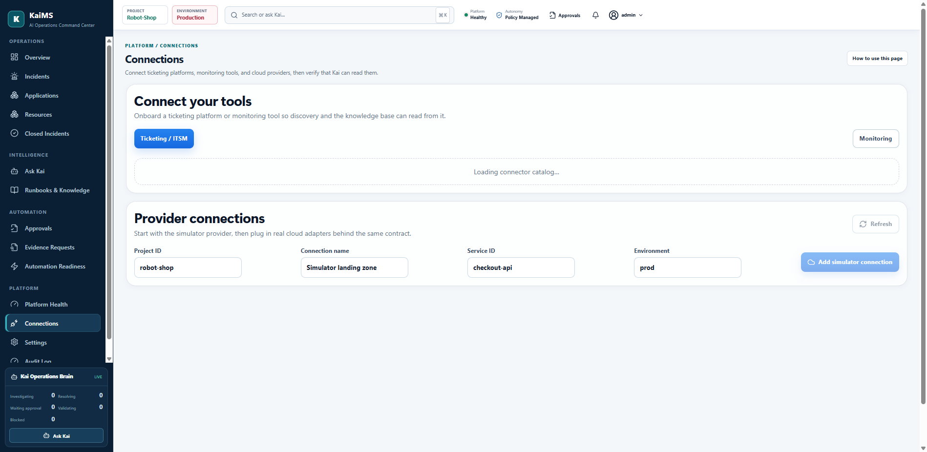
👉 WHERE TO CLICK & MOVE CURSOR
• Click 'Connections' in the sidebar.
• Point to the integration cards for Jira, ServiceNow, Prometheus, and Datadog.

🗣 WHAT TO SAY (Plain, Simple English)
"In Connections, KaiMS plugs directly into your existing infrastructure. With connectors for Jira, ServiceNow, Prometheus, Datadog, and Kubernetes, it receives alerts and syncs tickets automatically without changing your team's day-to-day tools."

Exact On-Screen Words to Mention: Connections, Jira, ServiceNow, Prometheus, Datadog

Scene 12: Automation Readiness Cockpit
⏱ Timing: 2:36 – 2:48 (12 Seconds) | 📍 Screen: Automation Readiness (/cloud-ops/cockpit)
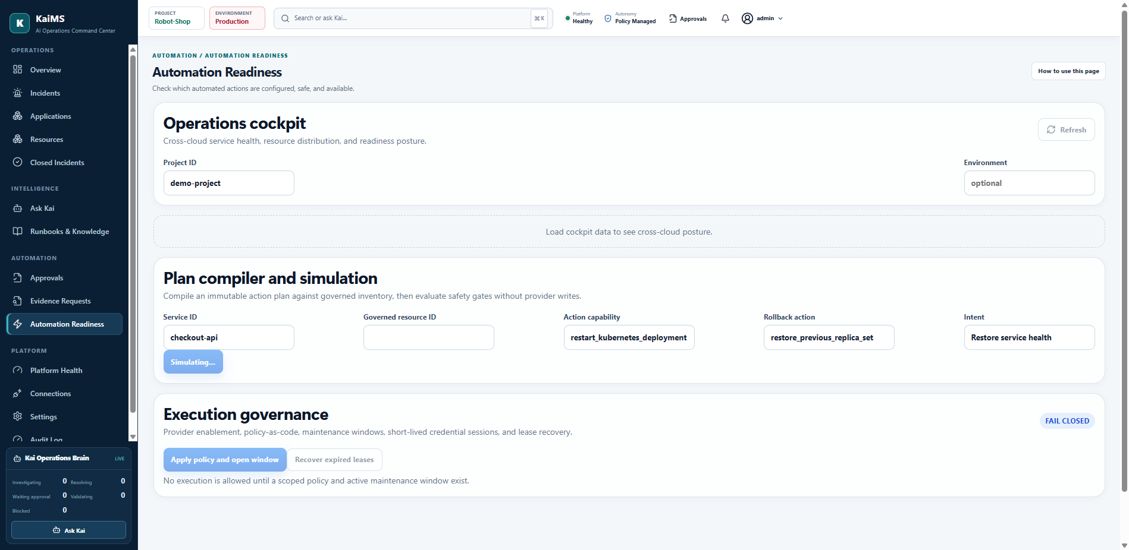
👉 WHERE TO CLICK & MOVE CURSOR
• Click 'Automation Readiness' under Automation in the sidebar.
• Hover over the playbook safety check matrix.

🗣 WHAT TO SAY (Plain, Simple English)
"In Automation Readiness, teams set safety boundaries for automated playbooks. You can verify connection health and decide exactly which actions can run automatically versus which ones require human approval."

Exact On-Screen Words to Mention: Automation Readiness, Capabilities, Safety policies, Execution

Scene 13: Immutable Audit Log, Closed Incidents & Wrap-Up
⏱ Timing: 2:48 – 3:00 (12 Seconds) | 📍 Screen: Audit Log (/audit) & Closed Incidents
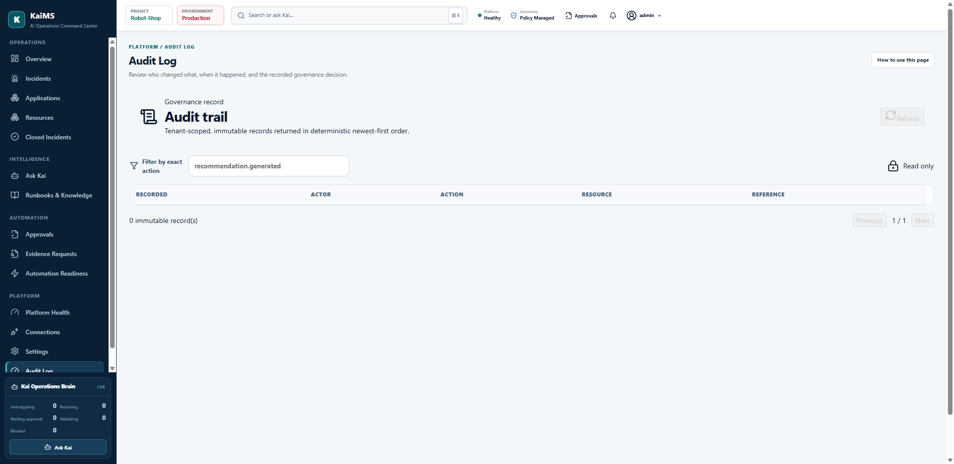
👉 WHERE TO CLICK & MOVE CURSOR
• Click 'Audit Log' in the sidebar.
• Scroll slightly to show the event table, then conclude the video with a smile.

🗣 WHAT TO SAY (Plain, Simple English)
"Finally, the Audit Log provides a tamper-proof record of every AI decision, operator approval, and remediation executed. Together with Closed Incidents, KaiMS gives you faster incident resolution, zero guesswork, and total human governance. Thank you!"

Exact On-Screen Words to Mention: Audit Log, Closed Incidents, Immutable compliance, Governed automation

3. Approval Workflow: Exactly What to Do
In the demo, you were specifically asked: 'for approval what do i need to do'. Here is the exact step-by-step checklist to follow during your recording:
Step 1: Navigate to Approvals
Click 'Approvals' in the left sidebar (under Automation), or click the green 'Review approvals' banner button at the top of the Overview page.

Step 2: Choose an Incident
In the 'Assigned decision queue', look at the summary cards showing the service name and risk level. Click 'Review packet →' on the card.

Step 3: Walk Through the Decision Packet
Scroll through the packet and point out:
• What happened: Brief explanation of the alert.
• Kai diagnosis: Root cause diagnosis and the AI confidence percentage.
• Affected resource & blast radius: What services are impacted.
• Proposed capability: The exact action Kai will take.
• Execution safety plan: Preconditions, validation check, and rollback plan.

Step 4: Explain Your 4 Choices as a Reviewer
Point your cursor to the bottom decision bar:
• 'Approve': (Green button) Signs the decision and triggers remediation immediately.
• 'Approve dry run': Runs safety checks without altering systems.
• 'Request more evidence': Prompts the agent or human to find missing context.
• 'Reject' / 'Modify': Rejects or customizes the plan with an operator note.

Step 5: Click 'Approve'
Click the 'Approve' button. Show the green banner: 'Immutable decision receipt recorded'. Explain that this receipt permanently records who approved it, the exact plan ID, and the timestamp.

