PROJECT DOCUMENTATION
FORESIGHT

AI-Powered Demand & Inventory Intelligence Platform
Project Documentation & Presentation

Demand Forecasting  XGBoost • 7-Day Forecast | Inventory Intelligence  Risk • Safety Stock • Reorder | Interactive Dashboard  Streamlit • Analytics
73,100 retail records | 100 Store–Product SKUs | 7-day forecast horizon

Contents
1. Abstract 3
Project at a glance 3
2. Introduction and Objectives 4
2.1 Background 4
2.2 Motivation 4
2.3 Problem Statement 4
2.4 Objectives 4
2.5 Scope of the Project 5
3. System Analysis 6
3.1 Existing System 6
3.2 Limitations of the Existing System 6
3.3 Proposed System 6
3.4 Advantages of the Proposed System 6
4. Technology Stack and Requirements 7
4.1 Technology Stack 7
4.2 System Requirements 7
5. Dataset and Data Preparation 8
5.1 Dataset Description 8
5.2 Data Preprocessing 8
5.3 Feature Engineering 8
6. Machine Learning Methodology 10
6.1 Modelling Approach 10
6.2 Chronological Train/Test Split 10
6.3 Random Forest Baseline 10
6.4 XGBoost Model 10
6.5 Model Evaluation 11
7. Demand Forecasting 12
7.1 Recursive Forecasting Process 12
7.2 Forecast Coverage and Validation 12
8. Inventory Intelligence and Simulation 13
8.1 Inventory Intelligence Layer 13
8.2 Safety Stock and Reorder Point 13
8.3 Stockout Risk Detection 13
8.4 Dynamic Inventory Simulation 14
9. System Architecture and Modules 15
9.1 Architecture 15
9.2 Module Description 15
10. Interactive Dashboard 16
10.1 Main Dashboard 16
10.2 Demand and Risk Analysis 16
10.3 Inventory and Recommendations 16
11. Results and Analysis 17
11.1 Observations 17
12. Advantages, Limitations, and Future Scope 18
12.1 Advantages 18
12.2 Limitations 18
12.3 Future Scope 18
13. Conclusion 19
References 19

1. Abstract
FORESIGHT is an AI-powered platform that combines short-term retail demand forecasting with inventory intelligence. The system analyzes historical sales and operational data, engineers time-series and business features, and uses XGBoost regression to forecast demand.
Forecasts are converted into safety-stock, reorder-point, stockout-risk, inventory-coverage, and recommended-order indicators. A seven-day recursive forecast is generated for 100 Store–Product combinations, followed by a scenario-based dynamic inventory simulation. An interactive Streamlit dashboard presents KPIs, demand trends, risk analysis, inventory coverage, and reorder recommendations.

Project at a glance
Dataset | 73,100 records, 15 variables, 2022-01-01 to 2024-01-01
Coverage | 5 stores × 20 products = 100 Store–Product combinations (SKUs)
Forecasting model | XGBoost regression pipeline (300 estimators), saved as xgboost_demand_model.pkl
Test performance | MAE 89.21 | RMSE 108.88 | WAPE 65.56% | SMAPE 72.19%
Forecast horizon | 7 days (2024-01-02 to 2024-01-08), 700 forecast records
Inventory assumptions | 3-day lead time, service factor 1.65
Interface | Interactive Streamlit dashboard with filters and CSV download

2. Introduction and Objectives

2.1 Background
Retail businesses must balance product availability with the cost and risk of holding excess inventory. Demand varies across products, stores, seasons, pricing conditions, promotions, and other business factors. Manual estimation and fixed reorder rules may not capture these changing patterns effectively.
FORESIGHT connects machine-learning demand prediction with inventory decision rules and interactive analytics.
How to read the inventory output
The future inventory output is treated as a scenario simulation based on explicit assumptions. It is not an actual procurement order.

2.2 Motivation
- Reduce dependence on manual demand estimation.
- Demonstrate a practical application of machine learning in retail analytics.
- Identify products requiring attention because of projected inventory pressure.
- Combine predictive analytics with business-oriented inventory rules.
- Provide an interactive interface for monitoring and analysis.
- Build an end-to-end analytical solution from raw data to decision-support output.

2.3 Problem Statement
Retail inventory planning requires reliable short-term demand estimates. Historical averages or fixed reorder levels may fail to reflect changing demand across Store–Product combinations. A demand forecast alone does not directly show when inventory may become insufficient.
The project therefore addresses the need for an integrated system that forecasts demand and converts predictions into stockout risk, reorder requirements, and projected inventory movement.

2.4 Objectives
- Analyze historical retail sales and inventory data.
- Preprocess data and create machine-learning-ready features.
- Engineer calendar, lag, rolling, categorical, and inventory-related variables.
- Develop and evaluate demand forecasting models.
- Use XGBoost for short-term demand prediction.
- Generate recursive seven-day forecasts for multiple SKUs.
- Calculate safety stock, reorder point, stockout risk, and recommended order quantity.
- Simulate inventory movement using a defined lead time.
- Present results through an interactive Streamlit dashboard.

2.5 Scope of the Project
The project covers:
- Historical retail demand and inventory analysis.
- Store–Product (SKU) level forecasting.
- Seven-day future demand forecasting.
- Inventory risk and reorder analysis.
- Scenario-based dynamic inventory simulation.
- Interactive dashboard and CSV output generation.
Out of scope
The current scope does not include live ERP integration, real purchase-order execution, or live external market feeds.

3. System Analysis

3.1 Existing System
Many basic inventory workflows rely on historical averages, spreadsheets, fixed reorder levels, or manually reviewed reports. Demand and inventory information may be analyzed separately, and risk identification can depend on manual thresholds and periodic review. Such approaches provide useful descriptive information but offer limited automated forecasting and scenario analysis.

3.2 Limitations of the Existing System
- Limited ability to model complex demand patterns.
- Manual processes can be time-consuming and inconsistent.
- Fixed reorder levels may not adapt to changing demand.
- Potential stockout conditions may be detected late.
- Forecasting and inventory analysis may remain disconnected.
- Limited interactive visualization for SKU-level decision support.

3.3 Proposed System
FORESIGHT integrates data preparation, feature engineering, machine learning, inventory intelligence, simulation, and visualization in a single workflow:
- Historical data is transformed into time-aware features and used to train and evaluate forecasting models.
- XGBoost generates recursive seven-day demand forecasts for 100 Store–Product combinations.
- Inventory rules use predicted demand and variability to calculate safety stock and reorder points.
- A dynamic simulation models inventory consumption and order arrivals using a three-day lead time.
- Streamlit provides an interactive dashboard for exploring the results.

3.4 Advantages of the Proposed System
- Combines prediction and inventory analytics in one workflow.
- Supports SKU-level demand forecasting.
- Uses chronological evaluation to respect time ordering.
- Provides explicit risk and reorder indicators.
- Enables scenario-based inventory simulation.
- Makes outputs accessible through an interactive dashboard.
- Produces reusable CSV outputs for further analysis.

4. Technology Stack and Requirements

4.1 Technology Stack
Table 1. Technologies used and their roles
Technology | Role in the project
Python | Data processing, feature engineering, model development, and simulation
Pandas / NumPy | Data manipulation and numerical processing
Scikit-learn | Preprocessing, pipelines, evaluation, and the Random Forest baseline
XGBoost | Gradient-boosted regression for demand forecasting
Joblib | Model persistence and loading
Streamlit | Interactive analytical dashboard
Plotly | Interactive visualizations
Google Colab / GPU | Model experimentation and forecasting workflow

4.2 System Requirements
Table 2. Minimum and recommended environment
Requirement | Specification
Operating system | Windows, Linux, or macOS
Python | Python 3.x environment
Memory | 8 GB RAM or more recommended for comfortable data processing
Network | Internet connection for package installation and optional cloud execution
Python libraries | pandas, numpy, scikit-learn, xgboost, joblib, streamlit, plotly
Browser | Chrome, Edge, Firefox, or another modern browser for the dashboard

5. Dataset and Data Preparation

5.1 Dataset Description
The project uses a retail store inventory dataset with daily records for every Store–Product combination. The target variable is Units Sold. Important business variables include inventory level, units ordered, price, discount, weather, holiday/promotion, competitor pricing, and seasonality.
Table 3. Dataset summary
Records | 73,100 original records
Variables | 15 columns
Date range | 2022-01-01 to 2024-01-01
Stores / products | 5 stores, 20 products, 100 Store–Product combinations
Categories / regions | 5 categories, 4 regions
Target variable | Units Sold

Avoiding target leakage
The original Demand Forecast field was excluded from the machine-learning features to avoid target leakage.

5.2 Data Preprocessing
- Date values were converted into a consistent datetime format.
- Data was ordered by Store, Product, and Date before time-series feature generation.
- Lag and rolling calculations were performed at Store–Product level.
- Rows with unavailable initial lag/rolling values were removed.
- The resulting machine-learning dataset contained 70,300 rows and 32 columns.
- Data-quality checks confirmed no duplicate Store–Product–Date records and correct daily sequencing.

5.3 Feature Engineering
Time-aware features give the model a memory of recent demand. Every lag and rolling value is calculated within a single Store–Product series, so no information from another SKU or from the future leaks into a prediction.
Table 4. Engineered features by group
Feature group | Features
Calendar | Year, Month, Day, DayOfWeek, WeekOfYear, Quarter, IsWeekend
Lag features | Lag_1, Lag_7, Lag_14, Lag_28
Rolling demand statistics | 7-, 14-, and 28-day means; 7- and 28-day standard deviations
Inventory and order history | Inventory_Lag_1, Units_Ordered_Lag_1
Categorical variables | Store ID, Product ID, Category, Region

Feature engineering was audited, and the lag and rolling calculations matched the Store–Product grouping.

6. Machine Learning Methodology

6.1 Modelling Approach
- Target: Units Sold.
- Categorical variables were one-hot encoded with an encoder configured to ignore unknown categories.
- Numerical features were passed through the preprocessing pipeline unchanged.
- Models: Random Forest as a baseline and XGBoost as the main forecasting model.

6.2 Chronological Train/Test Split
Because demand is a time series, the data was split by date rather than at random. Training uses the earlier 80% of dates and testing uses the most recent 20%, so evaluation reflects genuine forecasting of unseen future periods. The training set contains 56,200 rows (2022-01-29 to 2023-08-13) and the test set 14,100 rows (2023-08-14 to 2024-01-01).
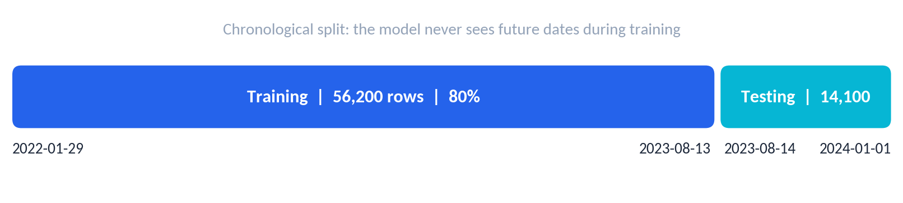
Figure 1. Chronological split date: 2023-08-14

6.3 Random Forest Baseline
A RandomForestRegressor with 150 trees, a maximum depth of 20, and a minimum split size of 5 provided a reference point for evaluating the boosted-tree model. Its test results were MAE 89.44, RMSE 108.60, WAPE 65.73%, and SMAPE 72.24%.

6.4 XGBoost Model
The main forecasting model is an XGBRegressor inside a scikit-learn pipeline. The trained pipeline was saved as xgboost_demand_model.pkl so that it can be reused without retraining.
Table 5. XGBoost hyperparameters
Parameter | Value | Parameter | Value
Number of estimators | 300 | Learning rate | 0.05
Maximum depth | 6 | Minimum child weight | 3
Row subsample | 0.8 | Column sampling (per tree) | 0.8
The training objective is squared-error regression.

6.5 Model Evaluation
Both tree-based models were evaluated on the held-out test period. The table also includes a naive reference that simply repeats the previous day's units sold, which any useful model should beat.
Table 6. Test-set performance (lower is better)
Model | MAE | RMSE | WAPE | SMAPE
Naive forecast (previous day)* | 119.66 | 153.30 | 87.94% | 93.10%
Random Forest (baseline) | 89.44 | 108.60 | 65.73% | 72.24%
XGBoost (main model) | 89.21 | 108.88 | 65.56% | 72.19%
* Naive reference computed on the same test period from the project notebook (Lag_1 as the prediction).
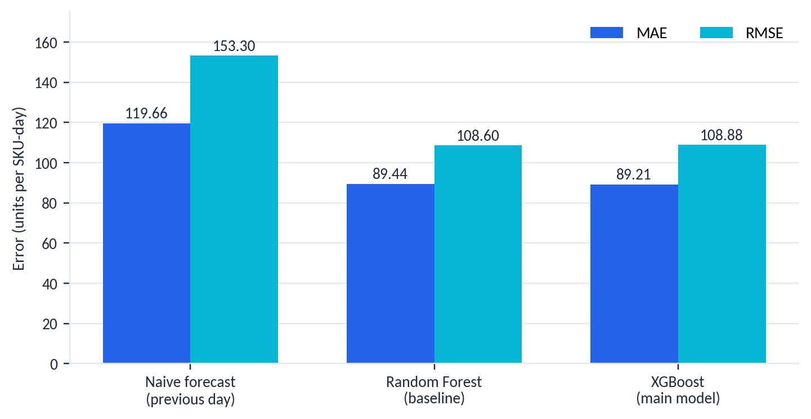
Figure 2. MAE and RMSE by model on the test period
Both machine-learning models reduce error by roughly 25% relative to the naive reference. XGBoost has the lowest MAE, WAPE, and SMAPE, while Random Forest has a marginally lower RMSE; the two models perform very similarly. XGBoost was retained as the main model and its saved pipeline drives the forecasting and dashboard workflow.
Choice of metrics
MAPE was not treated as the primary metric because the dataset contains very small and near-zero actual demand values, which can make percentage error extremely unstable. WAPE and SMAPE are reported instead.
Feature-engineering, leakage, chronological-split, and target-alignment audits were completed successfully.

7. Demand Forecasting
The trained XGBoost pipeline was validated by loading the saved model and reproducing sample predictions. A recursive seven-day forecasting process was then implemented for every Store–Product combination.

7.1 Recursive Forecasting Process
The model predicts one day ahead, so a multi-day forecast feeds each prediction back into the history used for the next day:
- Start from the most recent actual demand history of the Store–Product series.
- Build the calendar, lag, and rolling features for the next date.
- Predict that day's demand with the XGBoost pipeline.
- Append the prediction to the history and repeat for the following day, up to seven days.

7.2 Forecast Coverage and Validation
Table 7. Forecast output summary
Forecast period | 2024-01-02 to 2024-01-08
Coverage | 100 Store–Product combinations × 7 days = 700 forecast records
Feature updates | Future lag and rolling features are updated recursively from previous actual and predicted demand values
Validation | Predictions were checked for missing and negative values

Recursive forecast accuracy
Each predicted day becomes an input to the next, so uncertainty accumulates with the forecast horizon. This is why the horizon is kept short (seven days).

8. Inventory Intelligence and Simulation

8.1 Inventory Intelligence Layer
Predicted demand is combined with recent demand statistics and inventory information to produce operationally interpretable indicators:
- Demand trend is classified as Increasing, Stable, or Decreasing by comparing the forecast with the recent 7-day average (a change of more than 10% in either direction).
- Demand variability is represented by the rolling standard deviation of demand.
- Inventory coverage is estimated from inventory relative to predicted demand.
- Stockout and reorder indicators convert model output into decisions.

8.2 Safety Stock and Reorder Point
Safety Stock
Safety Stock = Demand Variability × Service Factor
Reorder Point
Reorder Point = Predicted Demand × Lead Time + Safety Stock
Table 8. Parameters used in the implemented scenario
Parameter | Value | Note
Service factor | 1.65 | Multiplier applied to demand variability
Lead time | 3 days | Used in the dynamic simulation

These are project assumptions and can be changed for different business scenarios. The recommended order quantity is based on the gap between the reorder requirement and the projected inventory position.

8.3 Stockout Risk Detection
Stockout risk is derived from projected inventory conditions relative to forecasted demand and reorder requirements. Risk levels are LOW, MEDIUM, and HIGH, and the overall status is escalated when the projected inventory position indicates a more serious stockout condition.
Table 9. Risk classification rules in the final simulation
Risk level | Condition
HIGH | Projected inventory after the day's demand is zero or below (overall status: STOCKOUT)
MEDIUM | Inventory before demand is below the reorder point, or coverage is less than one day
LOW | Neither condition applies
In the final seven-day simulation, 283 records were LOW, 264 were MEDIUM, and 153 were HIGH. The labels are rule-based outputs built on top of model forecasts and inventory assumptions.
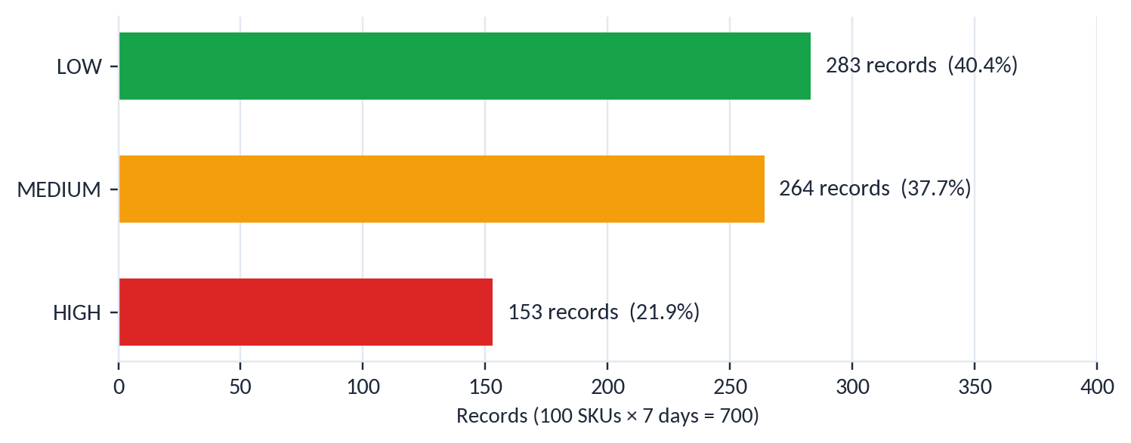
Figure 3. Stockout risk distribution across the 700 simulation records

8.4 Dynamic Inventory Simulation
- The simulation starts from the latest available inventory position.
- Forecasted demand is consumed from opening inventory each day.
- Reorder quantities are generated when projected inventory falls below the reorder point.
- Orders arrive after the defined three-day lead time.
- The simulation covers 700 records across 100 Store–Product combinations and seven forecast days.
Modelling assumption
The current implementation can represent negative inventory as unmet demand or backorder. This is a modelling assumption rather than a claim of physical stock.

9. System Architecture and Modules

9.1 Architecture
The architecture separates data preparation, forecasting, inventory logic, simulation, and visualization. The trained model is persisted and reused for future forecasting, and CSV outputs provide a simple interface between the forecasting/simulation workflow and the dashboard.
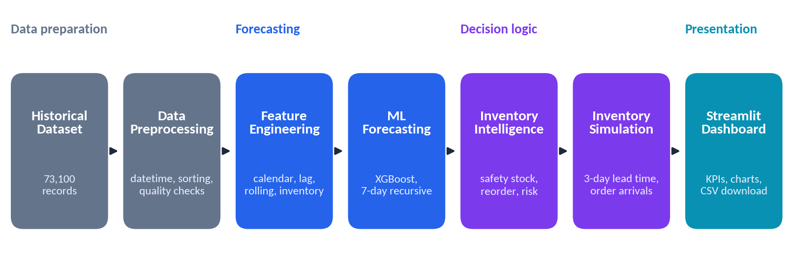
Figure 4. FORESIGHT system architecture

9.2 Module Description
Table 10. System modules and responsibilities
No. | Module | Responsibility
1 | Data Management | Loads and validates historical retail data
2 | Preprocessing & Feature Engineering | Creates time-series and business features
3 | Forecasting | Trains/loads models and produces demand predictions
4 | Inventory Intelligence | Calculates safety stock, reorder point, coverage, and risk
5 | Simulation | Models projected inventory and order arrivals
6 | Dashboard | Presents KPIs, charts, filters, recommendations, and downloads

10. Interactive Dashboard
The Streamlit dashboard turns the forecast and simulation outputs into filterable, visual decision-support information. It provides:
- Professional KPI cards summarizing the forecast and inventory position.
- Date, store, product, category, and region filters.
- Demand and risk charts.
- Inventory coverage analysis.
- AI recommendations and CSV download.

10.1 Main Dashboard
Screenshot placeholder
Insert the main Streamlit dashboard screenshot here.
Figure 5. Main Streamlit dashboard

10.2 Demand and Risk Analysis
This view shows actual versus predicted demand, the forecast difference, the stockout risk distribution, and the overall risk distribution.
Screenshot placeholder
Insert a screenshot of the demand chart and risk distribution here.
Figure 6. Demand chart and risk distribution

10.3 Inventory and Recommendations
This view presents inventory coverage, store-level inventory versus demand, the priority reorder table, and product intelligence.
Screenshot placeholder
Insert a screenshot of inventory coverage and reorder recommendations here.
Figure 7. Inventory coverage and reorder recommendations

11. Results and Analysis
The final forecasting workflow covers 100 Store–Product combinations over seven future days. The dashboard converts the outputs below into visual and filterable decision-support information.
Table 11. Key results
Measure | Value
Original dataset records | 73,100
Engineered ML dataset records | 70,300
Forecast records (100 SKUs × 7 days) | 700
Total predicted demand | 97,836.15 units
Average predicted daily demand | 139.77 units
Total recommended order quantity | 226,557 units
Total projected stockout quantity | 23,431.6 units
Average days of cover | 3.74 days

11.1 Observations
- About 22% of simulation records (153 of 700) are classified HIGH risk and about 38% MEDIUM, while roughly 40% are LOW.
- The recommended order quantity (226,557 units) is more than twice the predicted demand (97,836 units). This is consistent with the limitation noted in Section 12.2: under the simple reorder rule, further orders can be triggered before earlier orders arrive.
- The projected stockout quantity represents unmet demand under the simulation assumptions, not physical stock.
Screenshot placeholder
Insert a screenshot of the final forecast CSV, notebook output, or simulation results here.
Figure 8. Final forecast / simulation output

12. Advantages, Limitations, and Future Scope

12.1 Advantages
- End-to-end workflow from raw data to inventory intelligence.
- Uses machine learning rather than only fixed historical averages.
- Supports recursive multi-SKU forecasting.
- Provides interpretable inventory indicators.
- Interactive dashboard improves accessibility of analytical results.
- Reusable saved model avoids retraining for every dashboard session.
- Modular design allows future improvements to forecasting and inventory logic.

12.2 Limitations
- The dataset is structured and synthetic-looking and may not represent every real-world retail condition.
- The current model does not include live external demand signals.
- Future inventory values depend on assumptions such as lead time and service factor.
- The simulation may represent unmet demand as negative inventory rather than modelling backorders separately.
- Multiple replenishment orders can be triggered before earlier orders arrive under the simple reorder rule.
- The dashboard is a decision-support prototype and does not execute real procurement transactions.

12.3 Future Scope
- Integrate real ERP, POS, warehouse, and procurement data.
- Add live external signals such as weather, events, competitor pricing, and market trends.
- Evaluate advanced time-series and deep-learning models such as LSTM, Temporal Fusion Transformer, or other forecasting approaches.
- Add probabilistic forecasting and prediction intervals.
- Improve replenishment logic using order pipelines, minimum order quantities, supplier constraints, and service-level optimization.
- Separate physical inventory, unmet demand, and backorders explicitly.
- Add role-based dashboard access and cloud deployment.
- Introduce automated alerts for high-risk SKUs.

13. Conclusion
FORESIGHT demonstrates how machine learning can be integrated with inventory-management logic to support retail decision-making. The project implements data preparation, feature engineering, model evaluation, XGBoost demand forecasting, inventory intelligence, dynamic simulation, and interactive visualization.
The seven-day forecasting workflow provides SKU-level demand estimates for 100 Store–Product combinations. The inventory layer translates those forecasts into safety stock, reorder points, stockout risk, and recommended order quantities, and the Streamlit dashboard provides a practical interface for exploring them.
The system provides a strong foundation for future integration with real operational systems and more advanced forecasting and replenishment methods.

References
[1] Chen, T. & Guestrin, C. (2016). XGBoost: A Scalable Tree Boosting System. Proceedings of the 22nd ACM SIGKDD International Conference on Knowledge Discovery and Data Mining.
[2] Pedregosa, F. et al. (2011). Scikit-learn: Machine Learning in Python. Journal of Machine Learning Research, 12, 2825–2830.
[3] McKinney, W. (2010). Data Structures for Statistical Computing in Python. Proceedings of the 9th Python in Science Conference.
[4] Harris, C. R. et al. (2020). Array programming with NumPy. Nature, 585, 357–362.
[5] Streamlit Documentation. Streamlit — A faster way to build and share data apps.
[6] XGBoost Documentation. XGBoost Python API and User Documentation.
[7] Pandas Documentation. Pandas User Guide and API Reference.

