NAAC A++
Ph.: 07104-237919, 234623, 329249, 329250 Fax: 07104-232376, Website: www.ycce.edu

Department of Computer Technology
Vision Statement of the Department.
To be a preferred hub for nurturing computer engineering aspirants through innovative, ethical, value-based technical education, impactful research, and industry collaboration, to become successful professionals contributing for the betterment of society.
Mission Statement of the Department.
To nurture computer engineering professionals by offering Dynamic learning environment that encourages problem-solving using emerging technology, National Education Policy aligned evidence-based technical education, fostering ,innovation, research, and industry–institute collaboration & Holistic, ethical and sustainable development for lifelong success.

Session 2026-2027

Vision:Dream of where you want. | Mission: Means to achieve Vision

Program Educational Objectives of the program (PEO): (broad statements that describe the professional and career accomplishments)
PEO1 | Preparation | P: Preparation | Pep-CL abbreviation
PEO2 | Core Competence | E: Environment (Learning Environment) | pronounce as Pep-si-lL easy to recall
PEO3 | Breadth | P: Professionalism | pronounce as Pep-si-lL easy to recall
PEO4 | Professionalism | C: Core Competence | pronounce as Pep-si-lL easy to recall
PEO5 | Learning Environment | L: Breadth (Learning in diverse areas) | pronounce as Pep-si-lL easy to recall

Program Outcomes (PO): (statements that describe what a student should be able to do and know by the end of a program)

Keywords of POs:
Engineering knowledge,Problem analysis, Design/development of solutions,Conduct Investigations of Complex Problems, Engineering Tool Usage, The Engineer and The World,Ethics, Individual and Collaborative Team work,Communication, Project Management and Finance, Life-Long Learning

PSO Keywords: Cutting edge technologies, Research

“I am an engineer, and I know how to apply engineering knowledge to investigate, analyse and design solutions to complex problems using tools for entire world following all ethics in a collaborative way with proper management skills throughout my life.” to contribute to the development of cutting-edge technologies and Research.

Integrity: I will adhere to the Laboratory Code of Conduct and ethics in its entirety.

Name and Signature of Student and Date
(Signature and Date in Handwritten)

NAAC A++
Ph.: 07104-237919, 234623, 329249, 329250 Fax: 07104-232376, Website: www.ycce.edu

Department of Computer Technology
Vision Statement of the Department.

To be a preferred hub for nurturing computer engineering aspirants through innovative, ethical, value-based technical education, impactful research, and industry collaboration, to become successful professionals contributing for the betterment of society.
Mission Statement of the Department.
To nurture computer engineering professionals by offering Dynamic learning environment that encourages problem-solving using emerging technology, National Education Policy aligned evidence-based technical education, fostering ,innovation, research, and industry–institute collaboration & Holistic, ethical and sustainable development for lifelong success.

Session | 2024-25 (ODD) | Course Name | Web Technology Lab
Semester | 3 | Course Code | 23CT1301
Roll No | 32 | Name of Student | Arati Lod

Practical Number | 04-A
Course Outcome | - Understand various internet technologies.  - Design the web pages using HTML and CSS.  - Implement the XML technology to store the data.  - Develop the interactive web pages using JavaScript.
Aim | A. Introduction to JavaScript (Loop, Conditional Statement) and Form Validation.  Sample Problem Statement: Build a registration form (name, email, password, phone  number) and write JavaScript to validate all fields on submit, displaying inline error  messages
Problem Definition | To develop a registration form using HTML and use JavaScript conditional statements, loops, and form validation to validate fields such as name, email, password, and phone number, displaying appropriate error messages for invalid inputs.

NAAC A++
Ph.: 07104-237919, 234623, 329249, 329250 Fax: 07104-232376, Website: www.ycce.edu

Department of Computer Technology
Vision Statement of the Department.
Theory  (100 words) | Theory — JavaScript Loops, Conditional Statements & Form Validation  JavaScript is a scripting language used to create interactive and dynamic web pages. Conditional statements such as if, else if, and else are used to check whether input values meet specific requirements. Loops, such as for and while, can be used to repeatedly process or validate multiple form fields.  Form validation ensures that users enter correct and complete information before submission. In a registration form, JavaScript can validate the name, email, password, and phone number using conditions and regular expressions. The addEventListener() method can detect form submission, while DOM methods display inline error messages. This improves data accuracy and user experience.
Procedure and Execution (100 Words) | Step for Implementation:  - Create a registration form with fields for name, email, password, and phone number.  - Write JavaScript functions using conditional statements and loops.  - Validate each field when the form is submitted.  - Display inline error messages for invalid or empty fields.  5. If all inputs are valid, allow the form to be submitted.

NAAC A++
Ph.: 07104-237919, 234623, 329249, 329250 Fax: 07104-232376, Website: www.ycce.edu

Department of Computer Technology
Vision Statement of the Department.
Code:

NAAC A++
Ph.: 07104-237919, 234623, 329249, 329250 Fax: 07104-232376, Website: www.ycce.edu

Department of Computer Technology
Vision Statement of the Department.
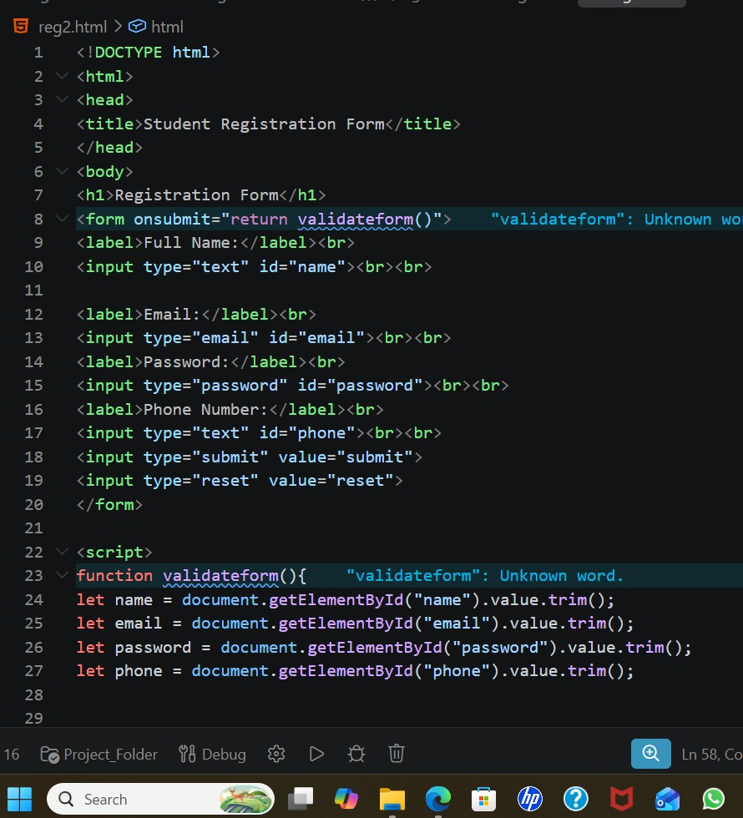

NAAC A++
Ph.: 07104-237919, 234623, 329249, 329250 Fax: 07104-232376, Website: www.ycce.edu

Department of Computer Technology
Vision Statement of the Department.
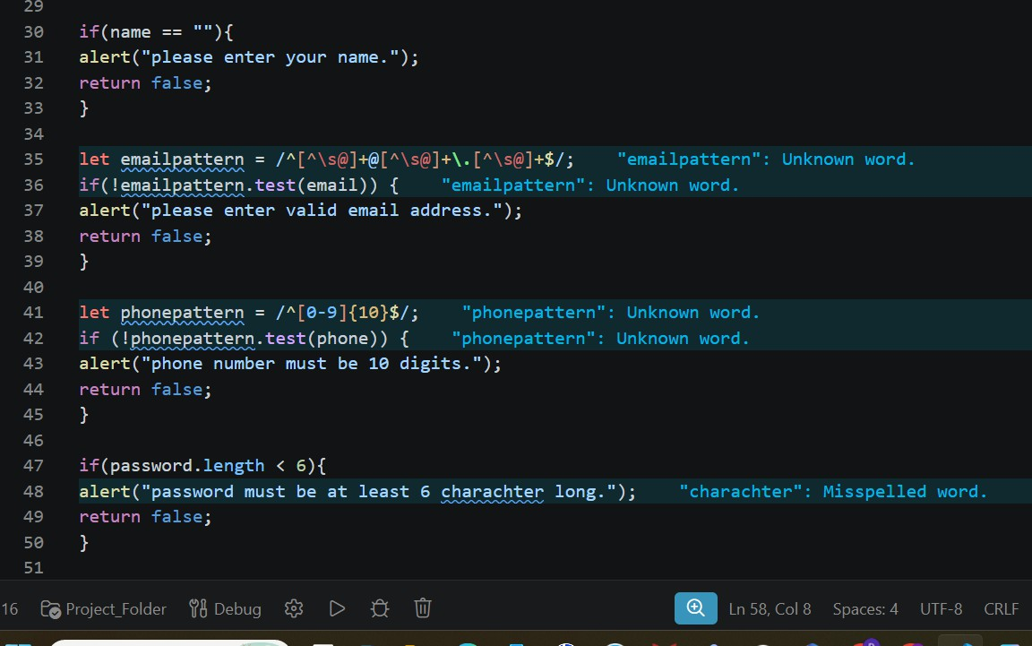

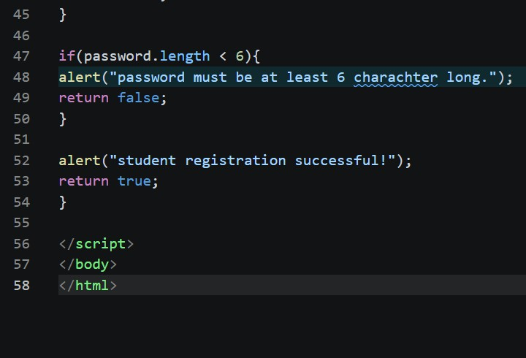

NAAC A++
Ph.: 07104-237919, 234623, 329249, 329250 Fax: 07104-232376, Website: www.ycce.edu

Department of Computer Technology
Vision Statement of the Department.
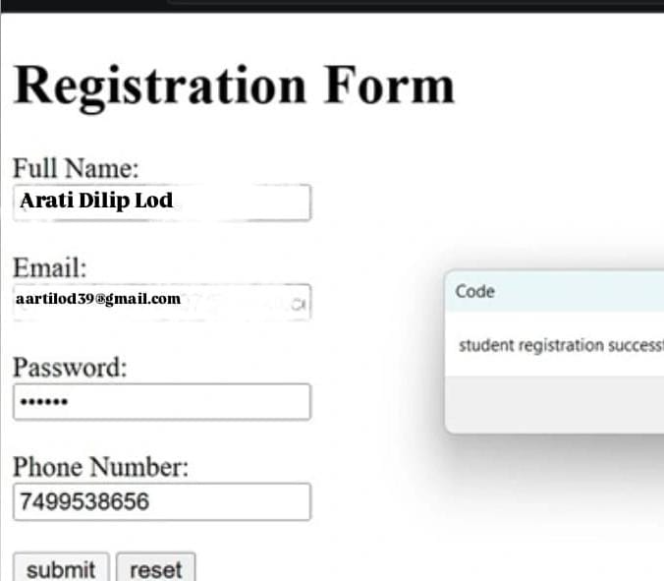

Output:
Output Analysis | The experiment successfully demonstrates the use of JavaScript loops, conditional statements, and form validation to create a user-friendly and validated registration form.
Link of student Github profile  where lab assignment has been  uploaded | https://github.com/aratilod/Web-Technology-Practicals
Conclusion | The registration form is successfully displayed and JavaScript validates the entered details. Appropriate inline error messages are shown for invalid inputs, while valid inputs are accepted.
Plag Report (Similarity index < 12%)
Date | 03-08-2026

