NAAC A++
Ph.: 07104-237919, 234623, 329249, 329250 Fax: 07104-232376, Website: www.ycce.edu

Department of Computer Technology
Vision Statement of the Department.
To be a preferred hub for nurturing computer engineering aspirants through innovative, ethical, value-based technical education, impactful research, and industry collaboration, to become successful professionals contributing for the betterment of society.
Mission Statement of the Department.
To nurture computer engineering professionals by offering Dynamic learning environment that encourages problem-solving using emerging technology, National Education Policy aligned evidence-based technical education, fostering ,innovation, research, and industry–institute collaboration & Holistic, ethical and sustainable development for lifelong success.

Session 2026-2027

Vision:Dream of where you want. | Mission: Means to achieve Vision

Program Educational Objectives of the program (PEO): (broad statements that describe the professional and career accomplishments)
PEO1 | Preparation | P: Preparation | Pep-CL abbreviation
PEO2 | Core Competence | E: Environment (Learning Environment) | pronounce as Pep-si-lL easy to recall
PEO3 | Breadth | P: Professionalism | pronounce as Pep-si-lL easy to recall
PEO4 | Professionalism | C: Core Competence | pronounce as Pep-si-lL easy to recall
PEO5 | Learning Environment | L: Breadth (Learning in diverse areas) | pronounce as Pep-si-lL easy to recall

Program Outcomes (PO): (statements that describe what a student should be able to do and know by the end of a program)

Keywords of POs:
Engineering knowledge,Problem analysis, Design/development of solutions,Conduct Investigations of Complex Problems, Engineering Tool Usage, The Engineer and The World,Ethics, Individual and Collaborative Team work,Communication, Project Management and Finance, Life-Long Learning

PSO Keywords: Cutting edge technologies, Research

“I am an engineer, and I know how to apply engineering knowledge to investigate, analyse and design solutions to complex problems using tools for entire world following all ethics in a collaborative way with proper management skills throughout my life.” to contribute to the development of cutting-edge technologies and Research.

Integrity: I will adhere to the Laboratory Code of Conduct and ethics in its entirety.

Name and Signature of Student and Date
(Signature and Date in Handwritten)

NAAC A++
Ph.: 07104-237919, 234623, 329249, 329250 Fax: 07104-232376, Website: www.ycce.edu

Department of Computer Technology
Vision Statement of the Department.

To be a preferred hub for nurturing computer engineering aspirants through innovative, ethical, value-based technical education, impactful research, and industry collaboration, to become successful professionals contributing for the betterment of society.
Mission Statement of the Department.
To nurture computer engineering professionals by offering Dynamic learning environment that encourages problem-solving using emerging technology, National Education Policy aligned evidence-based technical education, fostering ,innovation, research, and industry–institute collaboration & Holistic, ethical and sustainable development for lifelong success.

Session | 2024-25 (ODD) | Course Name | Web Technology Lab
Semester | 3 | Course Code | 23CT1301
Roll No | 32 | Name of Student | Arati Dilip Lod

Practical Number | 01-B
Course Outcome | - Understand various internet technologies.  - Design the web pages using HTML and CSS.  - Implement the XML technology to store the data.  - Develop the interactive web pages using JavaScript.
Aim | [B] Study HTML Tags and to implement basic Web page.
Problem Definition | To study basic HTML tags and implement a simple web page using headings, paragraphs, images, links, lists, and other basic HTML elements.

NAAC A++
Ph.: 07104-237919, 234623, 329249, 329250 Fax: 07104-232376, Website: www.ycce.edu

Department of Computer Technology
Vision Statement of the Department.
Theory  (100 words) | HTML stands for Hyper Text Markup Language. It creates a complete website structure of web pages.  HTML is a combination of Hypertext and Markup language. Hypertext defines the link between the web pages and markup language defines the text document within the tag. This HTML Tutorial provides basic  to advanced concepts for beginners and professionals. HTML is a markup language used by the browser to manipulate text, images, and other content, in order to display it in the required format. HTML was created by Tim Berners-Lee in 1991. The first-ever version of HTML was HTML 1.0, but the first standard version was  HTML 2.0, published in 1995.
Procedure and Execution (100 Words) | Step for Implementation:  - Open a text editor and create an HTML file.  - Write the basic HTML structure using tags.  - Add headings, paragraphs, images, links, and lists.  - Save the file with .html extension.  - Open it in a web browser and verify the output.

NAAC A++
Ph.: 07104-237919, 234623, 329249, 329250 Fax: 07104-232376, Website: www.ycce.edu

Department of Computer Technology
Vision Statement of the Department.
Code | 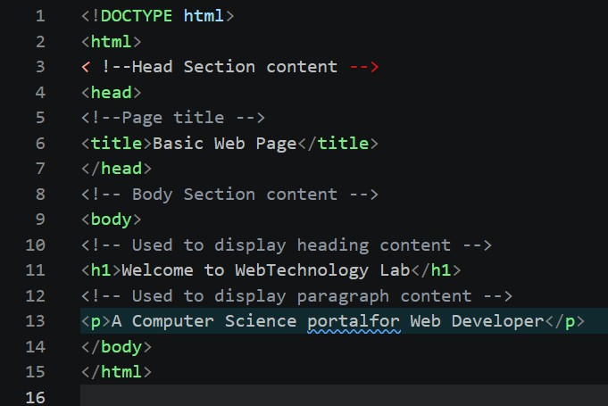
Code | Output: 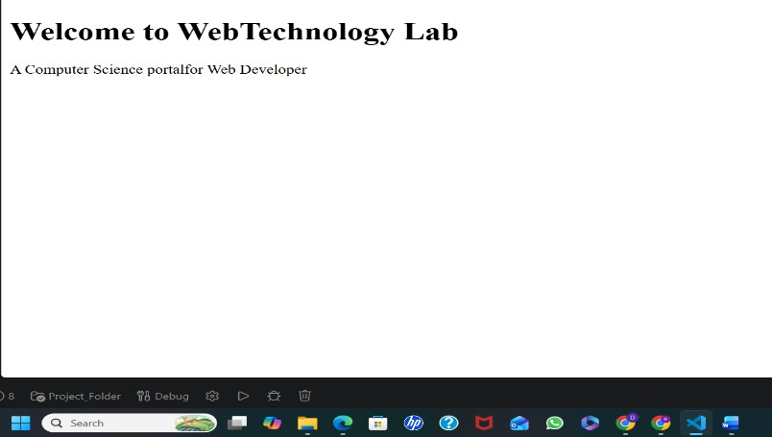
Output Analysis | The HTML program successfully creates and displays a basic web page in the browser using different HTML tags such as headings, paragraphs, images, links, and lists.
Link of student Github profile where lab assignment has been uploaded | https://github.com/aratilod/Web-Technology-Practicals

NAAC A++
Ph.: 07104-237919, 234623, 329249, 329250 Fax: 07104-232376, Website: www.ycce.edu

Department of Computer Technology
Vision Statement of the Department.
Conclusion | Thus we have successfully studied and executed various tags in html
Plag Report (Similarity index < 12%)
Date | 06-07-2026

