NAAC A++
Ph.: 07104-237919, 234623, 329249, 329250 Fax: 07104-232376, Website: www.ycce.edu

Department of Computer Technology
Vision Statement of the Department.
To be a preferred hub for nurturing computer engineering aspirants through innovative, ethical, value-based technical education, impactful research, and industry collaboration, to become successful professionals contributing for the betterment of society.
Mission Statement of the Department.
To nurture computer engineering professionals by offering Dynamic learning environment that encourages problem-solving using emerging technology, National Education Policy aligned evidence-based technical education, fostering ,innovation, research, and industry–institute collaboration & Holistic, ethical and sustainable development for lifelong success.

Session 2026-2027

Vision:Dream of where you want. | Mission: Means to achieve Vision

Program Educational Objectives of the program (PEO): (broad statements that describe the professional and career accomplishments)
PEO1 | Preparation | P: Preparation | Pep-CL abbreviation
PEO2 | Core Competence | E: Environment (Learning Environment) | pronounce as Pep-si-lL easy to recall
PEO3 | Breadth | P: Professionalism | pronounce as Pep-si-lL easy to recall
PEO4 | Professionalism | C: Core Competence | pronounce as Pep-si-lL easy to recall
PEO5 | Learning Environment | L: Breadth (Learning in diverse areas) | pronounce as Pep-si-lL easy to recall

Program Outcomes (PO): (statements that describe what a student should be able to do and know by the end of a program)

Keywords of POs:
Engineering knowledge,Problem analysis, Design/development of solutions,Conduct Investigations of Complex Problems, Engineering Tool Usage, The Engineer and The World,Ethics, Individual and Collaborative Team work,Communication, Project Management and Finance, Life-Long Learning

PSO Keywords: Cutting edge technologies, Research

“I am an engineer, and I know how to apply engineering knowledge to investigate, analyse and design solutions to complex problems using tools for entire world following all ethics in a collaborative way with proper management skills throughout my life.” to contribute to the development of cutting-edge technologies and Research.

Integrity: I will adhere to the Laboratory Code of Conduct and ethics in its entirety.

Name and Signature of Student and Date
(Signature and Date in Handwritten)

NAAC A++
Ph.: 07104-237919, 234623, 329249, 329250 Fax: 07104-232376, Website: www.ycce.edu

Department of Computer Technology
Vision Statement of the Department.

To be a preferred hub for nurturing computer engineering aspirants through innovative, ethical, value-based technical education, impactful research, and industry collaboration, to become successful professionals contributing for the betterment of society.
Mission Statement of the Department.
To nurture computer engineering professionals by offering Dynamic learning environment that encourages problem-solving using emerging technology, National Education Policy aligned evidence-based technical education, fostering ,innovation, research, and industry–institute collaboration & Holistic, ethical and sustainable development for lifelong success.

Session | 2024-25 (ODD) | Course Name | Web Technology Lab
Semester | 3 | Course Code | 23CT1301
Roll No | 32 | Name of Student | Arati Lod

Practical Number | 03
Course Outcome | - Understand various internet technologies.  - Design the web pages using HTML and CSS.  - Implement the XML technology to store the data.  - Develop the interactive web pages using JavaScript.
Aim | Develop and demonstrate the usage of inline, internal and external style sheet using CSS.
Problem Definition | To develop and demonstrate a web page using CSS (Cascading Style Sheets) by applying inline, internal, and external style sheets. The objective is to understand how each CSS method is used to control the appearance, layout, colors, fonts, and overall presentation of HTML elements.

NAAC A++
Ph.: 07104-237919, 234623, 329249, 329250 Fax: 07104-232376, Website: www.ycce.edu

Department of Computer Technology
Vision Statement of the Department.
Theory  (100 words) | 2. Internal CSS:  Internal CSS is written inside the <style> tag in the <head> section of an HTML document. It allows us to apply common styling to multiple elements on a single webpage. It is suitable when a webpage has its own specific design.
Procedure and Execution (100 Words) | Step for Implementation:  - Create an HTML file with the basic web page structure.  - Apply inline CSS using the style attribute.  - Apply internal CSS using the <style> tag inside  <head>.  - Create a separate external CSS file and link it using the <link> tag.  5. Open the HTML file in a browser and verify the  different styles.

NAAC A++
Ph.: 07104-237919, 234623, 329249, 329250 Fax: 07104-232376, Website: www.ycce.edu

Department of Computer Technology
Vision Statement of the Department.
Code:-INTERNA L CSS | 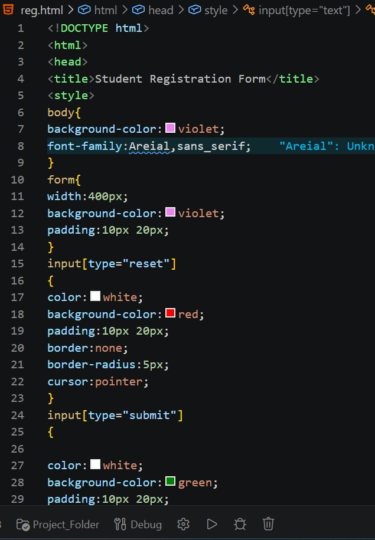

NAAC A++
Ph.: 07104-237919, 234623, 329249, 329250 Fax: 07104-232376, Website: www.ycce.edu

Department of Computer Technology
Vision Statement of the Department.
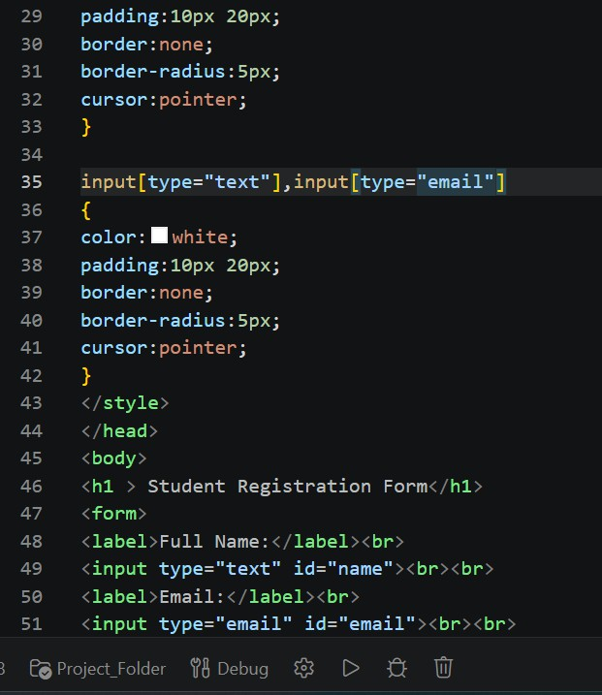

NAAC A++
Ph.: 07104-237919, 234623, 329249, 329250 Fax: 07104-232376, Website: www.ycce.edu

Department of Computer Technology
Vision Statement of the Department.
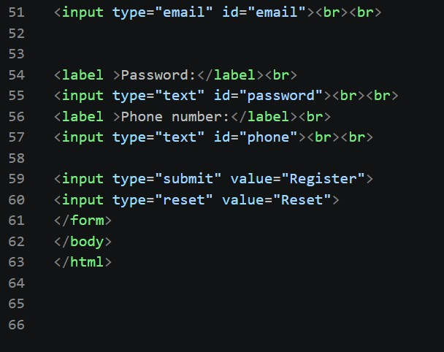
Output

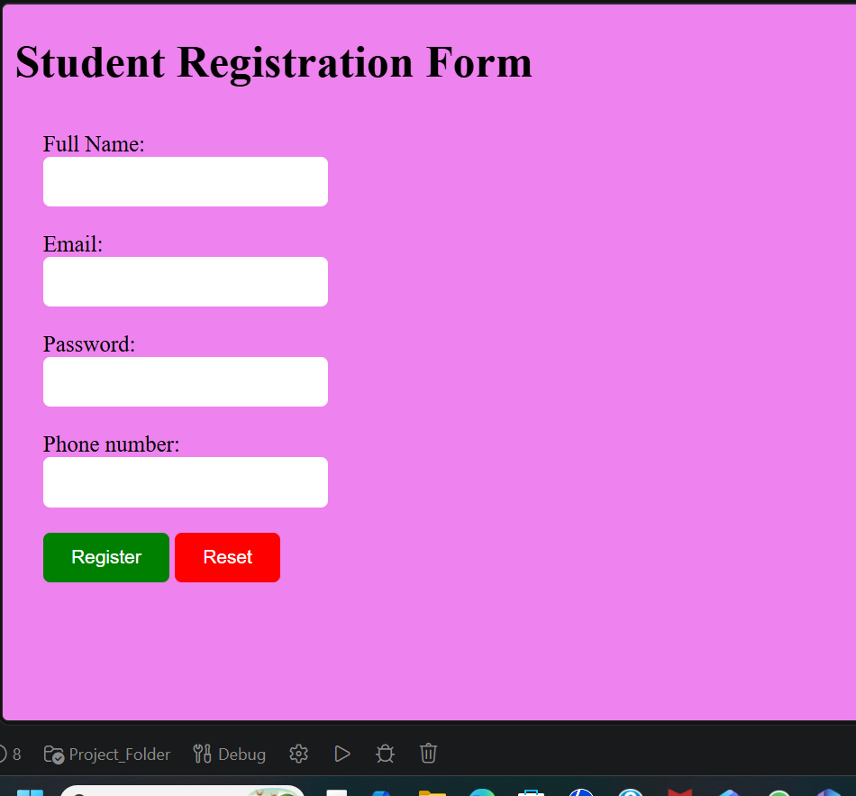

NAAC A++
Ph.: 07104-237919, 234623, 329249, 329250 Fax: 07104-232376, Website: www.ycce.edu

Department of Computer Technology
Vision Statement of the Department.
Output Analysis | The experiment demonstrates the use of three types of CSS and shows how CSS is used to style and design HTML web pages effectively.
Link of student Github profile where lab assignment has been uploaded | https://github.com/aratilod/Web-Technology-Practicals
Conclusion | The web page is successfully displayed with different styles applied using inline, internal, and external CSS. The changes in color, font, size, and layout can be observed in the browser.
Plag Report (Similarity index
< 12%)
Date | 20-07-2026

