NAAC A++
Ph.: 07104-237919, 234623, 329249, 329250 Fax: 07104-232376, Website: www.ycce.edu

Department of Computer Technology
Vision Statement of the Department.
To be a preferred hub for nurturing computer engineering aspirants through innovative, ethical, value-based technical education, impactful research, and industry collaboration, to become successful professionals contributing for the betterment of society.
Mission Statement of the Department.
To nurture computer engineering professionals by offering Dynamic learning environment that encourages problem-solving using emerging technology, National Education Policy aligned evidence-based technical education, fostering ,innovation, research, and industry–institute collaboration & Holistic, ethical and sustainable development for lifelong success.

Session 2026-2027

Vision:Dream of where you want. | Mission: Means to achieve Vision

Program Educational Objectives of the program (PEO): (broad statements that describe the professional and career accomplishments)
PEO1 | Preparation | P: Preparation | Pep-CL abbreviation
PEO2 | Core Competence | E: Environment (Learning Environment) | pronounce as Pep-si-lL easy to recall
PEO3 | Breadth | P: Professionalism | pronounce as Pep-si-lL easy to recall
PEO4 | Professionalism | C: Core Competence | pronounce as Pep-si-lL easy to recall
PEO5 | Learning Environment | L: Breadth (Learning in diverse areas) | pronounce as Pep-si-lL easy to recall

Program Outcomes (PO): (statements that describe what a student should be able to do and know by the end of a program)

Keywords of POs:
Engineering knowledge,Problem analysis, Design/development of solutions,Conduct Investigations of Complex Problems, Engineering Tool Usage, The Engineer and The World,Ethics, Individual and Collaborative Team work,Communication, Project Management and Finance, Life-Long Learning

PSO Keywords: Cutting edge technologies, Research

“I am an engineer, and I know how to apply engineering knowledge to investigate, analyse and design solutions to complex problems using tools for entire world following all ethics in a collaborative way with proper management skills throughout my life.” to contribute to the development of cutting-edge technologies and Research.

Integrity: I will adhere to the Laboratory Code of Conduct and ethics in its entirety.

Name and Signature of Student and Date
(Signature and Date in Handwritten)

NAAC A++
Ph.: 07104-237919, 234623, 329249, 329250 Fax: 07104-232376, Website: www.ycce.edu

Department of Computer Technology
Vision Statement of the Department.

To be a preferred hub for nurturing computer engineering aspirants through innovative, ethical, value-based technical education, impactful research, and industry collaboration, to become successful professionals contributing for the betterment of society.
Mission Statement of the Department.
To nurture computer engineering professionals by offering Dynamic learning environment that encourages problem-solving using emerging technology, National Education Policy aligned evidence-based technical education, fostering ,innovation, research, and industry–institute collaboration & Holistic, ethical and sustainable development for lifelong success.

Session | 2024-25 (ODD) | Course Name | Web Technology Lab
Semester | 3 | Course Code | 23CT1301
Roll No | 32 | Name of Student | Arati Lod

Practical Number | 04-B
Course Outcome | - Understand various internet technologies.  - Design the web pages using HTML and CSS.  - Implement the XML technology to store the data.  - Develop the interactive web pages using JavaScript.
Aim | B. JavaScript — DOM Manipulation  Sample Problem Statement:: Build a To-Do List web app where users can add,  delete, and mark tasks as complete, using vanilla JavaScript  DOM methods only.
Problem Definition | Develop a To-Do List web application using HTML, CSS, and vanilla JavaScript. The application should allow users to add new tasks, delete existing tasks, and mark tasks as completed. JavaScript DOM methods must be used to dynamically create, modify, and remove task elements without refreshing the webpage. The objective is to demonstrate practical knowledge of DOM manipulation and event handling.

NAAC A++
Ph.: 07104-237919, 234623, 329249, 329250 Fax: 07104-232376, Website: www.ycce.edu

Department of Computer Technology
Vision Statement of the Department.
Theory  (100 words) | The Document Object Model (DOM) represents an HTML document as a tree of objects that JavaScript can access and modify dynamically. DOM manipulation allows developers to create, change, or remove HTML elements without reloading the webpage. In a To-Do List application, methods such as querySelector(), createElement(), appendChild(), and remove() are used to manage tasks. Event listeners such as addEventListener() detect user actions like button clicks. The classList property can be used to add or remove classes for completed tasks. Using vanilla JavaScript DOM methods makes the application interactive and provides practical understanding of how JavaScript controls webpage content.
Procedure and Execution  (100 Words) | Step for Implementation:  - Create the basic HTML structure for the To-Do List.  - Add an input field for entering tasks.  - Add an Add Task button.  - Select the input, button, and task list using DOM methods.  - Create a new task element using createElement().  - Add the task to the list using appendChild().  - Add a Complete button for each task.  - Use classList to mark completed tasks.  - Add a Delete button using remove() to delete tasks.  - Test adding, completing, and deleting multiple tasks.

NAAC A++
Ph.: 07104-237919, 234623, 329249, 329250 Fax: 07104-232376, Website: www.ycce.edu

Department of Computer Technology
Vision Statement of the Department.
Code:

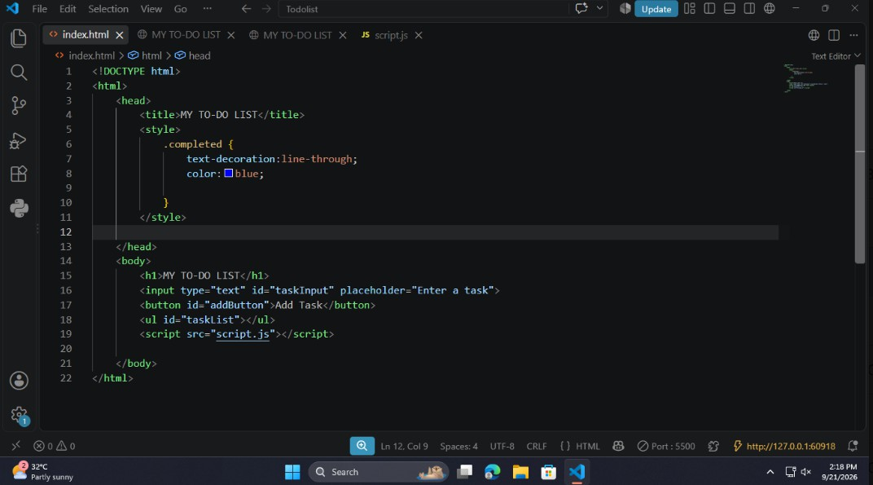

NAAC A++
Ph.: 07104-237919, 234623, 329249, 329250 Fax: 07104-232376, Website: www.ycce.edu

Department of Computer Technology
Vision Statement of the Department.
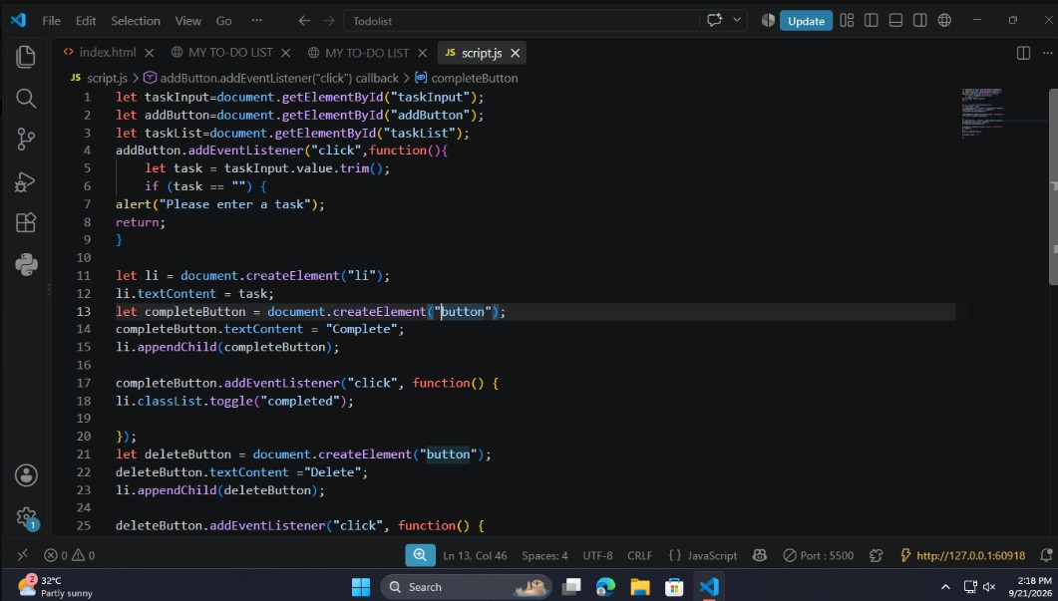

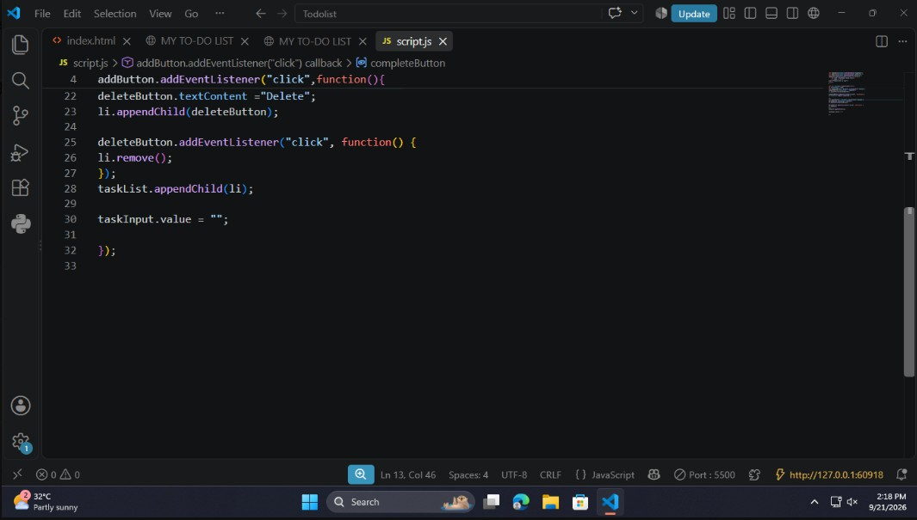

NAAC A++
Ph.: 07104-237919, 234623, 329249, 329250 Fax: 07104-232376, Website: www.ycce.edu

Department of Computer Technology
Vision Statement of the Department.
 | Output: 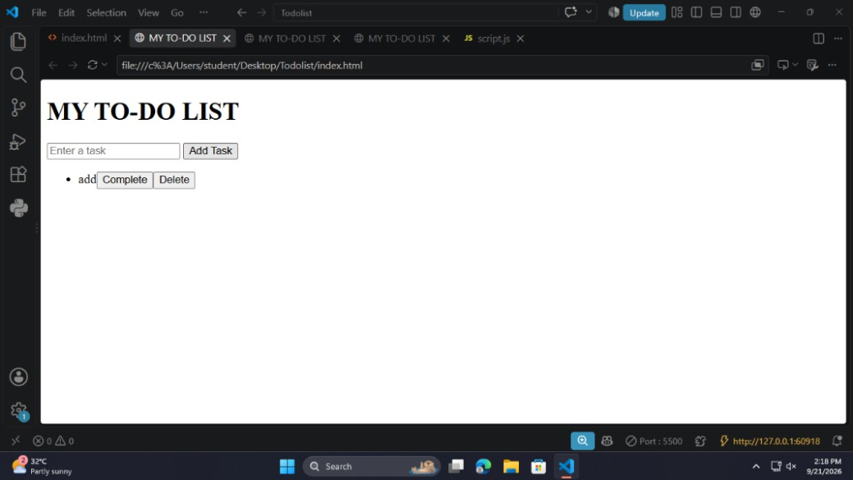
Output Analysis | The To-Do List application successfully allows users to add, delete, and complete tasks. New tasks are dynamically displayed on the webpage without refreshing it. Clicking the complete option changes the task's appearance, while the delete option removes it from the list. The output demonstrates effective use of JavaScript DOM methods and event handling.
Link of student Github profile  where lab assignment has been  uploaded | https://github.com/aratilod/Web-Technology-Practicals
Conclusion | The To-Do List project demonstrates the practical use of JavaScript DOM manipulation to create an interactive webpage. It shows how HTML elements can be dynamically created, modified, and removed using vanilla JavaScript. The application provides a clear understanding of DOM methods, event handling, and dynamic webpage updates.
Plag Report (Similarity index < 12%)

NAAC A++
Ph.: 07104-237919, 234623, 329249, 329250 Fax: 07104-232376, Website: www.ycce.edu

Department of Computer Technology
Vision Statement of the Department.
Date | 21-09-2026

