NAAC A++
Ph.: 07104-237919, 234623, 329249, 329250 Fax: 07104-232376, Website: www.ycce.edu

Department of Computer Technology
Vision Statement of the Department.
To be a preferred hub for nurturing computer engineering aspirants through innovative, ethical, value-based technical education, impactful research, and industry collaboration, to become successful professionals contributing for the betterment of society.
Mission Statement of the Department.
To nurture computer engineering professionals by offering Dynamic learning environment that encourages problem-solving using emerging technology, National Education Policy aligned evidence-based technical education, fostering ,innovation, research, and industry–institute collaboration & Holistic, ethical and sustainable development for lifelong success.

Session 2026-2027

Vision:Dream of where you want. | Mission: Means to achieve Vision

Program Educational Objectives of the program (PEO): (broad statements that describe the professional and career accomplishments)
PEO1 | Preparation | P: Preparation | Pep-CL abbreviation
PEO2 | Core Competence | E: Environment (Learning Environment) | pronounce as Pep-si-lL easy to recall
PEO3 | Breadth | P: Professionalism | pronounce as Pep-si-lL easy to recall
PEO4 | Professionalism | C: Core Competence | pronounce as Pep-si-lL easy to recall
PEO5 | Learning Environment | L: Breadth (Learning in diverse areas) | pronounce as Pep-si-lL easy to recall

Program Outcomes (PO): (statements that describe what a student should be able to do and know by the end of a program)
Keywords of POs:
Engineering knowledge,Problem analysis, Design/development of solutions,Conduct Investigations of Complex Problems, Engineering Tool Usage, The Engineer and The World,Ethics, Individual and Collaborative Team work,Communication, Project Management and Finance, Life-Long Learning

PSO Keywords: Cutting edge technologies, Research

“I am an engineer, and I know how to apply engineering knowledge to investigate, analyse and design solutions to complex problems using tools for entire world following all ethics in a collaborative way with proper management skills throughout my life.” to contribute to the development of cutting-edge technologies and Research.

Integrity: I will adhere to the Laboratory Code of Conduct and ethics in its entirety.

Name and Signature of Student and Date
(Signature and Date in Handwritten)

NAAC A++
Ph.: 07104-237919, 234623, 329249, 329250 Fax: 07104-232376, Website: www.ycce.edu

Department of Computer Technology
Vision Statement of the Department.

To be a preferred hub for nurturing computer engineering aspirants through innovative, ethical, value-based technical education, impactful research, and industry collaboration, to become successful professionals contributing for the betterment of society.
Mission Statement of the Department.
To nurture computer engineering professionals by offering Dynamic learning environment that encourages problem-solving using emerging technology, National Education Policy aligned evidence-based technical education, fostering ,innovation, research, and industry–institute collaboration & Holistic, ethical and sustainable development for lifelong success.

Session | 2024-25 (ODD) | Course Name | Web Technology Lab
Semester | 3 | Course Code | 23CT1301
Roll No | 09 | Name of Student | Divyanka Ramde

Practical Number | 06
Course Outcome | - Understand various internet technologies.  - Design the web pages using HTML and CSS.  - Implement the XML technology to store the data.  - Develop the interactive web pages using JavaScript.
Aim | JavaScript — Arrays, Objects & Higher-Order Functions  Sample Problem Statement: Model shopping-cart products as an array of objects and  implement add-to-cart, remove-item, and total-price calculation using map(), filter(),  and reduce().
Problem Definition | Develop a JavaScript-based shoe shopping cart that stores shoe details using an array of objects. The system should allow users to add and remove shoes, display shoe information, extract shoe names, and calculate the total cart price. The program demonstrates arrays, objects, arrow functions, and higher-order functions effectively.

NAAC A++
Ph.: 07104-237919, 234623, 329249, 329250 Fax: 07104-232376, Website: www.ycce.edu

Department of Computer Technology
Vision Statement of the Department.
Theory  (100 words) | JavaScript arrays are used to store multiple shoe objects in a single variable. Each object contains properties such as ID, name, price, and quantity. The push() method adds a new shoe to the cart, while filter() removes a shoe based on its ID. The map() method extracts shoe names from the array. The reduce() method calculates the total cart price by multiplying price and quantity and adding the results. Arrow functions provide a shorter syntax for functions. map(), filter(), and reduce() are higher-order functions because they accept functions as arguments. HTML and CSS provide the user interface for the shopping cart.
Procedure and Execution (100 Words) | - Create an index.  - html file for the shopping cart interface.  - Add input fields for shoe name, price, and quantity.  - Create buttons for adding and removing shoes.  - Create a table to display shoe details.  - Add CSS styling inside the HTML file.  - Create a script.js file for JavaScript functionality.  - Create an array containing shoe objects with ID, name, price, and quantity.  - Use push() to add a new shoe to the cart.  - Use filter() to remove a shoe using its ID.  - Use map() to extract and display shoe names.  - Use reduce() to calculate the total cart price.  - Use display() to update the cart information on the webpage.  - Link script.js with the HTML file.  - Open the HTML file in a browser and test all operations

NAAC A++
Ph.: 07104-237919, 234623, 329249, 329250 Fax: 07104-232376, Website: www.ycce.edu

Department of Computer Technology
Vision Statement of the Department.
Code: 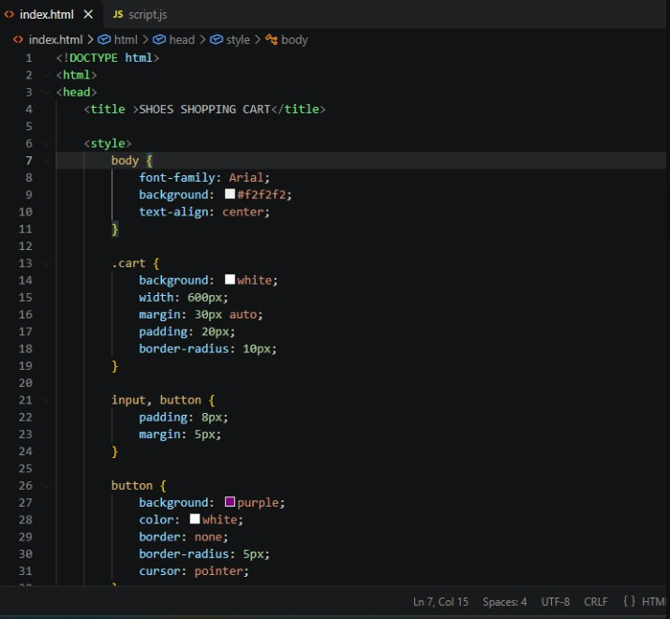

NAAC A++
Ph.: 07104-237919, 234623, 329249, 329250 Fax: 07104-232376, Website: www.ycce.edu

Department of Computer Technology
Vision Statement of the Department.
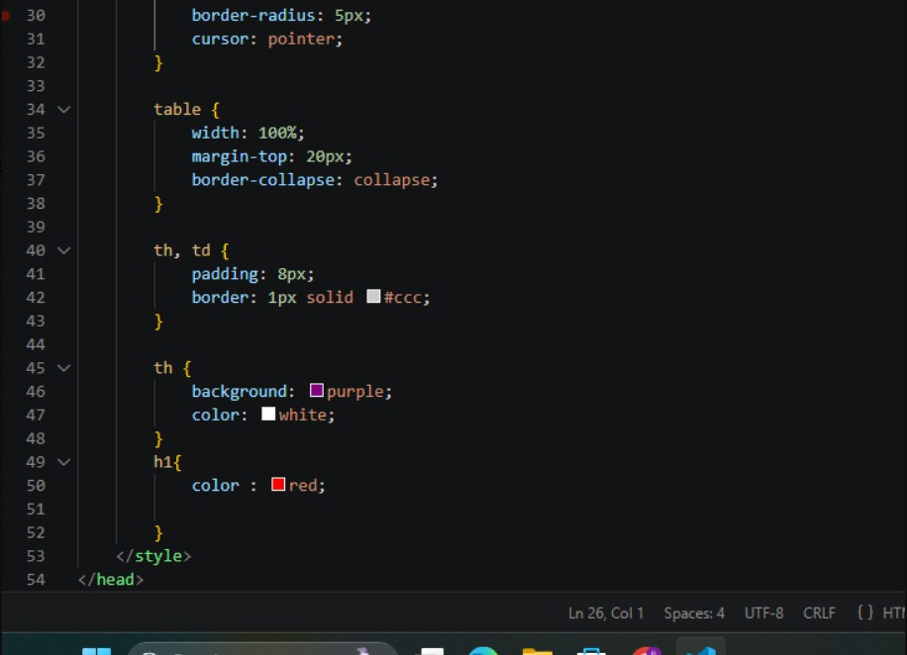

NAAC A++
Ph.: 07104-237919, 234623, 329249, 329250 Fax: 07104-232376, Website: www.ycce.edu

Department of Computer Technology
Vision Statement of the Department.
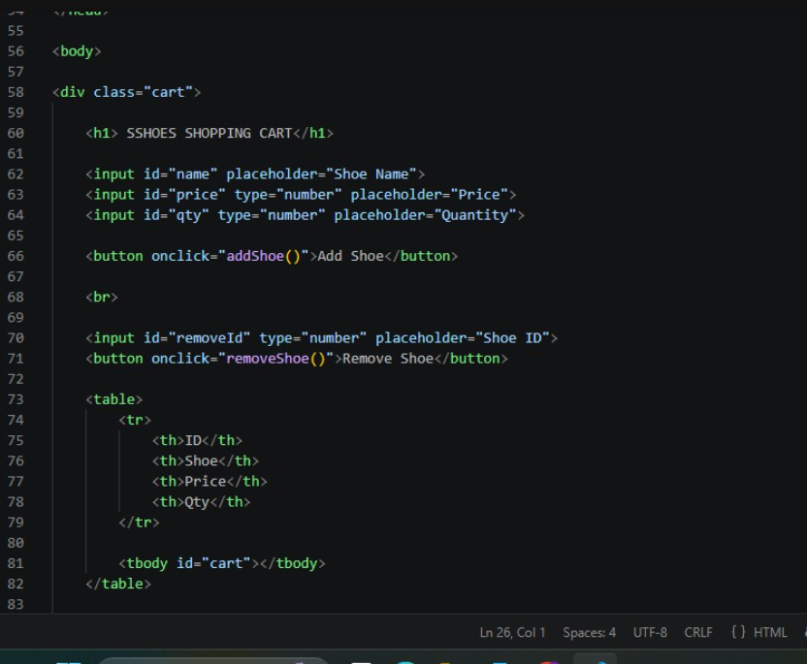

NAAC A++
Ph.: 07104-237919, 234623, 329249, 329250 Fax: 07104-232376, Website: www.ycce.edu

Department of Computer Technology
Vision Statement of the Department.
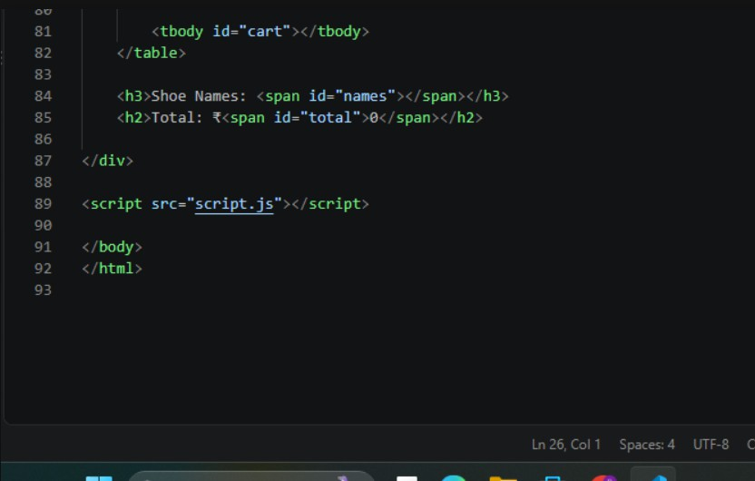

NAAC A++
Ph.: 07104-237919, 234623, 329249, 329250 Fax: 07104-232376, Website: www.ycce.edu

Department of Computer Technology
Vision Statement of the Department.
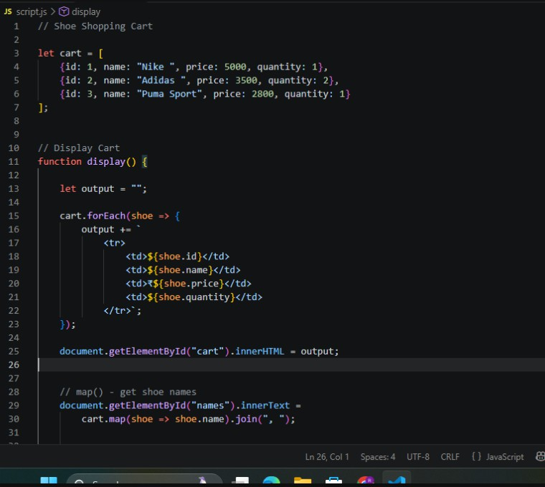

NAAC A++
Ph.: 07104-237919, 234623, 329249, 329250 Fax: 07104-232376, Website: www.ycce.edu

Department of Computer Technology
Vision Statement of the Department.
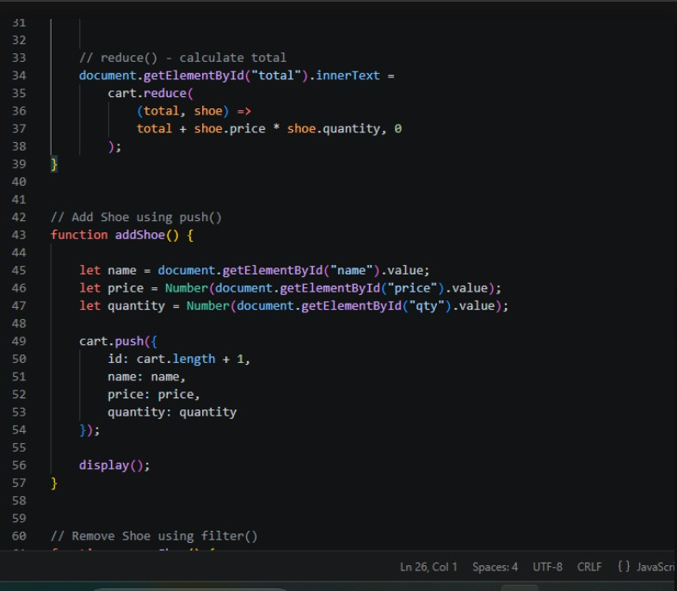

NAAC A++
Ph.: 07104-237919, 234623, 329249, 329250 Fax: 07104-232376, Website: www.ycce.edu

Department of Computer Technology
Vision Statement of the Department.
 | 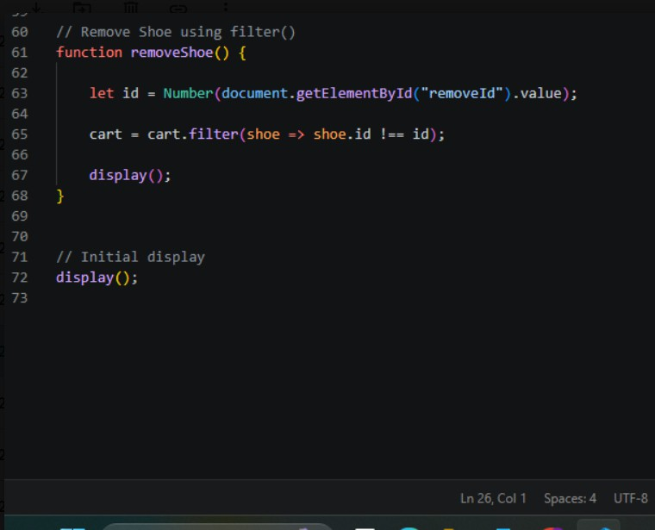
 | Output: 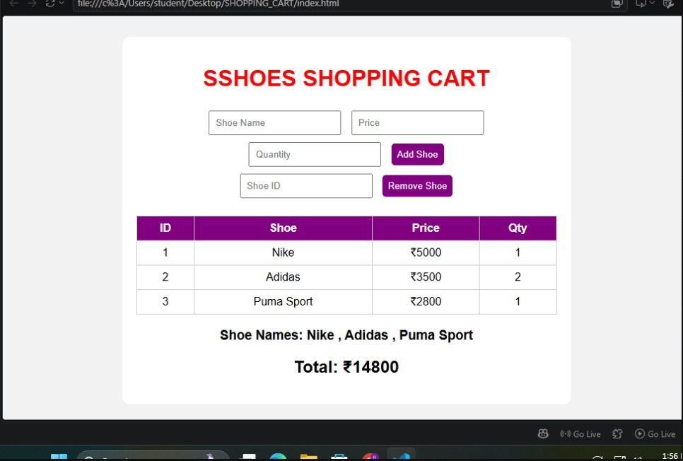
Output Analysis | Thus we have created shoping cart using html style.css and javascript.

NAAC A++
Ph.: 07104-237919, 234623, 329249, 329250 Fax: 07104-232376, Website: www.ycce.edu

Department of Computer Technology
Vision Statement of the Department.
Link of student Github profile  where lab assignment has been  uploaded | https://github.com/divyankaramde07-debug/Web_Technology_09.git
Conclusion | The shoe shopping cart was successfully developed using HTML, CSS, and JavaScript. The program demonstrates the practical use of arrays, objects, arrow functions, and  higher-order functions such as push(), filter(), map(), and reduce(). It successfully allows users to add and remove shoes, display shoe information, and calculate the total cart price.
Plag Report (Similarity index < 12%)
Date | 05-10-2026

