NAAC A++
Ph.: 07104-237919, 234623, 329249, 329250 Fax: 07104-232376, Website: www.ycce.edu

Department of Computer Technology
Vision Statement of the Department.
To be a preferred hub for nurturing computer engineering aspirants through innovative, ethical, value-based technical education, impactful research, and industry collaboration, to become successful professionals contributing for the betterment of society.
Mission Statement of the Department.
To nurture computer engineering professionals by offering Dynamic learning environment that encourages problem-solving using emerging technology, National Education Policy aligned evidence-based technical education, fostering ,innovation, research, and industry–institute collaboration & Holistic, ethical and sustainable development for lifelong success.

Session 2026-2027

Vision:Dream of where you want. | Mission: Means to achieve Vision

Program Educational Objectives of the program (PEO): (broad statements that describe the professional and career accomplishments)
PEO1 | Preparation | P: Preparation | Pep-CL abbreviation
PEO2 | Core Competence | E: Environment (Learning Environment) | pronounce as Pep-si-lL easy to recall
PEO3 | Breadth | P: Professionalism | pronounce as Pep-si-lL easy to recall
PEO4 | Professionalism | C: Core Competence | pronounce as Pep-si-lL easy to recall
PEO5 | Learning Environment | L: Breadth (Learning in diverse areas) | pronounce as Pep-si-lL easy to recall

Program Outcomes (PO): (statements that describe what a student should be able to do and know by the end of a program)

Keywords of POs:
Engineering knowledge,Problem analysis, Design/development of solutions,Conduct Investigations of Complex Problems, Engineering Tool Usage, The Engineer and The World,Ethics, Individual and Collaborative Team work,Communication, Project Management and Finance, Life-Long Learning

PSO Keywords: Cutting edge technologies, Research

“I am an engineer, and I know how to apply engineering knowledge to investigate, analyse and design solutions to complex problems using tools for entire world following all ethics in a collaborative way with proper management skills throughout my life.” to contribute to the development of cutting-edge technologies and Research.

Integrity: I will adhere to the Laboratory Code of Conduct and ethics in its entirety.

Name and Signature of Student and Date
(Signature and Date in Handwritten)

NAAC A++
Ph.: 07104-237919, 234623, 329249, 329250 Fax: 07104-232376, Website: www.ycce.edu

Department of Computer Technology
Vision Statement of the Department.

To be a preferred hub for nurturing computer engineering aspirants through innovative, ethical, value-based technical education, impactful research, and industry collaboration, to become successful professionals contributing for the betterment of society.
Mission Statement of the Department.
To nurture computer engineering professionals by offering Dynamic learning environment that encourages problem-solving using emerging technology, National Education Policy aligned evidence-based technical education, fostering ,innovation, research, and industry–institute collaboration & Holistic, ethical and sustainable development for lifelong success.

Session | 2024-25 (ODD) | Course Name | Web Technology Lab
Semester | 3 | Course Code | 23CT1301
Roll No | 32 | Name of Student | Arati Lod

Practical Number | 07
Course Outcome | - Understand various internet technologies.  - Design the web pages using HTML and CSS.  - Implement the XML technology to store the data.  - Develop the interactive web pages using JavaScript.
Aim | JavaScript — Asynchronous Programming (Fetch/Promises)  Sample Problem Statement: Build a small Weather App or Movie-Search App that fetches  data from ONE public API using fetch()/async-await and renders it dynamically.
Problem Definition | Develop a small Weather App using JavaScript asynchronous programming. The application should accept a city name from the user and fetch its current weather information from a public weather API using the fetch() method with async/await. The fetched data should be processed and displayed dynamically on the webpage. The application should show important information such as city name, temperature, weather condition, humidity, and wind speed. It should also handle invalid city names or API errors by displaying an appropriate error message.

NAAC A++
Ph.: 07104-237919, 234623, 329249, 329250 Fax: 07104-232376, Website: www.ycce.edu

Department of Computer Technology
Vision Statement of the Department.
Theory  (100 words) | Asynchronous programming allows JavaScript to perform tasks without blocking the execution of other operations. The fetch() API is used to request data from external APIs and returns a Promise. Promises represent the eventual success or failure of an asynchronous operation. async and await provide a simpler way to work with Promises. In a Weather App, JavaScript sends a request to a weather API, waits for the response using await, converts the response into JSON, and dynamically displays the required weather information using DOM manipulation.
Procedure and Execution (100 Words) | - Create an HTML page containing a heading, city input box, search button, and result section.  - Create a separate JavaScript file and link it with the HTML file.  - Read the city name entered by the user.  - Create an API request using the fetch() method.  - Use async/await to handle the Promise returned by fetch().  - Convert the API response into JSON format.  - Extract required information such as temperature, humidity, weather condition, and wind speed.  - Display the fetched information dynamically using DOM methods.  - Use try...catch to handle network or API errors.  - Test the application with valid and invalid city names.

NAAC A++
Ph.: 07104-237919, 234623, 329249, 329250 Fax: 07104-232376, Website: www.ycce.edu

Department of Computer Technology
Vision Statement of the Department.
Code:

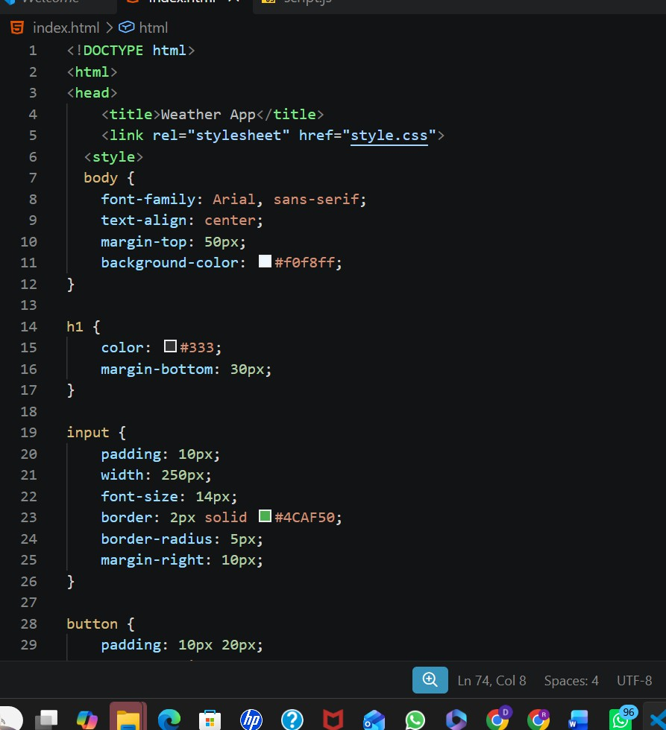

NAAC A++
Ph.: 07104-237919, 234623, 329249, 329250 Fax: 07104-232376, Website: www.ycce.edu

Department of Computer Technology
Vision Statement of the Department.
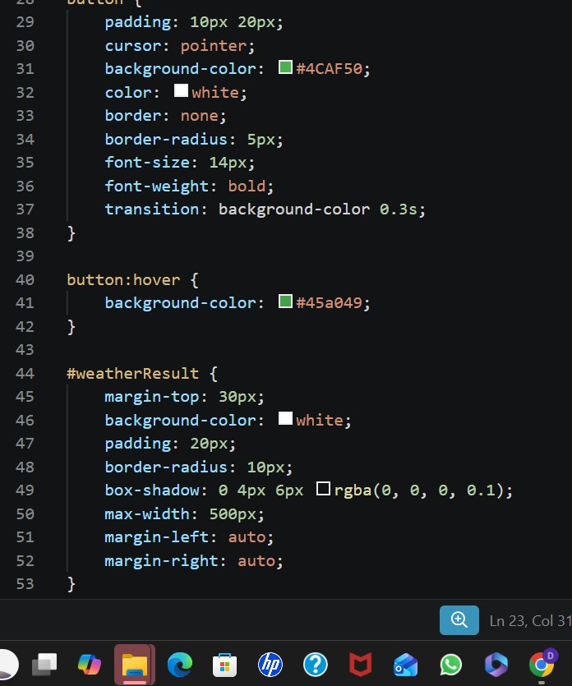
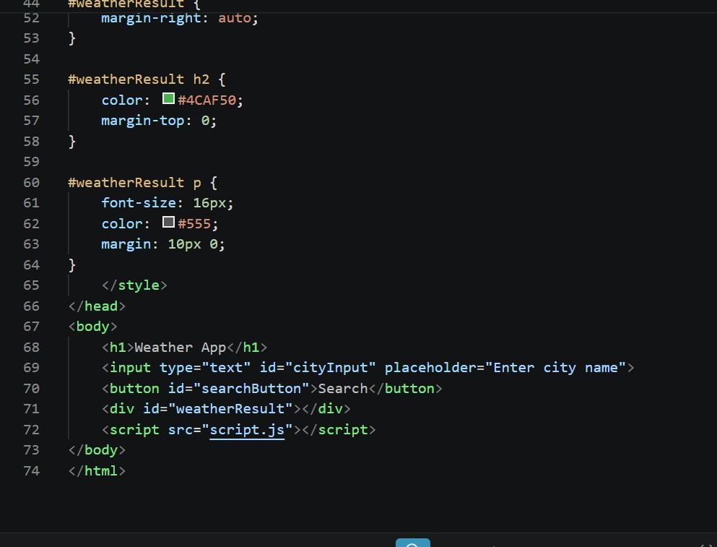

NAAC A++
Ph.: 07104-237919, 234623, 329249, 329250 Fax: 07104-232376, Website: www.ycce.edu

Department of Computer Technology
Vision Statement of the Department.
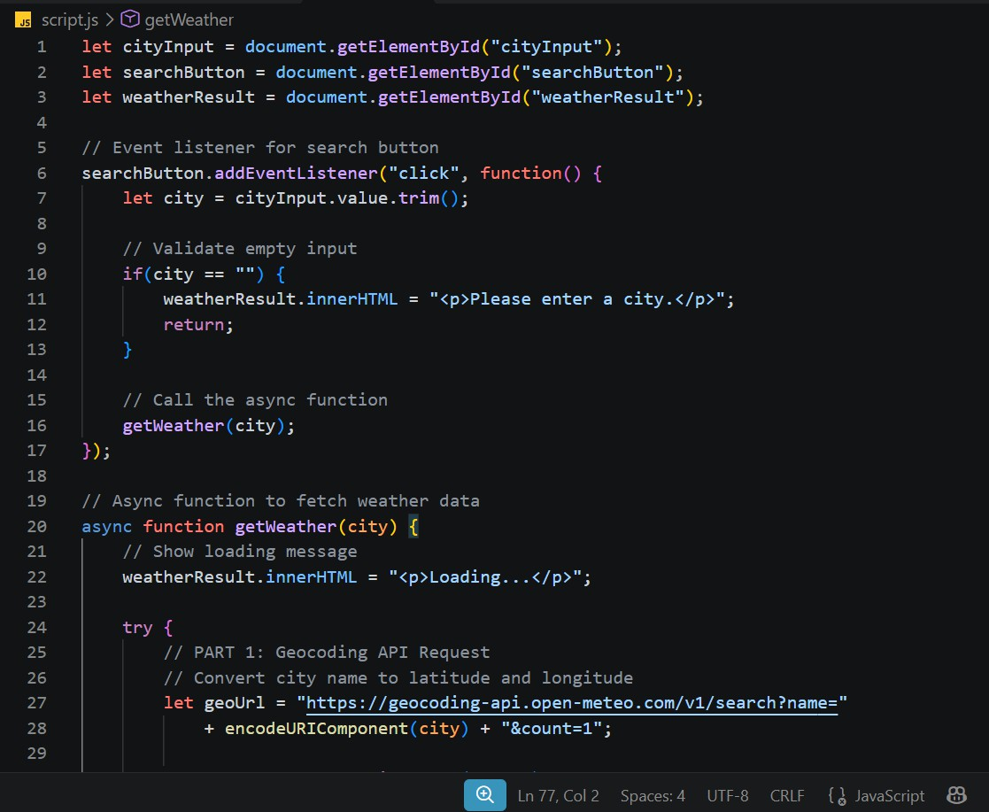

NAAC A++
Ph.: 07104-237919, 234623, 329249, 329250 Fax: 07104-232376, Website: www.ycce.edu

Department of Computer Technology
Vision Statement of the Department.
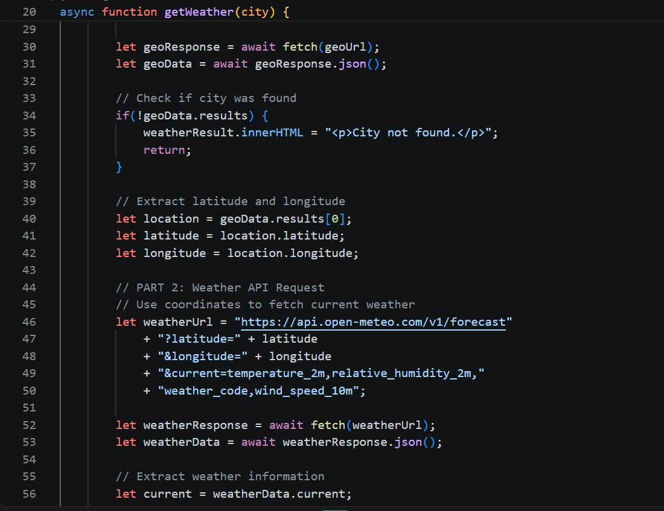

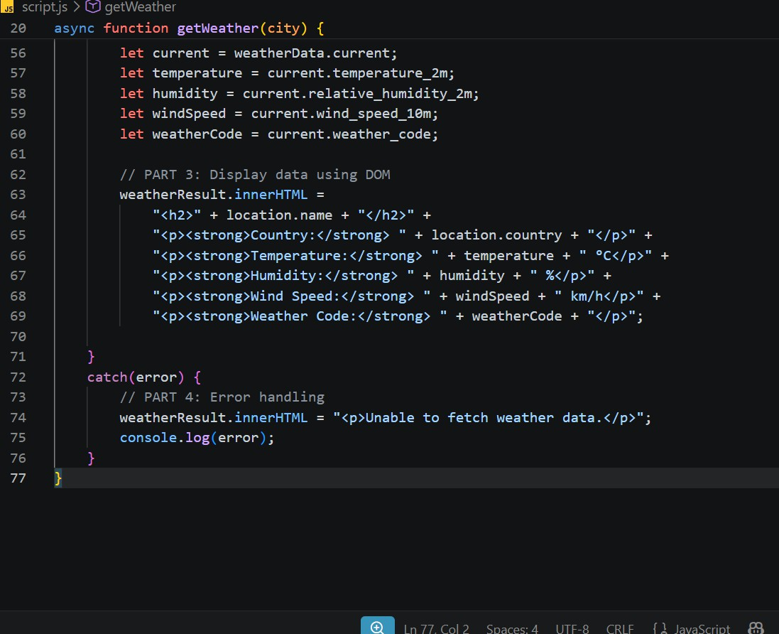

NAAC A++
Ph.: 07104-237919, 234623, 329249, 329250 Fax: 07104-232376, Website: www.ycce.edu

Department of Computer Technology
Vision Statement of the Department.
 | Output: 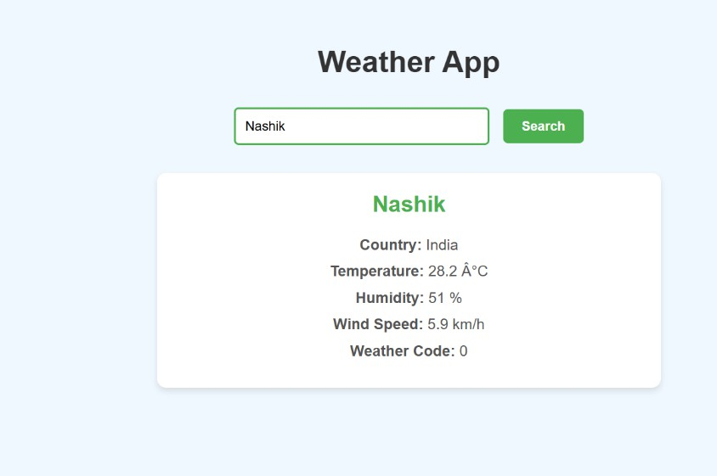
Output Analysis | The output demonstrates that the application successfully accepts a city name and retrieves weather information from a public API. The fetch() function sends the request asynchronously, while async/await waits for the response without blocking the webpage. The received JSON data is converted into useful weather details and displayed dynamically using JavaScript DOM manipulation. The error-handling mechanism ensures that users receive a meaningful message when the city is invalid or the API request fails.
Link of student Github profile where lab assignment has been uploaded | https://github.com/aratilod/Web-Technology-Practicals
Conclusion | The Weather App successfully demonstrates asynchronous programming in JavaScript using fetch(), Promises, and async/await. It retrieves data from an external API without reloading the webpage and displays the results dynamically. Error handling makes the application more reliable when an invalid city or network problem occurs. This practical helps understand how modern JavaScript applications communicate with external services and process data asynchronously.
Plag Report (Similarity index < 12%)
Date | 05-10-2026

