Chapter 2 - Political Stability Around the World Since the End of the Cold War

Adrien Ratsimbaharison

10/14/2018

In this section, we will apply some simple statistical procedures on Kaufman’s data on political stability estimate to assess the stability of the whole world and its trend from 1996 to 2017. We will also compare the stability of the different regions and identify some of the most unstable counties in the world. Next, we will use predictive analytics or machine learning on our compiled dataset that include different variables (political, economic, social, and others) to identify the predictors (or determinants or conditions) of political stability

## 2.1 - Descriptive Statistics

**Political Stability of the World Since the End of the Cold War**

Following Kaufman et al.’s methodology, the political stability estimate (or score) of a given country for a given year is based on the aggregation of the perceptions from several survey respondents, including what they call the “five representative sources”: Economist Intelligence Unit Riskwire & Democracy Index (EIU), World Economic Forum Global Competitiveness Report (GCS), Cingranelli Richards Human Rights Database and Political Terror Scale (HUM), Institutional Profiles Database (IPD), Political Risk Services International Country Risk Guide (PRS), and Global Insight Business Conditions and Risk Indicators (WMO). (see World Bank 2016; and Kaufmann, Kraay, and Mastruzzi 2011) In line with this, the annual political stability score assigned to a country ranges from -2.5 to 2.5, with some extreme values less than -2.5.[1] Using the dataset on the political stability estimate of all countries in the world for the period of 1996 to 2016, we can compute the stability of the world for the entire period and the annual stability trend from 1996 to 2016. Furthemore, we can compare the stability of the different regions in the world.

Refering to Figure 2.1 below, we can state that the whole world has been slightly stable since the end of the Cold War. Indeed, in computing the summary statistics of political stability during the time period of 1996-2017 around the world, we find that the average was 0.01739 (with standard deviation of 1.005123), the median 0.14080, the minimum -3.31494, and the maximum 1.96506.

As shown in Figure 2.2, the data on political stability is not normally distributed, but skweed to the left, which indicates the existence of outliers with negative values.

**Political Stability Trend and by Region**

With regard to its trend, Table 2.1 and Figure 2.3 indicate that the political stability annual average of the world hovered around zero during the period of 1996 to 2017. It remained positive from 1996 to 2005, and then dipped for the most parts into negative values from 2006 to 2017.[2]

Table 2.2 and Figure 3.4 clearly show that the regions of Africa and Asia, with respectively an average of -0.575 and -0.388, were the two most unstable regions in the world during the time period of 1996-2016. On the contrary, the regions of Oceania and Europe, with respectively an average of 0.820 and 0.651, were the two most unstable regions in the world

**Identifying the Most Stable and Most Unstable Countries in the World**

Table - The Most Stable Countries in the World

|  |  |  |
| --- | --- | --- |
| country | mean | sd |
| Greenland | 1.429409 | 0.4338408 |
| Finland | 1.429184 | 0.2142616 |
| Luxembourg | 1.419291 | 0.0926874 |
| Liechtenstein | 1.392809 | 0.1224679 |
| Iceland | 1.355168 | 0.1478003 |
| New Zealand | 1.344821 | 0.1394674 |
| Switzerland | 1.334871 | 0.1142218 |
| Andorra | 1.319678 | 0.0868767 |
| Norway | 1.299098 | 0.1354107 |
| Malta | 1.271740 | 0.1772432 |
| Tuvalu | 1.242575 | 0.2185381 |
| Singapore | 1.221618 | 0.1714109 |
| Sweden | 1.218142 | 0.1643163 |
| Aruba | 1.185663 | 0.1358765 |
| Brunei Darussalam | 1.182850 | 0.1131022 |
| Jersey, Channel Islands | 1.181069 | 0.2100489 |
| Anguilla | 1.176258 | 0.2167577 |
| Austria | 1.166689 | 0.1643222 |
| Ireland | 1.161019 | 0.2239086 |
| Kiribati | 1.144378 | 0.2537945 |

Table - The Most Unstable Countries in the World

|  |  |  |
| --- | --- | --- |
| country | mean | sd |
| Somalia | -2.690631 | 0.3953388 |
| Afghanistan | -2.440307 | 0.2086401 |
| Sudan | -2.249525 | 0.2814557 |
| Iraq | -2.242851 | 0.4409780 |
| Congo, Dem. Rep. | -2.237190 | 0.2266996 |
| Pakistan | -2.109500 | 0.5932585 |
| Yemen, Rep. | -1.971002 | 0.6224804 |
| Burundi | -1.782636 | 0.4341367 |
| Nigeria | -1.781799 | 0.3975589 |
| West Bank and Gaza | -1.752070 | 0.2841415 |
| Central African Republic | -1.747516 | 0.3784098 |
| Colombia | -1.602060 | 0.4470535 |
| Ethiopia | -1.443739 | 0.3065973 |
| Chad | -1.416341 | 0.2967583 |
| Nepal | -1.357977 | 0.5737496 |
| Côte d’Ivoire | -1.343048 | 0.6098092 |
| Lebanon | -1.310648 | 0.5657556 |
| Algeria | -1.305329 | 0.2770288 |
| Guinea | -1.289655 | 0.6041197 |
| Philippines | -1.245988 | 0.4427428 |

|  |  |  |
| --- | --- | --- |
| country | mean | sd |
| Botswana | 1.0209511 | 0.0633489 |
| Mauritius | 0.9145659 | 0.1400194 |
| Cabo Verde | 0.8647169 | 0.1809899 |
| Seychelles | 0.8119308 | 0.2041335 |
| Benin | 0.4112133 | 0.3005275 |
| Zambia | 0.2513122 | 0.2456729 |
| Gabon | 0.2492541 | 0.1789159 |
| Gambia, The | 0.1436938 | 0.3164540 |
| Lesotho | 0.0286985 | 0.2776482 |
| Mozambique | 0.0185902 | 0.4752727 |
| Equatorial Guinea | -0.0130375 | 0.2484493 |
| Ghana | -0.0271264 | 0.1372486 |
| Malawi | -0.0471483 | 0.1626098 |
| South Sudan | -0.0950476 | 1.5570929 |
| South Africa | -0.1394861 | 0.1749051 |
| Swaziland | -0.2032705 | 0.2252949 |
| Tunisia | -0.2114413 | 0.5348821 |
| Madagascar | -0.2226070 | 0.4305297 |
| Senegal | -0.2728599 | 0.2373224 |
| Comoros | -0.2779822 | 0.4751202 |

|  |  |  |
| --- | --- | --- |
| country | mean | sd |
| Somalia | -2.6906313 | 0.3953388 |
| Sudan | -2.2495253 | 0.2814557 |
| Congo, Dem. Rep. | -2.2371898 | 0.2266996 |
| Burundi | -1.7826364 | 0.4341367 |
| Nigeria | -1.7817987 | 0.3975589 |
| Central African Republic | -1.7475164 | 0.3784098 |
| Ethiopia | -1.4437390 | 0.3065973 |
| Chad | -1.4163414 | 0.2967583 |
| Côte d’Ivoire | -1.3430477 | 0.6098092 |
| Algeria | -1.3053291 | 0.2770288 |
| Guinea | -1.2896551 | 0.6041197 |
| Kenya | -1.1855079 | 0.1806655 |
| Liberia | -1.1718994 | 0.6769998 |
| Uganda | -1.0635466 | 0.2825169 |
| Zimbabwe | -0.9610872 | 0.2901719 |
| Egypt, Arab Rep. | -0.8891339 | 0.5342728 |
| Angola | -0.8251942 | 0.6764344 |
| Congo, Rep. | -0.7885261 | 0.4148421 |
| Eritrea | -0.7656588 | 0.1666288 |
| Guinea-Bissau | -0.7273718 | 0.3827602 |

## 2. Machine Learning: Identifying the Predictors of Political Stability

In this machine learning implementation (or predictive analytics), we follow the guidelines suggested by different data scientists who specialize in the use *r* statistical and programming language and particularly the Caret package, created and maintained by Max Kuhn. Among these guidelines, we found particularly useful Saurav Kaushik’s “Practical guide to implement machine learning with CARET in R” (2016) and Brett Lanz’s *Machine Learning with R*. (2015) After the initial step of installing the required packages (including the Caret package) and loading the dataset into r, this machine learning implementation includes the following:

* defining the problem,
* preprocessing the data,
* spliting the data into training and test sets,
* feature selection using the “recursive feature elimination”" or “rfe” function,
* traning models on the training set,
* generating variable importance,
* making predictions on the test set and assessing the accuracy of the models.

Since the complete *r* script used in this machine learning can be consulted in Appendix A, we will only focus on the following steps in this chapter: defining of the problem, feature selection using the “recursive feature elimination” (*rfe*) function, generating the variable importance, and making predictions to assess the accuracy of the selected model.

Defining the problem:

The problem in this machine learning implementation is to predict the stability score of a country. In other words, we are dealing here with a machine learning regression on the variable “stability.”

Feature (or variable) selection using the “recursive feature elimination” (*rfe*) function

Variables RMSE Rsquared MAE RMSESD RsquaredSD MAESD Selected 4 0.4687 0.8032 0.3552 0.04209 0.02860 0.02965  
8 0.2986 0.9151 0.2192 0.02050 0.01255 0.01355  
16 0.2904 0.9196 0.2120 0.01743 0.01050 0.01192  
24 0.2890 0.9203 0.2107 0.01715 0.00992 0.01166 *

The top 5 variables (out of 24): population, conflictHistory.1, ruleOfLaw, HDI, GNIperCapita

Generating the variable importance:

The variable importance procedure allows us to identify the following variables along with their respective importance

only 20 most important variables shown (out of 24)

Overall

conflictHistory.1 100.000 ruleOfLaw 95.658 population 48.325 regulatoryQuality 36.260 governmentEffectiveness 29.361 GNIperCapita 26.817 region.Asia 26.704 politicalChangeFH.no.change 26.147 region.Oceania 22.848 region.Americas 22.204 politicalChangeFH.democratization 19.487 GDPannualGrowthRate 17.083 date 15.842 GINI 10.748 povertyHeadCount 8.615 inverse_pr 7.966 corruptionControl 7.856 status.Not.Free 7.216 status.Partly.Free 6.638 region.Europe 5.812

Assessing the accuracy of the selected model:

stabilityModel_glm Generalized Linear Model

2838 samples 24 predictor

No pre-processing Resampling: Bootstrapped (25 reps) Summary of sample sizes: 2838, 2838, 2838, 2838, 2838, 2838, … Resampling results:

RMSE Rsquared MAE  
0.5356276 0.7182354 0.413647

# Assessing the accuracy of the prediction

postResample(pred = stabilityPrediction_glm, obs = stabilityTestSet$stability) RMSE Rsquared MAE 0.5344837 0.7042382 0.4188245

## Tables and Figures

Table 2.1 - Political Stability of the World: Summary statistics

|  |  |
| --- | --- |
| Statistics | Value |
| Minimum | -3.31494 |
| Mean | 0.01739 |
| Standard Deviation | 1.005123 |
| Median | 0.1408 |
| Maximum | 1.96506 |

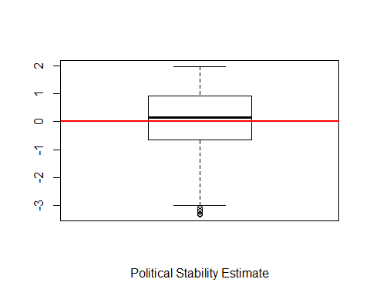

Figure 2.1 - Political Stability of the World: Summary Statistics

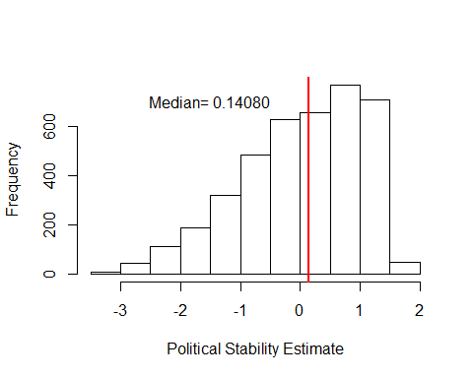

Figure 2 - Political Stability of the World: Frequency Distribution

#Table 2.2 - Political Stability Trend: Annual Average Around the World  
names(PoliticalStabilityTrendWorld) <- c("Date", "Annual Average")  
kable(PoliticalStabilityTrendWorld, caption = "Table 2.2 - Political Stability Trend of the World: Annual Average (1996-2017)")

Table 2.2 - Political Stability Trend of the World: Annual Average (1996-2017)

|  |  |
| --- | --- |
| Date | Annual Average |
| 1996 | 0.1074109 |
| 1998 | 0.0973128 |
| 2000 | 0.0973744 |
| 2002 | 0.0800506 |
| 2003 | 0.0552232 |
| 2004 | 0.0198044 |
| 2005 | 0.0092358 |
| 2006 | -0.0025699 |
| 2007 | 0.0006529 |
| 2008 | 0.0070466 |
| 2009 | -0.0043141 |
| 2010 | -0.0070637 |
| 2011 | -0.0419176 |
| 2012 | -0.0292790 |
| 2013 | -0.0242378 |
| 2014 | -0.0085303 |
| 2015 | -0.0096888 |
| 2016 | -0.0082385 |
| 2017 | -0.0075336 |

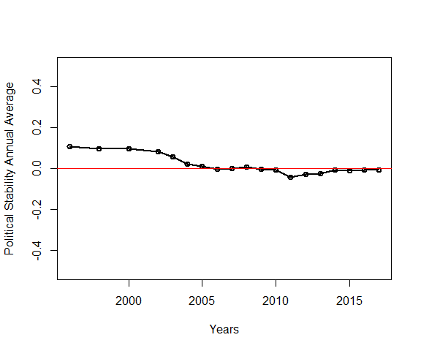

Fig. 2.3 - Political stability Trend of the world: Annual Average (1996-2017)

Table 2.3 - Political Stability: Average by Region

|  |  |  |
| --- | --- | --- |
| Region | Mean | Standard Deviation |
| Africa | -0.5824554 | 0.9294497 |
| Americas | 0.2239798 | 0.7533971 |
| Asia | -0.3880035 | 1.0492575 |
| Europe | 0.6477300 | 0.6853340 |
| Oceania | 0.8086275 | 0.5692837 |
| NA | 0.4304954 | 0.8228075 |

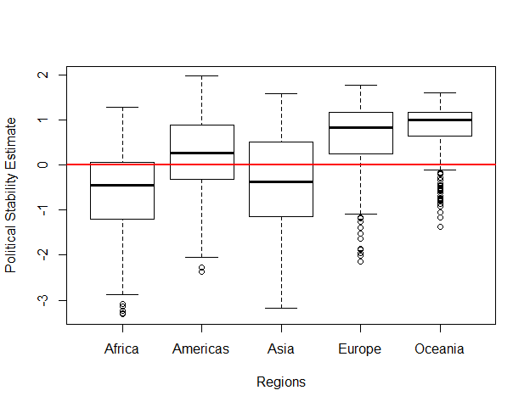

Fig. 2.4 - Political Stability: Summary Statistics by Region

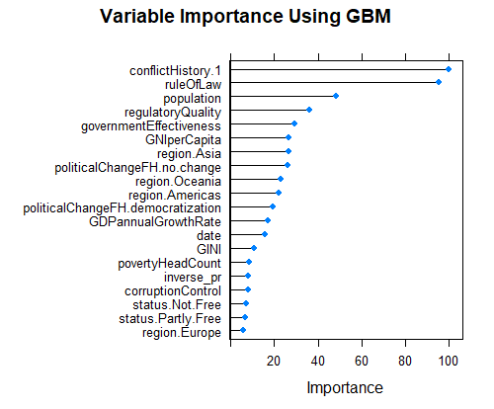

Fig. 2.5 Variable Importance Using the Generalized Linear Model (GLM)

## References

Kaufmann, Daniel, Aart Kraay, and Massimo Mastruzzi. 2011. “The Worldwide Governance Indicators: Methodology and Analytical Issues.” 1876-4053. Washington, DC: The World Bank.

Kaushik, Saurav. 2016. “Practical Guide to Implement Machine Learning with CARET in R.” *Analytics Vidhya*.

Lantz, Brett. 2015. *Machine Learning with R*. 2 edition. Birmingham, UK: Packt Publishing.

World Bank. 2016. “Worldwide Governance Indicators.” *The World Bank Databank*. http://databank.worldbank.org/data/reports.aspx?source=worldwide-governance-indicators.

1. When asked privately about these extreme values, one of Kaufman’s associates stated that these were the results of the computations and could be either removed or taken as they were. We chose to keep these extreme values in this study
2. See Table 2.1 and Fig. 2.3