Chapter 3 - Political Stability and the Curse of History and Geography

Adrien Ratsimbaharison

July 26, 2019

As we saw in Chapter 2, the variable conflict history was the most important factor, with a rate of 100%, that can predict the occurence of stability. The variable region appears also among the top 10 most important variable (with regions of Asia, Oceania, Americas having the rates higher than 20%). In other words, history and geography have great influence of the political stability of any country in the world.

In this section, we will first review the literature on the relationships between political stability, history of conflict and geography. Next, we will apply some basic correlation and regression analyses to assess the effect of these indicators on political stability.

## 4.1 - Literature review on political stability, history, and geography

## 4.2 - Quantitative analysis of the relationship political stability, conflict history, and geography

** 1) Basic Correlation **

As shown in Fig. find that political stability is strongly and significantly correlated with these other world governance indicators. The correlation coefficients range from 0.63 to 0.77, with a p-value close to zero.

There is a clearcut relationship between conflict history and stability. As shown in Fig. 3.1, countries that had an armed conflict during the previous period (1945-1995) were more likely to be unstable during the period of 1996-2017.

** 2) Analysis of Variance **

## Tables and Figures

library(dplyr)  
library(ggplot2)  
library(readxl)  
library(lubridate)  
library(psych)  
library(Hmisc)  
library(PerformanceAnalytics)

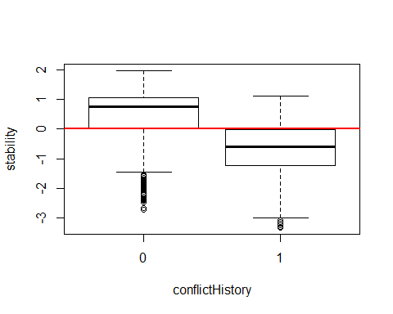

stabilityHistoryAndGeography <- na.omit(stabilityHistoryAndGeography)  
  
# Counting the instances of conflict history  
table(stabilityHistoryAndGeography$conflictHistory)

##   
## 0 1   
## 2166 1616

# Calculating the average stability for countries without conflict history  
noConflictHistory <- stabilityHistoryAndGeography[stabilityHistoryAndGeography$conflictHistory == 0,]  
 mean(noConflictHistory$stability, na.rm = TRUE)

## [1] 0.5016248

sd(noConflictHistory$stability, na.rm = TRUE)

## [1] 0.7927109

# Calculating the average stability for countries With conflict history  
ConflictHistory <- stabilityHistoryAndGeography[stabilityHistoryAndGeography$conflictHistory == 1,]  
 mean(ConflictHistory$stability, na.rm = TRUE)

## [1] -0.6753604

sd(ConflictHistory$stability, na.rm = TRUE)

## [1] 0.8635885

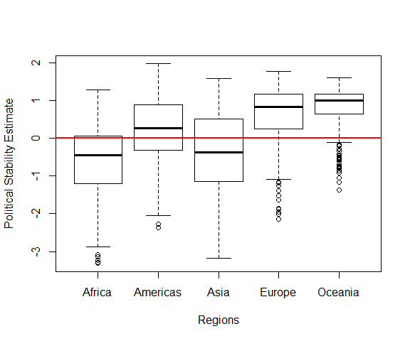

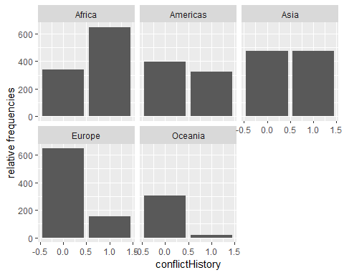

stabilityHistoryAndGeography <- na.omit(stabilityHistoryAndGeography)  
stabilityHistoryAndGeography %>%  
 group_by(region) %>% summarise(RuleOfLawAverage = mean(ruleOfLaw, na.rm = TRUE),  
 RuleOfLawSD = sd(ruleOfLaw, na.rm = TRUE))

## # A tibble: 5 x 3  
## region RuleOfLawAverage RuleOfLawSD  
## <fct> <dbl> <dbl>  
## 1 Africa -0.702 0.677  
## 2 Americas 0.0996 0.869  
## 3 Asia -0.208 0.874  
## 4 Europe 0.842 0.924  
## 5 Oceania 0.525 0.835

stabilityHistoryAndGeography <- na.omit(stabilityHistoryAndGeography)  
stabilityHistoryAndGeography %>%  
 group_by(region) %>% summarise(PopulationAverage = mean(population, na.rm = TRUE),  
 PopulationSD = sd(ruleOfLaw, na.rm = TRUE))

## # A tibble: 5 x 3  
## region PopulationAverage PopulationSD  
## <fct> <dbl> <dbl>  
## 1 Africa 19407736. 0.677  
## 2 Americas 23237490. 0.869  
## 3 Asia 80294694. 0.874  
## 4 Europe 17574937. 0.924  
## 5 Oceania 2110031. 0.835

stabilityHistoryAndGeography <- na.omit(stabilityHistoryAndGeography)  
stabilityHistoryAndGeography %>%  
 group_by(region) %>% summarise(GNIperCapitaAverage = mean(GNIperCapita, na.rm = TRUE),  
 GNIperCapitaSD = sd(ruleOfLaw, na.rm = TRUE))

## # A tibble: 5 x 3  
## region GNIperCapitaAverage GNIperCapitaSD  
## <fct> <dbl> <dbl>  
## 1 Africa 2227. 0.677  
## 2 Americas 9203. 0.869  
## 3 Asia 11318. 0.874  
## 4 Europe 27565. 0.924  
## 5 Oceania 10651. 0.835

stabilityHistoryAndGeography <- na.omit(stabilityHistoryAndGeography)  
stabilityHistoryAndGeography %>%  
 group_by(region) %>% summarise(PRCLAverage = mean(inverse_mean, na.rm = TRUE),  
 PRCLSD = sd(inverse_mean, na.rm = TRUE))

## # A tibble: 5 x 3  
## region PRCLAverage PRCLSD  
## <fct> <dbl> <dbl>  
## 1 Africa 3.57 1.65  
## 2 Americas 5.84 1.28  
## 3 Asia 3.64 1.85  
## 4 Europe 6.27 1.24  
## 5 Oceania 6.23 1.07