Zimbabwe

## Freedom House political status

The data set shows the Freedom House political scores and status of the country each year.

## # A tibble: 19 x 5  
## country iso3c date mean status   
## <chr> <chr> <dbl> <dbl> <chr>   
## 1 Zimbabwe ZWE 1996 5 Partly Free  
## 2 Zimbabwe ZWE 1998 5 Partly Free  
## 3 Zimbabwe ZWE 2000 5.5 Partly Free  
## 4 Zimbabwe ZWE 2002 6 Not Free   
## 5 Zimbabwe ZWE 2003 6 Not Free   
## 6 Zimbabwe ZWE 2004 6.5 Not Free   
## 7 Zimbabwe ZWE 2005 6.5 Not Free   
## 8 Zimbabwe ZWE 2006 6.5 Not Free   
## 9 Zimbabwe ZWE 2007 6.5 Not Free   
## 10 Zimbabwe ZWE 2008 6.5 Not Free   
## 11 Zimbabwe ZWE 2009 6 Not Free   
## 12 Zimbabwe ZWE 2010 6 Not Free   
## 13 Zimbabwe ZWE 2011 6 Not Free   
## 14 Zimbabwe ZWE 2012 6 Not Free   
## 15 Zimbabwe ZWE 2013 5.5 Not Free   
## 16 Zimbabwe ZWE 2014 5.5 Not Free   
## 17 Zimbabwe ZWE 2015 5 Partly Free  
## 18 Zimbabwe ZWE 2016 5 Partly Free  
## 19 Zimbabwe ZWE 2017 5.5 Not Free

## Freedom House classification of political change

The data set shows the GDP growth and the ecomic growth classification of the country each year.

## # A tibble: 19 x 4  
## country iso3c date politicalChangeFH  
## <chr> <chr> <dbl> <chr>   
## 1 Zimbabwe ZWE 1996 no change   
## 2 Zimbabwe ZWE 1998 no change   
## 3 Zimbabwe ZWE 2000 no change   
## 4 Zimbabwe ZWE 2002 no change   
## 5 Zimbabwe ZWE 2003 no change   
## 6 Zimbabwe ZWE 2004 autocratization   
## 7 Zimbabwe ZWE 2005 no change   
## 8 Zimbabwe ZWE 2006 no change   
## 9 Zimbabwe ZWE 2007 no change   
## 10 Zimbabwe ZWE 2008 no change   
## 11 Zimbabwe ZWE 2009 democratization   
## 12 Zimbabwe ZWE 2010 no change   
## 13 Zimbabwe ZWE 2011 no change   
## 14 Zimbabwe ZWE 2012 no change   
## 15 Zimbabwe ZWE 2013 democratization   
## 16 Zimbabwe ZWE 2014 no change   
## 17 Zimbabwe ZWE 2015 democratization   
## 18 Zimbabwe ZWE 2016 no change   
## 19 Zimbabwe ZWE 2017 autocratization

## Freedom House score trend

The plot shows the Freedom House scores trend of the country.

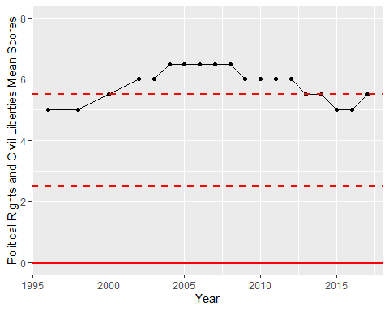

Freedom House Score Trend