Burundi

## Population Data

The data set shows the political stability estimate of the country each year.

## # A tibble: 19 x 5  
## country iso3c date population populationCategory5  
## <chr> <chr> <dbl> <dbl> <chr>   
## 1 Burundi BDI 1996 6060111 small   
## 2 Burundi BDI 1998 6185562 small   
## 3 Burundi BDI 2000 6378871 small   
## 4 Burundi BDI 2002 6704113 small   
## 5 Burundi BDI 2003 6909154 small   
## 6 Burundi BDI 2004 7131693 small   
## 7 Burundi BDI 2005 7364862 small   
## 8 Burundi BDI 2006 7607849 small   
## 9 Burundi BDI 2007 7862214 small   
## 10 Burundi BDI 2008 8126102 small   
## 11 Burundi BDI 2009 8397668 small   
## 12 Burundi BDI 2010 8675602 small   
## 13 Burundi BDI 2011 8958406 small   
## 14 Burundi BDI 2012 9245988 small   
## 15 Burundi BDI 2013 9540289 small   
## 16 Burundi BDI 2014 9844297 small   
## 17 Burundi BDI 2015 10160030 small   
## 18 Burundi BDI 2016 10487998 small   
## 19 Burundi BDI 2017 10827024 small

## Population trend

The plot shows the trends of stabilization and destabilization for the each country.

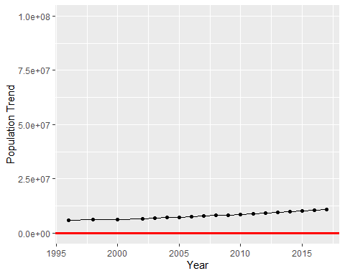

Political Stability Trend