Angola

## Political Stability Estimate Data

The data set shows the political stability estimate of the country for a given year and its classification in four categories (unstable, moderately unstable, moderately stable, stable).

## # A tibble: 19 x 5  
## country iso3c date stability stabilityCategory4   
## <chr> <chr> <dbl> <dbl> <chr>   
## 1 Angola AGO 1996 -2.06 highly unstable   
## 2 Angola AGO 1998 -2.31 highly unstable   
## 3 Angola AGO 2000 -2.04 highly unstable   
## 4 Angola AGO 2002 -1.58 highly unstable   
## 5 Angola AGO 2003 -1.01 highly unstable   
## 6 Angola AGO 2004 -1.06 highly unstable   
## 7 Angola AGO 2005 -0.888 moderately unstable  
## 8 Angola AGO 2006 -0.542 moderately unstable  
## 9 Angola AGO 2007 -0.666 moderately unstable  
## 10 Angola AGO 2008 -0.363 moderately unstable  
## 11 Angola AGO 2009 -0.347 moderately unstable  
## 12 Angola AGO 2010 -0.226 moderately unstable  
## 13 Angola AGO 2011 -0.369 moderately unstable  
## 14 Angola AGO 2012 -0.389 moderately unstable  
## 15 Angola AGO 2013 -0.391 moderately unstable  
## 16 Angola AGO 2014 -0.333 moderately unstable  
## 17 Angola AGO 2015 -0.501 moderately unstable  
## 18 Angola AGO 2016 -0.316 moderately unstable  
## 19 Angola AGO 2017 -0.295 moderately unstable

## Political Stability Estimate Plot

The plot shows the trends of stabilization and destabilization for the each country.

A stabilization trend can be classified as absolute, if the stability scores move from unstable or moderately unstable to moderately stable or stable (that is, crossing up the red line). The trend can be considered relative, if the scores remain in the same positive or negative areas. Similarly, a destabilization trend can be classified as absolute, if the stability scores move from stable or moderately stable to moderately unstable or unstable (that is, crossing down the red line). The trend is considered relative, if the scores remain in the same positive or negative areas.

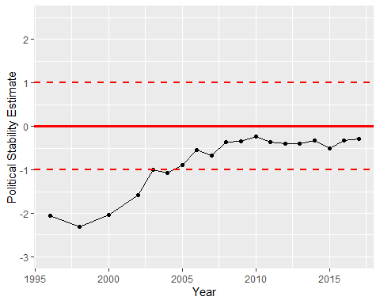

Political Stability Trend