Social and Economic Impact Assessment of the RCA Programme

Non Destructive Testing

Table of Contents

Disclaimer i

Acknowledgements i

Acronyms ii

Executive Summary iii

Introduction iv

Non Destructive Testing iv

Social and economic impact assessment methods iv

Social and economic impacts v

Criterion 1: Improved NDT capacity and capability v

Sub-criterion 1.1: Fulfillment of the Multilateral Recognition Agreement vi

Sub-criterion 1.2: NDT infrastructure to produce certified personnel vii

Sub-criterion 1.3: Self reliance in NDT x

Criterion 2: Increased scope and scale of NDT demand and use xv

Sub-criterion 2.1: Awareness, interest, and application xvi

Sub-criterion 2.2: Research and Development xix

Criterion 3: Improved health and safety xxiv

Economic value (Aaron) xxvi

Conclusion xxvii

Annex: Case studies xxviii

Annex B: Survey Analysis xxix

Introduction xxix

Criterion 1: Improved NDT capacity and capability xxix

Criterion 2: Increased scope and scale of NDT demand and use xxxiii

Criterion 3: Improved health and safety xxxv

Annex C: Economic Analysis xxxvi

Annex D: Theory of Change xxxvii

Annex E: Criteria and standards xxxviii

Annex F: Implementation of NDT technology by industrial sector xli

Work cited li

###### Report Information

|  |  |
| --- | --- |
| Prepared for | International Atomic Energy Agency |
| Prepared by | Julian King, Kate McKegg, Andres Arau, Aaron Schiff, Martina Garcia Aisa |
| Cover image |  |
| Citation | King,J., McKegg, K., Arau, A., Schiff, A., Garcia Aisa, M. (2021). *Social and Economic Impact Assessment of the RCA Programme: Non Destructive Testing Case Study.* Vienna, Austria: International Atomic Energy Agency. |

## Disclaimer

Disclaimer: The information in this document is presented in good faith using the information available to us at the time of preparation. It is provided on the basis that the authors of the document are not liable to any person or organisation for any damage or loss which may occur in relation to taking or not taking action in respect of any information or advice within this document

## Acknowledgements

The authors are grateful for the close and effective assistance of the Technical Cooperation division for Asia-Pacific (TCAP) and Technical Cooperation Division of Programme Support and Coordination (TCPC) of the International Atomic Energy Agency (IAEA), and the experts from the X participating GPs in the X Regional Cooperative Agreement (RCA):

# Acronyms

|  |  |
| --- | --- |
| Name | Acronym |
| Asia Pacific Federation of NDT | APFNDT |
| Eddy Current System | ET |
| Government Party | GP |
| International Atomic Energy Agency | IAEA |
| International Commitee on Non-destructive Testing | ICNDT |
| Multilateral Recognition Agreement | MRA |
| Magnetic Particle Testing | MT |
| National Certification Body | NCB |
| Non Destructuve Testing | NDT |
| Liquid Penetrant Testing | PT |
| Quality Assurance | QA |
| Quality Control | QC |
|  | RCVA |
| Radiographic Testing Method | RT |
| Time of Fligth Diffraction | TOFD |
| Ultrasonic Testing | UT |

# Executive Summary

# Introduction

This report presents the findings of the Social and Economic Impact Assessment of Non Destructive Testing (NDT) of the RCA in Asia and the Pacific. The data that informs the analysis was collected through an online survey conducted between June and August 2021. The respondents of the survey were national experts on the field of NDT from 20 countries whom provided relevant information about the equipment, training centres, certified personal, and health and safety impacts of the RCA programme in their country.

From the 22 countries that are part of the Cooperative Agreement for Research (RCA), 20 participated in the survey: Australia, Bangladesh, Cambodia, China, India, Indonesia, Japan, Laos, Malaysia, Mongolia, Myanmar, Nepal, New Zealand, Pakistan, Philippines, Singapore, South Korea, Sri Lanka, Thailand, and Vietnam.

Figure: 1 below shows the countries that participated in this study

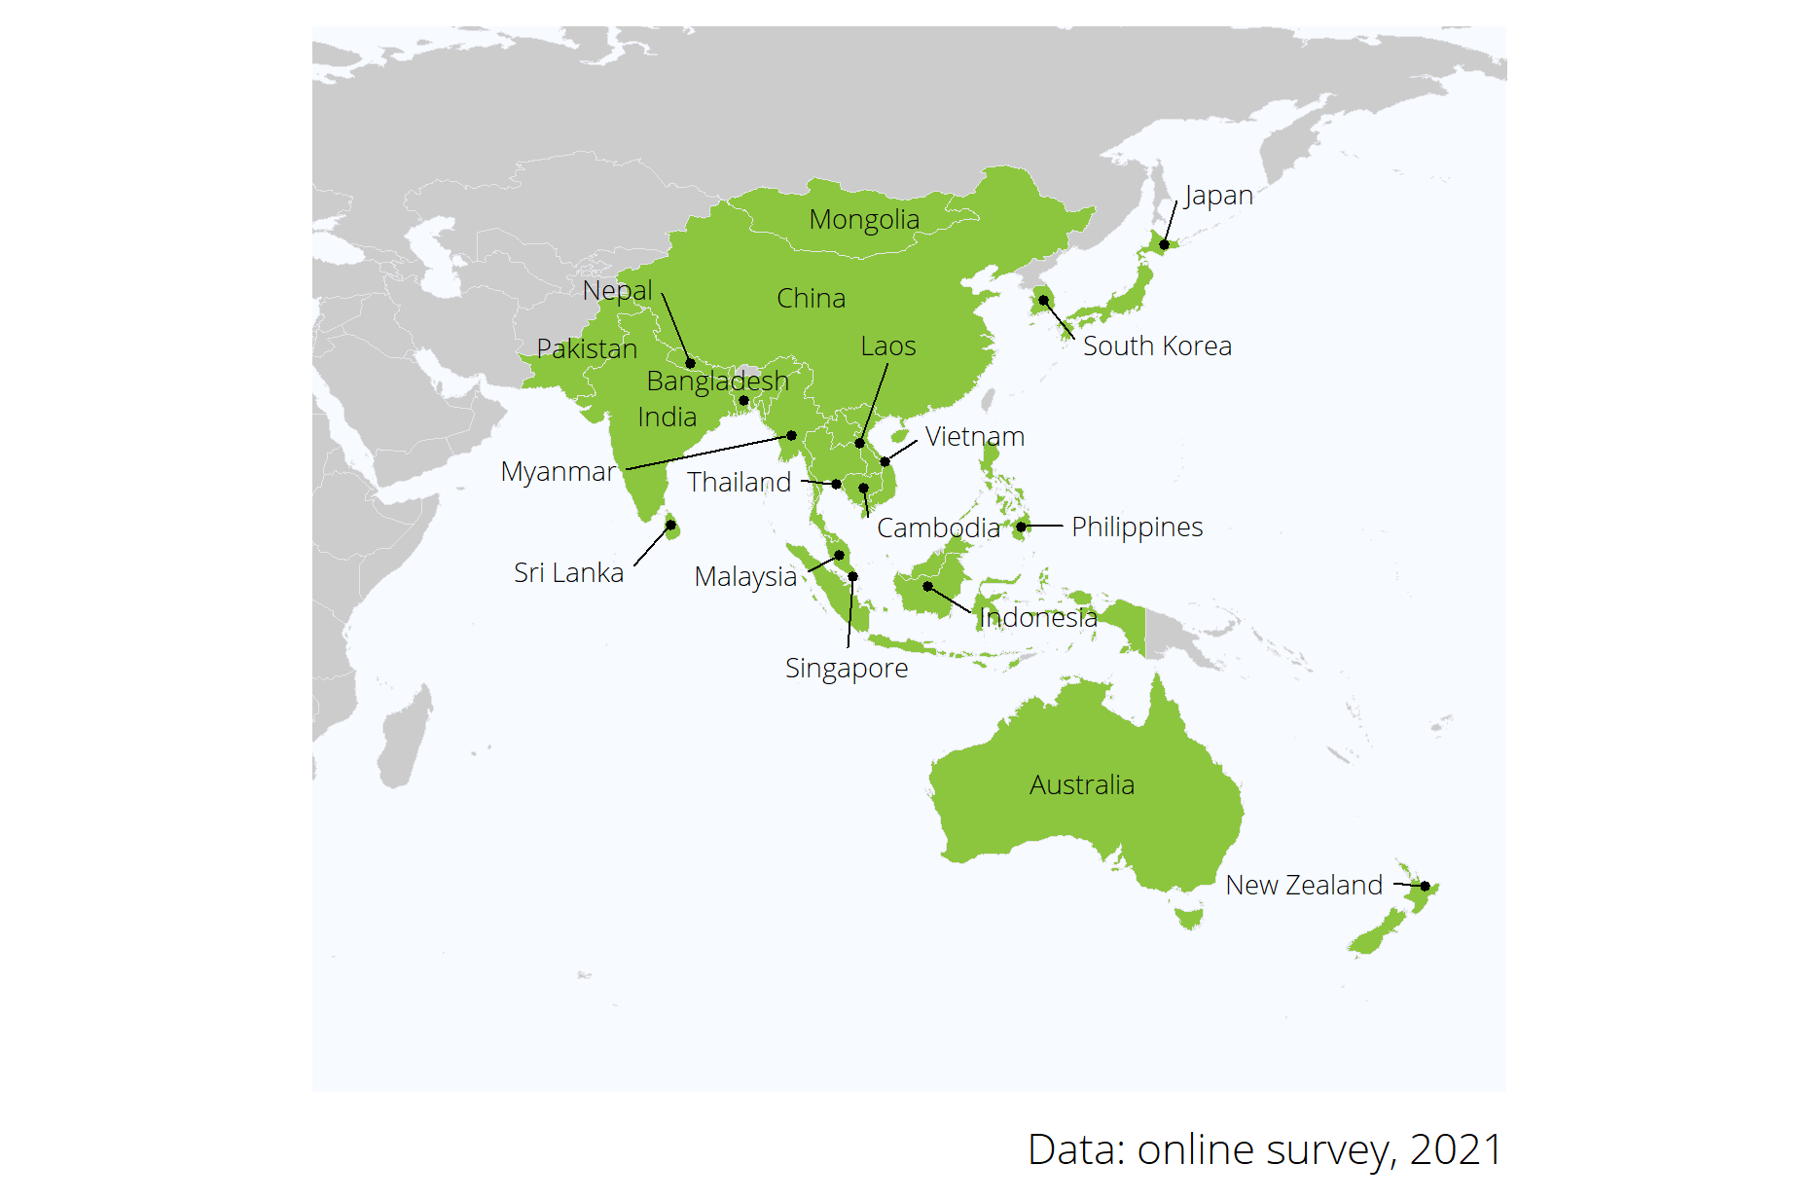

Figure 1: Map of the 20 countries that partipicated in the online survey.

## Non Destructive Testing

## Social and economic impact assessment methods

# Social and economic impacts

## Criterion 1: Improved NDT capacity and capability

To understand the contribution of the NDT RCA programme in the capacity and capability of the Government Parties (GPs) this section presents the results of the assessment of the extent to which the support of the NDT RCA programme has enabled GPs to:

1. Fulfill the Multilateral Recognition Agreement (MRA) requirements of the International Committee on Non-destructive Testing (ICNDT) as a result of the support under the NDT RCA programme;
2. Establish GPs’ NDT infrastructure to produce certified personnel in advanced techniques (RT-D, PAUT, TOFD, PEC, etc), in addition to the conventional methods (RT, UT, MT, PT, ET); and
3. Achieve self-reliance in NDT, including offering training and inspection activities to local industries as well as abroad.

Key results of this assessment are summarized in Table XXX below.

Key evidence for criterion 1: Improved NDT capacity and capability

|  |  |  |
| --- | --- | --- |
| Sub-criterion | Evidence | Finding |
| Fulfillment of MRA | % of GPs that have established a National Certification Scheme | 70% |
| Fulfillment of MRA | % of GPs that have established a National Certification Body | 85% |
| NDT infrastructure to produce certified personnel | Personnel certified in conventional and advanced techniques from 2000 to 2020 under NDT RCA | 307,700 |
| Self-reliance in NDT | Inspection centres owned by local firms | 3,607 |
| Self-reliance in NDT | Training centres owned by local firms | 191 |

Moreover, figure 2 below shows the performance standards of the impact of NDT RCA on the GPs’ capacity and capability in NDT. Further details on he criterion and standards for this dimension are presented in Annex E.

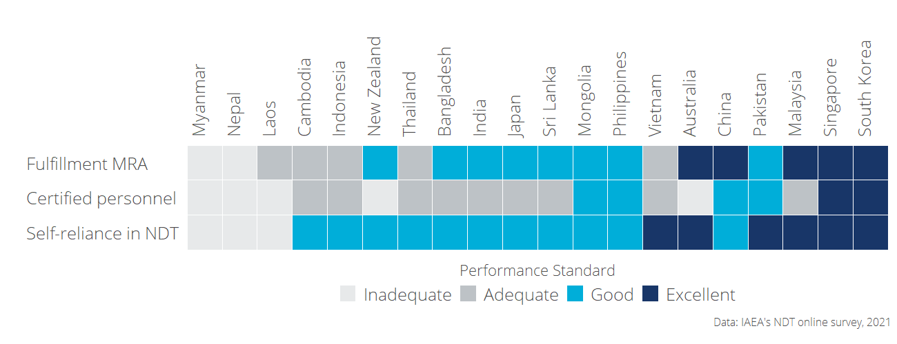

Figure 2: Capacity and capability of the Government Parties (GPs): Performance standard by criterion and country

The detailed analysis of each sub-criterion under improved NDT capacity and capability is presented in the sections below.

### Sub-criterion 1.1: Fulfillment of the Multilateral Recognition Agreement

An excellent performance standard for this dimension is defined as the extent to which a GP has fulfilled the MRA requirements of ICNDT and the status of the NDT infrastructure at the national level.

#### Performance standards of “Fulfillment of the Multilateral Recognition Agreement”

Figure 3 shows the level of NDT infrastructure that each GP has established and the performance standards for this dimension. From the 20 countries that participated in the study, only Nepal and Myanmar have not established a National Certification Scheme yet; Almost all countries but Laos, Cambodia, Nepal, and Myanmar have registered their NDT society in the Asia Pacific Federation of NDT (APFNDT); and for 10 out of the 20 GPs, their NCB for NDT has been accredited to ISO 17024.

Based on the criterion developed by RCA to assess the performance of GPs in terms of infrastructure, Australia, China, Malaysia, Singapore, and South Korea have excellent performance standards on this dimension. (See criterion and standards in Annex E)

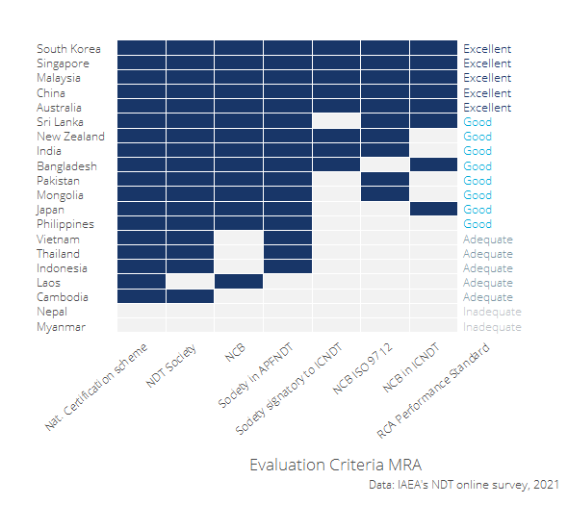

Figure 3: NDT infrastructure at the national level and assessment standards.

#### Contribution of the NDT RCA in GP’s establishing a NCB and NCS

To assess the contribution of RCA in the establishment of NCBs and National Certification Schemes, the participants of the online survey were asked whether their Government Party has established a National Certification scheme and a National Certification Body (NCB) and the extent to which they perceive that the RCA NDT programme has contributed to the establishment of this infrastructure in their countries.

As it can be seen in the Table 1 below, from the fourteen GPs that have established a NCB, ten **(Bangladesh, China, Laos, Malaysia, Mongolia, Pakistan, Philippines, Singapore, South Korea, and Sri Lanka) perceived that the RCA programme has contributed to a great extent in the establishment of their national NCB**. Only Australia, Japan, and New Zealand perceive that the establishment of their NCB could have been achieved without the support of the RCA programme.

Table 1: Contribution of RCA programme in GP’s infrastructure

|  |  |  |  |  |  |
| --- | --- | --- | --- | --- | --- |
| Country | Has NCB | RCA contribution to establish NCB | Has NDT certification scheme | RCA contribution to establish NDT certification scheme | RCA standard |
| Australia | Yes | Not at all | Yes | Not at all | Excellent |
| Bangladesh | Yes | To a great extent | Yes | To a great extent | Good |
| Cambodia | No |  | Yes | Not at all | Adequate |
| China | Yes | To a great extent | Yes | To a great extent | Excellent |
| India | Yes | Little | Yes | Little | Good |
| Indonesia | No |  | Yes | To a great extent | Adequate |
| Japan | Yes | Not at all | Yes | Not at all | Good |
| Laos | Yes | To a great extent | No |  | Adequate |
| Malaysia | Yes | To a great extent | Yes | To a great extent | Excellent |
| Mongolia | Yes | To a great extent | Yes | Little | Good |
| Myanmar | No |  | No |  | Inadequate |
| Nepal | No |  | No |  | Inadequate |
| New Zealand | Yes | Not at all | Yes | Not at all | Good |
| Pakistan | Yes | To a great extent | Yes | To a great extent | Good |
| Philippines | Yes | To a great extent | Yes | To a great extent | Good |
| Singapore | Yes | To a great extent | Yes | To a great extent | Excellent |
| South Korea | Yes | To a great extent | Yes | To a great extent | Excellent |
| Sri Lanka | Yes | To a great extent | Yes | To a great extent | Good |
| Thailand | No |  | Yes | Not at all | Adequate |
| Vietnam | No |  | Yes | To a great extent | Adequate |

### Sub-criterion 1.2: NDT infrastructure to produce certified personnel

This section presents the findings on the extent to which the NDT RCA has supported GPs in establishing NDT **infrastructure through the RCA programme has enabled GPs to produce certified personnel in conventional methods (RT, UT, MT, PT, ET) and in advanced techniques** (RT-D, PAUT, TOFD, PEC, etc).

#### Performance standards of “NDT infrastructure to produce certified personnel”

According to the methodology of the evaluation, an excellent performance for this dimension is given if the RCA NDT programme has enabled a GP to produce certified personnel in all conventional and advance techniques, a good and adequate performance is considered if the support has enabled to produce certified personnel in all conventional or at least one conventional technique respectively.

Figure 4 shows that based on this criteria, two countries have met an excellent standard (Singapore and South Korea) because RCA NDT has contributed or facilitated the introduction of all methods and techniques to their personnel, four GPs met a good standard (China, Mongolia, Pakistan, and Philippines) because the RCA NDT programme has facilitated the certification of their personnel in all the conventional techniques.

Australia, Laos, Myanmar, Nepal, and New Zealand are consider to have an inadequate standard because, according to responses provided by their experts, RCA NDT has not necesarily contributed to the certification of their personnel in any of these techniques.

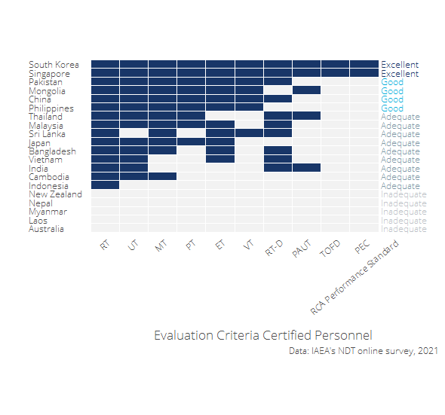

Figure 4: Personnel certified by methods: standards for self-reliance

#### Contribution of the NDT RCA in the certification of personnel

As it can be seen in Table 2, **since 2020, the NDT RCA programme has contributed to the certification of 307,700 personnel by local NDT Accredited Training Centres in 15** countries (Bangladesh, Cambodia, China, India, Indonesia, Japan, Malaysia, Mongolia, Pakistan, Philippines, Singapore, South Korea, Sri Lanka, Thailand, and Vietnam). From the total certified personnel, 5.6% are female.

The method for which RCA has contributed the most to the certification of personnel is Radiographic Testing (223,900 personnel trained), followed by Penetrant Testing and Ultrasonic Testing.

*As it can be seen in the table below, it is possible that RCA NDT programme has indeed sensitised and provided awareness in GP’s for the introduction of certifications in the main and advanced NDT techniques; For some countries "RCA had helped introduce and sensitise the NDT programme in the early years of cooperation. However, in the last 20 years, NDT centres in the country did conduct training and certification programmes under the national NDT Society and others but they have not been, necesarily, in association with RCA* (National expert, online survey 2021).

Table 2: Number of certified personnel by contry and technique

|  |  |  |  |  |  |  |
| --- | --- | --- | --- | --- | --- | --- |
| Method | Accronym | Type of technique | Persnonnel certified per year under RCA | Personnel certified from 2000 to 2020 under RCA | (%) of Certified female personnel | Countries supported by RCA NDT |
| Radiographic Testing | RT | Conventional | 11,195 | 223,900 | 5.01% | 15 |
| Ultrasonic Testing | UT | Conventional | 1,070 | 21,400 | 5.63% | 13 |
| Magnetic Testing | MT | Conventional | 1,003 | 20,060 | 9.73% | 12 |
| Penetrant Testing | PT | Conventional | 1,126 | 22,520 | 8.17% | 9 |
| Eddy Current Testing | ET | Conventional | 469 | 9,380 | 4.01% | 11 |
| Visual Testing | VT | Conventional | 359 | 7,180 | 4.49% | 7 |
| Radiographic Testing - Digital | RT-D | Advanced technique | 149 | 2,980 | 6.36% | 10 |
| Phased Array Ultrasonic Testing | PAUT | Advanced technique | 0 | 0 | - | 5 |
| Time of Flight Diffraction | TOFD | Advanced technique | 7 | 140 | 25% | 2 |
| Pulsed Eddy Current | PEC | Advanced technique | 7 | 140 | 25% | 2 |
| Total | - | - | 15,385 | 307,700 | 5.58% | 15 |

The total number of **certified personnel under the RCA programme** by country, technique, and sex is presented in Figure 5 below.

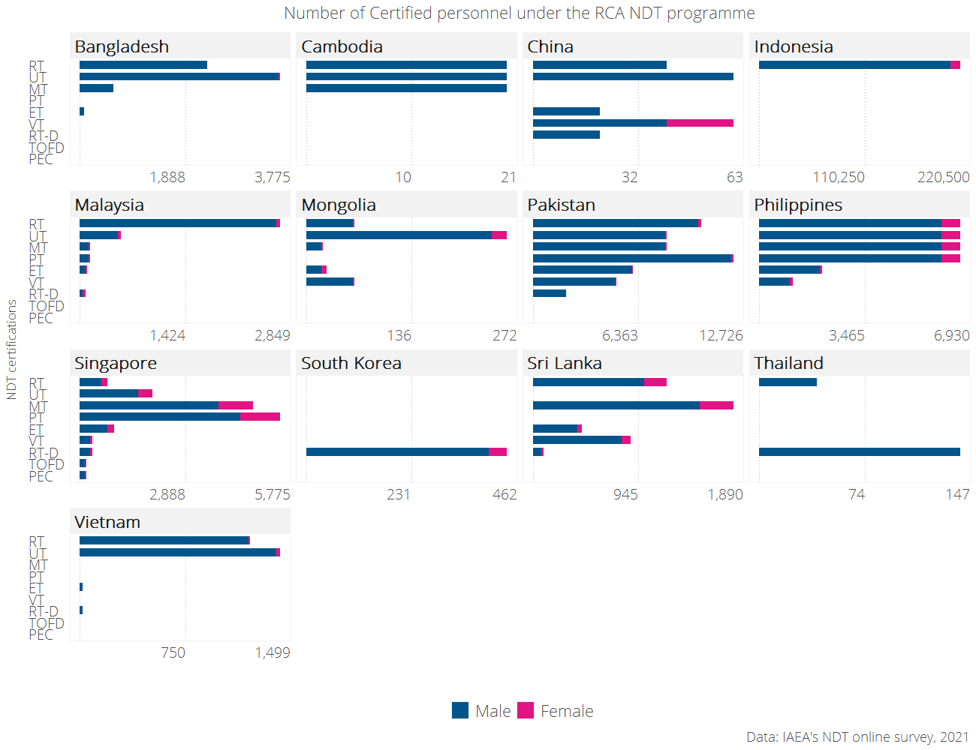

Figure 5: Number personnel that was certified by local NDT training centers as a result of participating in RCA NDT.

### Sub-criterion 1.3: Self reliance in NDT

Self reliance in NDT is a function of countries having the capacity to conduct inspection and train personnel without depending on external stakeholders. An assessment to map whether GPs have inspection and training centers owned locally or by foreigners was conducted to estimate the level of self-reliance that each GP has. According to the criterion developed, a GP is considered to have an excellent standard (or to have achieved increased self-reliance) if their local inspection and training centres offer their services abroad. On the other hand, the self-reliance of a GP is considered inadequate if it does not have both training and certification centres owned either by local or foreign firms.

#### Performance standards of “Self-reliance in NDT”

As it can be seen in Figure 6 that displays the criterion and standards for this dimension. 6 countries (Australia, Malaysia, Pakistan, Singapore, South Korea, and Vietnam) offer both training and inspection abroad. Moreover, Myanmar and Nepal do have access to inspection centres (either owned locally or by foreigners) but they do not have training centres offering services in their countries.

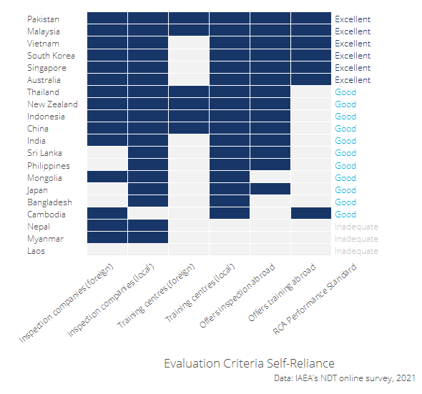

Figure 6: GP’s inspection and training centers: standards for self-reliance

#### Contribution of RCA in the development of local inspection and training centers

According to the own perception of the GPs which participated in the online survey, **the RCA NDT programme has contributed to a great extent in the establishment of inspection centres in nine of the twenty-two countries that are part of the programme** (Bangladesh, China, Indonesia, Malaysia, Pakistan, Philippines, Singapore, South Korea, and Vietnam); in ten countries RCA has facilitated the investment in local investment centres; and, twelve countries perceived that RCA has contributed to a great extent in the establishment of local training centres (See Table 3)

Table 3: Contribution of the NDT RCA programme to the establishment of local inspection and training centres.

|  |  |  |  |  |  |  |
| --- | --- | --- | --- | --- | --- | --- |
| Country | Has local inspection companies | RCA contribution to establish local inspection centres | RCA contributed to facilitate investment in inspection centres | Has local training centres | RCA contribution to establish local training centres | RCA standard |
| Australia | Yes | Not at all | No | Yes | Not at all | Excellent |
| Bangladesh | Yes | To a great extent | Yes | Yes | To a great extent | Good |
| Cambodia | No | Not at all | No | Yes | Little | Good |
| China | Yes | To a great extent | Yes | Yes | To a great extent | Good |
| India | Yes | Little | Yes | Yes | Not at all | Good |
| Indonesia | Yes | To a great extent | Yes | Yes | To a great extent | Good |
| Japan | Yes | Not at all | No | Yes | Not at all | Good |
| Laos | No |  | No | No |  | Inadequate |
| Malaysia | Yes | To a great extent | Yes | Yes | To a great extent | Excellent |
| Mongolia | Yes | Little | No | Yes | To a great extent | Good |
| Myanmar | Yes | Little | No | No |  | Inadequate |
| Nepal | Yes | Little | No | No |  | Inadequate |
| New Zealand | Yes | Not at all | No | Yes | To a great extent | Good |
| Pakistan | Yes | To a great extent | Yes | Yes | To a great extent | Excellent |
| Philippines | Yes | To a great extent | Yes | Yes | To a great extent | Good |
| Singapore | Yes | To a great extent | Yes | Yes | To a great extent | Excellent |
| South Korea | Yes | To a great extent | Yes | Yes | To a great extent | Excellent |
| Sri Lanka | Yes | Little | No | Yes | To a great extent | Good |
| Thailand | Yes | Not at all | No | Yes | Little | Good |
| Vietnam | Yes | To a great extent | Yes | Yes | To a great extent | Excellent |

Figure 7 below shows the number of **inspection centres** owned by local and foreign firms in each RCA country.

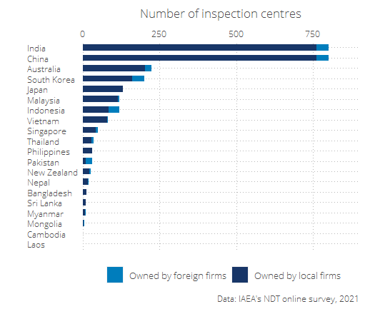

Figure 7: Number of inspection centres by type of ownership and country

Figure 8 below shows the number of **training centres** own by local and foreign firms in each RCA country.

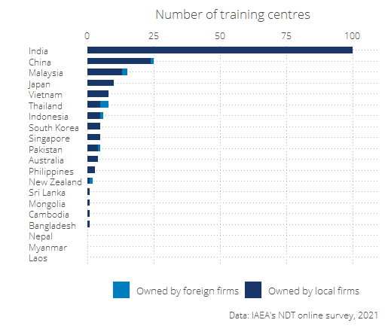

Figure 8: Number of inspection centres by type of ownership and country

## Criterion 2: Increased scope and scale of NDT demand and use

This section presents the findings of the contribution of the NDT RCA programme on the increased scope and scale of NDT demand and use of the Government Parties. Particularly, the analysis aims to understand the extent to which the support of the NDT programme has contributed to the enhancement of:

1. Awareness, interest, and application of NDT technology in the industrial sectors for the QA and QC of industrial components; and
2. Knowledge developed through R&D by publishing research articles, organising international and national seminars and conferences.

Key evidence for criterion 2: Increased scope and scale of NDT demand and use

|  |  |  |
| --- | --- | --- |
| Sub-criterion | Evidence | Finding |
| Awareness, interest, and application of NDT technology | % of GPs that have taken actions to create awareness among industrial organisations about the benefits of NDT technology for Quality Assurance and Quality Control | 90% |
| Awareness, interest, and application of NDT technology | % of GPs that have applied NDT technology for Quality Assurance and Quality Control in at least one industrial sector | 90% |
| Knowledge developed through R&D | % of GPS that have established any R&D activities related to NDT | 75% |
| Knowledge developed through R&D | Number of publications related to NDT that have been published since 2000 in as a result of being part of the RCA NDT programme | 1,620 |

Moreover, figure 9 below shows the performance standards of the impact of NDT RCA programme on the increased scope and scale of NDT demand and use of the Government Parties. Further details on the criterion and standards for this dimension are presented in Annex E.

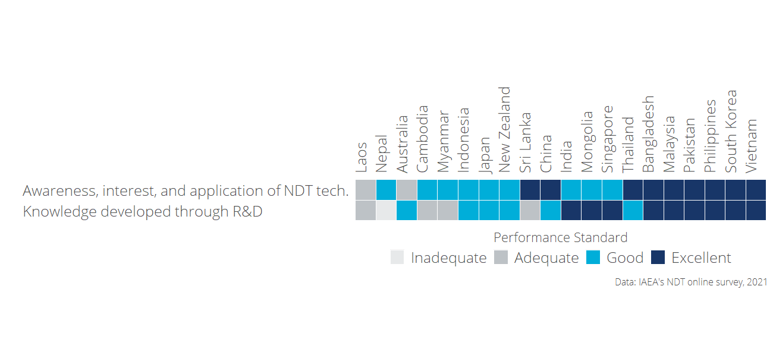

Figure 9: Increased scope and scale of NDT demand and use: Performance standard by criterion and country

The detailed analysis of each sub-criterion under improved NDT capacity and capability is presented in the sections below.

### Sub-criterion 2.1: Awareness, interest, and application

This sub-criterion explores **the extent into which participation in the RCA programme results in GPs applying NDT technology in the industrial sectors for the QA and QC** of industrial components: achieving better controlled manufacturing, lower production costs, ensuring material quality, and/or greater product integrity.

#### Performance standards of “Awareness, interest, and application of NDT technologies”

An *excellent* performance in terms of Awareness, interest, and application of NDT technologies is considered if participating in the RCA programme results in GPs applying NDT technology in at least one industrial sector for the QA and QC of industrial components - achieving better controlled manufacturing, lower production costs, ensuring material quality, and/or greater product integrity-.

A *good* performance is met if as a result of being part of the NDT RCA programme, GPs become more concerned and interested into applying NDT technology in the industrial sectors; and an *adequate* standard is when the NDT RCA programme has contributed to GPs initiating activities to create awareness among industrial organisations about the benefits of NDT technology for QA and QC.

Bangladesh, China, Malaysia, Pakistan, Philippines, South Korea, Sri Lanka, Thailand, and Vietnam are considered to have met an excellent performance in this sub-criterion because, as a result of applying NDT technology, positive improvements have been achieved in terms of *controlled manufacturing, lower production costs, ensuring material quality or greater productivity for at least one industrial sector* (all the positive improvements by country and industrial sector is presented in the next section).

Moreover, these nine GPs have taken actions to create awareness among industrial organisations about the benefits of NDT technology. For all these GPS, being part of the RCA NDT programme has also contributed to increase the concern/interest about applying NDT technologies for Quality Assurance and Quality Control in their industrial sector.

Figure 10 shows the criterion and standards for this sub-dimension. The detailed methodology and criteria is presented in Annex E.

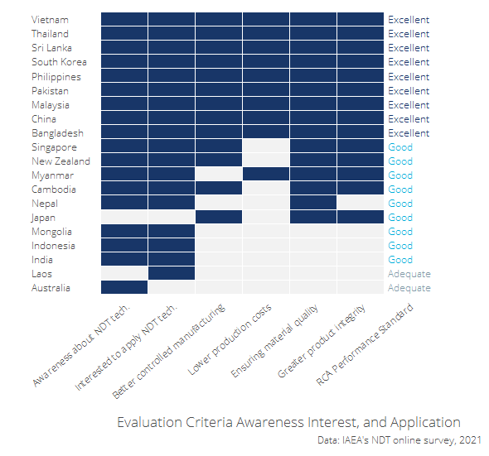

Figure 10: Performance standards: Awareness, interest, and application of NDT technology in the industrial sectors for the QA and QC of industrial components

#### Contribution of the NDT RCA in Awareness, interest, and application of NDT technologies

Table 4 shows that nine of the GPs have taken actions to create awareness among industrial organisations about the benefits of NDT technology for Quality Assurance and Quality Control. The table also shows the of actions taken by these GPs.

Table 4: Actions taken by GPs to create awareness among industrial organisations about the benefits of NDT technology for Quality Assurance and Quality Control

|  |  |  |  |  |
| --- | --- | --- | --- | --- |
| Country | Has taken actions to create awarenes about benefits of NDT | Has conducted seminars, workshops and/or forums | Has engaged with policymakers and regulatory body(s) | Has conducted talks to universities or colleges |
| Australia | Yes | Yes | Yes | No |
| Bangladesh | Yes | Yes | Yes | Yes |
| Cambodia | Yes | Yes | Yes | Yes |
| China | Yes | Yes | Yes | Yes |
| India | Yes | Yes | Yes | Yes |
| Indonesia | Yes | Yes | Yes | Yes |
| Japan | No |  |  |  |
| Laos | No |  |  |  |
| Malaysia | Yes | Yes | Yes | Yes |
| Mongolia | Yes | No | Yes | No |
| Myanmar | Yes | Yes | Yes | Yes |
| Nepal | Yes |  |  |  |
| New Zealand | Yes | Yes | Yes | Yes |
| Pakistan | Yes | Yes | Yes | Yes |
| Philippines | Yes | Yes | Yes | Yes |
| Singapore | Yes | Yes | Yes | Yes |
| South Korea | Yes | Yes | Yes | Yes |
| Sri Lanka | Yes | Yes | No | Yes |
| Thailand | Yes | Yes | Yes | Yes |
| Vietnam | Yes | Yes | Yes | Yes |

All the number of industrial sectors in which NDT technology has been applied for quality control and quality assurance in each GP is presented in figure below.

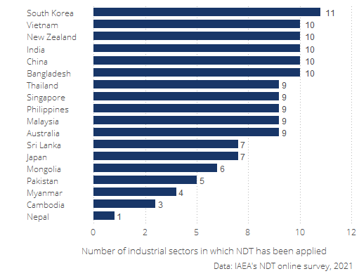

Figure 11: Number of industrial sectors in which NDT technology has been applied by GP

The extent to which the introduced NDT technology by the RCA programme led to improved manufacturing processes, lower production costs, enhanced material quality, and greater product integrity in each industrial sector is presented in Annex F. *For some countries, the information is incomplete because they did not provide this information in the online survey*

### Sub-criterion 2.2: Research and Development

This section aims to understand the extent into which the NDT RCA programme has contributed to the dissemination the knowledge developed through R&D.

#### Performance standards of “Research and Development”

An *“excellent”* performance of this sub-criterion is considered if **as a result of participating in the NDT RCA programme, GPs have managed to support the utilisation of the technology by industry and disseminate the knowledge developed through R&D** by publishing research articles, organising international and national seminars and conferences.

A *“good”* performance is met if the support of the NDT RCA programme has enable GPs to have successfully applied the NDT technology to local industry, and established R&D activities; and an *adequate* performance means that the GPs have successfully managed to train personnel in the introduced NDT technology.

From the 20 GPs that participated in the study, nine GPs (Bangladesh, India, Malaysia, Mongolia, Pakistan, Philippines, Singapore, South Korea, and Vietnam) met an excellent performance in R&D because as a result of participating in the NDT RCA programme, they have published research articles, and have organized international and national seminars and conferences.

Because Australia, China, Indonesia, Japan, New Zealand, and Thailand have established R&D activities but have not published or organized seminars, their performance is considered to be good.

Figure 12 shows the GPs’ performance in terms of R&D

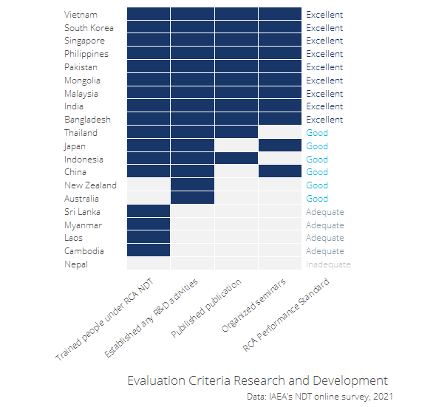

Figure 12: Performance standards: Research and Development

#### Contribution of the NDT RCA in Research and Development

A total 2,674 personnel has been trained in NDT under the RCA NDT programme. Figure 13 shows the number of personnel who have been trained in NDT under the RCA NDT programme by country

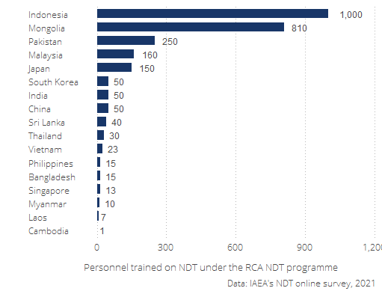

As it can be seen in figure 14, Since 2000 a total of 1,620 publications related to NDT have been published as a result of GPs being part of the RCA NDT programme.

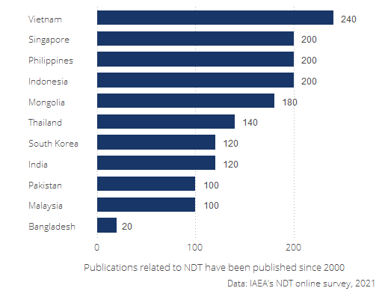

4,300 seminars/conferences related to NDT have been organised since 2000 as a result of GPs being part of the RCA NDT programme. (See figure 15).

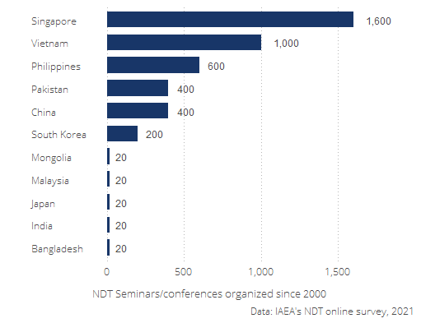

The table below shows the Extent to which the RCA NDT programme enabled or promoted the initiation of R&D activities related to NDT.

Table 5: Extent to which the RCA NDT programme enabled or promoted the initiation of R&D activities related to NDT

|  |  |  |  |  |
| --- | --- | --- | --- | --- |
| Country | Has established any R&D activities related to NDT | Publications related to NDT since 2000 | Seminars related to NDT organized since 2000 | Extent to which the RCA NDT enabled or promoted the initiation of R&D activities |
| Australia | Yes | 0 | 0 |  |
| Bangladesh | Yes | 20 | 20 | To a great extent |
| Cambodia | No |  |  |  |
| China | Yes | 0 | 400 | To a great extent |
| India | Yes | 120 | 20 | Little |
| Indonesia | Yes | 200 |  |  |
| Japan | Yes | 0 | 20 | To a great extent |
| Laos | No |  |  |  |
| Malaysia | Yes | 100 | 20 | To a great extent |
| Mongolia | Yes | 180 | 20 | Little |
| Myanmar | No |  |  |  |
| Nepal |  |  |  |  |
| New Zealand | Yes | 0 | 0 |  |
| Pakistan | Yes | 100 | 400 | To a great extent |
| Philippines | Yes | 200 | 600 | To a great extent |
| Singapore | Yes | 200 | 1600 | Little |
| South Korea | Yes | 120 | 200 | To a great extent |
| Sri Lanka | No |  |  |  |
| Thailand | Yes | 140 | 0 | To a great extent |
| Vietnam | Yes | 240 | 1000 | To a great extent |

## Criterion 3: Improved health and safety

The aim of this section is to understand **the extent to which participating in the NDT RCA program** of IAEA has enable GPs in **applying NDT technology** in the industrial sectors as set by countries’ industrial laws for the QA and QC of industrial components and whether it has **resulted in improved health and safety outcomes** (i.e. fewer deaths and injuries) and/or reduced environmental pollution.

Key evidence for criterion 3: Improved health and safety

|  |  |  |
| --- | --- | --- |
| Criterion | Evidence | Finding |
| Improved health and safety | % of GPs that perceive that the RCA NDT programme contributed to the awareness of the benefits of using NDT technologies for safer operations of nuclear and other industrial installations |  |
| Improved health and safety | % of GPs that perceive that the RCA NDT programme contributed contributed to applying NDT technologies for safer operations of nuclear and other industrial installations |  |
| Improved health and safety | Approximate total accumulated number of injuries that have been prevented in the industrial sector since 2000 as a result of applying NDT technologies |  |
| Improved health and safety | Approximate total accumulated number of deaths that have been prevented in the industrial sector since 2000 as a result of applying NDT technologies |  |
|  | Approximate total accumulated reduction of CHEMICAL WASTE (in tons) since 2000 as a result of applying NDT technologies |  |

Moreover, figure 9 below shows the performance standards of the impact of NDT RCA programme on the Improved health and safety criteria. Further details on the criterion and standards for this dimension are presented in Annex E.

The detailed analysis of each sub-criterion under improved NDT capacity and capability is presented in the sections below.

#### Performance standards of “Improved Health and Safety”

* Adequate: Participation in the RCA program of IAEA results in **GPs becoming more aware of the benefits of NDT technology for safer operation** of nuclear and other industrial installations. *hs_awareness*

9.1 To what extent has being part of the RCA NDT programme contributed to the AWARENESS of the benefits of using NDT technologies for safer operations of nuclear and other industrial installations in %country%?

* Good: Participation in the RCA program of IAEA results in **GPs applying NDT technology for safer operation** of nuclear and other industrial installations. *hs_applying*

To what extent has being part of the RCA NDT programme contributed to applying NDT technologies for safer operations of nuclear and other industrial installations in %country%?

* Excellent: As a result of participation in the RCA program of IAEA, GPs have been applying NDT technology in the industrial sectors as set by countries’ industrial laws for the QA and QC of industrial components, **resulting in improved health and safety outcomes (i.e. fewer deaths and injuries) and/or reduced environmental pollution**. *hs_injuries hs_deaths hs_pollution*

#### Contribution of the NDT RCA in Improved Health and Safety

## Economic value (Aaron)

# Conclusion

# Annex: Case studies

# Annex B: Survey Analysis

## Introduction

X GPs are part of the agreement, findings include analysis of data collected from X experts.

Add Description of how the standards and criterion were define

## Criterion 1: Improved NDT capacity and capability

Brief description of relevance and background of this criteria **Julian**

Table 6: Table 1: Key evidence for criterion 1

|  |  |  |  |  |  |  |  |  |
| --- | --- | --- | --- | --- | --- | --- | --- | --- |
| Varname | Evidence | Dimension | Standard | Source | Question | Comments | AS comment | JK comment |
|  | ** Official infrastructure ** |  |  |  |  |  |  |  |
| cert_schm | %GP% with a National Certification Scheme on NDT | Official infrastructure | Adequate | Online survey | Has %GP% established a national NDT Certification Scheme? |  |  |  |
| cert_schm_lkrt | %GP% claims that the RCA NDT programme contributed to the establishment of the National Certification Scheme on NDT | Official infrastructure | Adequate | Online survey | In your opinion, to what extent did the RCA NDT programme contribute to the establishment of the NDT Certification Scheme in %GP%? To a great extent / Little / Not at all |  |  |  |
| cert_ncb | %GP% with a established national NDT Certification Body (NCB) on NDT | Official infrastructure | Good | Online survey | Has %country% established a national NDT Certification Body (NCB)? |  |  |  |
| cert_ncb_ICNDT | %GP% with NCB which has been accepted for registration under ICNDT MRA | Official infrastructure | Excellent | Online survey | If NCB, Has the NCB been accepted for registration by the ICNDT under the MRA? |  |  |  |
| cert_ncb_iso17024 | %GP% with NCB which has been accredited to ISO 17024 | Official infrastructure | Excellent | Online survey | If NCB, Is the NCB offering ISO 9712 certification? Is it accredited to ISO 17024? |  |  |  |
| cert_body_lkrt | %GP% claims that the RCA NDT programme contributed to the establishment of the national NCB | Official infrastructure | Good | Online survey | In your opinion, to what extent did the RCA NDT programme contribute to the establishment of the NDT National Certification Body (NCB) in %GP%? |  |  |  |
| cert_society | %GP% with NDT Society established | Official infrastructure | Good | Online survey | Has the NDT Society been established in %country%? |  |  |  |
| cert_society_year |  |  | Good | Online survey | Please state the year when the NDT Society was established in %country%? |  |  |  |
| cert_society_mems |  |  | Good | Online survey | How many registered members does your NDT Society have? |  |  |  |
| cert_society_ICNDT | %GP% with NDT Society which is a signatory to ICNDT MRA | Official infrastructure | Excellent | Online survey | Is the NDT Society a signatory to the ICNDT MRA? |  |  |  |
| cert_society_APPFNDT | %GP% with NDT Society which is registered with APFNDT | Official infrastructure | Excellent | Online survey | Is the NDT Society a registered member of the Asia Pacific Federation of NDT (APFNDT)? |  |  |  |
|  | %GP% with NDT Society which is registered with APFNDT and ICNDT | Official infrastructure | Excellent | Online survey | We will use the combination of the above two questions. |  |  |  |
| cert_society_role | %GPs% with NDT societies playing a relevant role to flourish the NDT technology in its country | Official infrastructure | Excellent | Online survey | What are the role(s) of the NDT Society which contribute to promoting the uptake of NDT technology in %country%? List of roles is: |  |  |  |

Promote the establishment and acceptance of national NDT certification scheme at the national level Promote the establishment of the NCB, training centres, inspection companies, for a sustainable NDT infrastructure in the country Provide representatives in strategic national committees to uphold and protect the interests of NDT stakeholders Promote the recognition and acceptance of NDT certificates issued by the NCB at the international level through ICNDT MRA Advance scientific, engineering, and technical knowledge in the field of NDT through education, research, seminar, workshop, forum etc. Enhance technical and administrative awareness among decisionmakers and stakeholders on the progress and way forward of NDT at the global level |Do we want it single select or multiple select? |The wording of this question is very complicated, will people who are not fluent in english be able to understand it? Have rephrased |Multiple select, I think OK | |cert_society_lkrt |%GP% claims that the RCA NDT programme contributed to the establishment of the NDT Society |Official infrastructure |Good |Online survey |In your opinion, to what extent did the RCA NDT programme contribute to the establishment of the NDT Society in %GP%? | | | | | |** Inspection companies and training centres ** | | | | | | | | | |%GP% has inspection companies owned by foreign entities |Inspection companies and training centres |Adequate |Online survey |Approximately, how many NDT inspection companies are there in %country%? | | | | | |%GP% has local inspection companies |Inspection companies and training centres |Good |Online survey |Approximately, how many of these %insp_services% NDT inspection companies are local (not foreign) companies? | | | | | |%GP% has local inspection companies which provided services abroad |Inspection companies and training centres |Excellent |Online survey |Has any of the %insp_services_local% local NDT inspection companies provided its services abroad? | | | | | |%GP% claims that the RCA NDT programme contributed to the establishment of local inspection companies |Inspection companies and training centres |Good |Online survey |In your opinion, how much has the RCA NDT programme contributed to the establishment of these local inspection companies in %country%? | | | | | | |Inspection companies and training centres | | |Approximately, what was the estimated total revenues of NDT inspection companies in 2000 and 2020 in local currency %currency%? | | | | | | |Inspection companies and training centres | | |Approximately, what is the average net profit of NDT inspection companies as a proportion of revenues in %country%? Less than 5% of revenue…1 Between 5 - 10% of revenue…2 Between 10 - 15% of revenue…3 Between 15 - 20% of revenue…4 More than 20%…5 | | | | | | |Inspection companies and training centres | | |Approximately, what is the average number of NDT inspections carried out by each licensed NDT inspector per year? | | | | | | |Inspection companies and training centres | | |What is the overall average price charged for one NDT inspection carried out by a licensed inspector of a private sector NDT inspection company in local currency?  | | | | | |%GP% has NDT training centres owned by foreign entities |Inspection companies and training centres |Adequate |Online survey |How many NDT training centres are operating in %country%? | | | | | |%GP% has local NDT training centres |Inspection companies and training centres |Good |Online survey |How many of the %traincen% NDT training centres are local (not foreign) centres? | | | | | |%GP% has local training centres which provided training abroad |Inspection companies and training centres |Excellent |Online survey |Has any of the %traincen_locall% local NDT training centres provided training activities abroad? | | | | | |%GP% has local NDT training centres offering ISO 9712 training |Inspection companies and training centres |Good |Online survey |How many of the %traincen_local% local NDT training centers are offering ISO 9712 certification? | | | | | |%GP% has local NDT training centres accredited under the national NDT Certification Scheme |Inspection companies and training centres |Excellent |Online survey |How many of the %traincen_local% local NDT training centres are Accredited Training Centres under the national NDT Certification Scheme? |Removed | | | | |%GP% has local NDT training centres accredited by the NCB |Inspection companies and training centres |Excellent |Online survey |How many of the %traincen_local% local NDT training centres are Accredited Training Centres by the NCB? |Removed | | | | |%GP% claims that the RCA NDT programme contributed to the establishment of local NDT training centres |Inspection companies and training centres |Good |Online survey |In your opinion, how much has the RCA NDT programme contributed to the establishment of these local NDT training centres in %country%? | | | | | |** Certified personnel ** [ONLY FOR THOSE WHO HAVE LOCAL ACCREDITED NDT TRAINING CENTRES] | | | | | | | | | |Number of organisation-level personnel certified on each NDT method by local accredited centres under the RCA NDT programme per year, since 2000 |Trained personnel |Adequate |Online survey |What is the average number of organisation personnel certified on %train_advanced% by local NDT Accredited Training Centres under the RCA NDT programme, per year, since 2000? | | | | | |Personnel has been certified by local accredited NDT training centres in some of the five conventional methods (RT, UT, MT, PT, ET) |Trained personnel |Adequate |Online survey |From previous question | | | | | |Personnel has been certified by local accredited NDT training centres in all of the five conventional methods (RT, UT, MT, PT, ET) |Trained personnel |Good |Online survey |From previous question | | | | | |Personnel has been certified by local accredited NDT training centres in advanced techniques (RT-D, PAUT, TOFD, PEC, etc) in addition to the conventional methods (RT, UT, MT, PT, ET) |Trained personnel |Excellent |Online survey |From previous question | | | |

## Criterion 2: Increased scope and scale of NDT demand and use

Note: Remember to include a note saying that all the indicators refer to the result of having participated in the RCA programme of IAEA.

Table 6: Table 1: Key evidence for criterion 2

|  |  |  |  |  |  |  |  |
| --- | --- | --- | --- | --- | --- | --- | --- |
| Evidence | Dimension | Standard | Source | Question | Comments | AS comment | JK comment |
| ** Awareness, interest, and application ** |  |  |  |  |  |  |  |
| %GP% has initiated activities to create awareness among industrial organisations about the benefits of NDT technology for QA and QC | Awareness, interest, and application | Adequate | Online survey | Has %country% taken any step to create awareness among industrial organisations about the benefits of NDT technology for Quality Assurance and Quality Control? |  |  |  |
|  | Awareness, interest, and application | Adequate | Online survey | Which steps have been taken to create awareness? List of steps is: |  |  |  |

Stakeholders engagement through seminars, workshops and/or forums Engagement with policymakers and regulatory body(s) Technological talks to university and college lecturers and students Other |Multiple select | | | |RCA NDT programme has contributed to increase the concern/ interest about applying NDT technologies for Quality Assurance and Quality Control in the industrial sector in %country% |Awareness, interest, and application |Good |Online survey |To what extent has being part of the RCA NDT programme contributed to increase the concern/ interest about applying NDT technologies for Quality Assurance and Quality Control in the industrial sector in %country%? | | | | |%GP% started applying NDT technology for the QA and QC among industrial companies |Awareness, interest, and application |Good |Online survey |Has any NDT technology been applied for the Quality Assurance and Quality Control in any of the following industrial sectors in %country%? The list of sectors is the following: Oil and gas………………………..1 Power generation (excluding nuclear)…2 Petrochemical………………………3 Chemical…………………………..4 Aerospace………………………….5 Manufacturing………………………6 Railway……………………………7 Nuclear……………………………8 Construction……………………….9 Shipping…………………………..10Other…………………………..96 |Yes/no for each industrial sector | |In case there are any other significant categories not on the list, should we give them an “other - please specify” option? Done. Also, is there some way we can get a sense of the level adoption of NDT technology for QA/QC - e.g. A few early adopters, becoming widespread, well-embedded in business as usual? Added a question just below. | | |Awareness, interest, and application |Good |Online survey |In your opinion, what is the level of NDT technology for the QA and QC among industrail companies in %country%? | | | | |Through the application of NDT technology in the industrial sector, %GP% has achieved at least one of the following benefits: 1) controlled manufacturing, 2) lower production costs, 3) ensuring material quality, 4) greater product integrity. |Awareness, interest, and application |Excellent |Online survey |Has the introduction of NDT technology in the %productivity% industry caused positive improvements in any of the following dimensions between 2000 and 2020? The list of dimensions is the following: Controlled manufacturing….1 Lower production costs……2 Ensuring material quality…3 Greater product integrity…4 |Yes/no for each industrial sector |Can we clarify what time period for productivity improvements we are asking about? Added specification. My main question here is that we are asking about each of these dimensions PER INDUSTRY, which makes this quite long, specially now that we added the follow-up question on the proportion of costs reduced because of NDT introduction.Given that ultimately these 4 categories are actually dimensions of productivity themselves, can we at least eliminate the following two questions about productivity in general? |At the risk of making it more complicated, we might also need to get some sense of magnitude of the productivity improvements. Will you need this Aaron? | | |Awareness, interest, and application | |Online survey |Approximately, what is the percentage by which production costs are lower due to the introduction of NDT in the %productivity% industry between 2000 and 2020? Small decrease (1% decrease) / Moderate decrease (5% decrease) / Significant decrease (10% decrease or more) | | | | | |Awareness, interest, and application |Excellent |Online survey |Approximately, what was the average inspection productivity (in time to conduct an inspection) in 2000 in the industrial sector in %country%? |Do we really want to keep this one? It is confusing |It would be useful to know if productivity has changed between 2000 and 2020 and if any of that change is caused by the RCA. I don’t think we need to break it down by industry | | | |Awareness, interest, and application |Excellent |Online survey |Approximately, what was the average inspection productivity (in time to conduct an inspection) in 2020 in the industrial sector in %country%? |Do we really want to keep this one? It is confusing | | | |** RD ** | | | | | | | | |%GP% has successfully trained personnel in the NDT technology as a result of being part of the RCA NDT programme. |R&D |Adequate |Online survey | |Help here. What is the difference between this indicator and the certifications in row 30 under Criterion 1? | |Good thing to check with experts. I’m not sure if it’s the same or different. The difference might be training of public sector scientists who oversee the NDT in criterion 1 vs takeup by industry in criterion 2? This is only a wild guess. OK. I guess we will get to know when they test the questionnaire. | |%GP% has established R&D activities on NDT technology |R&D |Good |Online survey |Has %country% established any R&D activities related to NDT? | | | | | |R&D | |Online survey |To what extent have the trainings from the RCA NDT programme enabled or promoted the initiation of R&D activities related to NDT in %country%? | | | | |Number of NDT publications developed anually under the RCA NDT programme |R&D |Excellent |Online survey |On average, how many publications related to NDT have been published annually since 2000 in %country% as a result of being part of the RCA NDT programme? | | | | |Number of NDT seminars/conferences developed anually under the RCA NDT programme |R&D |Excellent |Online survey |On average, how many seminars/conferences related to NDT have been organised annually since 2000 in %country% as a result of being part of the RCA NDT programme? | | | | | |R&D |Excellent |Online survey |What are the institutions with whom RCA NDT trainees share the outputs (publications, invitations to seminars/conferences) of the R&D activities related to NDT? The list of institutions is the following: Plant/asset owners……….1 NDT inspection companies….2 NDT equipment suppliers…..3 Universities…………….4 Other research institutes…5 Other…………………..96 | | | |

## Criterion 3: Improved health and safety

[Brief description of relevance and background of this criteria] *Julian

# Annex C: Economic Analysis

# Annex D: Theory of Change

# Annex E: Criteria and standards

|  |  |
| --- | --- |
| Standard applied to each GP | Criterion 1: Improved NDT capacity and capability |
| **Excellent** (exceeding expectations)    GPs with excellent status meet the standard for Good, plus: | **GPs have fulfilled the MRA requirements of ICNDT** as a result of the support under the RCA programme of IAEA.   * NDT Society is registered with APFNDT and ICNDT * The society is a signatory to ICNDT MRA * NCB for NDT accredited to ISO 17024 * NCB accepted for registration under the ICNDT MRA * Accredited training centres offering ISO 9712 training.   The support in establishing GPs’ NDT infrastructure through the RCA programme has enabled **GPs to produce *certified personnel in advanced techniques (RT-D, PAUT, TOFD, PEC, etc)*, in addition to the conventional methods (RT, UT, MT, PT, ET).**  GPs have achieved increased self-reliance in NDT, including offering training and inspection activities to local industries as well as abroad. |
| **Good** (meeting expectations)  GPs with good status meet the standard for Adequate, plus: | **GPs have established internationally-recognised NDT infrastructure at the national leve**l as a result of the support under the RCA programme of IAEA.   * NDT Society has been established * National certification body on NDT has been established. * Local NDT training centres are offering ISO 9712 training   The support in establishing GPs’ NDT infrastructure through the RCA programme has enabled **GPs to produce certified personnel in all levels of NDTs’ *five main methods* (RT, UT, MT, PT, ET)** through the national NDT certification scheme.[^Since most national certification schemes started late compared to other certification, acceptance is the main challenge.]  GPs have local NDT training centres and inspection companies offering services to local industry. |
| **Adequate** (meeting bottom-line expectations) | GPs have established **basic NDT infrastructure at the national level** as a result of the support under the RCA programme of IAEA.  National certification scheme has been established and there are **certified personnel produced by the national NDT certification scheme, however, for limited method(s) and not for all 5 main methods.**  There are trained personnel at the GP organisation level.  GPs have training centres and inspection companies, owned by foreign entities. |
| **Inadequate** | The level of NDT infrastructure is below the standard for Adequate |

|  |  |
| --- | --- |
| Standard applied to each GP | Criterion 2: Increased scope and scale of NDT demand and use |
| **Excellent** (exceeding expectations)  GPs with excellent status meet the standard for Good, plus: | From the involvement in the RCA programme, **GPs have managed to support the utilisation of the technology by industry and disseminate the knowledge developed through R&D** by publishing research articles, organising international and national seminars and conferences.  **Participation in the RCA programme results in GPs applying NDT technology in the industrial sectors for the QA and QC of industrial components** - achieving better controlled manufacturing, lower production costs, ensuring material quality, and/or greater product integrity. |
| **Good** (meeting expectations)  GPs with good status meet the standard for Adequate, plus: | From the involvement in the RCA programme, **GPs have successfully applied the NDT technology to local industry, and established R&D activities**.  **Participation in the RCA programme results in GPs becoming more concerned and interested, and starting to apply NDT technology** in the industrial sectors for the QA and QC of industrial components. |
| **Adequate** (meeting bottom-line expectations) | From the involvement in the RCA programme, **GPs have successfully managed to train personnel in the introduced technology**.  **Participation in the RCA programme of IAEA results in GPs initiating activities to create awareness** among industrial organisations about the benefits of NDT technology for QA and QC. |
| **Inadequate** | Any of the standards for Adequate are not met. |

|  |  |
| --- | --- |
| Standard applied to each GP | Criterion 3: Improved health and safety |
| **Excellent** (exceeding expectations)  GPs with excellent status meet the standard for Good, plus: | As a result of participation in the RCA program of IAEA, **GPs have been applying NDT technology** in the industrial sectors as set by countries’ industrial laws for the QA and QC of industrial components - **resulting in  improved health and safety outcomes** (i.e. fewer deaths and injuries) and/or reduced environmental pollution. |
| **Good** (meeting expectations)  GPs with good status meet the standard for Adequate, plus: | Participation in the RCA program of IAEA results in **GPs applying NDT technology for safer operation** of nuclear and other industrial installations. |
| **Adequate** (meeting bottom-line expectations) | Participation in the RCA program of IAEA results in **GPs becoming more aware of the benefits of NDT technology for safer operation** of nuclear and other industrial installations. |
| **Inadequate** | Any of the standards for Adequate are not met. |

# Annex F: Implementation of NDT technology by industrial sector

Table 7: Extent to which the introduced NDT technology by the RCA programme led to improved manufacturing processes

|  |  |  |  |  |  |  |
| --- | --- | --- | --- | --- | --- | --- |
| Country | Industrial Sector | NDT has caused positive improvements in Controlled manufacturing | NDT has caused positive improvements in Ensuring material quality | NDT has caused positive improvements in Greater product integrity | NDT has caused positive improvements in Lower production costs | (%) by which production costs are lower between 2000 and 2020 |
| Australia | Aerospace |  |  |  |  |  |
| Australia | Chemical |  |  |  |  |  |
| Australia | Construction |  |  |  |  |  |
| Australia | Manufacturing |  |  |  |  |  |
| Australia | Oil and gas |  |  |  |  |  |
| Australia | Petrochemical |  |  |  |  |  |
| Australia | Power generation (excluding nuclear) |  |  |  |  |  |
| Australia | Railway |  |  |  |  |  |
| Australia | Shipping |  |  |  |  |  |
| Bangladesh | Aerospace | No | Yes | Yes | No |  |
| Bangladesh | Chemical | Yes | Yes | Yes | Yes | Moderate decrease (5% decrease) |
| Bangladesh | Construction | No | Yes | Yes | No |  |
| Bangladesh | Manufacturing | Yes | Yes | Yes | Yes | Moderate decrease (5% decrease) |
| Bangladesh | Nuclear | No | Yes | Yes | No |  |
| Bangladesh | Oil and gas | Yes | Yes | Yes | Yes | Moderate decrease (5% decrease) |
| Bangladesh | Petrochemical | Yes | Yes | Yes | Yes | Moderate decrease (5% decrease) |
| Bangladesh | Power generation (excluding nuclear) | Yes | Yes | Yes | Yes | Moderate decrease (5% decrease) |
| Bangladesh | Railway | No | Yes | Yes | No |  |
| Bangladesh | Shipping | Yes | Yes | Yes | Yes | Moderate decrease (5% decrease) |
| Cambodia | Construction | Yes | Yes | Yes | No |  |
| Cambodia | Manufacturing | Yes | Yes | Yes | No |  |
| Cambodia | Oil and gas | Yes | Yes | Yes | No |  |
| China | Aerospace | Yes | Yes | Yes | Yes | Significant decrease (10% decrease or more) |
| China | Chemical | Yes | Yes | Yes | Yes | Significant decrease (10% decrease or more) |
| China | Construction | Yes | Yes | Yes | Yes | Significant decrease (10% decrease or more) |
| China | Manufacturing | Yes | Yes | Yes | Yes | Significant decrease (10% decrease or more) |
| China | Nuclear | Yes | Yes | Yes | Yes | Significant decrease (10% decrease or more) |
| China | Oil and gas | Yes | Yes | Yes | Yes | Significant decrease (10% decrease or more) |
| China | Petrochemical | Yes | Yes | Yes | Yes | Significant decrease (10% decrease or more) |
| China | Power generation (excluding nuclear) | Yes | Yes | Yes | Yes | Significant decrease (10% decrease or more) |
| China | Railway | Yes | Yes | Yes | Yes | Significant decrease (10% decrease or more) |
| China | Shipping | Yes | Yes | Yes | Yes | Significant decrease (10% decrease or more) |
| India | Aerospace | Yes | Yes | Yes | Yes |  |
| India | Chemical | Yes | Yes | Yes | Yes |  |
| India | Construction |  |  |  |  |  |
| India | Manufacturing | Yes | Yes | Yes | Yes |  |
| India | Nuclear | Yes | Yes | Yes | Yes |  |
| India | Oil and gas | Yes | Yes | Yes | Yes | Small decrease (1% decrease) |
| India | Petrochemical | Yes | Yes | Yes | No |  |
| India | Power generation (excluding nuclear) | Yes | Yes | Yes | Yes |  |
| India | Railway | Yes | Yes | Yes | Yes |  |
| India | Shipping | Yes | Yes | Yes | Yes |  |
| Japan | Chemical | Yes | Yes | Yes | No |  |
| Japan | Construction | Yes | Yes | Yes | No |  |
| Japan | Manufacturing | Yes | Yes | Yes | No |  |
| Japan | Nuclear | Yes | Yes | Yes | No |  |
| Japan | Oil and gas | Yes | Yes | Yes | No |  |
| Japan | Petrochemical | Yes | Yes | Yes | No |  |
| Japan | Shipping | Yes | Yes | Yes | No |  |
| Malaysia | Aerospace | No | Yes | Yes | No |  |
| Malaysia | Chemical | No | Yes | Yes | No |  |
| Malaysia | Construction | Yes | Yes | Yes | Yes | Significant decrease (10% decrease or more) |
| Malaysia | Manufacturing | Yes | Yes | Yes | Yes | Significant decrease (10% decrease or more) |
| Malaysia | Oil and gas | No | Yes | Yes | No |  |
| Malaysia | Petrochemical | No | Yes | Yes | No |  |
| Malaysia | Power generation (excluding nuclear) | No | Yes | Yes | No |  |
| Malaysia | Railway | No | Yes | Yes | No |  |
| Malaysia | Shipping | No | Yes | Yes | No |  |
| Mongolia | Aerospace | No | Yes | Yes | No |  |
| Mongolia | Construction | No | Yes | No | No |  |
| Mongolia | Oil and gas |  |  |  |  |  |
| Mongolia | Petrochemical | No | Yes | No | No |  |
| Mongolia | Power generation (excluding nuclear) | Yes | Yes | No | No |  |
| Mongolia | Railway | Yes | Yes | No | No |  |
| Myanmar | Construction | No | Yes | Yes | No |  |
| Myanmar | Oil and gas | No | Yes | No | No |  |
| Myanmar | Petrochemical | No | No | Yes | Yes | Small decrease (1% decrease) |
| Myanmar | Shipping | No | Yes | Yes | No |  |
| Nepal | Construction | No | Yes | No | No |  |
| New Zealand | Aerospace | Yes | Yes | Yes | No |  |
| New Zealand | Chemical | Yes | Yes | Yes | No |  |
| New Zealand | Construction | Yes | Yes | Yes | No |  |
| New Zealand | Manufacturing | Yes | Yes | Yes | No |  |
| New Zealand | Oil and gas | Yes | Yes | Yes | No |  |
| New Zealand | Other | Yes | Yes | Yes | No |  |
| New Zealand | Petrochemical | Yes | Yes | Yes | No |  |
| New Zealand | Power generation (excluding nuclear) | Yes | Yes | Yes | No |  |
| New Zealand | Railway | No | Yes | Yes | No |  |
| New Zealand | Shipping | Yes | Yes | Yes | No |  |
| Pakistan | Manufacturing | Yes | Yes | Yes | Yes | Moderate decrease (5% decrease) |
| Pakistan | Nuclear | Yes | Yes | Yes | Yes | Moderate decrease (5% decrease) |
| Pakistan | Oil and gas | Yes | Yes | Yes | Yes | Moderate decrease (5% decrease) |
| Pakistan | Petrochemical | Yes | Yes | Yes | Yes | Moderate decrease (5% decrease) |
| Pakistan | Power generation (excluding nuclear) | Yes | Yes | Yes | Yes | Significant decrease (10% decrease or more) |
| Philippines | Aerospace | Yes | Yes | Yes | Yes | Significant decrease (10% decrease or more) |
| Philippines | Chemical | Yes | Yes | Yes | Yes | Moderate decrease (5% decrease) |
| Philippines | Construction | Yes | Yes | Yes | Yes | Significant decrease (10% decrease or more) |
| Philippines | Manufacturing | Yes | Yes | Yes | Yes | Moderate decrease (5% decrease) |
| Philippines | Oil and gas | Yes | Yes | Yes | Yes | Significant decrease (10% decrease or more) |
| Philippines | Petrochemical | Yes | Yes | Yes | Yes | Moderate decrease (5% decrease) |
| Philippines | Power generation (excluding nuclear) | Yes | Yes | Yes | Yes | Significant decrease (10% decrease or more) |
| Philippines | Railway | Yes | Yes | Yes | Yes | Moderate decrease (5% decrease) |
| Philippines | Shipping | Yes | Yes | Yes | Yes | Significant decrease (10% decrease or more) |
| Singapore | Aerospace | Yes | Yes | Yes | No |  |
| Singapore | Chemical | Yes | Yes | Yes | No |  |
| Singapore | Construction | Yes | Yes | Yes | No |  |
| Singapore | Manufacturing | Yes | Yes | Yes | No |  |
| Singapore | Oil and gas | Yes | Yes | Yes | No |  |
| Singapore | Petrochemical | Yes | Yes | Yes | No |  |
| Singapore | Power generation (excluding nuclear) | Yes | Yes | Yes | No |  |
| Singapore | Railway | Yes | Yes | Yes | No |  |
| Singapore | Shipping | Yes | Yes | Yes | No |  |
| South Korea | Aerospace | Yes | Yes | Yes | No |  |
| South Korea | Chemical | Yes | Yes | Yes | Yes | Significant decrease (10% decrease or more) |
| South Korea | Construction | Yes | Yes | Yes | No |  |
| South Korea | Manufacturing | Yes | Yes | No | No |  |
| South Korea | Nuclear | Yes | Yes | Yes | Yes | Significant decrease (10% decrease or more) |
| South Korea | Oil and gas | Yes | Yes | Yes | Yes | Significant decrease (10% decrease or more) |
| South Korea | Other | Yes | Yes | Yes | Yes | Moderate decrease (5% decrease) |
| South Korea | Petrochemical | Yes | Yes | Yes | Yes | Significant decrease (10% decrease or more) |
| South Korea | Power generation (excluding nuclear) | Yes | Yes | Yes | Yes | Significant decrease (10% decrease or more) |
| South Korea | Railway | Yes | Yes | Yes | No |  |
| South Korea | Shipping | Yes | Yes | Yes | Yes | Significant decrease (10% decrease or more) |
| Sri Lanka | Aerospace | No | Yes | No | No |  |
| Sri Lanka | Construction | No | Yes | Yes | No |  |
| Sri Lanka | Manufacturing | Yes | Yes | Yes | Yes | Moderate decrease (5% decrease) |
| Sri Lanka | Oil and gas | Yes | Yes | Yes | Yes | Moderate decrease (5% decrease) |
| Sri Lanka | Petrochemical | Yes | Yes | Yes | Yes | Small decrease (1% decrease) |
| Sri Lanka | Power generation (excluding nuclear) | Yes | Yes | Yes | Yes | Moderate decrease (5% decrease) |
| Sri Lanka | Shipping | Yes | Yes | Yes | Yes | Moderate decrease (5% decrease) |
| Thailand | Aerospace | Yes | Yes | Yes | No |  |
| Thailand | Chemical | Yes | Yes | Yes | Yes | Moderate decrease (5% decrease) |
| Thailand | Construction | Yes | Yes | Yes | No |  |
| Thailand | Manufacturing | Yes | Yes | Yes | Yes | Significant decrease (10% decrease or more) |
| Thailand | Oil and gas | Yes | Yes | Yes | Yes | Moderate decrease (5% decrease) |
| Thailand | Petrochemical | Yes | Yes | Yes | Yes | Moderate decrease (5% decrease) |
| Thailand | Power generation (excluding nuclear) | Yes | Yes | Yes | No |  |
| Thailand | Railway | Yes | Yes | Yes | No |  |
| Thailand | Shipping | Yes | Yes | Yes | No |  |
| Vietnam | Aerospace | No | Yes | No | No |  |
| Vietnam | Chemical | Yes | Yes | Yes | Yes | Moderate decrease (5% decrease) |
| Vietnam | Construction | Yes | Yes | Yes | Yes | Moderate decrease (5% decrease) |
| Vietnam | Manufacturing | Yes | Yes | Yes | Yes | Moderate decrease (5% decrease) |
| Vietnam | Oil and gas | Yes | Yes | Yes | Yes | Moderate decrease (5% decrease) |
| Vietnam | Other | Yes | Yes | Yes | No |  |
| Vietnam | Petrochemical | Yes | Yes | Yes | Yes | Moderate decrease (5% decrease) |
| Vietnam | Power generation (excluding nuclear) | Yes | Yes | Yes | Yes | Moderate decrease (5% decrease) |
| Vietnam | Railway | Yes | Yes | Yes | Yes | Moderate decrease (5% decrease) |
| Vietnam | Shipping | Yes | Yes | Yes | Yes | Moderate decrease (5% decrease) |

# Work cited