Survey Analysis

Non Destructive Testing

Table of Contents

Disclaimer i

Acknowledgements i

Acronyms ii

Main findings iii

Introduction iv

Criterion 1: Improved NDT capacity and capability vi

Sub-criterion 1.1: Fulfillment of the Multilateral Recognition Agreement vii

Performance standards of “Fulfillment of the Multilateral Recognition Agreement” vii

Contribution of the NDT RCA in GP’s establishing a NCB and NCS viii

Sub-criterion 1.2: NDT infrastructure to produce certified personnel ix

Performance standards of “NDT infrastructure to produce certified personnel” x

Contribution of the NDT RCA in the certification of personnel x

Sub-criterion 1.3: Self reliance in NDT xii

Performance standards of “Self-reliance in NDT” xii

Contribution of RCA in the development of local inspection and training centers xiii

Criterion 2: Increased scope and scale of NDT demand and use xvii

Sub-criterion 2.1: Awareness, interest, and application xviii

Performance standards of “Awareness, interest, and application of NDT technologies” xviii

Contribution of the NDT RCA in Awareness, interest, and application of NDT technologies xix

Sub-criterion 2.2: Research and Development xxi

Performance standards of “Research and Development” xxi

Contribution of the NDT RCA in Research and Development xxii

Criterion 3: Improved health and safety xxvi

Performance standards of “Improved Health and Safety” xxvii

Contribution of the NDT RCA in Improved Health and Safety xxvii

Overall impact of the NDT RCA programme xxix

Annex A: Criteria and standards xxxii

Annex B: Implementation of NDT technology by industrial sector xxxv

###### Report Information

|  |  |
| --- | --- |
| Prepared for | International Atomic Energy Agency |
| Prepared by | Julian King, Kate McKegg, Andres Arau, Aaron Schiff, Martina Garcia Aisa |
| Cover image |  |
| Citation | King,J., McKegg, K., Arau, A., Schiff, A., Garcia Aisa, M. (2021). *Social and Economic Impact Assessment of the RCA Programme: Non Destructive Testing Case Study.* Vienna, Austria: International Atomic Energy Agency. |

## Disclaimer

Disclaimer: The information in this document is presented in good faith using the information available to us at the time of preparation. It is provided on the basis that the authors of the document are not liable to any person or organisation for any damage or loss which may occur in relation to taking or not taking action in respect of any information or advice within this document

## Acknowledgements

The authors are grateful for the close and effective assistance of the Technical Cooperation division for Asia-Pacific (TCAP) and Technical Cooperation Division of Programme Support and Coordination (TCPC) of the International Atomic Energy Agency (IAEA), and the experts from the 22 participating countries in the the Non-Destructive Testing Regional Cooperative Agreement (RCA): Australia, Bangladesh, Cambodia, China, Fiji, India, Indonesia, Japan, Laos, Malaysia, Mongolia, Myanmar, Nepal, New Zealand, Pakistan, Palau, Philippines, Singapore, South Korea, Sri Lanka, Thailand, and Viet Nam

# Acronyms

|  |  |
| --- | --- |
| Name | Acronym |
| Asia Pacific Federation of NDT | APFNDT |
| Eddy Current System | ET |
| Government Party | GP |
| International Atomic Energy Agency | IAEA |
| International Commitee on Non-destructive Testing | ICNDT |
| Multilateral Recognition Agreement | MRA |
| Magnetic Particle Testing | MT |
| National Certification Body | NCB |
| Non Destructuve Testing | NDT |
| Liquid Penetrant Testing | PT |
| Quality Assurance | QA |
| Quality Control | QC |
|  | RCVA |
| Radiographic Testing Method | RT |
| Time of Fligth Diffraction | TOFD |
| Ultrasonic Testing | UT |

# Main findings

* From the 22 countries that are part of the Cooperative Agreement for Research (RCA), 20 participated in the online survey: Australia, Bangladesh, Cambodia, China, India, Indonesia, Japan, Laos, Malaysia, Mongolia, Myanmar, Nepal, New Zealand, Pakistan, Philippines, Singapore, South Korea, Sri Lanka, Thailand, and Vietnam.. **The support and cooperation of country representatives and IAEA staff during these unusual circumstances is gratefully acknowledged**.
* 70% Government Parties (GPs) have established a National Certification Body (NCB), 60% of them perceived that the RCA programme has contributed to a great extent in the establishment of their body.
* Since 2020, the NDT RCA programme has contributed to the certification of 307,780 personnel by local NDT Accredited Training Centres in 15 countries. From the total certified personnel, 5.6% are female.
* The method for which RCA has contributed the most to the certification of personnel is Radiographic Testing (223,900 personnel trained), followed by Penetrant Testing and Ultrasonic Testing.
* There are over 3,607 inspection centres owned by local firms across all the GPs that participate in the NDT RCA programme. According to the own perception of the GPs, the RCA NDT programme has contributed to a great extent in the establishment of inspection centres in nine of the twenty-two countries that are part of the programme.
* 75% of GPS that have established any R&D activities related to NDT and 1,620 publications related to NDT that have been published since 2000 in as a result of being part of the RCA NDT programme.
* 85% of GPs perceive that the RCA NDT programme contributed to applying NDT technologies for safer operations of nuclear and other industrial installations.
* For 75% of the GPs, RCA NDT has helped to speed up the adoption of NDT technologies in their country since 2000.
* 70% of the GPs perceive that NDT RCA has contributed to the adoption of NDT technologies by private business in their countries since 2000, from these countries, 50% estimate that the proportion of the total activity in their NDT sector can be attributed to being involved in the NDT RCA programme is 25% or more.
* 75% of the GPs consider that the the role of IAEA/RCA activities in achieving the general objectives and benefits of NDT on socio-economic impact through industrial growth in their countries is excellent or good.

# Introduction

This report presents the findings of the Social and Economic Impact Assessment of Non Destructive Testing (NDT) of the RCA in Asia and the Pacific. The data that informs the analysis was collected through an online survey that was designed and piloted in May 2021 and deployed between June and August 2021. The respondents of the survey were national experts on the field of NDT from 20 countries whom provided relevant information about the equipment, training centres, certified personal, and health and safety impacts of the RCA programme in their country.

From the 22 countries that are part of the Cooperative Agreement for Research (RCA), 20 participated in the survey: Australia, Bangladesh, Cambodia, China, India, Indonesia, Japan, Laos, Malaysia, Mongolia, Myanmar, Nepal, New Zealand, Pakistan, Philippines, Singapore, South Korea, Sri Lanka, Thailand, and Vietnam.

Figure: 1 below shows the countries that participated in this study

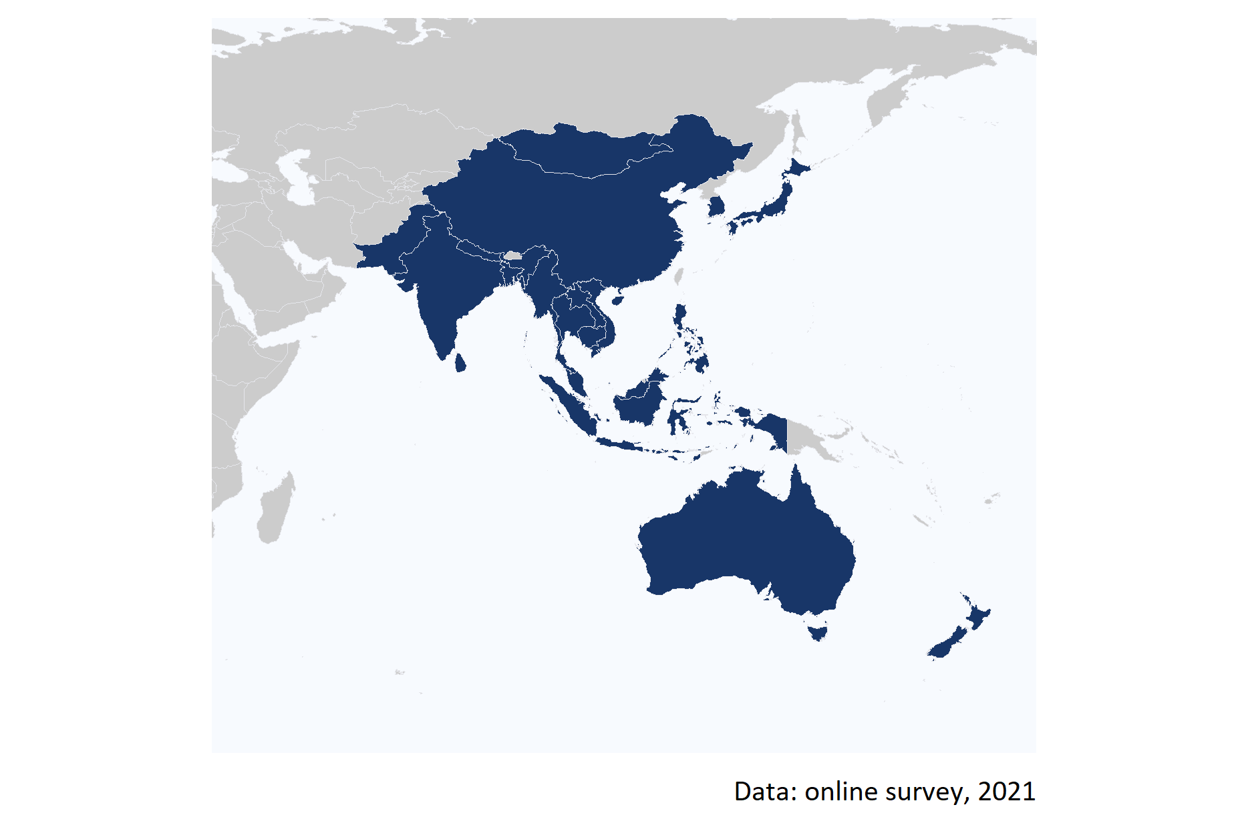

Figure 1: Map of the 20 countries that partipicated in the online survey.

The assessment of the social and economic impacts of the NDT RCA programme involved pre-defining agreed performance criteria (aspects of social and economic impacts that were the focus of the evaluation) and standards (narratives describing four levels of performance – excellent, good, adequate, and inadequate). These criteria and standards provided a transparent and robust framework for rating the impact of the mutation breeding RCA

To understand the contribution of the NDT RCA programme on social and economic indicators, the study analyses the extent into which being part of the programme has enabled the GPs to:

**Improve NDT capacity and capability**

1. Fulfill the Multilateral Recognition Agreement (MRA) requirements of the International Committee on Non-destructive Testing (ICNDT) as a result of the support under the NDT RCA programme;
2. Establish GPs’ NDT infrastructure to produce certified personnel in advanced techniques (RT-D, PAUT, TOFD, PEC, etc), in addition to the conventional methods (RT, UT, MT, PT, ET);
3. Achieve self-reliance in NDT, including offering training and inspection activities to local industries as well as abroad;

**Increase scope and scale of NDT demand and use**

1. Enhance awareness, interest, and application of NDT technology in the industrial sectors for the QA and QC of industrial components;
2. Develop knowledge developed through R&D by publishing research articles, organising international and national seminars and conferences; and

**Improved health and safety**

1. Improve health and safety by applying NDT technology in the industrial sectors.

Figure 2 summarises the criteria (aspects of performance) and standards (levels of performance) of each GP.

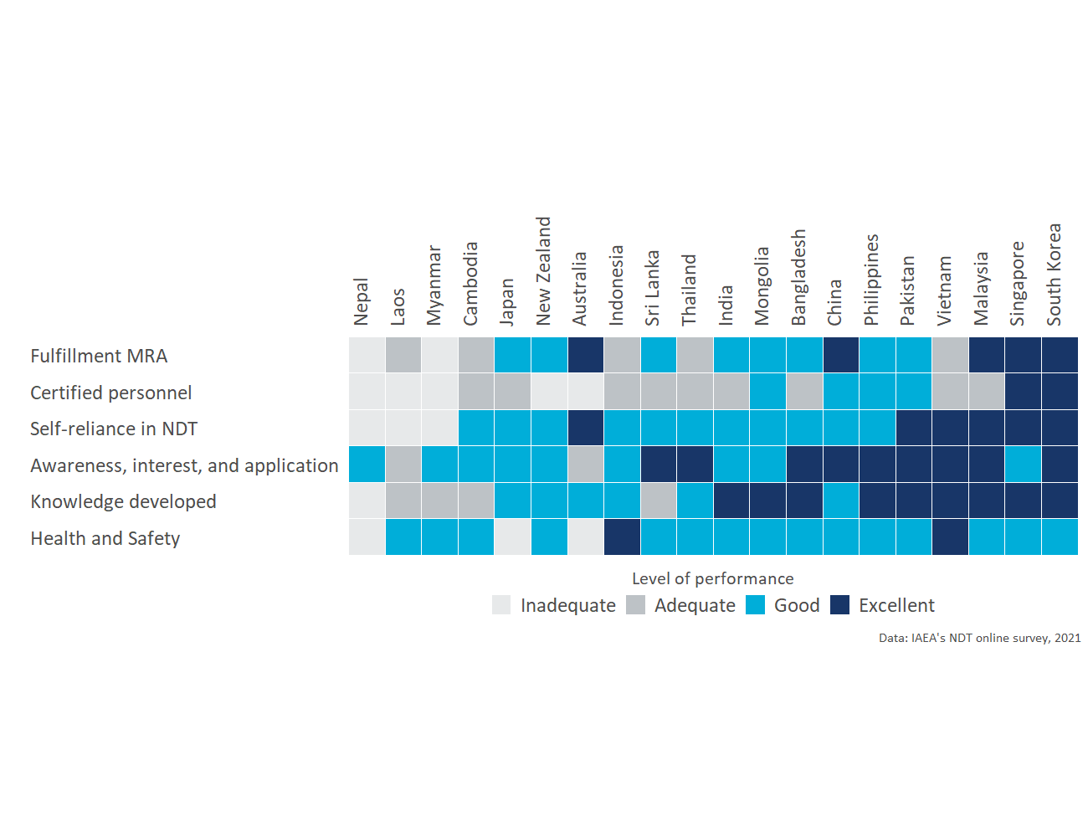

Figure 2: Performance standard by criterion and country

The complete analysis for all the aspects of performance is presented in the next sections.

# Criterion 1: Improved NDT capacity and capability

To understand the contribution of the NDT RCA programme in the capacity and capability of the Government Parties (GPs) this section presents the results of the assessment of the extent to which the support of the NDT RCA programme has enabled GPs to:

1. Fulfill the Multilateral Recognition Agreement (MRA) requirements of the International Committee on Non-destructive Testing (ICNDT) as a result of the support under the NDT RCA programme;
2. Establish GPs’ NDT infrastructure to produce certified personnel in advanced techniques (RT-D, PAUT, TOFD, PEC, etc), in addition to the conventional methods (RT, UT, MT, PT, ET); and
3. Achieve self-reliance in NDT, including offering training and inspection activities to local industries as well as abroad.

Key results of this assessment are summarized in the below table.

Key evidence for criterion 1: Improved NDT capacity and capability

|  |  |  |
| --- | --- | --- |
| Sub-criterion | Evidence | Finding |
| Fulfillment of MRA | % of GPs that have established a National Certification Body | 70% |
| Fulfillment of MRA | % of GPs that have established a National Certification Scheme | 85% |
| NDT infrastructure to produce certified personnel | Personnel certified in conventional and advanced techniques from 2000 to 2020 under NDT RCA | 307,780 |
| Self-reliance in NDT | Inspection centres owned by local firms | 3,607 |
| Self-reliance in NDT | Training centres owned by local firms | 191 |

Moreover, figure 3 below shows the levels of performance of the impact of NDT RCA on the GPs’ in each of the criteria of the capacity and capability in NDT dimension.

Further details on the criterion and standards for this dimension are presented in Annex E.

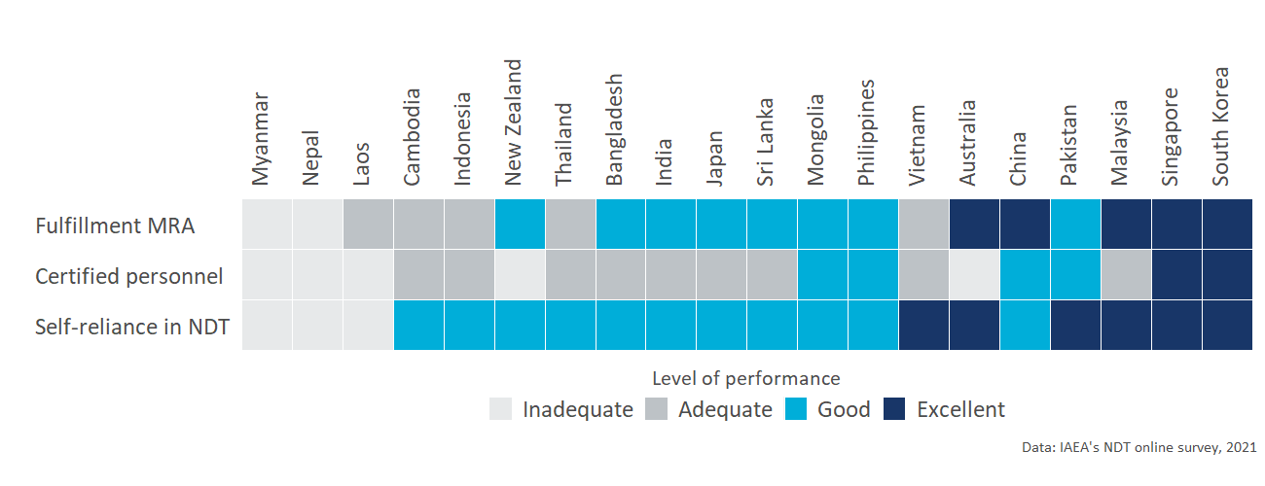

Figure 3: Capacity and capability of the Government Parties (GPs): Performance standard by criterion and country

The detailed analysis of each sub-criterion under improved NDT capacity and capability is presented in the sections below.

## Sub-criterion 1.1: Fulfillment of the Multilateral Recognition Agreement

This criteria aims to understand the the extent to which a GP has fulfilled the MRA requirements of ICNDT and the status of the NDT infrastructure at the national level. The criteria and standards (levels of performance) for the Fulfillment of the Multilateral Recognition Agreement are the following:

* **Adequate:** GPs have established a National Certification Scheme (NCS).
* **Good:** GPs have established a NCS and a National Certification Body (NCB) on NDT.
* **Excellent:** GPs’ NDT Society is registered with APFNDT and ICNDT, the society is a signatory to ICNDT MRA, NCB for NDT has been accredited to ISO 17024, and NCB has accepted for registration under the ICNDT MRA.

### Performance standards of “Fulfillment of the Multilateral Recognition Agreement”

From the 20 countries that participated in the study, only Nepal and Myanmar have not established a National Certification Scheme yet; Almost all countries but Laos, Cambodia, Nepal, and Myanmar have registered their NDT society in the Asia Pacific Federation of NDT (APFNDT); and for 10 out of the 20 GPs, their NCB for NDT has been accredited to ISO 17024.

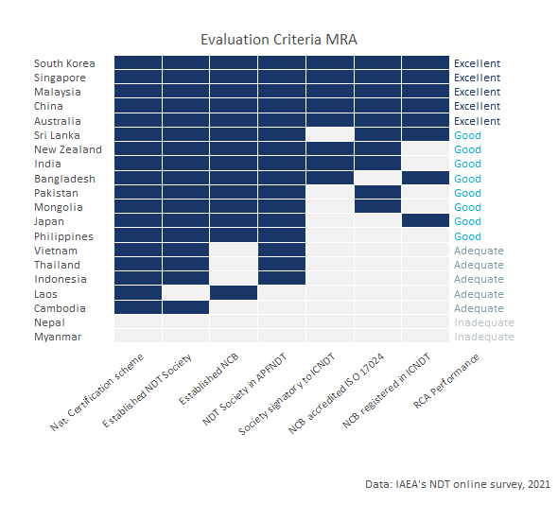

Figure 4: NDT infrastructure at the national level and assessment standards.

Based on the criterion developed by RCA to assess the performance of GPs in terms of Fulfillment of the Multilateral Recognition Agreement, Australia, China, Malaysia, Singapore, and South Korea have excellent performance standards on this criterion (See criterion and standards in Annex A)

Figure 4 above shows the level of NDT infrastructure that each GP has established and the performance for this criterion.

### Contribution of the NDT RCA in GP’s establishing a NCB and NCS

To assess the contribution of RCA in the establishment of a National Certification Body (NCB) and National Certification Schemes (NCS), the participants of the online survey were asked the extent to which they perceive that the RCA NDT programme has contributed to the establishment of this infrastructure in their countries.

As it can be seen in the Table 1 below, from the fourteen GPs that have established a NCB, ten **(Bangladesh, China, Laos, Malaysia, Mongolia, Pakistan, Philippines, Singapore, South Korea, and Sri Lanka) perceived that the RCA programme has contributed to a great extent in the establishment of their body**. Only Australia, Japan, and New Zealand perceive that the establishment of their NCB could have been achieved without the support of the RCA programme.

Moreover **50% of the GPs that are part of the programme, perceive that RCA has contributed to a great extent in the establishment of the certification scheme of their countries**.

Table 1: Contribution of RCA programme in GP’s infrastructure

|  |  |  |  |  |
| --- | --- | --- | --- | --- |
| Country | Has NCB | RCA contribution to establish NCB | Has NDT certification scheme | RCA contribution to establish NDT certification scheme |
| Australia | Yes | Not at all | Yes | Not at all |
| Bangladesh | Yes | To a great extent | Yes | To a great extent |
| Cambodia | No |  | Yes | Not at all |
| China | Yes | To a great extent | Yes | To a great extent |
| India | Yes | Little | Yes | Little |
| Indonesia | No |  | Yes | To a great extent |
| Japan | Yes | Not at all | Yes | Not at all |
| Laos | Yes | To a great extent | No |  |
| Malaysia | Yes | To a great extent | Yes | To a great extent |
| Mongolia | Yes | To a great extent | Yes | Little |
| Myanmar | No |  | No |  |
| Nepal | No |  | No |  |
| New Zealand | Yes | Not at all | Yes | Not at all |
| Pakistan | Yes | To a great extent | Yes | To a great extent |
| Philippines | Yes | To a great extent | Yes | To a great extent |
| Singapore | Yes | To a great extent | Yes | To a great extent |
| South Korea | Yes | To a great extent | Yes | To a great extent |
| Sri Lanka | Yes | To a great extent | Yes | To a great extent |
| Thailand | No |  | Yes | Not at all |
| Vietnam | No |  | Yes | To a great extent |

## Sub-criterion 1.2: NDT infrastructure to produce certified personnel

This section presents the findings on the extent to which the **NDT RCA has supported GPs in establishing NDT infrastructure through the RCA programme has enabled GPs to produce certified personnel in conventional methods (RT, UT, MT, PT, ET) and in advanced techniques** (RT-D, PAUT, TOFD, PEC, etc). The standards for this dimension are the following:

* **Adequate:** There are certified personnel produced by the national NDT certification scheme, however, for limited method(s) and not for all 5 main methods.
* **Good:** The support in establishing GPs’ NDT infrastructure through the RCA programme has enabled GPs to produce certified personnel in all levels of NDTs’ five main methods (RT, UT, MT, PT, ET) through the national NDT certification scheme.
* **Excellent:** The support in establishing GPs’ NDT infrastructure through the RCA programme has enabled GPs to produce certified personnel in all levels of NDTs’ five main methods (RT, UT, MT, PT, ET) through the national NDT certification scheme.

### Performance standards of “NDT infrastructure to produce certified personnel”

Figure 5 shows that based on the criteria developed by IAEA, two countries have met an excellent standard (Singapore and South Korea) because RCA NDT has contributed or facilitated the introduction of all methods and techniques to their personnel, four GPs met a good standard (China, Mongolia, Pakistan, and Philippines) because the RCA NDT programme has facilitated the certification of their personnel in all the conventional techniques.

Australia, Laos, Myanmar, Nepal, and New Zealand are considered to have an inadequate performance because, according to responses provided by their experts, RCA NDT has not necessarily contributed to the certification of their personnel in any of these techniques.

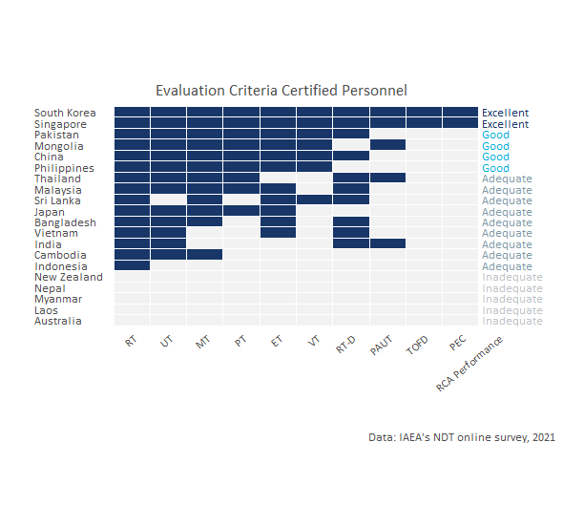

Figure 5: Personnel certified by methods: standards for self-reliance

### Contribution of the NDT RCA in the certification of personnel

As it can be seen in Table 2, **since 2020, the NDT RCA programme has contributed to the certification of 307,780 personnel by local NDT Accredited Training Centres in 15 countries** (Bangladesh, Cambodia, China, India, Indonesia, Japan, Malaysia, Mongolia, Pakistan, Philippines, Singapore, South Korea, Sri Lanka, Thailand, and Vietnam). From the total certified personnel, **5.6% are female**.

The method for which RCA has contributed the most to the certification of personnel is Radiographic Testing (223,900 personnel trained), followed by Penetrant Testing and Ultrasonic Testing.

*As it can be seen in the table below, it is possible that RCA NDT programme has indeed sensitised and provided awareness in GP’s for the introduction of certifications in the main and advanced NDT techniques; For some countries "RCA had helped introduce and sensitise the NDT programme in the early years of cooperation. However, in the last 20 years, NDT centres in the country did conduct training and certification programmes under the national NDT Society and others but they have not been, necesarily, in association with RCA* (National expert, online survey 2021).

Table 2: Number of certified personnel by contry and technique

|  |  |  |  |  |  |  |
| --- | --- | --- | --- | --- | --- | --- |
| Method | Accronym | Type of technique | Persnonnel certified per year under RCA | Personnel certified from 2000 to 2020 under RCA | (%) of Certified female personnel | Countries supported by RCA NDT |
| Radiographic Testing | RT | Conventional | 11,195 | 223,900 | 5.01% | 15 |
| Ultrasonic Testing | UT | Conventional | 1,070 | 21,400 | 5.63% | 13 |
| Magnetic Testing | MT | Conventional | 1,005 | 20,100 | 9.71% | 12 |
| Penetrant Testing | PT | Conventional | 1,128 | 22,560 | 8.16% | 9 |
| Eddy Current Testing | ET | Conventional | 469 | 9,380 | 4.01% | 11 |
| Visual Testing | VT | Conventional | 359 | 7,180 | 4.49% | 7 |
| Radiographic Testing - Digital | RT-D | Advanced technique | 149 | 2,980 | 6.36% | 10 |
| Phased Array Ultrasonic Testing | PAUT | Advanced technique | 0 | 0 | - | 5 |
| Time of Flight Diffraction | TOFD | Advanced technique | 7 | 140 | 25% | 2 |
| Pulsed Eddy Current | PEC | Advanced technique | 7 | 140 | 25% | 2 |
| Total | - | - | 15,389 | 307,780 | 5.58% | 15 |

The total number of **certified personnel under the RCA programme** by country, technique, and sex is presented in Figure 6 below.

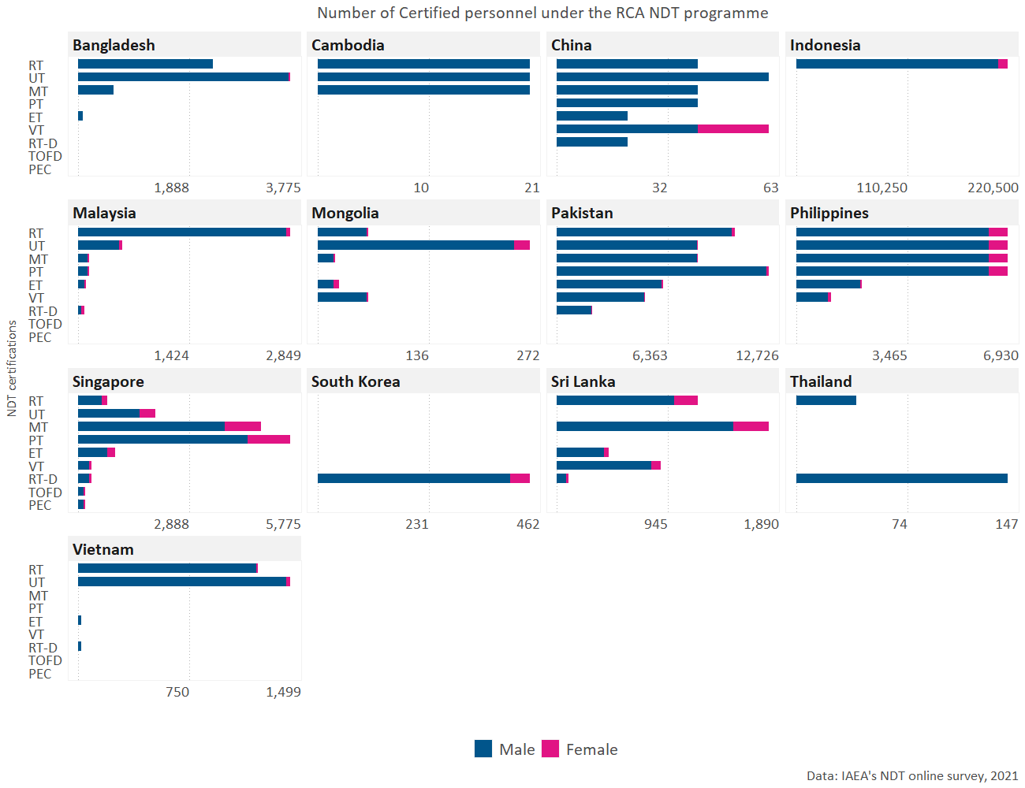

Figure 6: Number personnel that was certified by local NDT training centers as a result of participating in RCA NDT.

## Sub-criterion 1.3: Self reliance in NDT

Self reliance in NDT is a function of countries having the capacity to conduct inspection and train personnel without depending on external stakeholders. An assessment to map whether GPs have inspection and training centers owned locally or by foreigners was conducted to estimate the level of self-reliance that each GP has. According to the criterion developed, a GP is considered to have an excellent standard (or to have achieved increased self-reliance) if their local inspection and training centres offer their services abroad. On the other hand, the self-reliance of a GP is considered inadequate if it does not have both training and certification centres owned either by local or foreign firms.

The levels of performance for this criterion are the following:

* **Adequate:** GPs have training centres and inspection companies, owned by foreign entities.
* **Good:** GPs have local NDT training centres and inspection companies offering services to local industry.
* **Excellent:** GPs have achieved increased self-reliance in NDT, including offering training and inspection activities to local industries as well as abroad.

### Performance standards of “Self-reliance in NDT”

As it can be seen in Figure 7. 6 countries (Australia, Malaysia, Pakistan, Singapore, South Korea, and Vietnam) offer both training and inspection abroad. Moreover, Myanmar and Nepal do have access to inspection centres (either owned locally or by foreigners) but they do not have training centres offering services in their countries.

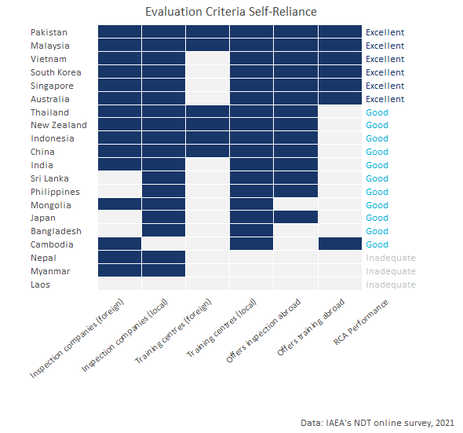

Figure 7: GP’s inspection and training centers: standards for self-reliance

### Contribution of RCA in the development of local inspection and training centers

According to the own perception of the GPs which participated in the online survey, **the RCA NDT programme has contributed to a great extent in the establishment of inspection centres in nine of the twenty-two countries that are part of the programme** (Bangladesh, China, Indonesia, Malaysia, Pakistan, Philippines, Singapore, South Korea, and Vietnam); **in ten countries RCA has facilitated the investment in local investment centres**; and, twelve countries perceived that RCA has contributed to a great extent in the establishment of local training centres (See Table 3)

Table 3: Contribution of the NDT RCA programme to the establishment of local inspection and training centres.

|  |  |  |  |  |  |
| --- | --- | --- | --- | --- | --- |
| Country | Has local inspection companies | RCA contribution to establish local inspection centres | RCA contributed to facilitate investment in inspection centres | Has local training centres | RCA contribution to establish local training centres |
| Australia | Yes | Not at all | No | Yes | Not at all |
| Bangladesh | Yes | To a great extent | Yes | Yes | To a great extent |
| Cambodia | No | Not at all | No | Yes | Little |
| China | Yes | To a great extent | Yes | Yes | To a great extent |
| India | Yes | Little | Yes | Yes | Not at all |
| Indonesia | Yes | To a great extent | Yes | Yes | To a great extent |
| Japan | Yes | Not at all | No | Yes | Not at all |
| Laos | No |  | No | No |  |
| Malaysia | Yes | To a great extent | Yes | Yes | To a great extent |
| Mongolia | Yes | Little | No | Yes | To a great extent |
| Myanmar | Yes | Little | No | No |  |
| Nepal | Yes | Little | No | No |  |
| New Zealand | Yes | Not at all | No | Yes | To a great extent |
| Pakistan | Yes | To a great extent | Yes | Yes | To a great extent |
| Philippines | Yes | To a great extent | Yes | Yes | To a great extent |
| Singapore | Yes | To a great extent | Yes | Yes | To a great extent |
| South Korea | Yes | To a great extent | Yes | Yes | To a great extent |
| Sri Lanka | Yes | Little | No | Yes | To a great extent |
| Thailand | Yes | Not at all | No | Yes | Little |
| Vietnam | Yes | To a great extent | Yes | Yes | To a great extent |

Figure 8 below shows the number of **inspection centres** owned by local and foreign firms in each RCA country. As it can be observed in the figure, **there are over 3,607 inspection centres owned by local firms across all the GPs that participate in the NDT RCA programme**.

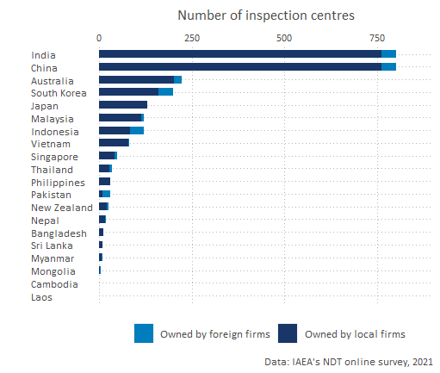

Figure 8: Number of inspection centres by type of ownership and country

Figure 9 below shows the number of **training centres** own by local and foreign firms in each RCA country. Across all the GPs that are part of the NDT RCA programme, **There are a total of 191 training centres owned by local firms**.

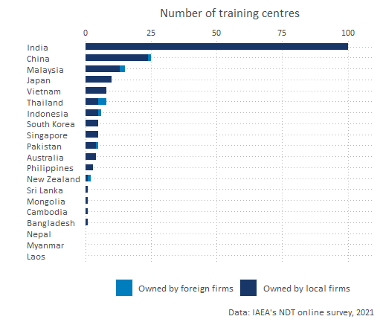

Figure 9: Number of training centres by type of ownership and country

# Criterion 2: Increased scope and scale of NDT demand and use

This section presents the findings of the contribution of the NDT RCA programme on the increased scope and scale of NDT demand and use of the Government Parties. Particularly, the analysis aims to understand the extent to which the support of the NDT programme has contributed to the enhancement of:

1. Awareness, interest, and application of NDT technology in the industrial sectors for the QA and QC of industrial components; and
2. Knowledge developed through R&D by publishing research articles, organising international and national seminars and conferences.

Key evidence for criterion 2: Increased scope and scale of NDT demand and use

|  |  |  |
| --- | --- | --- |
| Sub-criterion | Evidence | Finding |
| Awareness, interest, and application of NDT technology | % of GPs that have taken actions to create awareness among industrial organisations about the benefits of NDT technology for Quality Assurance and Quality Control | 90% |
| Awareness, interest, and application of NDT technology | % of GPs that have applied NDT technology for Quality Assurance and Quality Control in at least one industrial sector | 90% |
| Knowledge developed through R&D | % of GPS that have established any R&D activities related to NDT | 75% |
| Knowledge developed through R&D | Number of publications related to NDT that have been published since 2000 in as a result of being part of the RCA NDT programme | 1,620 |

Moreover, figure 10 below shows the performance standards of the impact of NDT RCA programme on the increased scope and scale of NDT demand and use of the Government Parties. Further details on the criterion and standards for this dimension are presented in Annex A.

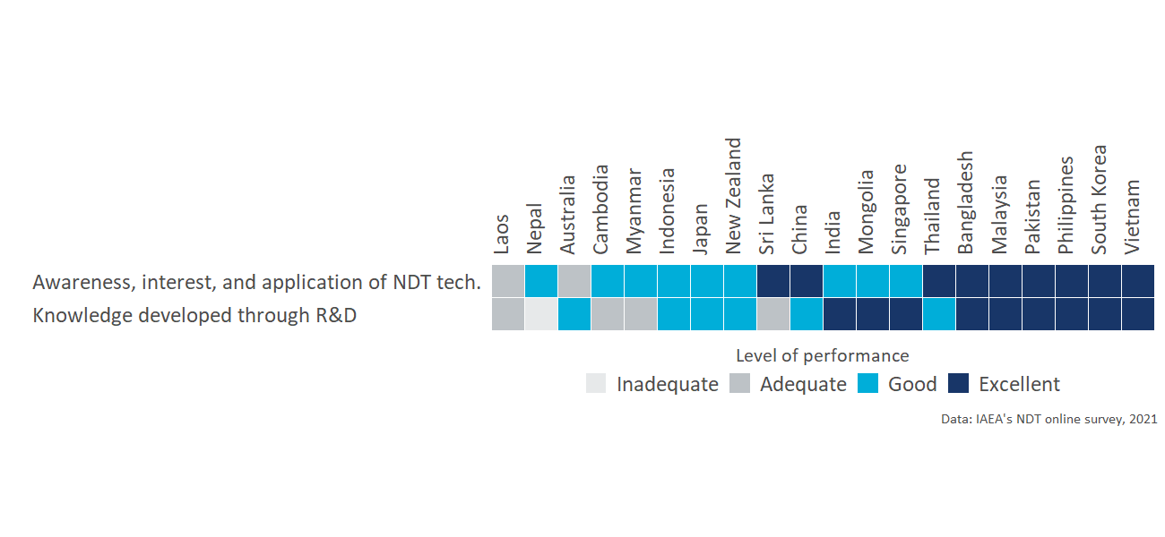

Figure 10: Increased scope and scale of NDT demand and use: Performance standard by criterion and country

The detailed analysis of each sub-criterion under improved NDT capacity and capability is presented in the sections below.

## Sub-criterion 2.1: Awareness, interest, and application

This sub-criterion explores **the extent into which participation in the RCA programme results in GPs applying NDT technology in the industrial sectors for the QA and QC** of industrial components: achieving better controlled manufacturing, lower production costs, ensuring material quality, and/or greater product integrity.

* **Adequate:** the NDT RCA programme has contributed to GPs initiating activities to create awareness among industrial organisations about the benefits of NDT technology for QA and QC.
* **Good:** as a result of being part of the NDT RCA programme, GPs become more concerned and interested into applying NDT technology in the industrial sectors; and an
* **Excellent:** Participating in the RCA programme results in GPs applying NDT technology in at least one industrial sector for the QA and QC of industrial components - achieving better controlled manufacturing, lower production costs, ensuring material quality, and/or greater product integrity-.

### Performance standards of “Awareness, interest, and application of NDT technologies”

**Bangladesh, China, Malaysia, Pakistan, Philippines, South Korea, Sri Lanka, Thailand, and Vietnam are considered to have met an excellent performance** in this sub-criterion because, as a result of applying NDT technology, positive improvements have been achieved in terms of *controlled manufacturing, lower production costs, ensuring material quality or greater productivity for at least one industrial sector* (all the positive improvements by country and industrial sector is presented in the next section).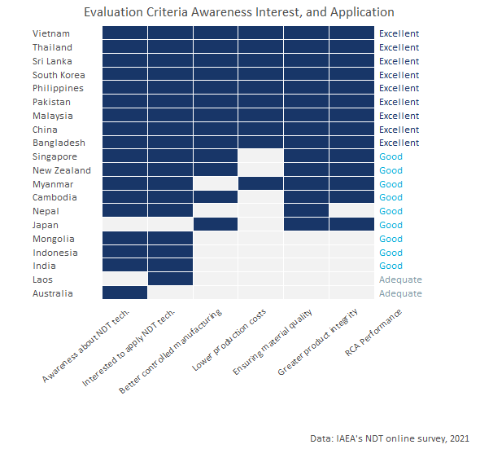

Figure 11: Performance standards: Awareness, interest, and application of NDT technology in the industrial sectors for the QA and QC of industrial components

Moreover, the **nine that met an excellent standards GPs have taken actions to create awareness among industrial organisations about the benefits of NDT technology**. For all these GPS, being part of the RCA NDT programme has also contributed to increase the concern/interest about applying NDT technologies for Quality Assurance and Quality Control in their industrial sector.

Figure 11 shows the criterion and standards for this sub-dimension. The detailed methodology and criteria is presented in Annex A.

### Contribution of the NDT RCA in Awareness, interest, and application of NDT technologies

Table 4 shows that **nine of the GPs have taken actions to create awareness among industrial organisations about the benefits of NDT technology for Quality Assurance and Quality Control**. The table also shows the of actions taken by these GPs.

Table 4: Actions taken by GPs to create awareness among industrial organisations about the benefits of NDT technology for Quality Assurance and Quality Control

|  |  |  |  |  |
| --- | --- | --- | --- | --- |
| Country | Has taken actions to create awarenes about benefits of NDT | Has conducted seminars, workshops and/or forums | Has engaged with policymakers and regulatory body(s) | Has conducted talks to universities or colleges |
| Australia | Yes | Yes | Yes | No |
| Bangladesh | Yes | Yes | Yes | Yes |
| Cambodia | Yes | Yes | Yes | Yes |
| China | Yes | Yes | Yes | Yes |
| India | Yes | Yes | Yes | Yes |
| Indonesia | Yes | Yes | Yes | Yes |
| Japan | No |  |  |  |
| Laos | No |  |  |  |
| Malaysia | Yes | Yes | Yes | Yes |
| Mongolia | Yes | No | Yes | No |
| Myanmar | Yes | Yes | Yes | Yes |
| Nepal | Yes |  |  |  |
| New Zealand | Yes | Yes | Yes | Yes |
| Pakistan | Yes | Yes | Yes | Yes |
| Philippines | Yes | Yes | Yes | Yes |
| Singapore | Yes | Yes | Yes | Yes |
| South Korea | Yes | Yes | Yes | Yes |
| Sri Lanka | Yes | Yes | No | Yes |
| Thailand | Yes | Yes | Yes | Yes |
| Vietnam | Yes | Yes | Yes | Yes |

All the number of industrial sectors in which NDT technology has been applied for quality control and quality assurance in each GP is presented in figure below.

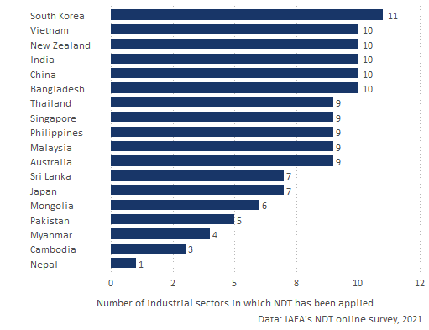

Figure 12: Number of industrial sectors in which NDT technology has been applied by GP

The extent to which the introduced NDT technology by the RCA programme led to improved manufacturing processes, lower production costs, enhanced material quality, and greater product integrity in each industrial sector is presented in Annex B. *For some countries, the information is missing because they did not provide this information in the online survey*

## Sub-criterion 2.2: Research and Development

This section aims to understand the extent into which the NDT RCA programme has contributed to the dissemination the knowledge developed through R&D.

The standards for this criterion are the following:

* **Adequate:** GPs have successfully managed to train personnel in the introduced NDT technology.
* **Good** The NDT RCA programme has enable GPs to have successfully applied the NDT technology to local industry, and established R&D activities.
* **Excellent** As a result of participating in the NDT RCA programme, GPs have managed to support the utilisation of the technology by industry and disseminate the knowledge developed through R&D** by publishing research articles, organising international and national seminars and conferences.

### Performance standards of “Research and Development”

**From the 20 GPs that participated in the study, nine GPs (Bangladesh, India, Malaysia, Mongolia, Pakistan, Philippines, Singapore, South Korea, and Vietnam) met an excellent performance in R&D** because as a result of participating in the NDT RCA programme, they have published research articles, and have organized international and national seminars and conferences.

Because Australia, China, Indonesia, Japan, New Zealand, and Thailand have established R&D activities but have not published or organized seminars, their performance is considered to be good.

Figure 13 shows the GPs’ performance in terms of R&D

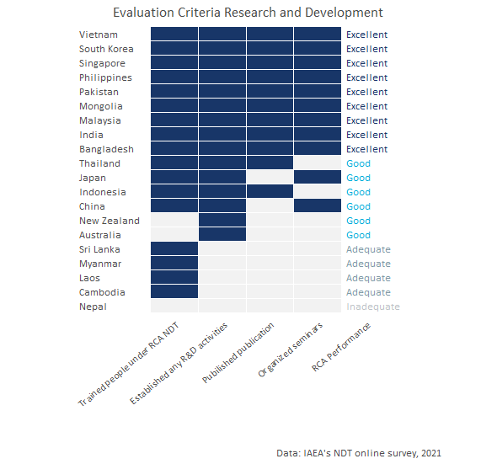

Figure 13: Performance standards: Research and Development

### Contribution of the NDT RCA in Research and Development

**A total 2,674 personnel has been trained in NDT under the RCA NDT programme**. Figure 14 shows the number of personnel who have been trained in NDT under the RCA NDT programme by country

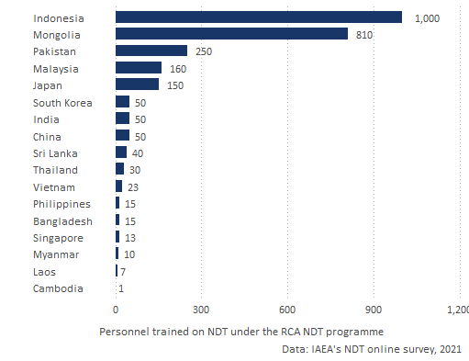

As it can be seen in figure 15, **since 2000 a total of 1,620 publications related to NDT have been published as a result of GPs being part of the RCA NDT programme**.

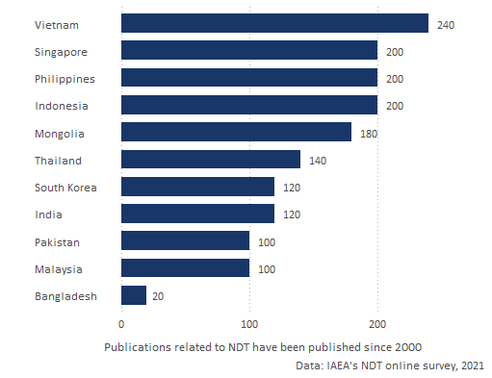

**4,300 seminars/conferences related to NDT have been organised since 2000 as a result of GPs being part of the RCA NDT programme**. (See figure 16).

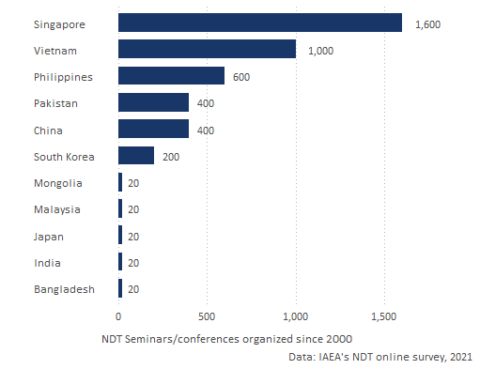

The table below shows the Extent to which the RCA NDT programme enabled or promoted the initiation of R&D activities related to NDT.

Table 5: Extent to which the RCA NDT programme enabled or promoted the initiation of R&D activities related to NDT

|  |  |  |  |  |
| --- | --- | --- | --- | --- |
| Country | Has established any R&D activities related to NDT | Publications related to NDT since 2000 | Seminars related to NDT organized since 2000 | Extent to which the RCA NDT enabled or promoted the initiation of R&D activities |
| Australia | Yes | 0 | 0 |  |
| Bangladesh | Yes | 20 | 20 | To a great extent |
| Cambodia | No |  |  |  |
| China | Yes | 0 | 400 | To a great extent |
| India | Yes | 120 | 20 | Little |
| Indonesia | Yes | 200 |  |  |
| Japan | Yes | 0 | 20 | To a great extent |
| Laos | No |  |  |  |
| Malaysia | Yes | 100 | 20 | To a great extent |
| Mongolia | Yes | 180 | 20 | Little |
| Myanmar | No |  |  |  |
| Nepal |  |  |  |  |
| New Zealand | Yes | 0 | 0 |  |
| Pakistan | Yes | 100 | 400 | To a great extent |
| Philippines | Yes | 200 | 600 | To a great extent |
| Singapore | Yes | 200 | 1600 | Little |
| South Korea | Yes | 120 | 200 | To a great extent |
| Sri Lanka | No |  |  |  |
| Thailand | Yes | 140 | 0 | To a great extent |
| Vietnam | Yes | 240 | 1000 | To a great extent |

# Criterion 3: Improved health and safety

The aim of this section is to understand **the extent to which participating in the NDT RCA program** of IAEA has enable GPs in **applying NDT technology** in the industrial sectors as set by countries’ industrial laws for the QA and QC of industrial components and whether it has **resulted in improved health and safety outcomes** (i.e. fewer deaths and injuries) and/or reduced environmental pollution.

Key evidence for criterion 3: Improved health and safety

|  |  |  |
| --- | --- | --- |
| Criterion | Evidence | Finding |
| Improved health and safety | % of GPs that perceive that the RCA NDT programme contributed to the awareness of the benefits of using NDT technologies for safer operations of nuclear and other industrial installations | 85% |
| Improved health and safety | % of GPs that perceive that the RCA NDT programme contributed contributed to applying NDT technologies for safer operations of nuclear and other industrial installations | 85% |
| Improved health and safety | Approximate total accumulated number of injuries that have been prevented in the industrial sector since 2000 as a result of applying NDT technologies | *GPs do not have an approximation* |
| Improved health and safety | Approximate total accumulated number of deaths that have been prevented in the industrial sector since 2000 as a result of applying NDT technologies | *GPs do not have an approximation* |
| Improved health and safety | Approximate total accumulated reduction of CHEMICAL WASTE (in tons) since 2000 as a result of applying NDT technologies | *GPs do not have an approximation* |

Moreover, figure 10 below shows the performance standards of the impact of NDT RCA programme on the Improved health and safety criteria. Further details on the criterion and standards for this dimension are presented in Annex E.

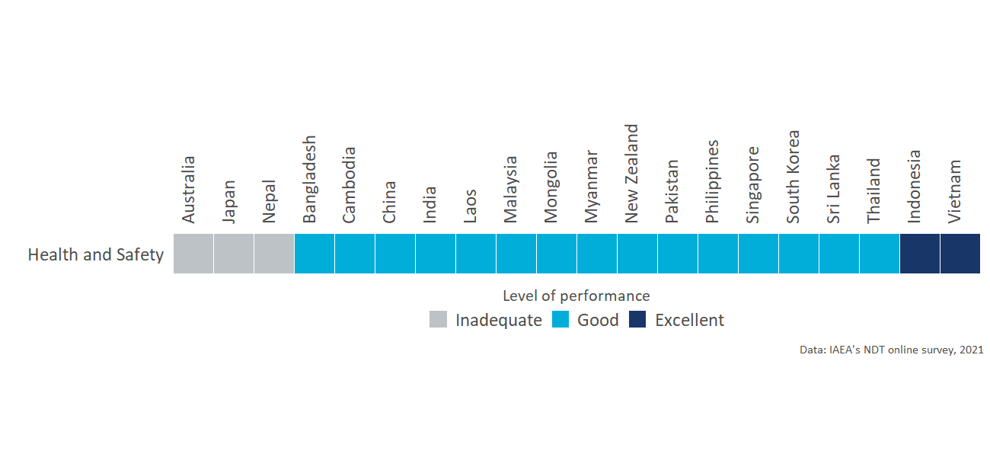

Figure 17: Improved health and safety: Performance standard by criterion and country

The detailed analysis of each sub-criterion under improved NDT capacity and capability is presented in the sections below.

### Performance standards of “Improved Health and Safety”

* **Adequate:** Participation in the RCA program of IAEA results in GPs becoming more aware of the benefits of NDT technology for safer operation of nuclear and other industrial installations.
* **Good:** Participation in the RCA program of IAEA results in GPs applying NDT technology for safer operation of nuclear and other industrial installations.
* **Excellent:** As a result of participation in the RCA program of IAEA, GPs have been applying NDT technology in the industrial sectors as set by countries’ industrial laws for the QA and QC of industrial components, resulting in improved health and safety outcomes (i.e. fewer deaths and injuries) and/or reduced environmental pollution.

Figure 18 shows the criterion and standards for this dimension. It is worth mentioning that all the countries except for Vietnam and Indonesia reported that their country does not have an approximation of the reduction of chemical waste, reduced injuries, or reduced deaths.

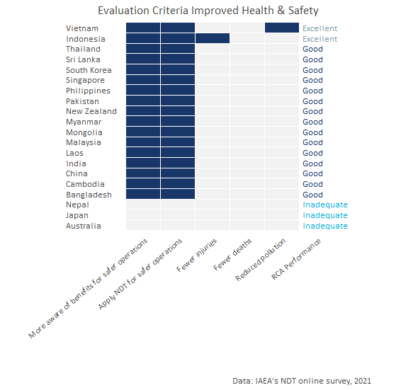

Figure 18: Performance standards: Improved Health and Safety

### Contribution of the NDT RCA in Improved Health and Safety

* **85% of the GP’s perceive that being part of the RCA NDT programme contributed to the AWARENESS of the benefits of using NDT technologies for safer operations** of nuclear and other industrial installations in their country.
* **85% of the GP’s perceive that being part of the RCA NDT programme contributed to applying NDT technologies for safer operations** of nuclear and other industrial installations in their country.
* All GPs but two reported that their country does not have an approximation of the reduction of chemical waste, reduced injuries, or reduced deaths.

# Overall impact of the NDT RCA programme

This section aims to summarise the overall role of IAEA/RCA activities in achieving the general objectives and benefits of NDT on socio economic impact through industrial growth in each GP that is part of the programme.

Table 6 shows the perception of the GPs on the role that RCA has had to:

* Help speed up the adoption of NDT technologies since 2000.
* Contribute to the adoption of NDT technologies by private businesses since 2000.
* The proportion of total activity in the NDT sector in 2020 can be attributed to the programme.
* The productivity of NDT inspections (reduction of the average time to complete an inspection).

According to the own perception of the experts who participated in the online survey, **for 75% of the GPs, RCA NDT has helped to speed up the adoption of NDT technologies in their country since 2000**. For Bangladesh, India, Indonesia, Laos, Malaysia, and Myanmar the adoption occurred 1-3 years faster. Moreover, China, Mongolia, Pakistan, Philippines, Singapore, Thailand, and Vietnam perceive that NDT RCA contributed for the adoption of NDT technologies to happen 4-5 years faster; and **China, Mongolia, Pakistan, Philippines, Singapore, Thailand, and Vietnam think that the adoption occurred 6-10 years faster than with out the support of IAEA.**

Additionally, **70% of the GPs perceive that NDT RCA has contributed to the adoption of NDT technologies by private business in their countries since 2000**. From these countries, **50% estimate that the proportion of the total activity in their NDT sector can be attributed to RCA at least 25% or more.**

South Korea, Thailand, and Vietnam estimate that between 25% - 50% of total activity in the NDT sector in 2020 can be attributed to the RCA NDT. And Bangladesh, Mongolia, Philippines, and Singapore that between 51% - 75%,

The table also displays the perception on the role of IAEA/RCA activities in achieving the general objectives and benefits.

Table 6: Contribution of IAEA/RCA activities in achieving general objectives and benefits by GP

|  |  |  |  |  |  |  |  |  |
| --- | --- | --- | --- | --- | --- | --- | --- | --- |
| Country | Year when first took part in the RCA NDT | RCA NDT help speed up the adoption of NDT technologies since 2000 | Years faster | RCA NDT contribute to the adoption of NDT technologies by private businesses since 2000 | proportion of total activity in the NDT sector in 2020 can be attributed to the RCA NDT | RCA NDT programme increased the productivity of NDT inspections | Impact on average inspection time | Role of IAEA/RCA activities in achieving the general objectives and benefits |
| Australia | 2009 | No |  | No |  | No |  | Poor |
| Bangladesh | 1987 | Yes | 1-3 years faster | Yes | Between 51% - 75% | Yes | Average inspection time reduced by 10% to 20% | Excellent |
| Cambodia | 2018 | No |  | No |  | No |  | Poor |
| China | 1995 | Yes | 4-5 years faster | Yes | Up to 25% | Yes | Average inspection time reduced by up to 10% | Excellent |
| India | 1972 | Yes | 1-3 years faster | Yes | Up to 25% | Yes |  | Good |
| Indonesia |  | Yes | 1-3 years faster | Yes | Up to 25% | No |  | Good |
| Japan | 1978 | No |  | No |  | No |  | Good |
| Laos | 2018 | Yes | 1-3 years faster | Yes | Up to 25% | No |  | Good |
| Malaysia | 1981 | Yes | 1-3 years faster | Yes | Up to 25% | Yes | Average inspection time reduced by 10% to 20% | Excellent |
| Mongolia | 1993 | Yes | 4-5 years faster | Yes | Between 51% - 75% | No |  | Poor |
| Myanmar | 1996 | Yes | 1-3 years faster | No |  | No |  | Good |
| Nepal | 2017 |  |  |  |  |  |  |  |
| New Zealand | 1990 | No |  | No |  | No |  | Poor |
| Pakistan | 2019 | Yes | 4-5 years faster | Yes | Up to 25% | Yes | Average inspection time reduced by 10% to 20% | Excellent |
| Philippines | 1980 | Yes | 4-5 years faster | Yes | Between 51% - 75% | Yes | Average inspection time reduced by 10% to 20% | Excellent |
| Singapore | 1980 | Yes | 4-5 years faster | Yes | Between 51% - 75% | Yes | Average inspection time reduced by 10% to 20% | Excellent |
| South Korea | 2000 | Yes | 6-10 years faster | Yes | Between 25% - 50% | Yes | Average inspection time reduced by more than 20% | Excellent |
| Sri Lanka | 1982 | Yes | 6-10 years faster | Yes | Up to 25% | Yes | Average inspection time reduced by 10% to 20% | Excellent |
| Thailand | 1983 | Yes | 4-5 years faster | Yes | Between 25% - 50% | Yes | Average inspection time reduced by more than 20% | Excellent |
| Vietnam | 1981 | Yes | 4-5 years faster | Yes | Between 25% - 50% | Yes | Average inspection time reduced by 10% to 20% | Excellent |

# Annex A: Criteria and standards

|  |  |
| --- | --- |
| Standard applied to each GP | Criterion 1: Improved NDT capacity and capability |
| **Excellent** (exceeding expectations)    GPs with excellent status meet the standard for Good, plus: | **GPs have fulfilled the MRA requirements of ICNDT** as a result of the support under the RCA programme of IAEA.   * NDT Society is registered with APFNDT and ICNDT * The society is a signatory to ICNDT MRA * NCB for NDT accredited to ISO 17024 * NCB accepted for registration under the ICNDT MRA * Accredited training centres offering ISO 9712 training.   The support in establishing GPs’ NDT infrastructure through the RCA programme has enabled **GPs to produce *certified personnel in advanced techniques (RT-D, PAUT, TOFD, PEC, etc)*, in addition to the conventional methods (RT, UT, MT, PT, ET).**  GPs have achieved increased self-reliance in NDT, including offering training and inspection activities to local industries as well as abroad. |
| **Good** (meeting expectations)  GPs with good status meet the standard for Adequate, plus: | **GPs have established internationally-recognised NDT infrastructure at the national leve**l as a result of the support under the RCA programme of IAEA.   * NDT Society has been established * National certification body on NDT has been established. * Local NDT training centres are offering ISO 9712 training   The support in establishing GPs’ NDT infrastructure through the RCA programme has enabled **GPs to produce certified personnel in all levels of NDTs’ *five main methods* (RT, UT, MT, PT, ET)** through the national NDT certification scheme.[^Since most national certification schemes started late compared to other certification, acceptance is the main challenge.]  GPs have local NDT training centres and inspection companies offering services to local industry. |
| **Adequate** (meeting bottom-line expectations) | GPs have established **basic NDT infrastructure at the national level** as a result of the support under the RCA programme of IAEA.  National certification scheme has been established and there are **certified personnel produced by the national NDT certification scheme, however, for limited method(s) and not for all 5 main methods.**  There are trained personnel at the GP organisation level.  GPs have training centres and inspection companies, owned by foreign entities. |
| **Inadequate** | The level of NDT infrastructure is below the standard for Adequate |

|  |  |
| --- | --- |
| Standard applied to each GP | Criterion 2: Increased scope and scale of NDT demand and use |
| **Excellent** (exceeding expectations)  GPs with excellent status meet the standard for Good, plus: | From the involvement in the RCA programme, **GPs have managed to support the utilisation of the technology by industry and disseminate the knowledge developed through R&D** by publishing research articles, organising international and national seminars and conferences.  **Participation in the RCA programme results in GPs applying NDT technology in the industrial sectors for the QA and QC of industrial components** - achieving better controlled manufacturing, lower production costs, ensuring material quality, and/or greater product integrity. |
| **Good** (meeting expectations)  GPs with good status meet the standard for Adequate, plus: | From the involvement in the RCA programme, **GPs have successfully applied the NDT technology to local industry, and established R&D activities**.  **Participation in the RCA programme results in GPs becoming more concerned and interested, and starting to apply NDT technology** in the industrial sectors for the QA and QC of industrial components. |
| **Adequate** (meeting bottom-line expectations) | From the involvement in the RCA programme, **GPs have successfully managed to train personnel in the introduced technology**.  **Participation in the RCA programme of IAEA results in GPs initiating activities to create awareness** among industrial organisations about the benefits of NDT technology for QA and QC. |
| **Inadequate** | Any of the standards for Adequate are not met. |

|  |  |
| --- | --- |
| Standard applied to each GP | Criterion 3: Improved health and safety |
| **Excellent** (exceeding expectations)  GPs with excellent status meet the standard for Good, plus: | As a result of participation in the RCA program of IAEA, **GPs have been applying NDT technology** in the industrial sectors as set by countries’ industrial laws for the QA and QC of industrial components - **resulting in  improved health and safety outcomes** (i.e. fewer deaths and injuries) and/or reduced environmental pollution. |
| **Good** (meeting expectations)  GPs with good status meet the standard for Adequate, plus: | Participation in the RCA program of IAEA results in **GPs applying NDT technology for safer operation** of nuclear and other industrial installations. |
| **Adequate** (meeting bottom-line expectations) | Participation in the RCA program of IAEA results in **GPs becoming more aware of the benefits of NDT technology for safer operation** of nuclear and other industrial installations. |
| **Inadequate** | Any of the standards for Adequate are not met. |

# Annex B: Implementation of NDT technology by industrial sector

Table 7: Extent to which the introduced NDT technology by the RCA programme led to improved manufacturing processes

|  |  |  |  |  |  |  |
| --- | --- | --- | --- | --- | --- | --- |
| Country | Industrial Sector | NDT has caused positive improvements in Controlled manufacturing | NDT has caused positive improvements in Ensuring material quality | NDT has caused positive improvements in Greater product integrity | NDT has caused positive improvements in Lower production costs | (%) by which production costs are lower between 2000 and 2020 |
| Australia | Aerospace |  |  |  |  |  |
| Australia | Chemical |  |  |  |  |  |
| Australia | Construction |  |  |  |  |  |
| Australia | Manufacturing |  |  |  |  |  |
| Australia | Oil and gas |  |  |  |  |  |
| Australia | Petrochemical |  |  |  |  |  |
| Australia | Power generation (excluding nuclear) |  |  |  |  |  |
| Australia | Railway |  |  |  |  |  |
| Australia | Shipping |  |  |  |  |  |
| Bangladesh | Aerospace | No | Yes | Yes | No |  |
| Bangladesh | Chemical | Yes | Yes | Yes | Yes | Moderate decrease (5% decrease) |
| Bangladesh | Construction | No | Yes | Yes | No |  |
| Bangladesh | Manufacturing | Yes | Yes | Yes | Yes | Moderate decrease (5% decrease) |
| Bangladesh | Nuclear | No | Yes | Yes | No |  |
| Bangladesh | Oil and gas | Yes | Yes | Yes | Yes | Moderate decrease (5% decrease) |
| Bangladesh | Petrochemical | Yes | Yes | Yes | Yes | Moderate decrease (5% decrease) |
| Bangladesh | Power generation (excluding nuclear) | Yes | Yes | Yes | Yes | Moderate decrease (5% decrease) |
| Bangladesh | Railway | No | Yes | Yes | No |  |
| Bangladesh | Shipping | Yes | Yes | Yes | Yes | Moderate decrease (5% decrease) |
| Cambodia | Construction | Yes | Yes | Yes | No |  |
| Cambodia | Manufacturing | Yes | Yes | Yes | No |  |
| Cambodia | Oil and gas | Yes | Yes | Yes | No |  |
| China | Aerospace | Yes | Yes | Yes | Yes | Significant decrease (10% decrease or more) |
| China | Chemical | Yes | Yes | Yes | Yes | Significant decrease (10% decrease or more) |
| China | Construction | Yes | Yes | Yes | Yes | Significant decrease (10% decrease or more) |
| China | Manufacturing | Yes | Yes | Yes | Yes | Significant decrease (10% decrease or more) |
| China | Nuclear | Yes | Yes | Yes | Yes | Significant decrease (10% decrease or more) |
| China | Oil and gas | Yes | Yes | Yes | Yes | Significant decrease (10% decrease or more) |
| China | Petrochemical | Yes | Yes | Yes | Yes | Significant decrease (10% decrease or more) |
| China | Power generation (excluding nuclear) | Yes | Yes | Yes | Yes | Significant decrease (10% decrease or more) |
| China | Railway | Yes | Yes | Yes | Yes | Significant decrease (10% decrease or more) |
| China | Shipping | Yes | Yes | Yes | Yes | Significant decrease (10% decrease or more) |
| India | Aerospace | Yes | Yes | Yes | Yes |  |
| India | Chemical | Yes | Yes | Yes | Yes |  |
| India | Construction |  |  |  |  |  |
| India | Manufacturing | Yes | Yes | Yes | Yes |  |
| India | Nuclear | Yes | Yes | Yes | Yes |  |
| India | Oil and gas | Yes | Yes | Yes | Yes | Small decrease (1% decrease) |
| India | Petrochemical | Yes | Yes | Yes | No |  |
| India | Power generation (excluding nuclear) | Yes | Yes | Yes | Yes |  |
| India | Railway | Yes | Yes | Yes | Yes |  |
| India | Shipping | Yes | Yes | Yes | Yes |  |
| Japan | Chemical | Yes | Yes | Yes | No |  |
| Japan | Construction | Yes | Yes | Yes | No |  |
| Japan | Manufacturing | Yes | Yes | Yes | No |  |
| Japan | Nuclear | Yes | Yes | Yes | No |  |
| Japan | Oil and gas | Yes | Yes | Yes | No |  |
| Japan | Petrochemical | Yes | Yes | Yes | No |  |
| Japan | Shipping | Yes | Yes | Yes | No |  |
| Malaysia | Aerospace | No | Yes | Yes | No |  |
| Malaysia | Chemical | No | Yes | Yes | No |  |
| Malaysia | Construction | Yes | Yes | Yes | Yes | Significant decrease (10% decrease or more) |
| Malaysia | Manufacturing | Yes | Yes | Yes | Yes | Significant decrease (10% decrease or more) |
| Malaysia | Oil and gas | No | Yes | Yes | No |  |
| Malaysia | Petrochemical | No | Yes | Yes | No |  |
| Malaysia | Power generation (excluding nuclear) | No | Yes | Yes | No |  |
| Malaysia | Railway | No | Yes | Yes | No |  |
| Malaysia | Shipping | No | Yes | Yes | No |  |
| Mongolia | Aerospace | No | Yes | Yes | No |  |
| Mongolia | Construction | No | Yes | No | No |  |
| Mongolia | Oil and gas |  |  |  |  |  |
| Mongolia | Petrochemical | No | Yes | No | No |  |
| Mongolia | Power generation (excluding nuclear) | Yes | Yes | No | No |  |
| Mongolia | Railway | Yes | Yes | No | No |  |
| Myanmar | Construction | No | Yes | Yes | No |  |
| Myanmar | Oil and gas | No | Yes | No | No |  |
| Myanmar | Petrochemical | No | No | Yes | Yes | Small decrease (1% decrease) |
| Myanmar | Shipping | No | Yes | Yes | No |  |
| Nepal | Construction | No | Yes | No | No |  |
| New Zealand | Aerospace | Yes | Yes | Yes | No |  |
| New Zealand | Chemical | Yes | Yes | Yes | No |  |
| New Zealand | Construction | Yes | Yes | Yes | No |  |
| New Zealand | Manufacturing | Yes | Yes | Yes | No |  |
| New Zealand | Oil and gas | Yes | Yes | Yes | No |  |
| New Zealand | Other | Yes | Yes | Yes | No |  |
| New Zealand | Petrochemical | Yes | Yes | Yes | No |  |
| New Zealand | Power generation (excluding nuclear) | Yes | Yes | Yes | No |  |
| New Zealand | Railway | No | Yes | Yes | No |  |
| New Zealand | Shipping | Yes | Yes | Yes | No |  |
| Pakistan | Manufacturing | Yes | Yes | Yes | Yes | Moderate decrease (5% decrease) |
| Pakistan | Nuclear | Yes | Yes | Yes | Yes | Moderate decrease (5% decrease) |
| Pakistan | Oil and gas | Yes | Yes | Yes | Yes | Moderate decrease (5% decrease) |
| Pakistan | Petrochemical | Yes | Yes | Yes | Yes | Moderate decrease (5% decrease) |
| Pakistan | Power generation (excluding nuclear) | Yes | Yes | Yes | Yes | Significant decrease (10% decrease or more) |
| Philippines | Aerospace | Yes | Yes | Yes | Yes | Significant decrease (10% decrease or more) |
| Philippines | Chemical | Yes | Yes | Yes | Yes | Moderate decrease (5% decrease) |
| Philippines | Construction | Yes | Yes | Yes | Yes | Significant decrease (10% decrease or more) |
| Philippines | Manufacturing | Yes | Yes | Yes | Yes | Moderate decrease (5% decrease) |
| Philippines | Oil and gas | Yes | Yes | Yes | Yes | Significant decrease (10% decrease or more) |
| Philippines | Petrochemical | Yes | Yes | Yes | Yes | Moderate decrease (5% decrease) |
| Philippines | Power generation (excluding nuclear) | Yes | Yes | Yes | Yes | Significant decrease (10% decrease or more) |
| Philippines | Railway | Yes | Yes | Yes | Yes | Moderate decrease (5% decrease) |
| Philippines | Shipping | Yes | Yes | Yes | Yes | Significant decrease (10% decrease or more) |
| Singapore | Aerospace | Yes | Yes | Yes | No |  |
| Singapore | Chemical | Yes | Yes | Yes | No |  |
| Singapore | Construction | Yes | Yes | Yes | No |  |
| Singapore | Manufacturing | Yes | Yes | Yes | No |  |
| Singapore | Oil and gas | Yes | Yes | Yes | No |  |
| Singapore | Petrochemical | Yes | Yes | Yes | No |  |
| Singapore | Power generation (excluding nuclear) | Yes | Yes | Yes | No |  |
| Singapore | Railway | Yes | Yes | Yes | No |  |
| Singapore | Shipping | Yes | Yes | Yes | No |  |
| South Korea | Aerospace | Yes | Yes | Yes | No |  |
| South Korea | Chemical | Yes | Yes | Yes | Yes | Significant decrease (10% decrease or more) |
| South Korea | Construction | Yes | Yes | Yes | No |  |
| South Korea | Manufacturing | Yes | Yes | No | No |  |
| South Korea | Nuclear | Yes | Yes | Yes | Yes | Significant decrease (10% decrease or more) |
| South Korea | Oil and gas | Yes | Yes | Yes | Yes | Significant decrease (10% decrease or more) |
| South Korea | Other | Yes | Yes | Yes | Yes | Moderate decrease (5% decrease) |
| South Korea | Petrochemical | Yes | Yes | Yes | Yes | Significant decrease (10% decrease or more) |
| South Korea | Power generation (excluding nuclear) | Yes | Yes | Yes | Yes | Significant decrease (10% decrease or more) |
| South Korea | Railway | Yes | Yes | Yes | No |  |
| South Korea | Shipping | Yes | Yes | Yes | Yes | Significant decrease (10% decrease or more) |
| Sri Lanka | Aerospace | No | Yes | No | No |  |
| Sri Lanka | Construction | No | Yes | Yes | No |  |
| Sri Lanka | Manufacturing | Yes | Yes | Yes | Yes | Moderate decrease (5% decrease) |
| Sri Lanka | Oil and gas | Yes | Yes | Yes | Yes | Moderate decrease (5% decrease) |
| Sri Lanka | Petrochemical | Yes | Yes | Yes | Yes | Small decrease (1% decrease) |
| Sri Lanka | Power generation (excluding nuclear) | Yes | Yes | Yes | Yes | Moderate decrease (5% decrease) |
| Sri Lanka | Shipping | Yes | Yes | Yes | Yes | Moderate decrease (5% decrease) |
| Thailand | Aerospace | Yes | Yes | Yes | No |  |
| Thailand | Chemical | Yes | Yes | Yes | Yes | Moderate decrease (5% decrease) |
| Thailand | Construction | Yes | Yes | Yes | No |  |
| Thailand | Manufacturing | Yes | Yes | Yes | Yes | Significant decrease (10% decrease or more) |
| Thailand | Oil and gas | Yes | Yes | Yes | Yes | Moderate decrease (5% decrease) |
| Thailand | Petrochemical | Yes | Yes | Yes | Yes | Moderate decrease (5% decrease) |
| Thailand | Power generation (excluding nuclear) | Yes | Yes | Yes | No |  |
| Thailand | Railway | Yes | Yes | Yes | No |  |
| Thailand | Shipping | Yes | Yes | Yes | No |  |
| Vietnam | Aerospace | No | Yes | No | No |  |
| Vietnam | Chemical | Yes | Yes | Yes | Yes | Moderate decrease (5% decrease) |
| Vietnam | Construction | Yes | Yes | Yes | Yes | Moderate decrease (5% decrease) |
| Vietnam | Manufacturing | Yes | Yes | Yes | Yes | Moderate decrease (5% decrease) |
| Vietnam | Oil and gas | Yes | Yes | Yes | Yes | Moderate decrease (5% decrease) |
| Vietnam | Other | Yes | Yes | Yes | No |  |
| Vietnam | Petrochemical | Yes | Yes | Yes | Yes | Moderate decrease (5% decrease) |
| Vietnam | Power generation (excluding nuclear) | Yes | Yes | Yes | Yes | Moderate decrease (5% decrease) |
| Vietnam | Railway | Yes | Yes | Yes | Yes | Moderate decrease (5% decrease) |
| Vietnam | Shipping | Yes | Yes | Yes | Yes | Moderate decrease (5% decrease) |