Survey Analysis

Radiotherapy

Table of Contents

Disclaimer i

Acknowledgements i

Acronyms ii

Main findings iii

Introduction iv

Criterion 1: Strengthened radiotherapy workforce vi

Criterion 1.1 Offer educational training programmes, and establish Radio Oncology (RO) Departments and Societies vi

Criterion 1.2 Produce RT specialists viii

Contribution of RT RCA in strengthening ratiotherapy workforce xi

Criterion 2: Increased access to quality radiotherapy xiii

Criterion 2.1 Increase operational RT equipment and technology xiv

Criterion 2.2 Increase the number and quality of treatment of cancer patients using domestic RT facilities xv

Contribution of RCA on increasing access to quality radiotherapy xvii

Criterion 3: Increased life span and quality of life xix

Criterion 3.1 Increase in local control xix

Criterion 3.2 Increase life-years xx

Contribution of RCA on increasing life span and quality of life xxi

Annex: Criteria and standards xxii

###### Report Information

|  |  |
| --- | --- |
| Prepared for | International Atomic Energy Agency |
| Prepared by | Julian King, Kate McKegg, Andres Arau, Aaron Schiff, Martina Garcia Aisa |
| Citation | King,J., McKegg, K., Arau, A., Schiff, A., Garcia Aisa, M. (2021). *Social and Economic Impact Assessment of the RCA Programme: Radiotherapy Case Study.* Vienna, Austria: International Atomic Energy Agency. |

## Disclaimer

The information in this document is presented in good faith using the information available to us at the time of preparation. It is provided on the basis that the authors of the document are not liable to any person or organisation for any damage or loss which may occur in relation to taking or not taking action in respect of any information or advice within this document

## Acknowledgements

The authors are grateful for the close and effective assistance of the Technical Cooperation division for Asia-Pacific (TCAP) and Technical Cooperation Division of Programme Support and Coordination (TCPC) of the International Atomic Energy Agency (IAEA), and the experts from the 22 participating countries in the the Radiotherapy Regional Cooperative Agreement (RCA): Australia, Bangladesh, Cambodia, China, Fiji, India, Indonesia, Japan, Laos, Malaysia, Mongolia, Myanmar, Nepal, New Zealand, Pakistan, Palau, Philippines, Singapore, South Korea, Sri Lanka, Thailand, and Viet Nam

# Acronyms

|  |  |
| --- | --- |
| Name | Acronym |
| 3-dimensional Conformal Radiation Therapy | 3D-CRT |
| 3-dimensional Image-Guided Brachytherapy | 3D-IGBT |
| Cooperative Agreement for Research | RCA |
| Educational /training programmes | ET |
| Government Party | GP |
| IAEA Technical Co-operation Programme | TCP |
| Intensity-Modulated Radiation Therapy | IMRT |
| International Atomic Energy Agency | IAEA |
| Member States | MS |
| Radio Oncology | RO |
| Radiotherapy | RT |
| Stereotactic Body | SRT |

# Main findings

* Out of the 22 countries that are part of the Regional Cooperative Agreement (RCA) for Research Radiotherapy (RT) in Asia and the Pacific, 21 participated in the online survey: Australia, Bangladesh, Cambodia, China, India, Indonesia, Japan, Laos, Malaysia, Mongolia, Myanmar, Nepal, New Zealand, Pakistan, Palau, Philippines, Singapore, South Korea, Sri Lanka, Thailand, and Vietnam. The only RCA country that did not participate in the survey was Fiji. **The support and cooperation of country representatives and IAEA staff during these unusual circumstances is gratefully acknowledged**.
* Out the 22 countries that are part of RCA, 18 currently act as recipients of the IAEA Technical Co-operation Programme (TCP). The other four (Australia, Japan, New Zealand, and very recently Korea) have voluntarily decided not to receive the IAEA TCP, but they work as resource countries to provide support for the IAEA TCP. **Based on this definition, the three countries that have historically acted as non-recipients (Australia, Japan and New Zealand) are excluded from the assessment of the criteria and level of performance conducted in this analysis. Given their historically non-recipient character, any assessment of the performance of RCA to accelerate and enlarge the application of RT technologies in those countries would result in a misinterpretation of the results**.
* In 2020, across all the GPs that are part of the Radiotherapy (RT) RCA programme, there were a total of 116 educational programmes on RT available, 3,215 Radio Oncology (RO) Departments, and 94 RO Societies. From the 17 GPs for which an educational programme is available, 15 (88%) reported that RCA’s support contributed to a great or some extent in their establishment.
* Compared to 2000, in 2020 there were 46,862 more RT specialists in all the countries that are part of RT RCA. This figure represents a growth of 231.9% in this period. And, 17 out of the 19 historically recipient countries consider that RCA contributed to certain extent to the increase of certified RT specialists between 2000 and 2020.
* Across all the GPs that are part of the RT RCA programme, in 2000, there were approximately 2,009 operational RT equipment (linear accelerators and Cobalt 60 machines). By 2020, this figure increased to 4,599 which represents a percentage growth of 128.9% between 2000 and 2020.
* Approximately, across all the GPs that are part of RT RCA, there were 753,636 more cancer patients treated using domestic RT facilities in 2020 than they were in 2020 (an increment of 120.5%). In 2000 there were 625,294 patients reported and 1,378,930 in 2020.
* The approximate average 5-year local control rate across all GPs in 2000 and 2020 was 39.1% and 54.7% respectively. Which implies an increase of 15.6 pp (percentage points) in this period. 93% of the 15 GPs that reported an increase of the 5-year control rate between 2000 and 2020, considered that RT RCA had some positive impact to achieve this result.
* From 2000 to 2020 the approximate average 5-year survival rate across all types of cancer increased 13.1 pp (percentage points) across all GPs. The average survival rate was 37.7% in 2000 and 54.7% in 2020. 86.6% of the 15 GPs that reported a positive increase in the 5-year survival rate between this period, considered that the RT RCA support contributed to it.

# Introduction

This report presents the findings of the Social and Economic Impact Assessment of Radiotherapy (RT) of the Regional Cooperative Agreement (RCA) in Asia and the Pacific. The data that informs the analysis was collected through an online survey that was designed and piloted in May 2021 and deployed between June and August 2021. The respondents to the survey were national experts on the field of RT. They provided relevant information about the educational programmes on RT available, Radio Oncology (RO) Departments, RO Societies, RT specialists, and the life span and quality of life of patients that the RCA programme has contributed to achieve in their countries.

Out of the 22 countries that are part of RCA, 21 participated in the IAEA’s RT online survey: Australia, Bangladesh, Cambodia, China, India, Indonesia, Japan, Laos, Malaysia, Mongolia, Myanmar, Nepal, New Zealand, Pakistan, Palau, Philippines, Singapore, South Korea, Sri Lanka, Thailand, and Vietnam.

Figure: 1 below shows the countries that participated in this study.

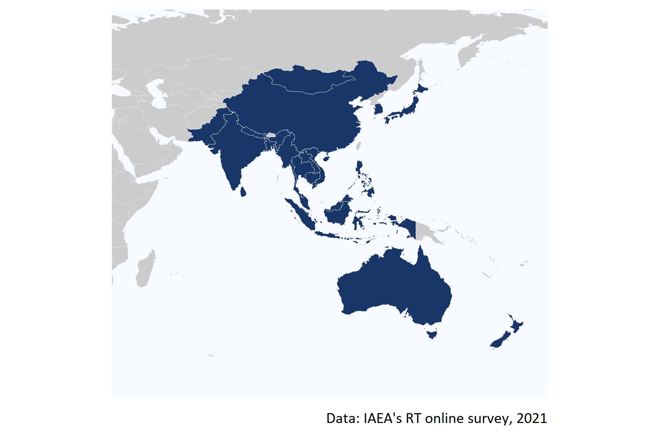

Figure 1: Map of the 20 countries that participated in the online survey.

The assessment of the social and economic impacts of the RT RCA programme involved pre-defining agreed performance criteria (aspects of social and economic impacts that were the focus of the evaluation) and standards (narratives describing four levels of performance – excellent, good, adequate, and inadequate). These criteria and standards (detailed in Annex) provided a transparent and robust framework for rating the impact of the RT RCA.

To understand the contribution of the RT RCA programme on social and economic indicators, the study analyses the extent to which being part of the programme has enabled the GPs to:

**Strengthened radiotherapy workforce**

1. Offer educational training programmes, and establish Radio Oncology (RO) Departments and Societies.
2. Produce RT specialists in Radiation Oncology, Radiation Oncologists, Medical Physicists, Radiation Technology Therapists, and Radiation Oncology Nurses.

**Increased access to quality radiotherapy**

1. Increase operational RT equipment and technology.
2. Increase the number and quality of treatment of cancer patients using domestic RT facilities.

**Increased life span and quality of life**

1. Increase in local control rates.
2. Increase in survival rates.

It is worth mentioning that the IAEA Technical Co-operation Programme (TCP) has been established by the IAEA to support IAEA Member States (MSs) (especially developing countries) to accelerate and enlarge the application of nuclear technologies in a safe, secure, effective, and efficient manner. In principle, every IAEA MS can receive and enjoy the benefit of the IAEA TCP. However, some MSs (especially developed/advanced MSs) volunteer not to receive the IAEA TCP, but they work as resource countries to provide support for the IAEA TCP. Under the RCA, there are 22 countries, of which 18 countries are TC recipients and 4 are TC non-recipients (Australia, Japan, New Zealand, and very recently Korea). **Based on this definition, the three countries that have historically acted as non-recipients (Australia, Japan and New Zealand) are excluded from the assessment of the criteria and level of performance conducted in this analysis. Given their historically non-recipient character, any assessment of the performance of RCA to accelerate and enlarge the application of RT technologies in those countries would result in a misinterpretation of the results.**

# Criterion 1: Strengthened radiotherapy workforce

To understand the contribution of the RT RCA programme to developing the capacity and capability of the Government Parties (GPs) to strength their radiotherapy workforce, this section presents the results of the assessment of the extent to which the support of the RT RCA has enabled GPs to:

1. Offer educational training programmes, and establish Radio Oncology (RO) Departments and Societies.
2. Produce RT specialists in Radiation Oncology, Radiation Oncologists, Medical Physicists, Radiation Technology Therapists, and Radiation Oncology Nurses.

Key indicators and results of this assessment are summarized in the below table

Key evidence for criterion 1: Strengthened radiotherapy workforce

|  |  |  |
| --- | --- | --- |
| Sub-criterion | Evidence | Finding |
| Offer educational training programmes, and RO Departments and Societies. | Total educational/training programmes on RT available in 2020 | 116 |
| Offer educational training programmes, and RO Departments and Societies. | Total Radiation Oncology (RO) Departments in 2020 | 3,215 |
| Offer educational training programmes, and RO Departments and Societies. | Total Radiation Oncology (RO) Societies in 2020 | 94 |
| Produce RT specialists | Approximate number of RT specialists in 2020 | 67,068 |
| Produce RT specialists | Increase of RT specialists between 2000 and 2020 | 231.9% |

## Criterion 1.1 Offer educational training programmes, and establish Radio Oncology (RO) Departments and Societies

To have an approximation of the capacity of each GP to strength its radiotherapy workforce, the number of educational/training programmes on RT, Radiation Oncology (RO) Departments, and RO Societies that are available in each country was estimated.

#### Educational training programmes

As can be seen in Figure 2, **there are a total of 116 educational/training programmes (ET) on RT available across all the RT RCA’s GPs**. Vietnam and China are the countries where more training programmes on RT are available (20), followed by South Korea and Japan where 15 and 10 ETs are available.

According to the responses of the GPs, there are none training programmes on RT available in Cambodia, Laos, Palau, and Sri Lanka.

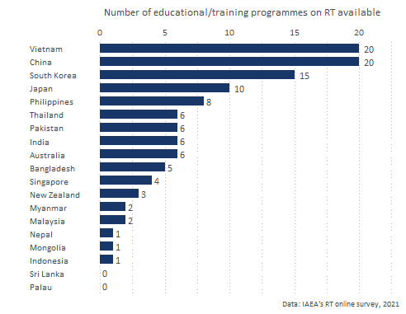

Figure 2: Number of educational or training programmes on RT available by GP.

#### Radiation Oncology Departments

**There a total of 3,215 Radiation Oncology (RO) Departments across all the GPs**. From all those departments 45.5% are located in China, 22.9% in Japan, and 15.6% in India. Figure 3 shows the number of RO Departments available in each GP.

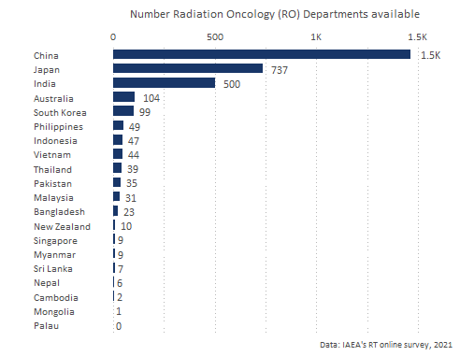

Figure 3: Number of educational or training programmes on RT available by GP.

#### Radiation Oncology Societies

**Accros all the GPs there are a total of 94 Societies from which 64.9% are regional societies**. The countries with the largest number of societies are China (39), India (14) and Japan (5). Australia, Mongolia, Myanmar, Nepal, New Zealand, Sri Lanka, Thailand, and Vietnam have societies at the national level but not at the regional one.

Figure 4 shows the number of national and regional RO societies established across the GPs.

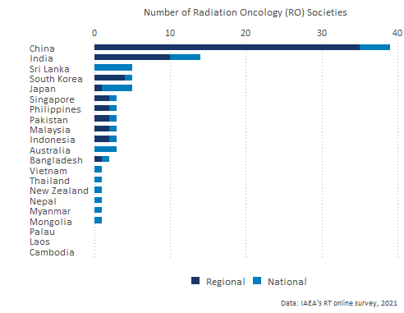

Figure 4: Number of Radiation Oncology (RO) Societies available by type and by GP.

## Criterion 1.2 Produce RT specialists

* Across all the GPs that are part of RT RCA, **in 2020 there were, approximately, a total of 67,068 RT specialists , from which 75.7% were certified specialists**. The country with more RT specialists is China with 44,721 specialists followed by India and Japan that have produced 7,003 and 6,656 specialists respectively.
* **The method for which more specialists have been trained is Radiation Oncologists with about 30,088 specialists trained on RT**.

Figure 5 shows the total number of RT specialist by GP and the proportion of specialists that are certified in 2020 by RT method.

*Australia, India, Laos, Myanmar, and New Zealand did not report, during the online survey, whether their RT specialist are certified or not. Thus, their bars are coded as “Unknown” in the Figure below*.

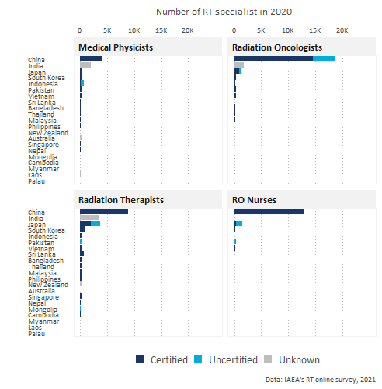

Figure 5: Number of RT specialists by GP in 2000 and 2020.

#### RT specialists in 2000 and 2020

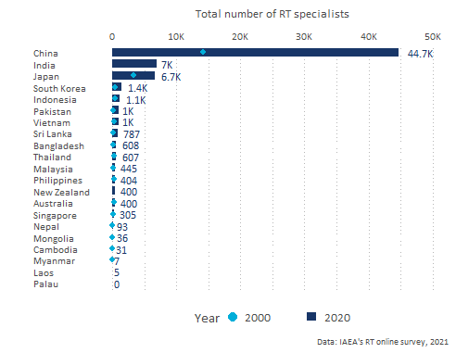

Figure 6: Number of RT specialists by GP.

As can be seen in Figure 6 above, that shows the distribution of RT specialists by country, **across all the GPs, there are 46,862 more RT specialists in 2020 than they were in 2000. This increase represents a growth of 231.9% for this period**. In absolute terms, the country with a higher growth of RT specialists since 2000 is China (30,524 new specialists) . However, in proportional terms, Pakistan is the GP with the fastest growing number of RT specialist (707.1% more in 2020 compared to 2000). Figure 7 shows the percentage change of RT specialists between 2000 and 2020.

*Myanmar is the only GP that reported a negative percentage change of RT specialists. Although they reported to have Medical Physicists, Radiation Oncologists, Radiation Therapists, and RO Nurses in 2000, they did not report the number of Medical Physicists, Radiation Therapists, and RO Nurses.*

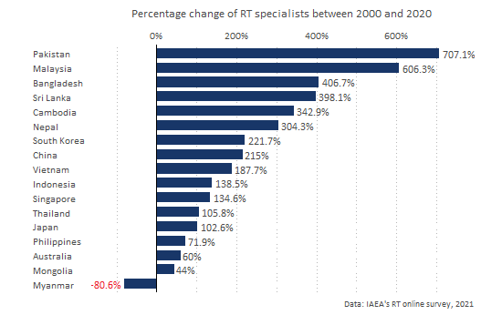

Figure 7: Percentage change of RT specialists between 2000 and 2020 by GP.

India, Laos, and New Zealand reported that they did not have RT specialist in 2000 but that they have managed to produce specialists ever since.

#### RT specialists by method

Figure 8 below shows the distribution of **certified specialists** by method and by GP in 2020 (*to make the distribution of specialists easier to read, the Figure excludes China because it has a much larger number of specialists than the rest of the GPs, and the countries for which the box is coded in gray is because they did not report whether their specialists are certified or not)*.

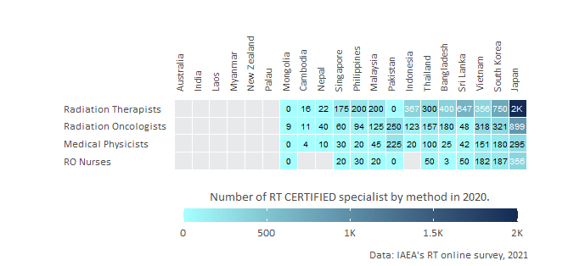

Figure 8: Number of RT specialists by GP.

As can be seen in the Figure above, **after China, the country with the highest number of Radiation Therapists (RT) specialists is Japan (about 2,000 specialists in this field)**, followed by South Korea (750). Japan is also the GP with the highest number of certified Oncologists (899).

## Contribution of RT RCA in strengthening ratiotherapy workforce

This section presents the results of the extent to which, the GPs perceived that, RCA has contributed in the establishment of training programmes, RO departments, RO societies, and the production of RT specialists in their countries.

* As can be seen in Figure 9 below, **out of the 17 GPs for which a training programme is available in their countries, 14 (82.3%) reported that RCA contributed to some extent in their establishment**. 2 GPs reported that the training programmes could had been available even without the support from RCA, one of these countries is New Zealand which is a non-recipient country and the other is Pakistan.
* **73% of the GPs where an RO Department has been established reported that RCA contributed to its establishment**. Cambodia, China, Philippines, Sri Lanka, and Vietnam reported that RCA contributed to a great extent in the establishment of their RO departments. Only Mongolia, New Zealand, and Singapore perceived that RCA has not contributed to the establishment of their RO departments.
* **China, Japan, Mongolia,Philippines, Sri Lanka, and Vietnam reported that RCA contribution was key to the establishment of their RO societies**.
* 9 out of the 19 historically recipient countries (Laos, Cambodia, Myanmar, Indonesia, Japan, Malaysia, Sri Lanka, Mongolia, and Philippines) reported that RCA contributed to a great extent in the production of RT specialists. And 6 of these 19 countries perceived that RCA contributed somehow to produce their specialists. Thus **17 out of the 19 historically recipient countries consider that RCA contributed to the increase of certified RT specialists between 2000 and 2020**.
* From the countries that provided information about RCA’s contribution, only Palau, and New Zealand reported that RCA has not contributed to the strengthening of their RT workforce. New Zealand have acted historically as non-recipients, and Palau joined RT RCA in 2019.

Figure 9 shows the detailed contribution of RCA to the GP’s self-reliance.

*The numbers within the boxes represent the total number of training programmes, RO departments, RO societies, and RT specialists that each GP reported for the 2020 period. The white boxes indicate that those GPs did not provide information about their perception of RCA’s contribution in that dimension*.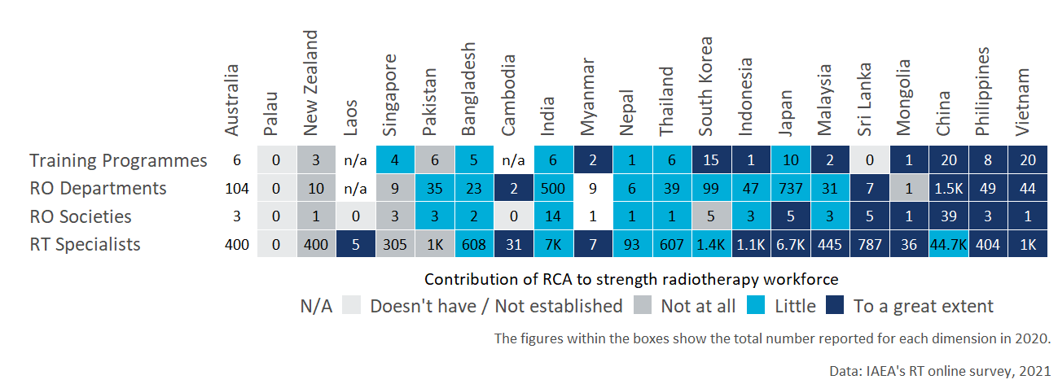

Figure 9: RCA contribution to strength radiotherapy workforce

# Criterion 2: Increased access to quality radiotherapy

This section presents the findings on the contribution of the RT RCA programme to the increased access to quality radiotherapy in the GPs that are part of the programme and that participated in the online survey. In particular, the objective of the analysis is to understand the extent to which the support of the RT programme has contributed to:

1. Increase operational RT equipment and technology.
2. Increase the number and quality of treatment of cancer patients using domestic RT facilities.

Key evidence for criterion 2: Increased access to quality radiotherapy

|  |  |  |
| --- | --- | --- |
| Sub-criterion | Evidence | Finding |
| Increase operational RT equipment and technology | Total number of operational RT equipment (linear accelerators and Cobalt 60 machines) in 2020 | 4,599 |
| Increase operational RT equipment and technology | % increase in the number of operational RT equipment (linear accelerators and Cobalt 60 machines) between 2000 and 2020 | 128.9% |
| Increase the number and quality of treatment of cancer patients using domestic RT facilities | Total number of cancer patients treated using domestic RT facilities in 2020 | 1,378,930 |
| Increase the number and quality of treatment of cancer patients using domestic RT facilities | % increase in the number of cancer patients treated using domestic RT facilities between 2000 and 2020 | 120.5% |
| Increase the number and quality of treatment of cancer patients using domestic RT facilities | Proporiton of patients that experienced less than 10 days of waiting time in 2020 | 60.8 % |

## Criterion 2.1 Increase operational RT equipment and technology

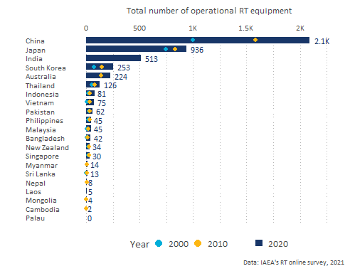

Figure 10: Total number of operational RT equipment by GP (linear accelerators and Cobalt 60 machines) by GP between 2000 and 2020.

Figure 10 above shows the total number of operational RT equipment (linear accelerators and Cobalt 60 machines) available by GP in 2000, 2010, and 2020. As can be seen in the figure China is the country where more operational RT equipment is available (2,087 machines) in 2020, followed by Japan that has 936 RT machines, and India (513). Palau is the only country that reported not to have any operational RT equipment available in their country.

The largest total increase in treatment machines in the period 2000 to 2020 was reported by China that reported a total increase of 1,091. However, in relative terms, the largest increase was observed for Vietnam which reported to have 733.3% more RT equipment in 2020 in relation to 2000.

**Overall, in 2000, there were approximately 2,009 operational RT equipment (linear accelerators and Cobalt 60 machines) across all the GPs that are part of the RT RCA programme**. By 2020, this figure has increased to 4,599 **which represents a percentage growth of 128.9% between 2000 and 2020**.

Figure 11 shows the percentage change of operational RT equipment between 2010 and 2020 by GP.

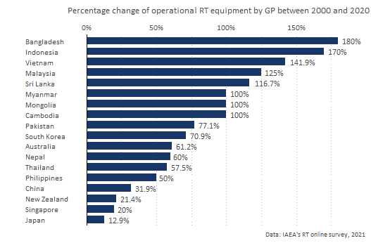

Figure 11: Percentage change of operational RT equipment between 2000 and 2020 by GP (linear accelerators and Cobalt 60 machines).

## Criterion 2.2 Increase the number and quality of treatment of cancer patients using domestic RT facilities

This section presents the findings on the analysis conducted on the total number of cancer patients treated and the approximate average waiting times for the patients to be treated in 2000 and 2020.

#### Cancer patients treated using domestic RT

Approximately, **across all the GPs that are part of RT RCA,there were 753,636 more total number of cancer patients treated using domestic RT facilities in 2020 than they were in 2000 (an increment of 120.5%)**. In 2000 there were 625,294 patients reported and 1,378,930 in 2020.

In 2020, among all the GPs, China was the country where more cancer patients were treated using domestic RT facilities (600,000 patients), followed by Japan (235,892 patients), and Pakistan (110,000).

Figure 12 shows the total number of cancer patients treated using domestic RT facilities by GPs between 2000 and 2020.

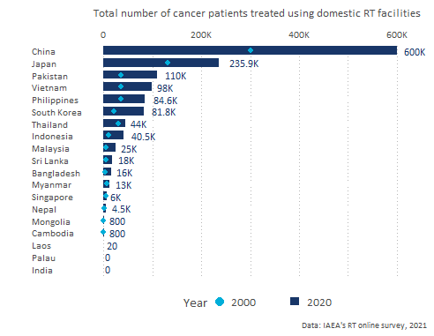

Figure 12: Total number of cancer patients treated using domestic RT facilities by GPs between 2000 and 2020.

Figure 13 shows the percentage change of cancer patients treated using domestic RT facilities by GPs between 2000 and 2020.

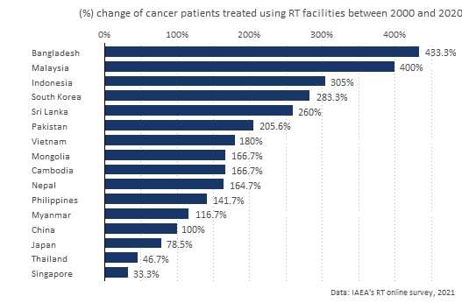

Figure 13: Percentage change of cancer patients treated using domestic RT facilities by GPs between 2000 and 2020.

#### Waiting times

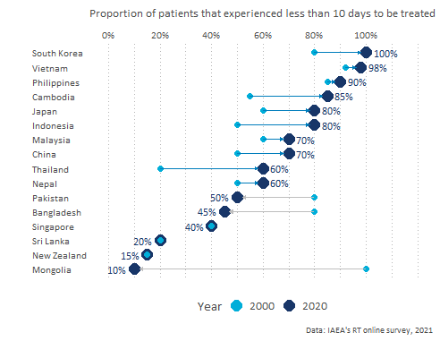

Figure 14: Proportion of patients that experienced less that 10 days of waiting time by GP and by year.

Figure 14 shows the proportion of patients that experienced less than 10 days of waiting time in 2000 and in 2020 for each of the GPs that provided this information. As can be seen in the Figure, **the proportion of patients that are treated in less than 10 days increased, during this period, for all countries except for Mongolia, Bangladesh, and Pakistan**. The proportion of patients that are treated in less that 10 days in 2000 and 2020 is the same for New Zealand, Singapore, and Sri Lanka.

In countries like Cambodia, Philippines, South Korea, and Vietnam more than 80% of the patients are treated in less than 10 days.

**Overall, the proportion of patients that experienced less than 10 days of waiting time increased from 58.6 % in 2000 to 60.8 % in 2020 across all the GPs that are part of the RT RCA programme**.

*Australia, India, Laos, Myanmar, and Palau are not shown in the Figure because information about waiting times was not provided by these countries during the online survey.*

## Contribution of RCA on increasing access to quality radiotherapy

This section presents the findings on the extent to which RT RCA has contributed to increased access to quality radiotherapy:

* As can be seen in Figure 15, **11 GPs reported that RT RCA has contributed to introduce the Intensity-Modulated Radiation Therapy (IMRT) technology in their countries** (Bangladesh, China, India, Indonesia, Japan, Malaysia, Myanmar, Nepal, Philippines, Thailand, and Vietnam).
* **55% of the GPs reported that being part of the programme contributed to the introduction of 3-dimensional Conformal Radiation Therapy (3D-CRT)** (Bangladesh, Cambodia, China, India, Indonesia, Malaysia, Mongolia, Myanmar, Philippines, Thailand, and Vietnam).

*In the chart below, the acronyms stand for: Intensity-Modulated Radiation Therapy (IMRT), 3-Dimensional Conformal Radiation Therapy (3D-CRT), 3-Dimensional Image-Guided Brachytherapy (3D-IGBT), and Stereotactic Body Radiation Therapy (SRT).*

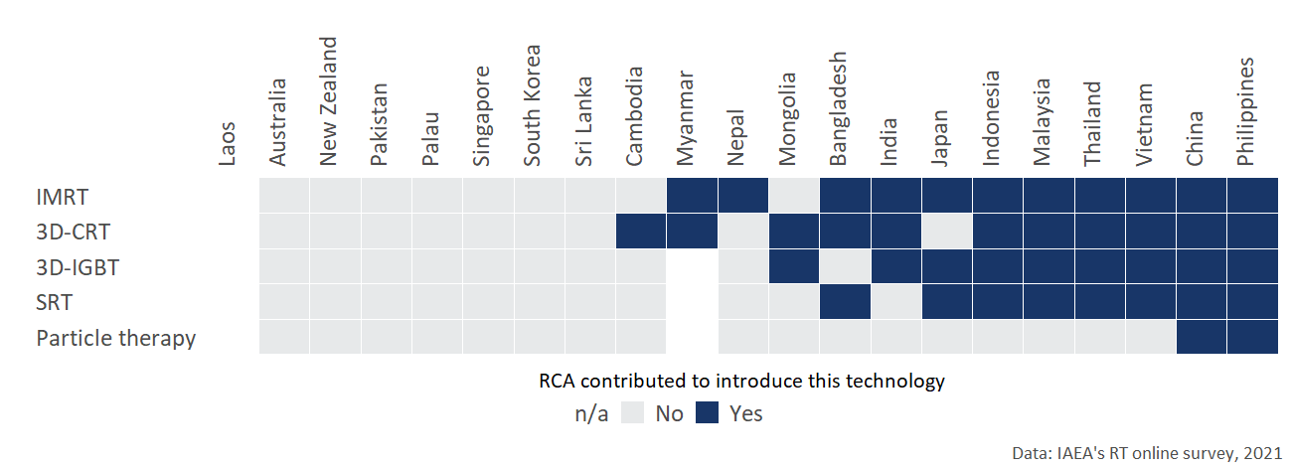

Figure 15: Contribution of RCA to introduce RT technologies.

* **6 out the 19 recipient GPs Cambodia, Malaysia, Myanmar, Nepal, Philippines, and Vietnam reported that between 2000 and 2020 being part of the RT RCA caused their country to invest in additional RT equipment** (linear accelerators and Cobalt 60 machines).
* **84.2% of the GPs consider that the quality of RT services offered in their improved as a result of participating in the RCA RT programme**.
* As can be seen in Figure 16 that shows the perception of each GP on the contribution of RCA to the decrease of waiting times, **75% of the GPs reported that RCA contributed somehow to the decrease in the average waiting time for treatment**. Philippines, and Vietnam perceived that RCA contributed to a great extent to reduce the average waiting time of treatment.

*Australia, India, Laos, Myanmar, and Palau did not reported information about waiting times during the online survey*.

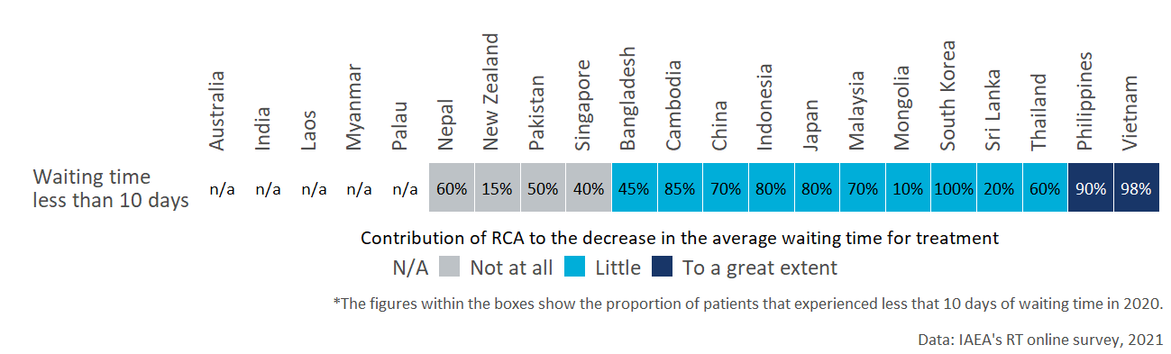

Figure 16: Contribution of RCA to the decrease in the average waiting time for treatment.

# Criterion 3: Increased life span and quality of life

The aim of this section is to understand the extent to which participating in the RT RCA programme has enabled GPs to:

1. Increase in local control rates.
2. Increase in survival rates.

Key evidence for criterion 3: Increased life span and quality of life

|  |  |  |
| --- | --- | --- |
| Sub-criterion | Evidence | Finding |
| Increase in local control or survival data | Approximate average 5-year local control rate in 2020 (average across all types of cancer) | 54.7% |
| Increase in local control or survival data | Increase in the approximate 5-year local control rate in the period 2000-2020 | 15.6 pp |
| Increase life-years | Approximate average 5-year survival rate in 2020 (average across all types of cancer) | 50.8% |
| Increase life-years | Increase in the approximate 5-year survival rate in the period 2000-2020 | 13.1 pp |

## Criterion 3.1 Increase in local control

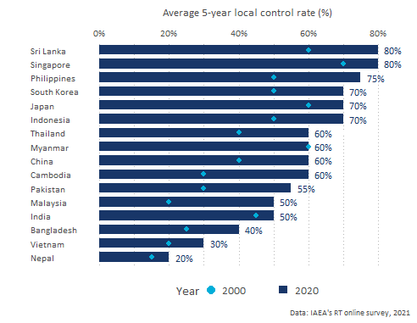

Figure 17: Approximate average 5-year control rate in 2000 and 2020 by GP.

Local control is defined as a complete tumor clearance at the primary site that has received treatment such as radiotherapy. And 5-year local control rate is the proportion of patients that still retain the status of clear tumor clearance in the primary site after five years, over all patients included in that patient’s population.

**Between 2000 and 2020, there was an increase in the average 5-year local control rate for all the GPs that reported information** on this indicator, except for Myanmar that reported a 60% average rate for both periods.

As can be seen in Figure 17, **the approximate average 5-year local control rate across all GPs in 2000 and 2020 was 39.1% and 54.7% respectively. Which implies an increase of 15.6 pp (percentage points) during this period**.

The GPs that reported the highest 5-year local control in 2020 are Sri Lanka (80%), Singapore (80%), and Philippines (75%).

Figure 17 above, shows the average 5-year local control rate in 2000 and 2020.

*Australia, Laos, Mongolia, New Zealand, and Palau did not report information about the average 5-year control rates during the online survey*.

## Criterion 3.2 Increase life-years

**From 2000 to 2020 the approximate average 5-year survival rate across all types of cancer increased 13.1 pp (percentage points) across all GPs**. The average survival rate was 37.7% in 2000 and 54.7% in 2020.

As can be seen in Figure 18, the average survival rate increased for all GPs that reported this information during the online survey. The GPs that reported the highest 5-year survival rate are South Korea, Singapore and Philippines (70%), followed by Thailand (65%) and New Zealand (63%).

*Australia, and Laos did not information about average 5 year survival rates during the online survey*.

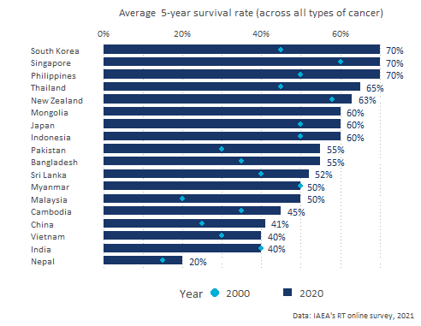

Figure 18: Approximate average 5-year survival rate in 2000 and 2020 by GP.

## Contribution of RCA on increasing life span and quality of life

This section summarises the perception that the GPs have on the extent to which RT RCA has contributed to increase life span and quality of life of patients treated using RT facilities.

* From the 21 that participated in the survey, 15 reported the extent to which RCA has contributed to the increase of life span and quality of life in their countries. This question was not administered to the countries that either did not report about the average rates or for which there was not an increase in the average rates between 2000 and 2020 (*“the”n/a" in Figure 19 shows the countries that did not provide this information*).
* **93% of the GPs that reported an increase of the 5-year control rate between 2000 and 2020, considered that RT RCA had some positive impact to achieve this result.** Pakistan was the only GP that reported that the RCA programme did not have an impact on the increase of control rates during this period.
* **Malaysia considered that RT RCA had a large impact to increase the 5-year control rates**. And China, Sri Lanka, and Vietnam reported that the impact of RCA was significant to achieve this increment.
* **86.6% of the GPs that reported a positive increase in the 5-year survival rate between 2000 and 2020, considered that the RT RCA support contributed to it**. Only Pakistan and New Zealand reported that RT RCA had no impact on this. Bangladesh, Cambodia, China, Indonesia, Nepal, Malaysia, Philippines, Japan, Singapore, South Korea, Sri Lanka, Thailand, Vietnam reported that RT RCA had from a moderate to a large impact in increasing he 5-year survival rate between 2000 and 2020 in their countries.

Figure 19 below shows the extent to which the RCA RT programme contributed to the increase in the 5-year survival and control rates between 2000 and 2020.

*The percentages within the boxes show the average 5-year control and survival rates reported by the GPs in 2020 and the colours show the perception of GPs to the extent to which RCA contributed to increase these rates. Australia, Laos, Mongolia, Myanmar and Palau did not provide this information during the online survey*.

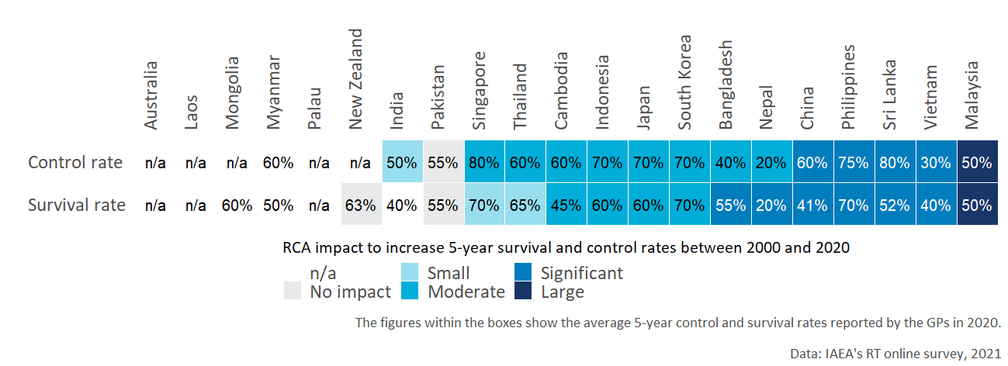

Figure 19: RCA impact to increase 5-year survival and control rates by GP.

# Annex: Criteria and standards

|  |  |
| --- | --- |
| Standard applied to each GP | Criterion 1: Strengthened radiotherapy workforce |
| **Excellent** (exceeding expectations)  GPs with excellent status meet the standard for Good, plus: | **Significant**\* increase in:   * Educational programs; * RO departments; * National societies/ regional RO societies; *and* * ROs/MPs/RTTs (certified and uncertified) |
| **Good** (meeting expectations)  GPs with good status meet the standard for Adequate, plus: | **Some** increase in:   * Educational programs; * RO departments; * National societies; *and* * ROs/MPs/RTTs (certified and uncertified) |
| **Adequate** (meeting bottom-line expectations) | **Any** increase in:   * Educational programs; * RO departments; * National societies; *and* * ROs/MPs/RTTs (certified and uncertified) |
| **Inadequate** | No material increase in *any one of:* educational programs, RO departments, national societies, or ROs/MPs/RTTs. |

|  |  |
| --- | --- |
| Standard applied to each GP | Criterion 2: Increased access to quality radiotherapy |
| **Excellent** (exceeding expectations)  GPs with excellent status meet the standard for Good, plus: | **Significant** increase in:   * Population coverage of radiotherapy machines * Technologies introduced by the RCA projects including 3D-CRT, IMRT, particle therapy, SRT, 3D-IGBT * Waiting times from admission to treatment < 5 days *and* * Patients receiving radiotherapy.   There is a **significant** upgrade of quality relevant to the radiotherapy technique/ service of the RCA in the participating countries. |
| **Good** (meeting expectations)  GPs with good status meet the standard for Adequate, plus: | **Some** increase in:   * Treatment machines * New technologies introduced by the RCA projects; * Waiting times from admission to treatment < 7 days *and* * Patients receiving radiotherapy.   There is some upgrade of quality relevant to the radiotherapy technique/ service of the RCA in the participating countries, though the increase is not remarkable in percentage terms. |
| **Adequate** (meeting bottom-line expectations) | **Any** increase in:   * Treatment machines * New technologies introduced by the RCA projects; * Patients receiving radiotherapy; * Waiting times from admission to treatment < 10 days *and* * Quality improvement. |
| **Inadequate** | No increase in *any one of:* treatment machines, new technologies introduced by RCA projects, patients. |

|  |  |
| --- | --- |
| Standard applied to each GP | Criterion 3: Increased life span and quality of life |
| **Excellent** (exceeding expectations)  GPs with excellent status meet the standard for Good, plus: | * **Significant** increase in local control data or survival data, with low incidence of complications. * **Significant** increase in life-years. * High satisfaction reported in radiotherapy centres by applying the relevant method/ technologies. |
| **Good** (meeting expectations)  GPs with good status meet the standard for Adequate, plus: | * **Some** increase in local control data or survival data, with low incidence of complications. * **Some** increase in life-years. * Patients were reported somewhat satisfied. |
| **Adequate** (meeting bottom-line expectations) | * **Any** increase in local control data or survival data, with low incidence of complications. * **Any** increase in life-years. * Neutral patient satisfaction |
| **Inadequate** | Any of the standards for Adequate are not met. |