IAEA TC Programme Achievements in the 21st Century

Progress and Impact

Contents

Food and Agriculture 1

Relevance: evolution of the contribution of the TC Programme in achieving results 1

Effectiveness: Evolution of introduction of improvements by TCP 2

Sustainability: Evolution of tangible results brought by the TCP 3

Regional Cooperation Agreements: Value added by participating. 4

Future perspective: Importance of the TCP in achieving results in the future. 5

Visibility: Contribution of the TCP to the socio-economic development of countries. 6

Health and Nutrition 7

Energy Planning and Nuclear Power 7

Industrial Applications and Radiation Technology 7

Water and Environment 7

Nuclear Safety and Security 7

# Food and Agriculture

## Relevance: evolution of the contribution of the TC Programme in achieving results

**From NLO 1:** How would you define the degree to which the TC programme has contributed to achieving results in each area of support in your country?

* QA of the responses: 47% of the answers were left unanswered.
* 50 out of the 181 respondents answered all the questions in this section.
* The data could be aggregated by thematic area, region, country, foa.
* Chart below shows a rapid scan of the answers given by region.

## Effectiveness: Evolution of introduction of improvements by TCP

**From NLO 1:** Please indicate the estimated time range when the improvements introduced by TC programme in each area were achieved in your country.

* Could be aggregated by theme, FOA, region.
* QA of the responses: 49% of the answers were left unanswered.
* 53 out of the 181 respondents answered all the questions in this section.
* Chart below shows a rapid scan of the results. The chart is groped by improvement of FOOD and AGRICLTURE and region only to serve as an example of how these data could be analysed.

## Sustainability: Evolution of tangible results brought by the TCP

**From NLO1:** Please indicate the estimated period when the improvements, introduced by the TC programme, have produced tangible results in the country.

* Could be aggregated by theme, region, foa.
* QA of responses: 50% of the questions were left unanswered.
* Out of the 181 interviews, only 46 answered all the questions of this section.
* The chart below is an example of how these data could be analysed.

## Regional Cooperation Agreements: Value added by participating.

**From NLO1:** What has been the value added by participating in activities led by the Regional Cooperation Agreements in the context of the TC Programme?

* Could be aggregated by theme, region, foa
* QA of responses: 67 respondents (out of 181) skipped this section without responding a single question.
* Example of how the data could be analysed.

## Future perspective: Importance of the TCP in achieving results in the future.

**From NLO1:** To the best of your knowledge (based for example on the CPF or on any current trends of engagement), how important will the contribution of the TC programme be in achievingresults in the following areas in your country over the next 5-10 years?

* Could be aggregated by region, theme, improvement.
* QA of responses: 84 of the 181 respondents did not respond to this section
* Example of how these data could be analysed:

## Visibility: Contribution of the TCP to the socio-economic development of countries.

**From NLO1:** In your opinion, how visible is the contribution of the IAEA TC programme to socioeconomic development in the different areas supported in your country?

* QA of responses: 67 out of the 181 respondents did not answer this section.
* Data could be aggregated by region, country, theme, foa
* Example of analysis:

## Partnerships: Significant partnerships established during the last 20 years

**From NLO1:** What are the most significant partnerships in the context of the TC programme thathave been established in your country during the last 20 years in the different thematic areas?

* Could be grouped by sector and theme

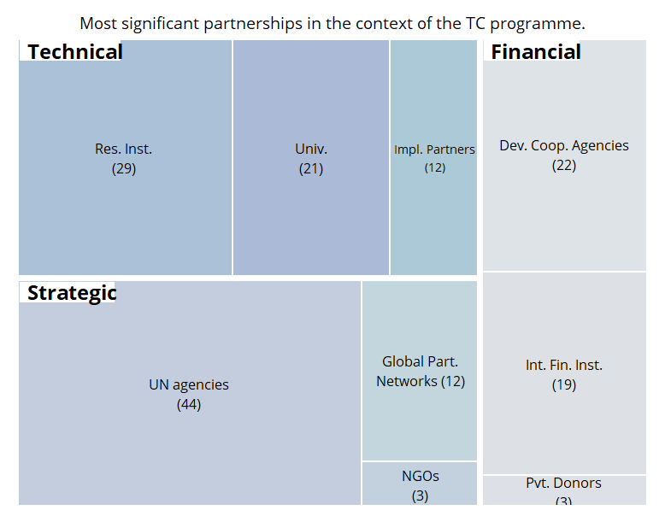

# Health and Nutrition

# Energy Planning and Nuclear Power

# Industrial Applications and Radiation Technology

# Water and Environment

# Nuclear Safety and Security