IAEA TC Programme Achievements in the 21st Century

Draft: Food & Agriculture

# 1 Projects Implemented

Administrative data is used to count the total number of projects supported by the TCP in the 21st century.

File used: Copy of CPs_2022_09_12

**A total of 8,559 projects** have been supported under the FOOD and AGRICULURE thematic area.

## 1.1 Number of Projects Across FOAs

The coding system of the FOAs has varied over time. To have a consistent coding, the analytical team grouped the FOAs to create a new coding system. Moreover, each FOA is expected to produce a certain improvement. Thus, the FOAs can also be grouped across improvements.

### 1.1.1 Using Names of the FOAs

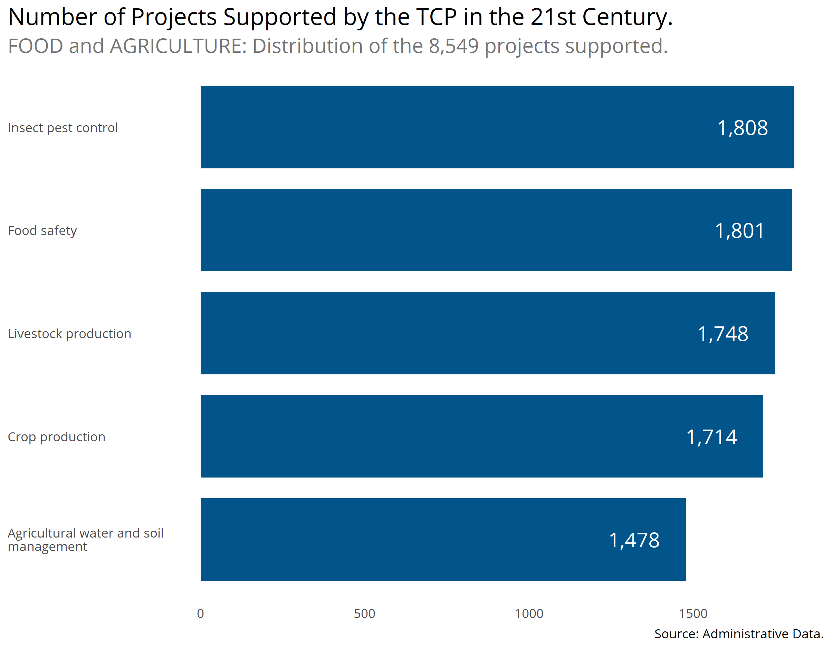

### 1.1.2 Using Names of the Improvements

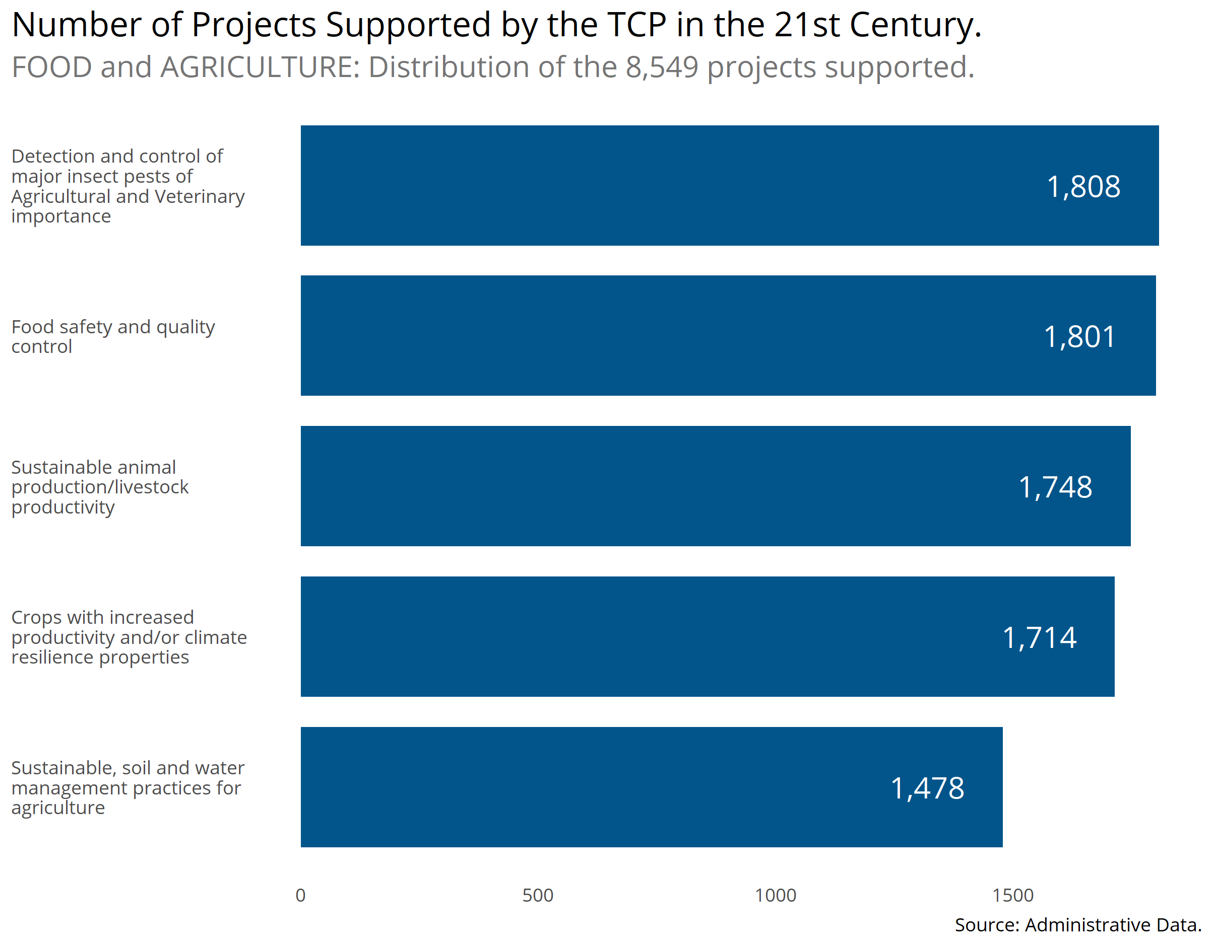

## 1.2 Number of Projects Across Regions

### 1.2.1 Using Names of the FOAs

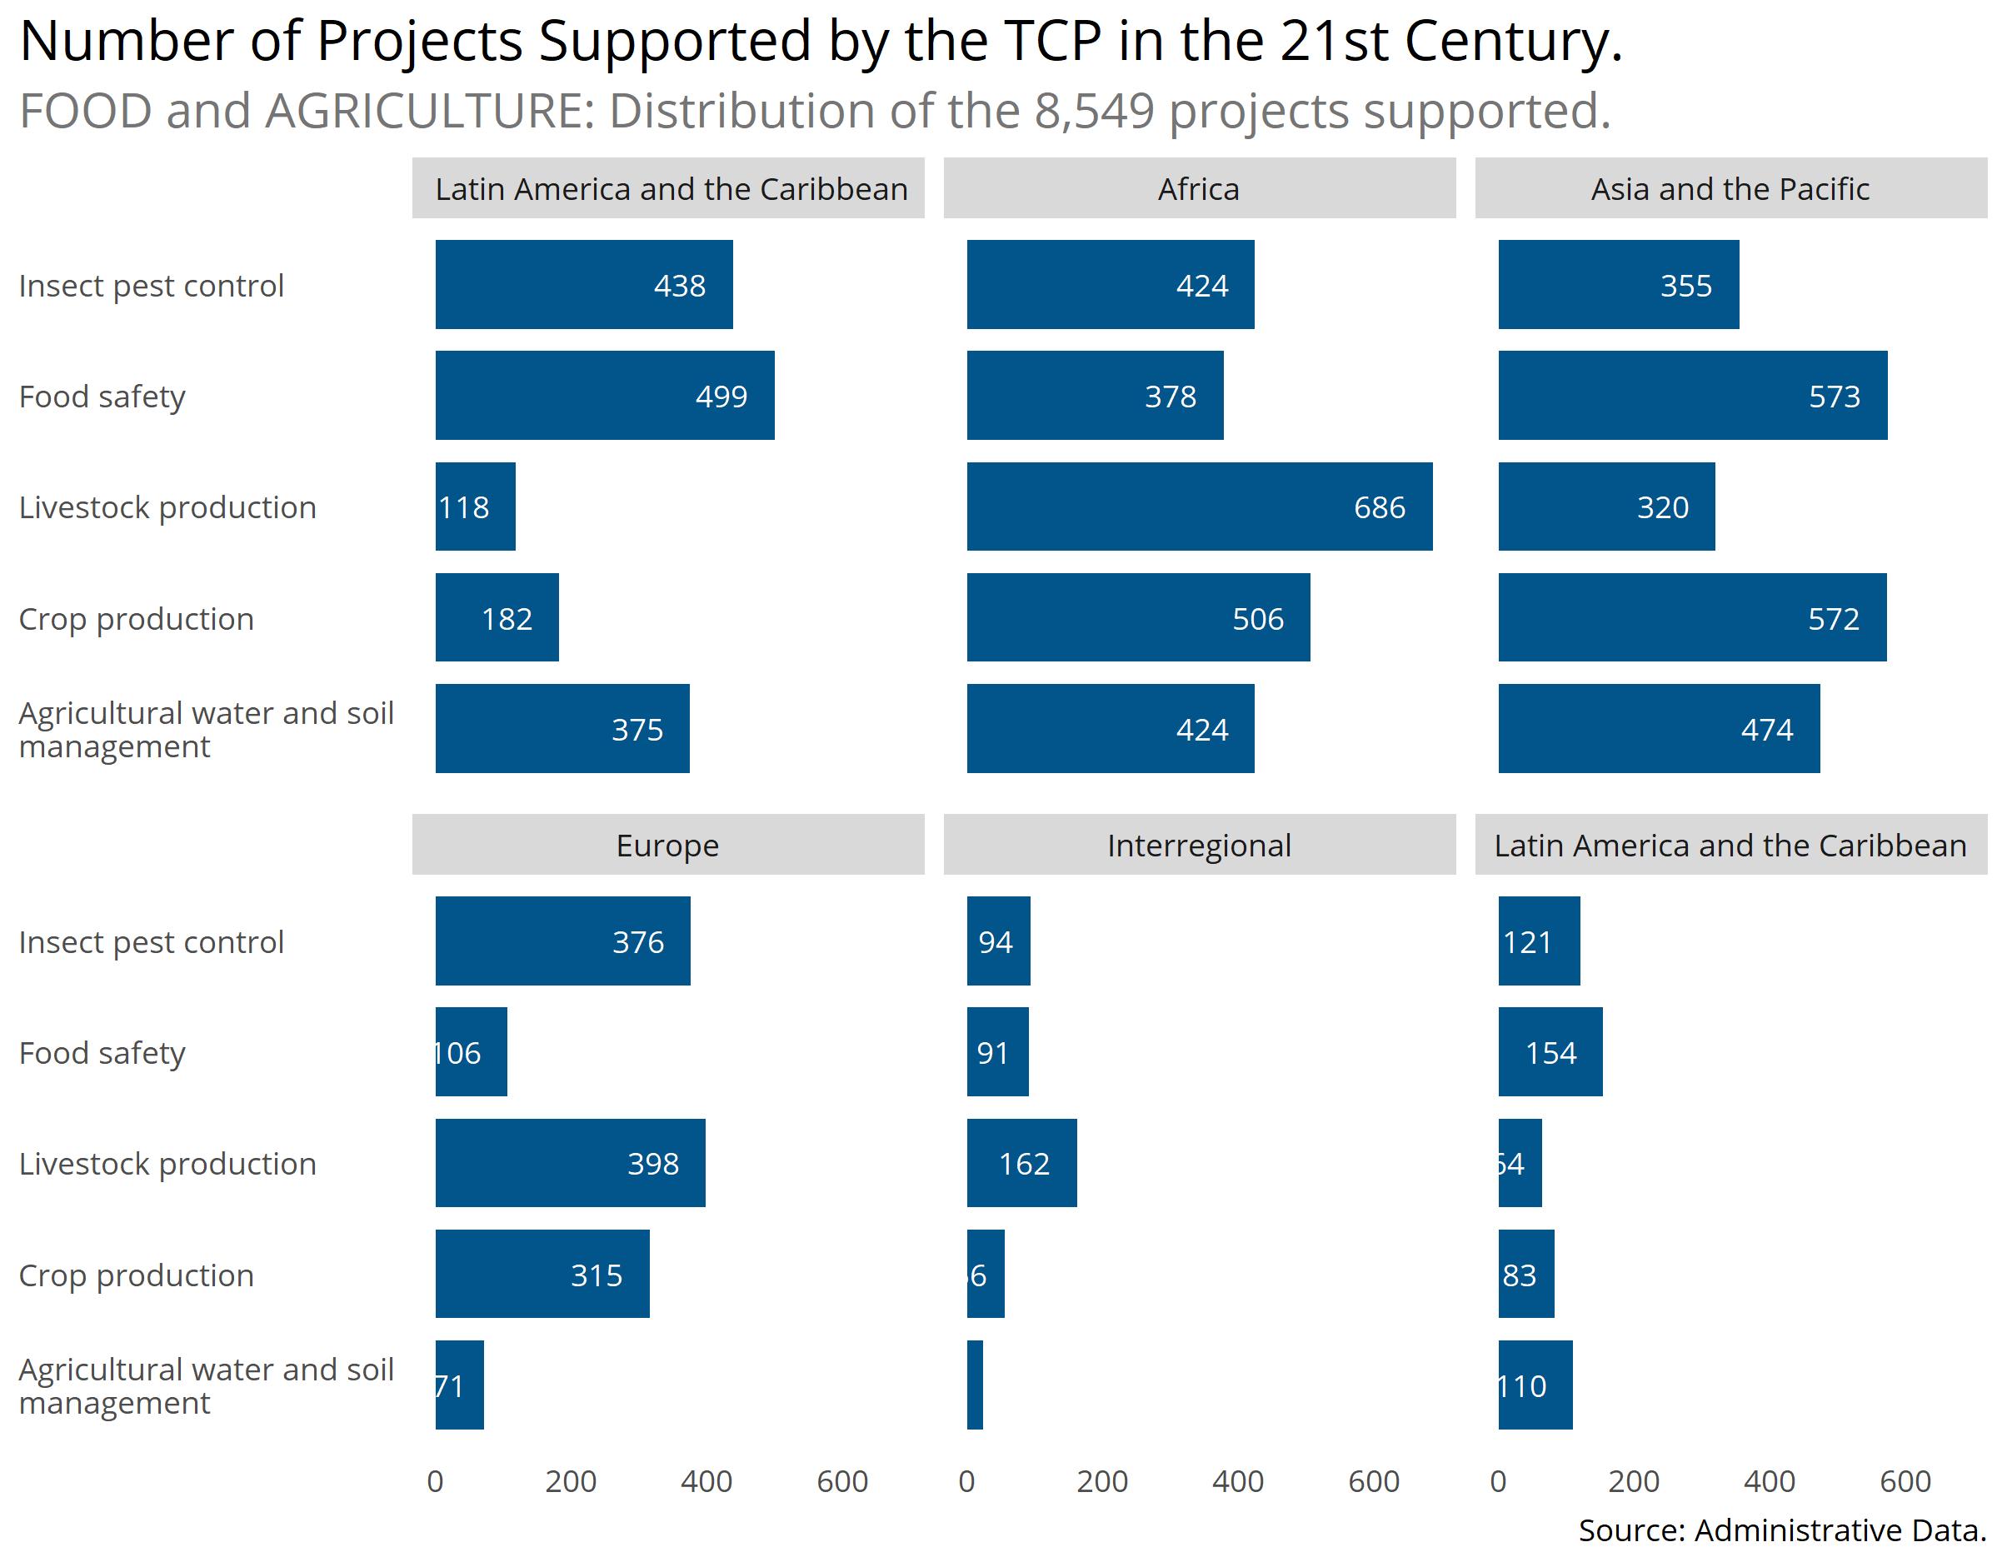

### 1.2.2 Using Names of Improvements

