RCA preliminary analysis of online survey and internal IAEA’s data collection

Andrés Arau

6/15/2020

Table of Contents

Introduction 1

Criterion 1: Increased food production 2

Mutant lines and mutant varieties developed under RCA since 2000 3

Productivity 5

Growing area 6

Quality traits 8

Criterion 3: Strengthened regional capacity and sustainability 9

Evidence needed for Criterion 3 9

National team and facilities for mutation breeding 10

Training in mutation breeding and associated techniques 11

Expert missions and workshops 12

Publications in mutation breeding 12

Networking, collaboration, and knowledge transfer 13

Annex 1 15

Mutant lines and mutant varities developed (by country and crop) 15

# Introduction

This analysis includes information of the 22 countries that are part of the Regional Cooperative Agreement for Research (RCA): Australia, Bangladesh, Cambodia, China, Fiji, India, Indonesia, Japan, Laos, Malaysia, Mongolia, Myanmar, Nepal, New Zealand, Pakistan, Palau, Philippines, Singapore, South Korea, Sri Lanka, Thailand, and Vietnam. The findings presented in this report include internal data provided by IAEA and information provided by national experts through the implementation of an online survey conducted between February to April, 2020. From the total 22 countries, 19 participated in the online survey. The three countries that did not take part on the online survey were Fiji, New Zealand, and Singapore

The map below shows all the countries that are part of this study.

#### Map of the 22 countries that participate in the RCA programme

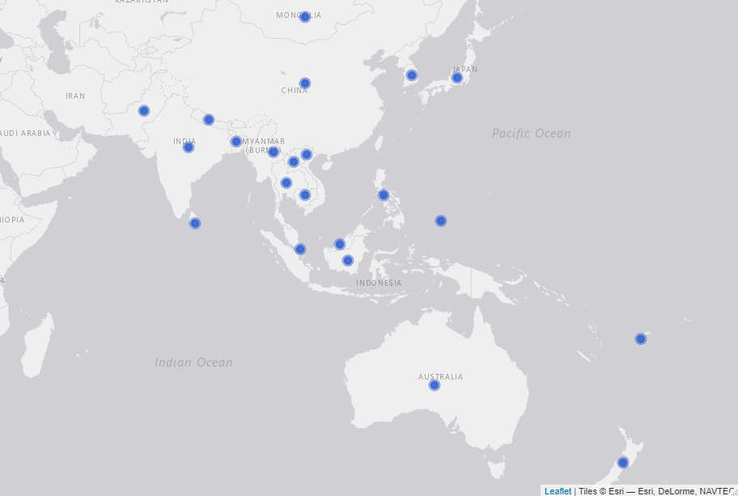

# Criterion 1: Increased food production

#### Table X. Evidence needed for criterion 1

|  |  |  |
| --- | --- | --- |
| Evidence needed | Finding | Source |
| Total Number of new mutant lines | 7,316 | Online survey |
| Total Number of new mutant varieties | 254 | Online survey |
| Average yield increase (% and tonne/Ha) | 40.4% | Online survey |
| Total growing area (in thousand Ha) | 33,546 | Online survey |
| % of new mutant varieties that improve quality traits | 80% | Online survey |
| Average increased income by farmers | ? | ? |
| Number of new mutant varieties adopted by policy makers | ? | ? |
| Number of new mutant varieties commercialised | ? | ? |

### Mutant lines and mutant varieties developed under RCA since 2000

The definition used by this report for mutant lines and mutant varities is the following: **mutant lines** are what also called breeding lines. They don’t have name yet but may have qualified for the target trait that it is been bred for (mostly with breeders to be released later). They have not yet been officially released while **mutant varities** are those which have name (example Bamati or NERICA rice, ug 99 for wheat blast etc). These have been certified and officially released. Passport data is in the public domain. All the information.

According to the responses from the online survey, **7,316 mutant lines and 254 mutant varieties have been developed under RCA since 2000**. As it is shown in the table below, from the 19 countries that participated in the online survey, two have not developed any mutant line under RCA - Bangladesh and Palau - and five have not developed a mutant variety yet - Bangladesh, Cambodia, Laos, Nepal, and Palau-. Thus, from all the countries that participated in the online survey 11% have not developed a mutation line and 26% have not developed a mutation variety yet. The countries that have developed more mutant varities under the RCA programme are Japan (60), China (42), Indonesia (40), Vietnam (36), and Pakistan (35). Refer to annex 1 to see all the mutant lines and mutant varities reported by country and crop.

*(QA! confirm if China did develop 5,000 lines of wheat or if that is typo in the response)*

#### Table X. Number of mutant lines and mutant varieties developed under the RCA programme since 2000 (by country)

Source: IAEA’s online survey, 2020

|  |  |  |  |  |
| --- | --- | --- | --- | --- |
| country | Has developed lines | Lines developed | Has developed varieties | Varieties developed |
| Australia | Yes | 150 | Yes | 1 |
| Bangladesh | No | 0 | No | 0 |
| Cambodia | Yes | 1 | No | 0 |
| China | Yes | 5000 | Yes | 42 |
| India | Yes | 65 | Yes | 7 |
| Indonesia | Yes | 450 | Yes | 40 |
| Japan | Yes | 60 | Yes | 60 |
| Laos | Yes | 93 | No | 0 |
| Malaysia | Yes | 16 | Yes | 1 |
| Mongolia | Yes | 20 | Yes | 3 |
| Myanmar | Yes | 35 | Yes | 5 |
| Nepal | Yes | 50 | No | 0 |
| Pakistan | Yes | 173 | Yes | 35 |
| Palau | No | 0 | No | 0 |
| Philippines | Yes | 34 | Yes | 7 |
| South Korea | Yes | 800 | Yes | 7 |
| Sri Lanka | Yes | 19 | Yes | 1 |
| Thailand | Yes | 100 | Yes | 9 |
| Vietnam | Yes | 250 | Yes | 36 |
|  |  |  |  |  |

The chart below shows the number of mutant lines and mutant varieties developed by crop. Thus, as the table shows, more than 900 mutant lines of rice have been developed in order to produce about 120 mutant varities of this crop; there have been more than 5,000 mutant lines of wheat to develop 45 mutant varieties. In the case of soybean, 347 mutant lines and 45 mutant varieties having feveloped under RCA since 2000 (See table below)

#### Figure X. Mutant lines and mutant varieties developed by crop

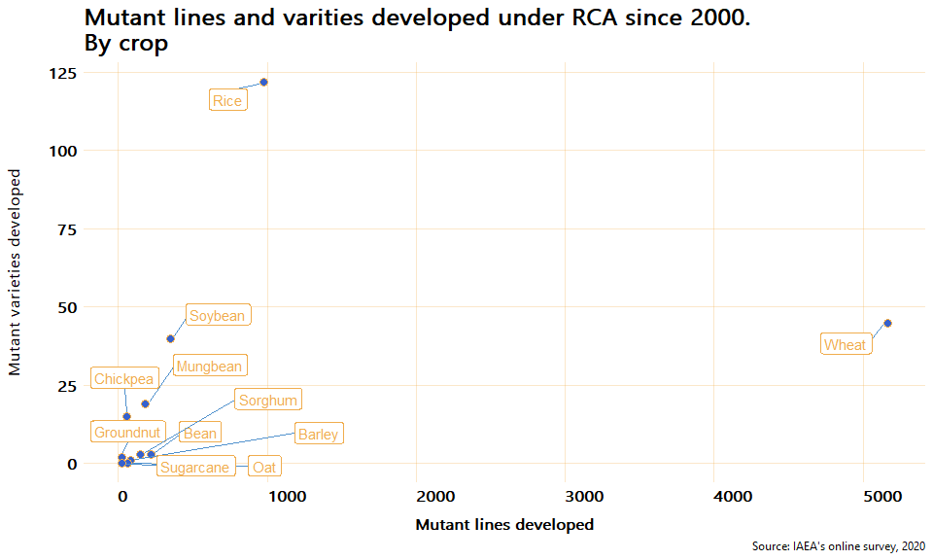

From the 254 mutant varieties developed under RCA since 2000, 145 are rice varieties, 45 wheat, and 40 soybean. The chart below presents the total number of mutant varieties developed by crop since 2000.

#### Figure X. Total mutant varieties developed by crop

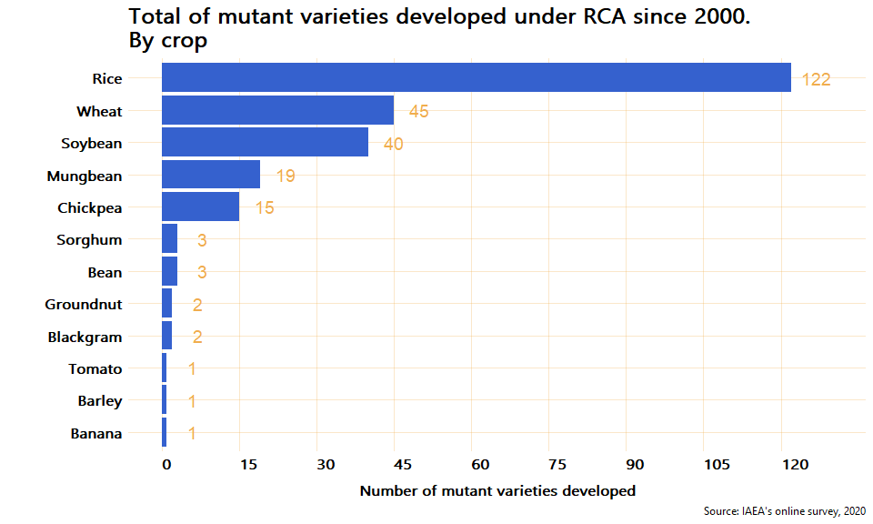

### Productivity

To estimate the impact that mutant varieties have on productivity, the online survey asked the experts to report on the average yield productivity (in tonnes/ha) for the mutant and the control crops respectively. According to the responses of the experts, all the mutant varities have a higher yield productivity than their control crops. On average, the mutant varieties have 40.4% higher productivity compared to the control crops. From all the reported mutant varieties crops, Bean shown the highest increase compare to its control crop (100%), followed by Sorghum with a 52.5% increase in yield productivity.

The chart below shows the average change in productivity between mutant and control crops.

*Note the graph below excludes Tomato and Banana because they have a much higher yield than the rest and including them would affect the visualization, they increased their yield 16.6% and 33.3% respectively*

#### Figure X. Average change in yield productivity: mutant vs control

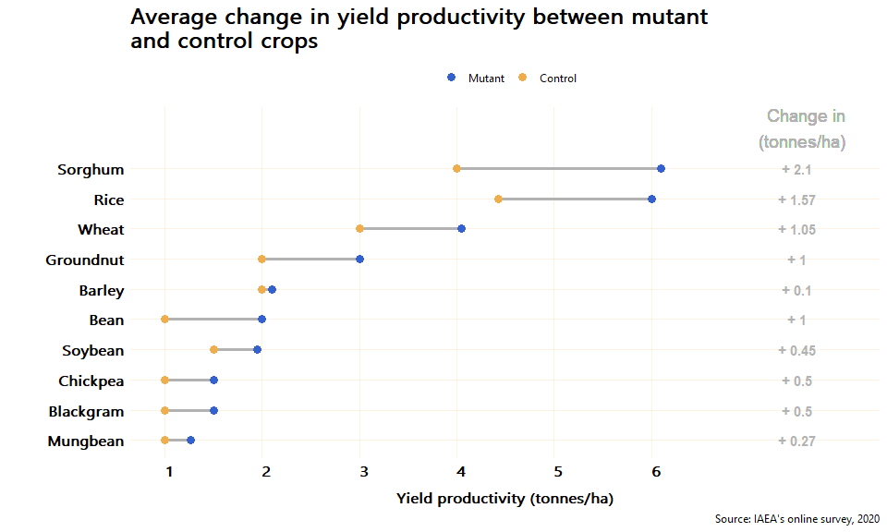

### Growing area

**QA! Ask Sinh and Kofi if the figures for accumulated growing area and yield are correct (i.e. if there’s not an unikely outlayer). See annex 1**

Approximately, **the total accumulated growing area of mutant crops in the 19 countries that participated in the online survey is 33,546 (in 1,000 ha)**. From the 14 countries with at least one mutant variety developed, Pakistan is the country with the largest growing area of mutant crops: 16,200 (thousand ha). The second largest growing area is in China, followed by Thailand, Vietnam, and Indonesia. From the countries with at least 1 mutant variety reported, Sri Lanka and Malaysia are the ones with the smallest growing area, .04 and .2 (1,000 ha) respectively. The average growing area of mutant crops in the RCA countries is 2,396 (thousand ha). The chart below shows the total growing area of mutant varietiess since 2000 by country.

#### Figure X. Total growing area of mutant crops by contry

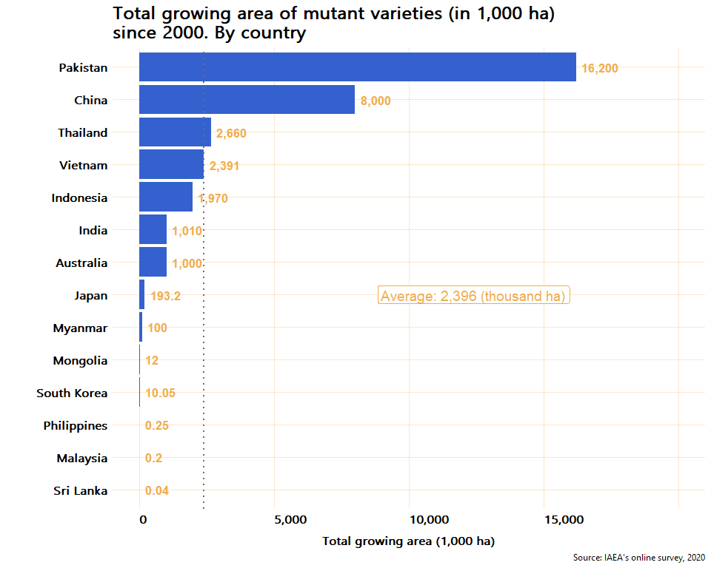

The crop with the largest growing area is Chikpea with 13,200 thousand ha and it is grown only in Pakistan **(Check this figure with Sinh)**, followed by Wheat (8,012 thousand ha) that is grown in China and Mongolia. The table below summarises the total mutant lines, varieties and their total growing area (in thousand ha) and yield (tonnes/ha). To see the total growing area for each crop by country, see table X in the annex.

#### Table: Growing area and productivity of mutant crops (sorted by growing area)

Source: IAEA’s online survey, 2020

|  |  |  |  |  |
| --- | --- | --- | --- | --- |
| Crop | Lines developed | Varieties developed | Total growing area (1,000 ha) | Average yield (tonnes/ha) |
| Chickpea | 55 | 15 | 13,200 | 1.5 |
| Wheat | 5,165 | 45 | 8,012 | 4.0 |
| Mungbean | 178 | 19 | 4,700 | 1.3 |
| Rice | 973 | 122 | 3,975 | 6.0 |
| Soybean | 347 | 40 | 1,929 | 2.0 |
| Barley | 84 | 1 | 1,000 | 2.1 |
| Blackgram | 15 | 2 | 600 | 1.5 |
| Sorghum | 150 | 3 | 120 | 6.1 |
| Groundnut | 25 | 2 | 10 | 3.0 |
| Banana | 7 | 1 | 0.1 | 40.0 |
| Bean | 216 | 3 | 0.05 | 2.0 |
| Tomato | 2 | 1 | 0.035 | 35.0 |

### Quality traits

The number of crops for which at least one quality trait (gluten free, grain size, grain shape, grain color, milling quality, eating quality, high mineral content, high oil content, and high seed protein content) improved by the mutant variety was estimated to assess whether, apart from improving the productivity of the crops, the mutant varieties contribute to an improvement in their quality or not. As a result of the online survey, it was found that 80% of the mutant varieties reported to have improved at least one quality trait. As it can be seen in the figure below, from the 10 crops for which a mutant variety has been developed, 8 have improved at least one quality trait. From all the mutant vareities, only Barley and Banana have not improved any quality trait.

#### Figure X. Number of quality traits improved by mutant varieties

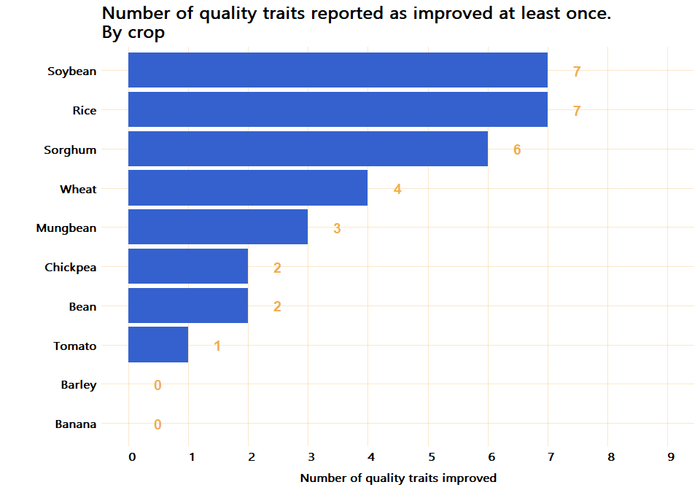

To better understand the quality traits improved, the proportion of responses that reported a positive improvement in quality crops was estimated. Thus, for each crop reported, the proportion of times the crop was reported to have improve a quality trait is presented in the figure below.

#### Figure X. Proportion of responses reporting improvement in quality traits of mutation varieties

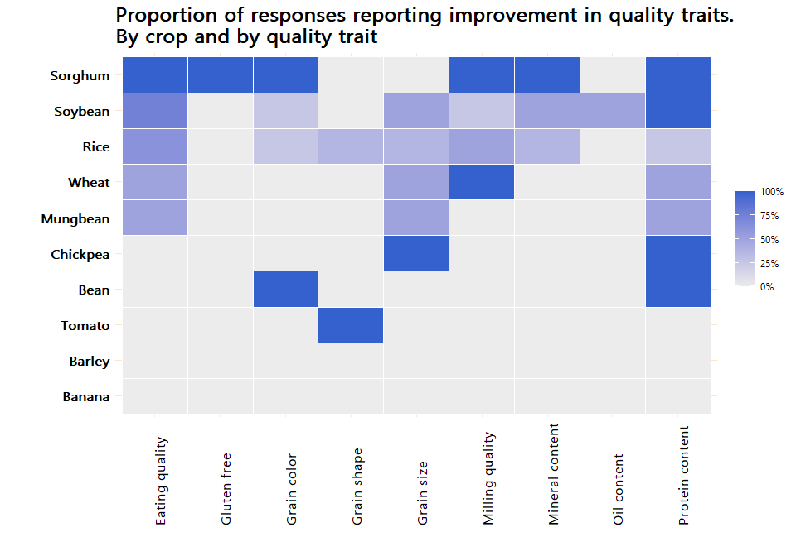

# Criterion 3: Strengthened regional capacity and sustainability

*Write a description of criterion 3 and its relation to the ToC*

### Evidence needed for Criterion 3

#### Table X. Evidence needed for criterion 3

|  |  |  |
| --- | --- | --- |
| Evidence needed | Finding | Source |
| Countries have a national team in MB | 73.7% | Online survey |
| *Description: Training responsive to dynamic needs* | ? | ? |
| Countries with access to field facilities | 89.5% | Online Survey |
| Countries with access to radiation facilities | 68.4% | Online survey |
| Number of group trainings in mutation breeding | 25 trainings | Internal IAEA’s data |
| Numbers of people trained in mutation breeding and associated techniques | 470 people trained | Internal IAEA’s data |
| Countries sharing knowledge to other countries | 13 countries to other countries | Online survey |
| Formal networks between countries and within country | networks with 493 institutions | Online survey |
| Scientific Publications in mutation breeding produced by GPs | 977 scientific publications | Online survey |

### National team and facilities for mutation breeding

The year in which a country started Mutation Breeding at the nationa level varies between countries. Countries like Japan, China, Sri Lanka, or India started in 1960 while Countries like Laos, Cambodia or Palau have started less than 15 years ago (See table below). As it can be seen in *Table 1*, **73.7% of the 19 countries that participated in the online survey have a national team in mutation breeding**, 89.5% have a field facility, and 68.4% have a radiation facility. It is worth noticing that none of the countries that started a mutation breeding program earlier than 40 years ago has a radiation facility yet.

#### Table X. Year in which mutation breeding started at the national level, human resources, and facilities by country

Source: IAEA’s online survey, 2020

|  |  |  |  |  |  |
| --- | --- | --- | --- | --- | --- |
| Country | Year mutation breeding started at the national level | Total years | National team | Field facility | Radiation facility |
| Japan | 1960 | 60 | Yes | No | Yes |
| China | 1960 | 60 | Yes | Yes | Yes |
| Sri Lanka | 1960 | 60 | Yes | Yes | Yes |
| India | 1960 | 60 | Yes | Yes | Yes |
| South Korea | 1960 | 60 | Yes | Yes | Yes |
| Philippines | 1962 | 58 | Yes | Yes | Yes |
| Thailand | 1965 | 55 | Yes | Yes | Yes |
| Pakistan | 1970 | 50 | Yes | Yes | Yes |
| Myanmar | 1970 | 50 | Yes | Yes | Yes |
| Australia | 1971 | 49 | No | Yes | Yes |
| Bangladesh | 1972 | 48 | Yes | Yes | Yes |
| Indonesia | 1972 | 48 | Yes | Yes | Yes |
| Malaysia | 1975 | 45 | No | No | No |
| Vietnam | 1978 | 42 | Yes | Yes | Yes |
| Mongolia | 1982 | 38 | Yes | Yes | No |
| Nepal | 1997 | 23 | No | Yes | No |
| Palau | 2009 | 11 | No | Yes | No |
| Laos | 2015 | 5 | Yes | Yes | No |
| Cambodia | 2018 | 2 | No | Yes | No |

### Training in mutation breeding and associated techniques

According to IAEA’s internal data, since 2000, a total of 25 courses in mutation breeding have been conducted and **a total of 470 individuals have been trained at the national level under RCA projects** . From this 470 individuals, 108 are women (23%). China is the country with the largest number of people trained with 47 trained individuals, followed by Vietnam and Indonesia with 36 people trained each. On average, 21 people have been trained in each country under RCA projects since 2000. See table below

#### Figure X. Total people trained under RCA by country

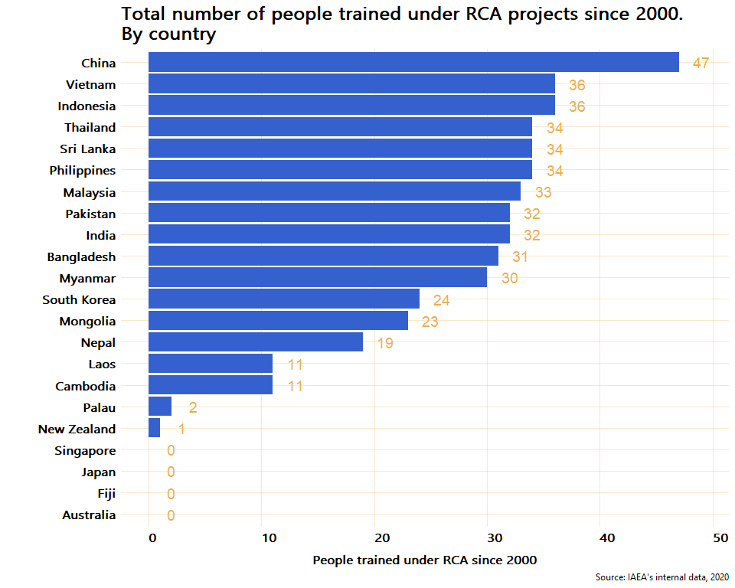

### Expert missions and workshops

According to IAEA’s internal data, **26 expert missions have occured since 2000 under RCA** to which 22 (5% women) national experts from from 6 countries (China, Australia, Phillipines, Pakistan, Myanmar, and India) have attended expert missions to other countries. The chart below presents the total number of national experts that have joined at least one expert mission to to other country.

#### Figure X. Total number of experts that have joint missions to other countries under RCA

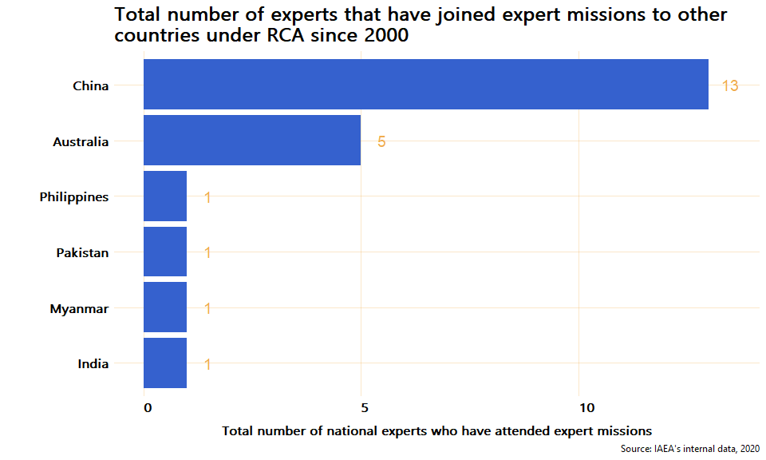

Moreover, **23 meetings/workshops for senior members in mutation breeding research** teams were facilitated. A total of 453 senior members have participated in these type of meetings/workshops.

### Publications in mutation breeding

**QA!: Confirm that the number of reported publications of China is correct. China reported over 30,000)**

In the online survey, country experts were asked to report the total number of publications in mutation breeding developed in each country since 2000. By publication, the study means: journal articles, newspaper articles, thesis, books (and e-books), websites, conferences, online blogs, encyclopedia articles, etc. As a result, it was reported that **a total of 1,801 publicatos have been developed** in the 19 countries that participated in the online survey since 2000. From this publicatios, 54.2% are scientific publications. Chart x below presents the total number of publications by type (scientific and non scientific) and by country since 2000. *Note to the team: This chart exludes China because the number reported of publications was very high (over 30,000)*

#### Figure X. Total number of publications developed since 2000 under RCA

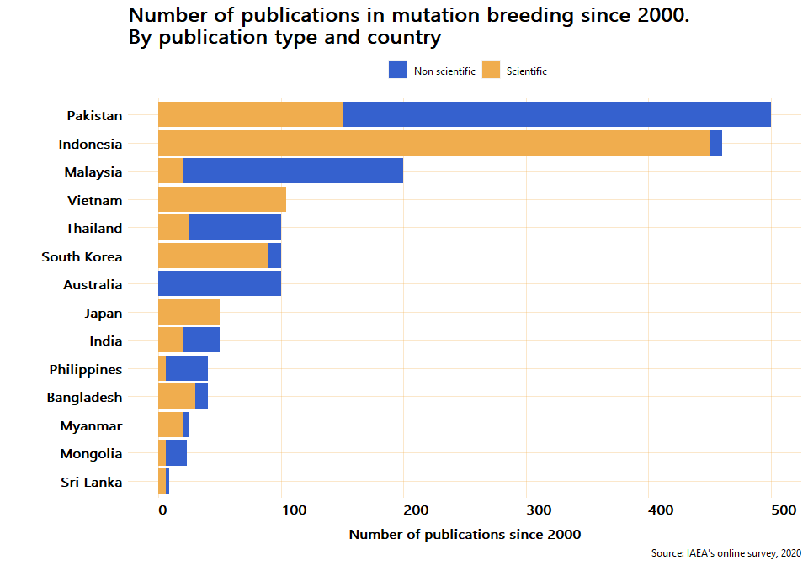

### Networking, collaboration, and knowledge transfer

To estimate the level of collaboration bewteen countries, the online survey asked the exeperts if their country have provided services and knowledge related to mutation breeding to other countries. Examples of services and knowledge could be: data, events, funding, infrastructure, jobs, projects, publications, research, skills shares, tools, etc. According to the answers provided by the experts, **a total of 13 RCA countries - Japan, Pakistan, Bangladesh, China, Indonesia, Thailand, Sri Lanka, India, Vietnam, Malaysia, Australia, Philippines, and South Korea - have provided services and knowledge related to mutation breeding to other countries**. From these 13 countries that have shared knowledge or services to other countries, 9 have shared skillshares and publications, 8 have organized events, 7 have shared reserach, and 6 have shared data. The table below shows the number of countries that have shared the different types of collaboration with other countries.

#### Figure X. Number of countries that have share knowledge or services to other countries

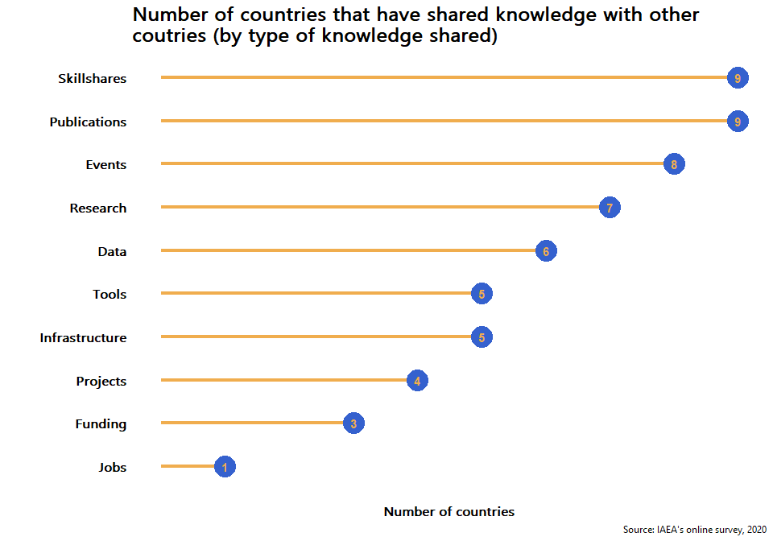

Moreover, to estimate the level and scope of networks within the countries and to approximate the level of connection with other national stakeholders, the online survey asked the experts to provide information about the number of companies/institutions that have cooperated with the country for mutation breeding, dissemination of mutant varieties, and contribution to knowledge and the approximate number of donors that have provided funding to research projects since 2000. As a result, approximately, **493 companies/institutions have cooperated with the partner countries in the dissemination of mutant varietes and about 85 donors have provided funds since 2000**. As it can be observed in the chart below, the level of cooperation and networking within countries varies between partners. From the 19 countries, only 3 - Cambodia, Myanmar, and Palau - have not had reported any relationship with other institutions or donors within their countries. For the other partners who have established cooperation with other national organizations, Bangladesh and China are the ones with a larger network of collaboration with other institutions, 150 and 100 respectively. As for the number of donors who have provided funding for research projects, since 2000, China, Pakistan, and India have reported 20, 15, and 10 fundings from donors respectively. From the countries that reported a collaboration with either a donor or an insitution, only Thailand have not received funding from any donors.

#### Figure X. Number of institutions and donors that have cooperated for mutation breeding by country

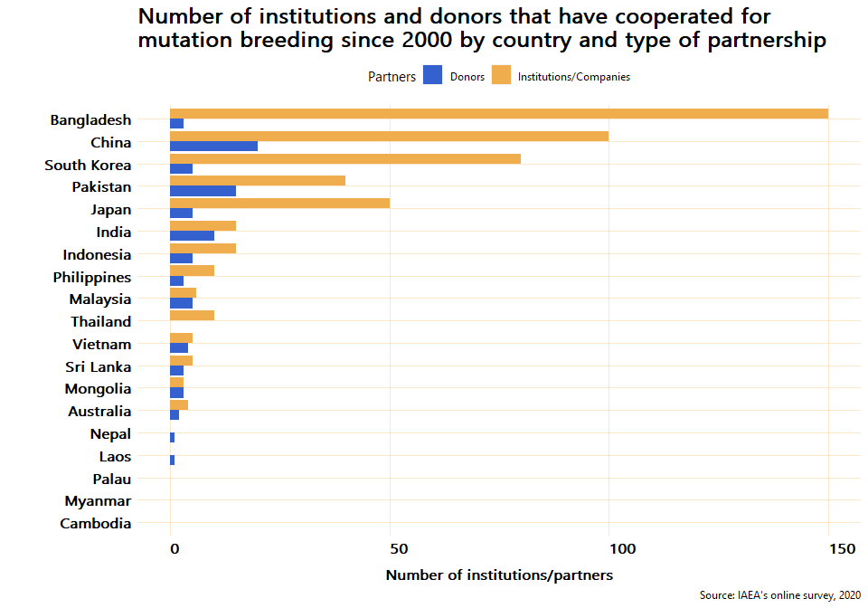

# Annex 1

### Mutant lines and mutant varities developed (by country and crop)

**QA! Ask Sinh and Kofi if the figures for growing area and yield are correct (i.e. if there’s not an unikely outlayer)**

Source: IAEA’s online survey, 2020

|  |  |  |  |  |  |
| --- | --- | --- | --- | --- | --- |
| Country | Crop | Lines developed | Varities developed | Growing area (in thousand ha) | Yield (tonnes/ha) |
| Australia | Barley | 80 | 1 | 1,000 | 2.1 |
| Australia | Lupin | 8 | 0 | NA | NA |
| Australia | Oat | 12 | 0 | NA | NA |
| Australia | Wheat | 50 | 0 | NA | NA |
| Bangladesh | Groundnut | 0 | 0 | NA | NA |
| Bangladesh | Rice | 0 | 0 | NA | NA |
| Bangladesh | Sugarcane | 0 | 0 | NA | NA |
| Cambodia | Banana | 0 | 0 | NA | NA |
| Cambodia | Maize | 0 | 0 | NA | NA |
| Cambodia | Rice | 1 | 0 | NA | NA |
| China | Wheat | 5,000 | 42 | 8,000 | 6.5 |
| India | Blackgram | 15 | 2 | 600 | 1.5 |
| India | Groundnut | 20 | 2 | 10 | 3.0 |
| India | Mungbean | 30 | 3 | 400 | 1.5 |
| Indonesia | Rice | 200 | 25 | 1,050 | 7.5 |
| Indonesia | Sorghum | 100 | 3 | 120 | 6.1 |
| Indonesia | Soybean | 150 | 12 | 800 | 2.4 |
| Japan | Rice | 43 | 43 | 180.2 | 5.0 |
| Japan | Soybean | 17 | 17 | 13 | 1.7 |
| Laos | Mungbean | 10 | 0 | NA | NA |
| Laos | Rice | 63 | 0 | NA | NA |
| Laos | Soybean | 20 | 0 | NA | NA |
| Malaysia | Banana | 3 | 0 | NA | NA |
| Malaysia | Pineapple | 3 | 0 | NA | NA |
| Malaysia | Rice | 10 | 1 | 0.2 | 10.0 |
| Mongolia | Barley | 4 | 0 | NA | NA |
| Mongolia | Rice | 1 | 0 | NA | NA |
| Mongolia | Wheat | 15 | 3 | 12 | 1.6 |
| Myanmar | Mungbean | 9 | 0 | NA | NA |
| Myanmar | Rice | 26 | 5 | 100 | 4.5 |
| Myanmar | Sesame | 0 | 0 | NA | NA |
| Nepal | Groundnut | 5 | 0 | NA | NA |
| Nepal | Rice | 20 | 0 | NA | NA |
| Nepal | Sugarcane | 25 | 0 | NA | NA |
| Pakistan | Chickpea | 55 | 15 | 13,200 | 1.5 |
| Pakistan | Mungbean | 88 | 12 | 2,600 | 1.3 |
| Pakistan | Rice | 30 | 8 | 400 | 5.5 |
| Palau | Banana | 0 | 0 | NA | NA |
| Palau | Groundnut | 0 | 0 | NA | NA |
| Palau | Pineapple | 0 | 0 | NA | NA |
| Philippines | Adlai | 1 | 0 | NA | NA |
| Philippines | Banana | 4 | 1 | 0.1 | 40.0 |
| Philippines | Rice | 29 | 6 | 0.146 | 3.0 |
| Philippines | Sugarcane | 0 | 0 | NA | NA |
| South Korea | Bean | 200 | 3 | 0.05 | 2.0 |
| South Korea | Oat | 50 | 0 | NA | NA |
| South Korea | Rice | 400 | 4 | 10 | NA |
| South Korea | Sorghum | 50 | 0 | NA | NA |
| South Korea | Wheat | 100 | 0 | NA | NA |
| Sri Lanka | Bean | 16 | 0 | NA | NA |
| Sri Lanka | Mungbean | 1 | 0 | NA | NA |
| Sri Lanka | Tomato | 2 | 1 | 0.035 | 35.0 |
| Thailand | Mungbean | 40 | 4 | 1,700 | 1.0 |
| Thailand | Soybean | 60 | 5 | 960 | 1.7 |
| Vietnam | Rice | 150 | 30 | 2,235 | 6.5 |
| Vietnam | Soybean | 100 | 6 | 156 | 2.0 |