RCA preliminary analysis

Andrés Arau

6/15/2020

## Introduction

This analysis includes information of the 22 countries that are part of the Regional Cooperative Agreement for Research (RCA): Australia, Bangladesh, Cambodia, China, Fiji, India, Indonesia, Japan, Laos, Malaysia, Mongolia, Myanmar, Nepal, New Zealand, Pakistan, Palau, Philippines, Singapore, South Korea, Sri Lanka, Thailand, and Vietnam. The findings presented in this report include internal data provided by IAEA and information provided by national experts through the implementation of an online survey conducted between February to April, 2020. From the total 22 countries, 19 participated in the online survey.

The map below shows all the countries that are part of this study.

### Map of the 22 countries that participate in the RCA programme

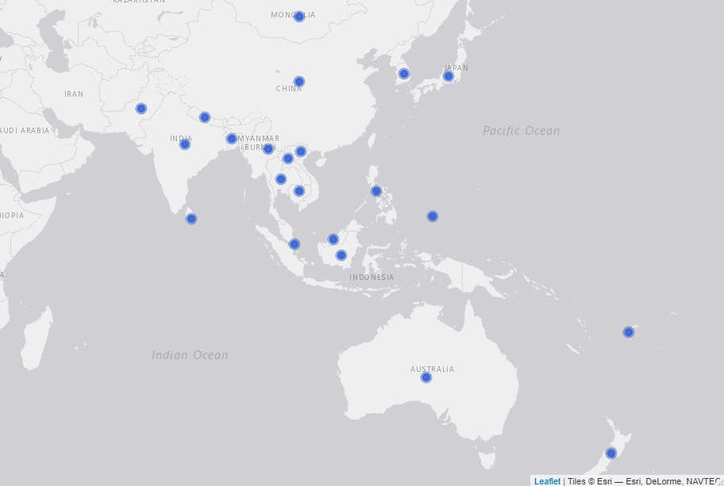

# Criterion 3: Strengthened regional capacity and sustainability

*Write a description of criterion 3 and its relation to the ToC*

## Evidence needed for Criterion 3:

* Countries have a national team in MB
* Numbers of people trained in mutation breeding and associated techniques
* Number of group trainings
* Description: Training responsive to dynamic needs

### National team and facilities

The year in which a country started Mutation Breeding at the nationa level varies between countries. Countries like Japan, China, Sri Lanka, or India started in 1960 while Countries like Laos, Cambodia or Palau have started less than 15 years ago (See table below). As it can be seen in *Table 1*, **73.7% of the 19 countries that participated in the online survey have a national team in mutation breeding**, 89.5% have a field facility, and 68.4% have a radiation facility. It is worth noticing that none of the countries that started a mutation breeding program earlier than 40 years ago have a radiation facility yet.

#### Table 1. Year in which mutation breeding started at the national level, human resources, and facilities by country

Source: IAEA’s online survey, 2020

|  |  |  |  |  |  |
| --- | --- | --- | --- | --- | --- |
| Country | Year mutation breeding started at the national level | Total years | National team | Field facility | Radiation facility |
| Japan | 1960 | 60 | Yes | No | Yes |
| China | 1960 | 60 | Yes | Yes | Yes |
| Sri Lanka | 1960 | 60 | Yes | Yes | Yes |
| India | 1960 | 60 | Yes | Yes | Yes |
| South Korea | 1960 | 60 | Yes | Yes | Yes |
| Philippines | 1962 | 58 | Yes | Yes | Yes |
| Thailand | 1965 | 55 | Yes | Yes | Yes |
| Pakistan | 1970 | 50 | Yes | Yes | Yes |
| Myanmar | 1970 | 50 | Yes | Yes | Yes |
| Australia | 1971 | 49 | No | Yes | Yes |
| Bangladesh | 1972 | 48 | Yes | Yes | Yes |
| Indonesia | 1972 | 48 | Yes | Yes | Yes |
| Malaysia | 1975 | 45 | No | No | No |
| Vietnam | 1978 | 42 | Yes | Yes | Yes |
| Mongolia | 1982 | 38 | Yes | Yes | No |
| Nepal | 1997 | 23 | No | Yes | No |
| Palau | 2009 | 11 | No | Yes | No |
| Laos | 2015 | 5 | Yes | Yes | No |
| Cambodia | 2018 | 2 | No | Yes | No |

### Training

According to IAEA’s internal data, since 2000, a total of 25 courses in mutation breeding have been conducted and **a total of 470 individuals have been trained at the national level under RCA projects** . From this 470 individuals, 108 are women (23%). China is the country with the largest number of people trained with 47 trained individuals, followed by Vietnam and Indonesia with 36 people trained each. On average, 21 people have been trained in each country under RCA projects since 2000. See table below

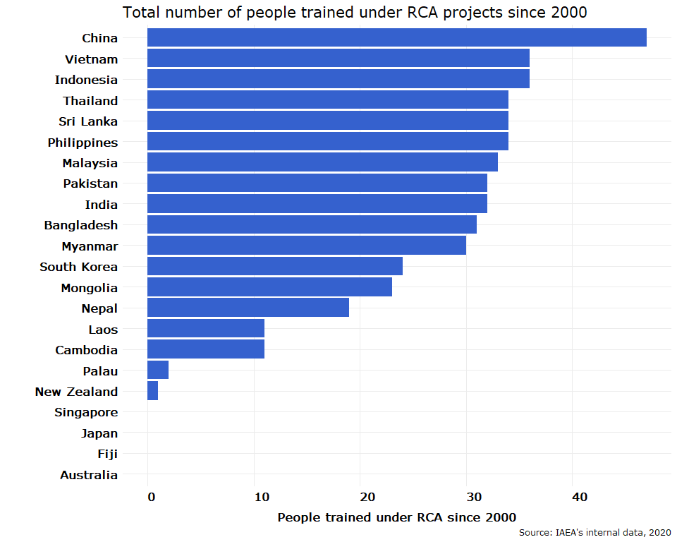

#### Expert missions and workshops

According to IAEA’s internal data, **26 expert missions have occured since 2000 under RCA** to which 22 (5% women) national experts from from 6 countries (China, Australia, Phillipines, Pakistan, Myanmar, and India) have attended expert missions to other countries. The chart below presents the total number of national experts that have joined at least one expert mission to to other country.

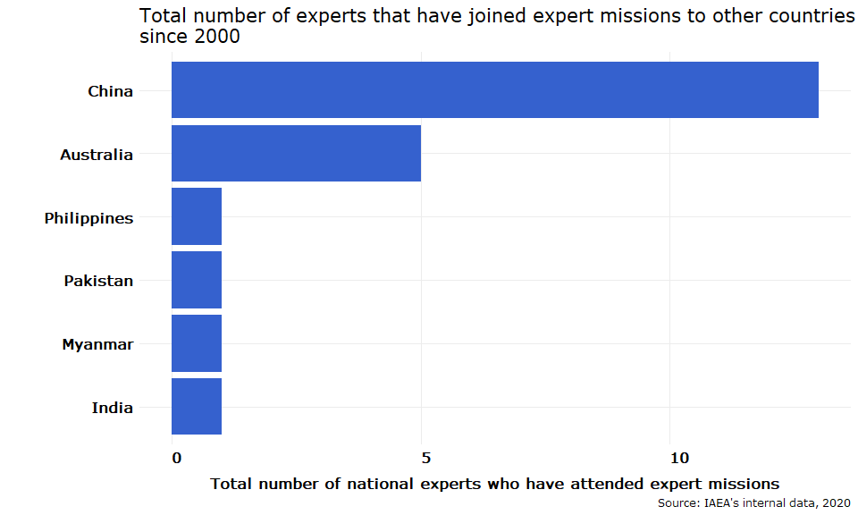

Moreover, **23 meetings/workshops for senior members in mutation breeding research** teams were facilitated. A total of 453 senior members have participated in these type of meetings/workshops.

#### Publications in mutation breeding

In the online survey, country experts were asked to report the total number of publications in mutation breeding developed in each country since 2000. By publication, the study means: journal articles, newspaper articles, thesis, books (and e-books), websites, conferences, online blogs, encyclopedia articles, etc. As a result, it was reported that **a total of 1,801 publicatos have been developed** in the 19 countries that participated in the online survey since 2000. From this publicatios, 54.2% are scientific publications. Chart x below presents the total number of publications by type (scientific and non scientific) and by country since 2000. *Note to the team: This chart exludes China because the number reported of publications was very high (over 30,000)*

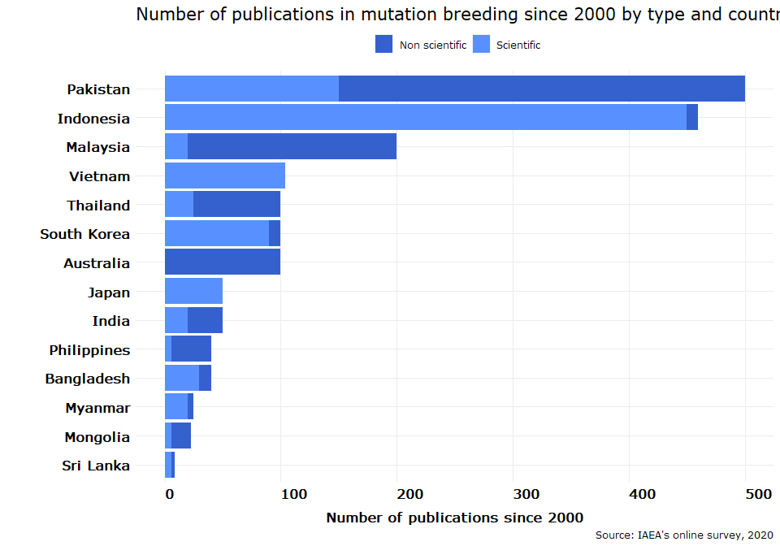

#### Networking, collaboration, and knowledge transfer

In order to estimate the level of collaboration bewteen countries, the online survey asked the exeperts if their country have provided services and knowledge related to mutation breeding to other countries. Examples of services and knowledge could be: data, events, funding, infrastructure, jobs, projects, publications, research, skills shares, tools, etc. According to the answers provided by the experts, **a total of 13 RCA countries - Japan, Pakistan, Bangladesh, China, Indonesia, Thailand, Sri Lanka, India, Vietnam, Malaysia, Australia, Philippines, and South Korea - have provided services and knowledge related to mutation breeding to other countries**. From these 13 countries that have shared knowledge or services to other countries, 9 have shared skillshares and publications, 8 have organized events, 7 have shared reserach, and 6 have shared data. The table below shows the number of countries that have shared the different types of collaboration with other countries.

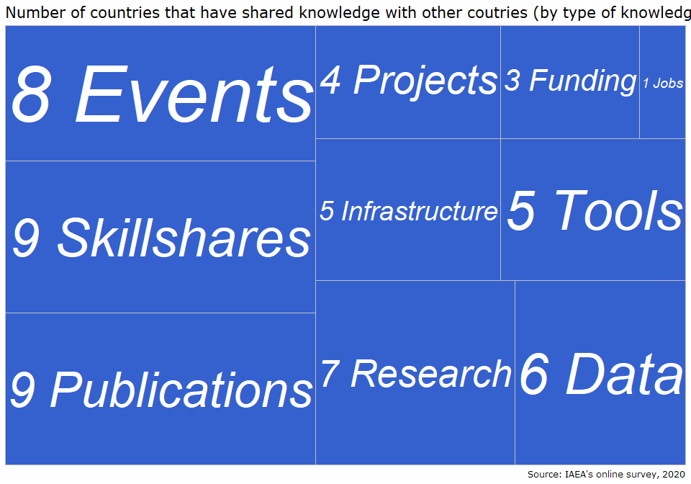

In order to approximate the level of networking by country……# how many companies/institutions have cooperated with each for mutation breeding, dissemination of mutant varieties, and contribution to knowledge and the approximate number of donors that have provided funding to research projects since 2000