Comcast Telecom Consumer Complaints

Aravindhan

20/11/2022

Comcast is an American global telecommunication company. The firm has been providing terrible customer service. They continue to fall short despite repeated promises to improve. Only last month (October 2016) the authority fined them a $2.3 million, after receiving over 1000 consumer complaints.

The existing database will serve as a repository of public customer complaints filed against Comcast. It will help to pin down what is wrong with Comcast’s customer service.

Tasks to be performed:-

* Import data into R environment.
* Provide the trend chart for the number of complaints at monthly and daily granularity levels.
* Provide a table with the frequency of complaint types.
* Which complaint types are maximum i.e., around internet, network issues, or across any other domains.
* Create a new categorical variable with value as Open and Closed. Open & Pending is to be categorized as Open and Closed & Solved is to be categorized as Closed.
* Provide state wise status of complaints in a stacked bar chart. Use the categorized variable from Q3. Provide insights on:
* Which state has the maximum complaints
* Which state has the highest percentage of unresolved complaints
* Provide the percentage of complaints resolved till date, which were received through theInternet and customer care calls.

#Importing necessary packages  
library(dplyr)

##   
## Attaching package: 'dplyr'

## The following objects are masked from 'package:stats':  
##   
## filter, lag

## The following objects are masked from 'package:base':  
##   
## intersect, setdiff, setequal, union

library(ggplot2)  
library(lubridate)

## Loading required package: timechange

##   
## Attaching package: 'lubridate'

## The following objects are masked from 'package:base':  
##   
## date, intersect, setdiff, union

#Importing Comcast Dataset  
comcast_data<- read.csv("Comcast Telecom Complaints data.csv",header = TRUE)  
  
#Manipulating Field Names  
names(comcast_data)<-gsub(pattern = '\\.',replacement = "",x=names(comcast_data))  
names(comcast_data)

## [1] "Ticket" "CustomerComplaint"   
## [3] "Date" "Time"   
## [5] "ReceivedVia" "City"   
## [7] "State" "Zipcode"   
## [9] "Status" "FilingonBehalfofSomeone"

View(comcast_data)

From the dataset, we can see that the format of Date column is not same throughout, so we need to make it same for analysis.

#Processing Date  
comcast_data$Date<- dmy(comcast_data$Date)  
View(comcast_data)

* Now we need to get the complaints on a daily level basis and plot a trend chart for it.

ans<-comcast_data %>% group_by(Date) %>% summarize(NumOfComplaints=n())  
  
#Plotting for daily granularity level  
ggplot(data = ans,aes(as.POSIXct(Date),NumOfComplaints))+  
 geom_line()+  
 geom_point(size = 1)+  
 scale_x_datetime(breaks = "1 weeks",date_labels = "%d/%m")+  
 labs(title = "Daily Ticket Count",x= "Days",y ="No. of Tickets")+  
 theme(axis.text.x = element_text(angle = 75),  
 plot.title = element_text(hjust = 0.5))

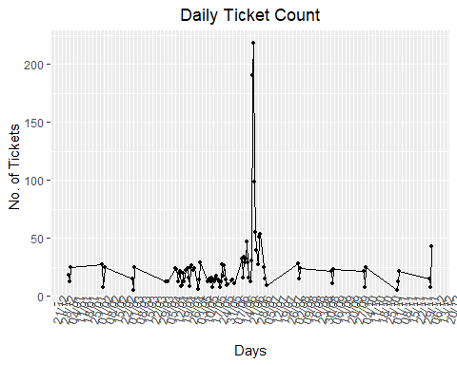

* Now we need to get the complaints on a monthly level basis and plot a trend chart for it.

#Making month field  
comcast_data$Month<-months(comcast_data$Date)  
ans1<-comcast_data %>% group_by(Month =as.integer(month(Date))) %>% summarize(NumOfComplaints=n()) %>% arrange(desc(NumOfComplaints))  
  
#Plotting for monthly granularity level  
ggplot(data = ans1,aes(Month,NumOfComplaints,label = NumOfComplaints))+  
 geom_line()+  
 geom_point(size = 0.8)+  
 geom_text()+  
 scale_x_continuous(breaks = ans1$Month)+  
 labs(title = "Monthly Ticket Count",x= "Months",y ="No. of Tickets")+  
 theme(plot.title = element_text(hjust = 0.5))

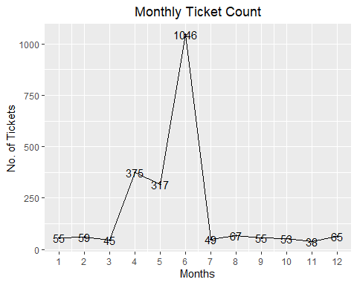 INSIGHTS:- From the above trend chart, we can clearly see that complaints for the month of June are maximum i.e.1046.

* Now we need to make a frequency table basis the complaint types.

# Complaint Type Processing  
network_tickets<- contains(comcast_data$CustomerComplaint,match = 'network',ignore.case = T)  
internet_tickets<- contains(comcast_data$CustomerComplaint,match = 'internet',ignore.case = T)  
billing_tickets<- contains(comcast_data$CustomerComplaint,match = 'bill',ignore.case = T)  
email_tickets<- contains(comcast_data$CustomerComplaint,match = 'email',ignore.case = T)  
charges_ticket<- contains(comcast_data$CustomerComplaint,match = 'charge',ignore.case = T)  
  
comcast_data$ComplaintType[internet_tickets]<- "Internet"  
comcast_data$ComplaintType[network_tickets]<- "Network"  
comcast_data$ComplaintType[billing_tickets]<- "Billing"  
comcast_data$ComplaintType[email_tickets]<- "Email"  
comcast_data$ComplaintType[charges_ticket]<- "Charges"  
  
comcast_data$ComplaintType[-c(internet_tickets,network_tickets,  
 billing_tickets,charges_ticket,email_tickets)]<- "Others"  
table(comcast_data$ComplaintType)

##   
## Billing Charges Email Internet Network Others   
## 363 139 16 472 1 1233

INSIGHTS:- From the above table we can see that the Internet type complaints are maximum.

* Now we need to make a new categorical variable for Complaint Status.

open_complaints<-(comcast_data$Status == 'Open' | comcast_data$Status == 'Pending')  
closed_complaints<-(comcast_data$Status == 'Closed' | comcast_data$Status == 'Solved')  
comcast_data$ComplaintStatus[open_complaints]<-'Open'  
comcast_data$ComplaintStatus[closed_complaints]<-'Closed'

* Now we need to plot state wise status of complaints in a stacked bar chart.

stack<-table(comcast_data$ComplaintStatus,comcast_data$State)  
stack

##   
## Alabama Arizona Arkansas California Colorado Connecticut Delaware  
## Closed 17 14 6 159 58 9 8  
## Open 9 6 0 61 22 3 4  
##   
## District of Columbia District Of Columbia Florida Georgia Illinois  
## Closed 1 14 201 208 135  
## Open 0 2 39 80 29  
##   
## Indiana Iowa Kansas Kentucky Louisiana Maine Maryland Massachusetts  
## Closed 50 1 1 4 12 3 63 50  
## Open 9 0 1 3 1 2 15 11  
##   
## Michigan Minnesota Mississippi Missouri Montana Nevada New Hampshire  
## Closed 92 29 23 3 1 1 8  
## Open 23 4 16 1 0 0 4  
##   
## New Jersey New Mexico New York North Carolina Ohio Oregon Pennsylvania  
## Closed 56 11 6 3 3 36 110  
## Open 19 4 0 0 0 13 20  
##   
## Rhode Island South Carolina Tennessee Texas Utah Vermont Virginia  
## Closed 1 15 96 49 16 2 49  
## Open 0 3 47 22 6 1 11  
##   
## Washington West Virginia  
## Closed 75 8  
## Open 23 3

comcast_data<- group_by(comcast_data,State,ComplaintStatus)  
chart_data<- summarise(comcast_data,Count = n())

## `summarise()` has grouped output by 'State'. You can override using the  
## `.groups` argument.

#Plotting on stacked bar chart  
ggplot(as.data.frame(chart_data) ,mapping = aes(State,Count))+  
 geom_col(aes(fill = ComplaintStatus),width = 0.95)+  
 theme(axis.text.x = element_text(angle = 90),  
 axis.title.y = element_text(size = 15),  
 axis.title.x = element_text(size = 15),  
 title = element_text(size = 16,colour = "#0073C2FF"),  
 plot.title = element_text(hjust = 0.5))+  
 labs(title = "Ticket Status Stacked Bar Chart ",  
 x = "States",y = "No of Tickets",  
 fill= "Status")

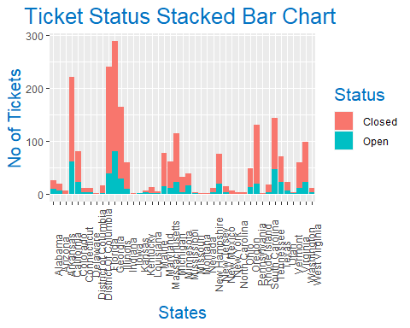

INSIGHTS:- From the above chart, we can clearly see that Georgia has maximum complaints.

* Now we need to see which state has maximum unresolved complaints

comcast_data %>% filter(ComplaintStatus=='Open') %>% group_by(State) %>% summarize(NumOfComplaints=n()) %>% arrange(desc(NumOfComplaints))

## # A tibble: 34 × 2  
## State NumOfComplaints  
## <chr> <int>  
## 1 Georgia 80  
## 2 California 61  
## 3 Tennessee 47  
## 4 Florida 39  
## 5 Illinois 29  
## 6 Michigan 23  
## 7 Washington 23  
## 8 Colorado 22  
## 9 Texas 22  
## 10 Pennsylvania 20  
## # … with 24 more rows

INSIGHTS:- From the table generated above we can see that Georgia has maximum unresolved complaints i.e. 80.

* Now we want to see the percentage of resolved complaints.

tot<-comcast_data %>% group_by(ComplaintStatus) %>% summarize(NumOfComplaints=n())  
tot

## # A tibble: 2 × 2  
## ComplaintStatus NumOfComplaints  
## <chr> <int>  
## 1 Closed 1707  
## 2 Open 517

slices<-tot$NumOfComplaints  
pct<-round((slices/sum(slices)*100),2)  
lbls<-paste(tot$ComplaintStatus," ",pct,"%",sep="")  
  
#Plotting pie chart  
pie(slices,labels=lbls)

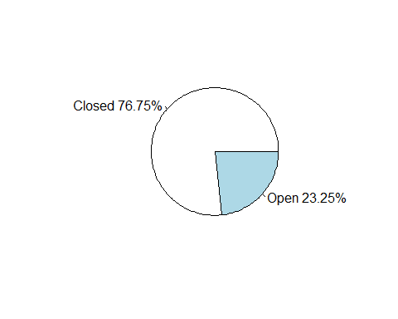 INSIGHTS:- From the above pie chart we can clearly see that there are total 76.75% Complaints resolved.

int<-comcast_data %>% filter(ReceivedVia=='Internet',ComplaintStatus=='Closed') %>% group_by(ReceivedVia,ComplaintStatus) %>% summarize(NumOfComplaints=n())

## `summarise()` has grouped output by 'ReceivedVia'. You can override using the  
## `.groups` argument.

ccc<-comcast_data %>% filter(ReceivedVia=='Customer Care Call',ComplaintStatus=='Closed') %>% group_by(ReceivedVia,ComplaintStatus) %>% summarize(NumOfComplaints=n())

## `summarise()` has grouped output by 'ReceivedVia'. You can override using the  
## `.groups` argument.

#Percentage of resolved internet Complaints  
intpct<-round(int$NumOfComplaints/sum(tot$NumOfComplaints)*100,2)  
intpct

## [1] 37.9

#Percentage of resolved Customer Care Call Complaints  
cccpct<-round(ccc$NumOfComplaints/sum(tot$NumOfComplaints)*100,2)  
cccpct

## [1] 38.85

INSIGHTS:- From the above output we can see that of the 76.75% resolved Complaints, 37.9% complaints are Internet type while 38.85% are Customer Care Call type.