Screenshots with Explanation
Role-Based Student Academic Risk Prediction using NLP and Federated Learning
National Institute of Technology, Tiruchirappalli
Federated Learning Project

Purpose of this Document
This document presents the important project screenshots with short explanations. The screenshots cover model evaluation outputs, role-based frontend dashboards, and the final working flow of the application. These images can be used as supporting evidence for project demonstration, report submission, and GitHub documentation.
Note: Only project-related screenshots are included. The unrelated personal identity screenshot uploaded earlier was not used in this project explanation document.

Screenshot Summary
Screenshot | Module | Explanation
Confusion Matrix | Model Evaluation | Shows class-wise prediction performance for High, Low and Medium risk levels.
Accuracy Result Table | Model Evaluation | Compares Logistic Regression, SVM, Random Forest and the final federated weighted model.
Classification Report | Model Evaluation | Shows precision, recall, F1-score and support for every risk class.
Faculty Portal | Frontend | Allows faculty to view assigned students and their latest risk status.
Faculty Review Panel | Frontend | Allows faculty to review feedback and add guidance remarks.
HOD Dashboard | Frontend | Shows overall summary such as total faculty, total students and high-risk count.
Student Portal | Frontend | Allows student feedback submission and displays prediction output and recommendations.
HOD Student Roster | Frontend | Allows HOD to view and filter complete student information across faculty advisors.

1. Model Evaluation Screenshots
This section shows the experimental output of the federated NLP model. The evaluation confirms that the final weighted average model achieved the required accuracy range while maintaining balanced performance across all three risk classes.
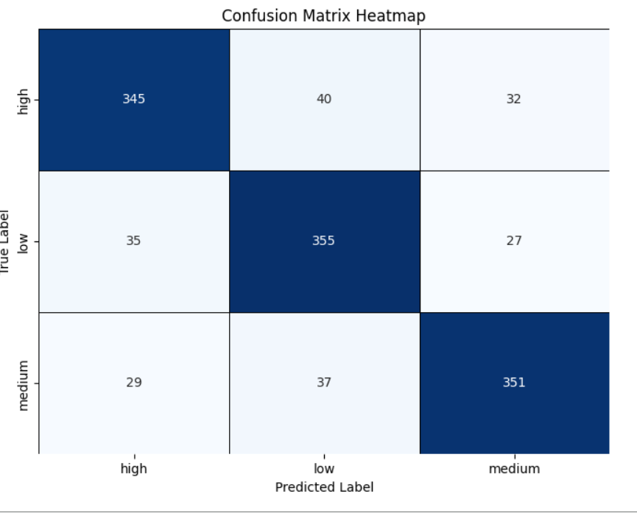
Figure 1: Confusion Matrix Heatmap
The confusion matrix shows how the final model classified student feedback into High, Low and Medium risk classes. Most predictions are concentrated along the diagonal, which indicates that the model correctly predicted a large number of samples in each class. The off-diagonal values show the limited misclassifications between neighbouring risk levels.
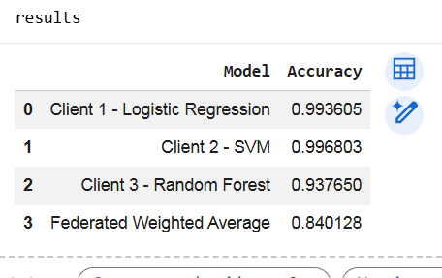
Figure 2: Client-wise and Federated Model Accuracy
This output compares the accuracy of the three client models and the final federated weighted average model. Logistic Regression, SVM and Random Forest are trained as separate clients, and their prediction probabilities are combined using weighted average aggregation. The final federated model accuracy is approximately 0.84, which satisfies the target range of 0.80 to 0.85.
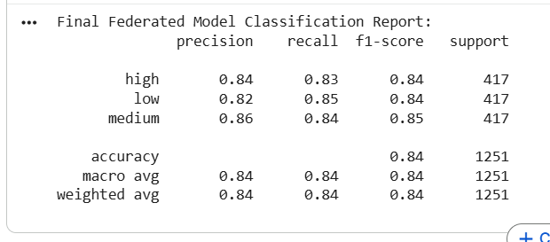
Figure 3: Final Classification Report
The classification report presents precision, recall, F1-score and support for High, Low and Medium risk levels. The values are balanced across all classes, showing that the model does not strongly favor only one class. This makes the prediction output suitable for academic risk monitoring.
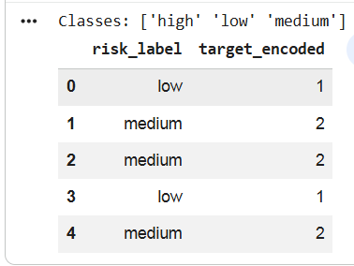
Figure 4: Target Label Encoding
This screenshot shows the target labels used for risk prediction. The textual labels High, Low and Medium are encoded into numerical form before model training. Label encoding allows machine learning algorithms to process the risk categories correctly.

2. Frontend Dashboard Screenshots
The frontend is developed using React and Vite. It provides separate dashboard views for HOD, faculty and students. The screenshots below show how the role-based access design works in the final application.
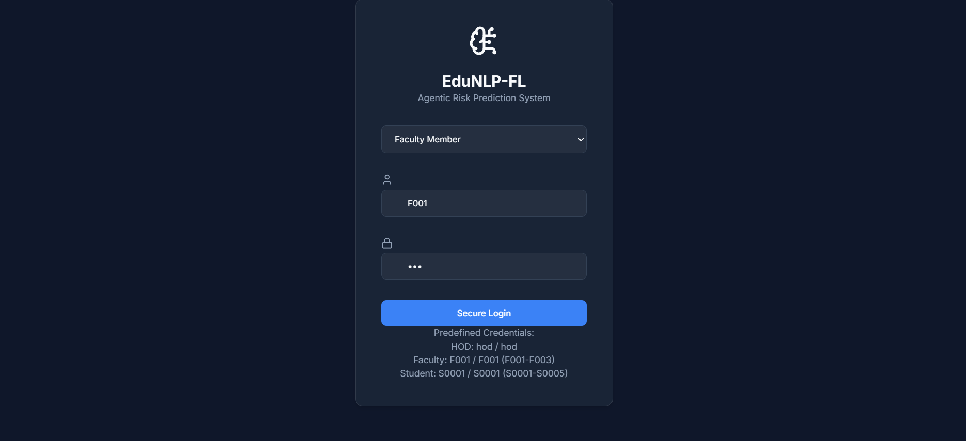
Figure 6: Role-Based Login Page of the EduNLP-FL System
The login page acts as the entry point of the EduNLP-FL system. It provides role-based authentication for three types of users: HOD, Faculty Member, and Student. The user selects their role from the dropdown menu and enters the predefined username and password. After successful login, the system redirects the user to the corresponding dashboard. The HOD is redirected to the HOD dashboard, faculty members are redirected to the faculty portal, and students are redirected to the student portal. This page ensures that each user can access only the features and data permitted for their role.

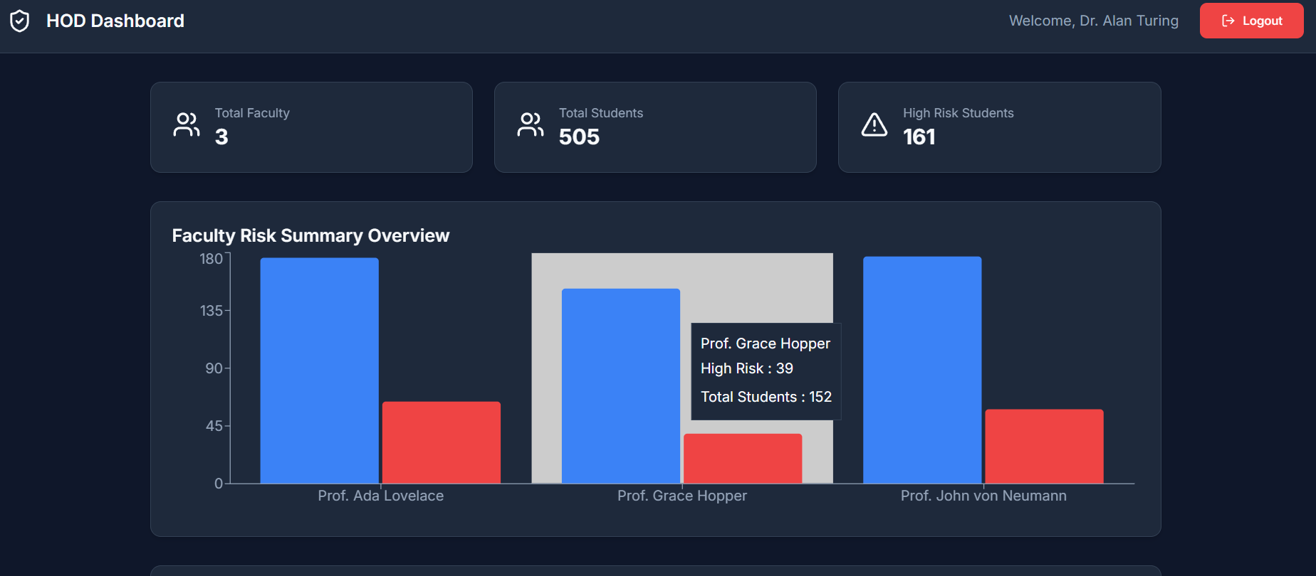
Figure 5: HOD Dashboard - Faculty Risk Summary
The HOD dashboard provides a department-level view of the system. It displays total faculty, total students, high-risk students and a faculty-wise risk summary chart. This helps the HOD quickly identify the overall academic risk situation across faculty groups.
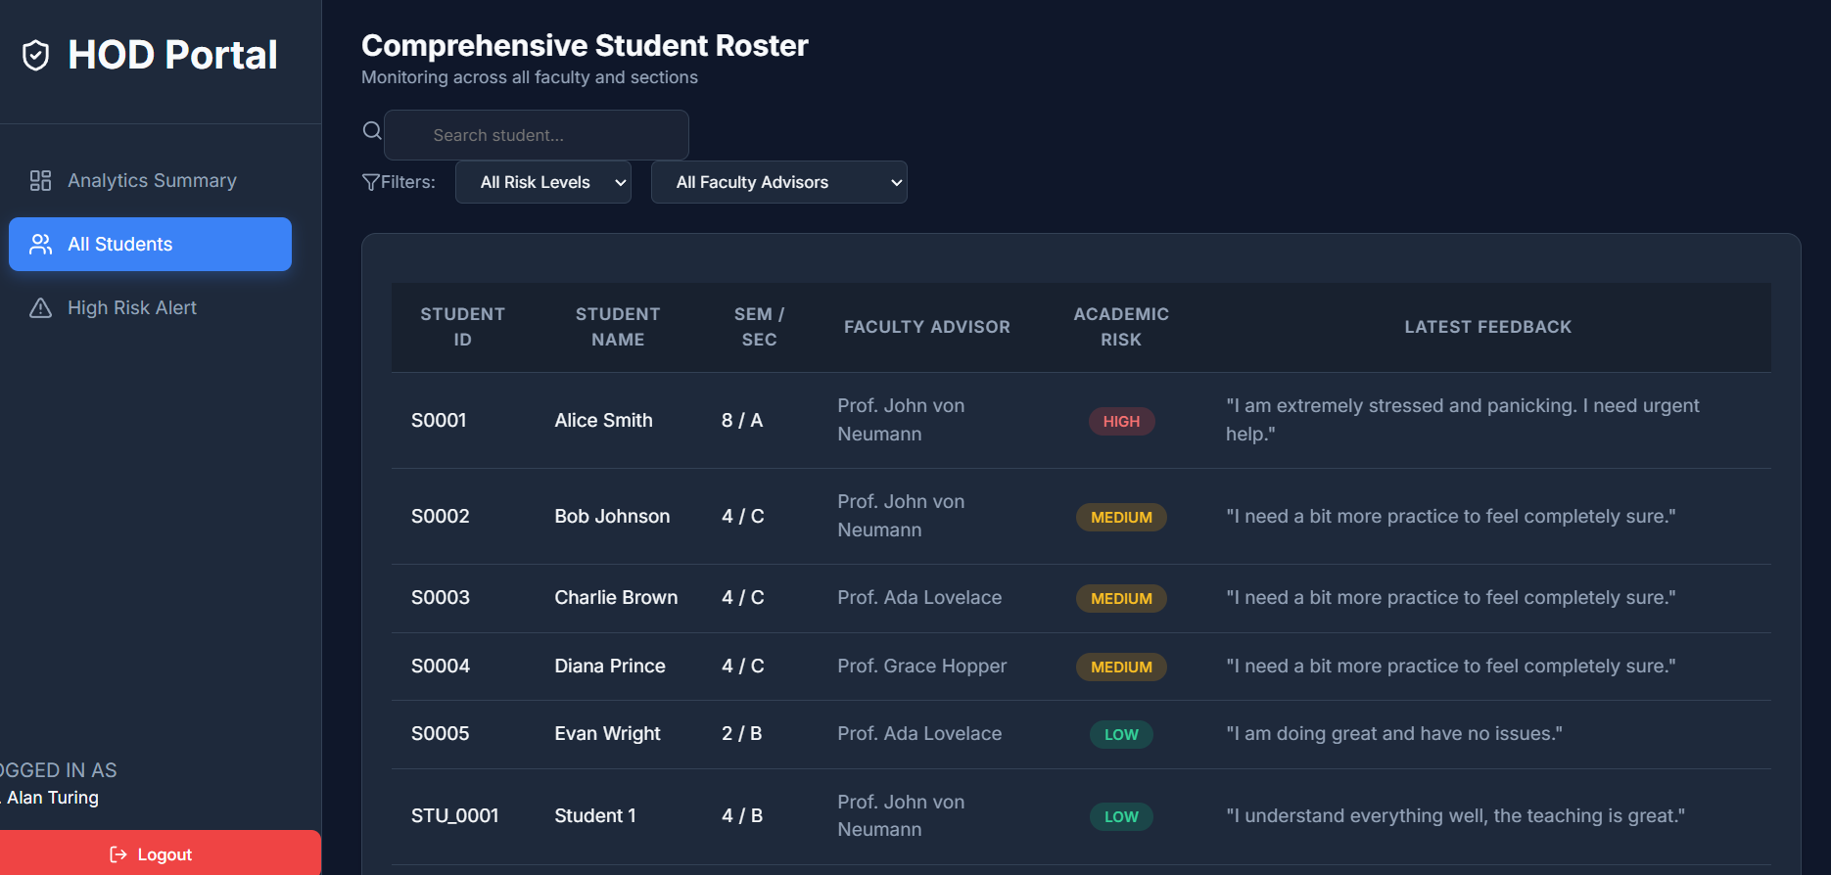
Figure 6: HOD Dashboard - Comprehensive Student Roster
This screen allows the HOD to view the complete student roster. The HOD can see student ID, student name, semester, section, faculty advisor, academic risk level and latest feedback. Search and filter options help in monitoring students based on risk level and faculty advisor.

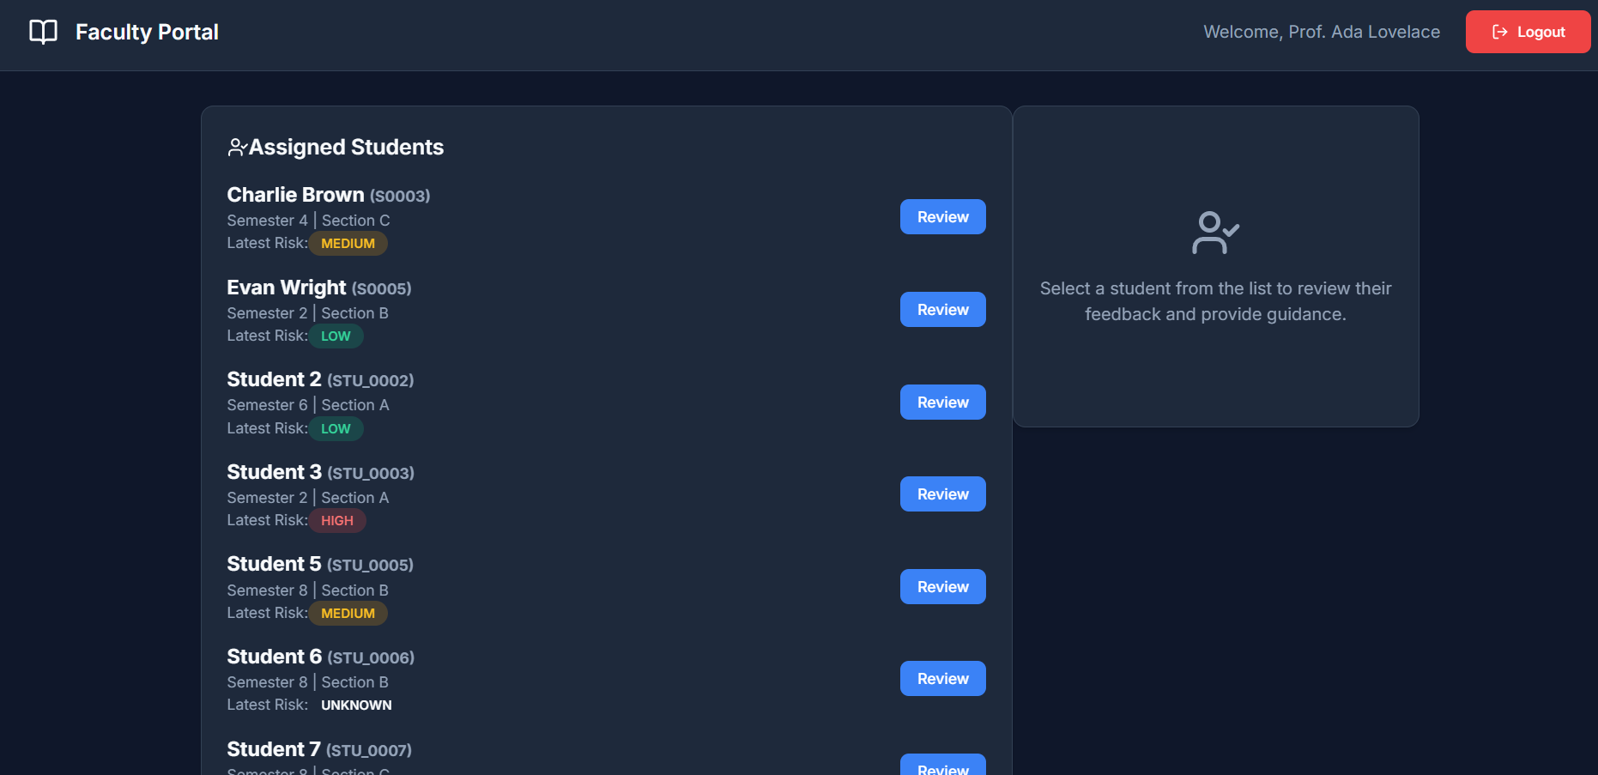
Figure 7: Faculty Portal - Assigned Students
The faculty portal displays only the students assigned to the logged-in faculty member. Each student card shows the latest academic risk level and provides a review button. This confirms the role-based restriction where a faculty member cannot view all students, but only the assigned students.
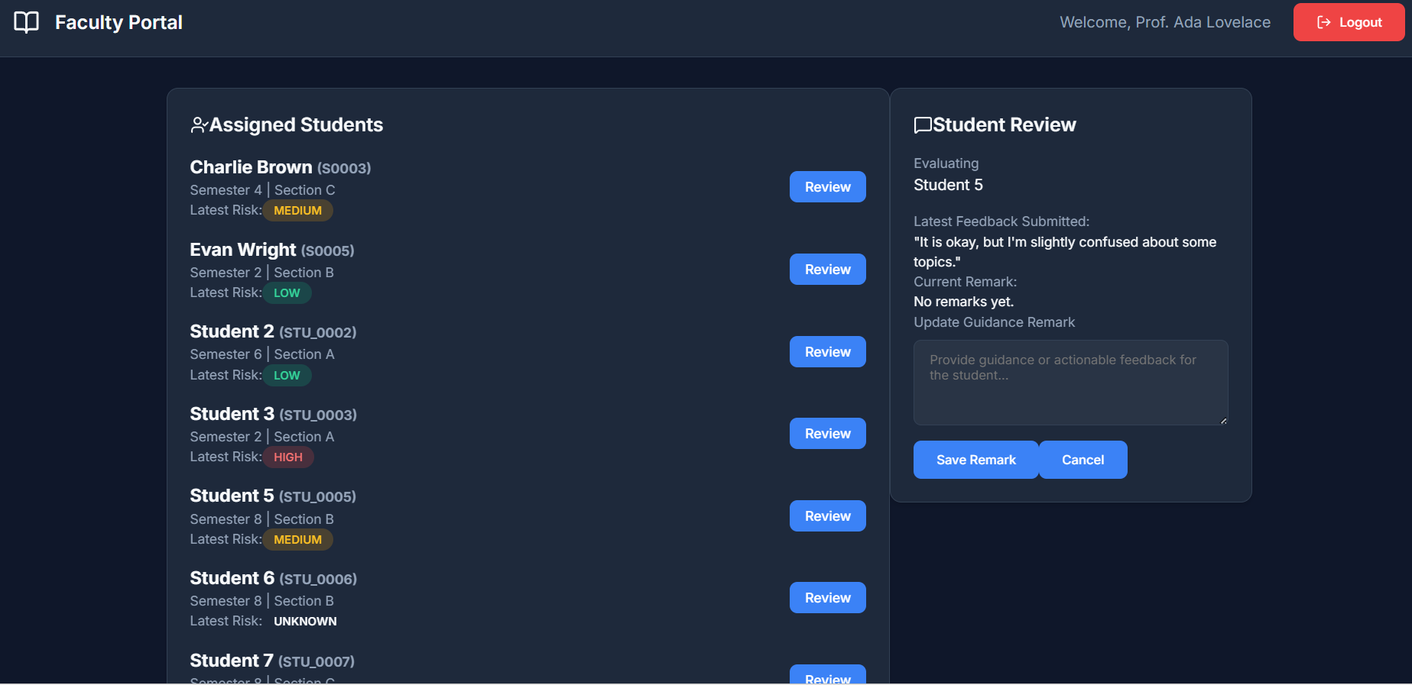
Figure 8: Faculty Portal - Student Review and Guidance
After selecting a student, the faculty can review the latest submitted feedback, observe the current risk status and add a guidance remark. This feature connects the model prediction with human academic mentoring, making the system more useful for student support.

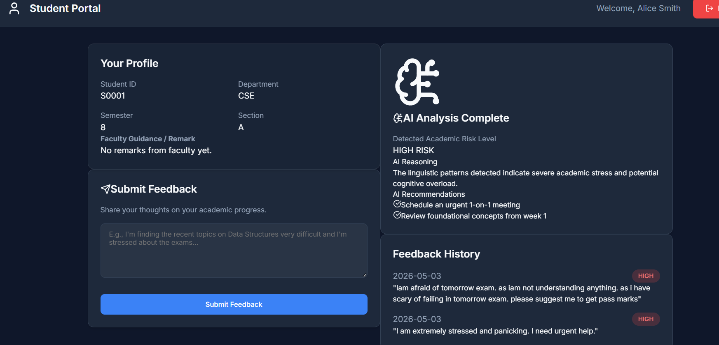
Figure 9: Student Portal - Feedback Submission and AI Analysis
The student portal allows students to submit feedback related to their academic progress. After prediction, the system displays the detected academic risk level, AI reasoning, recommendations and previous feedback history. This helps students receive immediate support suggestions.

3. Overall Project Explanation
The uploaded screenshots together represent the complete project workflow. A student submits feedback through the student portal. The backend applies NLP preprocessing and extracts TF-IDF and HMM-based features. The client models generate prediction probabilities, and the weighted average aggregation method produces the final academic risk level. The prediction is then displayed to the student, the assigned faculty and the HOD according to role-based access rules.
The HOD dashboard supports overall monitoring, the faculty dashboard supports student guidance, and the student dashboard supports feedback submission and personalized recommendations. The model evaluation screenshots prove that the final federated weighted average model gives balanced performance with an accuracy around 84%.

