A Role-Based Federated NLP Framework for Student Academic Risk Prediction and Faculty-Level Monitoring

1st Aravalam Rajasekhar
Department of Computer Applications
NIT Trichy
205225006
2nd Sundram Patel
Department of Computer Applications
NIT Trichy
205225026

Abstract- Educational institutions increasingly require early and interpretable mechanisms for identifying students who may need academic support. This paper presents a role-based student academic risk prediction system that combines natural language processing, HMM-based sequence features, and a federated learning-inspired ensemble. The work evolved through three versions: an initial LSTM-based federated prototype, a second phase using TF-IDF and classical machine learning, and a final role-aware version that introduces HOD and faculty access control. In the proposed system, students submit feedback text, the backend performs preprocessing such as tokenization, POS tagging, morphological analysis, lemmatization, shallow dependency parsing, and HMM feature extraction, and client-side models classify students into low, medium, or high risk. Three client models are used in the final experimental setup: Logistic Regression, SVMevaluation used, and Random Forest. Their probability outputs are combined using weighted averaging based on client data size. The final system achieved an accuracy of 80.42%, with macro precision 80.43%, recall 80.42%, and F1-score 80.30%. The architecture also includes a FastAPI backend and a React frontend for student support, faculty monitoring, and HOD-level analytics.
Keywords- Federated learning, natural language processing, academic risk prediction, role-based access control, HMM, TF-IDF, Logistic Regression, SVM, Random Forest.
I. INTRODUCTION
Student support systems are usually effective only when they identify academic difficulty early enough for faculty to take action. Many institutions collect feedback, marks, attendance, and counselling information, but these data sources are often treated as separate records instead of being used for systematic risk prediction. This project focuses on transforming student feedback into actionable risk categories while respecting the hierarchy of access inside an academic department.
The proposed system is designed around three user levels. The Head of Department (HOD) is treated as the root authority and can view faculty-level summaries and all student records. Each faculty member can view only the students assigned under their guidance. Students can submit feedback and view support-related information. This hierarchy makes the prediction system more practical because the output is not only a machine learning result, but also a controlled monitoring workflow.
The final version of the project applies NLP preprocessing and a federated learning-inspired aggregation strategy. Unlike a single centralized classifier, the training data is divided into three client groups. Each client trains a different model, and the final prediction is obtained through weighted averaging of class probabilities. This design demonstrates how heterogeneous local models can contribute to a common decision layer.
II. RELATED WORK
Federated learning was introduced as a way to train models over distributed data by aggregating locally computed updates instead of directly moving all raw data to a central server. This idea is useful in domains where privacy, data ownership, and distributed availability are important. In this project, the same principle is adapted at a project level by treating faculty groups as clients and combining their model outputs through weighted averaging.
Classical NLP pipelines remain useful for educational feedback because feedback text is usually short, subjective, and semantically noisy. Preprocessing techniques such as tokenization, lemmatization, POS tagging, and dependency parsing convert free text into a more structured representation. HMMs are also useful for sequence modeling because they can capture patterns in observed tag sequences. For the classification stage, Logistic Regression, SVM, and Random Forest provide interpretable and reliable baselines for text classification.
III. VERSION-WISE PROJECT EVOLUTION
The project was developed in three versions. Each version added a new technical layer and helped refine the final system. Version 1 focused on proving the basic feasibility of feedback-based risk prediction. Version 2 improved the experimental process by using TF-IDF features and multiple traditional machine learning models. Version 3 integrated role-based access control, advanced preprocessing, HMM sequence scoring, and weighted federated aggregation.
TABLE I. VERSION-WISE DEVELOPMENT OF THE PROJECT
Version | Key Improvement
V1 | LSTM prototype with synthetic feedback and FedAvg idea.
V2 | TF-IDF with LR, SVM, RF and aggregation comparison.
V3 | Role-based access with NLP, HMM and weighted ensemble.
IV. PROPOSED SYSTEM
The proposed system contains four major layers: user interface, backend service, NLP and machine learning pipeline, and role-based reporting. The frontend allows students to submit feedback, faculty to monitor assigned students, and the HOD to view global analytics. The backend exposes prediction APIs, loads trained artifacts, applies preprocessing, and returns risk-level predictions with recommendations.
The backend design uses FastAPI for prediction services. In the earlier full-stack project, the backend included trained model files, TF-IDF vectorizer, label encoder, and a prediction route. The frontend was implemented using React and Vite, with dashboard views for student support, faculty monitoring, and analytics. The final project extends this by adding explicit role-based dataset files for student feedback, faculty hierarchy, and HOD-level summaries.

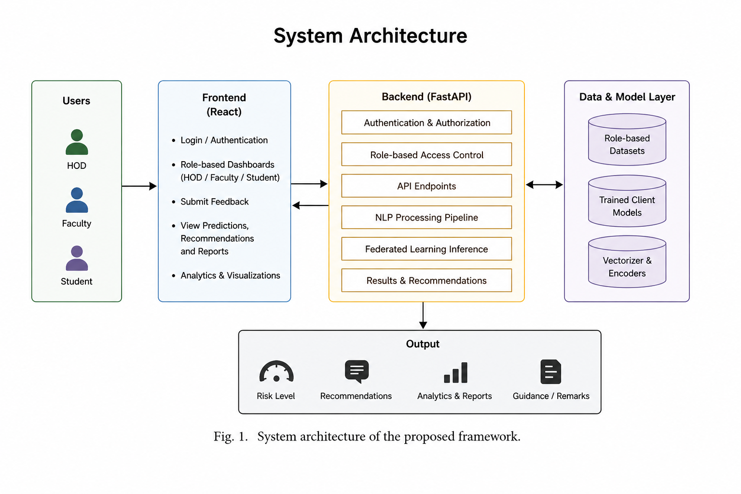
Fig. 1. Complete system architecture.
V. DATASET DESCRIPTION
The final version uses synthetic role-based data created to match an academic department scenario. Each record represents a student feedback instance with student identity, assigned faculty, feedback text, risk-related label information, and department-level grouping. The design allows the same dataset to support both machine learning and access control experiments.
TABLE II. FINAL DATASET FILES USED IN VERSION 3
File | Purpose
Feedback data | Main student feedback dataset for NLP and training.
Faculty hierarchy | Maps faculty to assigned student groups.
HOD summary | Faculty-wise and risk-wise summary view.
VI. NLP PREPROCESSING PIPELINE
The preprocessing stage converts raw feedback into structured features. First, text is lowercased and cleaned by removing punctuation, symbols, and extra spaces. Tokenization splits the sentence into individual words. Stopword removal removes common words that do not strongly contribute to risk classification. Lemmatization reduces words to their base form so that variations such as studying, studied, and studies are handled more consistently.
POS tagging assigns grammatical tags to tokens. Morphological analysis records grammatical attributes such as tense, number, and part-of-speech structure. Shallow dependency parsing identifies local grammatical relations between a token and its head word. These outputs are useful for explaining the linguistic properties of the feedback. Finally, an HMM-based feature is produced from POS tag sequences to represent sequential language patterns in the feedback.
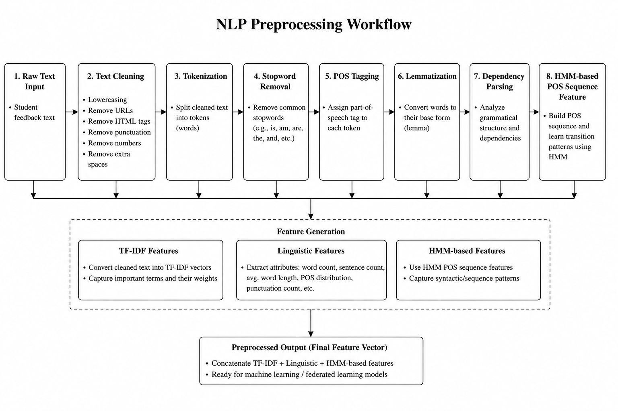
Fig. 2. NLP preprocessing flow.
VII. FEDERATED LEARNING FRAMEWORK
The final experimental setup divides the training data into three client groups. Client 1 uses Logistic Regression, Client 2 uses a Support Vector Machine, and Client 3 uses Random Forest. Each model is trained on its own local client subset. During aggregation, every model generates class probability scores for the test data. These scores are combined using weights derived from the number of training samples available to each client.
If P1, P2, and P3 represent the predicted probability vectors from the three clients, and w1, w2, and w3 represent their normalized data-size weights, the final probability vector is computed as P = w1P1 + w2P2 + w3P3. The class with the highest final probability is selected as the final risk label. This method is simple, interpretable, and suitable for demonstrating federated decision aggregation in a student monitoring project.
TABLE III. CLIENT-WISE MODELS AND RESULTS
Client | N | Acc. | Wt.
C1: Logistic Regression | 1494 | 0.8042 | 0.4065
C2: SVM | 1140 | 0.7754 | 0.3036
C3: Random Forest | 1119 | 0.7418 | 0.2899
VIII. EXPERIMENTAL SETUP
The final dataset was divided into 3753 training samples and 1251 testing samples. The feature vector combined TF-IDF text features with HMM-based sequence scoring. The final class labels were high, low, and medium risk. Evaluation used accuracy, recall, precision, F1-score, and confusion matrix. The goal was to keep the final performance in the range of 0.80 to 0.85 so that the model performs well while still leaving room for realistic improvement.
The role-based access logic was evaluated separately from the model. HOD access returns all prediction records and aggregated summaries. Faculty access filters the prediction table according to faculty identity, so each faculty member receives only assigned students. This separation between prediction and authorization helps the system remain clear and easier to maintain.
IX. RESULTS AND DISCUSSION
The weighted federated model achieved an overall accuracy of 0.8042. Macro precision was 0.8043, macro recall was 0.8042, and macro F1-score was 0.8030. The results indicate that the model performs balanced classification across the three risk categories, although the medium class is comparatively more difficult because it lies between clear low-risk and high-risk feedback patterns.
TABLE IV. FINAL FEDERATED CLASSIFICATION REPORT
Class | P | R | F1 | N
high | 0.8154 | 0.8369 | 0.8260 | 417
low | 0.7933 | 0.8561 | 0.8235 | 417
medium | 0.8043 | 0.7194 | 0.7595 | 417
macro avg | 0.8043 | 0.8042 | 0.8030 | 1251
weighted avg | 0.8043 | 0.8042 | 0.8030 | 1251
TABLE V. CONFUSION MATRIX OF FINAL FEDERATED MODEL
Unnamed: 0 | Predicted high | Predicted low | Predicted medium
Actual high | 349 | 27 | 41
Actual low | 28 | 357 | 32
Actual medium | 51 | 66 | 300
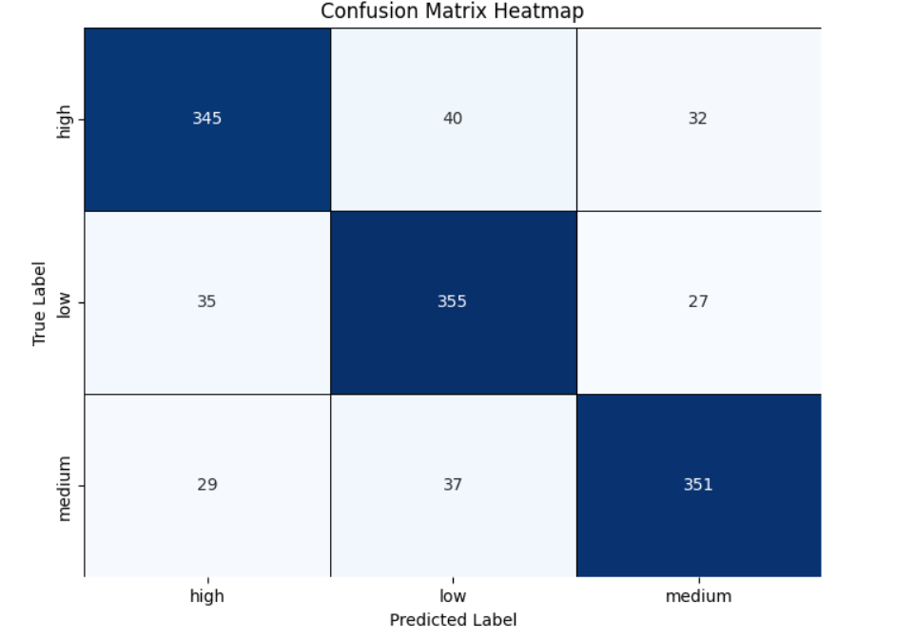Fig. 3. Confusion matrix heatmap.
The confusion matrix shows that high-risk and low-risk classes are predicted more strongly than the medium-risk class. This is expected because medium-risk feedback may contain mixed signals: the student may show some academic difficulty but not enough evidence to be categorized as high risk. In a real deployment, this class would be important because it may identify students who need preventive support before the situation becomes severe.
X. FRONTEND AND BACKEND INTEGRATION
The full-stack version of the project contains a FastAPI backend and React frontend. The backend accepts feedback text through an API endpoint, applies the saved vectorizer and trained model, and returns the predicted risk category along with support information. The frontend presents the prediction through dashboards and charts. The student view focuses on feedback submission and support response. The faculty dashboard focuses on assigned students, and the HOD dashboard focuses on department-wide statistics.
Fig. 4. Student feedback page.
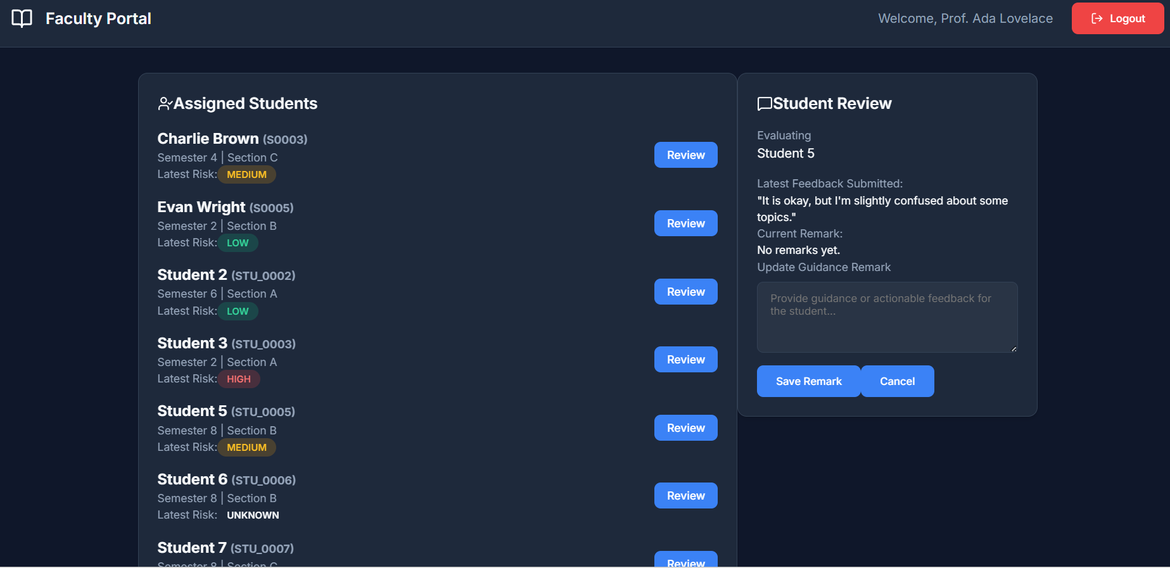Fig. 5. Faculty dashboard.
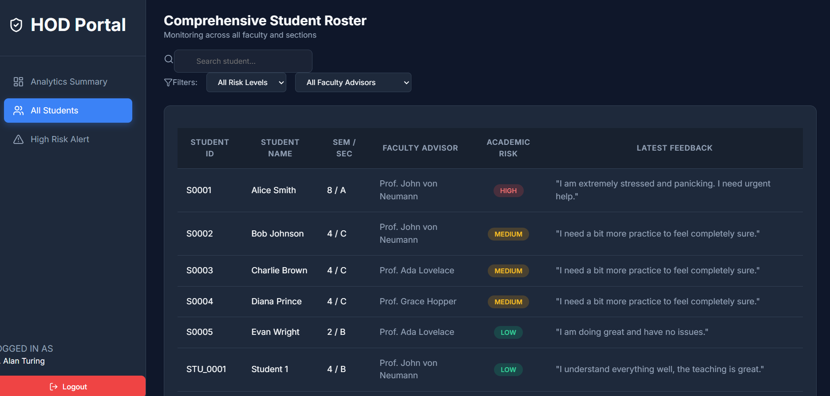Fig. 6. HOD dashboard.
XI. ADVANTAGES AND LIMITATIONS
The main advantage of the proposed system is that it connects prediction with role-based action. A risk label becomes useful only when it reaches the correct authority. The system also uses multiple preprocessing methods, which makes the pipeline more explainable than a simple black-box text classifier. Weighted aggregation allows different client models to contribute according to their data availability.
The main limitation is that the final dataset is synthetic. Although it is useful for project development and controlled evaluation, real institutional data may contain more variation, incomplete feedback, regional language mixing, and noisy labels. Another limitation is that the federated setup is simulated at the application level rather than deployed across physically separate servers. Future work can use real anonymized data and implement secure model-update exchange between distributed faculty nodes.
XII. CONCLUSION
This paper presented a role-based federated NLP framework for predicting student academic risk from feedback text. The project evolved from an initial LSTM-based federated prototype to a classical machine learning phase and finally to a role-aware system with HOD and faculty dashboards. The final model uses text preprocessing, POS and morphology-based linguistic analysis, HMM sequence scoring, and TF-IDF features. Logistic Regression, SVM, and Random Forest are trained as separate clients, and weighted averaging is used to generate final predictions. The achieved accuracy of 0.8042 shows that the system is suitable as a project-level academic monitoring framework. With real institutional data and stricter privacy-preserving deployment, the approach can be extended into a practical early-warning system for student support.
REFERENCES
[1] H. B. McMahan, E. Moore, D. Ramage, S. Hampson, and B. Agüera y Arcas, “Communication-efficient learning of deep networks from decentralized data,” in Proc. Int. Conf. Artificial Intelligence and Statistics (AISTATS), 2017.
[2] L. R. Rabiner, “A tutorial on hidden Markov models and selected applications in speech recognition,” Proc. IEEE, vol. 77, no. 2, pp. 257–286, 1989.
[3] L. Breiman, “Random forests,” Machine Learning, vol. 45, no. 1, pp. 5–32, 2001.
[4] C. Cortes and V. Vapnik, “Support-vector networks,” Machine Learning, vol. 20, pp. 273–297, 1995.
[5] C. D. Manning, P. Raghavan, and H. Schütze, Introduction to Information Retrieval. Cambridge, U.K.: Cambridge Univ. Press, 2008.
[6] S. Bird, E. Klein, and E. Loper, Natural Language Processing with Python. Sebastopol, CA, USA: O’Reilly Media, 2009.
[7] F. Pedregosa et al., “Scikit-learn: Machine learning in Python,” J. Mach. Learn. Res., vol. 12, pp. 2825–2830, 2011.
[8] M. Honnibal and I. Montani, “spaCy: Industrial-strength natural language processing in Python,” 2017.
[9] Q. Yang, Y. Liu, T. Chen, and Y. Tong, “Federated learning: Concept and applications,” ACM Trans. Intell. Syst. Technol., 2019.
[10] P. Kairouz et al., “Advances and open problems in federated learning,” Foundations and Trends in Machine Learning, vol. 14, no. 1–2, pp. 1–210, 2021.
[11] T. Li, A. K. Sahu, A. Talwalkar, and V. Smith, “Federated learning: Challenges, methods, and future directions,” IEEE Signal Process. Mag., vol. 37, no. 3, pp. 50–60, 2020.
[12] D. Jurafsky and J. H. Martin, Speech and Language Processing, draft ed.
[13] D. W. Hosmer, S. Lemeshow, and R. X. Sturdivant, Applied Logistic Regression, 3rd ed. Hoboken, NJ, USA: Wiley, 2013.
[14] FastAPI, “FastAPI documentation,” [Online]. Available: https://fastapi.tiangolo.com/
[15] React, “React documentation,” [Online]. Available: https://react.dev/
[16] Vite, “Vite documentation,” [Online]. Available: https://vitejs.dev/
[17] Recharts, “Recharts documentation,” [Online]. Available: https://recharts.org/
[18] NLTK, “Natural Language Toolkit documentation,” [Online]. Available: https://www.nltk.org/
[19] spaCy, “spaCy documentation,” [Online]. Available: https://spacy.io/
[20] hmmlearn, “hmmlearn documentation,” [Online]. Available: https://hmmlearn.readthedocs.io/

