**Conclusion**

* Customers are showed more interest in purchasing **datascience** related books **(53.8 %)**

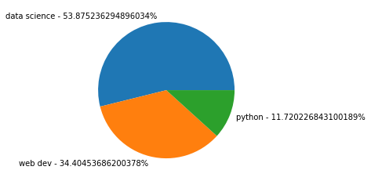

* Data science with python,Data science for dummies,Machine learning with python,Data science from scratch,Practical statistics for data scientist are top-5 books which the customers purchased frequently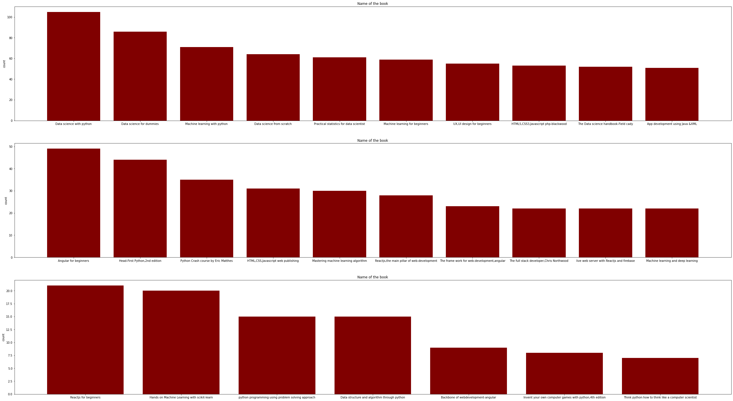
* Exceptionally in top-10 buyers list, Angular for beginners tops in their purchase history list followed by data science related books

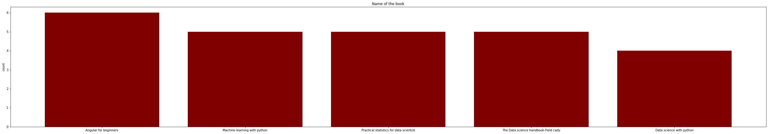

* But top buyers also purchased more number of data science related books(35 books) when compared to web-dev & python related books.

