Week-1 Programs
- Welcome Program
- Read User Name

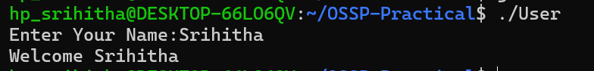

- Display Process ID

- Fork
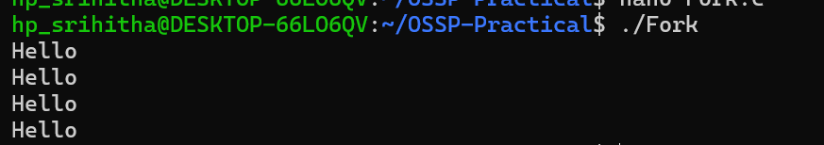
- Parent and Child Process
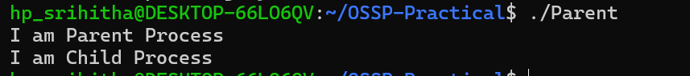

- Fork Name

