Skill – 1
WSL Installation Steps
1) Press Windows
2) Search PowerShell
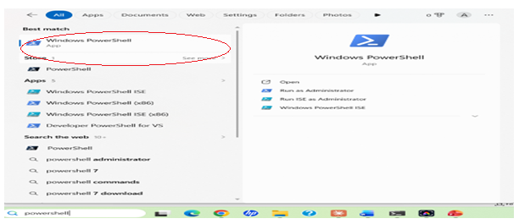
3) Right click on windows PowerShell and then click run as administration
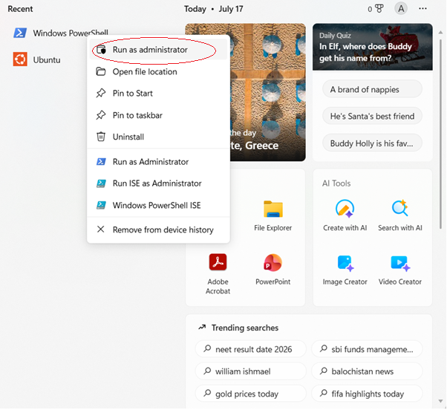
4) Now Press wsl --install command in PoweShell
5) Restart your computer
After installation restart your pc
6) Now Ubuntu opens automatically (or search for Ubuntu in the Start menu). Wait for the installation to finish.
7)Create a Linux username.
8)Enter a new UNIX username: hp_srihitha
9)Then create a password. It will ask for New Password and then Retype New Password
10)Then we have to do ubuntu update
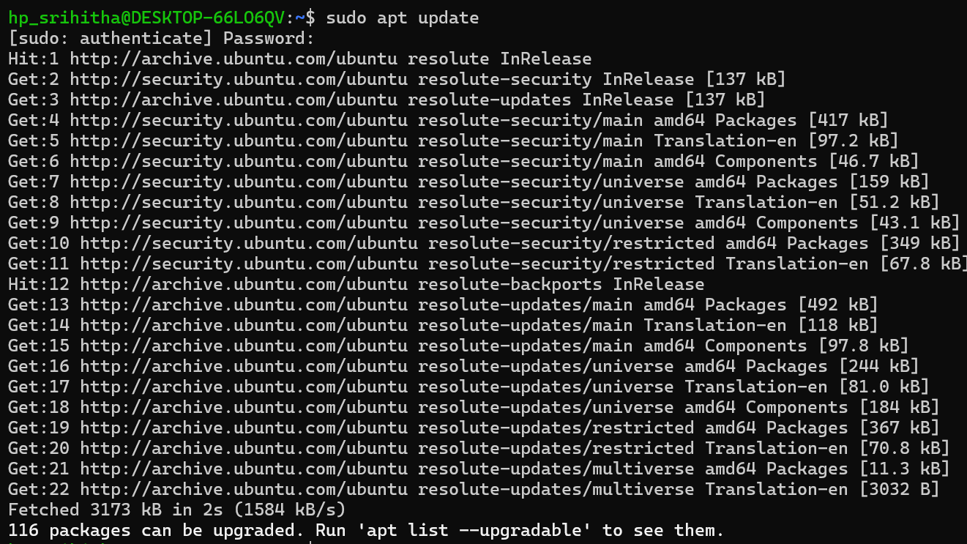
11)Now type sudo apt install build-essential to install gcc compiler
12)Verify the environment
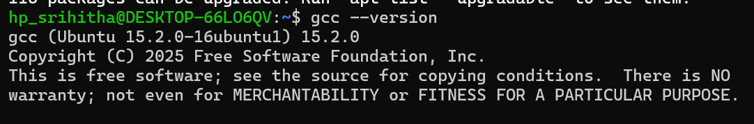
13)Create a c program
For creating a program file we have to use nano file.c
14)Compile the program
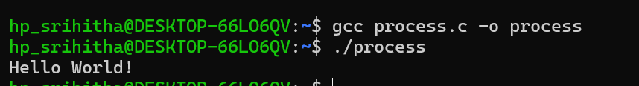

GitHub Repository Structure
1)Open your GitHub account
2)Go to repositories and click new
3)Then type OSSP-Skill in repository name
4)And it must be in public
