CineVault – IWP Project Report 🎬

NIRMA University
Institute of Technology
Department of Computer Science and Engineering

Team Members:
• Arav M. Chaudhary (25ITJ062)
• Zeel Panchal (25ITJ065)

Chapter 1 – Introduction 🎬

1.1 Overview
CineVault is a web-based application designed to organize and display information related to movies, actors, directors, and series in an interactive and visually appealing way. The platform provides a smooth user experience with its clean UI, dynamic layout, and responsive design. It allows users to explore various entertainment categories, view detailed information, and upload custom posters for personalization.
1.2 Objective of the Project
The main objective of CineVault is to create a structured and user-friendly interface for browsing cinematic information.
The project aims to:
- Present movies, actors, directors, and series in an organized format
- Allow users to easily navigate through different sections
- Provide a dynamic poster banner with hover animations
- Implement a search and filter feature for quick access
- Enable users to upload local posters using the Manage Poster section
- Demonstrate the use of HTML, CSS, and JavaScript to build an interactive web application
1.3 Problem Statement
Finding categorized and interconnected entertainment data online often requires navigating multiple platforms. CineVault solves this by providing a single, clean, and structured interface where all information is organized properly.
It removes clutter and presents information in:
- A minimal but informative format
- An aesthetic and visually consistent layout
- An easy-to-browse structure that improves user experience
1.4 Technologies Used
CineVault is developed using the following technologies:
- HTML5 – defines the structure of the web pages
- CSS3 – used for layout, design, and visual styling
- JavaScript – handles dynamic content, interactions, and page functionality

Chapter 2 – Features 🎞️

CineVault includes multiple interconnected features that allow users to browse movies, actors, directors, series, posters, and more in an organized and interactive manner.
Each feature is designed to provide a smooth and visually appealing experience.

2.1 Home / Intro Page

The intro page welcomes the user with a clean layout and an attractive design. It contains the sidebar navigation and a poster banner at the top, which gives the application a cinematic feel.

Key Points:

Clear navigation menu on the left

Random movie posters displayed at the top

Clean and responsive UI

Intro Page
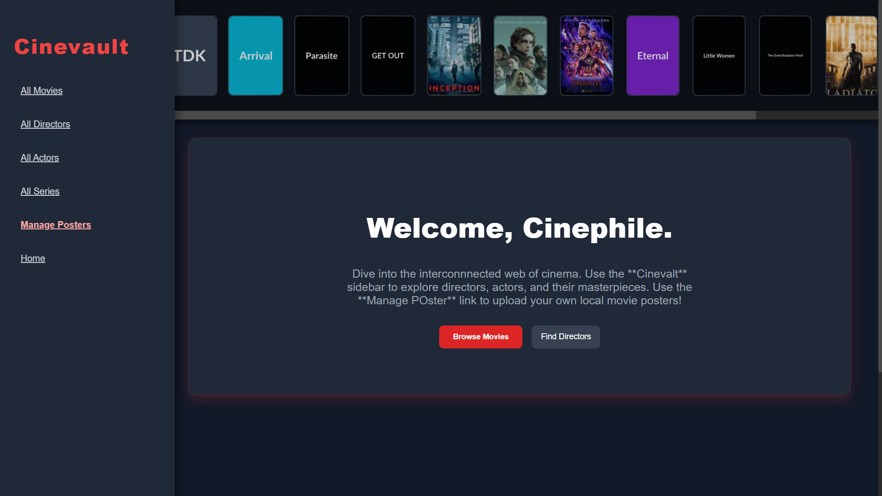

2.2 Poster Banner (Hover & Refresh Effects)

The poster banner at the top of every page displays a row of movie posters. These posters are loaded randomly each time.

Hover Effect

When the user hovers over a poster:

The poster enlarges slightly

It tilts in 3D

Neighboring posters shift to create a smooth animation

Hover Effect
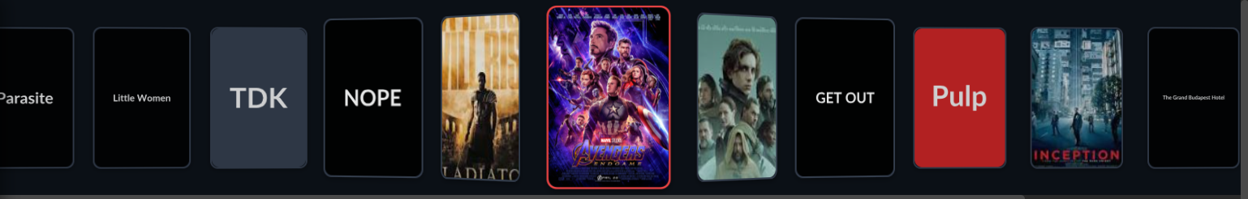
Refresh Feature
Every time the user starts the application or switches sections, the poster lineup changes randomly. This makes the application feel more dynamic.
Poster
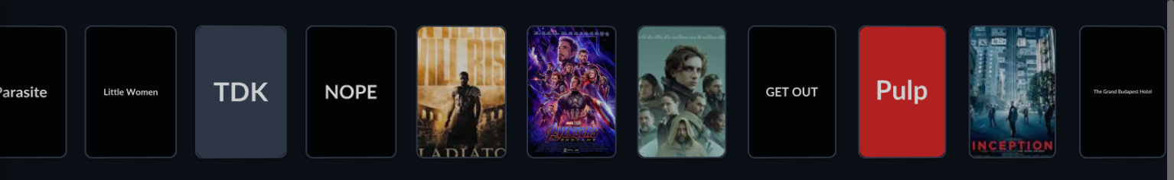

Poster after refreshing page
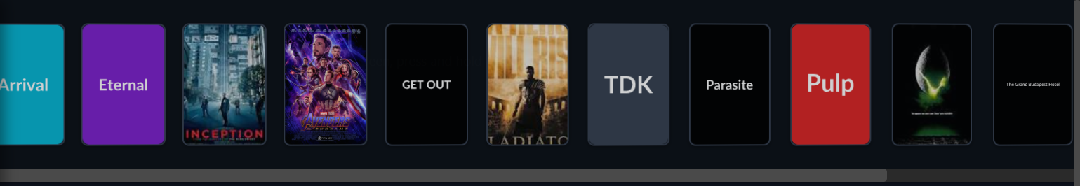

2.3 Movies Section

This section displays a complete list of movies available in CineVault.

All Movies Page

All movies are shown in a card layout

Each card contains the title and year

Clicking on a movie opens its details page

All Movies Page
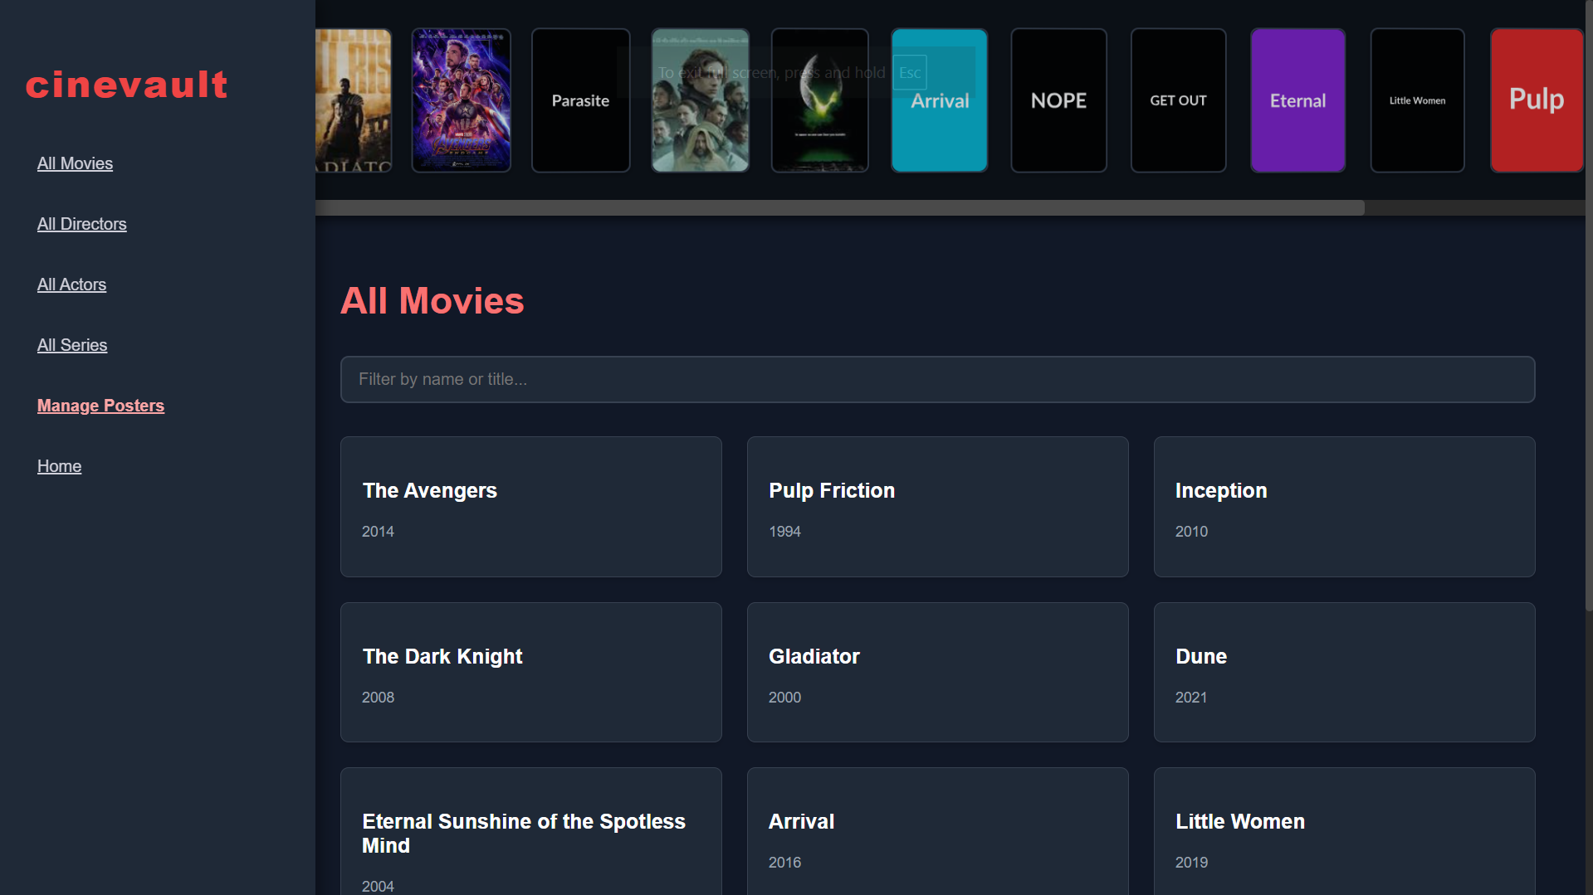
Movie Details Page
Shows important information such as:
- Movie title
- Release year
- Director
- Cast
- Summary
- Streaming platforms

Particular Movie page
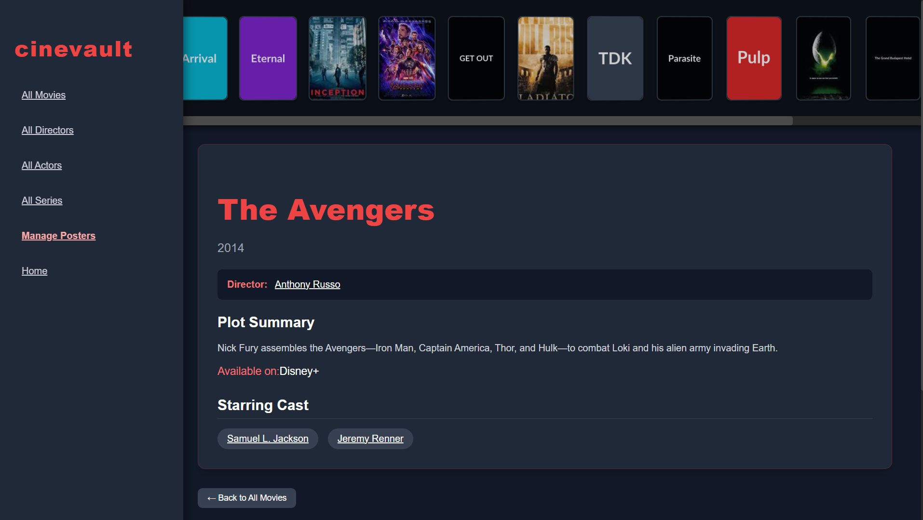
Search / Filter Feature
A search bar is provided to instantly filter movies based on the entered text.

Search output
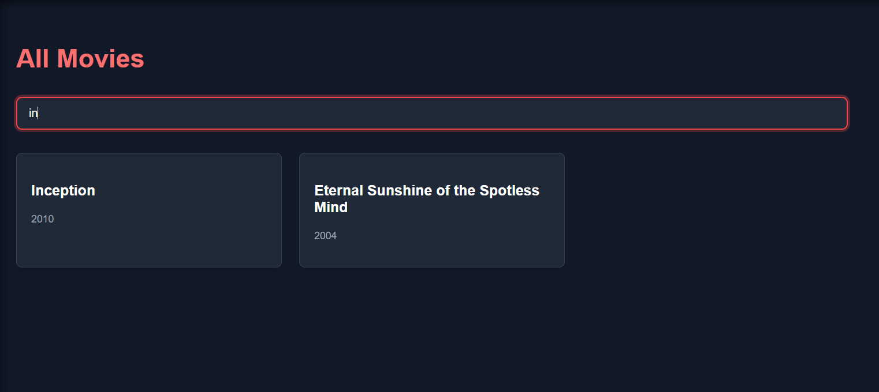

2.4 Actors Section

This section contains a full directory of actors along with their details.

All Actors Page

Displays all actors in a grid

Each card shows the actor’s name and birth year

All Actors page
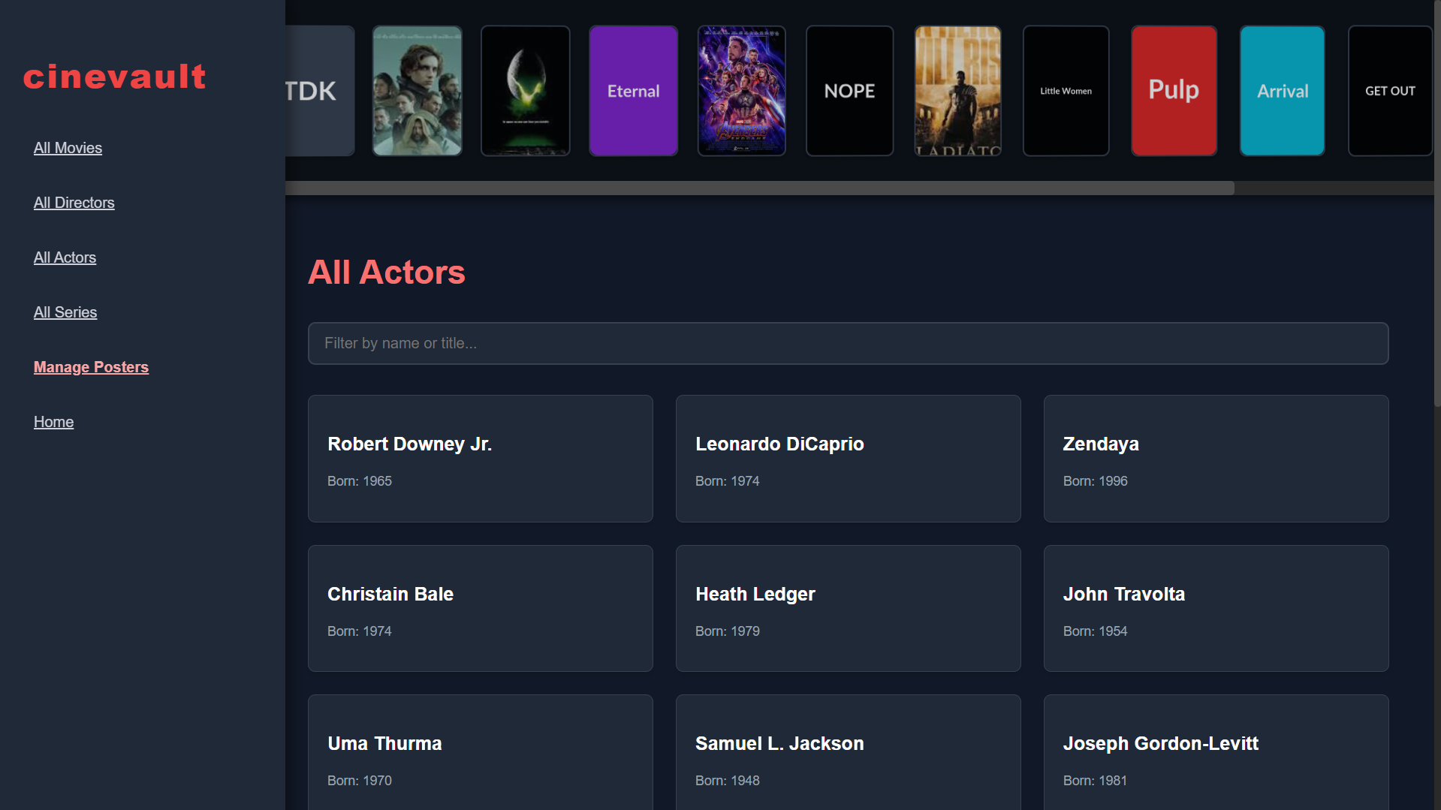

Actor Details Page

Shows:

Name

Birth year

Biography

Related movies

Particular Actor page
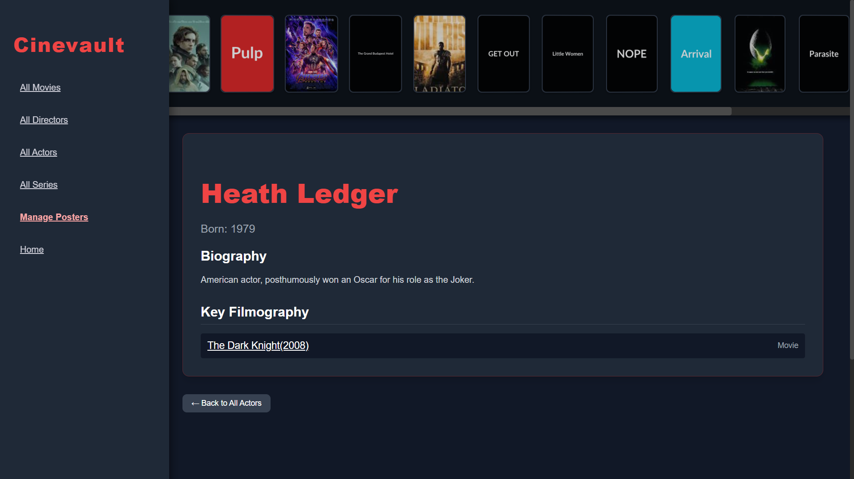

2.5 Directors Section

This section lists all directors and their associated works.

All Directors Page

Displays all directors in a structured card layout

All Director page
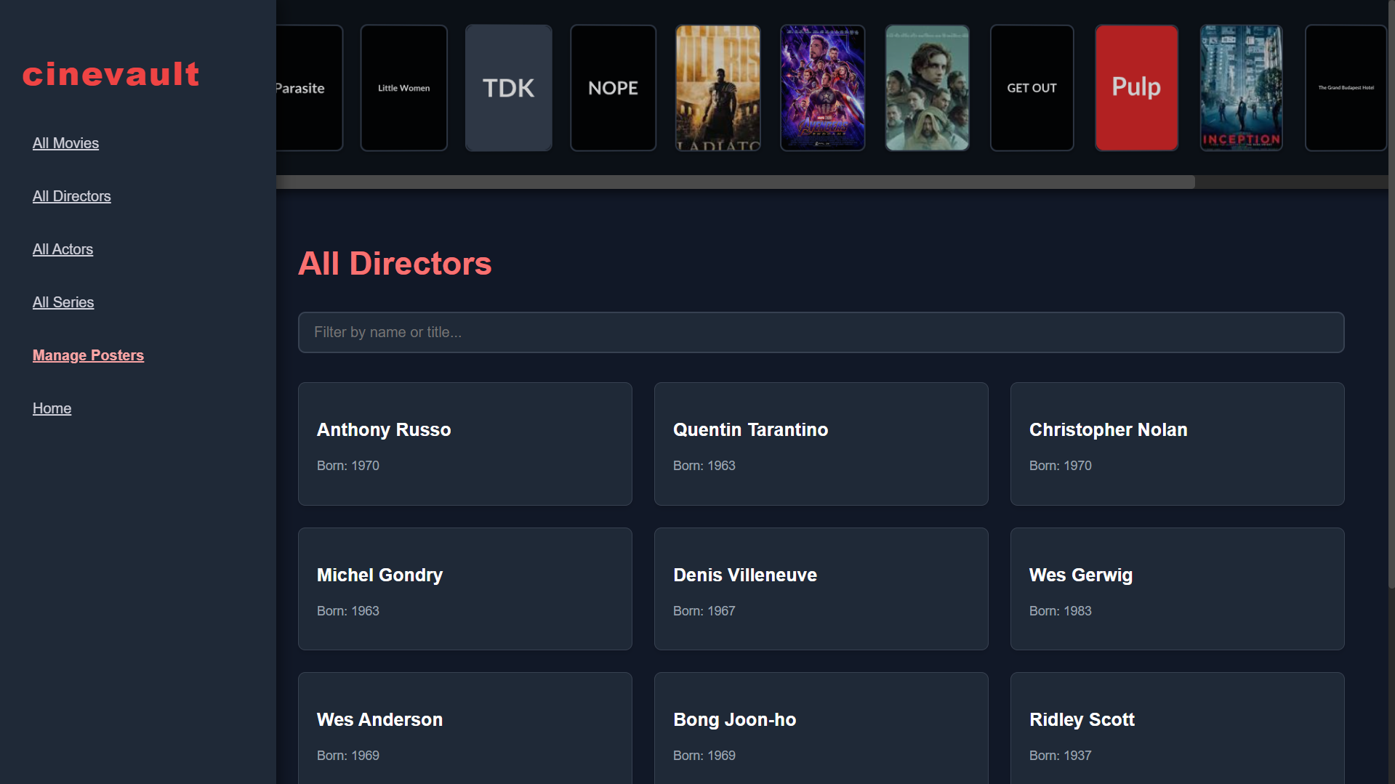
Director Details Page
Shows:
- Biography
- Birth year
- Key filmography
- Clickable movie links

Particular Director page
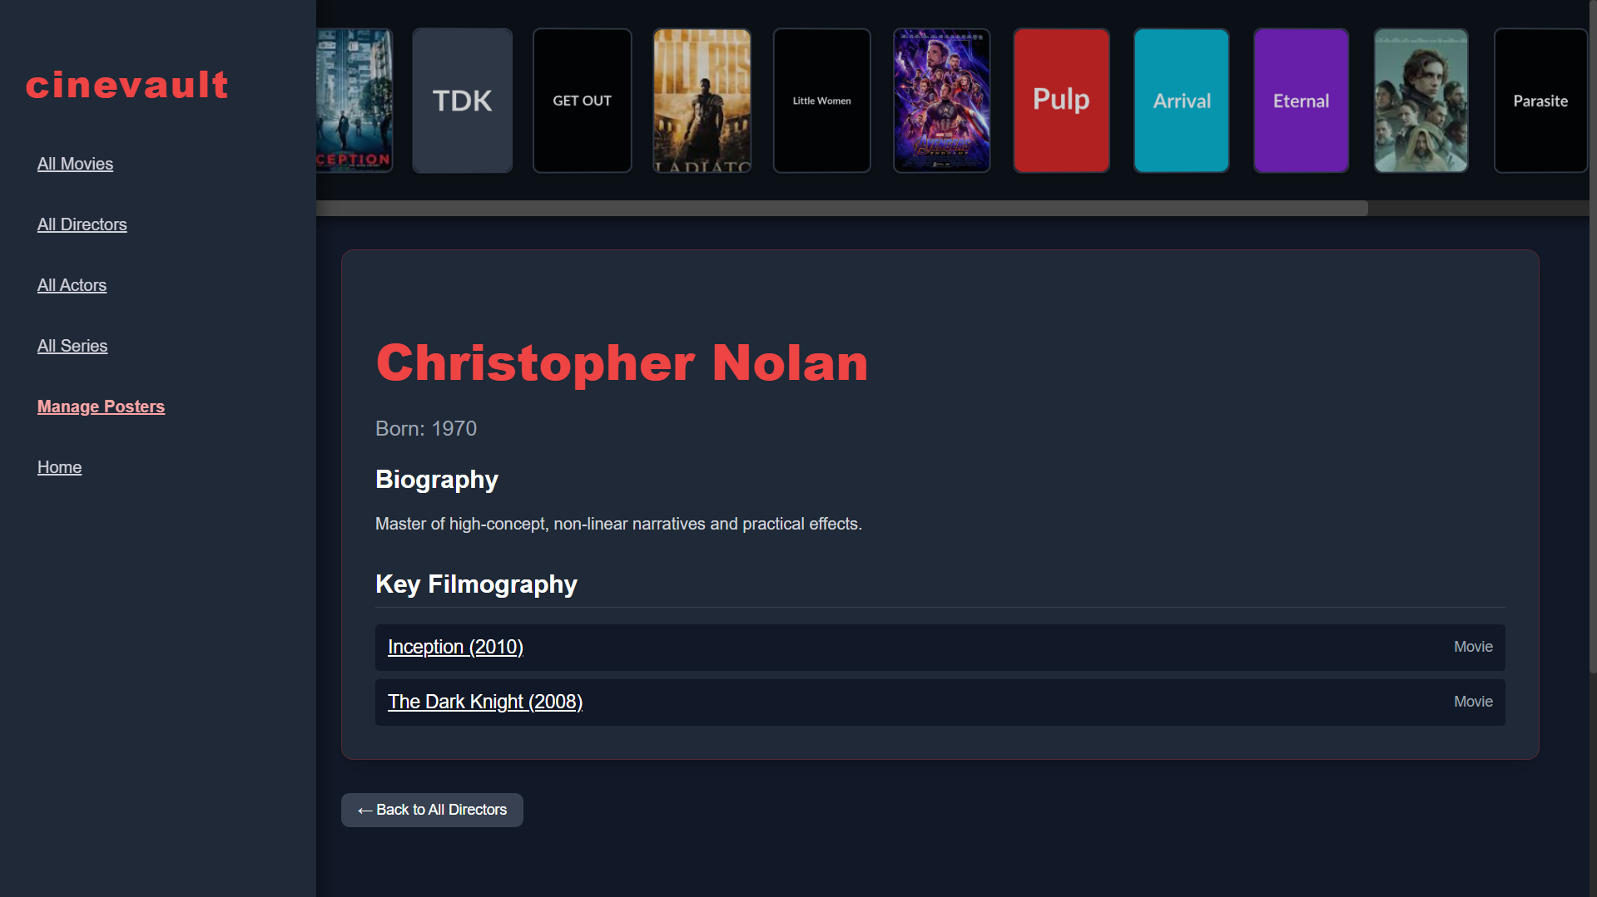
2.6 Series Section
This section contains a list of web series along with important details.
All Series Page
- Shows all series with their titles and release years

All Series page
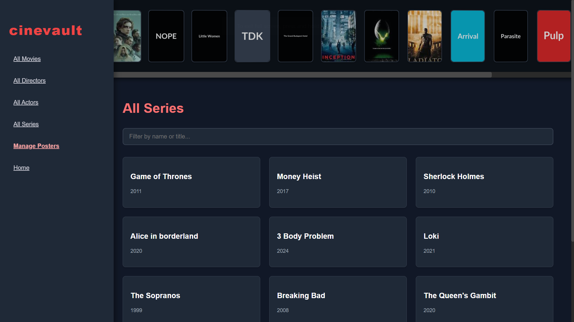

Series Details Page

Shows:

Title

Release year

Directors

Synopsis

Streaming platform

Particular Series page
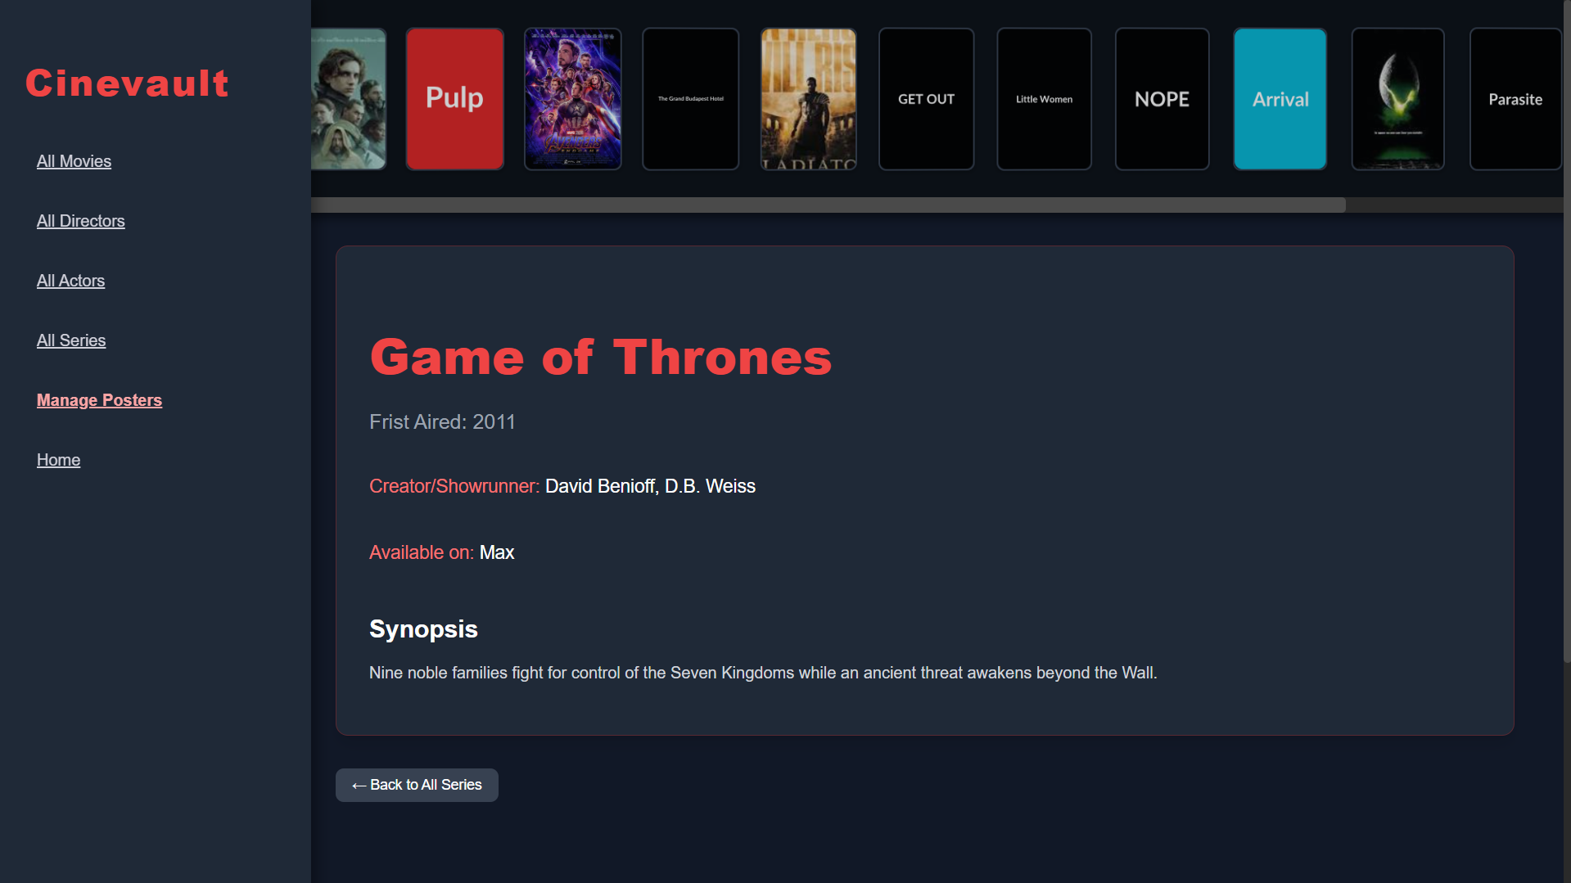
2.7 Manage Posters Section
This feature allows users to upload custom poster images from their device.
Manage Posters Page
Users can:
- View all movies in a grid
- Upload a new poster by selecting a file
- Instantly see the updated poster

Manage poster page
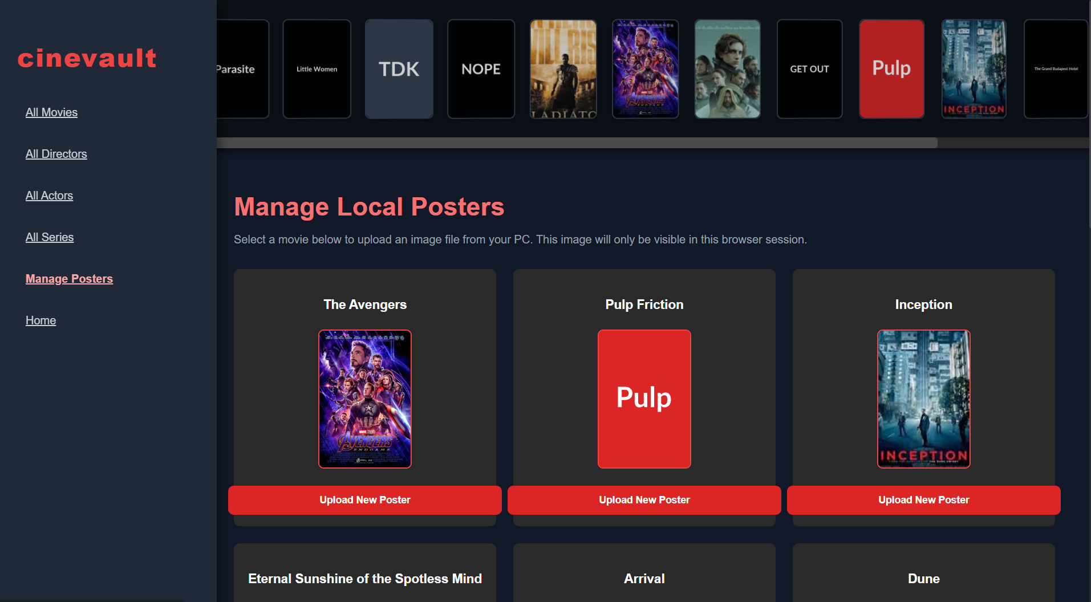
Upload Process
When the user selects a new image, the poster updates locally and reflects in the poster banner as well.

Poster Upload Way
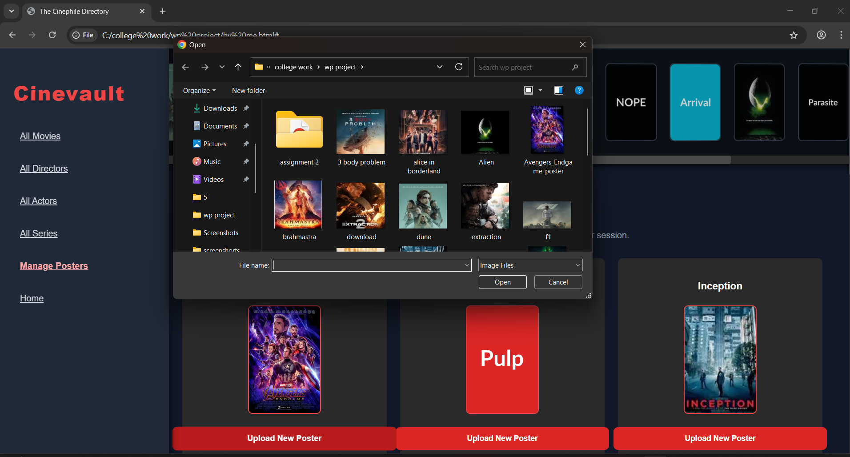

Chapter 3 – Implementation
This chapter explains how CineVault is structured internally and how its different components work together to deliver a smooth browsing experience. The implementation mainly focuses on using HTML for structure, CSS for styling, and JavaScript for dynamic functionalities.

3.1 Project Structure
CineVault is designed as a single-page web application with clearly separated roles:
- HTML defines the layout of the sidebar, poster banner, and content area.
- CSS handles the theme, colors, spacing, hover effects, and responsive screens.
- JavaScript controls navigation, data loading, poster updates, and dynamic rendering of all pages.
The application loads different content based on user interaction, without requiring page refreshes.

3.2 Data Handling
All information (movies, actors, directors, series) is stored in JavaScript objects/arrays.
Each section fetches its data from these structures, making the application:
- Fast to load
- Easy to navigate
- Independent of any backend or database
This approach allows dynamic filtering, linking related content, and generating pages without reloading.

3.3 Navigation System
CineVault uses a JavaScript-based navigation system, where clicking on items automatically changes the content section.
Examples of navigation actions:
- Clicking "Movies" loads the movies list
- Clicking a movie loads its details
- Clicking an actor’s name on a movie page takes you to the actor’s profile
This creates a smooth, app-like experience.

3.4 Poster Banner Functionality
The poster banner at the top is fully dynamic. Its implementation includes:
Random Poster Selection
Each time the application loads or a new section is opened:
- A set of posters is selected randomly
- They are displayed in a horizontal banner
Hover Animation
JavaScript and CSS combine to:
- Enlarge the hovered poster
- Tilt it slightly in 3D
- Adjust surrounding posters for a dynamic effect
Poster Refresh
The banner automatically refreshes when navigating sections, showing a new combination of posters.

3.5 Search & Filter System
The search bar in the Movies section uses JavaScript to:
- Detect user input
- Filter the movie list in real-time
- Instantly update the displayed results
This helps users find a movie quickly without manual scrolling.

3.6 Manage Posters Feature
The Manage Posters page allows users to personalize posters.
How it works (simple explanation):
- Users choose an image file from their computer
- JavaScript reads the file and updates the poster instantly
- The new poster is shown in:
  - The Manage Posters page
  - The Poster Banner at the top
This feature works locally in the browser without uploading data to a server.

3.7 Responsive Design
CineVault is built to adjust across devices:
- Mobile view collapses the sidebar and rearranges the content
- Tablet view adjusts grid layouts
- Desktop view shows full sidebar, banner, and multi-column grids
CSS media queries ensure a smooth look on all screen sizes.

3.8 Overall Workflow
- User selects a section from the sidebar
- JavaScript loads the corresponding layout
- Data is fetched from stored objects
- UI updates instantly without reloading
- Posters, details, and lists are displayed dynamically
This workflow keeps CineVault fast and interactive.

Chapter 4 – Future Scope
Although CineVault performs well as a front-end-based application, it can be expanded further with additional functionalities. Some potential improvements include:
1. Backend Integration
Adding a database and server to:
- Store movie, actor, and user-uploaded poster data permanently
- Sync information across sessions
- Allow real user accounts and personalization
2. API Integration
Using real APIs such as TMDB API to:
- Fetch live movie details
- Display trending movies
- Add real posters and cast information
3. User Accounts & Login System
Implementing authentication to allow:
- Personalized watchlists
- Favorites
- Custom saved posters
4. Reviews & Ratings
Allow users to give ratings and write short reviews for movies or series.
5. Mobile Application Version
Creating a mobile app (using React Native or Flutter) for a better user experience on smartphones.
6. Advanced Search Filters
Adding filters such as:
- Year
- Genre
- Rating
- Actor/Director name
7. UI/UX Enhancements
Improving themes, animations, and accessibility for a smoother and more modern interface.

