augmentedRCBD

# Details

| Item | Details |
| --- | --- |
| Number of blocks | 3 |
| Number of treatments | 12 |
| Number of check treatments | 4 |
| Number of test treatments | 8 |
| Check treatments | 1, 2, 3, 4 |

# ANOVA, Treatment Adjusted

| **Source** | **Df** | **Sum Sq** | **Mean Sq** | **F value** | **Pr(>F)** |
| --- | --- | --- | --- | --- | --- |
| Block (ignoring Treatments) | 2 | 360.07 | 180.04 | 6.67 | 0.03 |
| Treatment (eliminating Blocks) | 11 | 285.1 | 25.92 | 0.96 | 0.55 |
| Treatment: Check | 3 | 52.92 | 17.64 | 0.65 | 0.61 |
| Treatment: Test and Test vs. Check | 8 | 232.18 | 29.02 | 1.08 | 0.48 |
| Residuals | 6 | 161.83 | 26.97 |  |  |

# ANOVA, Block Adjusted

| **Source** | **Df** | **Sum Sq** | **Mean Sq** | **F value** | **Pr(>F)** |
| --- | --- | --- | --- | --- | --- |
| Treatment (ignoring Blocks) | 11 | 575.67 | 52.33 | 1.94 | 0.21 |
| Treatment: Check | 3 | 52.92 | 17.64 | 0.65 | 0.61 |
| Treatment: Test | 7 | 505.88 | 72.27 | 2.68 | 0.13 |
| Treatment: Test vs. Check | 1 | 16.87 | 16.87 | 0.63 | 0.46 |
| Block (eliminating Treatments) | 2 | 69.5 | 34.75 | 1.29 | 0.34 |
| Residuals | 6 | 161.83 | 26.97 |  |  |

# Standard Errors and Critical Differences

| **Std. Error of Diff.** | **CD (5%)** |
| --- | --- |
| 4.24 | 10.38 |
| 7.34 | 17.97 |
| 8.21 | 20.09 |
| 6.36 | 15.56 |

# Overall Adjusted Mean

81.06

# Coefficient of Variation

6.37

# Means

| **Treatment** | **Block** | **Means** | **SE** | **r** | **Min** | **Max** | **Adjusted Means** |
| --- | --- | --- | --- | --- | --- | --- | --- |
| 1 |  | 84.67 | 3.84 | 3 | 79 | 92 | 84.67 |
| 10 | 3 | 74 |  | 1 | 74 | 74 | 77.25 |
| 11 | 1 | 89 |  | 1 | 89 | 89 | 86.5 |
| 12 | 1 | 82 |  | 1 | 82 | 82 | 79.5 |
| 2 |  | 79 | 1.15 | 3 | 77 | 81 | 79 |
| 3 |  | 82 | 2.65 | 3 | 78 | 87 | 82 |
| 4 |  | 83.33 | 3.93 | 3 | 78 | 91 | 83.33 |
| 5 | 2 | 79 |  | 1 | 79 | 79 | 78.25 |
| 6 | 3 | 75 |  | 1 | 75 | 75 | 78.25 |
| 7 | 1 | 96 |  | 1 | 96 | 96 | 93.5 |
| 8 | 3 | 70 |  | 1 | 70 | 70 | 73.25 |
| 9 | 2 | 78 |  | 1 | 78 | 78 | 77.25 |

# Frequency Distribution

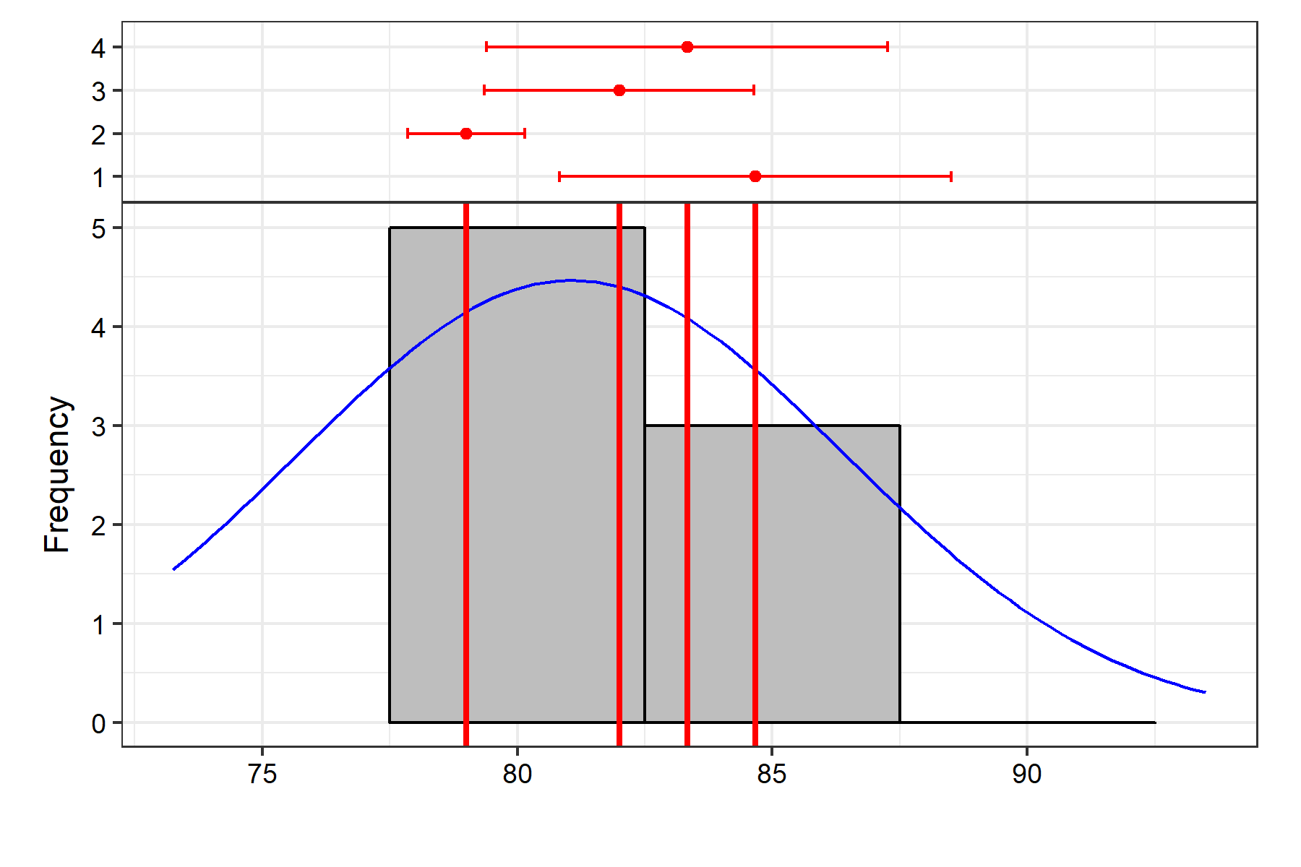

| **Statistic** | **Value** |
| --- | --- |
| Count | 12 |
| Mean | 81.06 |
| Std.Error | 1.55 |
| Std.Deviation | 5.36 |
| Min | 73.25 |
| Max | 93.5 |
| Skewness | 0.93 ns |
| Kurtosis | 3.52 ns |

ns P > 0.05; * P â‰¤ 0.05; ** P â‰¤ 0.01

| **Statistic** | **Value** |
| --- | --- |
| Mean | 81.06 |
| PV | 72.27 |
| GV | 45.3 |
| EV | 26.97 |
| GCV | 8.3 |
| GCV.category | Low |
| PCV | 10.49 |
| PCV.category | Medium |
| ECV | 6.41 |
| hBS | 62.68 |
| hBS.category | High |
| GA | 10.99 |
| GAM | 13.56 |
| GAM.category | Medium |

# Comparisons

Comparison method: lsd

| **contrast** | **estimate** | **SE** | **df** | **t.ratio** | **p.value** | **sig** |
| --- | --- | --- | --- | --- | --- | --- |
| 1 - 2 | 5.67 | 4.24 | 6 | 1.34 | 0.23 |  |
| 1 - 3 | 2.67 | 4.24 | 6 | 0.63 | 0.55 |  |
| 1 - 4 | 1.33 | 4.24 | 6 | 0.31 | 0.76 |  |
| 1 - 5 | 6.42 | 6.36 | 6 | 1.01 | 0.35 |  |
| 1 - 6 | 6.42 | 6.36 | 6 | 1.01 | 0.35 |  |
| 1 - 7 | -8.83 | 6.36 | 6 | -1.39 | 0.21 |  |
| 1 - 8 | 11.42 | 6.36 | 6 | 1.79 | 0.12 |  |
| 1 - 9 | 7.42 | 6.36 | 6 | 1.17 | 0.29 |  |
| 1 - 10 | 7.42 | 6.36 | 6 | 1.17 | 0.29 |  |
| 1 - 11 | -1.83 | 6.36 | 6 | -0.29 | 0.78 |  |
| 1 - 12 | 5.17 | 6.36 | 6 | 0.81 | 0.45 |  |
| 2 - 3 | -3 | 4.24 | 6 | -0.71 | 0.51 |  |
| 2 - 4 | -4.33 | 4.24 | 6 | -1.02 | 0.35 |  |
| 2 - 5 | 0.75 | 6.36 | 6 | 0.12 | 0.91 |  |
| 2 - 6 | 0.75 | 6.36 | 6 | 0.12 | 0.91 |  |
| 2 - 7 | -14.5 | 6.36 | 6 | -2.28 | 0.06 |  |
| 2 - 8 | 5.75 | 6.36 | 6 | 0.9 | 0.4 |  |
| 2 - 9 | 1.75 | 6.36 | 6 | 0.28 | 0.79 |  |
| 2 - 10 | 1.75 | 6.36 | 6 | 0.28 | 0.79 |  |
| 2 - 11 | -7.5 | 6.36 | 6 | -1.18 | 0.28 |  |
| 2 - 12 | -0.5 | 6.36 | 6 | -0.08 | 0.94 |  |
| 3 - 4 | -1.33 | 4.24 | 6 | -0.31 | 0.76 |  |
| 3 - 5 | 3.75 | 6.36 | 6 | 0.59 | 0.58 |  |
| 3 - 6 | 3.75 | 6.36 | 6 | 0.59 | 0.58 |  |
| 3 - 7 | -11.5 | 6.36 | 6 | -1.81 | 0.12 |  |
| 3 - 8 | 8.75 | 6.36 | 6 | 1.38 | 0.22 |  |
| 3 - 9 | 4.75 | 6.36 | 6 | 0.75 | 0.48 |  |
| 3 - 10 | 4.75 | 6.36 | 6 | 0.75 | 0.48 |  |
| 3 - 11 | -4.5 | 6.36 | 6 | -0.71 | 0.51 |  |
| 3 - 12 | 2.5 | 6.36 | 6 | 0.39 | 0.71 |  |
| 4 - 5 | 5.08 | 6.36 | 6 | 0.8 | 0.45 |  |
| 4 - 6 | 5.08 | 6.36 | 6 | 0.8 | 0.45 |  |
| 4 - 7 | -10.17 | 6.36 | 6 | -1.6 | 0.16 |  |
| 4 - 8 | 10.08 | 6.36 | 6 | 1.59 | 0.16 |  |
| 4 - 9 | 6.08 | 6.36 | 6 | 0.96 | 0.38 |  |
| 4 - 10 | 6.08 | 6.36 | 6 | 0.96 | 0.38 |  |
| 4 - 11 | -3.17 | 6.36 | 6 | -0.5 | 0.64 |  |
| 4 - 12 | 3.83 | 6.36 | 6 | 0.6 | 0.57 |  |
| 5 - 6 | -9.8e-15 | 8.21 | 6 | -1.2e-15 | 1 |  |
| 5 - 7 | -15.25 | 8.21 | 6 | -1.86 | 0.11 |  |
| 5 - 8 | 5 | 8.21 | 6 | 0.61 | 0.56 |  |
| 5 - 9 | 1 | 7.34 | 6 | 0.14 | 0.9 |  |
| 5 - 10 | 1 | 8.21 | 6 | 0.12 | 0.91 |  |
| 5 - 11 | -8.25 | 8.21 | 6 | -1 | 0.35 |  |
| 5 - 12 | -1.25 | 8.21 | 6 | -0.15 | 0.88 |  |
| 6 - 7 | -15.25 | 8.21 | 6 | -1.86 | 0.11 |  |
| 6 - 8 | 5 | 7.34 | 6 | 0.68 | 0.52 |  |
| 6 - 9 | 1 | 8.21 | 6 | 0.12 | 0.91 |  |
| 6 - 10 | 1 | 7.34 | 6 | 0.14 | 0.9 |  |
| 6 - 11 | -8.25 | 8.21 | 6 | -1 | 0.35 |  |
| 6 - 12 | -1.25 | 8.21 | 6 | -0.15 | 0.88 |  |
| 7 - 8 | 20.25 | 8.21 | 6 | 2.47 | 0.05 | * |
| 7 - 9 | 16.25 | 8.21 | 6 | 1.98 | 0.1 |  |
| 7 - 10 | 16.25 | 8.21 | 6 | 1.98 | 0.1 |  |
| 7 - 11 | 7 | 7.34 | 6 | 0.95 | 0.38 |  |
| 7 - 12 | 14 | 7.34 | 6 | 1.91 | 0.11 |  |
| 8 - 9 | -4 | 8.21 | 6 | -0.49 | 0.64 |  |
| 8 - 10 | -4 | 7.34 | 6 | -0.54 | 0.61 |  |
| 8 - 11 | -13.25 | 8.21 | 6 | -1.61 | 0.16 |  |
| 8 - 12 | -6.25 | 8.21 | 6 | -0.76 | 0.48 |  |
| 9 - 10 | -3.1e-15 | 8.21 | 6 | -3.8e-16 | 1 |  |
| 9 - 11 | -9.25 | 8.21 | 6 | -1.13 | 0.3 |  |
| 9 - 12 | -2.25 | 8.21 | 6 | -0.27 | 0.79 |  |
| 10 - 11 | -9.25 | 8.21 | 6 | -1.13 | 0.3 |  |
| 10 - 12 | -2.25 | 8.21 | 6 | -0.27 | 0.79 |  |
| 11 - 12 | 7 | 7.34 | 6 | 0.95 | 0.38 |  |

* P ≤ 0.05; ** P ≤ 0.01

# Groups

Comparison method: lsd

| **Treatment** | **Adjusted Means** | **SE** | **df** | **lower.CL** | **upper.CL** | **Group** |
| --- | --- | --- | --- | --- | --- | --- |
| 8 | 73.25 | 5.61 | 6 | 59.52 | 86.98 | 1 |
| 9 | 77.25 | 5.61 | 6 | 63.52 | 90.98 | 12 |
| 10 | 77.25 | 5.61 | 6 | 63.52 | 90.98 | 12 |
| 5 | 78.25 | 5.61 | 6 | 64.52 | 91.98 | 12 |
| 6 | 78.25 | 5.61 | 6 | 64.52 | 91.98 | 12 |
| 2 | 79 | 3 | 6 | 71.66 | 86.34 | 12 |
| 12 | 79.5 | 5.61 | 6 | 65.77 | 93.23 | 12 |
| 3 | 82 | 3 | 6 | 74.66 | 89.34 | 12 |
| 4 | 83.33 | 3 | 6 | 76 | 90.67 | 12 |
| 1 | 84.67 | 3 | 6 | 77.33 | 92 | 12 |
| 11 | 86.5 | 5.61 | 6 | 72.77 | 100.23 | 12 |
| 7 | 93.5 | 5.61 | 6 | 79.77 | 107.23 | 2 |

################## The End ##################