augmentedRCBD

# Details

| Item | Details |
| --- | --- |
| Number of blocks | 3 |
| Number of treatments | 12 |
| Number of check treatments | 4 |
| Number of test treatments | 8 |
| Check treatments | 1, 2, 3, 4 |
| Number of Traits | 2 |
| Traits | y1, y2 |

# ANOVA, Treatment Adjusted

| **Source** | **Df** | **y1** | **y2** |
| --- | --- | --- | --- |
| Block (ignoring Treatments) | 2 | 180.04 * | 3509.67 ** |
| Treatment (eliminating Blocks) | 11 | 25.92 ns | 5360.49 ** |
| Treatment: Check | 3 | 17.64 ns | 716.75 ns |
| Treatment: Test and Test vs. Check | 8 | 29.02 ns | 7101.89 ** |
| Residuals | 6 | 26.97 | 286.25 |

ns P > 0.05; * P <= 0.05; ** P <= 0.01

# ANOVA, Block Adjusted

| **Source** | **Df** | **y1** | **y2** |
| --- | --- | --- | --- |
| Treatment (ignoring Blocks) | 11 | 52.33 ns | 5882.5 ** |
| Treatment: Check | 3 | 17.64 ns | 716.75 ns |
| Treatment: Test vs. Check | 1 | 16.87 ns | 27694.41 ** |
| Treatment: Test | 7 | 72.27 ns | 4980.41 ** |
| Block (eliminating Treatments) | 2 | 34.75 ns | 638.58 ns |
| Residuals | 6 | 26.97 | 286.25 |

ns P > 0.05; * P <= 0.05; ** P <= 0.01

# Standard Errors

| **Comparison** | **y1** | **y2** |
| --- | --- | --- |
| A Test Treatment and a Control Treatment | 6.36 | 20.72 |
| Control Treatment Means | 4.24 | 13.81 |
| Two Test Treatments (Different Blocks) | 8.21 | 26.75 |
| Two Test Treatments (Same Block) | 7.34 | 23.93 |

# Critical Difference (5%)

| **Comparison** | **y1** | **y2** |
| --- | --- | --- |
| A Test Treatment and a Control Treatment | 6.36 | 20.72 |
| Control Treatment Means | 4.24 | 13.81 |
| Two Test Treatments (Different Blocks) | 8.21 | 26.75 |
| Two Test Treatments (Same Block) | 7.34 | 23.93 |

# Coefficient of Variance

| **Trait** | **CV** |
| --- | --- |
| y1 | 6.37 |
| y2 | 6.06 |

# Overall Adjusted Mean

| **Trait** | **Overall.adjusted.mean** |
| --- | --- |
| y1 | 81.06 |
| y2 | 298.48 |

# Descriptive Statistics

| **Trait** | **Count** | **Mean** | **Std.Error** | **Std.Deviation** | **Min** | **Max** | **Skewness** | **Kurtosis** |
| --- | --- | --- | --- | --- | --- | --- | --- | --- |
| y1 | 12 | 81.06 | 1.55 | 5.36 | 73.25 | 93.5 | 0.93 ns | 3.52 ns |
| y2 | 12 | 298.48 | 18.92 | 65.55 | 213.67 | 437.67 | 0.74 ns | 2.79 ns |

ns P > 0.05; * P <= 0.05; ** P <= 0.01

# Frequency Distribution

## y1

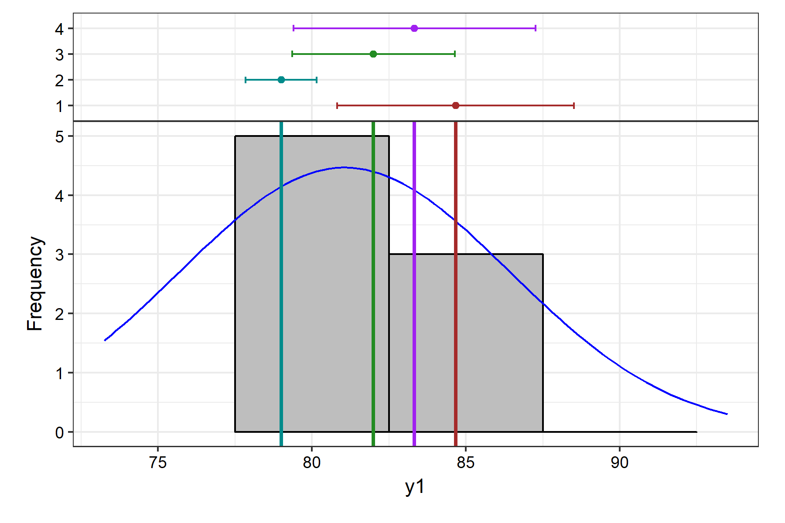

## y2

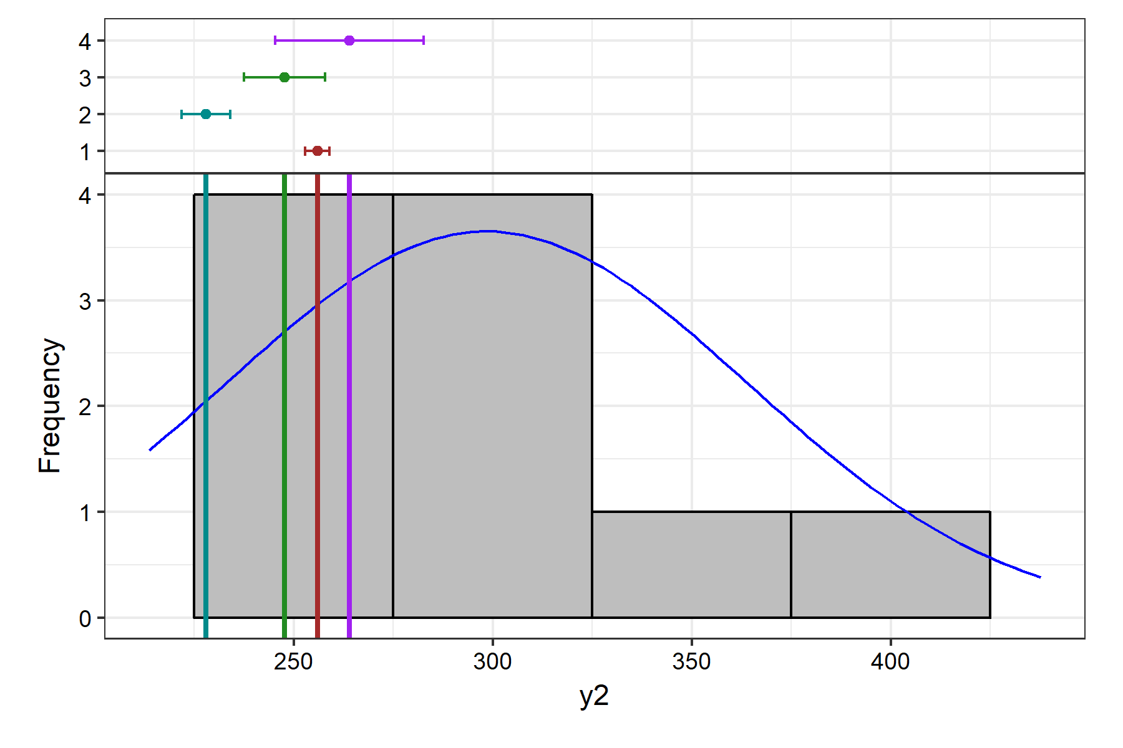

# Genetic Variability Analysis

| **Trait** | **Mean** | **PV** | **GV** | **EV** | **GCV** | **GCV.category** | **PCV** | **PCV.category** | **ECV** | **hBS** | **hBS.category** | **GA** | **GAM** | **GAM.category** |
| --- | --- | --- | --- | --- | --- | --- | --- | --- | --- | --- | --- | --- | --- | --- |
| y1 | 81.06 | 72.27 | 45.3 | 26.97 | 8.3 | Low | 10.49 | Medium | 6.41 | 62.68 | High | 10.99 | 13.56 | Medium |
| y2 | 298.48 | 4980.41 | 4694.16 | 286.25 | 22.95 | High | 23.64 | High | 5.67 | 94.25 | High | 137.22 | 45.97 | High |

# Genetic Variablity Analysis Plots

## Phenotypic and Genotypic Coefficient of Variability

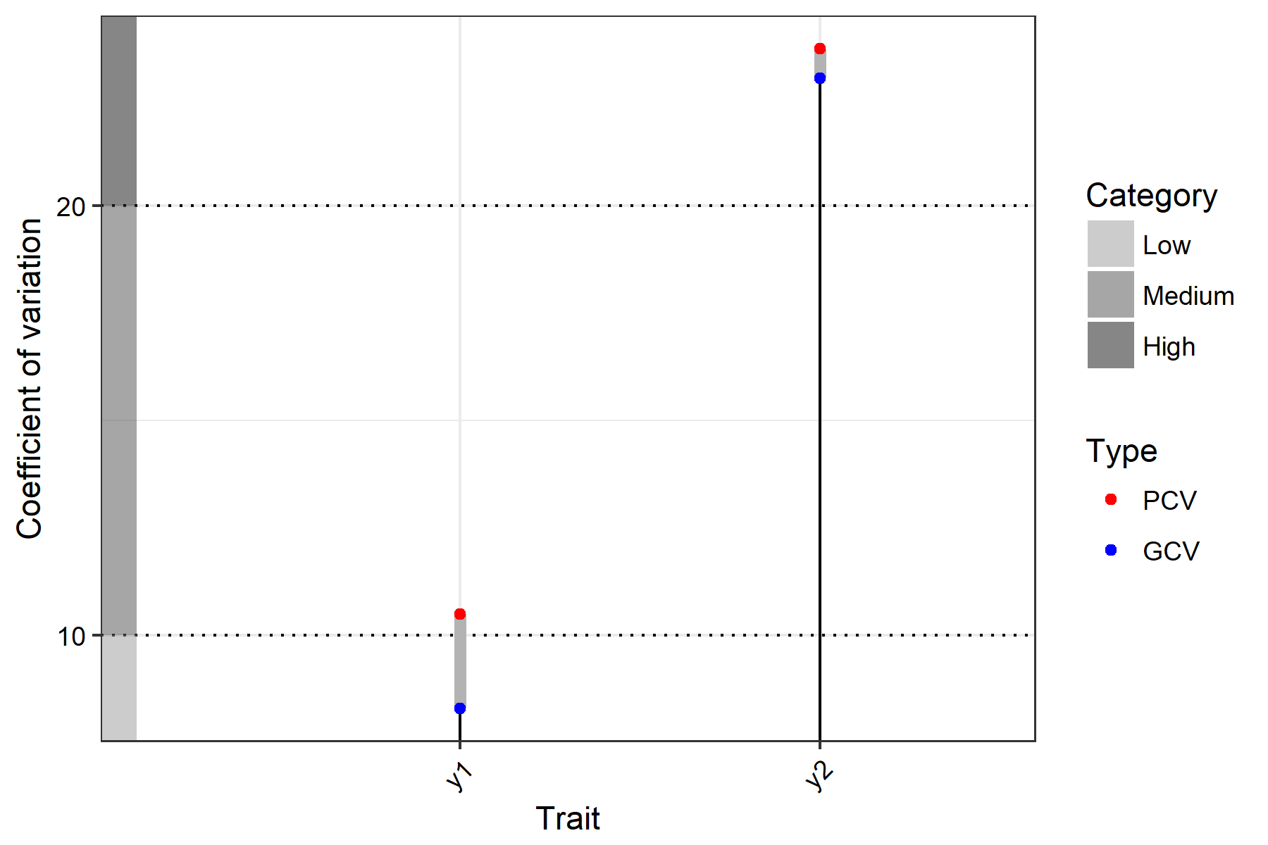

## Broad Sense Heritability

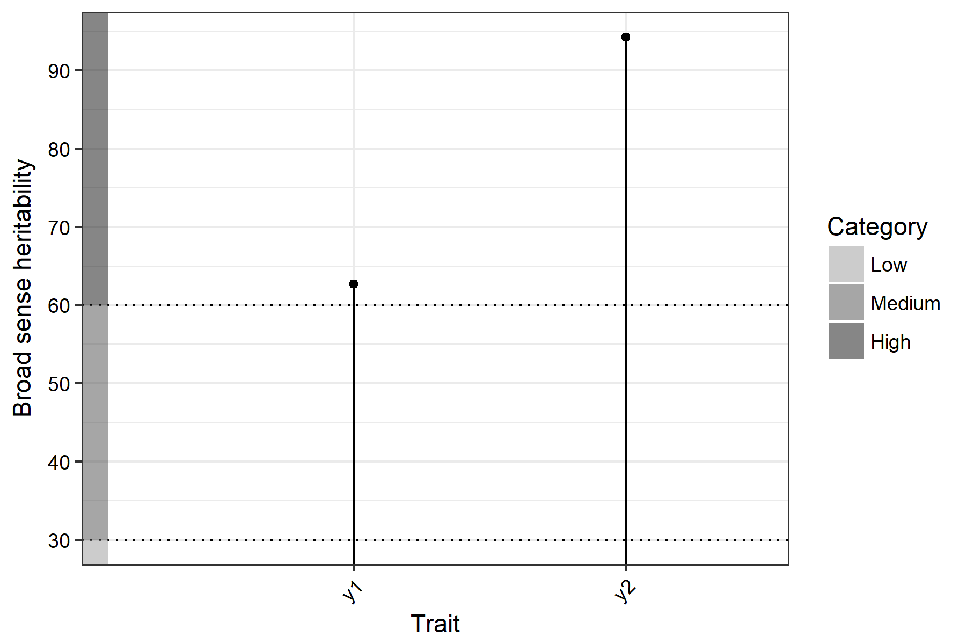

## Genetic Advance Over Mean

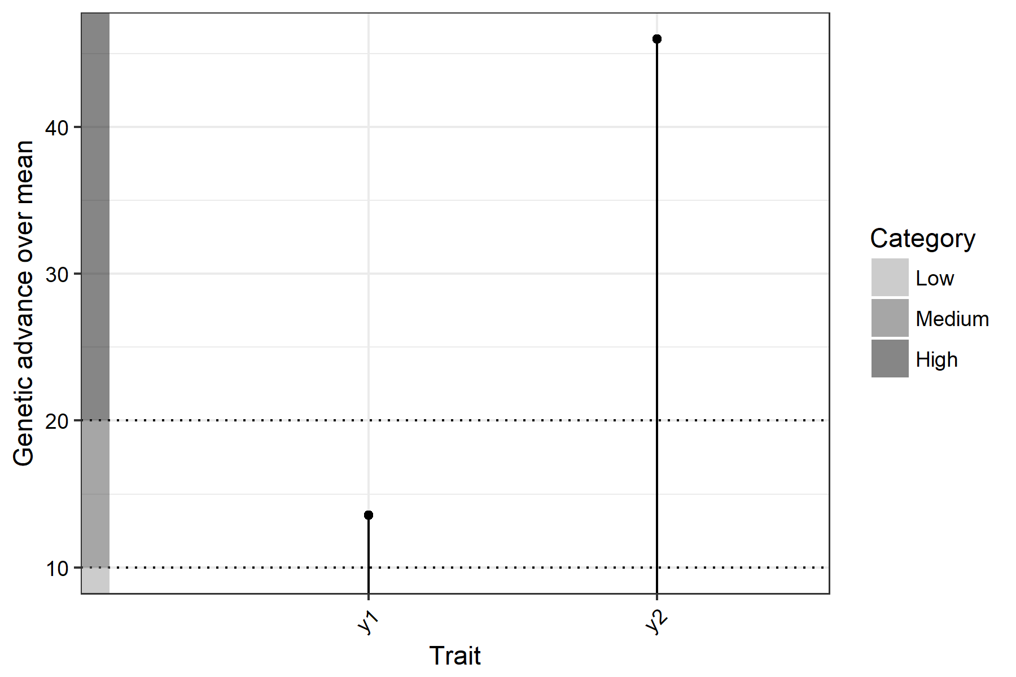

# Adjusted Means

| **Treatment** | **y1** | **y2** |
| --- | --- | --- |
| 1 | 84.67 | 256 |
| 10 | 77.25 | 437.67 |
| 11 | 86.5 | 299.42 |
| 12 | 79.5 | 288.42 |
| 2 | 79 | 228 |
| 3 | 82 | 247.67 |
| 4 | 83.33 | 264 |
| 5 | 78.25 | 293.92 |
| 6 | 78.25 | 382.67 |
| 7 | 93.5 | 346.42 |
| 8 | 73.25 | 213.67 |
| 9 | 77.25 | 323.92 |

# Warnings

## Frequency distribution

y1

Removed 1 rows containing missing values (geom_bar).

y2

Removed 2 rows containing missing values (geom_bar).

################## The End ##################