OUTPUT

**Question 1:**

**Query**

select  
o.orderNumber,  
p.productName,  
c.customerName,  
pay.amount,  
pay.checkNumber  
from  
orders o inner join orderdetails od on o.orderNumber = od.orderNumber  
inner join products p on od.productCode = p.productCode  
inner join customers c on o.customerNumber = c.customerNumber  
inner join payments pay on c.customerNumber = pay.customerNumber  
where  
o.orderNumber = 10100

**Screenshot:**

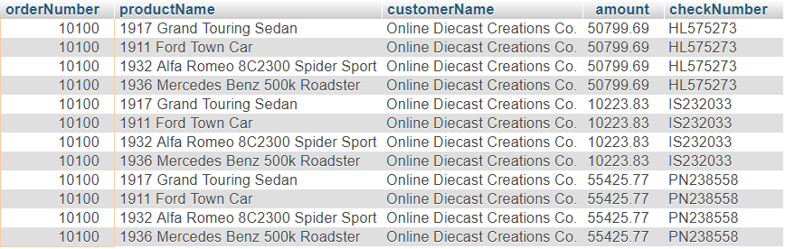

**Question 2:**

**Query**

select  
o.orderNumber,  
sum(pay.amount) as total_paid_amount_for_the_order_10100  
from  
orders o inner join orderdetails od on o.orderNumber = od.orderNumber  
inner join products p on od.productCode = p.productCode  
inner join customers c on o.customerNumber = c.customerNumber  
inner join payments pay on c.customerNumber = pay.customerNumber  
where  
o.orderNumber = 10100

**Screenshot**



**Question 3:**

**Query**

select  
o.orderNumber,  
pay.checkNumber  
from  
orders o inner join orderdetails od on o.orderNumber = od.orderNumber  
inner join products p on od.productCode = p.productCode  
inner join customers c on o.customerNumber = c.customerNumber  
inner join payments pay on c.customerNumber = pay.customerNumber  
where  
o.orderNumber = 10100  
group by  
pay.checkNumber

**Screenshot**

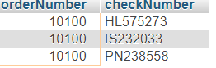

**Question 4:**

**Query**

select min(quantityInStock) as least_value_in_quantityInStock,   
max(quantityInStock) as max_value_in_quantityInStock from products;

**Screenshot**



**Question 5:**

**Query**

select  
products.productCode,  
products.productLine,  
(select htmlDescription from productlines where productlines.productLine   
= products.productLine) as htmlDescription  
from  
products  
where  
productCode in ('S12_3380', 'S12_3891', 'S12_3990')

**Screenshot**

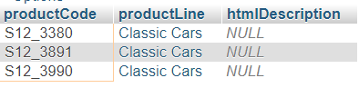

**Question 6:**

**Query**

select count(*) as NULL_COUNT from productlines where htmlDescription is   
null;

**Screenchot**



**Question 7:**

**Query**

select date_format('2019-07-18 12:49:24', '%d-%b-%a');