# **Text-Curie-003 Model**

## **Demo**

## **Confusion Matrix for Test Data**

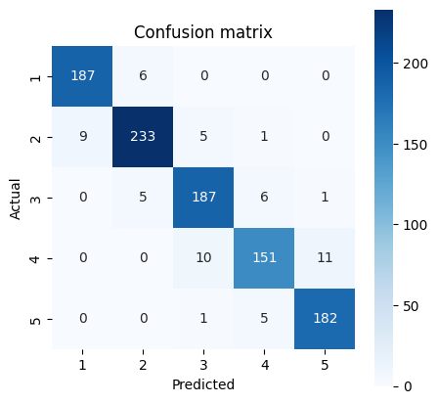

Classification report:

precision recall f1-score support

1 0.95 0.97 0.96 193

2 0.95 0.94 0.95 248

3 0.92 0.94 0.93 199

4 0.93 0.88 0.90 172

5 0.94 0.97 0.95 188

accuracy 0.94 1000

macro avg 0.94 0.94 0.94 1000

weighted avg 0.94 0.94 0.94 1000

Text Curie 3 is a large language model (LLM) in the OPENAI GPT-3 family that can understand and generate natural language¹. It is named after Marie Curie, the first woman to win the Nobel Prize in Physics and Chemistry². Text Curie is more capable than Text Babbage, but less capable than Text Davinci¹.

The Text Curie 3 model that has been pre-trained on a sizable dataset of text and code. It can be used for a variety of tasks, including sentiment classification, summarization, and question answering.

## **What can it do?**

* Text Curie can perform various natural language tasks, such as language translation, complex classification, text sentiment, and summarization¹. It is also good at answering questions and performing Q&A and as a general service chatbot¹.
* Text Curie is based on a deep neural network architecture called Transformer³, which uses attention mechanisms to learn the relationships between words and sentences. Text Curie is trained on a large corpus of text data from various sources, such as books, news articles, web pages, and social media posts⁴. Text Curie learns from the patterns and structures of natural language and can generate coherent and fluent texts based on a given prompt or context.

## **Merits**

* It is very large and has been trained on a massive dataset. This means that it has a deep understanding of language and can generate very accurate and informative text. This allows it to learn the nuances of human language and to identify sentiment in text with a high degree of accuracy.
* It is very fast. This makes it ideal for real-time applications, such as sentiment analysis of social media posts.
* It can handle multiple domains and tasks with a single model¹.
* It can generate high-quality texts that are relevant and informative⁴.
* It can adapt to different styles and tones of natural language⁴.
* It can perform sentiment analysis on texts and classify them as positive, negative, or neutral³.

## **Demerits**

* It is expensive to train and use. This is because it requires a lot of computing power and data.
* It is less powerful and accurate than Text Davinci, which is the most capable model in the GPT-3 family¹.
* It may generate texts that are biased, inaccurate, or inappropriate due to the limitations of its training data or its inherent randomness⁴.
* It may not be able to handle complex reasoning or logic that requires external knowledge or common sense⁴.
* It can be biased. This is because it was trained on a dataset that was created by humans, who are all biased in their own way.
* It can be inaccurate. This is because it is still under development and is not perfect.

## **Opportunities for improvement**

* Making it more affordable. This could be done by making it more efficient or by finding ways to share the cost of training and use.
* Reducing its bias. This could be done by using a more diverse dataset or by developing better algorithms for detecting and removing bias.
* Improving its accuracy. This could be done by training it on a larger and more diverse dataset or by developing better algorithms for sentiment classification.
* Fine-tuning it on specific domains or tasks that require more specialized knowledge or skills¹.
* Incorporating more diverse and reliable sources of text data to reduce bias and increase accuracy⁴.
* Enhancing its ability to perform multimodal tasks that involve images, audio, or video inputs or outputs¹.
* Developing methods to evaluate and monitor its performance and quality on different natural language tasks⁴.

Overall, the text Curie model is a powerful tool for sentiment classification. It is accurate, fast, and efficient. However, it is still under development, and there are some areas where it could be improved.

# **Suggestions to Customers based on Data Analysis**

## Atlanta Airport

* Expanding security checkpoints to reduce wait times.
* Adding more food and drink options, and comfortable seating.
* Investing in new baggage handling technology to improve efficiency.
* Training staff on customer service.
* Investing in new technology to improve traffic flow and reduce delays.

# REFERENCES

(1) Azure OpenAI Service models - Azure OpenAI | Microsoft Learn. https://learn.microsoft.com/en-us/azure/cognitive-services/openai/concepts/models.

(2) OpenAI Platform. https://platform.openai.com/docs/models.

(3) A Guide to Text Classification and Sentiment Analysis. https://towardsdatascience.com/a-guide-to-text-classification-and-sentiment-analysis-2ab021796317.

(4) Sentiment Classification of News Text Data Using Intelligent Model. https://www.frontiersin.org/articles/10.3389/fpsyg.2021.758967/full.

(5) Applied Sciences | Free Full-Text | Sentiment Classification Using .... <https://www.mdpi.com/2076-3417/9/11/2347>.