Low Level Design

# SWIGGY OUTLET DATA ANALYSIS

|  |  |
| --- | --- |
| **Written By** | Aravind S |
| **Document Version** | 0.3 |
| **Last Revised Date** | 07-04-2022 |

**DOCUMENT CONTROL**

**Change Record:**

|  |  |  |  |
| --- | --- | --- | --- |
| **VERSION** | **DATE** | **AUTHOR** | **COMMENTS** |
| 0.1 | 4- April -  2022 | Aravind S | Introduction and architecture defined |
|  |  |  |  |
|  |  |  |  |
|  |  |  |  |

**Approval Status:**

|  |  |  |  |  |  |
| --- | --- | --- | --- | --- | --- |
| **VERSION** | **REVIEW**  **DATE** | **REVIEWED BY** |  | **APPROVED BY** | **COMMENTS** |
|  |  |  |  |  |  |

# Contents

1. **Introduction** 
   1. **What is Low-Level Design Document?**

|  |  |  |
| --- | --- | --- |
| **1.2** | | **Scope** |
| **2.** | **Architecture**  **2.1 Architecture**  **2.2 Tableau Architecture** | |
| **3.** | **Architecture Description** | |
|  | **3.1** | **Data Description** |
|  | **3.2** | **Tools** |
|  | **3.3** | **Data insertion into database** |
|  | **3.4** | **EDA** |
|  | **3.5** | **Data cleaning and Data manipulation using SQL.** |
|  | **3.5** | **Set up the data source** |
|  | **3.6** | **Visualization in Tableau** |
|  | **3.7** | **Deployment** |
| **4.** | **Unit** | **test cases** |

# Introduction

## What is a Low-Level design document?

The goal of the LDD or Low-level design document (LLDD) is to give the internal logic design of the actual program code for the House Price Prediction dashboard. LDD describes the class diagrams with the methods and relations between classes and programs specs. It describes the modules so that the programmer can directly code the program from the document.

## Scope

Low-level design (LLD) is a component-level design process that follows a step-by-step refinement process. The process can be used for designing data structures, required software architecture, source code and ultimately, performance algorithms. Overall, the data organization may be defined during requirement analysis and then refined during data design work.

# Architecture

DATA SOURCE

ETL AND EDA

DATA CLEANING AND TRANSFORMATION

DATA VISUALIZATION

**Tableau Server Architecture**

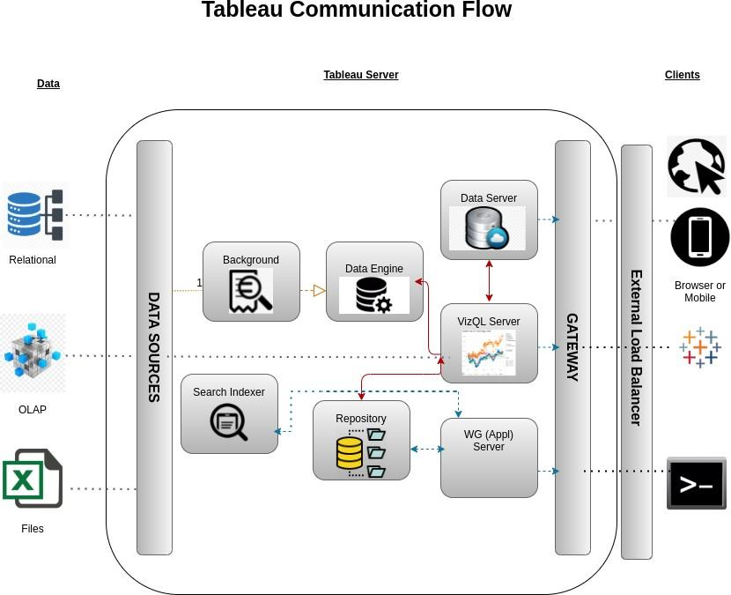

Tableau has a highly scalable, n-tier client-server architecture that serves mobile clients, web clients and desktop-installed software. Tableau Server architecture supports fast and flexible deployments.

The following diagram shows Tableau Server’s architecture:

**LOW LEVEL DESIGN**

**6**

# Architecture Description

## Data Description

The Dataset contains Swiggy Bangalore outlet details in columns Shop name, Cuisine, Location, Rating, Cost for Two.

* + 1. Shop Name: Registered name of the Hotel.
    2. Cuisine: Cuisines which are available in the respective Hotels/Outlet.
    3. Location: Address of the Hotel/Outlet.
    4. Rating: Rating given through votes by the customer in app. (1-5)
    5. Cost for Two: Approximate Cost for two people.

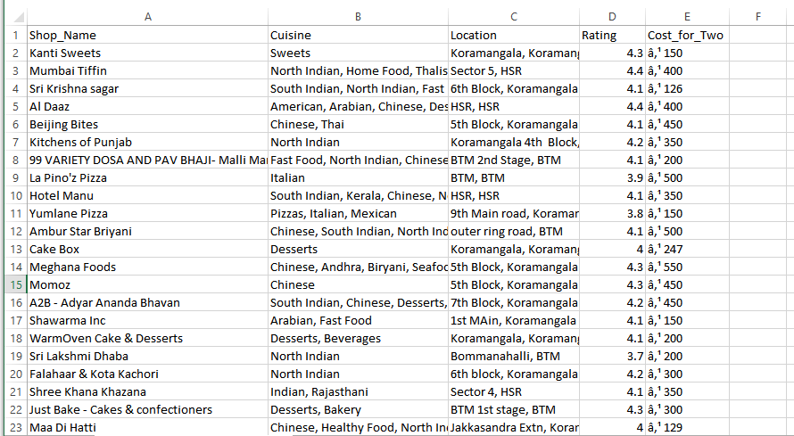

This is the Data set which was given by the company in CSV format.

* + 1. As we have seen earlier, in our Swiggy dataset, we have around 118 records with 5 different features. Features are distributed as 2 Continuous features and 3 Categorical features

## Tools used

## 

## 

## Data Insertion into Database

1. Database Creation and connection – Created a database in PostgreSQL, and opened the connection to the database.
2. Table creation in the database.
3. Insertion of files in the table

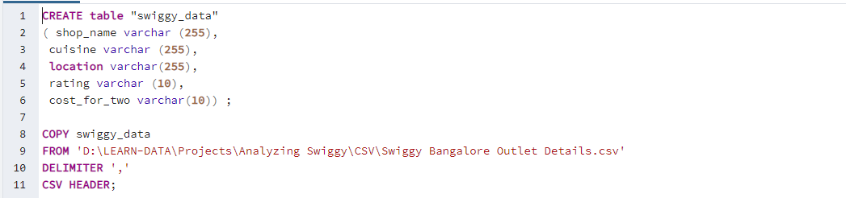

Read the data

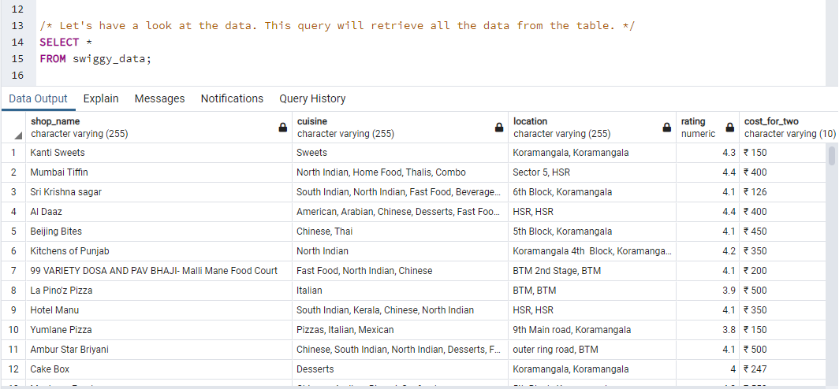

## 

## EDA

* "Exploratory Data Analysis" (EDA) is a "Data Exploration" step in the Data Analysis Process, where a number of techniques are used to better understand the dataset being used.
* Extracting Important "Variables".
* Identifying "Outliers", "Missing Values", or "Human Error".
* Understanding the Relationships between variables.
* Ultimately, maximizing our insights of a dataset and minimizing potential "Error" that may occur later in the process

1. The dataset contains 118 rows and 5 columns.
2. Had 1 null value in the ratings column.
3. Checked the locations column to find any anomalies.
4. Cost for two column was in currency format.
5. Min and max range for ratings is 3.6 and 4.8 respectively.
6. Min and max range for cost of two is 100 and 800.

## Data cleaning and Data manipulation using SQL.

## Review the data quality to ensure that it is ready for our analysis and visualization. Remember to take note of any assumptions or issues we need to go back to the client on.

## Set up the data source

**Step 1: Configuring Tableau**

Launch Tableau on your workstation and select Text from the connect column on the left. This will open a dialogue box where you need to provide the locate details for CSV

**Step 2: Configuring Data Source**

Select the data source name option and give a unique name to the database you are using. It’s considered a good practice to have a unique name as it makes it much easier for users to identify the database from which data is being fetched.

To select the desired schema, you can use the schema drop-down list from the column on the left. You can also perform a text-based search to find the desired option. Now similarly find and select the desired table and drag it onto the Canva.

## Export Data from Database

Data Export from Database - The data in a stored database is exported as a CSV file to be used for Data Pre-processing.

## Deployment.

Once you’ve completed your dashboard, follow these steps: **- Server, Tableau Public, Save to Tableau Public As**

You may be prompted to log into your Tableau Public profile first if this is your first-time publishing.

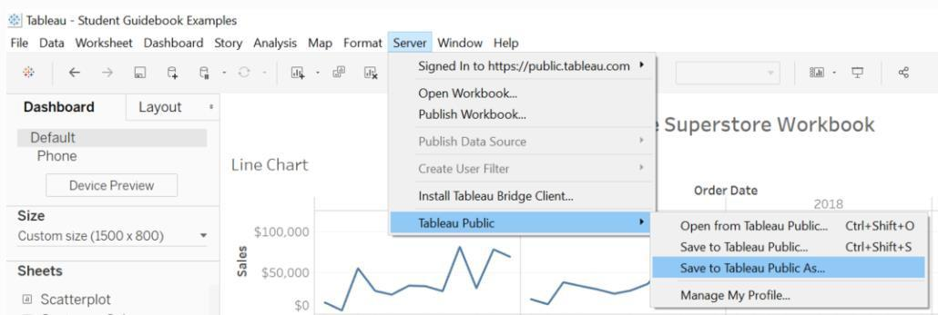

Next, fill out the title you want your viz to have and click “save”.

``````````````````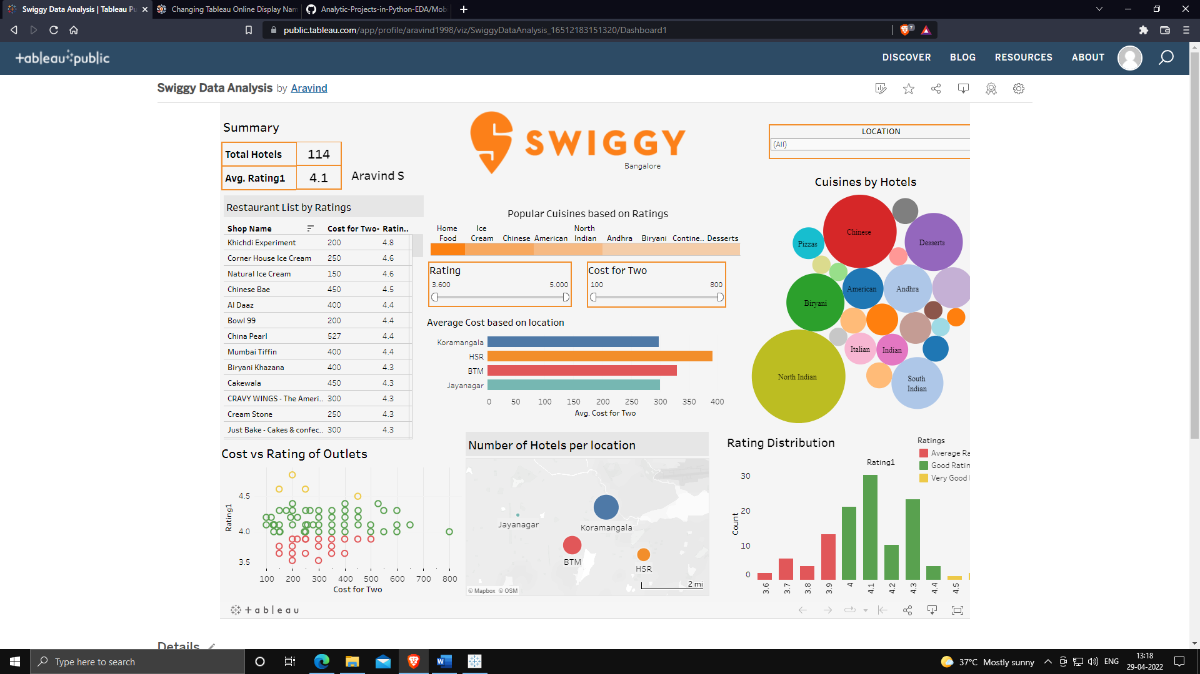

Link for TABLEAU PUBLIC [Swiggy data analysis](https://public.tableau.com/views/SwiggyDataAnalysis_16512183151320/Dashboard1?:language=en-US&:display_count=n&:origin=viz_share_link)

1. **Unit Test Cases**

|  |  |
| --- | --- |
| **TEST CASE DESCRIPTION** | **EXPECTED RESULTS** |
| Location Dropdown (Filter) | When clicked on the location box, a dropdown should occur which has all the locations available |
| Rating Slider (Filter) | When clicked on the slider, we can filter out the restaurants according to our rating needs. |
| Restaurants List by Ratings | Here a Table which shows the list of restaurants based on our location, rating and price filter which is automatically sorted by the highest rating in first. |
| Cost for two Slider (Filter) | When clicked on the slider we can filter the dashboard based on the cost for two. |
| Other Visualizations are the Relationship and analysis based on the data | The visual should show a bubble diagram, Bar chart, scatter plot and a map chart. |
| Summary | The summary shows the overview of the user filtered data, for example if user clicks HSR with cost of two as 600, the summary gives the available hotels and average ratings for the specified Area |

### LOW LEVEL DESIGN

**12**

**13 LOW LEVEL DESIGN**