**Project Development Phase**

**Model Performance Test**

| Date | 04 November 2023 |
| --- | --- |
| Team ID: | NM2023TMID02816 |
| Project Name | Food Tracking System |
| Maximum Marks | 4 marks |

**Model Performance Testing:**

Project team shall fill the following information when working for blockchain.

| **S. No.** | **Parameter** | **Values** | **Screenshot** |
| --- | --- | --- | --- |
| **1.** | Information gathering | Setup all the Prerequisite: |  |

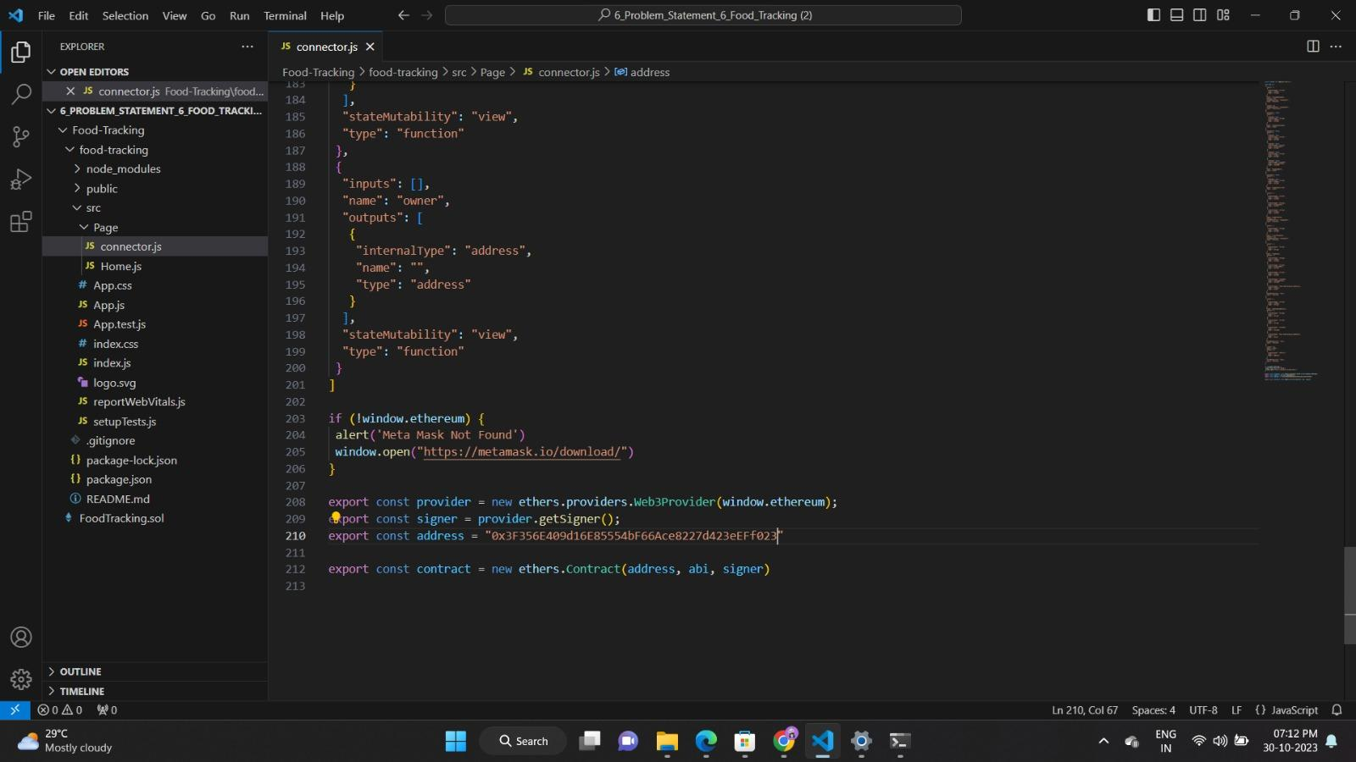

| **2.** | Extract the zip files | Open to VS Code |  |
| --- | --- | --- | --- |

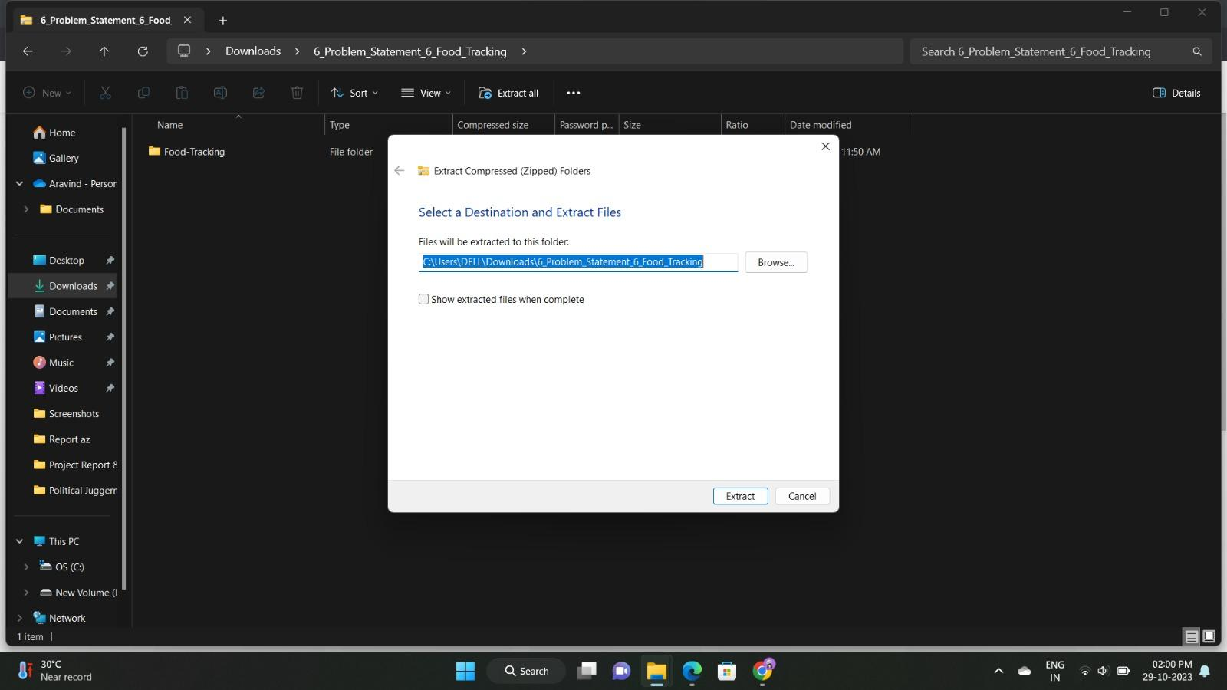

| **3.** | Remix IDE Platform Exploring | Deploy the smart contract code Deploy and run the transaction. By selecting the environment - inject the MetaMask. |  |
| --- | --- | --- | --- |

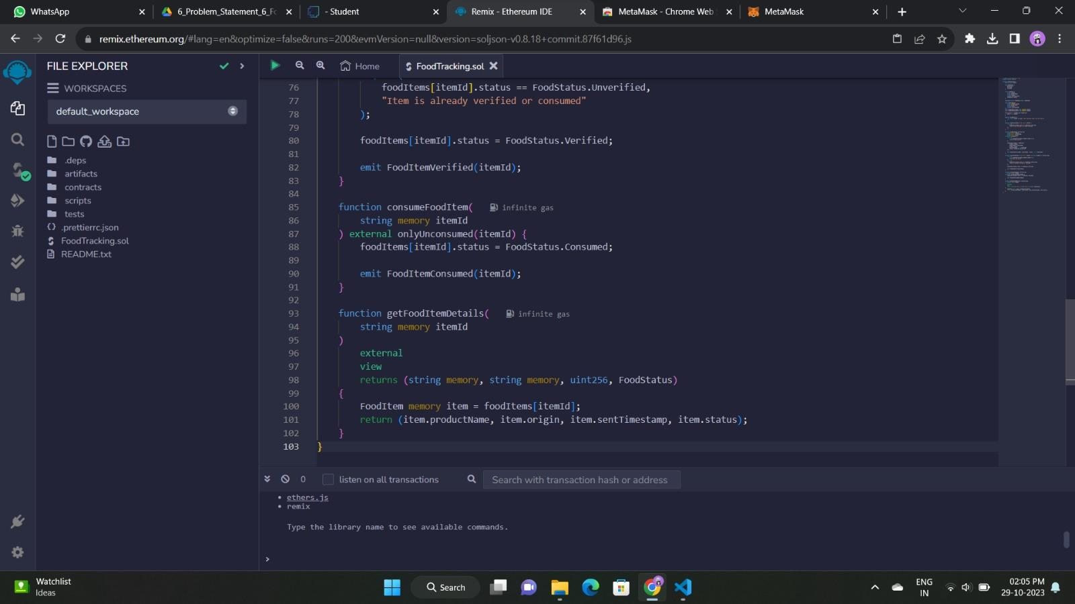

| **4.** | Open file explorer | Open the extracted file and click on the folder. Open src, and search for utiles. Open cmd enter commands 1.npm install 2.npm bootstrap 3. npm start |  |
| --- | --- | --- | --- |

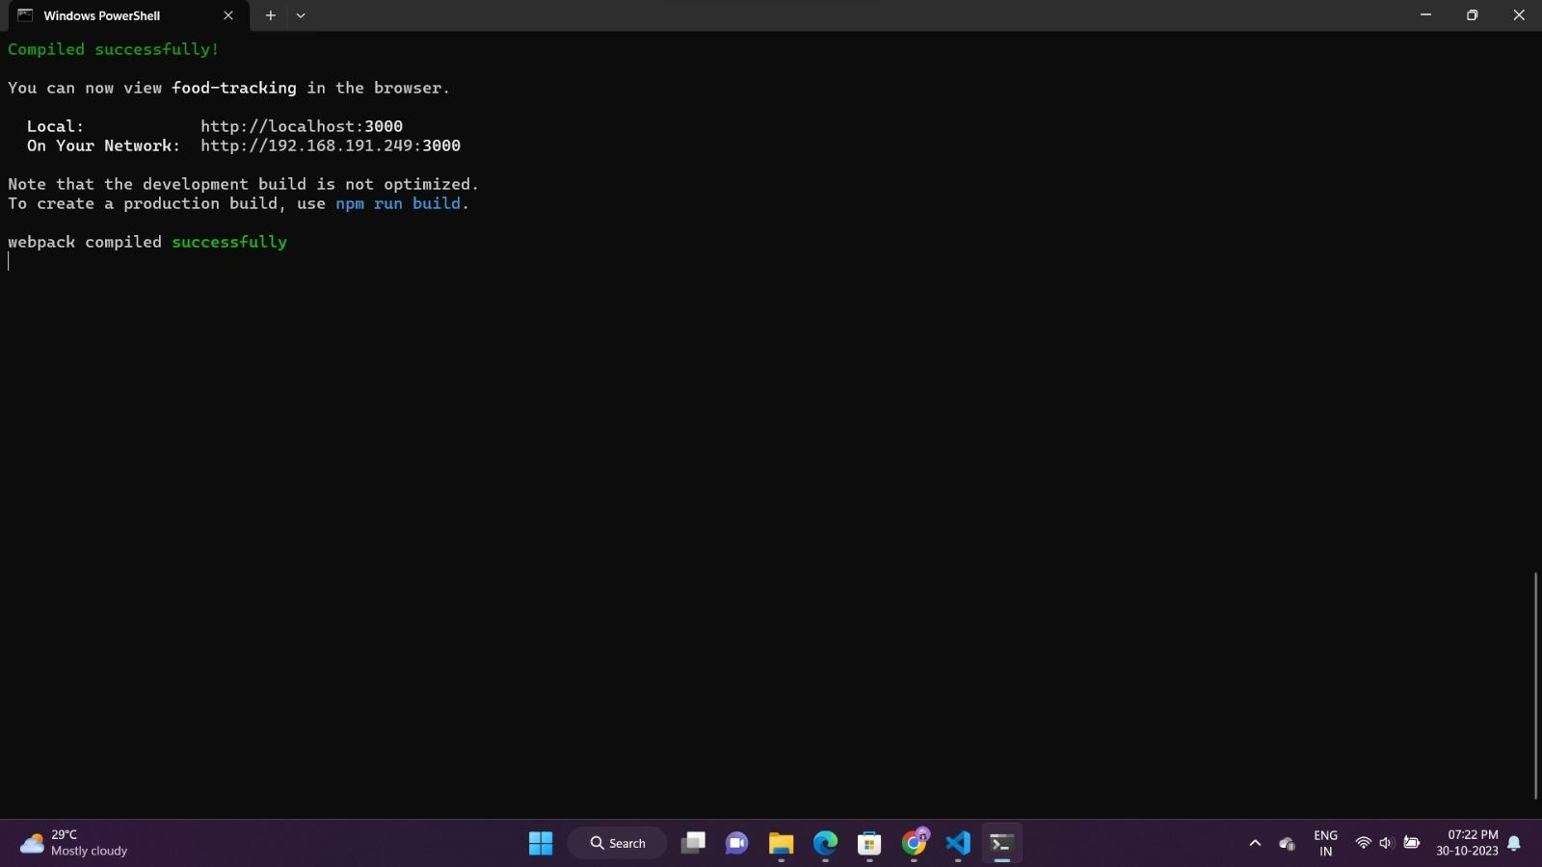

| **5.** | LOCALHOST IP ADDRESS | copy the address and open it to chrome so you can see the front end of your project |  |
| --- | --- | --- | --- |

