MENU BAR

Home page content

We are the Manufacturer

We are the Marketer

An Elite Product for the Elite People

Welcome to THE AVADHAR

The Avadhar Cotton Mills is the Textile Manufacturing Company. We are in the Production of varieties of Dhoti, Shirt, Towel and Lungi. In Future we are planned to launch Ladies Garments, Pants etc. The Complete Traditional Men’s wear are available at Best Quality and Best Price. Our Supply is around South India.

How We Do . . .

Choosing the Best

Cotton Processing

Cloth Production

Turned to Perfect

We Reach You

Our Products

The Avadhar Dhoties

The Avadhar Shirts

The Avadhar Towel

The Avadhar Lungies

Map, Contact Details

Remove all other details below this

Men’s

Dhoties

Shirts

Towel

Lungies

Dhoties ( page)

1. Gold Jarigai 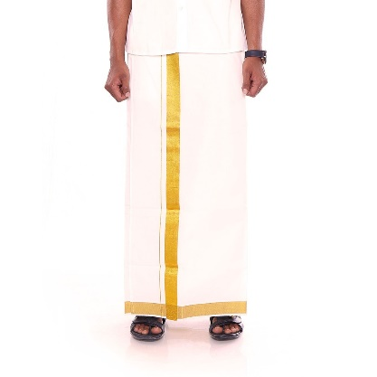   
   (Available in Different Borders Size)

2. Silver Jarigai

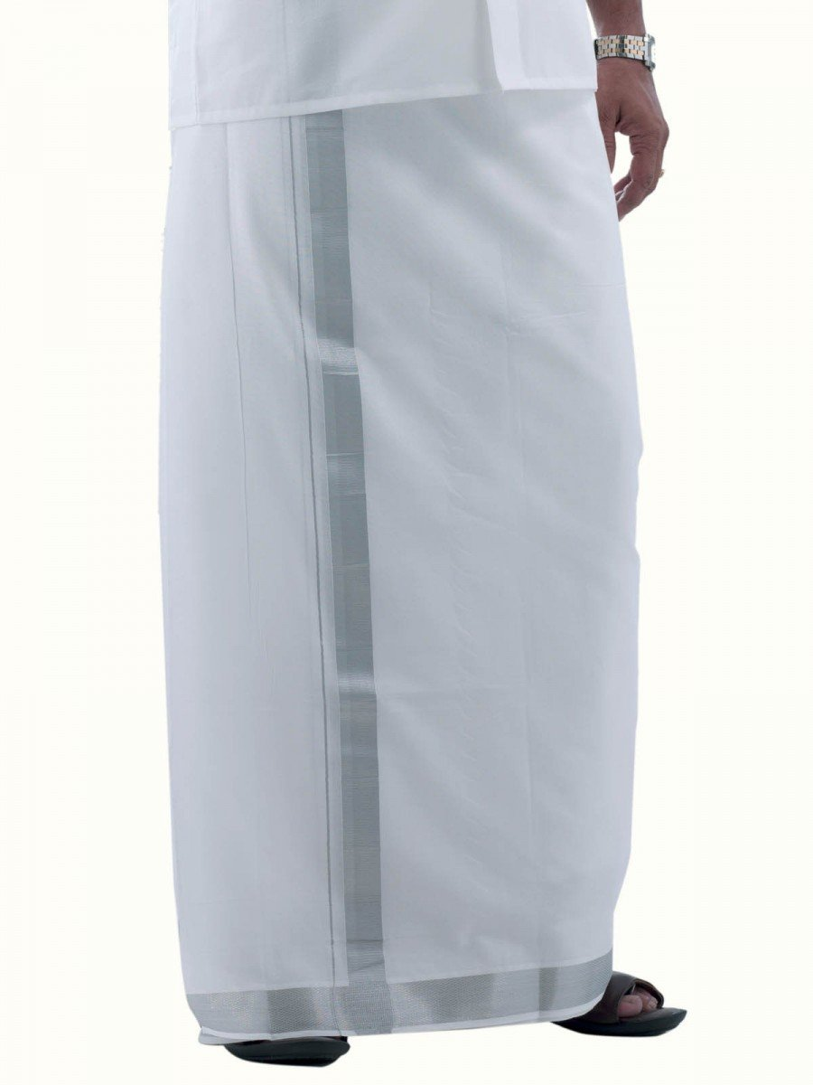

(Available in Different Borders Size)

3. Small Border

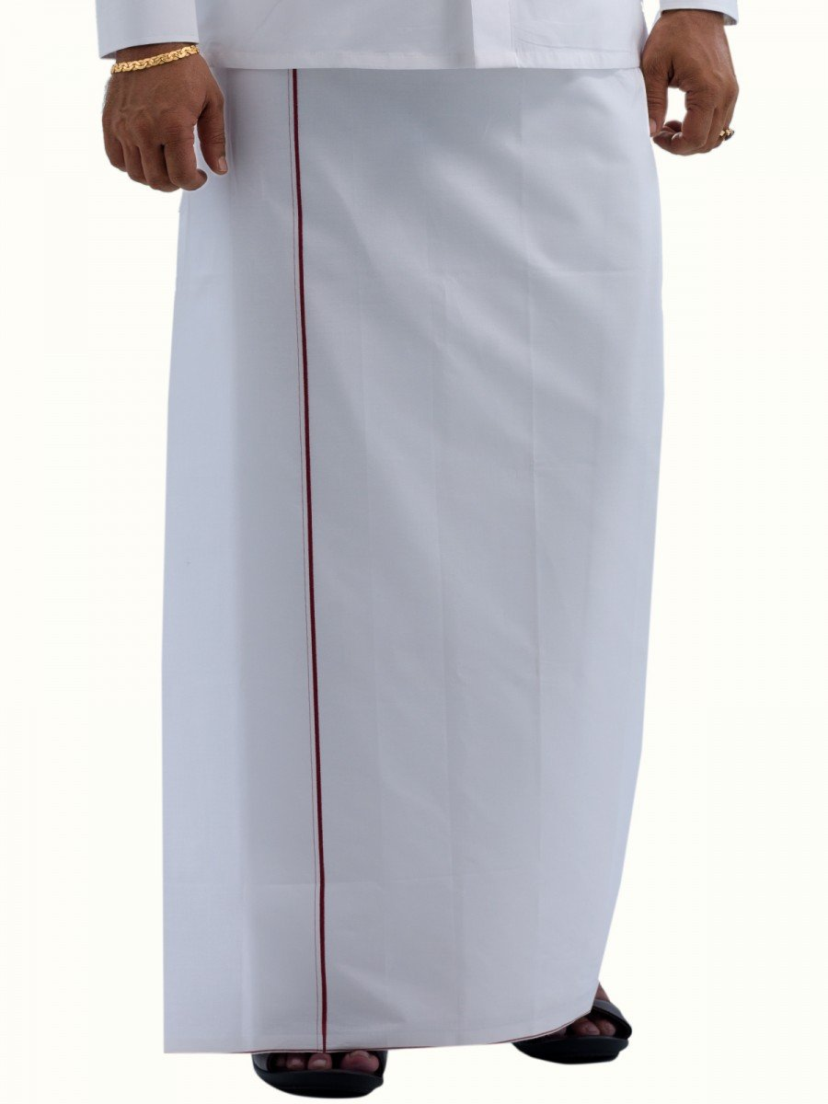

(Available in Different Borders Colors)

4. Big Border

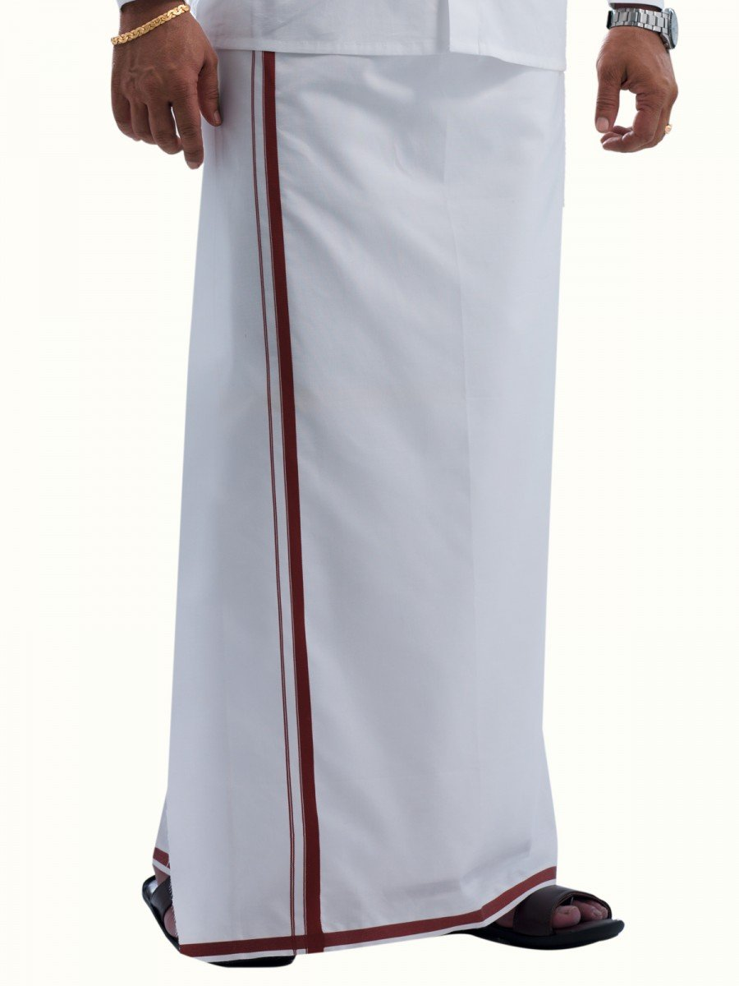

(Available in Different Borders Colors)

5. Fancy Border

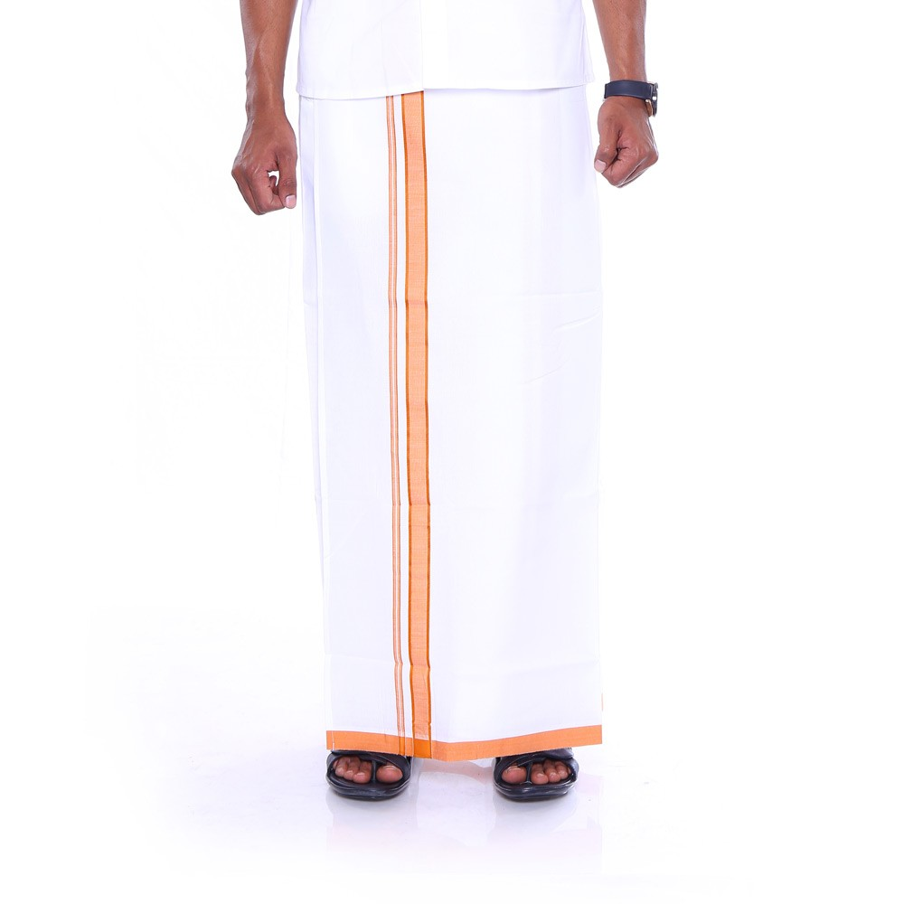

( Available in Different Borders design and Border Colors)

6. Political Border

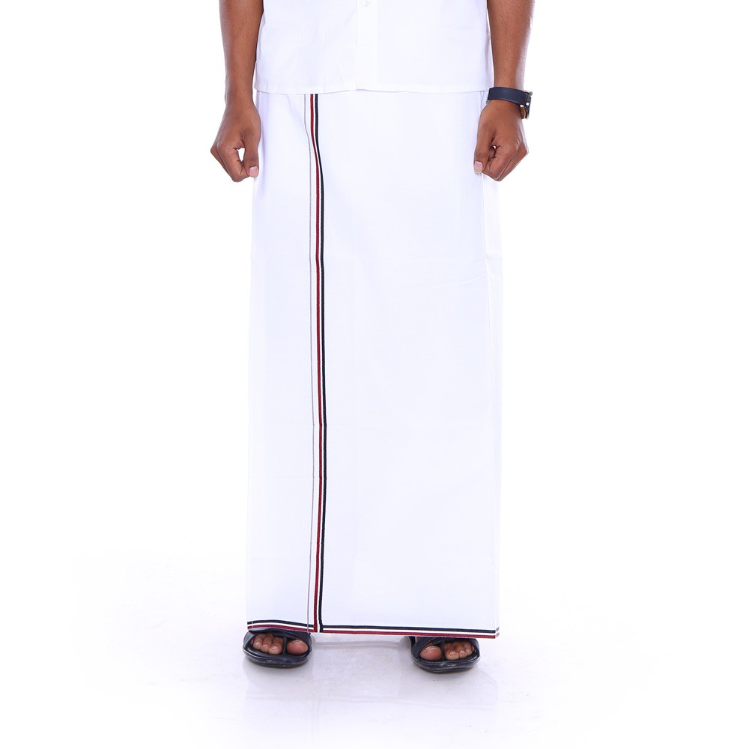

( Available in all Political Parties Border)

7. Khavi Dhoties

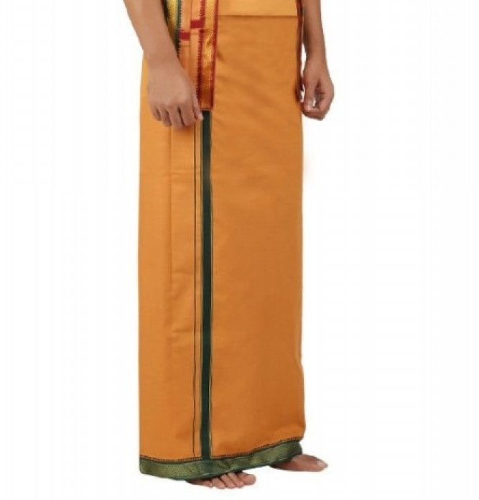

( Available in Different Borders And Colors Like Khavi, Yellow, Blue, Grey, Black, Green etc)

Shirt Page

**White Shirts**

We provide a varieties of White Shirts in Half and Full Sleeve at Perfect Formal Fit with Good looking and Stylish.

**Linen Shirts**

A Premium Linen Shirt are available at different color at a finest Quality

