

**Personal Travel Assistant (PTA)**

# **Abstract**

The Personal Travel Assistant (PTA) is a backend-driven solution designed to streamline travel planning by integrating multiple services into a unified platform. Built using FastAPI for API development and MongoDB Atlas for secure data storage, PTA consolidates weather forecasts, bus listings, and hotel options to simplify the travel experience. By leveraging third-party APIs such as Open-Meteo for real-time weather updates, MakCorps for hotel data, and a mock bus service simulating APSRTC, TSRTC, and private operators, PTA provides users with a seamless workflow—from searching destinations to booking buses and hotels in one step. The system ensures persistent booking management through MongoDB while maintaining scalability and deployment readiness via Docker and cloud platforms like AWS or Azure. With robust endpoints for search, booking, and retrieval, PTA addresses the challenge of fragmented travel planning by offering an efficient, secure, and extendable backend framework suitable for real-time applications.



**Personal Travel Assistant (PTA)**

# **1. Introduction**

The Personal Travel Assistant (PTA) is a backend solution designed to simplify travel planning. It is built with FastAPI (for REST APIs) and MongoDB (for storage).

PTA integrates:

* 🌦 Weather API → Provides live weather forecasts with travel safety suggestions.
* 🚌 Bus Listings → APSRTC, TSRTC, and Private travel buses.
* 🏨 Hotels API → Hotels with ratings & pricing.
* 💾 MongoDB Atlas → Stores user bookings securely.

# **2. Use Case**

PTA addresses the challenge of fragmented travel planning by offering a unified backend:

* Plan trips with real-time weather and safety suggestions.
* Search and choose from APSRTC, TSRTC, and private buses.
* Explore hotels based on ratings and prices.
* Book both bus & hotel in one step.
* Store and retrieve bookings seamlessly from MongoDB Atlas.

# **3. System Architecture**

Components:

* FastAPI backend – API layer for search, booking, and retrieval.
* MongoDB Atlas – Cloud database for persistent bookings.
* Open-Meteo API – Provides weather forecasts.
* MakCorps API – Hotel listings.
* Mock Bus Service – Simulated APSRTC, TSRTC, and Private travels.

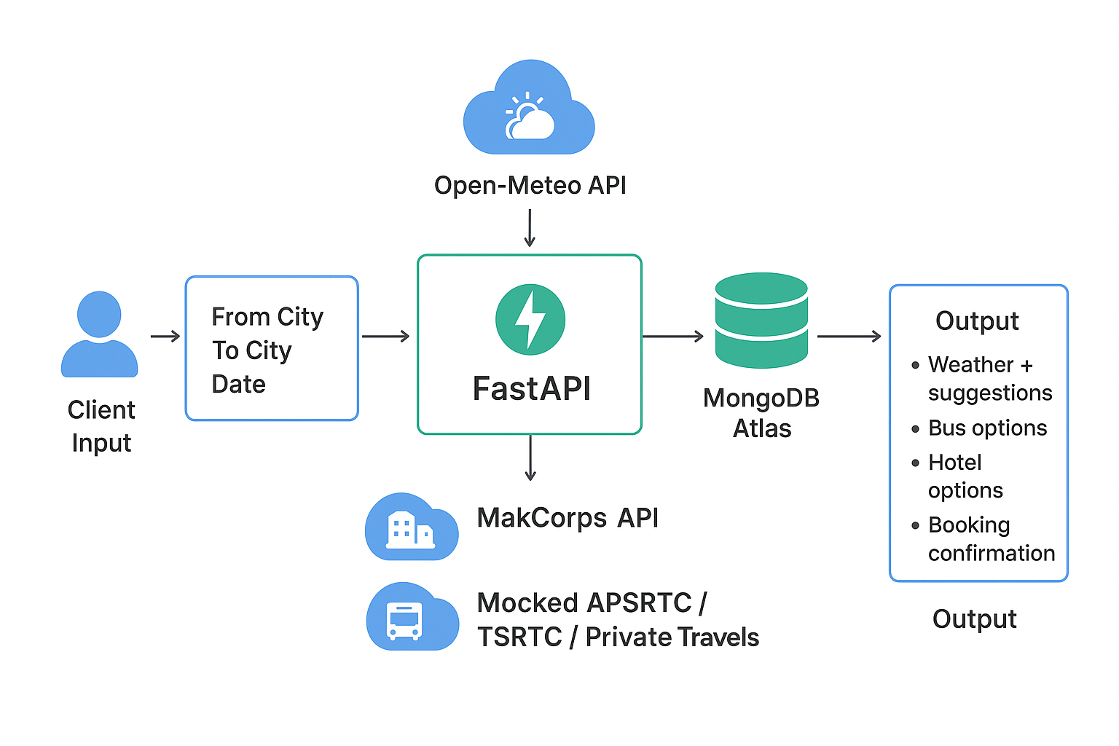

# **4. Workflow**

1. Search → Input from_city, to_city, depart_date → Output: Weather + Buses + Hotels
2. Book → Choose bus + hotel, store in DB
3. Get Bookings → Retrieve all saved bookings

# **5. API Endpoints**

|  |  |  |
| --- | --- | --- |
| Method | Endpoint | Description |
| POST | /search | Search destination (weather, buses, hotels). |
| POST | /book | Book bus + hotel (saves to DB). |
| GET | /bookings | Retrieve all saved bookings. |
| POST | /delete | Delete bookings using booking ID |

# **6. MongoDB Schema**

{  
 "_id": ObjectId,  
 "user_name": "string",  
 "email": "string",  
 "from_city": "string",  
 "to_city": "string",  
 "depart_date": "string",  
 "bus": { "id": 1, "operator": "APSRTC" },  
 "hotel": { "id": 2, "name": "Grand Hotel" },  
 "created_at": "timestamp"  
}

# **7. Endpoints Screenshots**

* **search travel**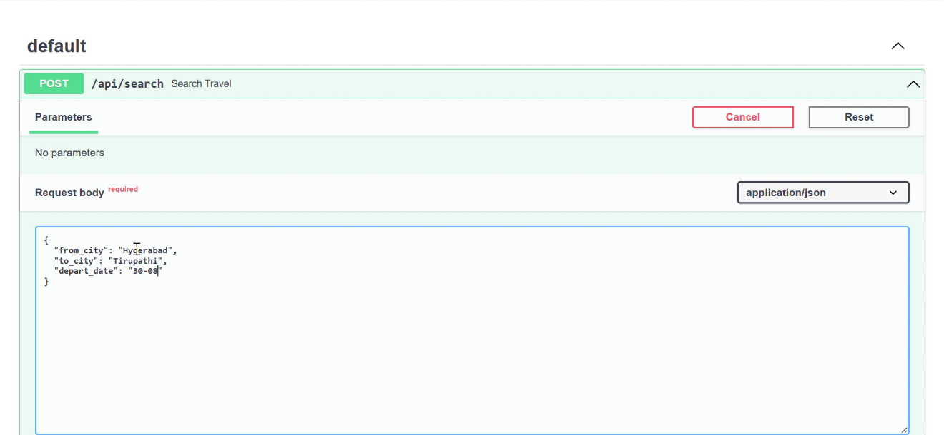
* **Booking process**

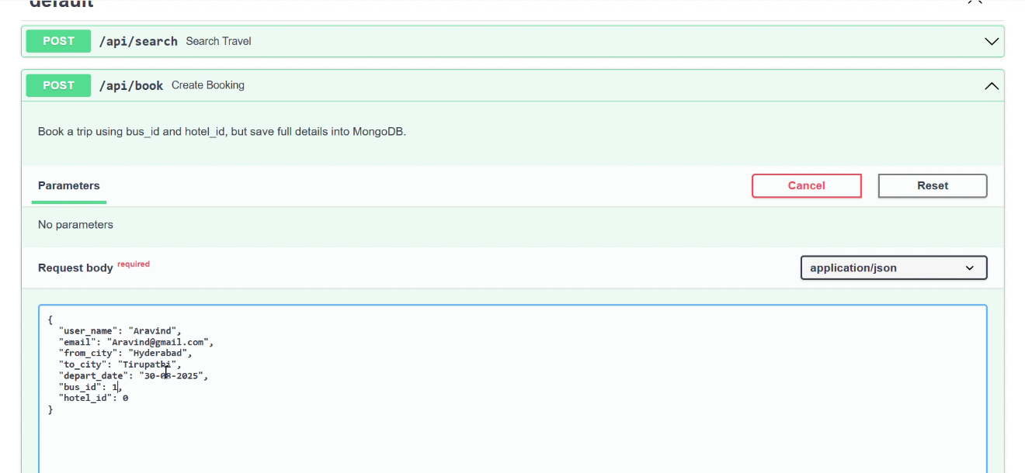

* **Final bookings retrieval**

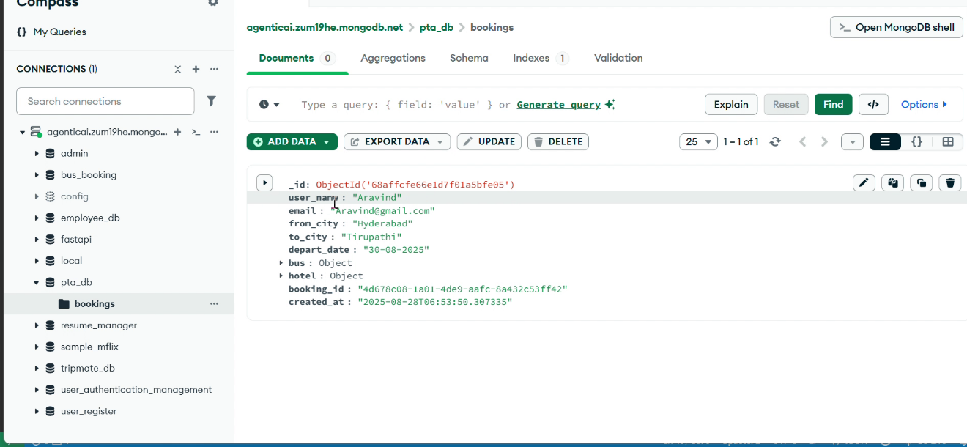

# **8. Sample JSON Response**

{  
 "count": 1,  
 "bookings": [  
 {  
 "user_name": "Aravind",  
 "email": "p.aravind123@gmail.com",  
 "from_city": "Hyderabad",  
 "to_city": "Tirupathi",  
 "depart_date": "2025-08-30",  
 "bus": {  
 "operator": "APSRTC Express",  
 "departure_time": "2025-08-30 06:00",  
 "price": 500  
 },  
 "hotel": {  
 "name": "Vijayawada Grand Hotel",  
 "price_per_night": 2500,  
 "rating": 4.2  
 }  
 }  
 ]  
}

# **9. Deployment Notes**

- 🚀 Deploy on AWS / Azure (EC2, App Service, or containerized).  
- 🐳 Use Docker for portability and consistency.  
- ☁️ Database: MongoDB Atlas (cloud-managed, scalable).  
- 🔐 Secure APIs with authentication in production.

# **10. Conclusion**

✅ PTA is scalable, production-ready, and client-focused.  
✅ It integrates weather, buses, and hotels into one backend system.  
✅ Suitable for real-time travel planning and extendable for production use.  
  
📌 **Deliverables (included in repo):**  
- Full FastAPI + MongoDB source code (Personal_Travel_Assitant(PTA).  
- API documentation & Swagger UI.  
- Sample outputs (response_1756364051907.json).  
- Demo video (Screen Recording 2025-08-28.mp4).  
- Professional PPT (for client presentation).