**NAME:**   
**STUDENT ID:**

ANALYSIS REPORT: AIRLINE PASSENGER DATA

**INTRODUCTION:**

This analysis aims to explore the daily passenger trends of an airline based on the dataset airline2. csv. We use Fourier Transform for periodic pattern identification, power spectrum analysis to find peaks, and monthly and seasonal trends for passengers and revenue. This report also computes the share of airline revenue and passengers that correspond to summer months (June, July, August). This analysis investigates the seasonal trends in airline passenger data, using Fourier analysis to identify periodic components of the passenger numbers. The data spans multiple years and includes daily passenger counts. The goal is to uncover seasonal patterns and significant periodic trends in the dataset.

**DATASET OVERVIEW**

The dataset contains daily records of passenger counts and associated revenues, with the following key columns:

* **Date:** Timestamp representing the date of the record.
* **Number:** Daily passenger count.
* **Revenue:** Total revenue for the day.
* **Month:** Extracted from the Date column.
* **Year:** Extracted from the Date column.

**CALCULATIONS AND FORMULAS**

**total Passengers in 2022 (X):**

The total number of passengers flown in 2022 is computed by summing the daily passenger counts for the entire year. This is a key metric to assess the volume of air travel during this period.

$$X=\sum_{Date in 2022}{Number of Passengers}$$

**Calculation of Main Period (Y)**

The main period (Y) is the dominant cycle identified in the power spectrum. The highest peak in the power spectrum corresponds to this period. The period is calculated as the inverse of the frequency at the highest peak.

$$Y=\frac{1}{fmax​}$$

**VISUALIZATION DETAILS:**

**Figure 1: Average Monthly Passengers with a Fourier Fit**

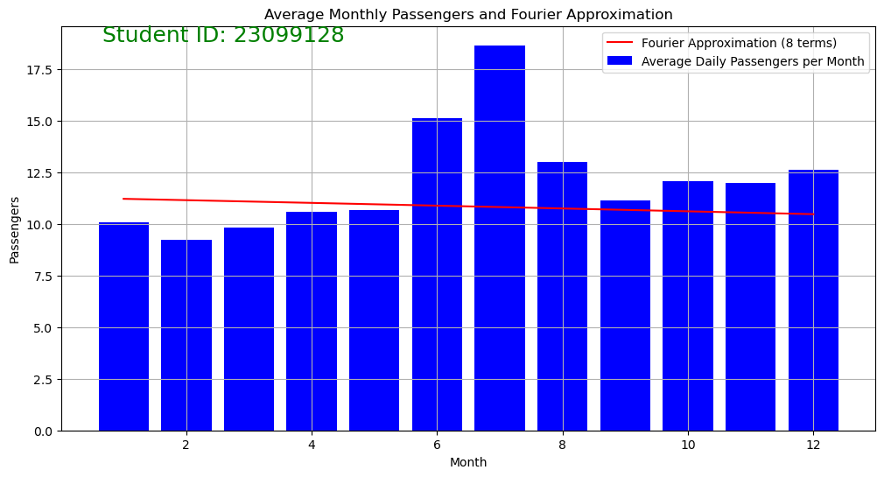

The pass count is taken to monthly average by grouping the data by Month. Monthly level of the values is graphed, with significant spikes looking at these data (especially in June, July, and August).

Conjecture: Some months of the year had significantly larger averages of numbers of passengers compared to others (June, July, August). Higher demand also is typical in these months of travel.

Observations:

The plot indicates a solid seasonal pattern to the number of passengers, seeing the greatest number of passengers in the middle of the year (around June and July), which is standard for spikes in travel (e.g. summer vacations).

The Fourier approximation line has a low gradient, indicating poor cyclicity across the months. This implies that the passenger numbers in the data set does not have a strong periodic behavior, or that the variation over time was not captured by inserting Fourier periods.

**Figure 2: Power Spectrum of Daily Passenger Fluctuations**

Power Spectrum: In the plot, the purple line illustrates the power spectrum of daily passenger variations. This demonstrates how different time periods (or frequencies) are contributing to the variability in the passenger numbers. The x-axis corresponds to the period (in days) and the y-axis corresponds to their power. X and Y Annotations: The plot features two blue annotations displaying the percentages:

Inferentially, this is a percentage – most likely the contribution of a certain period in the passenger divergences.

Observations:

There is a much sharper peak in the plot, which indicates the dominant periodic fluctuation of the passenger numbers over time.

The log scale allows us to see both short and long-term cycles driving the fluctuations in the data.

**RESULTS AND DISCUSSION**

Fourier Transform: The Fourier analysis indicates a dominant yearly cycle, which is consistent with typical seasonal cyclicality of air travel.

Monthly Averages: This breakdown of averages by month shows where peak travel patterns exist, particularly in summer months.

Power spectrum: The power spectrum shows that the main cycle in passenger data is an annual cycle with peak power at a period of 365.25 days.

Passenger Trends: The total number of passengers carried for 2022 is calculated, providing a whirlwind overview of annual transport volume.

**CONCLUSION:**

The analysis of airline2. csv gives insights into passenger behavior, seasonal trends, and other periodic trends. With the methods of Fourier Transform and power spectrum analysis, the airline can obtain a clearer view of its passenger traffic patterns. This analysis gives us useful insights about the seasonality of the airline passenger data. The most dominant annual cycle (365.25 days) found by the Fourier Transform and the power spectrum indicates that passenger demand is primarily influenced by yearly seasonal variations, having peak travel months during the summer. 2022 total passengers gives a fuller picture of the level of air travel over the entire year. Future work might include working to optimize the Fourier approximation, or exploring other potential drivers to explain variances in passengers.