**DATA ANALYTICS PYTHON PROJECT**

1) Import libraries such as Pandas, matplotlib, NumPy, and seaborn and load the insurance dataset.

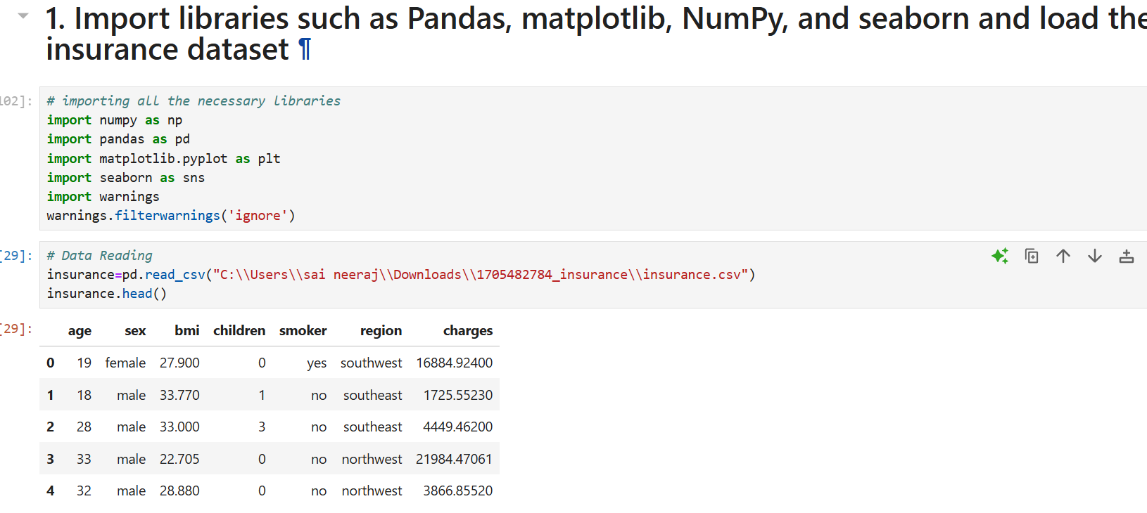

2) Check the shape of the data along with the data types of the column.

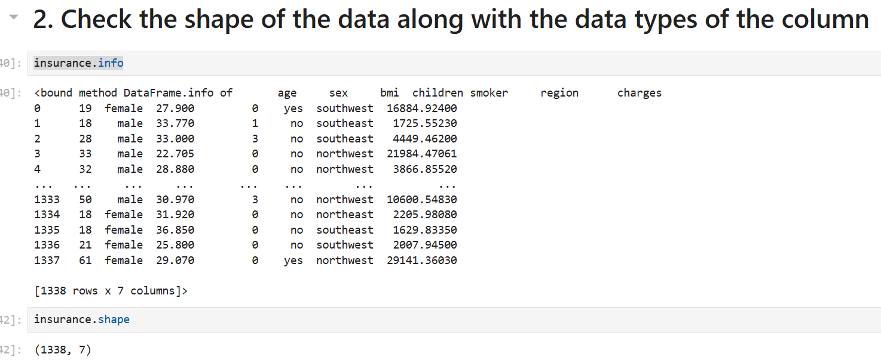

3) Check missing values in the dataset and find the appropriate measures to fill in the missing values.

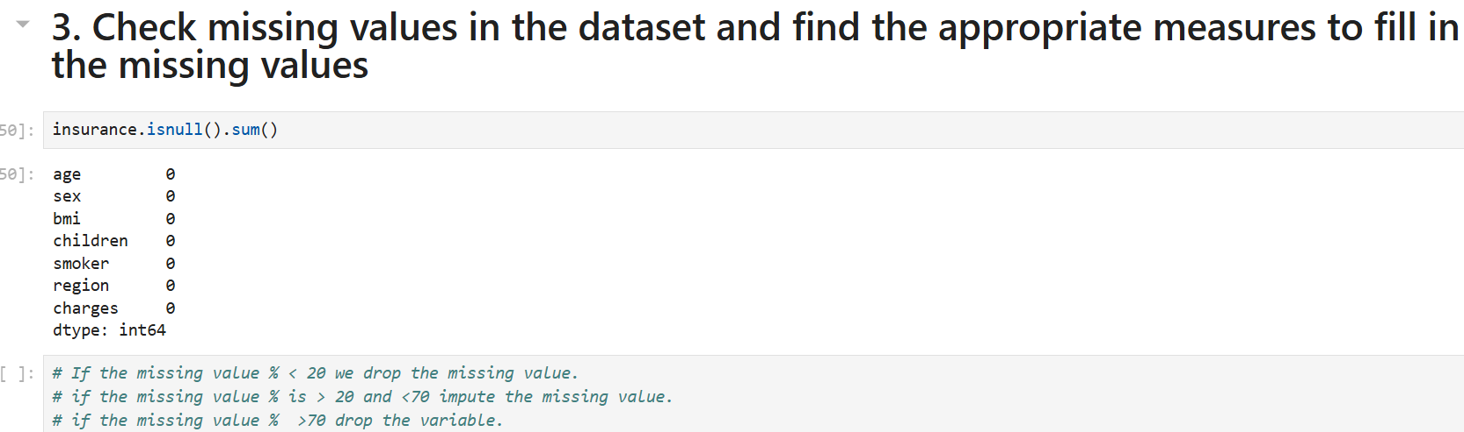

4) Explore the relationship between the feature and target column using a count plot of categorical columns and a scatter plot of numerical columns.

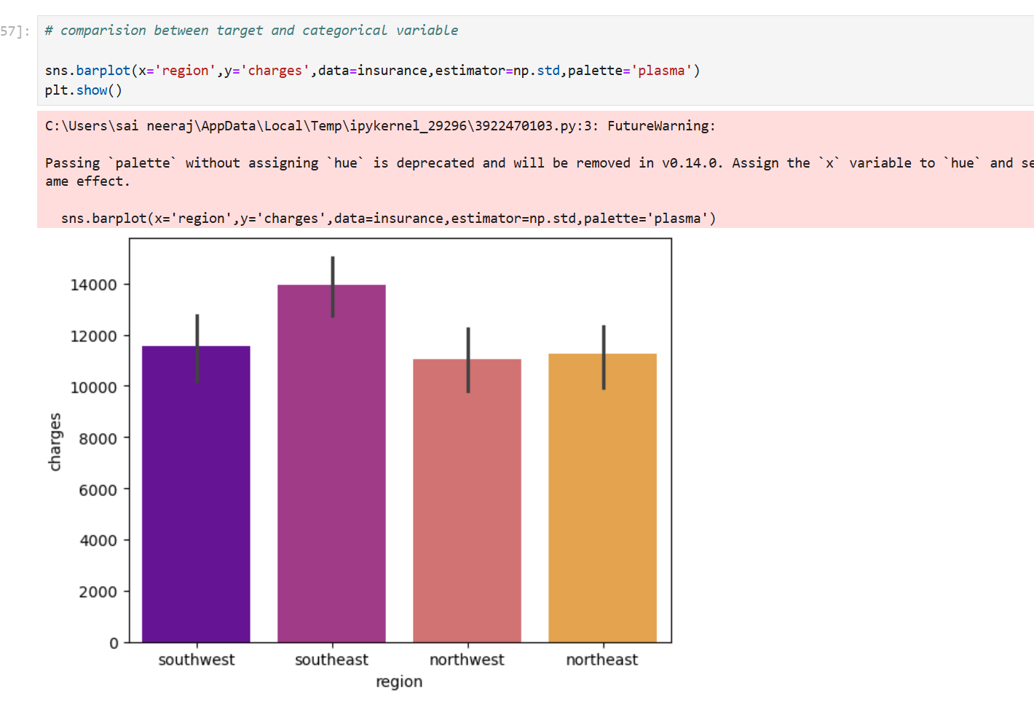

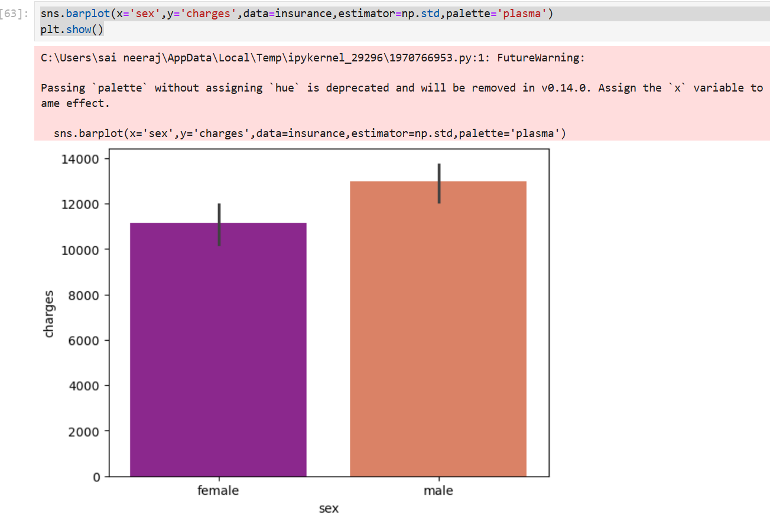

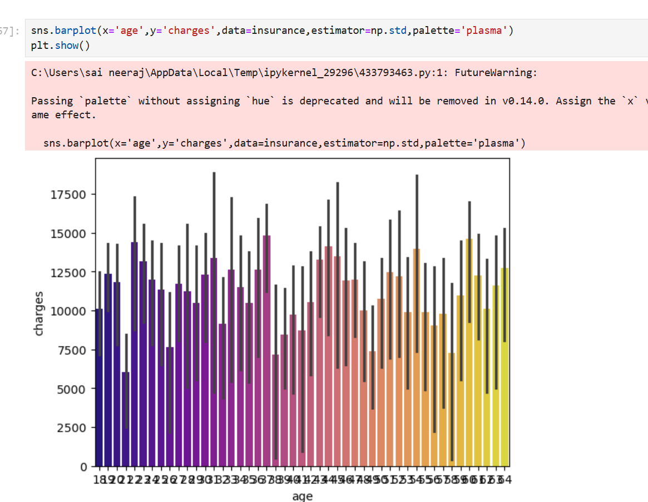

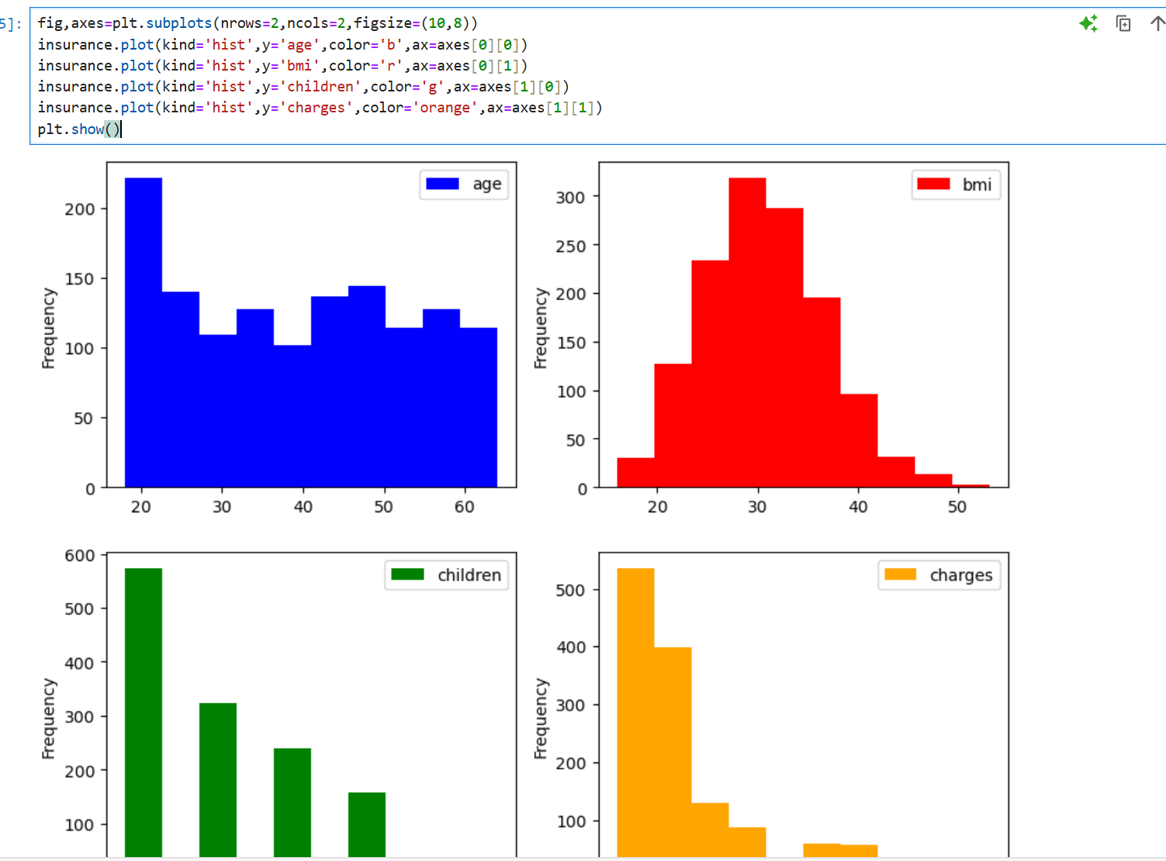

5) Perform data visualization using plots of feature vs feature.

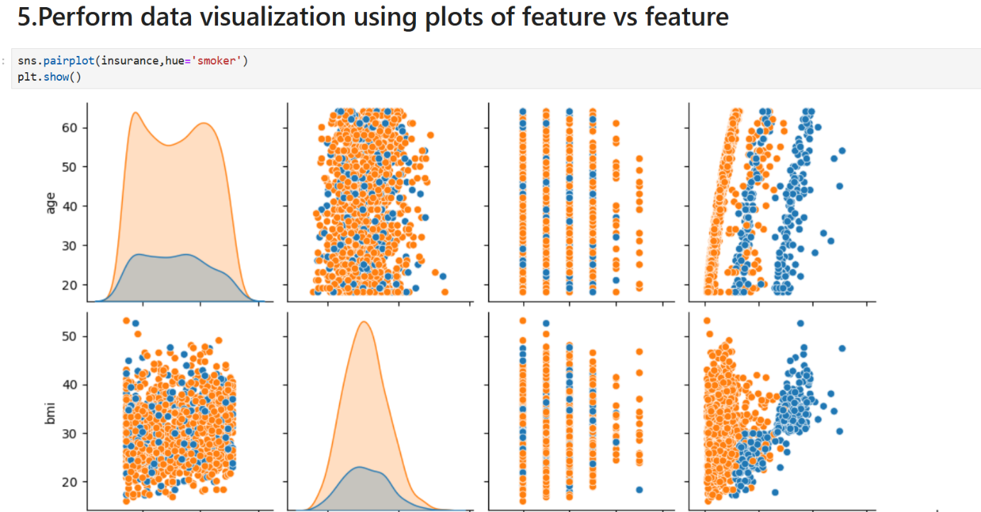

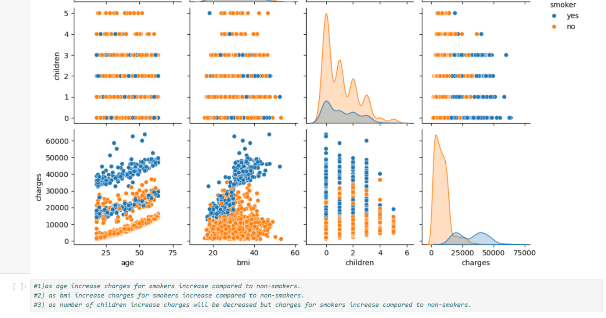

6) Check if the number of premium charges for smokers or non-smokers is increasing as they are aging.

