INVEST IQ - AI POWERED MARKET SIMULATOR
A Real-time Research Project report
Submitted in partial fulfilment of requirements for the Award of the Degree of

BACHELOR OF TECHNOLOGY IN
COMPUTER SCIENCE ENGINEERING(AI&ML)

By
S. JOEL VISHAL KUMAR (24TQ1A66I0)
S. SRI VINAYA REDDY (24TQ1A66I1)
SHEERJANA BK (24TQ1A66F7)
R. ARAVIND (25TQ5A6613)

Under the Esteemed Guidance of
VNS MANASWINI

(Assistant Professor) Dept. Of CSE(AI&ML)


DEPARTMENT OF COMPUTER SCIENCE AND ENGINEERING(AI&ML)

SIDDHARTHA INSTITUTE OF TECHNOLOGY & SCIENCES (UGC-ATUTONOMOUS)

(Approved by AICTE, New Delhi & Affiliated to JNTUH, Hyderabad) Accredited by NBA and NAAC with ‘A+’ Grade
Narapally, Korremula Road, Ghatkesar, Medchal-Malkajgiri (Dist)-500 088

2026- 2027

SIDDHARTHA INSTITUTE OF TECHNOLOGY & SCIENCES (UGC-ATUTONOMOUS)
(Approved by AICTE, New Delhi & Affiliated to JNTUH, Hyderabad) Accredited by NBA and NAAC with ‘A+’ Grade
Narapally, Korremula Road, Ghatkesar, Medchal-Malkajgiri (Dist)-500 088

DEPARTMENT OF COMPUTER SCIENCE AND ENGINEERING(AI&ML)

CERTIFICATE

This is to certify that the project work entitled “GENAI FOR PREDICTIVE CODE REVIEW AND BUG DETECTION” is a bonafide record of project work done jointly by S. JOEL VISHAL KUMAR (24TQ1A66I0) , S. SRI VINAYA REDDY (24TQ1A66I1), SHEERJANA BK(24TQ1A66F7), RATNAM SHASHI VARDHAN
(24TQ1A66F1) under my guidance and supervision and is submitted in partial fulfilment of the requirements for the award of the Degree of Bachelor of Technology in Computer Science & Engineering(AI&ML) by Jawaharlal Nehru Technological University Hyderabad (JNTUH), Hyderabad during the academic year 2025-2026.

PROJECT GUIDE  VNS Manaswini (Assistant Professor) Dept. of CSE(AI&ML) | PROJECT CO-ORDINATOR  Mrs. B.Rajasri (Assistant Professor) Dept. of CSE(AI&ML) | HEAD OF THE DEPARTMENT  VNS.Manaswini (Assistant Professor) Dept. of CSE(AI&ML)

INTERNAL EXAMINER

ACKNOWLEDGMENT

We would like to express our sincere gratitude to our project guide, Mrs.B.Rajasri, Assistant Professor, for his invaluable guidance, constructive comments, insightful suggestions, and constant support throughout the course of this project.
We express our heartfelt thanks to VNS Manaswini, Head of the Department, Computer Science and Engineering (AI&ML), for his valuable support and encouragement in completing this project on time.
We are deeply grateful to our Vice-Principal, Dr. G. Praveen, who has shown utmost patience and has been a constant source of motivation through his thoughtful suggestions, vigilant guidance, and valuable directions.
We convey our profound sense of gratitude to our Principal Dr. M. Janardhan, for providing an excellent academic environment and extending his support at every stage to help us accomplish our task successfully.
We would like to express our deepest gratitude and sincere thanks to Smt. V. Jyothi, Director & Chairperson, Siddhartha Institute of Technology & Sciences, Narapally, Hyderabad (UGC Autonomous) for her constant encouragement and support in providing all the necessary facilities to carry out this project work.
Finally, we extend our sincere thanks to all the faculty members, supporting staff of the CSE(AI&ML) Department, and our friends for their kind cooperation, valuable help, and encouragement throughout the completion of this project.
.

Project Associates
S. JOEL VISHAL KUMAR (24TQ1A66I0)
S. SRI VINAYA REDDY (24TQ1A66I1)
SHEERJANA BK (24TQ1A66F7)
R. ARAVIND (25TQ5A6613)



SIDDHARTHA INSTITUTE OF TECHNOLOGY AND SCIENCES (UGC – AUTONOMOUS)

Approved by AICTE, Affiliated to JNTU Hyderabad, Accredited by NAAC(A+))
Korremula Road, Narapally(V), Ghatkesar Mandal, Medchal-Dist:-500088

Vision of the Department:To produce highly skilled and intellectually competent technologists with needs of the global computing industry..

Mission of the Department:

MISSION | STATEMENT
DM1 | Provide a robust theoretical and practical foundation in Al applications.
DM2 | Equip students to become engaged global citizens and lifelong learners.
DM3 | Foster collective development through industry-aligned Al activities.

Programme Educational Objectives (PEO)
- PEO1: Become Effective Professionals: Tackle real-world problems and excel in teamwork, communication, and critical thinking.
- PEO2: Build Career Flexibility: Gain skills for immediate employment and continual learning in advanced tech fields.
- PEO3: Adapt to a Dynamic World: Quickly learn and apply new technologies in evolving environments

ABSTRACT

The increasing complexity and volatility of financial markets have created a significant challenge for beginners and young investors who seek to understand stock trading and investment strategies. Traditional learning approaches often separate theoretical financial education from practical trading experience, while real-world trading exposes beginners to financial risk and behavioral mistakes such as overtrading, revenge trading, excessive position sizing, and sector concentration.
The proposed system combines real-time and historical market data with a virtual trading environment, technical analysis, and a multi-agent Artificial Intelligence layer. Users receive virtual capital to practice buying and selling NSE and global equities while the system calculates realistic transaction costs, including brokerage, Securities Transaction Tax (STT), and short-term capital gains tax. The technical analysis engine evaluates indicators such as RSI, MACD, Bollinger Bands, and volume ratios, while AI-generated explanations interpret these signals in plain English along with historical win-rate information.
A key feature of Invest IQ is its five-agent AI architecture, consisting of the Watchdog Agent for behavioral risk monitoring, Curator Agent for daily watchlist suggestions, Research Agent for conversational stock analysis, Lesson-Sequencing Agent for adaptive learning, and Debrief Agent for post-trade reflection. The system proactively identifies behavioral patterns, provides educational feedback, and adapts learning content according to the user's trading activity. Built using Next.js, React, TypeScript, Python, Flask, Supabase, yfinance, and Groq-hosted LLMs, the platform incorporates resilient market-data fallbacks, authentication, automated testing, and cloud deployment across Vercel, Render, and Supabase. By combining paper trading, technical analysis, generative AI, and behavioral coaching, Invest IQ provides a transparent, low-risk environment that helps users develop informed and disciplined investment habits without providing real-money investment advice.
Keywords: Artificial Intelligence, Generative AI, Investment Simulation, Paper Trading, Financial Technology, Multi-Agent Systems, Technical Analysis, Behavioral Finance, LLMs, Stock Market, Investment Education.

VI
TABLE OF CONTENTS

DESCRIPTION PAGE NUMBER
CHAPTER 1: INTRODUCTION 8
  - PROBLEM STATEMENT 8
  - OBJECTIVE 8
  - SCOPE OF THE PROJECT 9
CHAPTER 2: LITERATURE SURVEY 10
  - TRADITIONAL STATIC ANALYSIS APPROACH 10
  - MACHINE LEARNING APPROACHES TO BUG DETECTION 10
  - LARGE LANGUAGE MODELS FOR CODE 10
  - AUTOMATED CODE REVIEW SYSTEMS 11
  - RESEARCH GAP AND MOTIVATION 11
CHAPTER 3: EXISITING SYSTEM 12
  - EXISTING SYSTEM ANALYSIS 12
  - FEASIBILITY ANALYSIS 12
CHAPTER 4: PROPOSED SYSTEM 15
  - SYSTEM DESIGN PHILOSOPHY 15
  - SYSTEM ARCHITECTURE 15
  - KEY COMPONENTS 15
CHAPTER 5: HARDWARE AND SOFTWARE REQUIREMENTS 17
  - HARDWARE REQUIREMENTS 17
  - SOFTWARE REQUIREMENTS 17
CHAPTER 6: SYSTEM DESIGN 20
  - OVERALL SYSTEM ARCHITECTURE 20
  - DATASET DESCRIPTION 20
  - DATA PREPROCESSING 20
  - UML DIAGRAMS 20
CHAPTER 7: IMPLEMENTATION 22
  - DEVELOPMENT ENVIRONMENT 22
  - MODEL ARCHITECTURE - LLAMA 3.3 70B 22
  - ALGORITHMS USED 22
  - MODEL TRAINING PROCEDURE 23
  - TESTING AND VALIDATION 23
  - DEPLOYMENT 23
  - KEY IMPLEMENTATION DETAILS 30
CHAPTER 8: RESULTS 26
  - SYSTEM INTERFACE 27
  - PERFORMANCE EVALUATION METRICS 27
  - PRECISION, RECALL AND F1-SCORE 27
  - LANGUAGE-WISE PERFORMANCE 27
CHAPTER 9: CONCLUSION 30
CHAPTER 10: FUTURE SCOPE 32
CHAPTER 11: REFERENCES 33
APPENDIX 44

1. INTRODUCTION

Invest IQ is an AI-powered paper trading and investment learning simulator designed to help beginners understand stock trading in a safe environment. The system uses virtual money, realistic market data, technical indicators, and AI-based guidance to provide users with practical investment learning without risking real money. It combines trading simulation with behavioral monitoring and personalized learning to help users understand both market concepts and their own trading habits.

1.1 Problem Statement
Many beginners learn stock trading by using real money, which makes mistakes costly. Traditional trading applications mainly show prices, orders, and profit or loss, but they generally do not explain why a user is making repeated trading mistakes.
Common problems include:
- Lack of a safe environment to practice trading.
- Limited understanding of technical indicators such as RSI, MACD, and Bollinger Bands.
- Overtrading and impulsive trading after losses.
- Poor risk management and excessive investment in a single sector.
- Separation between investment education and actual trading practice.
Therefore, there is a need for a system that allows users to practice trading with virtual money while also explaining market signals, monitoring trading behavior, and providing personalized learning support.

1.2 Objectives
The main objectives of the Invest IQ system are:
- To provide a safe paper-trading environment using virtual money.
- To simulate realistic stock trading using market data and trading costs.
- To explain technical indicators and market signals in simple language.
- To identify unhealthy trading behaviors such as overtrading and revenge trading.
- To provide AI-based educational guidance through multiple specialized agents.
- To provide personalized learning based on the user's trading behavior.

- To help users review completed trades and understand their mistakes.
- To provide a transparent and educational investment experience without real-money transactions.

1.3 Scope of the Project

In Scope
The following features are included in the Invest IQ system:
- Paper Trading: Users can buy and sell stocks using virtual money.
- Market Analysis: The system provides stock prices, charts, and technical indicators such as RSI, MACD, and Bollinger Bands.
- AI Assistance: Multiple AI agents provide market explanations, trading-behavior monitoring, learning suggestions, and post-trade analysis.
- Behavior Monitoring: The system identifies patterns such as loss streaks, overtrading, revenge sizing, and high sector concentration.
- Learning Support: The system provides adaptive lessons and explanations based on the user's trading activity.

Out of Scope
The following are not included in the project:
- Real-Money Trading: The system does not execute real stock market transactions or connect to a real brokerage account.
- Direct Investment Advice: The system does not provide specific instructions to buy or sell stocks.
- Guaranteed Market Predictions: The system does not guarantee profits or predict future stock prices with certainty

CHAPTER 2: LITERATURE SURVEY
The development of artificial intelligence and financial technology has created new ways of learning and practicing investment. Several existing systems focus on stock market analysis, paper trading, technical indicators, and AI-based financial assistance. However, these areas are often provided separately. The following literature survey summarizes the major areas related to the development of Invest IQ.

2.1 Paper Trading and Investment Simulators
Paper trading systems allow users to practice buying and selling financial assets without using real money. These systems are useful for beginners because they provide a risk-free environment for learning trading concepts. Users can understand how orders, portfolios, profits, losses, and market movements work before entering real markets.
However, many basic paper-trading platforms mainly focus on simulating transactions and displaying portfolio performance. They provide limited support for explaining why a user made a particular trading decision or how the user can improve their trading behavior. Invest IQ extends this concept by combining paper trading with AI-based explanations and learning support.

2.2 Technical Analysis in Stock Trading
Technical analysis is commonly used to study market prices and identify possible trading patterns. Indicators such as Relative Strength Index (RSI), Moving Average Convergence Divergence (MACD), and Bollinger Bands are widely used to understand market momentum, trends, and price conditions.
These indicators can provide useful information, but beginners may find it difficult to understand their meaning and apply them correctly. Invest IQ addresses this problem by presenting technical signals along with simple explanations. The system also provides historical information about signal performance to help users understand that technical indicators do not guarantee a particular market outcome.

2.3 Artificial Intelligence in Financial Applications
Artificial Intelligence is increasingly being used in financial applications for data analysis, information retrieval, prediction, and user assistance. Large Language Models can process financial information and generate explanations in natural language. This makes AI useful for helping users understand complex financial concepts.
However, simply adding a chatbot to a trading application does not provide complete learning support. Invest IQ uses multiple specialized AI agents instead of depending on a single general-purpose assistant. These agents perform different functions such as research, behavioral monitoring, learning recommendations, and post-trade analysis.

2.4 Behavioral Finance and Trading Psychology
Trading performance is affected not only by market knowledge but also by human behavior. Beginners may make impulsive decisions after losses, trade too frequently, take unnecessarily large positions, or concentrate too much money in one sector.
Traditional trading platforms generally focus on the financial result of a transaction rather than the behavior that produced the result. Invest IQ introduces behavioral monitoring through its Watchdog Agent. The system can identify patterns such as consecutive losses, revenge sizing, excessive trading frequency, and high sector concentration. It can then provide warnings or temporary restrictions to encourage more disciplined trading.

2.5 AI-Based Personalized Learning
Traditional financial education generally follows a fixed sequence of topics. Every learner receives similar lessons regardless of their individual strengths and weaknesses. An adaptive learning approach can instead use the learner's activity and performance to determine what should be studied next.
Invest IQ uses a Lesson-Sequencing Agent to provide personalized learning support. The system can identify behavioral patterns and recommend relevant topics, such as risk management or position sizing, based on the user's recent trading activity. This creates a connection between practical trading experience and financial education.

2.6 Research Gap
From the above areas, it can be observed that existing approaches generally focus on individual aspects such as paper trading, technical analysis, financial information, or educational content. These functions are often separated across different platforms.
Invest IQ attempts to combine these features into one educational environment. It provides virtual trading, technical analysis, AI-based explanations, behavioral monitoring, adaptive learning, and post-trade reflection. The system also uses multiple AI agents with specific responsibilities instead of treating AI as only a question-answering tool.
Therefore, the main focus of Invest IQ is to create a safe and interactive learning environment where users can practice trading, understand market signals, recognize their trading behavior, and learn from their previous decisions without risking real money.

CHAPTER 3: SYSTEM ANALYSIS

3.1 Existing System

In the existing system, users learn about stock markets through financial websites, videos, books, or basic trading simulators. Some platforms allow users to practice buying and selling, but they may not provide personalized AI-based guidance.

The main limitations are:

Beginners may find market concepts difficult to understand.

Real investment involves financial risk.

Basic simulators provide limited guidance.

Users may need to analyze market information manually.

There is limited personalized support for learning investment decisions.

Therefore, a simple and intelligent simulation system is needed for beginners to practice investment without financial risk.

3.2 Proposed System
The proposed system, INVESTIQ, is an AI-powered market simulator that provides a safe environment for users to practice investment using virtual money.
The system allows users to view market information, buy and sell stocks virtually, manage their portfolio, and track performance. AI features are used to provide simple market insights and help users understand possible risks and investment decisions.
The main features are:
- User registration and login.
- Virtual money for investment.
- Market and stock information.
- Virtual buying and selling.
- Portfolio management.
- Performance tracking.
- AI-based market insights.
- User-friendly dashboard.

3.3 Feasibility Study
The feasibility study checks whether the proposed system can be developed successfully.

Technical Feasibility
The system can be developed using available technologies such as Python, databases, APIs, and AI/ML tools. Therefore, it is technically feasible.

Economic Feasibility
The project can use open-source software and development tools. It does not involve real-money transactions, reducing development and operational costs. Hence, it is economically feasible.

Operational Feasibility
The system is designed with a simple interface so that beginners can easily use it. Users can practice investment and understand market information without advanced knowledge. Therefore, it is operationally feasible.

3.4 System Requirements
System requirements specify the hardware and software needed to develop and operate INVESTIQ.

Hardware Requirements
- Processor: Intel Core i3 or equivalent.
- RAM: Minimum 4 GB; 8 GB recommended.
- Storage: At least 10 GB of free space.
- Internet connection.
- Standard keyboard, mouse, and display.

Software Requirements
- Operating System: Windows, Linux, or macOS.
- Programming Language: Python.
- Frontend & Backend: Web-based interface with a Python backend framework.
- Database: Suitable database for storing user and portfolio data.
- AI/ML Tools: Required libraries and frameworks for AI-based analysis.
- Development & Tools: VS Code, Git/GitHub, and a modern web browser

CHAPTER 4: PROPOSED SYSTEM
INVESTIQ: An AI-Powered Market Simulator uses Artificial Intelligence (AI), Machine Learning (ML), and Generative AI (GenAI) to provide an interactive environment for learning and practicing investment decisions. The system uses virtual money, allowing users to simulate investments without financial risk.

4.1 System Overview
The system collects market-related data from suitable APIs or data sources. The data is processed and analyzed using AI/ML techniques to identify patterns, trends, and other useful information. GenAI then converts the analysis into simple natural-language explanations for the user.
The basic workflow is:
Market Data → Data Processing → AI/ML Analysis → GenAI → User Dashboard
Users can view stock information, perform simulated transactions, and monitor their virtual portfolio through the dashboard.

4.2 Role of AI and ML
AI and ML are used to analyze market data and support the generation of useful investment insights. The models can process historical and current data to identify patterns and trends.
The AI/ML components are used for:
- Market trend and pattern analysis.
- Stock data analysis.
- Portfolio performance analysis.
- Basic risk analysis.
- Generating data-based market insights.
The system provides analytical support for learning and simulation and does not guarantee future stock prices or investment returns.

4.3 Role of Generative AI
Generative AI makes the system more interactive by converting complex market information into simple explanations. Users can ask questions about stocks, portfolios, market conditions, and investment concepts.
GenAI is mainly used to:
- Answer user queries in natural language.
- Summarize market and portfolio information.
- Explain AI/ML-generated insights.
- Provide simple explanations of investment risks.
- Support chatbot-based interaction.
This helps beginners understand financial information without having to analyze large amounts of data manually.

4.4 AI/ML System Workflow
The proposed system follows these main steps:
1. Data Collection:
Market data such as stock prices and historical information is collected from suitable sources or APIs.
2. Data Processing:
The collected data is cleaned and organized so that it can be used by the AI/ML models.
3. AI/ML Analysis:
The processed data is analyzed to identify trends, patterns, and relevant market information.
4. GenAI Processing:
The analysis results are converted into understandable natural-language responses using GenAI.
5. User Interaction:
The final information is displayed on the dashboard, where users can view insights, manage virtual investments, and monitor their portfolio.

4.5 Main Components
The proposed system consists of the following components:
- Data Collection Module: Collects market information through APIs or other sources.
- AI/ML Module: Analyzes market data and identifies useful patterns.
- Risk Analysis Module: Provides basic risk-related information.
- GenAI Module: Generates explanations and answers user questions.
- Portfolio Module: Tracks virtual investments and portfolio performance.
- User Interface: Displays market data, portfolio details, and AI-generated insights.

4.6 Expected Outcome
The proposed GenAI–AI/ML system provides a practical and interactive environment for learning about investment and market behavior. By combining market simulation, AI/ML analysis, and GenAI-based explanations, INVESTIQ helps users understand market information and practice investment decisions using virtual money.
The system is intended as an educational and simulation platform, rather than a real-money trading or guaranteed investment prediction system.

5. DATASET DESCRIPTION
The dataset used in INVESTIQ: An AI-Powered Market Simulator contains market-related information required for analyzing stocks and simulating investment activities. The data provides information about stock prices and market movements, which can be processed by the AI/ML components of the system.
The dataset helps the system understand historical market behavior and generate useful information for the simulation. It is also used to display stock information and calculate portfolio performance.

5.1 Dataset Source
The market data can be collected from publicly available financial data sources or stock market APIs. These sources provide historical and current stock-related information that can be used by the application.
The dataset may contain information for multiple stocks and different time periods. The data can be updated periodically so that the simulator works with recent market information.

5.2 Dataset Attributes
The main attributes used in the dataset are:
Attribute |  | Description
Date |  | Date on which the market data was recorded.
Open |  | Opening price of the stock for the trading period.
High |  | Highest price reached during the trading period.
Low |  | Lowest price reached during the trading period.
Close |  | Closing price of the stock for the trading period.
Volume |  | Number of shares traded during the period.
Stock Symbol |  | Unique symbol used to identify the stock.

5.3 Data Preprocessing
Before using the dataset, the collected data is prepared for analysis. Data preprocessing helps improve the quality and consistency of the information provided to the AI/ML models.
The main preprocessing steps include:
- Removing duplicate records.
- Handling missing or incomplete values.
- Converting dates into a suitable format.
- Checking stock prices for invalid values.
- Sorting data according to date.
- Selecting the required attributes for analysis.
After preprocessing, the cleaned data is provided to the analysis module.

5.4 Use of Dataset in INVESTIQ
The dataset is used by different parts of the INVESTIQ system. Historical stock information helps the system identify price movements and market trends. The processed data can also be used to calculate changes in stock prices and portfolio performance.
The dataset is mainly used for:
- Analyzing historical stock prices.
- Identifying market trends and patterns.
- Supporting AI/ML-based analysis.
- Providing stock information to users.
- Calculating simulated portfolio performance.
- Supporting risk-related analysis.
The data is therefore an important input for the AI/ML and simulation components of the system.

5.5 Dataset and AI/ML Processing
The cleaned dataset is provided to suitable AI/ML models for analysis. The models process the available stock information to identify patterns and trends in the market data.
The results obtained from the AI/ML analysis can then be provided to the GenAI component. GenAI converts these results into simple natural-language explanations that users can understand through the INVESTIQ interface.
The overall data flow can be represented as:
Raw Market Data → Preprocessing → AI/ML Analysis → GenAI → User Dashboard

5.6 Dataset Limitations
Market datasets have certain limitations. Historical data represents past market behavior and cannot guarantee future stock prices or investment returns. The accuracy of the system also depends on the quality, availability, and frequency of the collected market data.
Therefore, the dataset is mainly used to support market simulation, analysis, and learning, rather than providing guaranteed investment predictions.

6. DATA PREPROCESSING
Data preprocessing is an important step in the INVESTIQ system because raw market data may contain missing values, duplicate records, incorrect formats, or unnecessary information. The collected data is cleaned and prepared before it is used for AI/ML analysis and market simulation.
The main preprocessing steps used in the system are as follows.

6.1 Data Collection
Market data is collected from suitable financial APIs or publicly available market data sources. The collected data may include stock symbols, dates, opening prices, closing prices, high and low prices, and trading volume.

6.2 Data Cleaning
The collected data is checked for errors and unnecessary records. Duplicate entries are removed, and invalid or incomplete records are identified. This helps maintain consistency in the dataset.

6.3 Handling Missing Values
Some records may contain missing values due to incomplete data collection. Missing values are identified and handled using suitable methods. Records that cannot be reliably completed may be removed to avoid affecting the analysis.

6.4 Data Formatting
The data is converted into a consistent format before processing. Dates are converted into a standard date format, and numerical fields such as stock prices and trading volume are converted into appropriate numerical values.

6.5 Feature Selection
Only the attributes required for analysis are selected from the dataset. Important features such as Date, Open, High, Low, Close, Volume, and Stock Symbol are retained. Removing unnecessary attributes reduces the complexity of the data.

6.6 Data Sorting
The processed records are arranged according to date and stock symbol. Proper ordering helps the system analyze historical price movements and identify changes over time.

6.7 Data Preparation for AI/ML
After cleaning and formatting, the prepared data is provided to the AI/ML module. The data can be transformed into a suitable structure for identifying market patterns, analyzing trends, and generating insights.
The overall preprocessing flow is:
Raw Data → Data Cleaning → Missing Value Handling → Formatting → Feature Selection → Sorted Data → AI/ML Analysis
Proper data preprocessing improves the quality and consistency of the dataset and helps the AI/ML components of INVESTIQ produce more reliable analysis. The processed data is also used by the simulation and portfolio modules to provide users with meaningful market information.

7. MODEL ARCHITECTURE
The model architecture of INVESTIQ: An AI-Powered Market Simulator describes how different components of the system work together to collect market data, process it, perform AI/ML analysis, and provide useful information to the user. The architecture combines data processing, machine learning, Generative AI, and a user interface.
The overall architecture can be represented as:
Data Source → Data Preprocessing → AI/ML Model → GenAI Module → Application Interface → User

7.1 Data Source Layer
The data source layer provides the market information required by the system. Stock-related data such as stock symbols, prices, trading volume, and historical market information can be collected through financial APIs or other suitable data sources.
This data acts as the main input for the AI/ML components.

7.2 Data Preprocessing Layer
The collected data is passed to the preprocessing layer before analysis. This layer cleans and organizes the data by handling missing values, removing duplicate records, converting data into suitable formats, and selecting the required features.
The prepared data is then passed to the AI/ML model for further processing.

7.3 AI/ML Layer
The AI/ML layer analyzes the processed market data. It identifies patterns, trends, and relationships within the available data. The model can use historical stock information to support market analysis and provide data-based insights.
This layer mainly supports:
- Market trend analysis.
- Stock data analysis.
- Portfolio performance analysis.
- Basic risk analysis.
- Generation of useful market insights.
The AI/ML layer provides analytical results to the next stage of the system.

7.4 Generative AI Layer
The Generative AI layer makes the system more interactive. It receives relevant analysis results and converts them into simple natural-language responses.
Users can ask questions related to stocks, market information, portfolio performance, or investment concepts. The GenAI component processes the query and provides an understandable response based on the available information.
This layer acts as an intelligent communication layer between the AI system and the user.

7.5 Simulation and Portfolio Layer
The simulation layer manages virtual investment activities. Users are provided with virtual funds that can be used to perform simulated buying and selling of stocks.
The portfolio module maintains information such as:
- Virtual balance.
- Stocks purchased.
- Quantity of stocks.
- Current portfolio value.
- Simulated profit or loss.
This allows users to observe how their investment decisions affect their virtual portfolio.

7.6 Application Interface
The application interface provides the main interaction point for users. It displays stock information, market insights, portfolio details, and simulation results.
Users can interact with the system through the interface to:
- View market information.
- Search for stocks.
- Perform simulated transactions.
- Monitor their portfolio.
- Ask questions using the GenAI feature.
- View AI-generated insights.

7.7 Overall Working
The complete model architecture follows a sequence of connected components. Market data is first collected and preprocessed. The cleaned data is then analyzed by the AI/ML model. The results are passed to the GenAI module when a natural-language explanation is required.
At the same time, the simulation and portfolio modules manage the user's virtual investments. Finally, all relevant information is presented through the application interface.
The complete flow is:
Market Data
↓
Data Preprocessing
↓
AI/ML Analysis
↓
GenAI Processing
↓
Simulation & Portfolio Management
↓
User Interface
This architecture provides a structured way to combine AI/ML analysis, Generative AI, and market simulation in a single system. INVESTIQ therefore provides users with an interactive environment for understanding market behavior and practicing investment decisions using virtual money

8. SYSTEM WORKFLOW FLOWCHART
The system workflow of INVESTIQ: An AI-Powered Market Simulator represents the sequence of activities performed by the system, starting from user login and data collection to market analysis, simulation, and display of results.
The workflow can be represented as follows:
Start
↓
User Login / Registration
↓
Open INVESTIQ Dashboard
↓
Collect Market Data
↓
Preprocess Data
↓
AI/ML Market Analysis
↓
Generate Market Insights
↓
User Selects Stock / Portfolio
↓
Simulated Buy / Sell Action
↓
Update Virtual Portfolio
↓
GenAI Assistance / Explanation
↓
Display Results
↓
Continue Simulation?
↓
Yes → Continue Using Dashboard
No → Logout / End
↓
End

8.1 User Registration and Login
The workflow begins when the user opens the INVESTIQ application. A new user can register by providing the required details. Existing users can log in using their credentials.
After successful authentication, the user is directed to the main dashboard.

8.2 Dashboard
The dashboard acts as the main interface of the system. It provides access to market information, stock details, portfolio information, simulation features, and AI-based assistance.
The user can select a stock or view their current virtual portfolio from the dashboard.

8.3 Market Data Collection
The system collects required market information from suitable APIs or data sources. The data may include stock prices, historical prices, trading volume, and other relevant market information.
This data is used as input for further processing and analysis.

8.4 Data Preprocessing
The collected market data is cleaned and prepared before it is used by the AI/ML model. Missing values, duplicate records, incorrect formats, and unnecessary information are handled during this stage.
The processed data is then passed to the AI/ML analysis module.

8.5 AI/ML Analysis
The AI/ML module analyzes the processed market data to identify useful patterns and trends. It can support stock analysis, market trend analysis, portfolio analysis, and basic risk analysis.
The results are used to generate useful information for the user.

8.6 Simulated Investment
The user can select a stock and perform a simulated buying or selling operation using virtual money. The system checks the available virtual balance and updates the virtual portfolio after the transaction.
No real-money transaction takes place in the simulation.

8.7 Portfolio Update
After every simulated transaction, the system updates the user's portfolio. It maintains information about the selected stocks, quantity, virtual balance, current value, and simulated profit or loss.
The updated information is displayed on the dashboard.

8.8 GenAI Assistance
The GenAI module allows users to ask questions about market information, stocks, portfolio performance, and investment concepts. It uses the available analysis and information to generate simple natural-language explanations.
This makes the system easier to understand, especially for users who are new to financial markets.

8.9 Display Results
The final results are presented through the dashboard. The user can view market information, AI-generated insights, portfolio performance, and simulation results.
The user can then continue performing simulations or end the session.

8.10 Workflow Summary
The complete workflow of INVESTIQ can be summarized as:
User → Login → Dashboard → Market Data → Preprocessing → AI/ML Analysis → Investment Simulation → Portfolio Update → GenAI Assistance → Results → Continue / End

9. ALGORITHMS USED
INVESTIQ uses a combination of data processing, Machine Learning, and Generative AI techniques to analyze market information and provide useful insights. The algorithms are selected based on their ability to process financial data and support the simulation system.

9.1 Data Preprocessing Algorithm
The preprocessing algorithm prepares raw market data before it is given to the AI/ML model. It removes duplicate records, handles missing values, converts data into suitable formats, and selects the required features.
Steps:
- Collect market data.
- Check for missing and duplicate values.
- Clean and format the data.
- Select required features.
- Arrange the data chronologically.
- Provide the processed data to the model.

9.2 Machine Learning Algorithm
A suitable ML algorithm can be used to identify patterns and trends in historical market data. Depending on the implementation, regression or other supervised learning techniques can be used for numerical market analysis.
The model uses features such as opening price, highest price, lowest price, closing price, and trading volume. The processed information is used to generate data-based market insights.

9.3 Generative AI Algorithm
Generative AI is used to convert analytical results into natural-language responses. A Large Language Model (LLM) processes user questions and generates understandable explanations based on the information provided by the application.

9.4 Portfolio Calculation Algorithm
The portfolio algorithm maintains virtual investments and calculates portfolio value and simulated profit or loss.
Basic calculation:
Investment Value = Quantity × Current Price
Profit/Loss = Current Value − Investment Cost
These calculations allow users to monitor the performance of their simulated investments.

10. MODEL TRAINING PROCEDURE
Model training is the process of teaching the Machine Learning model to identify patterns from historical market data. The quality of training data and preprocessing directly affects the performance of the model.

10.1 Data Preparation
The cleaned dataset is first prepared for training. Required features such as Open, High, Low, Close, Volume, and other selected values are extracted.

10.2 Train-Test Split
The dataset is divided into training and testing data. The training portion is used to develop the model, while the testing portion is kept separate for evaluating its performance.
For time-series market data, the data should generally be divided according to time rather than randomly so that future information is not used during training.

10.3 Feature Processing
The selected numerical features are converted into a suitable format for the ML algorithm. If required, normalization or scaling can be applied so that features with different ranges can be processed effectively.

10.4 Model Training
The training data is provided to the selected ML algorithm. The model learns relationships and patterns between the input features and the target variable.
During training, the model adjusts its internal parameters to reduce prediction errors.

10.5 Model Saving
After training, the model can be saved and loaded by the application. This avoids retraining the model every time the system is started.

10.6 GenAI Integration

The trained ML model provides analytical results, while the GenAI component uses these results to generate understandable explanations for users.

11. MODEL TESTING AND VALIDATION PROCEDURE
Model testing and validation are performed to determine whether the trained model works correctly on data that was not used during training. This helps identify errors and reduces the possibility of overfitting.

11.1 Testing Dataset
A separate testing dataset is used after model training. The model generates results for the testing data, and these results are compared with the actual values.

11.2 Validation
Validation helps check whether the model performs consistently on unseen data. Different model settings can be compared using validation data to select a suitable configuration.

11.3 Error Analysis
The predicted results are compared with actual market values. The difference between the two values is analyzed to identify prediction errors.
Large errors may indicate that the model needs better preprocessing, features, or training.

11.4 Overfitting Check
Overfitting occurs when a model performs well on training data but poorly on unseen data. Training and testing performance are compared to identify this problem.

11.5 Functional Testing
Apart from ML testing, the complete INVESTIQ application is tested for:
- User login and registration.
- Market data loading.
- Stock selection.
- Simulated buying and selling.
- Portfolio updates.
- Profit/loss calculations.
- GenAI responses.
- Dashboard display.

11.6 Validation Outcome
The testing process ensures that the model and application work correctly before deployment. Any identified errors are corrected and the system is tested again.

12. PERFORMANCE EVALUATION METRICS
Performance evaluation metrics are used to measure the quality of the AI/ML model and the overall system. The selected metrics depend on the type of ML task performed.

12.1 Mean Absolute Error (MAE)
MAE measures the average absolute difference between actual and predicted values.
MAE = Average(|Actual − Predicted|)
A lower MAE indicates that the predictions are closer to the actual values.

12.2 Mean Squared Error (MSE)
MSE calculates the average of squared prediction errors.
MSE = Average((Actual − Predicted)²)
It gives greater importance to larger errors.

12.3 Root Mean Squared Error (RMSE)
RMSE is the square root of MSE.
RMSE = √MSE
A lower RMSE represents smaller prediction errors.

12.4 R² Score
R² measures how well the model explains variation in the target values. A higher R² generally indicates that the model explains more of the variation in the test data.

12.5 System-Level Evaluation
The complete system can also be evaluated based on:
- Response time.
- Accuracy of portfolio calculations.
- Correctness of simulated transactions.
- Availability of market data.
- Quality and relevance of GenAI responses.
- User interface usability.
These metrics help evaluate both the ML component and the practical performance of INVESTIQ.

13. IMPLEMENTATION
The INVESTIQ system is implemented as an AI-powered market simulation application. The implementation connects market data, preprocessing, AI/ML analysis, Generative AI, portfolio management, and the user interface.

13.1 Application Development
The application is developed using suitable programming and web technologies. Python can be used for backend processing, data analysis, and AI/ML integration.

13.2 Market Data Integration
A suitable financial API or data source is connected to the application to obtain market information. The collected data is processed before being displayed or used by the analysis module.

13.3 AI/ML Integration
The processed market data is provided to the selected ML model. The model analyzes the data and generates useful analytical results.

13.4 GenAI Integration
A Generative AI model is integrated into the application to provide natural-language interaction. Users can ask questions and receive explanations based on the available market and portfolio information.

13.5 Simulation Module
The simulation module provides users with virtual funds. Users can select stocks and perform simulated buy and sell operations. The system updates the virtual balance and portfolio after each transaction.

13.6 Portfolio Management
The portfolio module stores information about the user's virtual investments. It calculates the current value and simulated profit or loss based on available stock prices.

13.7 User Interface
The dashboard displays important information such as stock details, market insights, virtual balance, portfolio value, and simulation results. The interface is designed to be simple and easy to use.
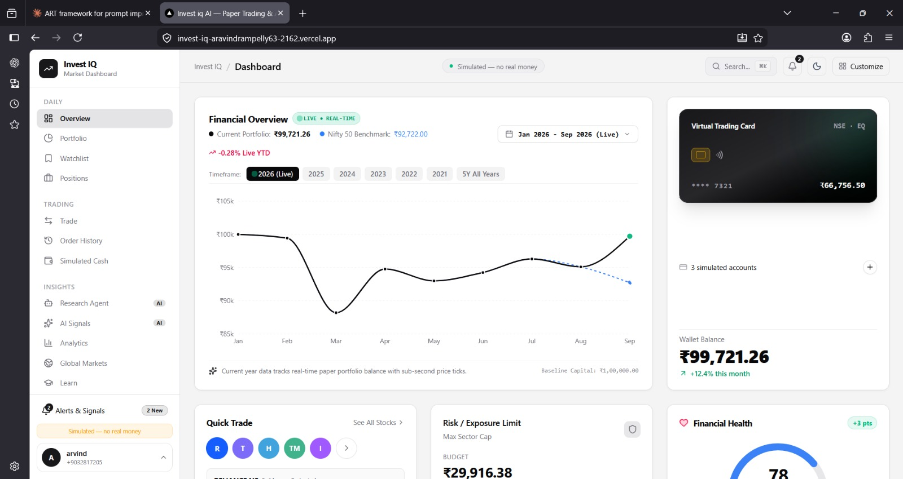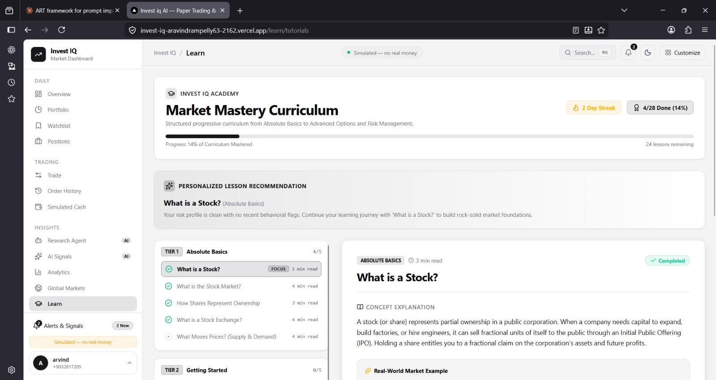

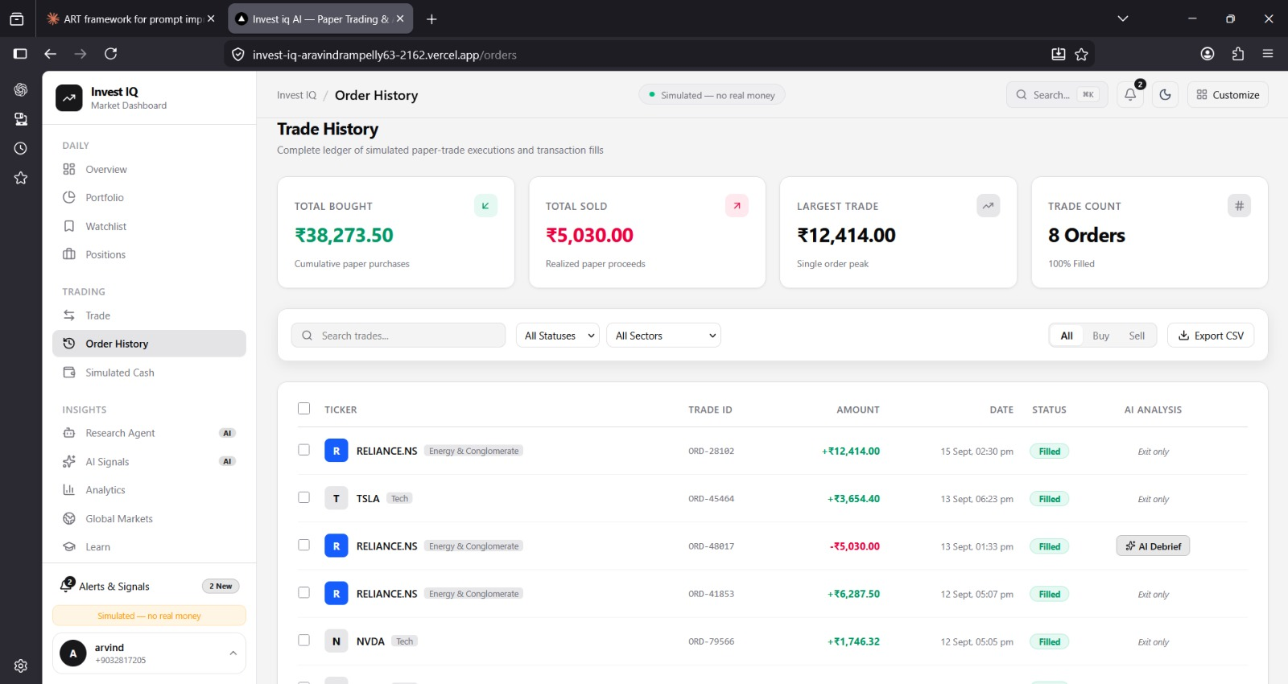

14. RESULTS AND ANALYSIS
The implemented INVESTIQ system provides an interactive environment for practicing investment decisions using virtual money. The system combines market information, AI/ML analysis, GenAI assistance, and portfolio simulation.

14.1 Market Data Results
The system successfully displays available stock information through the application interface. Users can view relevant price information and use it for simulated investment activities.

14.2 AI/ML Results
The AI/ML component processes the available market data and provides analytical insights. The results can be evaluated using metrics such as MAE, MSE, RMSE, and R² when a numerical prediction model is implemented.

14.3 Simulation Results
Users can perform simulated buy and sell operations using virtual funds. The system updates the portfolio after each transaction and calculates the resulting portfolio value and simulated profit or loss.

14.4 GenAI Results
The GenAI component allows users to interact with the system using natural language. It can provide explanations of market information, portfolio performance, and investment-related concepts.

14.5 Overall Analysis
The combination of simulation and AI-based assistance makes the application more interactive than a basic stock simulator. Users can practice investment decisions while observing how changes in stock prices affect their virtual portfolio.
The system is intended for educational and simulation purposes. Market analysis generated by the system should not be considered a guarantee of future stock performance.

15. CONCLUSION
INVESTIQ: An AI-Powered Market Simulator is designed to provide a practical and risk-free environment for learning about investment and market behavior. The system uses virtual money so that users can practice buying and selling stocks without performing real financial transactions.
The proposed system combines market data processing, AI/ML analysis, Generative AI, and portfolio simulation. The AI/ML component helps analyze market information and identify useful patterns, while GenAI provides simple explanations and interactive responses.
The simulation module allows users to manage virtual investments and monitor portfolio performance. It also helps users understand how investment decisions can affect profit and loss.
The system provides an interactive dashboard through which users can access market information, portfolio details, simulated transactions, and AI-based assistance.
Overall, INVESTIQ provides a useful educational platform for understanding basic investment concepts and market behavior. It demonstrates how AI and Generative AI can be integrated with a market simulator to create a more interactive learning experience.

16. FUTURE ENHANCEMENTS
INVESTIQ can be improved further by adding advanced features and more accurate data processing techniques.

16.1 Advanced ML Models
Future versions can use advanced time-series and deep-learning models to improve market analysis. Different models can also be compared to determine their suitability for different types of market data.

16.2 Real-Time Market Data
The system can be enhanced with real-time market data so that stock prices and portfolio values are updated continuously.

16.3 Improved Risk Analysis
More detailed risk-analysis techniques can be added to help users understand volatility, portfolio risk, and diversification.

16.4 Personalized AI Assistance
The GenAI module can be improved to provide responses based on the user's simulation history, portfolio composition, and selected learning objectives.

16.5 More Financial Assets
Future versions can include additional assets such as exchange-traded funds, indices, and other market instruments.

16.6 Advanced Portfolio Features
Features such as portfolio diversification analysis, performance charts, transaction history, and investment strategy comparison can be added.

16.7 Mobile Application
A mobile version can be developed to allow users to access the simulator and monitor their virtual portfolios from smartphones.

17. REFERENCES / BIBLIOGRAPHY
The following types of sources can be used for developing and documenting the INVESTIQ system:
- Python Software Foundation. Python Documentation. Documentation for Python programming and standard libraries.
- Scikit-learn Developers. Scikit-learn User Guide. Documentation for machine learning algorithms, model training, and evaluation.
- Pandas Development Team. Pandas Documentation. Documentation for data processing and analysis using Python.
- NumPy Developers. NumPy Documentation. Documentation for numerical computing and array operations.
- TensorFlow Developers. TensorFlow Documentation. Documentation for machine learning and deep learning techniques.
- OpenAI. Generative AI and Large Language Model Documentation. Reference material for developing AI-based natural-language applications.
- Research papers and academic articles related to Machine Learning in Financial Market Analysis.
- Research papers and academic articles related to Generative AI and Financial Applications.
- Documentation of the selected Financial Market Data API used in the project.
- Documentation of the selected database, web framework, and other software libraries used during implementation.

18. APPENDIX
The appendix contains additional information related to the implementation and operation of INVESTIQ. It can include screenshots, sample outputs, selected code sections, configuration details, and testing results.

18.1 Application Screenshots
Screenshots of important application pages can be included, such as:
- Login and registration page.
- Main dashboard.
- Stock information page.
- Simulated trading page.
- Portfolio page.
- AI/GenAI interaction page.
- Results and analysis page.

18.2 Sample Input
A sample input may include a selected stock, quantity, transaction type, or user question submitted to the system.

18.3 Sample Output
The corresponding output can include updated portfolio value, simulated profit/loss, market analysis, or a GenAI-generated explanation.

18.4 Testing Details
The appendix can contain selected test cases showing the input, expected output, actual output, and testing status.

18.5 Code Snippets
Important implementation snippets can be included, such as:
- Market data collection.
- Data preprocessing.
- ML model loading.
- Portfolio calculation.
- GenAI integration.
- Simulated buy/sell operations.
The appendix provides supporting material for the main project report without interrupting the explanation in the previous chapters.

THANK YOU

