**HOME PAGE**

**What is car dealership?**

A car dealership is a business that sells new or used cars at the retail level, based on a dealership contract with an automaker or its sales subsidiary. Car dealerships also often sell spare parts and automotive maintenance services.

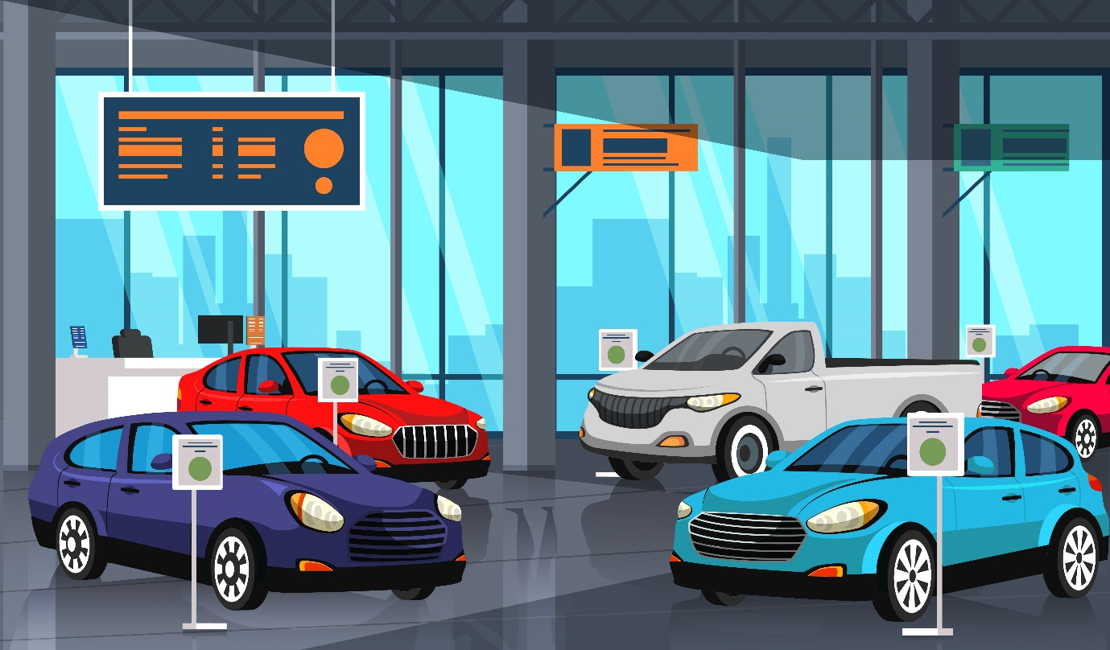

**What do we do?**

We, at our dealership site, help you filter cars based on your preferences and narrow down your choices. We also help you choose a dealer based on your convenience.

**ABOUT US**

At our dealership, we believe in providing our customers with the finest selection of vehicles and a stress-free buying experience. We are committed to delivering the highest standards of professionalism and integrity in everything we do.

Thank you for considering our dealership for your automotive needs. We look forward to serving you!

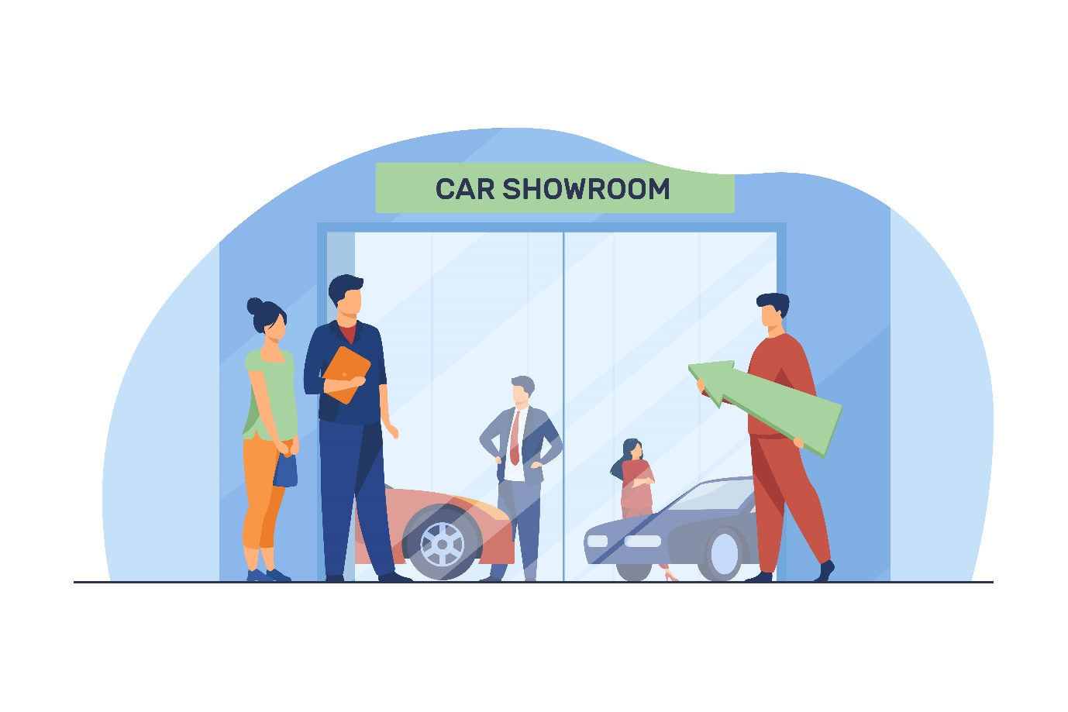

**CUSTOMER STORIES PAGE**

1. Emily's Smooth Car Buying Journey

Emily had been searching for a new car for weeks but was frustrated with the limited options and pushy salespeople at local dealerships. Then, she stumbled upon CarLabz. She was pleasantly surprised to find a user-friendly interface that allowed her to filter cars based on her preferences. The detailed car listings, including photos and specifications, made it easy for her to choose her dream car.

Emily's experience with our website was so seamless that she highly recommends it to anyone looking for a stress-free car buying experience.

1. Sarah's Time-Saving Experience

Sarah is a busy professional with little time to spend at traditional dealerships. She was looking for a car dealer that would respect her time and offer a convenient buying experience. Sarah found exactly what she needed from CarLabz. The search filters allowed her to narrow down her choices, and the compare filter allowed her to choose the right car.

She also praised the FAQ feature which helped her navigate to the site features more easily.

1. Michael's First-Time Buyer Success

Michael was a first-time car buyer with little knowledge of the car-buying process. He was nervous about making such a significant purchase. However, CarLabz made it a breeze for him. The informative "compare cars" section guided him through each step of the process for choosing the right car. Michael also found the customer reviews on our website to be invaluable. They provided insights from other first-time buyers, helping him make an informed decision. With the website's easy-to-use interface, Michael's first car buying experience was a resounding success.

1. Susan's Road Trip Ready Purchase

Susan was planning a cross-country road trip and needed a reliable vehicle to make the journey. She turned to CarLabz, where she found a comprehensive selection of SUVs and vans suitable for her adventure. The website's detailed descriptions, like fuel efficiency, helped her narrow down her choices. She was able to locate a dealer nearest to her from our locate a dealer page.

1. David's Family-Friendly Choice

David was on a quest to find the perfect family car that met both his safety and budget requirements. He came across our dealership website and was thrilled to discover a wide range of family-friendly vehicles. The search options allowed him to filter cars based on safety features, seating capacity, and price range.

He found the ideal car for his family and appreciated CarLabz’s locate a dealer page, which made it easy for him to go to the nearest dealer. David now enjoys peaceful road trips with his family, thanks to our website.

1. Laura's Family-Friendly Solution

Laura and her husband were in search of a family-friendly vehicle to accommodate their growing family. They had specific requirements, including safety features and ample space. Our car dealership website's advanced search options allowed them to narrow down their choices quickly.

What truly impressed Laura was the "Compare" feature, which enabled her to compare multiple cars side by side. This feature made their decision-making process a breeze. Laura and her husband found their ideal family car through our website, and they now recommend it to fellow parents looking for practical and safe vehicles.

**CARS PAGE**

* **Maruti Suzuki Alto 800**

Price Range: ₹2.99 - ₹4.41 lakh

Engine: 0.8L Petrol

Power Output: 47 bhp

Mileage: 22.05 kmpl

Seating Capacity: 5

Transmission: 5-speed manual or automatic

Safety Features: Dual airbags, ABS with EBD

Key Features: Manual air conditioning, touchscreen infotainment system

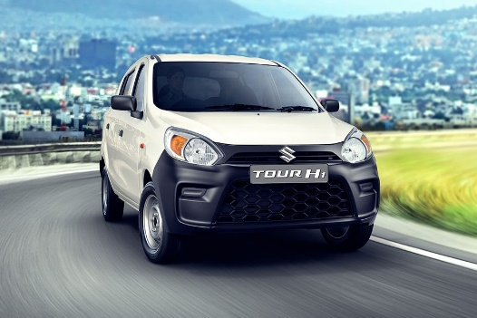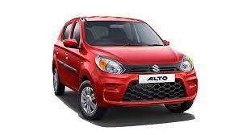

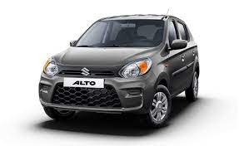

* **Hyundai i20**

Price Range: ₹6.85 - ₹11.40 lakh

Engine: 1.2L Petrol, 1.5L Diesel, 1.0L Turbo Petrol

Power Output: 83 bhp (Petrol), 98 bhp (Diesel), 118 bhp (Turbo Petrol)

Mileage: 20.25 kmpl (Petrol), 25.2 kmpl (Diesel), 20.28 kmpl (Turbo Petrol)

Seating Capacity: 5

Transmission: 5-speed manual, 6-speed manual, or automatic

Safety Features: 6 airbags, ABS with EBD

Key Features: Touchscreen infotainment system, wireless charging

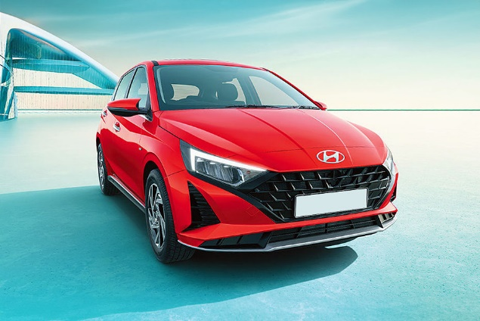 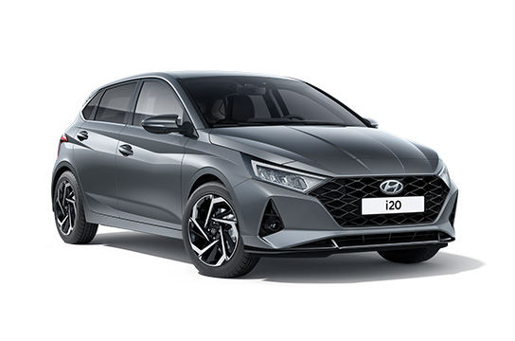 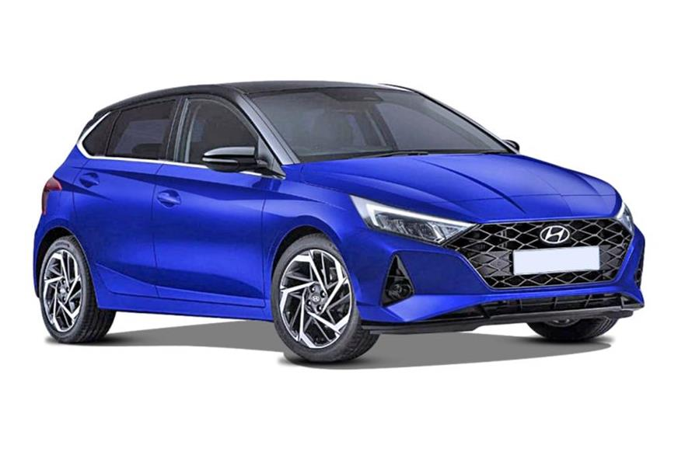

* **Tata Nexon**

Price Range: ₹7.19 - ₹13.04 lakh

Engine: 1.2L Petrol, 1.5L Diesel

Power Output: 118 bhp (Petrol), 108 bhp (Diesel)

Mileage: 17.4 kmpl (Petrol), 21.5 kmpl (Diesel)

Seating Capacity: 5

Transmission: 6-speed manual or automatic

Safety Features: Dual front airbags, ESP, Hill Hold Control

Key Features: Harman infotainment system, multi-drive modes

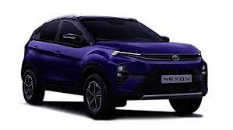 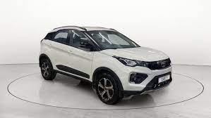 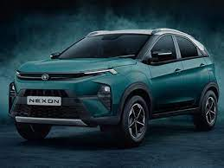

* **Honda City**

Price Range: ₹11.16 - ₹15.53 lakh

Engine: 1.5L Petrol, 1.5L Diesel

Power Output: 118 bhp (Petrol), 98 bhp (Diesel)

Mileage: 17.8 kmpl (Petrol), 24.1 kmpl (Diesel)

Seating Capacity: 5

Transmission: 6-speed manual or automatic

Safety Features: 6 airbags, ABS with EBD

Key Features: 7-inch touchscreen infotainment, sunroof

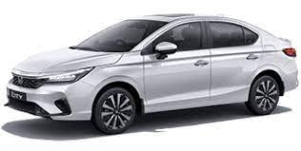 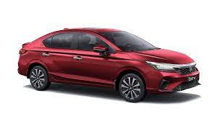 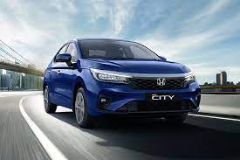

* **Kia Seltos**

Price Range: ₹9.95 - ₹17.65 lakh

Engine: 1.5L Petrol, 1.4L Turbo Petrol, 1.5L Diesel

Power Output: 113 bhp (Petrol), 138 bhp (Turbo Petrol), 113 bhp (Diesel)

Mileage: 16.5 kmpl (Petrol), 18.0 kmpl (Turbo Petrol), 21.0 kmpl (Diesel)

Seating Capacity: 5

Transmission: 6-speed manual or automatic

Safety Features: 6 airbags, ABS with EBD, ESC

Key Features: UVO Connect, Bose sound system

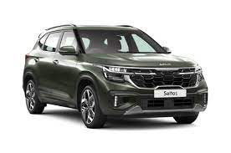 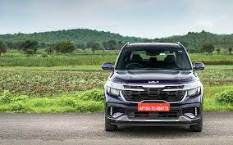

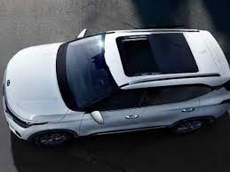

* **Mahindra Thar**

Price Range: ₹12.11 - ₹16.25 lakh

Engine: 2.0L Petrol, 2.2L Diesel

Power Output: 150 bhp (Petrol), 130 bhp (Diesel)

Mileage: 13.0 kmpl (Petrol), 15.2 kmpl (Diesel)

Seating Capacity: 4/6

Transmission: 6-speed manual or automatic

Safety Features: Dual airbags, ABS with EBD, Roll Cage

Key Features: 4x4 capability, removable roof and doors

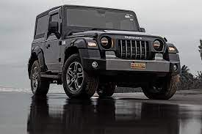 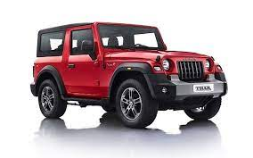



* **Ford EcoSport**

Price Range: ₹8.19 - ₹11.73 lakh

Engine: 1.5L Petrol, 1.5L Diesel

Power Output: 120 bhp (Petrol), 99 bhp (Diesel)

Mileage: 15.9 kmpl (Petrol), 21.7 kmpl (Diesel)

Seating Capacity: 5

Transmission: 5-speed manual or automatic

Safety Features: 6 airbags, ABS with EBD, ESC

Key Features: SYNC 3 infotainment, sunroof

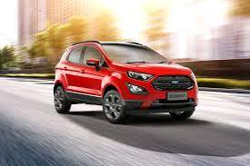 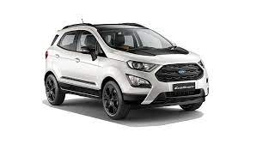

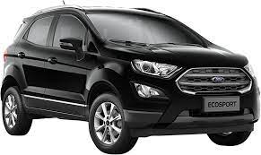

* **Volkswagen Polo**

Price Range: ₹6.17 - ₹10.58 lakh

Engine: 1.0L Petrol, 1.0L TSI Petrol

Power Output: 75 bhp (Petrol), 108 bhp (TSI Petrol)

Mileage: 18.24 kmpl (Petrol), 18.24 kmpl (TSI Petrol)

Seating Capacity: 5

Transmission: 5-speed manual or automatic

Safety Features: Dual airbags, ABS with EBD

Key Features: Touchscreen infotainment, cruise control

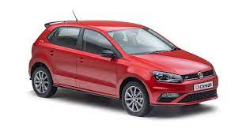 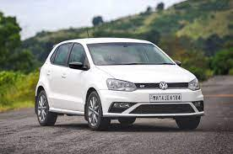

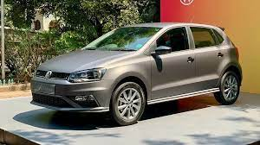

* **Renault Kwid**

Price Range: ₹3.40 - ₹5.87 lakh

Engine: 0.8L Petrol, 1.0L Petrol

Power Output: 53 bhp (0.8L), 67 bhp (1.0L)

Mileage: 22.3 kmpl (0.8L), 21.7 kmpl (1.0L)

Seating Capacity: 5

Transmission: 5-speed manual or automatic

Safety Features: Driver airbag, ABS with EBD

Key Features: Touchscreen infotainment, reverse camera

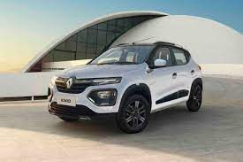 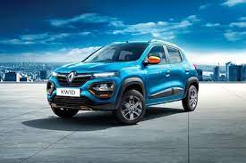

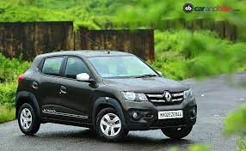

* **Toyota Innova Crysta**

Price Range: ₹16.59 - ₹24.92 lakh

Engine: 2.7L Petrol, 2.4L Diesel

Power Output: 164 bhp (Petrol), 148 bhp (Diesel)

Mileage: 11.25 kmpl (Petrol), 15.1 kmpl (Diesel)

Seating Capacity: 7/8

Transmission: 5-speed manual or automatic

Safety Features: 7 airbags, ABS with EBD

Key Features: Captain seats, touchscreen infotainment

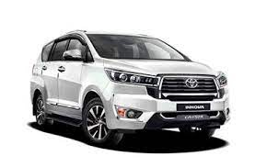 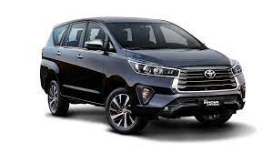

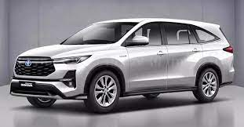

* **Hyundai Creta**

Price Range: ₹10.16 - ₹17.81 lakh

Engine: 1.5L Petrol, 1.4L Turbo Petrol, 1.5L Diesel

Power Output: 113 bhp (Petrol), 138 bhp (Turbo Petrol), 113 bhp (Diesel)

Mileage: 16.8 kmpl (Petrol), 16.9 kmpl (Turbo Petrol), 21.4 kmpl (Diesel)

Seating Capacity: 5

Transmission: 6-speed manual or automatic

Safety Features: 6 airbags, ABS with EBD, ESC

Key Features: Panoramic sunroof, touchscreen infotainment

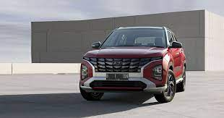 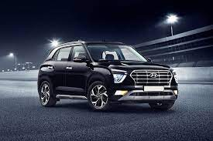

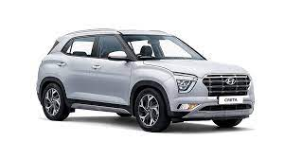

* **Maruti Suzuki Swift**

Price Range: ₹5.97 - ₹9.22 lakh

Engine: 1.2L Petrol, 1.3L Diesel

Power Output: 82 bhp (Petrol), 74 bhp (Diesel)

Mileage: 23.2 kmpl (Petrol), 28.4 kmpl (Diesel)

Seating Capacity: 5

Transmission: 5-speed manual or automatic

Safety Features: Dual airbags, ABS with EBD

Key Features: Touchscreen infotainment, sporty design

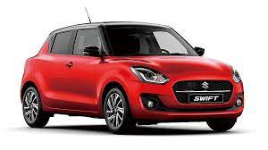 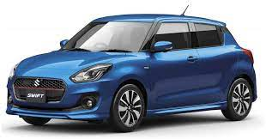 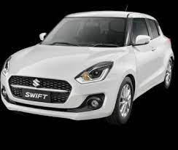

* **Nissan Magnite**

Price Range: ₹5.59 - ₹10.0 lakh

Engine: 1.0L Turbo Petrol

Power Output: 98 bhp

Mileage: 17.7 kmpl

Seating Capacity: 5

Transmission: 5-speed manual or CVT automatic

Safety Features: Dual airbags, ABS with EBD

Key Features: 8-inch touchscreen, wireless Apple CarPlay

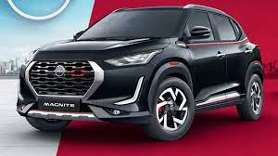 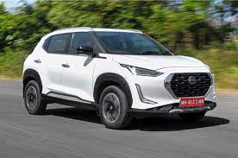

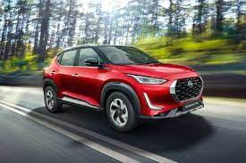

* **Tata Harrier**

Price Range: ₹14.59 - ₹21.09 lakh

Engine: 2.0L Diesel

Power Output: 168 bhp

Mileage: 16.35 kmpl

Seating Capacity: 5

Transmission: 6-speed manual or automatic

Safety Features: 6 airbags, ABS with EBD, ESP

Key Features: Large touchscreen infotainment, premium interiors

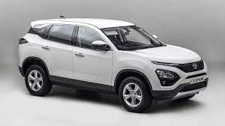 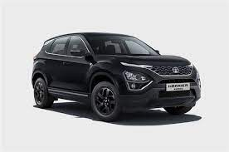

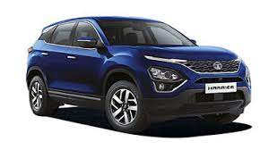

* **Ford Figo**

Price Range: ₹5.82 - ₹9.27 lakh

Engine: 1.2L Petrol, 1.5L Diesel

Power Output: 95 bhp (Petrol), 99 bhp (Diesel)

Mileage: 18.5 kmpl (Petrol), 24.4 kmpl (Diesel)

Seating Capacity: 5

Transmission: 5-speed manual or automatic

Safety Features: 6 airbags, ABS with EBD, ESP

Key Features: SYNC 3 infotainment, comfortable cabin

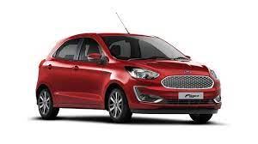 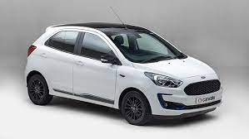 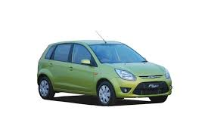

* **Mahindra XUV300**

Price Range: ₹8.3 - ₹12.68 lakh

Engine: 1.2L Petrol, 1.5L Diesel

Power Output: 109 bhp (Petrol), 115 bhp (Diesel)

Mileage: 17.0 kmpl (Petrol), 20.0 kmpl (Diesel)

Seating Capacity: 5

Transmission: 6-speed manual or automatic

Safety Features: 7 airbags, ABS with EBD, Hill Start Assist

Key Features: Touchscreen infotainment, sunroof

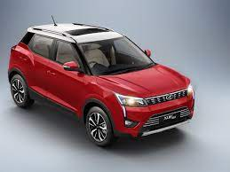 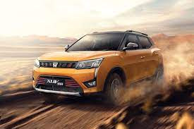 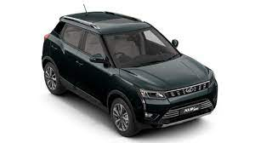

* **Volkswagen Vento**

Price Range: ₹10.00 - ₹14.50 lakh

Engine: 1.0L TSI Petrol

Power Output: 108 bhp

Mileage: 17.69 kmpl

Seating Capacity: 5

Transmission: 6-speed manual or automatic

Safety Features: 4 airbags, ABS with EBD

Key Features: Solid build quality, comfortable ride

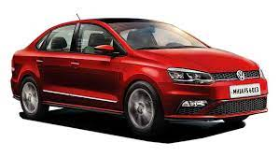 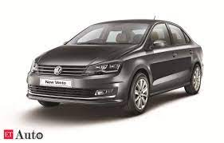 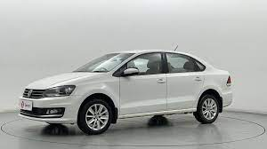

* **Renault Triber**

Price Range: ₹5.30 - ₹7.82 lakh

Engine: 1.0L Petrol

Power Output: 71 bhp

Mileage: 19.0 kmpl

Seating Capacity: 7

Transmission: 5-speed manual or AMT

Safety Features: Dual airbags, ABS with EBD

Key Features: Modular seating, spacious cabin

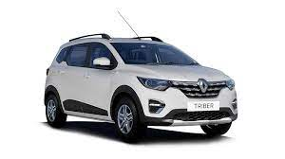 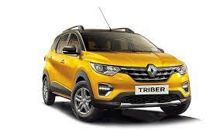

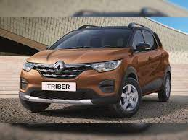

* **Skoda Octavia**

Price Range: ₹25.99 - ₹35.99 lakh

Engine: 2.0L Petrol, 2.0L Diesel

Power Output: 187 bhp (Petrol), 143 bhp (Diesel)

Mileage: 15.81 kmpl (Petrol), 21 kmpl (Diesel)

Seating Capacity: 5

Transmission: 7-speed DSG automatic

Safety Features: 8 airbags, ABS with EBD, ESC

Key Features: Premium interiors, virtual cockpit

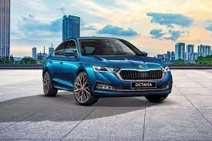 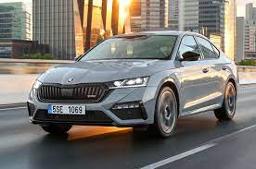 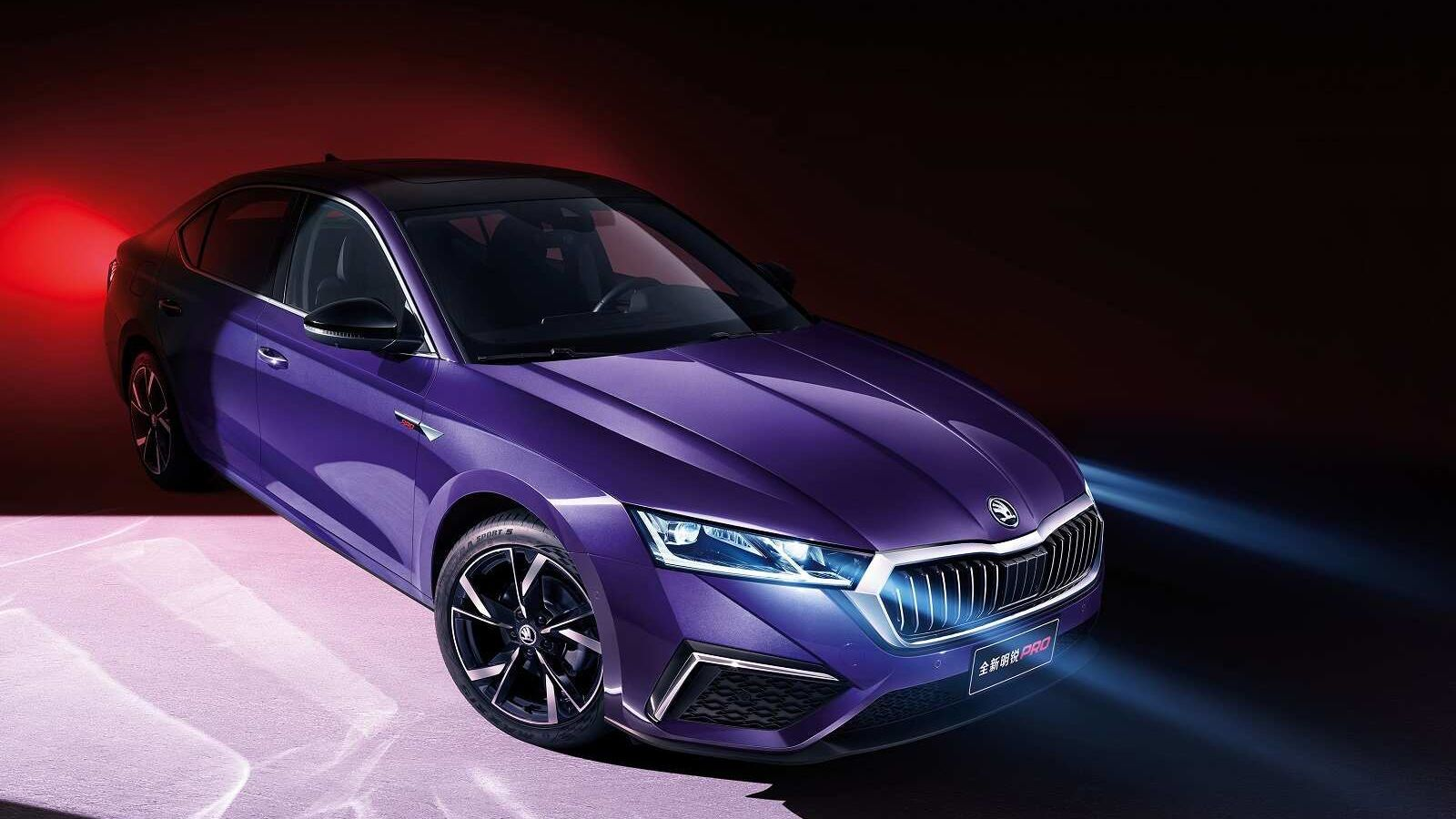

* **Jeep Compass**

Price Range: ₹17.29 - ₹28.29 lakh

Engine: 1.4L Turbo Petrol, 2.0L Diesel

Power Output: 163 bhp (Petrol), 170 bhp (Diesel)

Mileage: 14.3 kmpl (Petrol), 17.1 kmpl (Diesel)

Seating Capacity: 5

Transmission: 6-speed manual or automatic

Safety Features: 6 airbags, ABS with EBD, Hill Start Assist

Key Features: Off-road capability, UConnect infotainment

