Architecture of Swiggy
Distributed Computing Mini Project - Phase 1

Registration number: 23MCCE11
App studied: Swiggy (food delivery)
September 2026

Contents
1. Introduction 3
1.1 How this study was done 3
2. Overview of the architecture 3
3. Main components 4
3.1 Client apps 4
3.2 Edge layer 5
3.3 Core services 5
3.4 Supporting platforms 5
4. Data flow: the life of an order 6
5. Storage 6
6. Communication 7
7. Deployment and scaling 7
8. Summary 8
Items from memory (unverified) 8
References 9

1. Introduction
Swiggy is an Indian on-demand delivery platform, started in 2014 [5], [37]. It began with restaurant food delivery and later grew into a hyper-local marketplace for other items as well (Swiggy Stores) [13]. Every order connects three groups of people in real time:
- the customer, who browses restaurants and places an order,
- the restaurant, which accepts and prepares it,
- the delivery partner (also called delivery executive, "DE" [6]), who picks it up and delivers it.
This makes Swiggy a good example of a large distributed system. Traffic has sharp peaks at lunch and dinner. Many services must agree on the state of one order. Location data arrives all the time. A slow or failed service directly delays somebody's food.
This document summarises how Swiggy is built, based on what Swiggy's engineers have published themselves. It covers the main components, how data flows through them, storage, communication, and deployment and scaling.

1.1 How this study was done
- Sources used. Swiggy's engineering blog Swiggy Bytes, Swiggy's company blog, AWS and vendor case studies that name Swiggy, and conference talk abstracts. Every source in the References was opened and read. Search-result snippets were not used as evidence.
- Access limits. The blog could not be fetched directly by automated tools, so articles were read through Medium's RSS feed or a reader service that returns the same text (see References). Some pages were blocked, so a few topics may be under-represented.
- Dates. The articles span 2017 to 2026, and Swiggy's systems change over time. Where a fact comes from an older article, the year is given.
- Marking. Statements that come from general knowledge and not from a source are marked (unverified). Statements that are my own conclusions are marked (inference).

2. Overview of the architecture
At the highest level Swiggy is a cloud-native microservice system on AWS. Swiggy's own words are "We were born into the cloud, specifically AWS" [37]. Client traffic enters through an edge layer: AWS load balancers [11], [41], and for the web front-end a CDN, the Kong API gateway and HAProxy [10]. Behind the edge sit hundreds of small services running on Kubernetes. The services talk to each other with synchronous calls (REST/HTTP and gRPC) and asynchronous events (mainly Apache Kafka). Each service keeps its data in a store suited to its job: MySQL, DynamoDB, Redis, Aerospike, Elasticsearch and others.
Key numbers reported by Swiggy:
Fact | Value | Source
Microservices in production | "over 400+", of which "130+" are directly in the order fulfilment path | [1], [4]
Typical fan-out of one page request | 3-5x, so "several services end up with a latency budget of ~50 ms at P99" | [1]
Lunch-time traffic swing | "from practically 100K rpm to 300K rpm" (requests per minute) | [3]
Kubernetes | "10 Kubernetes clusters" with "around 400+ EC2 instances" | [8]
Containers in production | "10,000+" | [37]
Services on the main order Kafka cluster | "more than 50 services" | [15]

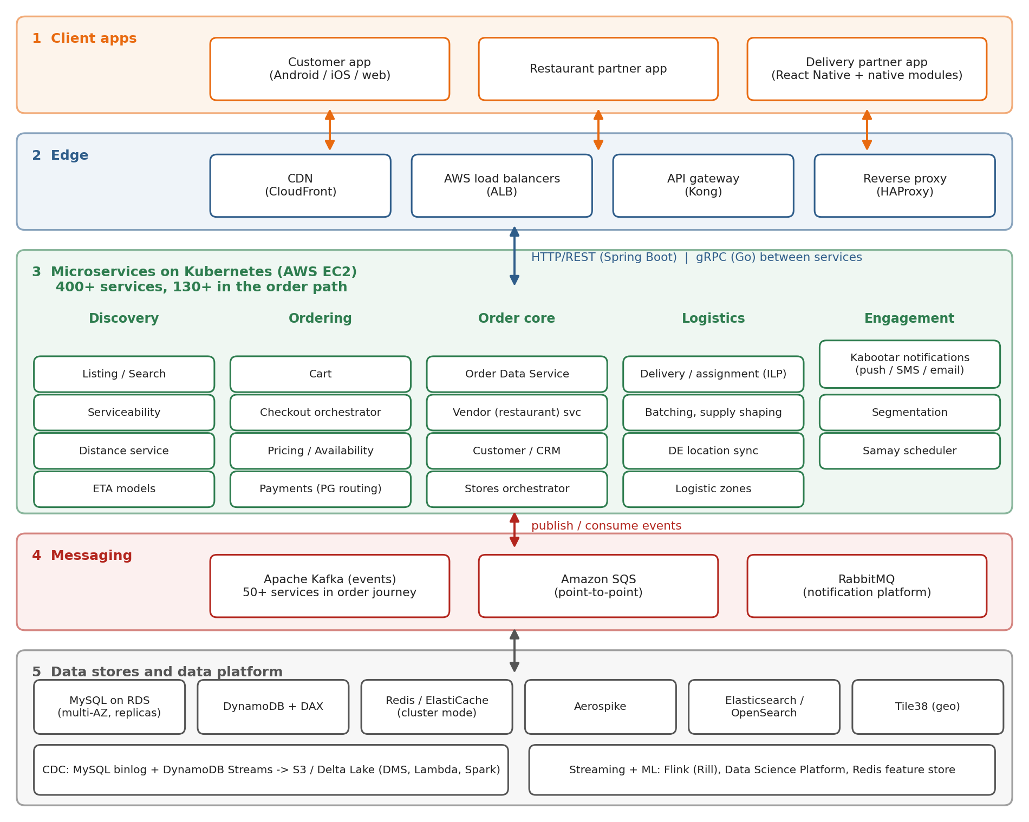
Figure 1: High-level architecture of Swiggy, drawn from the sources in the References
Figure 1 is my own summary diagram. The components are named in the sources, but the exact grouping and connections are simplified (inference). Swiggy has not published one complete official diagram.

3. Main components

3.1 Client apps
- Customer app (Android, iOS and web). The web front-end is served through Kong and HAProxy, with gradual (canary) rollouts [10].
- Restaurant partner app. Restaurants receive new orders and update their status. The order events reach the "Vendor" service [14].
- Delivery partner app. Built with React Native plus native modules. It tracks location "needed to assign trips, real-time tracking of an order, payment based on distance travelled" [24]. Each delivery flow in the app is modelled as a finite state machine. Changes are sent through a sync module with "retry flows, lazy sync mechanisms", so the app keeps working on weak mobile networks [24]. A 2019 post lists "gRPC, MQTT, Server Push" as options Swiggy planned to try for the partner app [25]; whether they were adopted is not stated.

3.2 Edge layer
- CDN: Amazon CloudFront for web assets [10].
- Load balancers: AWS Application Load Balancers (ALB) are used, for example in front of the event-ingestion service [41]. During IPL cricket matches, traffic coming from the JioHotstar app is separated at the load-balancer level and sent to "dedicated downstream instances with their own auto-scaling policies" [11].
- API gateway and reverse proxy: for the web front-end, "Kong as the API gateway and Haproxy as the reverse proxy layer" [10]. Whether the mobile apps use the same gateway is not stated (unverified).

3.3 Core services
Swiggy's services fall into a few groups. The names below are the ones used in the sources.
Group | Services and their job | Sources
Discovery | Listing/Search; Serviceability decides which restaurants can deliver to a customer, handling about 100k listing requests per minute and about 200 million distance calculations per minute; Distance service (15 million distance queries per minute at peak, 2017); ETA models | [21], [22], [19], [27]
Ordering | Cart service (calls availability, pricing, DynamoDB); Checkout orchestrator, which calls downstream services "from delivery to availability"; Payments, where an ML model picks the payment gateway | [2], [12], [32]
Order core | Order Data Service publishes order events to Kafka; Vendor and CRM services consume them; Swiggy Stores added a stateless orchestrator and an anomaly detection engine | [14], [13]
Logistics | Assignment of delivery partners with an Integer Linear Program, run per logistic zone; batching of two orders into one trip; supply shaping; location sync from the partner app | [26], [34], [28], [24]
Engagement | Kabootar, the notification platform for push, SMS and email (8 microservices on RabbitMQ in 2017); Segmentation of users; Samay scheduler | [7], [18]

Logistics was re-architected. The older "Delivery monolith" was "backed by Mysql and Redis clusters running at the peak of vertical scale and there were multiple issues in partitioning data to scale horizontally" [5]. It was replaced by an "event driven service oriented multi-tier architecture" with utility, platform and service tiers, built as "a multi-tenant multi-service-line logistics platform" [5]. The same platform can then serve food, groceries and other delivery lines.

3.4 Supporting platforms
- Messaging: Apache Kafka is the main event backbone. SQS and RabbitMQ are used for specific cases [15], [14], [7].
- Data platform: change data capture (CDC) copies data from MySQL and DynamoDB into a data lake on S3/Delta Lake [16], [17]. Flink-based stream processing ("Rill") runs over Kafka [31].
- Data Science Platform (DSP): serves ML models online, "1B+ predictions per day" (2019) [29]. Its online feature store runs on Redis/ElastiCache, which AWS reports at 50 million queries per second [36].

4. Data flow: the life of an order
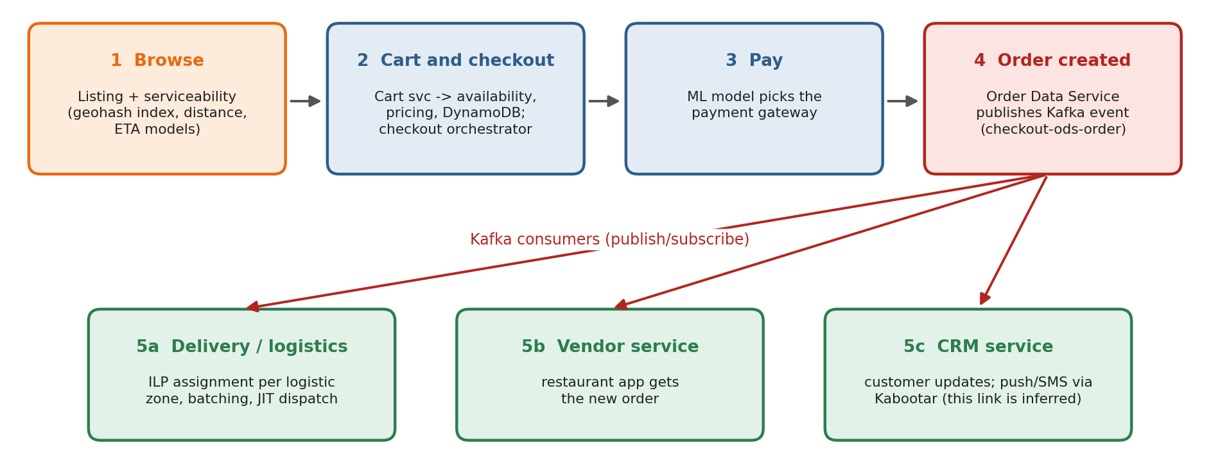
Figure 2: The main steps of one order through Swiggy's services
- Browse. The app asks for restaurants near the customer. Serviceability checks each restaurant against the customer's location, using a GeoHash-based index of clusters held in memory [22], distance and ETA estimates [19], [27], and the current "stress" of the area [23].
- Cart and checkout. The cart service checks availability and pricing and stores the cart in DynamoDB [2]. The checkout orchestrator calls the downstream services needed to confirm the order [12].
- Payment. An ML model chooses which payment gateway to route the transaction to [32].
- Order created. The Order Data Service publishes the order to Kafka topics such as checkout-ods-order (also order_cancel and order_edit) [14].
- Consumers react. The Delivery, Vendor and CRM services consume these events [14]:
  - Delivery assigns a delivery partner. An Integer Linear Program "tries to minimise the overall cost of delivery and maximise customer experience". It runs at short, regular intervals for all active batches in a city, or per logistic zone to keep latency low [26].
  - Vendor informs the restaurant.
  - Customer notifications are sent through Kabootar [7]. That this is triggered by the same Kafka event is my (inference); the sources do not state it.
- Delivery and tracking. The partner app sends location updates and state changes through its sync module [24]. ETA predictions are made by four models, one for each leg of the journey, and are "refreshed at fixed time intervals" [27].
The flow mixes two styles. The checkout path is orchestrated: one service calls the others in order [12], [13]. After the order exists, the flow is choreographed: services react to Kafka events on their own [15].

5. Storage
Swiggy uses different databases for different jobs ("polyglot persistence"):
Store | Used for | Sources
MySQL on Amazon RDS | Primary transactional data. "180+ MySQL RDS servers deployed in multi-AZ, single-AZ replicas, and standalone nodes" | [17], [38]
Amazon DynamoDB (+ DAX cache) | Transactional data; the Segmentation service handles "2.5 Million requests per minute" at "p99 latency of 25ms", partitioned by entity ID; cart data | [17], [18], [2], [40]
Redis / ElastiCache (cluster mode) | Caches and the ML online feature store | [29], [30], [36]
Aerospike | Distance cache. "Aerospike being multithreaded offered higher queries-per-second compared to Redis per server node" (2017) | [19]
Elasticsearch / OpenSearch | Elasticsearch inside the notification platform (2017); OpenSearch for search autocomplete | [7], [42]
Tile38 | Geo-spatial queries, with Kafka-backed "masterless clones" | [20]
S3 + Delta Lake, Hive, Snowflake | Data lake and analytics, filled by CDC | [16], [17], [29]

Two published storage designs are worth noting for this course:
- The serviceability cache splits its data into partitions and replicates each partition: "the data partitions need to be replicated across multiple nodes". It is "horizontally scalable". It evicts data above a "High Water Mark" and stops writes at a higher "Stop Write" mark. There is "a logically separate secondary failover cache cluster which is a close replica of the primary cache cluster" [22].
- CDC reads the MySQL binlog and DynamoDB Streams, so analytics no longer needs a MySQL read replica: "Major cost gain is achieved by removing the MySQL read replica" [16].

6. Communication
Kind | Technology at Swiggy | Sources
App to backend | HTTPS through load balancers; the web front-end also through CloudFront, Kong and HAProxy | [10], [11], [41]
Service to service (synchronous) | REST over HTTP with Java/Spring Boot ("We chose Spring-boot as our micro-service architecture"); gRPC for Go services, with request deadlines passed along the call chain | [6], [2]
Events (asynchronous, publish/subscribe) | Apache Kafka: "event streaming and processing, microservice orchestration, and choreography"; later a managed Confluent Kafka service processing "millions of messages every second" | [15], [39]
Queues (point-to-point) | Amazon SQS, after some point-to-point topics were moved "from Kafka to SQS"; RabbitMQ inside Kabootar | [14], [7]
To users | Push notifications, SMS and email through Kabootar ("1 million messages in a 15 minute window", 2017) | [7]

Swiggy stresses that synchronous calls must have timeouts that follow the caller's deadline: "create one Context with Timeout which matches the SLA we provide to the upstream client" [2]. This stops a slow downstream service from holding up the whole request chain.

7. Deployment and scaling
- Cloud and containers. Everything runs on AWS [37]. Services run in containers on 10 Kubernetes clusters, moved to ARM-based Graviton EC2 instances to save cost [8]. Test environments are short-lived Kubernetes namespaces with their own HAProxy and Kafka [9]. (Whether Kubernetes is managed EKS or self-managed is unverified.)
- Horizontal scaling and autoscaling. Services scale out behind load balancers. JioHotstar traffic got its own instances "with their own auto-scaling policies", tuned to the match schedule [11]. DynamoDB on-demand tables autoscale, and Swiggy has written about putting limits on that [40].
- Planned peaks. For New Year's Eve, Swiggy uses expected orders per minute "to calculate the maximum requests per minute" for each service and scales ahead of time. They "convert any critical caches or databases on single Availability Zone (AZ) instances to Multi-AZ (MAZ) before the event", and watch "46 different metrics" on "seven different dashboards" [35].
- Protecting the core flow. For IPL traffic there are "two layers of rate limiting". The second works as a "circuit breaker ensuring that even a massive IPL-driven traffic surge can't compromise Swiggy's core app flow" [11].
- Safe releases. Front-end changes roll out gradually (canary releases through Kong and CloudFront) [10]. Services have service-level tests [4], and incidents get public post-mortems [14], [15].

8. Summary
Swiggy is a large, event-driven microservice system on AWS. Reads that must be fast (listing, serviceability, distance) are served from partitioned, replicated in-memory caches. Writes that matter (orders, payments) go to replicated databases and are then broadcast as Kafka events, so logistics, restaurants and notifications can react independently. Reliability comes from redundancy (multi-AZ, replicas, failover clusters), from isolation (separate instances and rate limits for traffic spikes), and from defensive patterns (timeouts, circuit breakers, graceful degradation). The next document, ParadigmsandAlgorithms_23MCCE11, looks at these patterns one by one.

Items from memory (unverified)
The following are commonly said about Swiggy but were not confirmed by an opened source, so this document does not rely on them:
- the founders' names and that the head office is in Bengaluru;
- the main AWS region (believed to be Mumbai, ap-south-1);
- whether Kubernetes runs on Amazon EKS;
- use of Istio as a service mesh (seen only in a search snippet);
- use of ScyllaDB, Cassandra or PostgreSQL (only on third-party sites);
- which circuit-breaker or rate-limiter library is used.

References
All Swiggy Bytes articles are on Swiggy's engineering blog (bytes.swiggy.com, a Medium publication; the same articles are also at medium.com/swiggy-bytes/...). Accessed 29 September 2026. Automated tools could not open bytes.swiggy.com directly, so the article text was read through the publication's Medium RSS feed or a reader service (r.jina.ai) that returns the same article. Five key quotes were checked a second time ([1], [15], [22], [26], [11]).
No. | Source
[1] | V. Seshadri, "Designing Resilient Microservices - Part 1", Swiggy Bytes, 24 Nov 2021. https://bytes.swiggy.com/designing-resilient-microservices-part-1-6a72fe964759
[2] | V. Seshadri, "Designing Resilient Microservices - Part 2", Swiggy Bytes, 17 May 2022. https://bytes.swiggy.com/designing-resilient-microservices-part-2-14f8b564f622
[3] | V. Seshadri, "A brief introduction to Engineering challenges at Swiggy", Swiggy Bytes, 15 Mar 2021. https://bytes.swiggy.com/engineering-challenges-at-swiggy-430dea6c86a3
[4] | N. Chalasani, "Service Level Testing for Microservices in Swiggy", Swiggy Bytes, 4 May 2021. https://bytes.swiggy.com/service-level-testing-for-microservices-in-swiggy-62b6b3f865f4
[5] | R. Singh, "Re-Architecting Swiggy's logistics systems", Swiggy Bytes, 15 Feb 2021. https://bytes.swiggy.com/re-architecting-swiggys-logistics-systems-ddf301a29fa0
[6] | S. Srivastava, "Swiggy-Rest - Opinionated CRUD Library On Spring", Swiggy Bytes, 22 Sep 2017. https://bytes.swiggy.com/swiggy-rest-opinionated-crud-library-on-spring-a78715074eb4
[7] | S. Srivastava, "Kabootar - Swiggy's Communication Platform", Swiggy Bytes, 31 May 2017. https://bytes.swiggy.com/kabootar-swiggys-communication-platform-e5a43cc25629
[8] | A. Ranjan, "How Swiggy migrated its k8s workload to Graviton", Swiggy Bytes, 4 Sep 2023. https://bytes.swiggy.com/how-swiggy-migrated-its-k8s-workload-to-graviton-d2643bbc7871
[9] | M. Kabra, "How we improved testing processes using Ephemeral Environment", Swiggy Bytes, 17 Jul 2023. https://bytes.swiggy.com/how-we-improved-testing-processes-using-ephemeral-environment-852ed3952429
[10] | A. C. Wardhan, "Building a Robust Controlled Rollout System for Frontend at Scale", Swiggy Bytes, 13 Feb 2025. https://bytes.swiggy.com/building-a-robust-controlled-rollout-system-for-frontend-at-scale-91cabeea2898
[11] | A. C. Wardhan, "Ordering Biryani Without Missing a Six: The Swiggy x JioHotstar Story", Swiggy Bytes, 4 May 2026. https://medium.com/swiggy-bytes/ordering-biryani-without-missing-a-six-the-swiggy-jiohotstar-story-601a22cc340e
[12] | T. Bhat, "POP faster: How automated ops improved UX & led to 17% more orders!", Swiggy Bytes, 4 May 2020. https://bytes.swiggy.com/pop-faster-how-automated-ops-improved-ux-led-to-17-more-orders-c155af3a169b
[13] | T. Bhat, "Building Blocks of Swiggy Stores - From Food Delivery to a Hyper-Local Marketplace", Swiggy Bytes, 4 Sep 2019. https://bytes.swiggy.com/building-blocks-of-swiggy-stores-from-food-delivery-to-a-hyper-local-marketplace-brief-tech-b8c40b1f4509
[14] | A. Sahoo, "#BehindTheBug: Breaking the Event Pipeline: A Migration Gone Wrong", Swiggy Bytes, 30 Oct 2023. https://bytes.swiggy.com/behindthebug-breaking-the-event-pipeline-a-migration-gone-wrong-23ed215d6754
[15] | A. Sahoo, "#BehindTheBug - Kafka Under The Water", Swiggy Bytes, 23 Aug 2022. https://bytes.swiggy.com/behindthebug-kafka-under-the-water-288c3d05b202
[16] | Dibyendu, "Introduction to CDC System: an efficient way to replicate transactional data into data lake", Swiggy Bytes, 2 Feb 2022. https://bytes.swiggy.com/introduction-to-cdc-system-an-efficient-way-to-replicate-transactional-data-into-data-lake-c10f99c7a3fd
[17] | Dibyendu, "Architecture of CDC System", Swiggy Bytes, 10 Nov 2022. https://bytes.swiggy.com/architecture-of-cdc-system-a975a081691f
[18] | M. Masand, "Segmentation at Swiggy - Part 2", Swiggy Bytes, 15 Feb 2022. https://bytes.swiggy.com/segmentation-at-swiggy-part-2-a1fcb503751d
[19] | A. Bagla, "Swiggy Distance Service", Swiggy Bytes, 4 Oct 2017. https://bytes.swiggy.com/swiggy-distance-service-9868dcf613f4
[20] | T. Singh, "Running Geo Queries At Scale", Swiggy Bytes, 15 Sep 2020. https://bytes.swiggy.com/running-geo-queries-at-scale-adea70f5af45
[21] | S. Bairi, "What Serviceability means at Swiggy?", Swiggy Bytes, 16 Dec 2020. https://bytes.swiggy.com/what-serviceability-means-at-swiggy-c94c1aad352a
[22] | S. Bairi, "Designing the Serviceability Platform at Swiggy for High Scale - Part 1", Swiggy Bytes, 28 Jun 2021. https://bytes.swiggy.com/designing-the-serviceability-platform-at-swiggy-for-high-scale-part-1-751a631f0379
[23] | S. Bairi, "Designing the Serviceability Platform at Swiggy for High Scale - Part 2", Swiggy Bytes, 5 Sep 2021. https://bytes.swiggy.com/designing-the-serviceability-platform-at-swiggy-for-high-scale-part-2-ab20365fbc23
[24] | Narendra, "Architecture and Design Principles Behind the Swiggy's Delivery Partners app", Swiggy Bytes, 13 Nov 2019. https://bytes.swiggy.com/architecture-and-design-principles-behind-the-swiggys-delivery-partners-app-4db1d87a048a
[25] | M. Chandrashekar, "App-solutely No More Deli-worries!", Swiggy Bytes, 9 Aug 2019. https://bytes.swiggy.com/app-solutely-no-more-deli-worries-df3fa56bcaff
[26] | R. Moghe, "Logistic Zones for Assignment", Swiggy Bytes, 16 Aug 2022. https://bytes.swiggy.com/logistic-zones-for-assignment-48d9ce06c4a8
[27] | V. Agarwal, "Where is my order? - Part I" (also listed as "How ML powers - When is my Order coming? - Part I"), Swiggy Bytes, 22 May 2023. https://bytes.swiggy.com/how-ml-powers-when-is-my-order-coming-part-i-4ef24eae70da
[28] | A. Tiwari et al., "A Real-Time Supply-Shaping System to Meet Demand Under Constraints", Swiggy Bytes, 29 Oct 2021. https://bytes.swiggy.com/a-real-time-supply-shaping-system-to-meet-demand-under-constraints-ff449a73874b
[29] | J. Sathyanarayana, "Enabling data science at scale at Swiggy: the DSP story", Swiggy Bytes, 9 Nov 2019. https://bytes.swiggy.com/enabling-data-science-at-scale-at-swiggy-the-dsp-story-208c2d85faf9
[30] | R. Narayana, "Optimizing batch writes to Redis using Pipelining", Swiggy Bytes, 3 Jan 2023. https://bytes.swiggy.com/optimizing-batch-writes-to-redis-using-pipelining-d480ebaf4653
[31] | S. Lalwani, "Rill State Implementation", Swiggy Bytes, 26 May 2025. https://bytes.swiggy.com/rill-state-implementation-937bf51e077f
[32] | Mithun T M, "An ML Approach for Routing Payment Transactions", Swiggy Bytes, 27 Oct 2022. https://bytes.swiggy.com/an-ml-approach-for-routing-payment-transactions-5a14efb643a8
[33] | S. Paul, S. Rathee, J. Matthew, K. Adusumilli, "An Optimization Framework for On-Demand Meal Delivery System", IEEM 2020. Read via the Swiggy Bytes post of 8 Apr 2021 (the paper itself was not opened). https://bytes.swiggy.com/outstanding-conference-paper-award-at-ieem2020-18c576b60b40
[34] | R. Moghe, S. Rathee, B. Nayak, K. Adusumilli, "Machine Learning based Batching Prediction System for Food Delivery", CODS-COMAD 2021, pp. 316-322. Read via the Swiggy Bytes post of 23 Feb 2022 (the paper itself was not opened). https://bytes.swiggy.com/paper-on-ml-based-batching-prediction-published-ba3f16d060c1
[35] | P. Praveen, "Swiggy's NYE War Room - The fight was on as the sun went down", Swiggy blog, 5 Jan 2023. https://blog.swiggy.com/life-at-swiggy/heres-how-swiggy-setup-a-war-room-for-nye/
[36] | Karuturi, Misra, Srivastava, "Build an ultra-low latency online feature store for real-time inferencing using Amazon ElastiCache for Redis", AWS Database Blog, 25 Sep 2023. https://aws.amazon.com/blogs/database/build-an-ultra-low-latency-online-feature-store-for-real-time-inferencing-using-amazon-elasticache-for-redis/
[37] | Orca Security, "Swiggy Scales Cloud Security Across 10,000+ Containers with Orca" (case study), 15 Sep 2025. https://orca.security/resources/case-studies/swiggy/
[38] | Mydbops, "Swiggy Achieves 43% Cost Savings with AWS DMS and Amazon RDS" (case study, no date shown). https://www.mydbops.com/case-studies/swiggy-aws-dms-rds-case-study
[39] | A. Agarwal, "Powering Real-Time Analytics, Predictions, and Recommendations at Swiggy with Confluent Kafka", talk abstract, Current 2025 Bengaluru. https://current.confluent.io/archive/2025/bengaluru-sessions
[40] | A. Garg, "How to limit autoscaling in on-demand DynamoDB tables?", Swiggy Bytes, 4 Jan 2022. https://bytes.swiggy.com/how-to-limit-autoscaling-in-on-demand-dynamodb-tables-c57e20cbbbcf
[41] | S. Dubey, V. Singh, "Unlocking Cost Savings: Compression in Ingestion's ALB Optimization", Swiggy Bytes, 11 Sep 2024 (only part of the text could be read). https://bytes.swiggy.com/unlocking-cost-savings-compression-in-ingestions-alb-optimization-c7f99fecd744
[42] | L. Kumili, "Swiggy Improves Search Autocomplete Using Real Time Machine Learning Ranking", InfoQ, 18 May 2026. https://www.infoq.com/news/2026/05/swiggy-autocomplete-rt-ranking/

