Requirement Specification: MiniSwiggy
Distributed Computing Mini Project - Phase 3

Registration number: 23MCCE11
A simplified, socket-based version of Swiggy
September 2026

Contents
1. Purpose 3
2. Scope 3
2.1 In scope 3
2.2 Out of scope 3
3. Definitions 3
4. Actors and use cases 4
4.1 Actors 4
4.2 Use cases 4
5. Functional requirements 5
6. Non-functional requirements 6
7. System architecture 7
7.1 Order state machine 8
7.2 Write path (replication before acknowledgement) 8
7.3 Failure detection, failover and recovery 9
7.4 Ordered delivery of events 9
8. Protocol and message format 9
8.1 Framing and encoding 9
8.2 Messages 10
8.3 Errors 10
8.4 Topics (publish/subscribe) 11
8.5 Example (captured from a real run) 11
8.6 Timing values 11
9. Assumptions and constraints 12
10. Distributed concepts demonstrated 12
11. Verification summary 13

1. Purpose
This document specifies MiniSwiggy, a small distributed food-ordering system built for this mini project. It is a simplified version of Swiggy (studied in ArchitectureofApp_23MCCE11 and ParadigmsandAlgorithms_23MCCE11).
The aim is not to copy Swiggy's features. The aim is to show, in working code, a few of the distributed-systems ideas that Swiggy depends on:
- load balancing,
- replication,
- failure detection and failover,
- publish/subscribe,
- ordered delivery of messages.
The whole system uses raw TCP sockets in Java, with no frameworks, message brokers or databases. This keeps every message and every design decision visible.
The document is written for the course examiner and for anyone who wants to run or extend the code.

2. Scope

2.1 In scope
- Three kinds of client programs: customer, restaurant and rider (delivery partner).
- One gateway, which is the entry point, load balancer, failure detector and event broker.
- Two order nodes, which store orders in memory and replicate them as primary and backup.
- A fixed catalogue of 3 restaurants and their menus.
- The full order life cycle: PLACED -> ACCEPTED -> READY -> PICKED_UP -> DELIVERED.
- Live order updates pushed to clients.
- Surviving the crash of one order node, and bringing it back.
- Automated tests and a scripted demo.

2.2 Out of scope
- Payments, prices beyond a simple total, discounts, ratings, search.
- Maps, real locations, distance or ETA calculation. Riders simply take the oldest waiting order.
- Persistent storage on disk. Orders live in memory.
- User accounts, passwords and encryption.
- Replicating the gateway. It is a single point of failure, which is stated as a known limitation.

3. Definitions
Term | Meaning
Node | An order-service server process (OrderNode). There are two: N1 and N2.
Primary | The node that currently accepts writes.
Backup | The other node. It holds a full copy and serves reads.
Epoch | A number that goes up by one each time a new primary is chosen. Used to reject messages from an old primary.
Heartbeat | A PING message sent by the gateway to each node every second.
Read | A request that does not change data (list restaurants, get menu, get order, list orders).
Write | A request that changes an order (place, update status, claim).
Version / seq | A per-order counter that goes up by one on every change. Called version in the store and seq in events.
Topic | A named channel in the gateway's publish/subscribe system, such as order:O-3.
reqId | A request ID chosen by the client. Replies carry the same reqId.

4. Actors and use cases

4.1 Actors
Actor | Program | Goal
Customer | client.CustomerClient | Find food, order it, follow it live
Restaurant | client.RestaurantClient | Receive orders, accept them, mark them ready
Rider (delivery partner) | client.RiderClient | Take waiting orders, pick up, deliver
Operator / examiner | demo.DemoRunner, CLUSTER message | Start the system, watch cluster state, cause failures
Time / failures (system actor) | - | Node crashes, restarts, network delays

4.2 Use cases
ID | Use case | Actor | Short description
UC-1 | Browse restaurants | Customer | List restaurants (restaurants)
UC-2 | View menu | Customer | Show items and prices of one restaurant (menu R1)
UC-3 | Place order | Customer | Order items from one restaurant (order R1 R1-M1x2,R1-M3x1)
UC-4 | Track order live | Customer | Receive pushed updates in the right order; or ask with track O-1
UC-5 | Accept order | Restaurant | Move an order from PLACED to ACCEPTED
UC-6 | Mark ready | Restaurant | Move an order from ACCEPTED to READY
UC-7 | Claim order | Rider | Get the oldest accepted order without a rider
UC-8 | Pick up | Rider | Move own order from READY to PICKED_UP
UC-9 | Deliver | Rider | Move own order from PICKED_UP to DELIVERED
UC-10 | View cluster state | Operator | See which nodes are up, who is primary, and the epoch
UC-11 | Survive node crash | System | Keep serving when one order node dies; re-sync it when it returns

Main flow of UC-3 (place order):
- The customer types order R1 R1-M1x2,R1-M3x1.
- The client sends PLACE_ORDER with a new reqId to the gateway.
- The gateway adds the customer ID (taken from the connection's HELLO) and forwards the write to the primary.
- The primary checks the items, builds version 1 of the order, and sends it to the backup (REPLICATE).
- The backup stores it and replies OK. Only then does the primary commit the order and reply OK.
- The gateway subscribes the customer to order:O-n and publishes a PLACED event.
- The gateway returns the reply to the customer, who sees "ORDER PLACED".
Alternative flows:
- (3a) The primary has crashed. The gateway holds the write and retries until failover has promoted the backup, then sends it there.
- (4a) The item is not on the menu. The reply is ERROR BAD_REQUEST.
- (5a) The backup is down. The primary commits without a replica and logs "NOT replicated".

5. Functional requirements
ID | Requirement
FR-1 | A client shall connect to the gateway over TCP and identify itself with HELLO (role and ID).
FR-2 | Customers shall be able to list restaurants and view a restaurant's menu.
FR-3 | Customers shall be able to place an order of one or more menu items from one restaurant. The system shall reject unknown items, items from another restaurant, and quantities outside 1-20.
FR-4 | Each order shall get a unique ID (O-1, O-2, ...) even when many customers order at the same time.
FR-5 | An order shall move only forward, one step at a time: PLACED, ACCEPTED, READY, PICKED_UP, DELIVERED.
FR-6 | Only the order's restaurant may set ACCEPTED and READY. Only the rider assigned to the order may set PICKED_UP and DELIVERED.
FR-7 | A rider shall be able to claim the oldest order that is ACCEPTED or READY and has no rider. A rider carries one order at a time.
FR-8 | Customers, restaurants and riders shall be able to look up an order and list their orders.
FR-9 | The gateway shall push an event to interested clients after every successful change: the customer and rider of that order, and its restaurant. Riders shall also hear about newly accepted orders.
FR-10 | Each client shall show an order's updates in sequence-number order, even if they arrive out of order. Duplicates shall be dropped.
FR-11 | The gateway shall send read requests to the live order nodes in round-robin order.
FR-12 | The gateway shall send write requests only to the current primary node.
FR-13 | The primary shall copy every write to the backup and receive an acknowledgement before committing it and replying to the client.
FR-14 | The gateway shall send a heartbeat to each node every second and mark a node DOWN after 3 missed heartbeats in a row.
FR-15 | If the primary is DOWN, the gateway shall promote a live backup to PRIMARY with a higher epoch number.
FR-16 | Writes that arrive while the primary is unreachable shall be held by the gateway and retried for up to 10 seconds.
FR-17 | A retried write shall not be applied twice: the same reqId from the same customer returns the existing order, and setting an order to the status it already has is accepted without change.
FR-18 | A node shall refuse replication or role messages from an older epoch (fencing), and step down if it sees a newer epoch.
FR-19 | A restarted node shall copy all orders from its peer before it reports itself ready, and then rejoin as BACKUP.
FR-20 | Clients shall have an interactive mode (typed commands with help) and a script mode (--script). Restaurants and riders shall also have an automatic mode (--auto).
FR-21 | The system shall provide a scripted demo and automated tests that check the features above, including a node crash.

6. Non-functional requirements
ID | Category | Requirement | How it is checked
NFR-1 | Availability | The system keeps accepting orders when one order node crashes. Writes pause for about the failure-detection time (3 missed heartbeats, about 3 s) and then continue. | Test "FAILOVER" (write held about 3.1 s); demo step 5
NFR-2 | Durability | An order that was acknowledged to a client is not lost when one node crashes. | Demo step 7: all 7 orders present and DELIVERED
NFR-3 | Consistency | After recovery both replicas hold identical data (same orders, versions, statuses). | Checksum comparison in tests and demo
NFR-4 | Ordering | Each client sees an order's updates in sequence order, with 0-300 ms random network delay injected. | Test "ordering with jitter"
NFR-5 | Concurrency | At least 20 clients can order at the same time without duplicate IDs or lost orders. One thread serves each connection. | Test "concurrency"
NFR-6 | Performance | No hard target; this is a teaching system. On a laptop, 20 concurrent orders complete in well under a second. | Test timings
NFR-7 | Portability | Runs on any OS with JDK 17 or newer. No external libraries, no build tool needed. | Built with javac --release 17
NFR-8 | Simplicity | Plain text protocol, readable in logs; every component logs timestamped lines. | Screenshots
NFR-9 | Security (basic) | The gateway fills in the acting customer/restaurant/rider from the connection's HELLO, so a client cannot act for another. No authentication or encryption (out of scope). | Interactive test: R1 cannot accept R2's order

7. System architecture
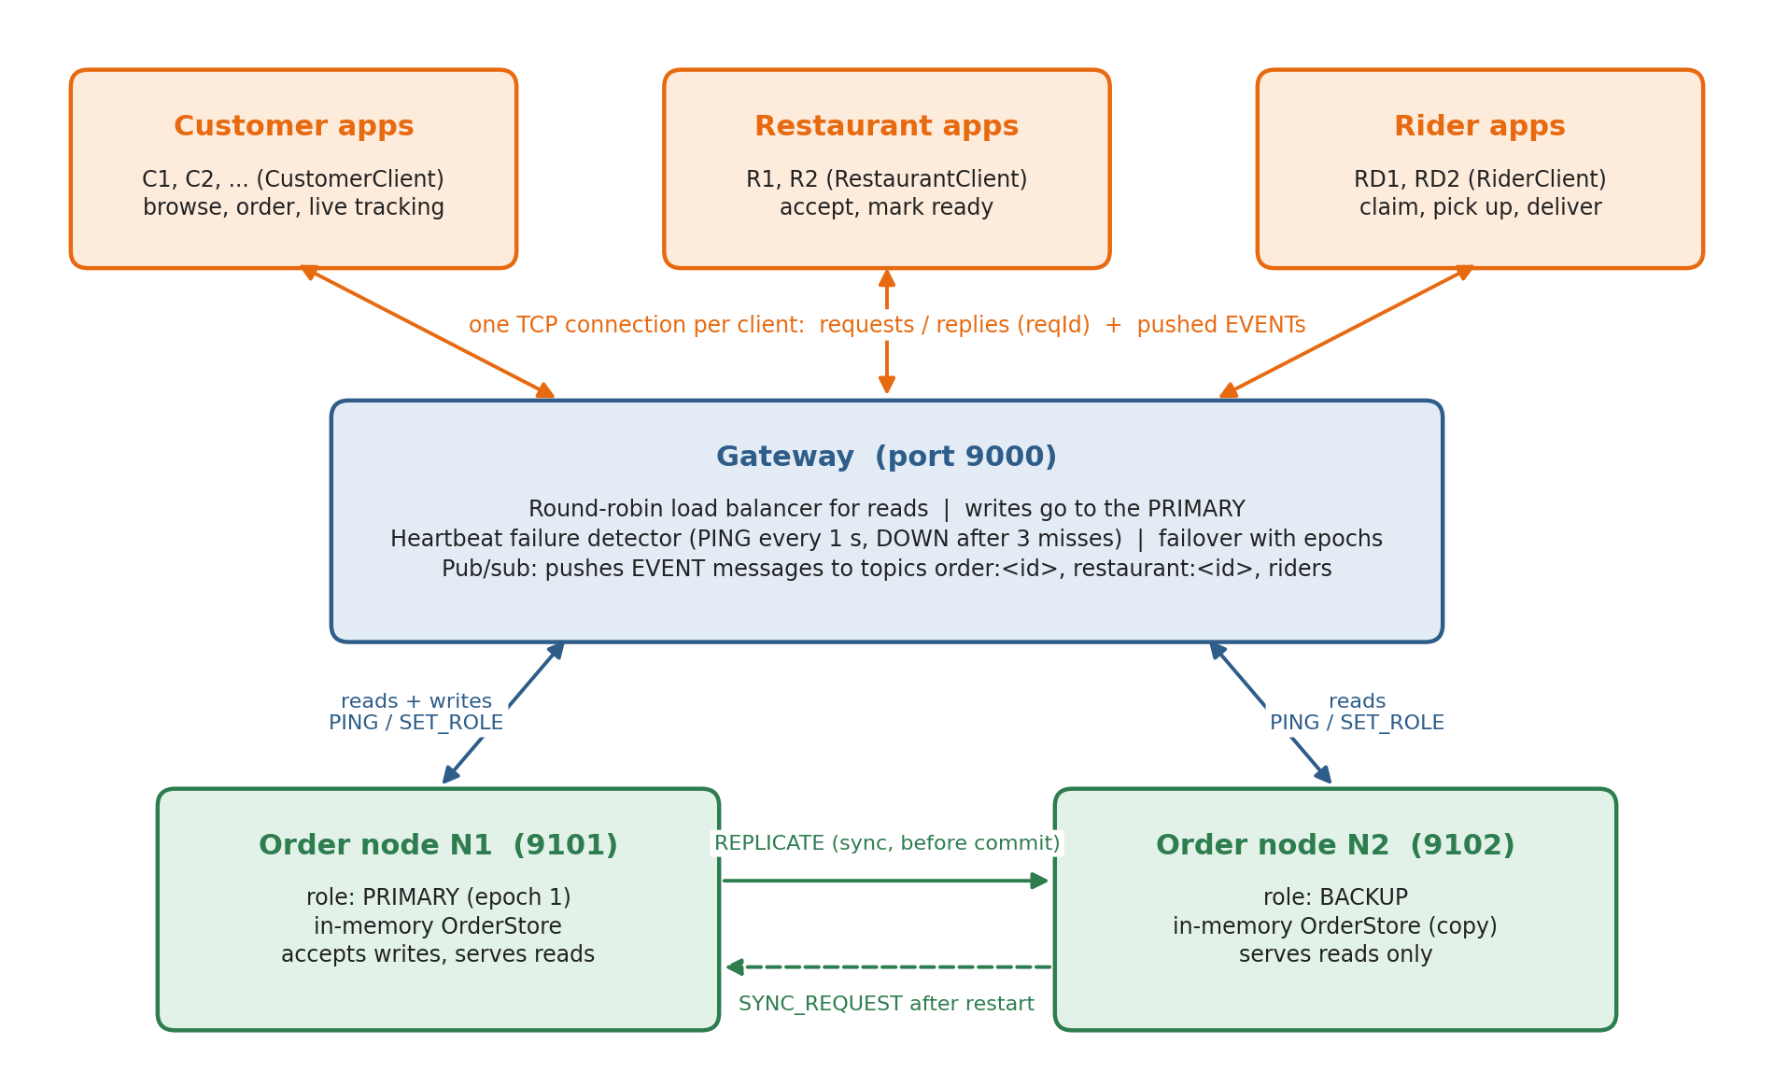
Figure 1: MiniSwiggy components and connections
Component | Class(es) | Port | Responsibility
Gateway | gateway.Gateway, PubSub, ClientSession | 9000 | Accepts clients; round-robin reads; writes to primary; heartbeats; failover; pub/sub push
Order node N1 / N2 | node.OrderNode, OrderStore | 9101 / 9102 | Holds orders in memory; validates changes; primary-backup replication; re-sync after restart
Customer client | client.CustomerClient | - | Commands for browsing, ordering, tracking; prints live updates
Restaurant client | client.RestaurantClient | - | Receives new orders; accept / ready (manual or --auto)
Rider client | client.RiderClient | - | Claim, pick up, deliver (manual or --auto)
Shared client code | client.GatewayClient, OrderedEventBuffer | - | One socket per client; matches replies by reqId; re-orders events
Shared code | common.* | - | Message format, protocol names, socket helpers, order and catalogue data

Threads. Each server (gateway and nodes) accepts connections in one thread and serves each connection in its own thread from a thread pool. On a node, writes go through one lock, so the steps "prepare, replicate, commit" happen in a single order. Each client has one reader thread and one event thread, so listeners can send requests without blocking the socket.

7.1 Order state machine
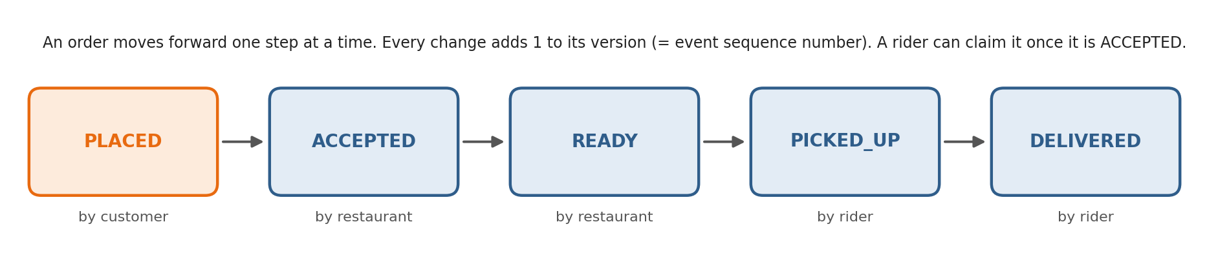
Figure 2: Order states and who may change them

7.2 Write path (replication before acknowledgement)
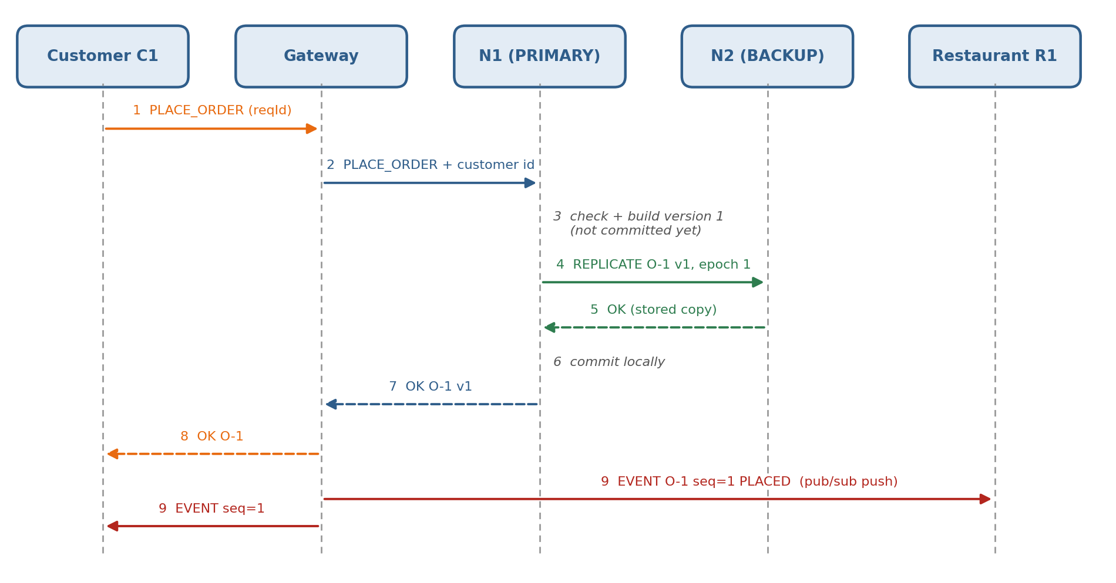
Figure 3: How one order is written and replicated

7.3 Failure detection, failover and recovery
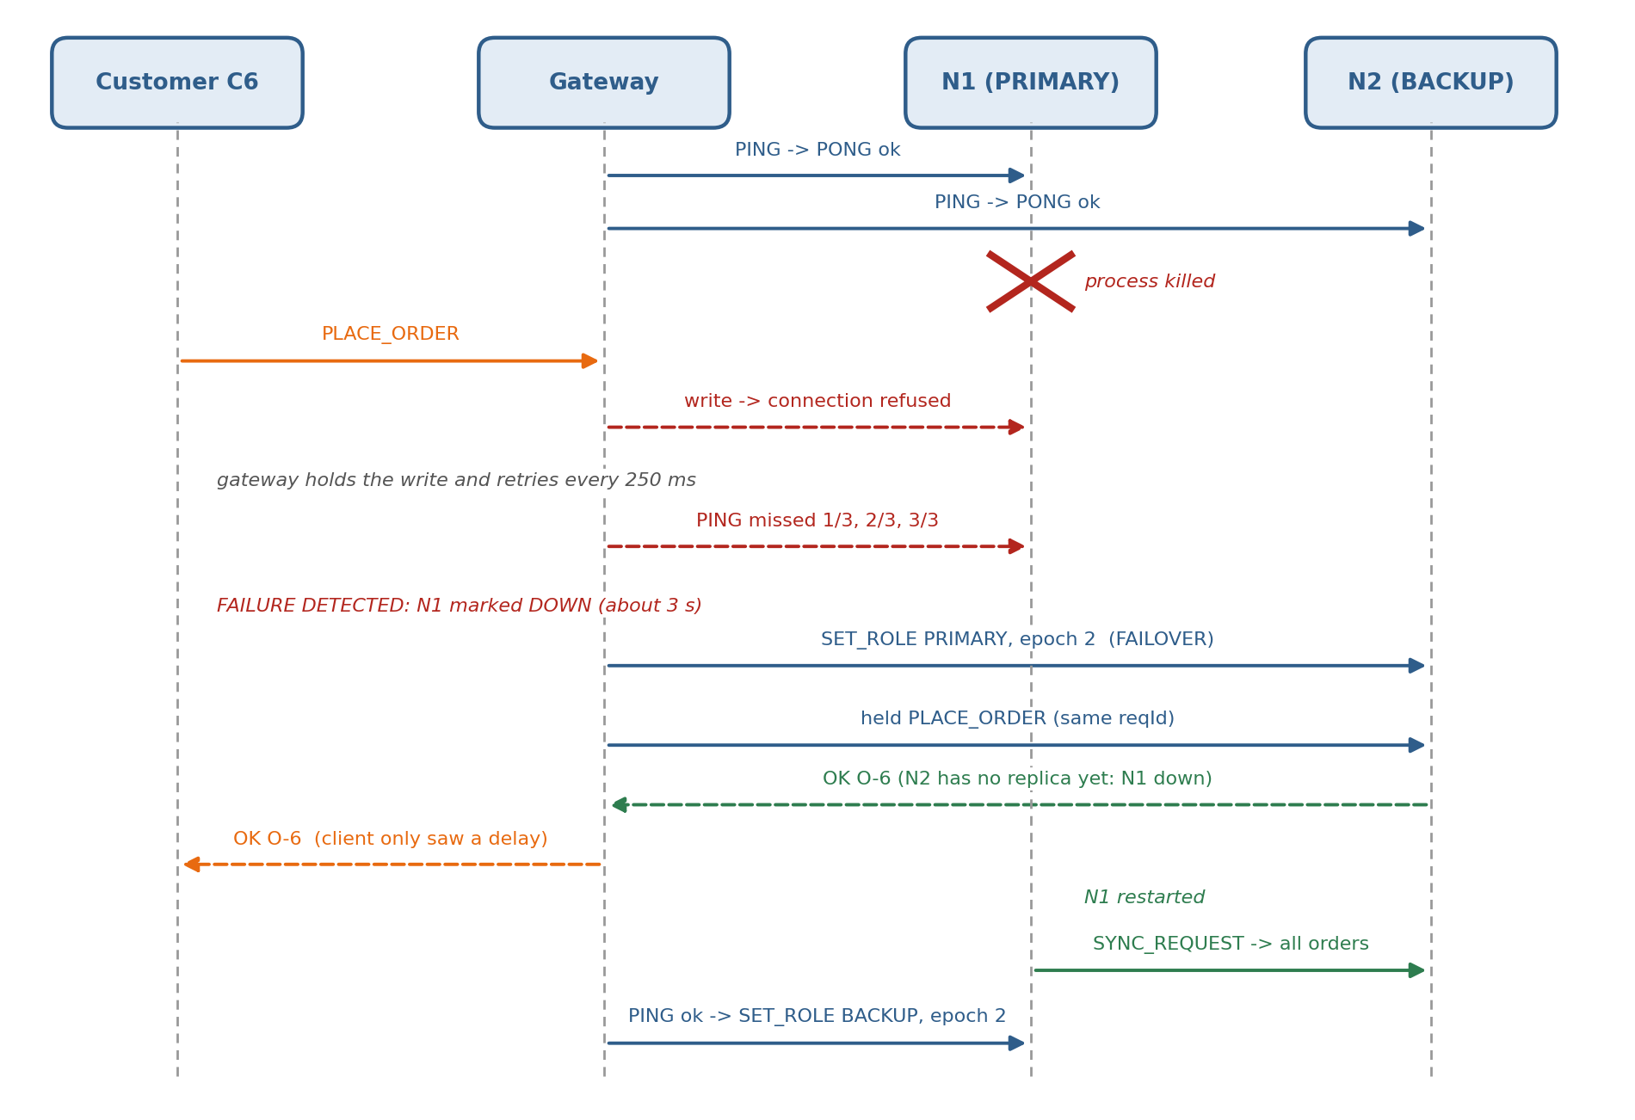
Figure 4: Crash of the primary, failover and re-sync

7.4 Ordered delivery of events
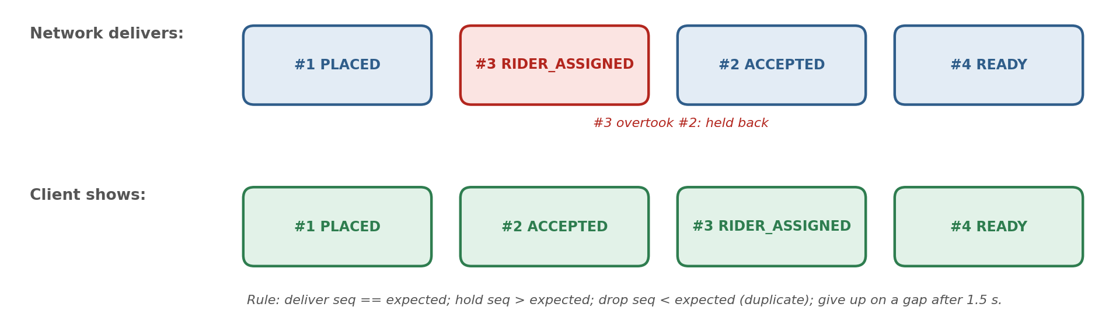
Figure 5: The client's hold-back queue puts events back in order

8. Protocol and message format

8.1 Framing and encoding
- Transport: TCP. A client keeps one connection open to the gateway. The gateway and the nodes open a short connection per call.
- One message = one line of UTF-8 text, ended by a newline (\n).
- Format: TYPE|key1=value1|key2=value2|...
- Values are URL-encoded (URLEncoder), so they may contain |, =, spaces or newlines. For example R2-M1x1,R2-M3x1 is sent as R2-M1x1%2CR2-M3x1.
- Lists are sent as numbered keys, for example count=2|o0.orderId=O-1|...|o1.orderId=O-2|....
- Every request may have a reqId. The reply (OK or ERROR) echoes it. Pushed EVENT messages have no reqId, which is how a client tells replies and events apart on the same socket.

8.2 Messages
Type | From -> To | Main fields | Reply
HELLO | client -> gateway | role (CUSTOMER / RESTAURANT / RIDER), id | OK
SUBSCRIBE / UNSUBSCRIBE | client -> gateway | topic | OK
CLUSTER | anyone -> gateway | - | OK: primary, epoch, n0.id, n0.up, n0.role, n0.orders, ...
LIST_RESTAURANTS | client -> gateway -> any node | - | OK: count, r0.id, r0.name, r0.cuisine, ...
GET_MENU | client -> gateway -> any node | restaurant | OK: name, count, m0.id, m0.name, m0.price, ...
GET_ORDER | client -> gateway -> any node | orderId | OK: order fields
LIST_ORDERS | client -> gateway -> any node | optional: customer, restaurant, rider, status | OK: count, o0.(order fields), ...
PLACE_ORDER | customer -> gateway -> primary | restaurant, items (gateway adds customer) | OK: event=PLACED, retry, order fields
UPDATE_STATUS | restaurant/rider -> gateway -> primary | orderId, status (gateway adds actor) | OK: event, retry, order fields
CLAIM_ORDER | rider -> gateway -> primary | (gateway adds actor) | OK: event=RIDER_ASSIGNED, order fields
PING | gateway -> node | - | PONG: node, role, epoch, ready, orders
SET_ROLE | gateway -> node | role (PRIMARY / BACKUP), epoch | OK, or ERROR STALE_EPOCH
STATS | anyone -> node | - | OK: epoch, orders, reads, writes, checksum
REPLICATE | primary -> backup | from, epoch, order fields | OK, or ERROR STALE_EPOCH
SYNC_REQUEST | restarted node -> peer | from | OK: count, epoch, o0.(order fields), ...
EVENT | gateway -> subscribers (push) | event, orderId, seq, status, customer, restaurant, rider, total, items; or kind=JOB for rider announcements | none

Order fields: orderId, customer, restaurant, items, total, status, rider, version, requestId, createdAt. Every OK from a node also carries servedBy (the node ID) and role.

8.3 Errors
Errors are sent as ERROR|code=...|reason=...|reqId=....
Code | When
BAD_REQUEST | Malformed line, unknown message type, unknown item, bad quantity, HELLO missing
NOT_FOUND | Unknown order or restaurant
NOT_ALLOWED | Actor may not make this change (for example another restaurant's order)
INVALID_TRANSITION | Status would skip a step or go backwards
NO_ORDER_AVAILABLE | A rider asked for an order but none is waiting
NOT_PRIMARY | A write reached a node that is not the primary (the gateway retries)
STALE_EPOCH | A message from an older epoch was refused (fencing)
NO_NODE_AVAILABLE | No live node, or no primary within the 10-second retry window

8.4 Topics (publish/subscribe)
Topic | Subscribers | Events
order:<id> | The customer who placed it (added automatically); the rider who claimed it (added automatically) | Every change of that order, numbered by seq
restaurant:<id> | That restaurant (added at HELLO) | Every change of its orders
riders | All riders (added at HELLO) | kind=JOB when an order is ACCEPTED and needs a rider (not numbered)

8.5 Example (captured from a real run)
A raw TCP session with the gateway (>> sent, << received; long lines shortened with ...). The EVENT arrives before the OK of the same request; the client can tell them apart because only the reply has a reqId.
>> HELLO|role=CUSTOMER|id=RAW1|reqId=2
<< OK|reqId=2
>> PLACE_ORDER|restaurant=R2|items=R2-M1x1%2CR2-M3x1|reqId=4
<< EVENT|event=PLACED|orderId=O-1|seq=1|status=PLACED|customer=RAW1|restaurant=R2|rider=|total=170|...
<< OK|servedBy=N1|role=PRIMARY|event=PLACED|retry=false|orderId=O-1|...|version=1|requestId=4|...|reqId=4
>> UPDATE_STATUS|orderId=O-1|status=DELIVERED|reqId=5
<< ERROR|code=INVALID_TRANSITION|reason=O-1+is+PLACED%2C+it+cannot+become+DELIVERED|reqId=5

8.6 Timing values
Setting | Value | Where
Heartbeat interval / timeout | 1 s / 0.5 s | Gateway
Missed heartbeats before DOWN | 3 | Gateway
Write retry window / retry step | 10 s / 0.25 s | Gateway
Gateway-to-node call timeout | 3 s | Gateway
Replication call timeout | 1.5 s | OrderNode
Connect timeout | 0.5 s | all
Client request timeout | 20 s | GatewayClient
Maximum hold-back time for a missing event | 1.5 s | OrderedEventBuffer

9. Assumptions and constraints
- Crash-stop failures. A node that fails stops completely. It does not send wrong or malicious messages (no Byzantine faults).
- One gateway. The gateway itself does not fail during the demo. It decides who is primary, so the two nodes never have to agree on their own.
- Reliable, ordered links. TCP delivers bytes on one connection in order. Out-of-order events are caused by concurrent gateway threads and by the optional jitter setting, which simulates network delay.
- At most one node down at a time. If both nodes are down together, in-memory data is lost.
- Local clocks are not used for ordering. Only per-order version numbers decide order.
- Small data. A full snapshot fits in one message, which is fine for a demo but not for production.
- Localhost by default. Everything binds to 127.0.0.1. Running on several machines needs --bind 0.0.0.0 and real IP addresses.
- Language and tools. Java 17+ standard library only (java.net.Socket, ServerSocket, threads). No JUnit: a small self-written test runner is used.

10. Distributed concepts demonstrated
Concept (Phase 2 section) | How MiniSwiggy does it | Code | Shown by
Client-server (3.1) | Clients talk only to the gateway over TCP | GatewayClient, Gateway.serveClient | All tests and the demo
Load balancing (4.1) | Round-robin over live nodes for reads; failed node skipped | Gateway.forwardRead | Test "load balancing"; demo step 4
Replication (4.4), durability (4.5) | Synchronous primary-backup; replicate before commit; version-based apply | OrderNode.handleWrite, replicate, OrderStore.apply | Test "replication"; demo step 7 checksum
Failure detection (4.7) | Heartbeats; DOWN after 3 misses | Gateway.ping | Test "FAILOVER"; demo step 5
Leader election / failover (4.6) | Coordinator (gateway) promotes the first live node; epoch number | Gateway.reconcileRoles | Demo step 5 "FAILOVER ... epoch 2"
Fencing | Refuse older epochs; step down on newer | OrderNode.acceptEpoch | Test "fencing"
Recovery | Snapshot pull from peer before ready | OrderNode.syncFromPeer | Test "RECOVERY"; demo step 6
Publish/subscribe (3.3) | Topics in the gateway, events pushed after each write | PubSub, Gateway.publishChange | Test "pub/sub"; demo step 3
Message ordering (5) | Per-order sequence numbers, hold-back queue, gap timeout | OrderedEventBuffer | Unit test; jitter test; demo "held back" lines
Retries and idempotency (4.8) | Gateway retries held writes; node recognises repeats | Gateway.forwardWrite, OrderStore.preparePlace | Test "idempotency"; demo step 5
Finite state machine (4.12) | Status moves forward one step; actor checks | OrderStatus, OrderStore.prepareStatus | Test "store: status moves forward only"
Concurrency | Thread per connection; one write lock per node | OrderNode, Gateway | Test "concurrency" (20 clients)

The project brief asked for at least two distributed concepts. MiniSwiggy runs five main ones: round-robin load balancing, primary-backup replication, heartbeat failure detection with failover, publish/subscribe, and message ordering. It also runs the supporting ideas above (fencing, re-sync, idempotent retries).

11. Verification summary
Requirement(s) | Automated test (tests.TestRunner) | Demo step (demo.DemoRunner)
FR-3, FR-5, FR-6 | store: status moves forward only, and only by the right actor | -
FR-10, NFR-4 | ordering: hold-back buffer ...; ordering with 0-300 ms jitter | Step 3 ("held back" lines)
FR-11 | load balancing: reads are spread round-robin | Steps 4 and 6
FR-13, NFR-2 | replication: order is on BOTH nodes | Step 7
FR-4, NFR-5 | concurrency: 20 customers at once | Step 3 (3 customer processes)
FR-17 | idempotency: a retried PLACE_ORDER is applied once | Step 5 (held writes)
FR-18 | fencing: REPLICATE from an old epoch is refused; roles: backup refuses writes | -
FR-9 | pub/sub: customer receives all 6 live updates in order | Steps 3, 5, 6
FR-14, FR-15, FR-16, NFR-1 | FAILOVER: kill primary N1 ... no data lost | Step 5
FR-19, NFR-3 | RECOVERY: restarted N1 re-syncs from N2 | Steps 6 and 7
FR-20 | (checked by hand with piped input; see Tutorial) | Steps 2-6 use --auto and --script

